**Who do I want to be by my side?**

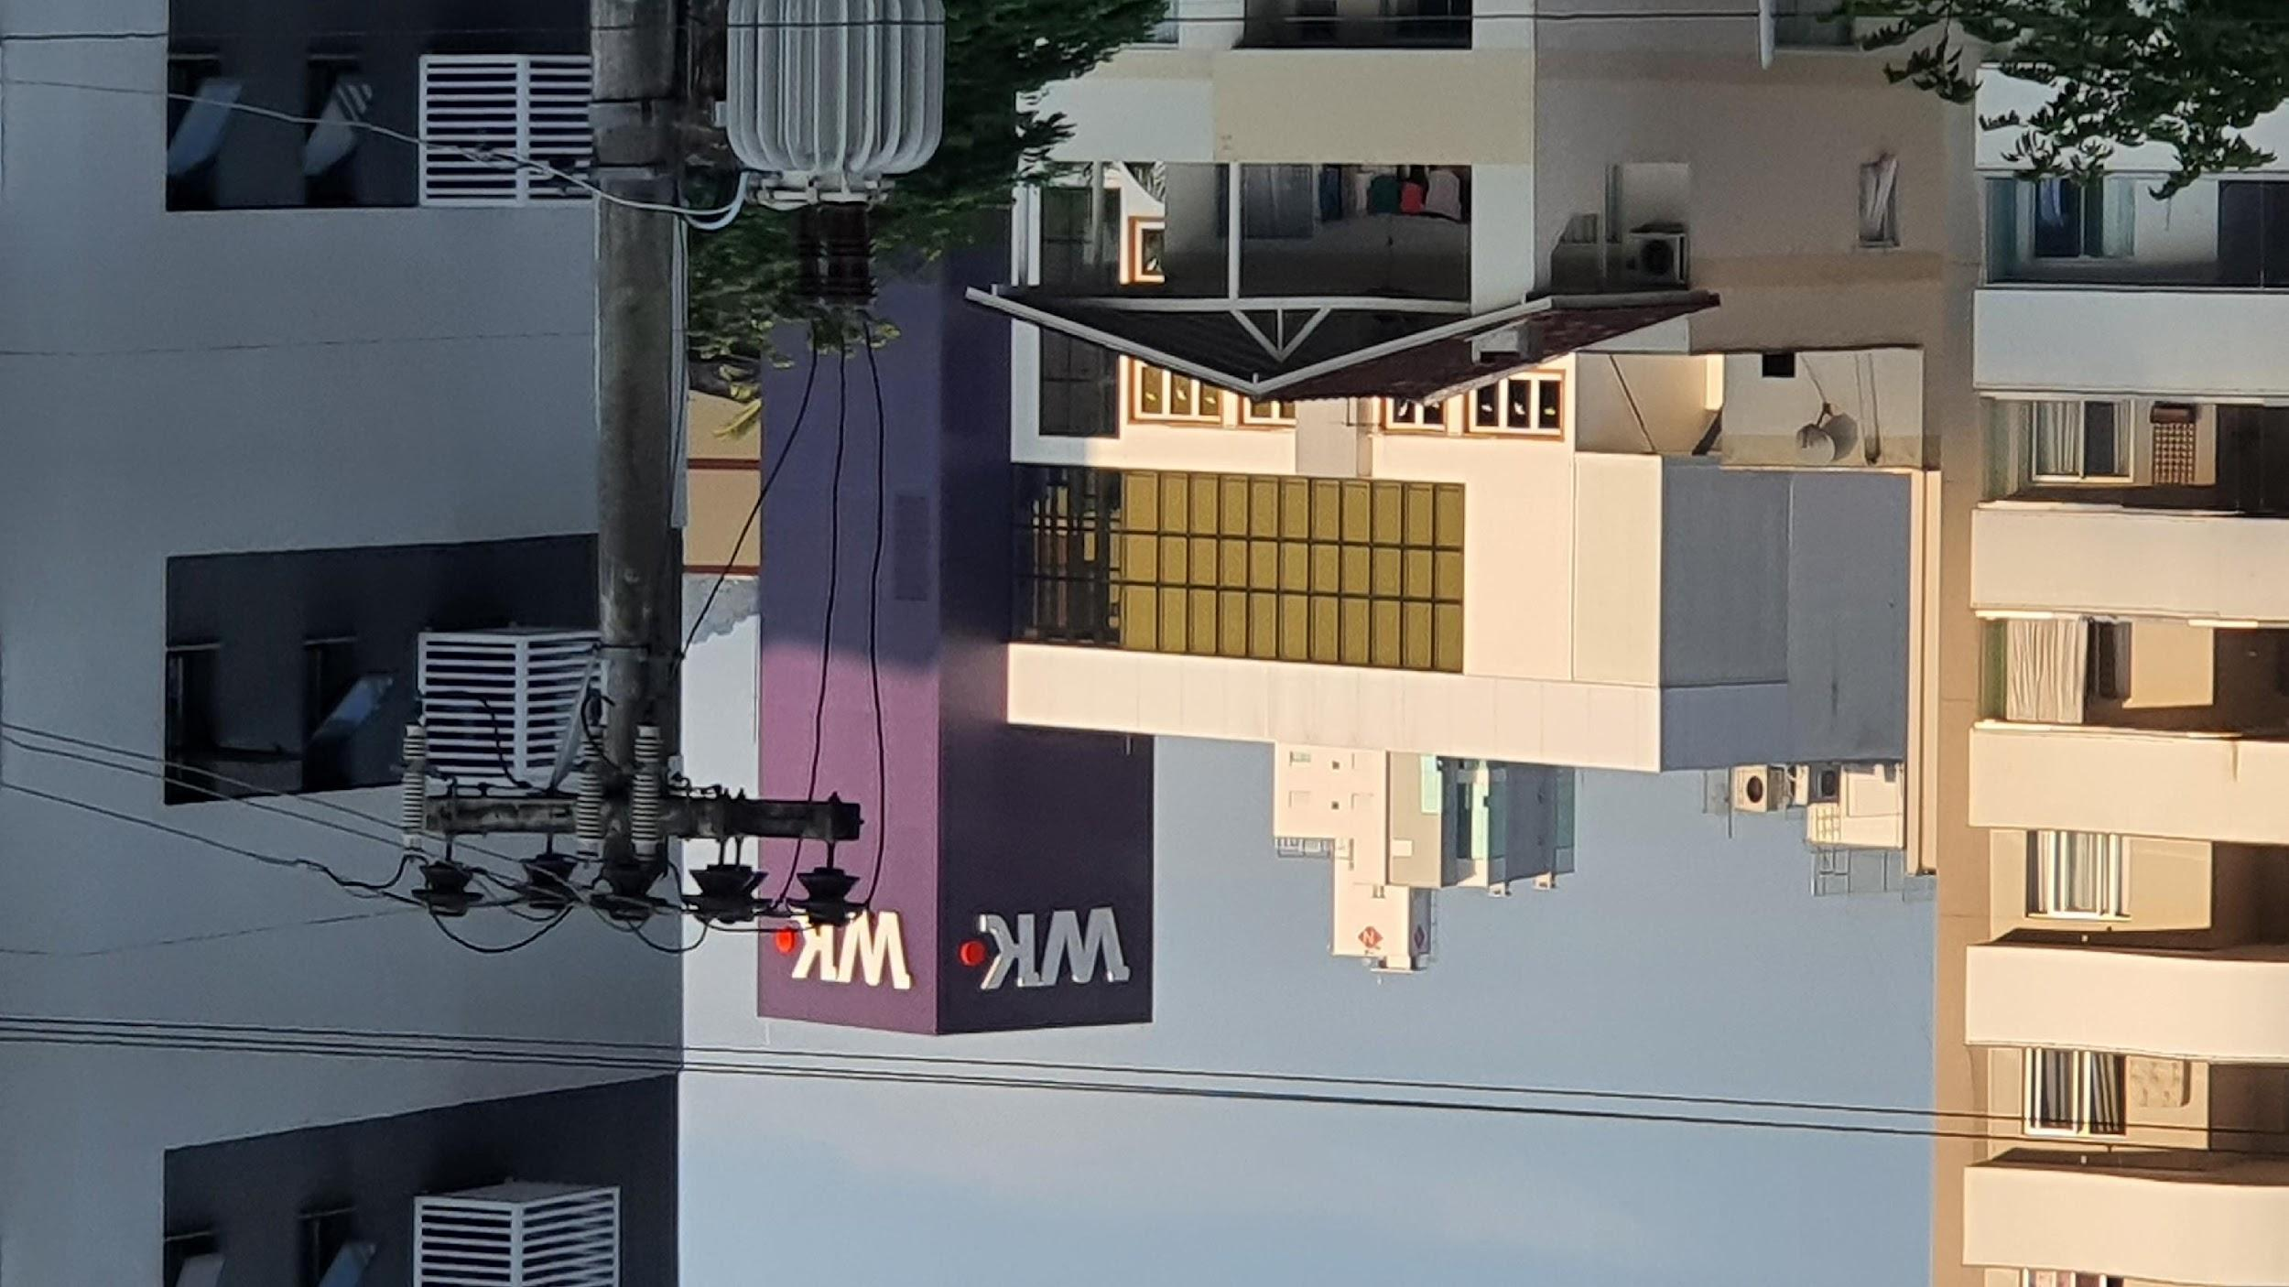

The view of this picture means a lot to me. Because, it's like a goal, something to remember how and why I am studying for.

I have this view from my home, and that company W.K, was my inspiration to believe that there are opportunities to be employed, for to have a good job and financial stability.

* **How long** am I studying development? About two years.

* **Why** did I choose this area? Because it is in a good environment of work and an exciting brain challenge.

* Before the program Entra21, **where** did I study? While in my job as a hairdresser.

* **Who** inspired me to join this universe? A friend and customer which is also a development.

* **How** **often** am I practicing programming science? Almost every day.

* **How** **fast** can I learn development? What can I say, it has already been two years that am I studying, and I still have a lot to learn.

* **How well** is my knowledge in programming? I think it is not good enough to be a junior, but, enough to join in the business.

* **What** would I do if I were employed? I will try to use all that I have learned and be ready to grow up mine development skills.

* Backend or Frontend, **Which** area do I like as a job? Backend.

* **When** will I actually be an actual development worker? God knows.

* While nothing is certain and everything still seems far away, **who** do I want by my side? I am sure that God is already with me, and no matter what will happening, with him, I will have peace.

By Sérgio F. Starke.