Shyann Felix- Z23813474
Professor Ana
CAP 5768
07 Aug 2026
Analyzing Diabetes and Health Indicators
Introduction:
The CDC Diabetes Health Indicators dataset represents critical healthcare statistics and lifestyle information collected from individuals nationwide. According to the CDC's National Diabetes Statistics Report, approximately 40.1 million Americans, or roughly 12% of the U.S. population, currently live with diabetes, making it one of the country's major public health issues. Analyzing these statistics in the CDC dataset allows us to identify the most critical risk factors for diabetes. This topic is relevant because analyzing possible patterns among populations can help us determine which risk factors are critical and contribute more than others. This study focuses on one central research question: In what ways does a history of heart risk factors, such as high blood pressure, high cholesterol, and does heart disease affect the likelihood of an individual being diagnosed with diabetes? To evaluate this question, six hypotheses were tested across three statistical approaches, followed by predictive modeling and unsupervised clustering:
- Hypothesis 1 (t-test): There is a difference in average poor mental health days (MentHlth) between individuals with and without high blood pressure (HighBP).
- Hypothesis 2 (t-test): There is a difference in average income level (Income) between individuals with and without a history of heart disease or attack (HeartDiseaseorAttack).
- Hypothesis 3 (chi-square): Stroke history and high cholesterol status (HighChol) are associated rather than independent.
- Hypothesis 4 (chi-square): Sex and heavy alcohol consumption (HvyAlcoholConsump) are associated rather than independent.
- Hypothesis 5 (linear regression): There is a linear relationship between Education and Income, controlling for Age and Sex.
- Hypothesis 6 (linear regression): There is a linear relationship between heavy alcohol consumption and BMI, controlling for Physical Activity and Age.
The dataset analyzed in this project is the CDC’s 2015 Behavioral Risk Factor Surveillance System (BRFSS) Diabetes Health Indicators dataset. The raw dataset contained 253,680 observations across 22 unique health and demographic variables. To process a dataset of this size, several data-wrangling techniques were used. Firstly, a check for missing values was performed, which indicated that the data had none. Secondly, a duplicate check was performed, which indicated that 23,399 rows were identical and were removed to prevent inaccuracies in the statistical report findings. Thirdly, one column named Sex was renamed to Gender for clarity. Fourthly, the variable Education was converted from a float to a categorical data type. Lastly, a new variable, HealthyDiet, was created that includes two data frames from the fruits and veggies columns.
Descriptive Statistics:
The primary variables evaluated in this study include BMI (Body Mass Index; a measure of body fat percentage based on height and weight), Age (Age category, with 13 levels representing different age groups from 18 to 80+), PhysActivity (Physical activity measured in the previous 30 days, not including work), HighBP (Blood pressure rated on a scale of 0 being not high and 1 being high), HighChol (High cholesterol with 0 being not high and 1 being high), HeartDiseaseorAttack (History of heart disease indicated by CHD or myocardial infarction, with 0 being no and 1 being yes), and Education (Education level based on a scale of 1–6, ranging from never attended school to 4 or more years of college).
Descriptive statistics were calculated, and for BMI revealed a mean of 28.69 with a standard deviation of 6.79. The quartiles for BMI ranged from 12.0 to 98.0, with a first quartile of 24.0, a median of 27.0, and a third quartile of 32.0. These figures reveal that 50% of respondents have a BMI of 27 or lower, while over 25% fall into the obese category.
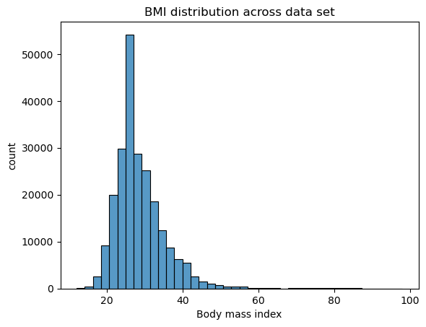

Figure 1. BMI distribution across the dataset. Most respondents fall between BMI 20–40, with a long right tail of outliers.

The Age variable was also viewed as older individuals may be more likely to develop diabetes. The histogram below (Figure 2) shows that most participants in this dataset fall between age categories 7 and 13, corresponding to ages 50 and older, with the largest single group falling in category 7, ages 50 to 54. The distribution is left-skewed, meaning there are fewer younger respondents and a greater concentration of older ones.
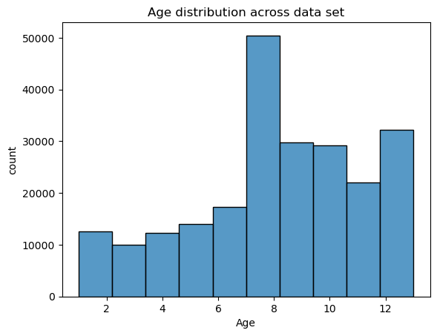
Figure 2. Age distribution. The sample skews older, with a concentration in the 50-and-older age range.

In Figure 3, a grouped bar chart was used to visualize the rate of heart disease across diabetes and blood pressure status. According to the chart, the rate of heart disease steadily increases in all categories of diabetes status in both those with high blood pressure and those without. Supporting the research question by showing that heart disease history, blood pressure status, and diabetes status all increase.
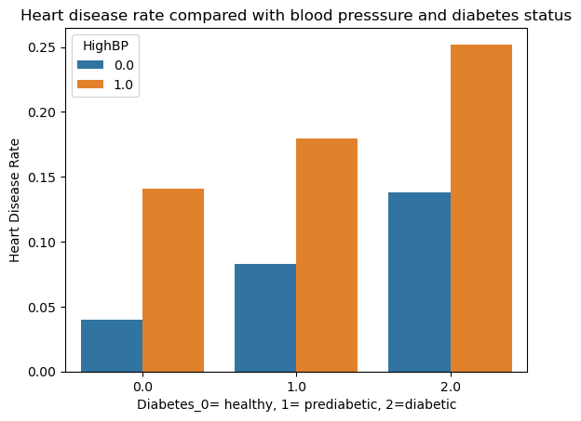
Figure 3. Heart disease rate by diabetes status and blood pressure rates

The chart below (Figure 4) is a grouped bar chart used to visualize the rates of high cholesterol and diabetes among those with and without high blood pressure. According to the chart, both those with and those without high blood pressure show a steady increase in high-cholesterol rate amongst all statuses of diabetes.
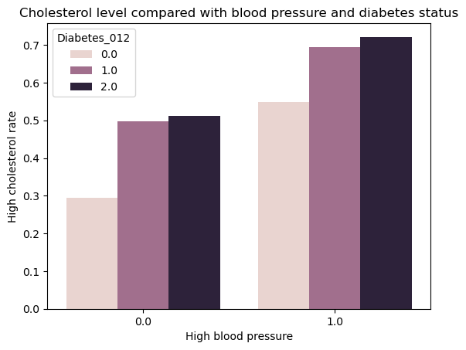
Figure 4. Cholesterol level compared with blood pressure and diabetes status.
The box plot below was used to compare BMI across individuals with and without high blood pressure. As established earlier in this report, BMI has a mean of 28.7, a standard deviation of 6.8, a minimum of 12, a quartile 1 of 24, a median of 27, a quartile 3 of 32, and a maximum of 98. According to the box plot, those with high blood pressure show a higher median BMI than those without. The group without high blood pressure is also reflected as left-skewed, and those with right-skewed. This box plot supports the research question by comparing two direct risk factors.

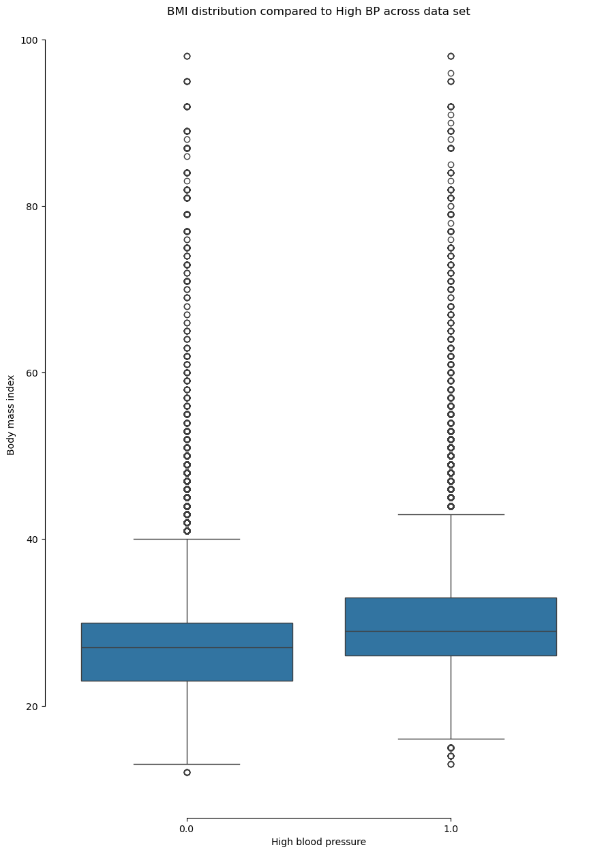
Figure 5. BMI distribution compared to high blood pressure status.
Below is another box plot (Figure 6). This box plot shows participants who don't have diabetes, those who do, and those who are prediabetic, along with their Physical health in prior days. Those without and those who are prediabetic have a low median, compared to those who have diabetes. indicating that those with diabetes have experienced more days of poor health conditions than the rest, all three boxes of those with and without prediabetes are right-skewed. Each box has a decent number of individuals who experienced poor physical health days. The box for those with diabetes doesn't have outliers, but I assume that is because they all experience poor health days to some extent, making the outliers less extreme. This research question will help others gain a deeper understanding by examining physical health quality days and using that to assess cardiovascular health.

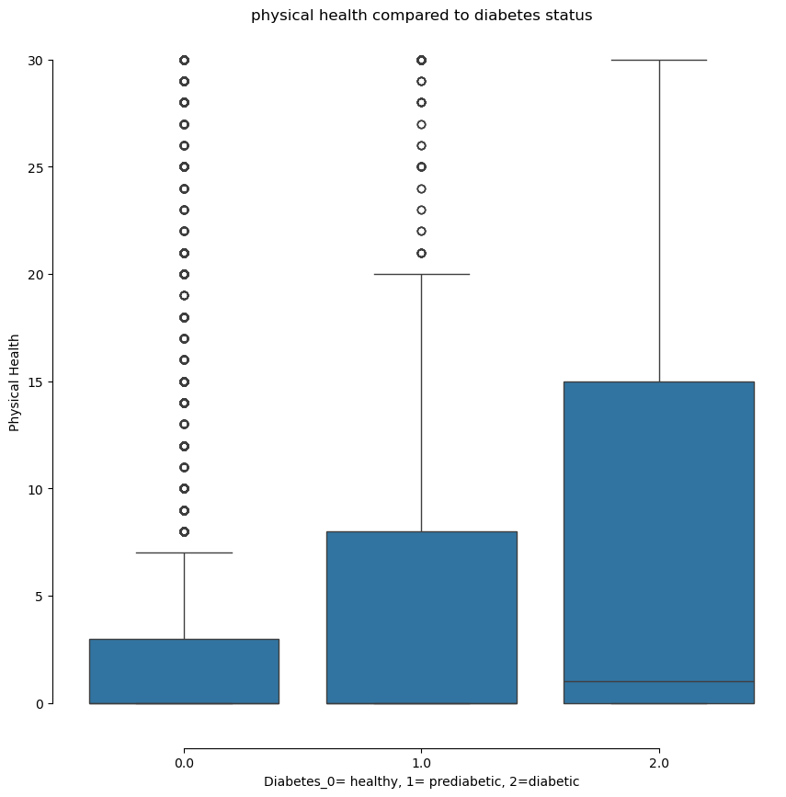
Figure 6. Physical health compared to diabetes status.
The KDE chart below (Figure 7) shows the density of physical health by diabetes status. This chart is right-skewed, and all have a decent rise at 0, especially for those who don’t have diabetes. The zero indicates no bad health days. The lines representing prediabetic and diabetic are much lower, indicating a greater spread of individuals experiencing poor health days. This graph supports the research question by clearly showing how diabetes may affect physical health, and the other graphs will help me link physical health to cardiovascular health.
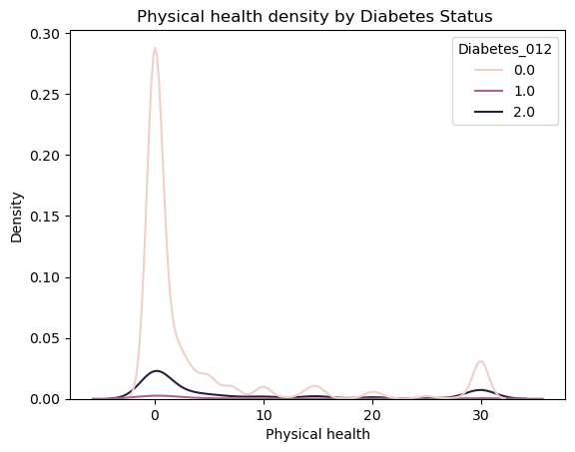
Figure 7. Physical health density by diabetes status.

Methodology:
Data wrangling and EDA both focused on cleaning the raw dataset. The data set was parsed for missing values and duplicates, which were dropped. Then the variable Sex was renamed to Gender, Education was converted to a categorical type, and a new variable, HealthyDiet, was created from the Fruits and Veggies columns. Descriptive stats and visualizations were then made for BMI, Age, PhysHlth, HighBP, HighChol, and HeartDiseaseorAttack to look for early patterns before running any formal tests.
For hypothesis testing, two t-tests were run; MentHlth which was the dependent variable grouped by HighBP, the independent variable, testing whether an individual’s mental health days changed according to their blood pressure status. The second t-test used Income as a dependent variable, which was grouped by HeartDiseaseorAttack being the independent variable, which tested whether an individuals income differed by their heart disease history. Two chi-square tests checked whether Stroke and HighChol are associated, and whether Sex and HvyAlcoholConsump are associated. Lastly, there are also two linear regressions: Income, the Dependent variable, on Education, the independent variable, with two controls, Age and Sex, and BMI, the dependent variable, on HvyAlcoholConsump, the independent variable, with the controls PhysActivity and Age.
In logistic regression, the dependent variable was Diabetes_012, and the independent variables were Smoker, BMI, PhysActivity, HighBP, HighChol, and Age. The data was split into training and testing sets. Upon evaluation, the training data appeared heavily imbalanced across the three classes, as the number of individuals without diabetes (0) is much higher than the number of individuals with diabetes (2) and prediabetes (1). In order to balance the dataset, RandomOverSampler was used, so the model wouldn't default to predicting no diabetes every time. Then, a Logistic Regression model, a Decision Tree model, and a Random Forest model were initialized and compared to choose and retrain the best model on the training set. Afterward, logistic regression models were run with L1, L2, and Elastic Net regularizations to see whether regularization helped and which predictors mattered least, given that some features would zero out or shrink to zero.
Lastly, for Principal Component Analysis, the same independent variables as above were standardized and reduced to keep at least 90% of the variance. Lastly, a K-Means test was run using all features from the original dataset. After plotting inertia for k values, the number of clusters was selected using the elbow method. Then K-Means was refitted using the selected number of clusters, and each cluster was closely examined and analyzed.
Results:
Based on the p-value of test 1, p < 0.05, so we reject the null hypothesis. This indicates there is a difference in the average number of poor mental health days between people with and without high blood pressure. For test 2, based on a p-value of 0.0, which is less than 0.05, we also reject the null hypothesis, indicating a difference in average income between those with and without a history of heart disease or attack.
For the first chi-square test, the test of independence yielded a p-value of 0, so the null hypothesis was rejected, and it was concluded that stroke history and high cholesterol status are associated. For the second chi-square test, the p-value was 0.004, which is less than 0.05, so again the null hypothesis was rejected, and it was concluded that sex and heavy alcohol consumption were associated.
The first scatter plot for linear regression is hard to read at first glance, and it seems there is no relationship between Income and Education. However, a closer look revealed Education has a positive relationship with Income, with a coefficient of 0.92, meaning that as Education increases, the dependent variable increases. This also had a p-value of 0, indicating that the null hypothesis was rejected and that there is a statistically significant relationship between Education and Income. After applying the control variables Age and Sex, Age shows a negative relationship with the dependent variable, with a coefficient of -0.05, meaning that as Age increases, the dependent variable decreases; the relationship between the two is also statistically significant (p = 0). Sex has a positive relationship with the dependent variable, with a coefficient of 0.49, meaning that as Sex increases, the dependent variable increases; this relationship is also statistically significant. And according to the R² table, 22% of the variance in income is explained by Education, Age, and Sex.
For the second scatter plot, it's also hard to read because HvyAlcoholConsump is binary, so the points cluster around 0 and 1 instead of showing a group correlation. At first glance, it's hard to tell if there's a relationship, but after a closer look at the correlation, there appears to be a weak negative relationship between HvyAlcoholConsump and BMI. In the linear regression, HvyAlcoholConsump has a negative relationship with the dependent variable, with a coefficient of -1.40, meaning that as HvyAlcoholConsump increases, the dependent variable decreases. Its p-value (p < 0.05) means we reject the null hypothesis. PhysActivity has a coefficient of -2.33, meaning that as PhysActivity increases, the dependent variable decreases. Age also has a negative coefficient of -0.11, meaning that as Age increases, the dependent variable decreases. According to the R² table, only 2.7% of the variance in BMI is explained by HvyAlcoholConsump, Age, and PhysActivity.
Logistic regression models (baseline, L1, L2, Elastic Net):
The final random forest model performed well, achieving a test accuracy of 0.54, meaning the model gets the correct category right about half the time, which is better than random guessing. It also scored a precision of 0.812 (a noticeable jump from 0.595 in the initial training model), a recall of 0.54, and an F1 score of 0.63. All random forest performance scores were slightly higher than those of the other two models. Random Forest was chosen as the best-performing model because it achieved the highest mean accuracy, precision, recall, and F1 across all 5 cross-validation folds, compared to Logistic Regression and Decision Tree.
Compared to the best-performing model from cross-validation, L1 performs better across all metrics. Random Forest's test set scores were accuracy at 0.540, precision at 0.812, recall at 0.54, F1 at 0.63, while L1 scored an accuracy of 0.64, a weighted precision of 0.82, a weighted recall of 0.64, and a weighted F1 of 0.70. The variables that zeroed out were Age_4.0 and Age_5.0 (not diabetic), Smoker (pre-diabetic), and Age_6.0 (diabetic), and their removal makes sense since that information is likely the same or close to BMI, HighBP, and HighChol, given the rest of the variables already cover what those groups tell us.
L2 performed almost the same as L1, scoring an accuracy of 0.63, a precision of 0.82, a recall of 0.63, and an F1 score of 0.69. No coefficients were zeroed out here, as expected, since L2 only shrinks coefficients rather than eliminating them. The fact that L1 and L2 scored nearly the same, even after L1 dropped Age_4.0, Age_5.0, Smoker, and Age_6.0, suggests those variables didn't add much value.
Elastic Net zeroed out Smoker, PhysActivity, and HighBP in the pre-diabetic row, indicating that those three variables add little value for identifying pre-diabetic cases, though they're still useful for the other two classes. Its performance was: precision 0.82, recall 0.62, F1 0.68, and accuracy 0.62, all slightly below L1’s (accuracy 0.64, precision 0.82, recall 0.64, F1 0.70) and L2’s (accuracy 0.63, precision 0.82, recall 0.63, F1 0.69). Compared to the best baseline model, Random Forest (accuracy 0.540, precision 0.812, recall 0.540, F1 0.630), Elastic Net still scored higher across all categories.
PCA and K-Means clustering:
For the PCA portion, a three-dimensional scatter plot was created first, followed by K-Means clustering. After running the clustering, the number of clusters was determined using the elbow method. For the PCA, 14 components were used because they explained about 90% of the variance, according to the explained variance ratio.
In Cluster 0, HighBP is 0.71, HighChol is 0.43, BMI is 0.09, Smoker is 0.11, Stroke is -0.02, HeartDiseaseorAttack is 0.11, PhysActivity is close to average at 0.03, Age is high at 0.54, and Education is -0.04. This cluster represents individuals who are older and have higher health risk factors, mainly blood pressure and cholesterol.
In Cluster 1, HighBP is -0.78, HighChol is -0.49, BMI is -0.23, Smoker is -0.21, Stroke is -0.19, HeartDiseaseorAttack is -0.31, PhysActivity is slightly above average at 0.23, GenHlth is -0.49, Education is 0.26, and Income is 0.31. In this cluster, important factors like HighBP and HighChol appear below average, indicating a low risk across many of the adverse health indicators. Based on the Age column, this cluster represents individuals who are slightly younger.
In Cluster 2, HighBP is 0.45, HighChol is 0.33, AnyHealthcare stands out the most at close to average (-0.08), CholCheck is 0.09, Age is 0.29, Education is -0.56, and Income is -0.87. This cluster represents individuals with decent average healthcare access, elevated blood pressure and cholesterol, and below-average income and education.
Conclusion:
To conclude, all features used in this project, as well as the overall sampled dataset, were associated with diabetes status in one way or another. The hypothesis tests also provided statistics showing the extent to which these health factors are tied not just to diabetes but to one another. For predicting diabetes status, the regularized logistic models outperformed Random Forest and showed that only a few predictors were needed, as other features already captured much of the same information. K-Means still ended up with three clusters that roughly matched different risk levels. PCA didn't shrink the features much, because the variance was evenly distributed across numerous components
As for a few limitations in this dataset, I believe that, since it is self-reported, there could be some bias. Also, when it comes to running some of the tests, accuracy was never high across the board. So, it goes to say that there are possibly other variables that would be better at predicting diabetes. As for future work, I'd probably figure out how to approach this same dataset, or another dataset of this nature dealing with health, and possibly use other methods/models to go deeper into identifying links between the factors and features that contribute to whatever the data sample represents.

