**Practical: 1**

**Aim: Write a HTML page to print Hello World in bold and italic font.**

<html>

<head>

<title>Practical: 1 Bold, Italic</title>

</head>

<body>

<p>

<b>Hello World!</b><br>

<i>Hello World!</i>

</p>

</body>

</html>

**Output:**

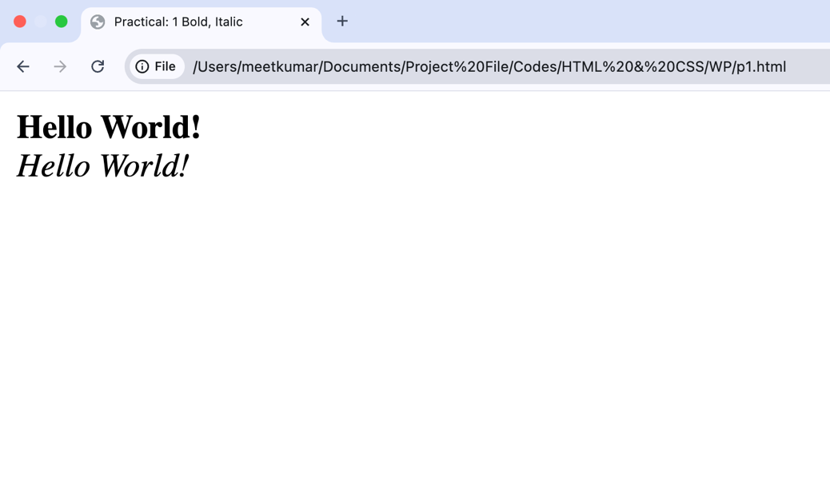

**Practical: 2**

**Aim: Display various text formatting methods available in HTML.**

**(i.e. <h1>, <b>, <u> etc…)**

<html>

<head>

<title>Practical: 2 Stylized Text</title>

</head>

<body bgcolor="F5EFFF">

<h2>Stylized Text Showcase</h2>

<pre>Sample Text: Hlw</pre>

<p><b>Bold Text</b></p>

<p><u>Underlined Text</u></p>

<p><i>Italic Text</i></p>

<p><font size="5" color="purple" face="Georgia">Enhanced Font Styling</font></p>

<p><mark>Highlighted Text</mark></p>

<p><em>Emphasized Text</em></p>

<p>A<sup>2</sup> + B<sup>2</sup> = C<sup>2</sup></p>

<p>CH<sub>2</sub>OOH</p>

</body>

</html>

**Output:**

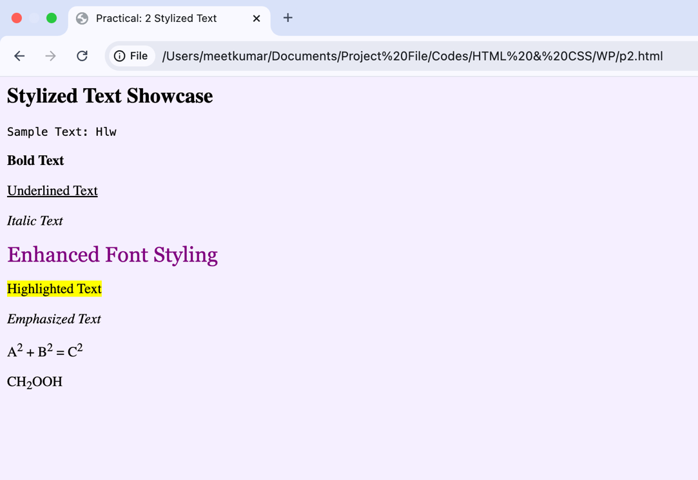

**Practical: 3**

**Aim: Create a HTML file using special characters.**

<html>

<head>

<title>Special Characters in HTML</title>

</head>

<body>

<h3>HTML Special Characters</h3>

<p>

1. Ampersand - &amp; <br>

2. Less than - &lt; <br>

3. Greater than - &gt; <br>

4. Double Quote - &quot; <br>

5. Single Quote - &apos; <br>

6. Copyright - &copy; <br>

7. Registered - &reg; <br>

8. Euro - &euro; <br>

9. Pound - &pound; <br>

10. Yen - &yen; <br>

11. Cent - &cent; <br>

12. Trademark - &trade; <br>

13. Heart - &#9829; <br>

</p>

</body>

</html>

**Output:**

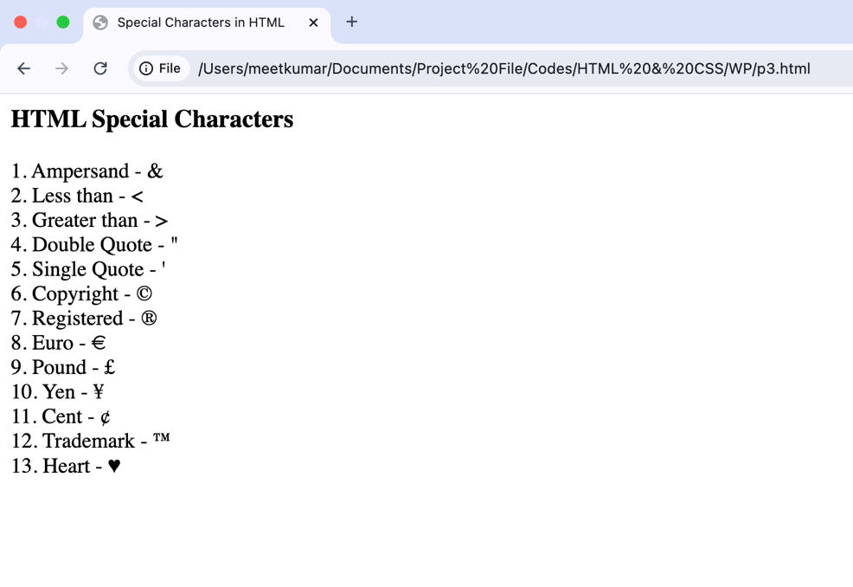

**Practical: 4**

**Aim: Create a HTML file which displays 3 images at LEFT, RIGHT and**

**CENTER respectively in the browser.**

<html>

<head>

<title>Image Alignment</title>

</head>

<body bgcolor="F5EFFF">

<img src="/Users/meetkumar/Documents/left-img.png" alt="Left Image" align="left"

width="493px">

<img src="/Users/meetkumar/Documents/right-img.png" alt="Right Image" align="right"

width="493px">

<div align="center">

<img src="/Users/meetkumar/Documents/center-img.png" alt="Center Image"

width="493px">

</div>

</body>

</html>

**Output:**

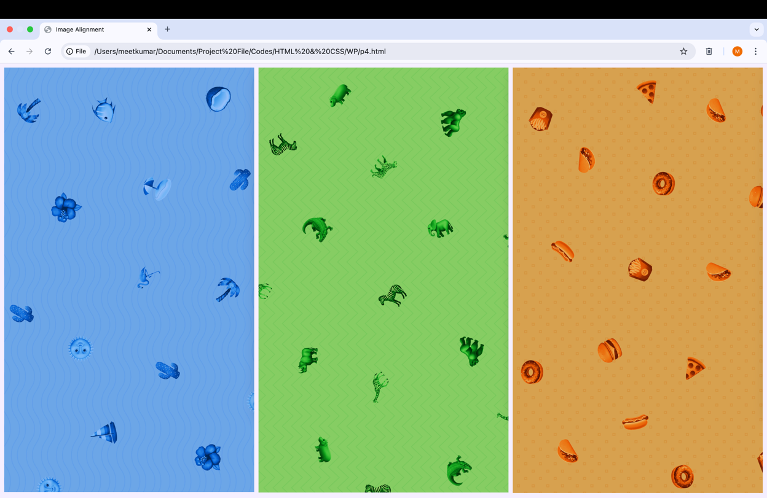

**Practical: 5**

**Aim: Create a HTML file which contains hyperlinks.**

<html>

<head>

<title>Practial 5: Hyperlinks</title>

</head>

<body>

<a href="https://www.ssasit.ac.in">College website</a><br>

<a href="p2.html">Stylized Texts</a><br>

<a href="p3.html" target="_blank">Special Characters</a>

<br>

<p> In today's fast-paced world, the internet is a powerful tool that has revolutionized how

we communicate, learn, work, and play. Every time you open a website or use an app,

there are many technologies working behind the scenes to make everything run smoothly. At the heart of web development, there are a few key technologies that you must understand: HTML, JavaScript, and PHP. These tools help create the websites and applications that you interact with daily. <br>When you first visit a website, it's the HTML (HyperText Markup Language) that defines the structure of the page. From there, JavaScript adds interactivity, allowing you to click buttons, fill out forms, and see real-time updates. But that's not all—PHP (Hypertext Preprocessor) is another crucial language used to make dynamic, server-side applications. It helps you create websites that can interact with databases and perform actions based on user input, such as submitting a form or retrieving information. <br>Whether you’re a beginner in web development or someone looking to understand how the web works, learning HTML, JavaScript, and PHP gives you a strong foundation. These languages work together to create the seamless experience we enjoy every day when browsing the internet. So, let’s take a closer look at each of these technologies and explore how they bring websites to life.

</p>

<p> .<br>.<br>.<br>.<br>.<br>.<br>.<br>.<br>.<br>.<br>.<br>.<br>.<br>.<br>.<br>

.<br>.<br>

</p>

<a href="#"><mark>Move to Top</mark></a><br>

</body>

</html>

**Output:**

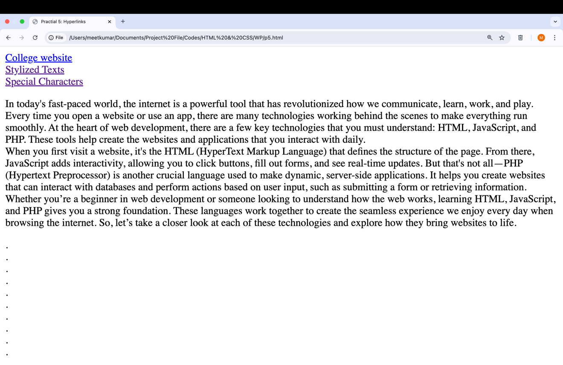



**Practical: 6**

**Aim: Table of Contents**

**Chapter 1: Introduction**

**Chapter 2: What is HTML?**

**Chapter 3: What is JavaScript?**

**.**

**.**

**By clicking on the link takes to the respective topic within the same**

**page.**

<html>

<head>

<title>Practical 6: Table of Contents</title>

</head>

<body>

<table border="1" cellpadding="15">

<tr>

<td colspan="2" align="center">Table of Contents</td>

</tr>

<tr>

<td>Chapter 1</td>

<td><a href="#chapter1">Introduction</a></td>

</tr>

<tr>

<td>Chapter 2</td>

<td><a href="#chapter2">What is HTML?</a></td>

</tr>

<tr>

<td>Chapter 3</td>

<td><a href="#chapter3">What is JavaScript?</td>

</tr>

<tr>

<td>Chapter 4</td>

<td><a href="#chapter4">What is CSS?</a></td>

</tr>

<tr>

<td>Chapter 5</td>

<td><a href="#chapter5">What is PHP?</a></td>

</tr>

</table>

<br>

<h2 id="chapter1">Chapter 1: Introduction</h2>

<p>In today's fast-paced world, the internet is a powerful tool that has revolutionized how we communicate, learn, work, and play. Every time you open a website or use an app, there are many technologies working behind the scenes to make everything run smoothly. At the heart of web development, there are a few key technologies that you must understand: HTML, JavaScript, and PHP. These tools help create the websites and applications that you interact with daily. <br>When you first visit a website, it's the HTML (HyperText Markup Language) that defines … </p>

<a href="#">Move to Top</a><br>

<h2 id="chapter2">Chapter 2: What is HTML?</h2>

<p>HTML, or HyperText Markup Language, is the standard language used to create and structure content on the web. It serves as the backbone of every website, allowing developers to define how different types of content (text, images, links, videos, etc.) should be displayed on a webpage. HTML is not a programming language but rather a markup language, which means it uses special tags or "elements" to describe the structure and layout of a webpage.<br>Each HTML document is made up of elements, which are typically enclosed in angle brackets, such as … </p>

<a href="#">Move to Top</a><br>

<h2 id="chapter3">Chapter 3: What is Javascript?</h2>

<p>JavaScript is a dynamic programming language that makes websites interactive. Unlike HTML, which is used to structure content, JavaScript controls the behavior of that content. It enables websites to respond to user actions, such as clicks, scrolls, and key presses, in real-time. When you see things like pop-up windows, image sliders, or live chat features on a website, that's likely JavaScript at work.<br>One of the key features of JavaScript is that it is a client-side language, meaning it runs directly in your web browser. This makes JavaScript incredibly fast because … </p>

<a href="#">Move to Top</a><br>

<h2 id="chapter4">Chapter 4: What is CSS?</h2>

<p>CSS stands for Cascading Style Sheets and is a language used to style and design the appearance of web pages. While HTML provides the structure of a webpage, such as headings, paragraphs, images, and links, CSS controls how that content looks including its colors, fonts, layout, spacing, and overall visual presentation. Think of HTML as the foundation of a house and CSS as the paint, furniture, and decorations that make it visually appealing. CSS works by applying rules to HTML elements, where each rule consists of a selector that targets specific HTML elements and … </p>

<a href="#">Move to Top</a><br>

<h2 id="chapter5">Chapter 5: What is PHP?</h2>

<p>PHP (Hypertext Preprocessor) is a popular server-side scripting language used to create dynamic web pages and applications. Unlike HTML and JavaScript, which mainly handle what happens in the browser, PHP runs on the server, which means it processes data and sends the resulting content to the user's browser. PHP is used for tasks like handling form submissions, managing sessions, interacting with databases, and generating dynamic content based on user requests … </p>

<a href="#">Move to Top</a><br>

</body>

</html>

**Output:**

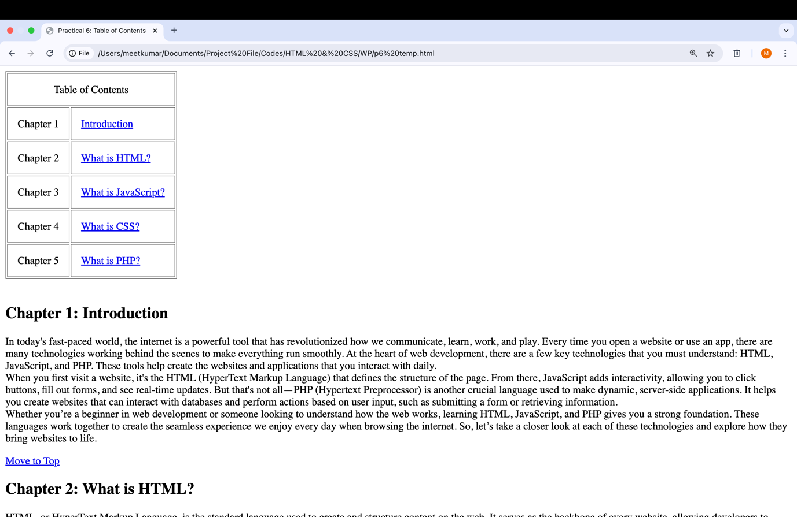

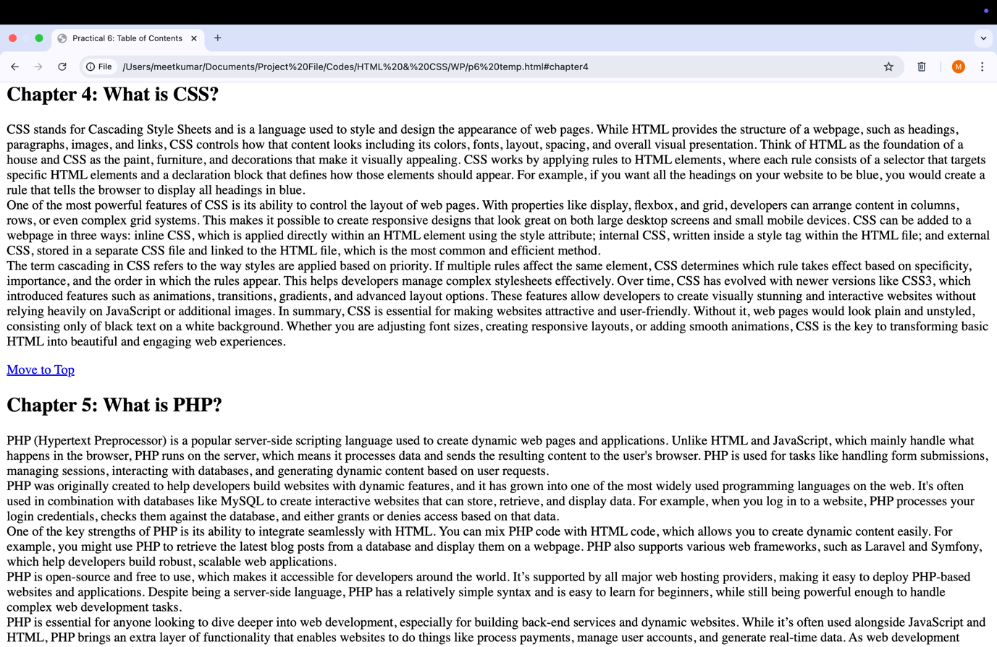

**Practical: 7**

**Aim: Create a HTML page as given below:**

**List of Subjects**

**1. Computer Engineering Department**

**a. Software Engineering**

**b. Information Security**

**c. Computer Graphics**

**2. Electrical Engineering Department**

**• Electrical Machine**

**• Power Electronics**

**• Micro Controller**

**3. Computer Engineering**

**Is a discipline that integrates several fields required to**

**develop computer systems.**

<head>

<title>Practical 7: List</title>

</head>

<body>

<p><h3>List of Subjects</h3></p>

<ol>

<li>Computer Engineering Department</li>

<ul>

<li type="a">Software Engineering</li>

<li type="a">Information Security</li>

<li type="a">Computer Graphics</li>

</ul>

<li>Electrical Engineering Department</li>

<ul type="disc">

<li>Electrical Machine</li>

<li>Power Electronics</li>

<li>Micro Controller</li>

</ul>

<li>Computer Engineering</li>

<dd>Is a discipline that integrates several fields required to develop computer

systems.

</dd>

</ol>

</body>

</html>

**Output:**

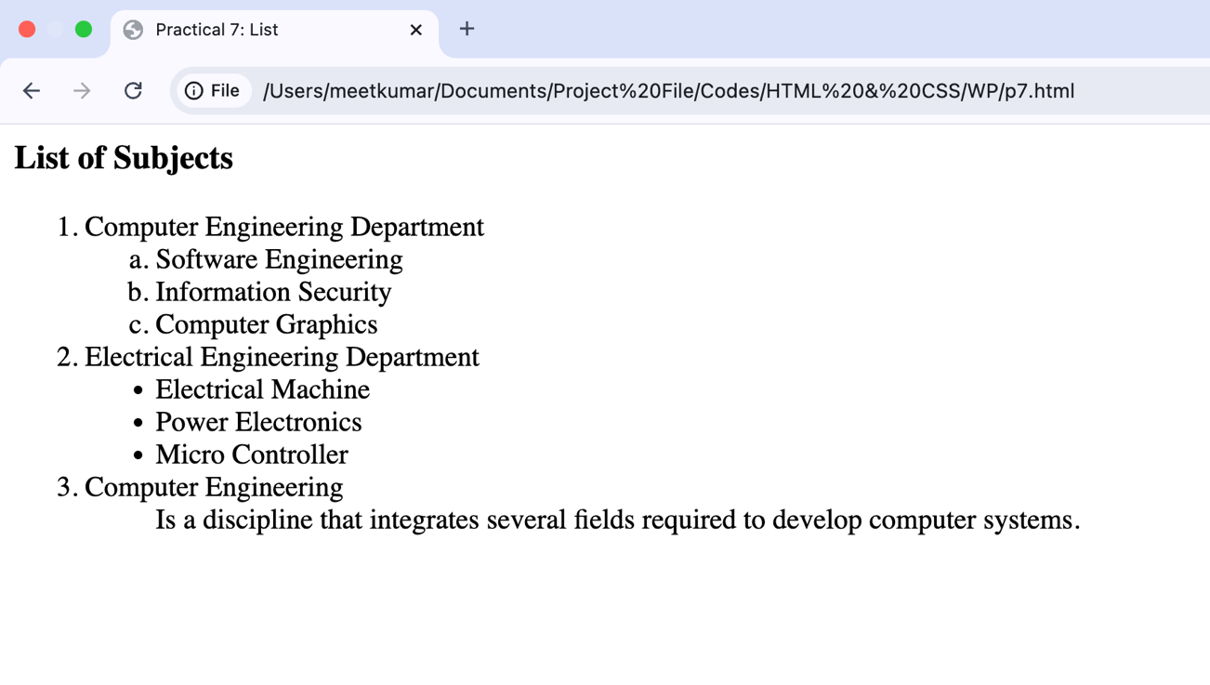

**Practical: 8**

**Aim: Create table with ROWSPAN and COLSPAN attribute of TABLE in**

**HTML (Prepare timetable of your class). Include CELLSPACING &**

**CELLPADDING**

<html>

<head>

<title>Practical 8: Class Timetable</title>

<style>

table {

width: 95%;

height: 95%;

border-collapse: collapse;

}

th, td {

font-size: 19;

padding: 10px;

text-align: center;

}

th {

background-color: #D8C4B6;

color: #213555;

}

td {

background-color: #F5EFE7;

color: #3E5879;

}

</style>

</head>

<body>

<table cellspacing="0" cellpadding="5" border="1">

<tr>

<th colspan="8" style="background-color: #213555; color: #D8C4B6;"><font size="5">Shree Swami Atmanand Saraswati Institute of Technology<br>Computer Engineering Department<br>B.E.-III (VI Sem.) (Class-32) Time Table</font></th>

</tr>

<tr>

<th colspan="5" style="background-color: #3E5879; color: #D8C4B6; text-align: left; padding-left: 20px; border: none;"><font size="5">Class :- Computer (Room No. - 311)</font></th>

<th colspan="3" style="background-color: #3E5879; color: #D8C4B6; padding-left: 65px; border: none;"><font size="5">Year: 2024-25</font></th>

</tr>

<tr>

<th>Day & Time</th>

<th>9:15 - 10:15 AM</th>

<th>10:15 - 11:15 AM</th>

<th>11:15 - 12:15 PM</th>

<th>12:15 - 12:45 PM</th>

<th>12:45 - 1:45 PM</th>

<th>1:45 - 2:45 PM</th>

<th>2:45 - 3:45 PM</th>

</tr>

<tr>

<th>Monday</th>

<td>AJ<br>(KVK)</td>

<td>MPI<br>(APL)</td>

<td>WP<br>(ADP)</td>

<td rowspan="6"><font size="6">B<br>R<br>E<br>A<br>K</font></td>

<td>IOT<br>(HCS)</td>

<td colspan="2">AJ - A - KVK - 315A<br>AJ - B - TRD - 315A<br>MPI - C - HVR

- 315C</td>

</tr>

<tr>

<th>Tuesday</th>

<td>MPI<br>(HVR)</td>

<td>IOT<br>(NAP)</td>

<td>TOC<br>(VDS)</td>

<td>WP<br>(DSM)</td>

<td colspan="2">WP - A - ADP - 315B<br>WP - B - DSM - 315B<br>IOT - C -

NAP - 315C</td>

</tr>

<tr>

<th>Wednesday</th>

<td>IPDC<br>(NAP)</td>

<td>WP<br>(ADP)</td>

<td>AJ<br>(TRD)</td>

<td>TOC<br>(VDS)</td>

<td colspan="2">DE - IIB - KVK, TRD</td>

</tr>

<tr>

<th>Thursday</th>

<td>AJ<br>(KVK)</td>

<td>TOC<br>(PHV)</td>

<td>MPI-A - HVR - 315B<br>MPI-B - APL - 315B<br>AJ-C - KVK - 315C</td>

<td>MPI-A - HVR - 315B<br>MPI-B - APL - 315B<br>AJ-C - KVK - 315C</td>

<td>IPDC<br>(DJC)</td>

<td></td>

</tr>

<tr>

<th>Friday</th>

<td colspan="2">IOT - A - NAP - 315B<br>IOT - B - HCS - 315B<br>WP - C -

TRD - 315C</td>

<td>TOC<br>(PHV)</td>

<td>MPI<br>(HVR)</td>

<td>TOC - T (PHV, VDS)</td>

<td></td>

</tr>

<tr>

<th>Saturday</th>

<td></td>

<td></td>

<td></td>

<td></td>

<td></td>

<td></td>

</tr>

</table>

</body>

</html>

**Output:**

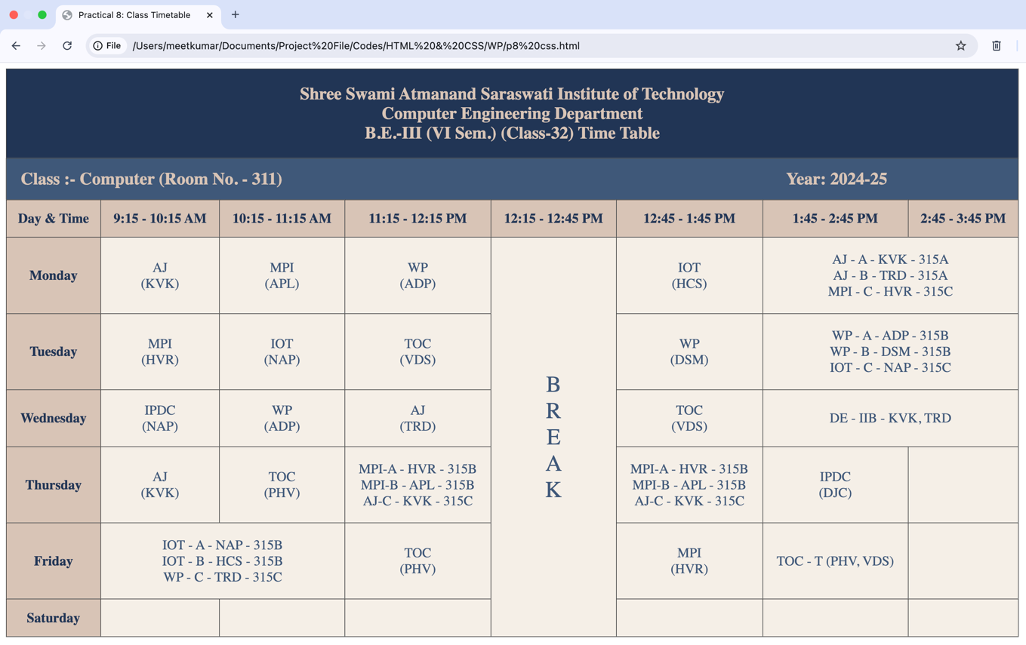

**Practical: 9**

**Aim: Create HTML page using Frames.**

|  |  |
| --- | --- |
| **WEB Technology**  Author:  Date: | |
| TOC  1. Link1  2. Link2  .  . | CONTENT |

<html>

<head>

<title>Practical 9: Frameset</title>

<style>

#head {

background-color: #578E7E;

}

#toc {

background-color: #F5ECD5;

}

#content {

background-color: #FFFAEC;

}

</style>

</head>

<frameset rows="20%, 80%" border="1">

<frame src="head.html" id="head" name="headFrame">

<frameset cols="30%, 70%">

<frame src="toc.html" id="toc" name="tocFrame">

<frame src="content.html" id="content" name="contentFrame">

</frameset>

</frameset>

</html>

**Output:**

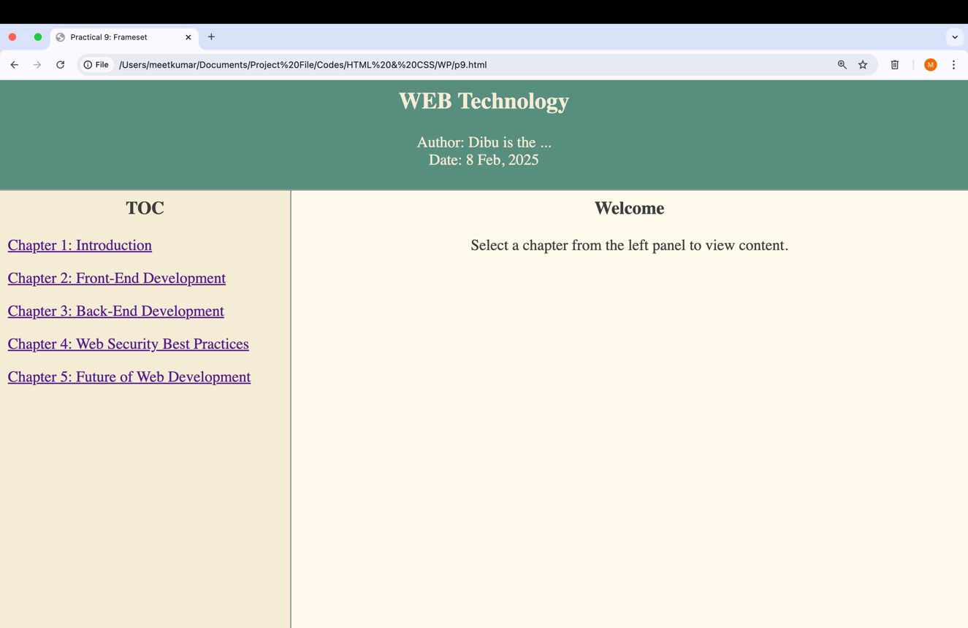

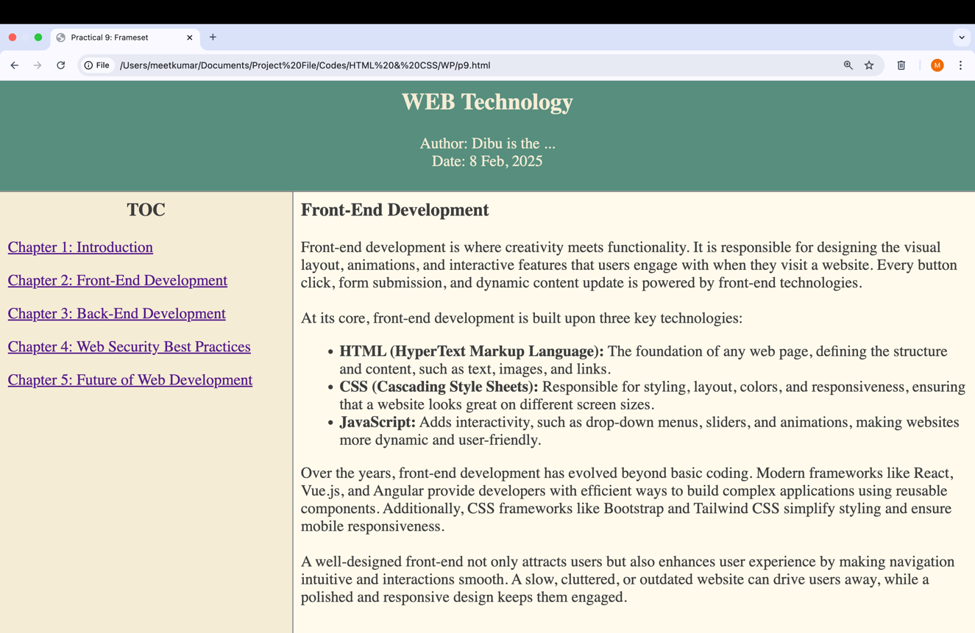

**Practical: 10**

**Aim: Create a simple form that will show all the INPUT METHODS available in HTML.**

<html>

<head>

<title>Practical 10: Form</title>

<link rel="stylesheet" href="./css/styles.css">

</head>

<body>

<form action="data.jsp" method="post">

<fieldset>

<legend>Travel Reservation Form</legend>

<label>Full name: <input type="text" name="name" placeholder="Enter your full

name..." required></label><br><br>

<label>Phone no.: <input type="tel" name="phone" placeholder="Enter your phone

no..."></label><br><br>

<label>Email address: <input type="email" name="mail" placeholder="Enter your

email address..."></label><br><br>

<label>Select tour package:

<select name="tour">

<option value="gujarat">Gujarat</option>

<option value="mumbai">Mumbai</option>

<option value="goa">Goa</option>

<option value="kolkata">Kolkata</option>

<option value="kerala">Kerala</option>

<option value="jnk">Jammu and Kashmir</option>

</select>

</label><br><br>

<label>Arrival Date: <input type="date" name="date"></label><br><br>

<label>Number of persons: <input type="number" name="persons"

placeholder="Enter no. of persons..."></label><br><br>

<label>What would you like to avail?</label><br>

<lable><input type="checkbox" id="checkbox" name="boarding"

value="boarding">Boarding</lable><br>

<lable><input type="checkbox" id="checkbox" name="Fooding"

value="fooding">Fooding</lable><br>

<lable><input type="checkbox" id="checkbox" name="Sight seeing"

value="seeing">Sight seeing</lable><br><br>

<label>Any comments: <textarea name="comments" placeholder="Write

here..."></textarea></label><br><br>

<label>Terms and Conditions:</label><br>

<label><input type="radio" id="radio" name="tnc">I agree</label><br>

<label><input type="radio" id="radio" name="tnc">I disagree</label><br><br>

<input type="submit" id="submit" value="Submit">

</fieldset>

</form>

</body>

</html>

**CSS File Code:**

form {

width: 700px;

}

fieldset {

border: 2px solid #007bff;

border-radius: 5px;

padding: 15px;

}

legend {

font-size: 18px bold;

font-weight: bold;

color: #007bff;

}

label {

margin-top: 10px;

font-weight: bold;

}

input, select, textarea {

width: 100%;

padding: 8px;

margin-top: 5px;

border: 1px solid #cccccc;

border-radius: 5px;

}

#checkbox, #radio {

width: auto;

margin-right: 5px;

}

#submit {

background-color: #007bff;

color: white;

border: none;

padding: 10px;

border-radius: 5px;

width: 100%;

font-size: 16px;

}

**Output:**

