**Practical: 1**

**Aim: Write a HTML page to print Hello World in bold and italic font.**

<html>

<head>

<title>Practical: 1 Bold, Italic</title>

</head>

<body>

<p>

<b>Hello World!</b><br>

<i>Hello World!</i>

</p>

</body>

</html>

**Output:**



**Practical: 2**

**Aim: Display various text formatting methods available in HTML.**

**(i.e. <h1>, <b>, <u> etc…)**

<html>

<head>

<title>Practical: 2 Stylized Text</title>

</head>

<body bgcolor="F5EFFF">

<h2>Stylized Text Showcase</h2>

<pre>Sample Text: Hlw</pre>

<p><b>Bold Text</b></p>

<p><u>Underlined Text</u></p>

<p><i>Italic Text</i></p>

<p><font size="5" color="purple" face="Georgia">Enhanced Font Styling</font></p>

<p><mark>Highlighted Text</mark></p>

<p><em>Emphasized Text</em></p>

<p>A<sup>2</sup> + B<sup>2</sup> = C<sup>2</sup></p>

<p>CH<sub>2</sub>OOH</p>

</body>

</html>

**Output:**

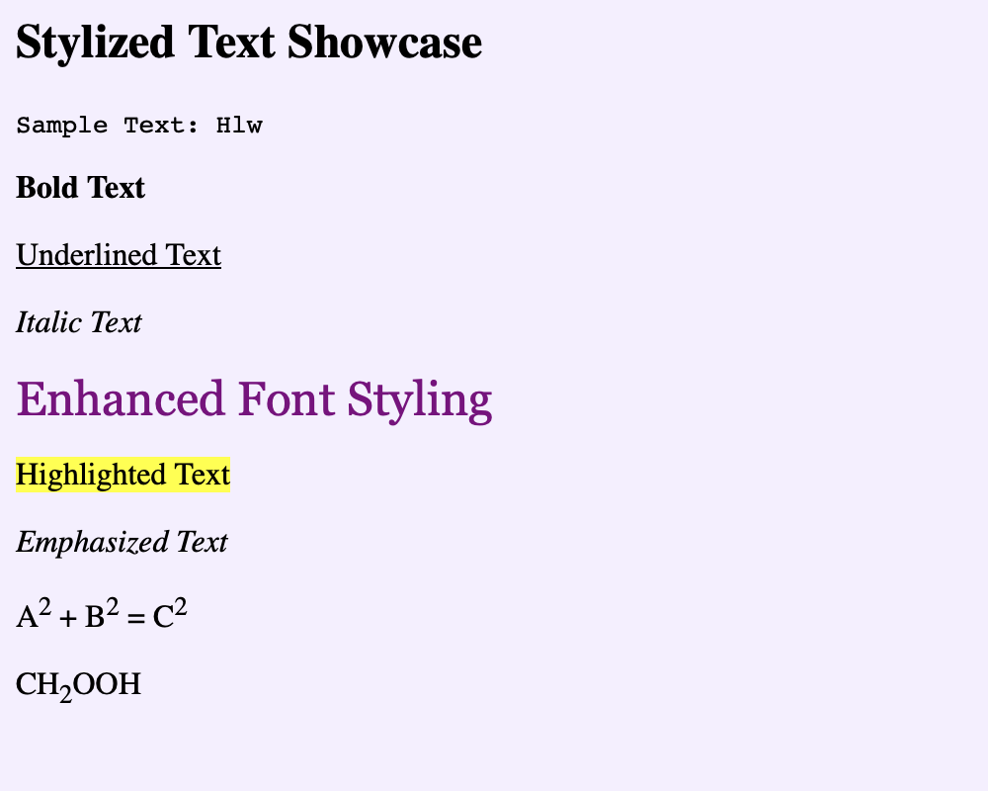

**Practical: 3**

**Aim: Create a HTML file using special characters.**

<html>

<head>

<title>Special Characters in HTML</title>

</head>

<body>

<h3>HTML Special Characters</h3>

<p>

1. Ampersand - &amp; <br>

2. Less than - &lt; <br>

3. Greater than - &gt; <br>

4. Double Quote - &quot; <br>

5. Single Quote - &apos; <br>

6. Copyright - &copy; <br>

7. Registered - &reg; <br>

8. Euro - &euro; <br>

9. Pound - &pound; <br>

10. Yen - &yen; <br>

11. Cent - &cent; <br>

12. Trademark - &trade; <br>

13. Heart - &#9829; <br>

</p>

</body>

</html>

**Output:**

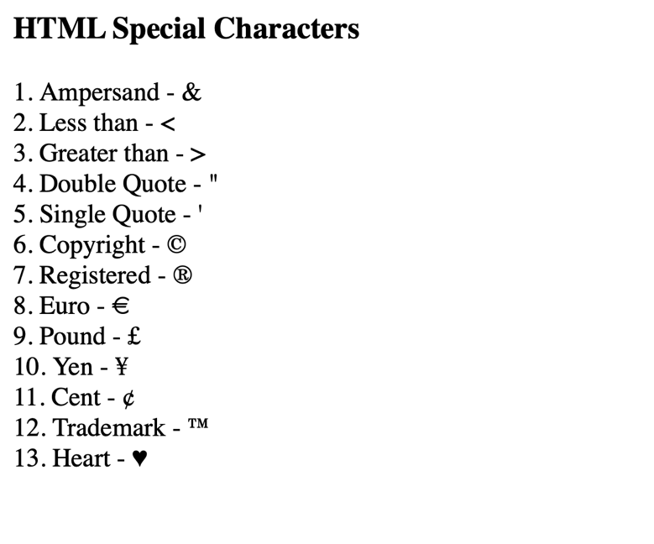

**Practical: 4**

**Aim: Create a HTML file which displays 3 images at LEFT, RIGHT and**

**CENTER respectively in the browser.**

<html>

<head>

<title>Image Alignment</title>

</head>

<body bgcolor="F5EFFF">

<img src="/Users/meetkumar/Documents/left-img.png" alt="Left Image" align="left"

width="493px">

<img src="/Users/meetkumar/Documents/right-img.png" alt="Right Image" align="right"

width="493px">

<div align="center">

<img src="/Users/meetkumar/Documents/center-img.png" alt="Center Image"

width="493px">

</div>

</body>

</html>

**Output:**

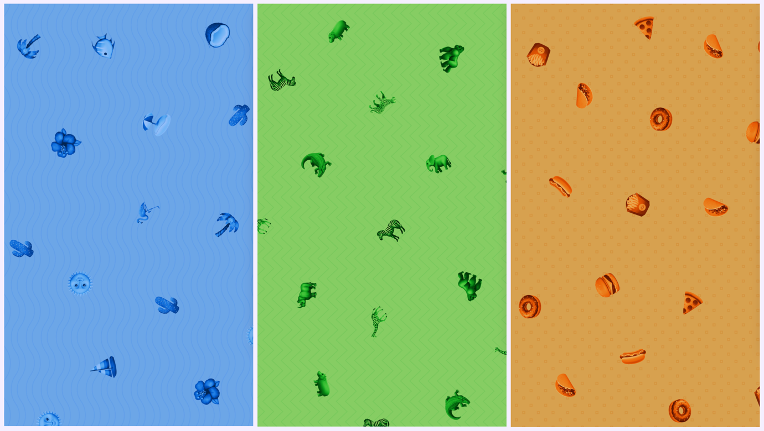

**Practical: 5**

**Aim: Create a HTML file which contains hyperlinks.**

<html>

<head>

<title>Practial 5: Hyperlinks</title>

</head>

<body>

<a href="https://www.ssasit.ac.in">College website</a><br>

<a href="p2.html">Stylized Texts</a><br>

<a href="p3.html" target="_blank">Special Characters</a>

<br>

<p> In today's fast-paced world, the internet is a powerful tool that has revolutionized how

we communicate, learn, work, and play. Every time you open a website or use an app,

there are many technologies working behind the scenes to make everything run smoothly. At the heart of web development, there are a few key technologies that you must understand: HTML, JavaScript, and PHP. These tools help create the websites and applications that you interact with daily. <br>When you first visit a website, it's the HTML (HyperText Markup Language) that defines the structure of the page. From there, JavaScript adds interactivity, allowing you to click buttons, fill out forms, and see real-time updates. But that's not all—PHP (Hypertext Preprocessor) is another crucial language used to make dynamic, server-side applications. It helps you create websites that can interact with databases and perform actions based on user input, such as submitting a form or retrieving information. <br>Whether you’re a beginner in web development or someone looking to understand how the web works, learning HTML, JavaScript, and PHP gives you a strong foundation. These languages work together to create the seamless experience we enjoy every day when browsing the internet. So, let’s take a closer look at each of these technologies and explore how they bring websites to life.

</p>

<p> .<br>.<br>.<br>.<br>.<br>.<br>.<br>.<br>.<br>.<br>.<br>.<br>.<br>.<br>.<br>

.<br>.<br>

</p>

<a href="#"><mark>Move to Top</mark></a><br>

</body>

</html>

**Output:**

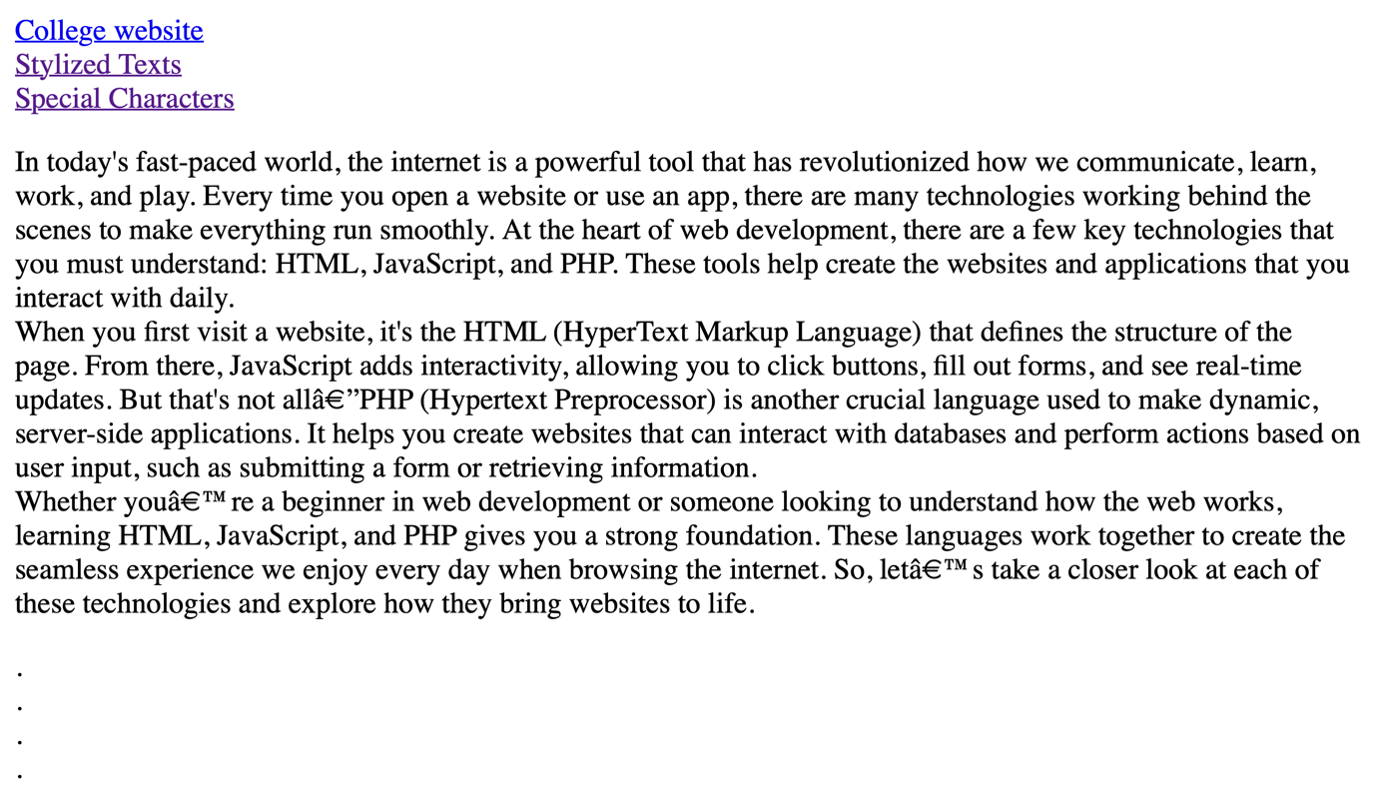



**Practical: 6**

**Aim: Table of Contents**

**Chapter 1: Introduction**

**Chapter 2: What is HTML?**

**Chapter 3: What is JavaScript?**

**.**

**.**

**By clicking on the link takes to the respective topic within the same**

**page.**

<html>

<head>

<title>Practical 6: Table of Contents</title>

</head>

<body>

<center>

<table border="1" cellpadding="20">

<tr>

<td colspan="2" align="center">Table of Contents</td>

</tr>

<tr>

<td>Chapter 1</td>

<td><a href="intro.html">Introduction</a></td>

</tr>

<tr>

<td>Chapter 2</td>

<td><a href="html.html">What is HTML?</a></td>

</tr>

<tr>

<td>Chapter 3</td>

<td><a href="js.html">What is JavaScript?</td>

</tr>

<tr>

<td>Chapter 4</td>

<td><a href="css.html">What is CSS?</a></td>

</tr>

<tr>

<td>Chapter 5</td>

<td><a href="php.html">What is PHP?</a></td>

</tr>

</table>

</center>

</body>

</html>

**Output:**

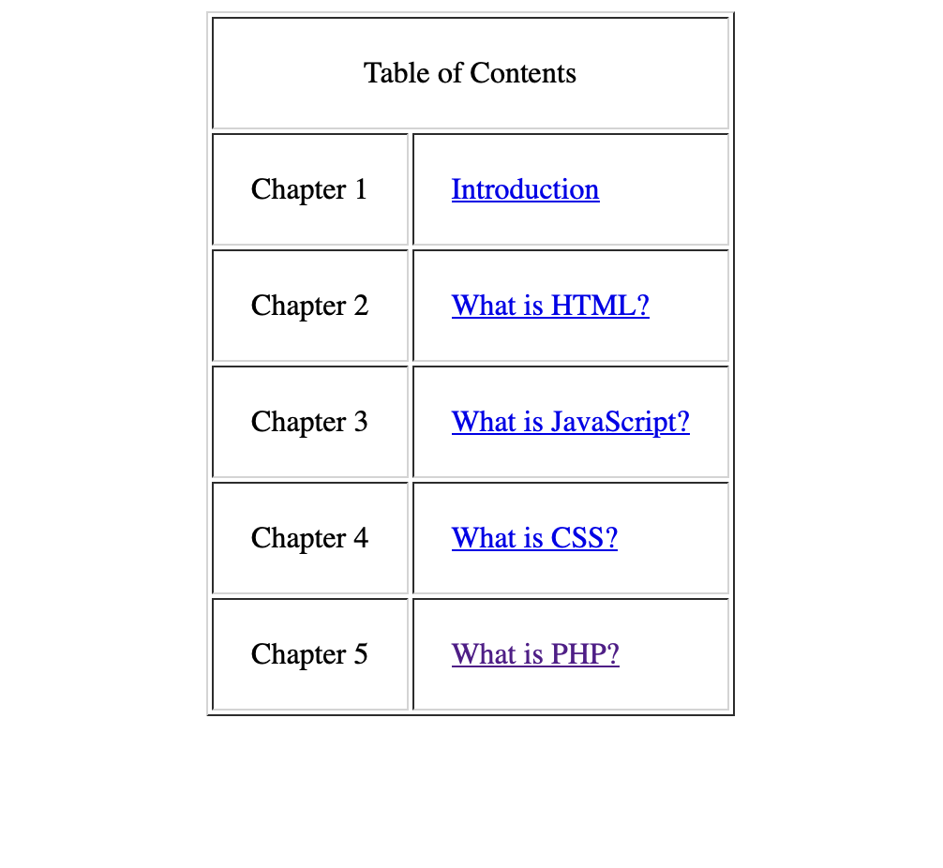

**Practical: 7**

**Aim: Create a HTML page as given below:**

**List of Subjects**

**1. Computer Engineering Department**

**a. Software Engineering**

**b. Information Security**

**c. Computer Graphics**

**2. Electrical Engineering Department**

**• Electrical Machine**

**• Power Electronics**

**• Micro Controller**

**3. Computer Engineering**

**Is a discipline that integrates several fields required to**

**develop computer systems.**

<head>

<title>Practical 7: List</title>

</head>

<body>

<p><h3>List of Subjects</h3></p>

<ol>

<li>Computer Engineering Department</li>

<ul>

<li type="a">Software Engineering</li>

<li type="a">Information Security</li>

<li type="a">Computer Graphics</li>

</ul>

<li>Electrical Engineering Department</li>

<ul type="disc">

<li>Electrical Machine</li>

<li>Power Electronics</li>

<li>Micro Controller</li>

</ul>

<li>Computer Engineering</li>

<dd>Is a discipline that integrates several fields required to develop computer

systems.

</dd>

</ol>

</body>

</html>

**Output:**

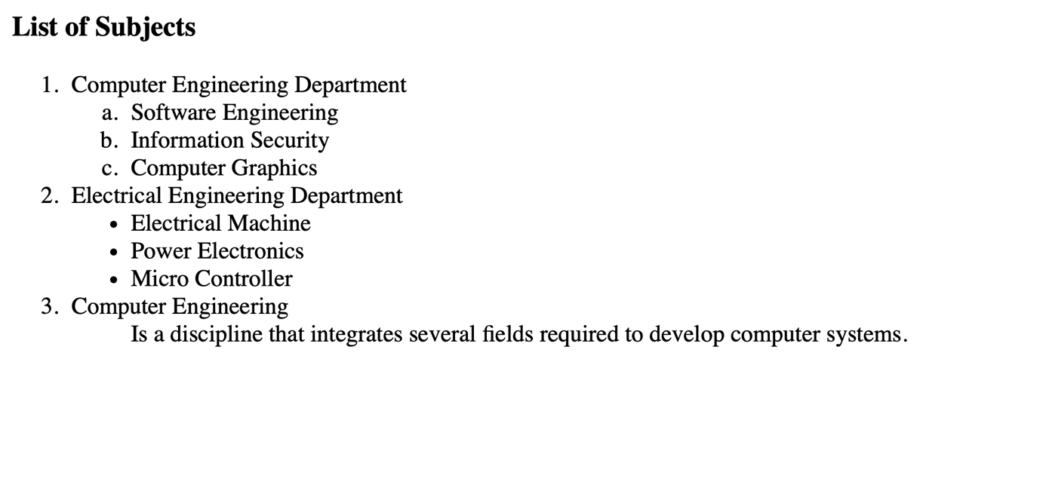

**Practical: 8**

**Aim: Create table with ROWSPAN and COLSPAN attribute of TABLE in**

**HTML (Prepare timetable of your class). Include CELLSPACING &**

**CELLPADDING**