A:
Pump-to-Motor Alignment
Performing both parallel and angular pump-to-motor alignment for every installation is essential for maintaining critical clearances that support rotor stiffness and damping. Requiring mechanical inspection of the driver during motor refurbishment and machining “truth bands” on stuffing box or discharge head surfaces aids in improved alignment processes.

B:
Packing Best Practices
For pumps using packing, providing a hardened shaft sleeve to reduce wear rate and using best practices when cutting and installing packing reduces leakage. Packing should be cut on a mandrel at an angle and installed with packing seams clocked 90 degrees.
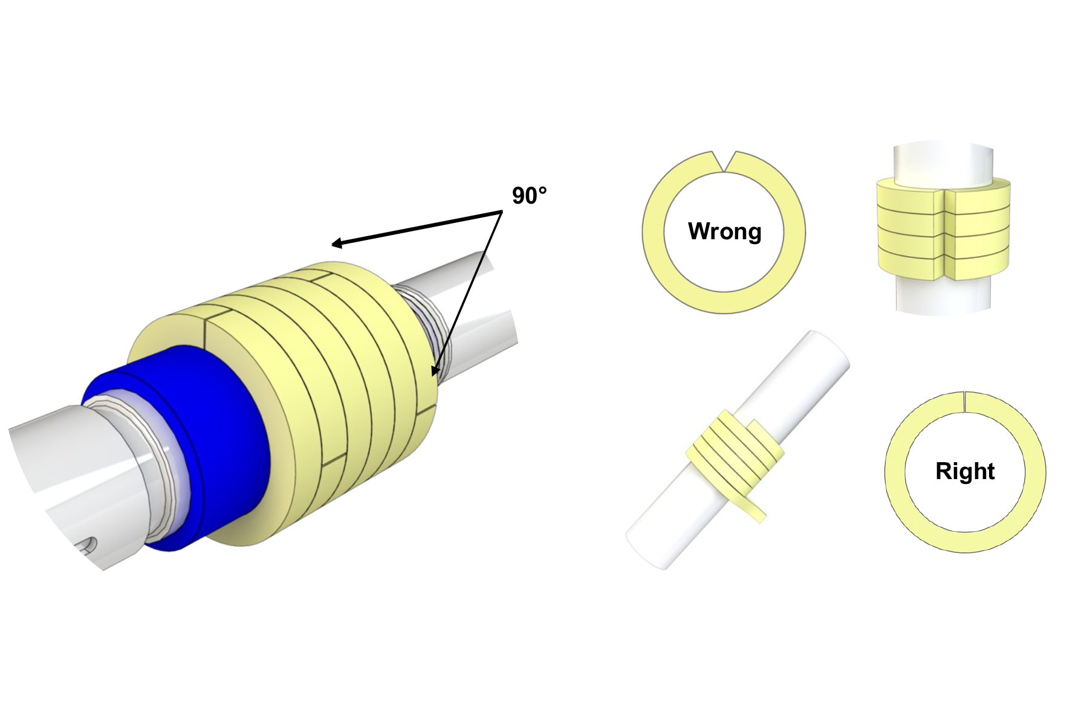

C:
Resonance & Modal Analysis
With a long, cantilevered stationary element, vertical pumps are highly susceptible to resonant excitation. For pumps with known vibration issues or accelerated wear, performing a modal analysis supports accurate diagnosis of resonant conditions and developing modifications without costly trial and error.

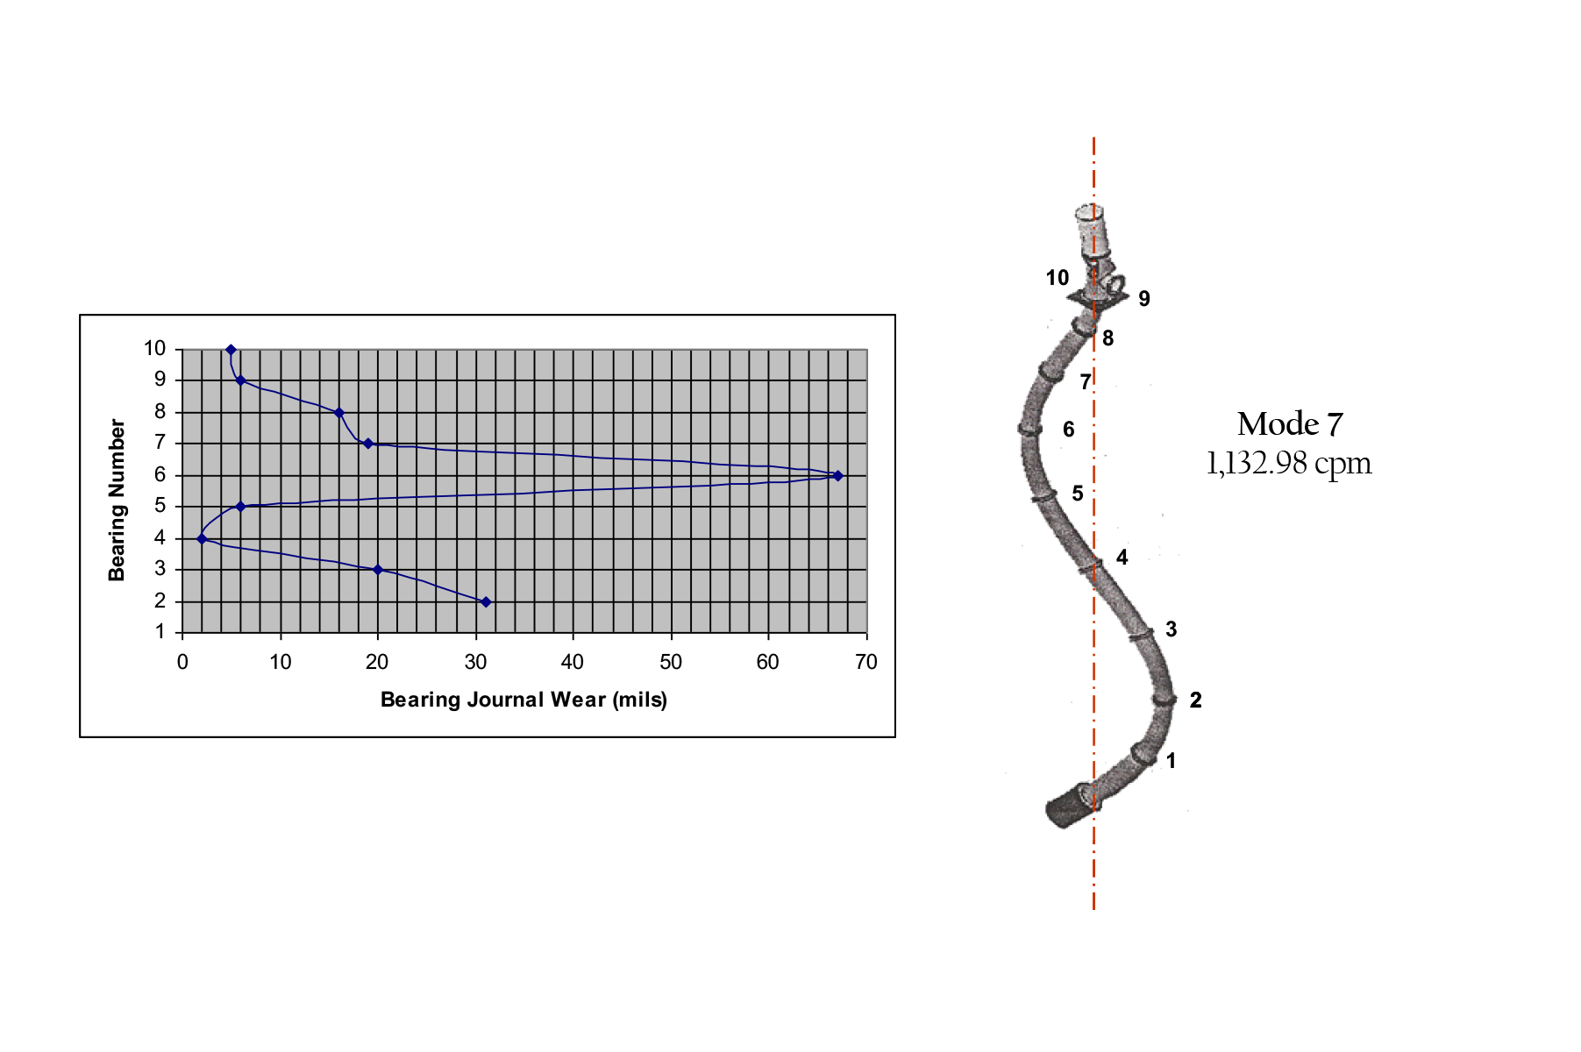

D:
Upgraded Lineshaft Coupling
Many vertical pumps employ threaded lineshaft couplings, which are more prone to misalignment and often need to be cut off due to difficulty during disassembly. Upgrading to a sleeve-and-keyed or split clamp lineshaft coupling will improve both of these issues.

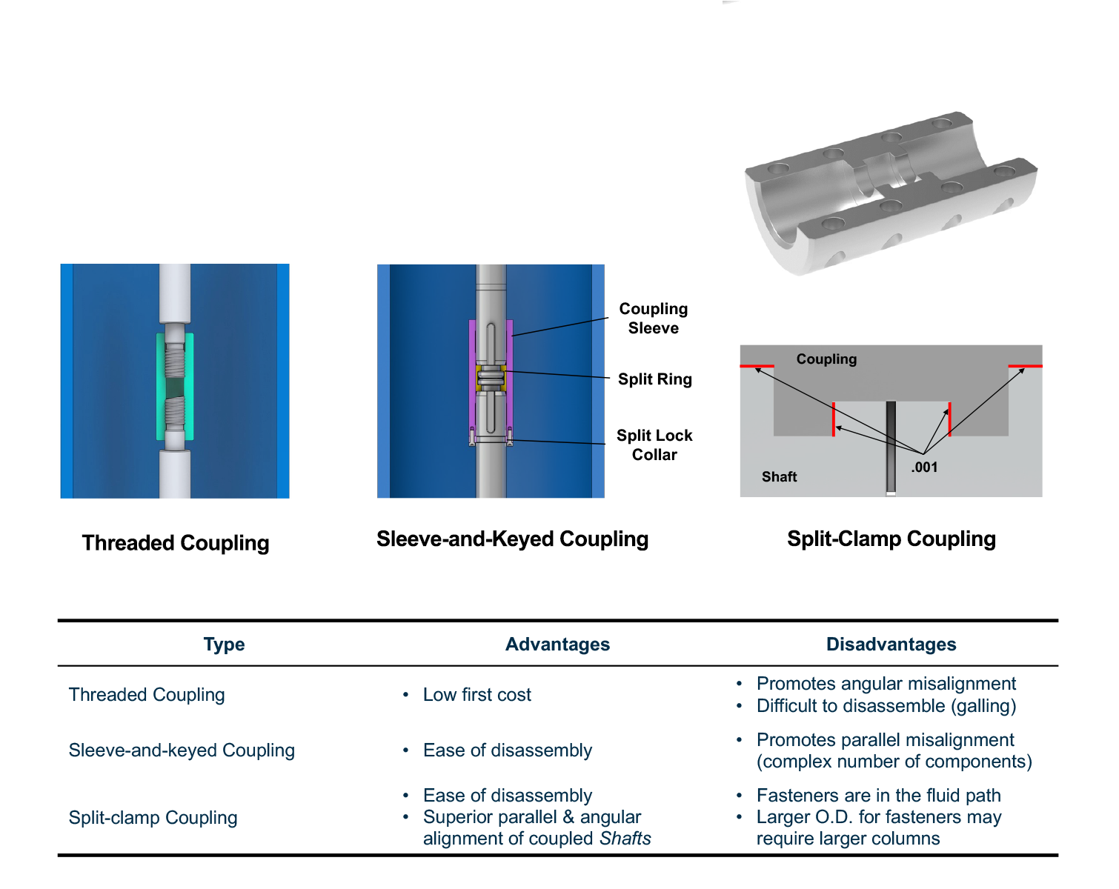

E:
Upgraded Lineshaft Bearing Material
Lineshaft bearings that are above the water line and not provided with a flush can cause issues during startup for the time they are operating dry. Bearing materials with a dry-start capability, such as composite materials, will eliminate this issue.

F:
Eliminate Floating Spiders
Floating spiders provide another loose fit that increases the risk of angular and parallel misalignment of the stationary bearings to the rotor. Providing integral bearings and ensuring concentricity of the bearing bore to the register fit reduces the risk of premature wear.

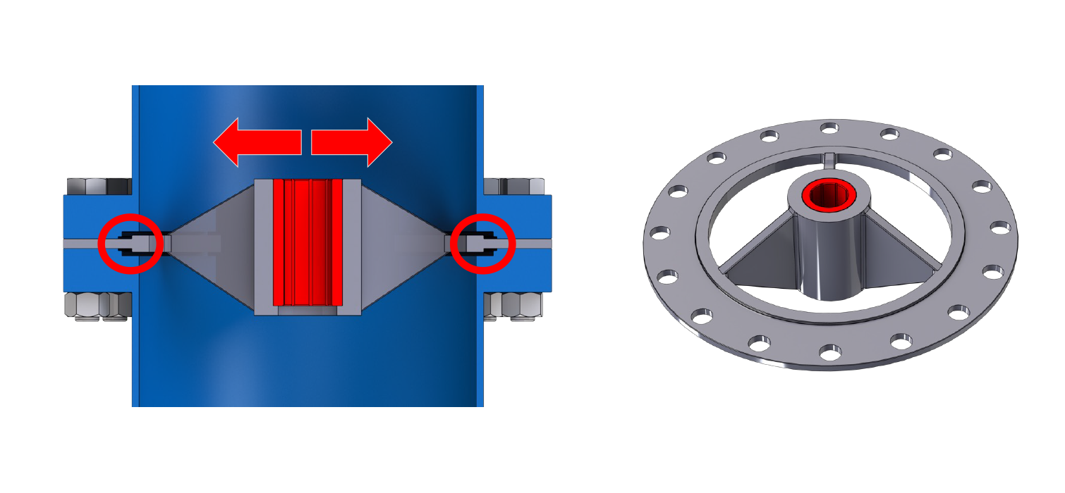

G:
Require Stringent Tolerances
Because vertical pumps are constructed from several stacked components, ensuring stringent tolerances is critical for maintaining alignment of the stationary assembly. Reducing register fits to 0.001 – 0.002” L, ensuring concentricity of fits to each other and to the bearing holder, and maintaining perpendicularity of the mating faces to their respective fits will ensure a better-built pump.
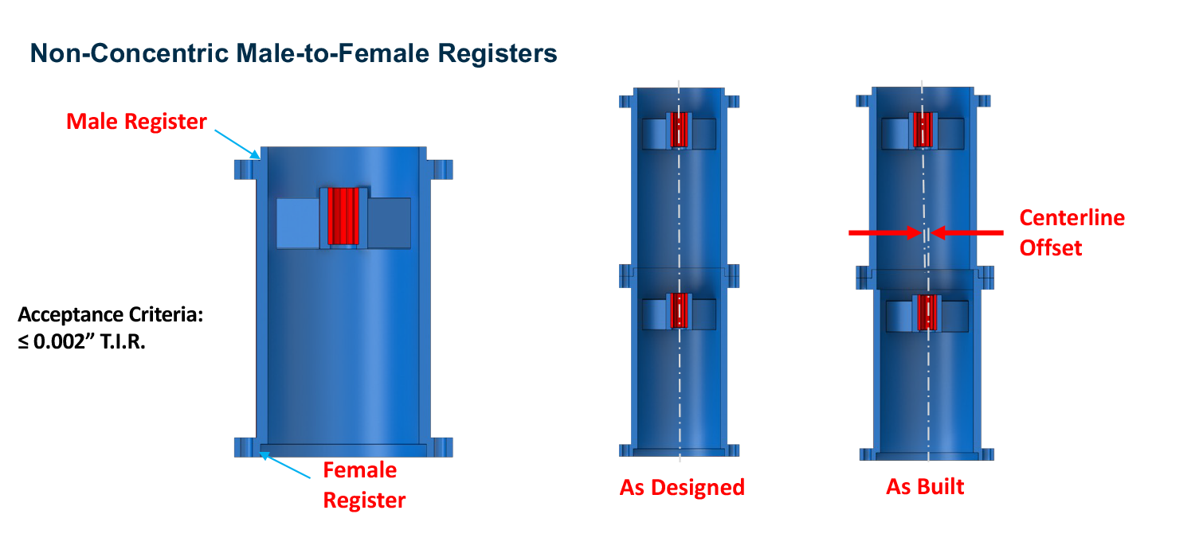

H:
Upgrade Impeller Attachment
Upgrading collet designs to a lock collar will reduce any misalignment of the impeller on the shaft and guard against any axial displacement.

I:
Monitor Condition at the Hydraulic Element
Many vertical pumps rely on vibration measurements at the motor, which is far away from the source of the vibration and usually fairly well damped. By the time vibration is measurable at the motor, significant wear or damage may have already occurred at the impeller or lineshaft bearing location. Monitoring vibration below the water level supports more accurate assessment of equipment health.

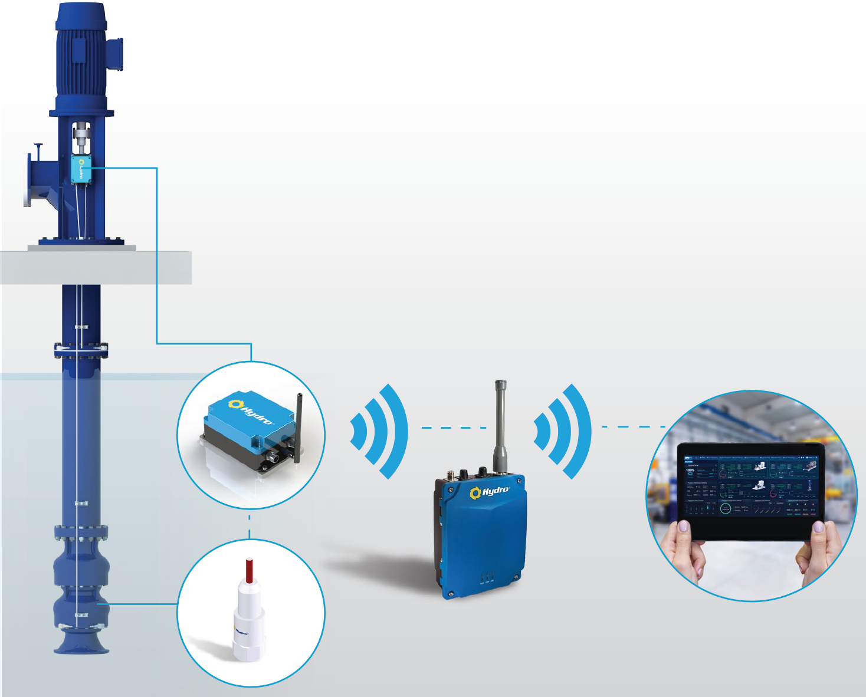

J:
Reduce Inlet Velocity
For pumps without the required minimum submergence or where surface vortex entrainment has been observed, providing an “umbrella” to the suction bell will reduce fluid velocity into the pump and decrease the possibility of vortex formation.

