Table of Contents
1. Introduction 2
2. Notifications Flow - High Level 2
3. Pipeline Hierarchy 2
3.1 Orchestrator (Master) Pipelines 3
3.2 Parent Pipelines 4
3.3 Worker Pipelines 4
Type 1 : Pipeline-driven workers 4
Type 2 : Standalone workers 4
3.4 Hierarchy Summary 6
4. CTL_NOTIFICATION_CONFIG — Recipient Configuration Table 6
4.2 Table Structure 7
4.3 Notification Lookup: 7
5. Central Child Pipeline - PL_NOTIFY_CHILD_PIPELINE_EXECUTION_DETAILS 8
5.1 Parameters 9
5.2 Activities 9
6. Logic App : LA_NOTIFICATION_SERVICE 10
6.1 Entry Condition – ConditionBodyCheck 11
6.2 Initialisation Actions 12
6.3 SwitchOnNotificationType 12
6.4 Ad-hoc Email Path (body present) 15
7. Logic App Trigger Schema 16
8. Bad File Detection Pipeline — PL_EMAIL_BADFILES 18
9. Making Changes 19
9.1 Adding a new pipeline to the notification framework 19

Introduction
This document describes the centralised notification and alerting components implemented across the HSIO Azure Data Factory ETL platform
Before this components were implemented, multiple Logic Apps existed for different alert scenarios, email recipients were hardcoded inside pipeline bodies, and success and failure emails used inconsistent formats with no central control. This enhancement replaces all of that with a single Logic App, a configuration-driven recipient table, and a standardised notification child pipeline that handles all alert types uniformly.

Notifications Flow - High Level
Every notification in the platform follows the same path regardless of whether it is a pipeline success, a pipeline failure, or a file rejection:
- An ADF pipeline reaches a state that requires a notification (started, succeeded, failed, file rejected)
- The pipeline calls the central child pipeline PL_LOG_CHILD_PIPELINE_EXECUTION_DETAILS, passing context about what happened
- The child pipeline looks up the correct recipients from CTL_NOTIFICATION_CONFIG in the database
- The child pipeline calls the Logic App LA_NOTIFICATION_SERVICE via HTTP POST with a structured JSON payload
- The Logic App routes the payload to the correct email template and Teams adaptive card based on notification type and status
- Email and Teams notifications are delivered to the configured recipients

Pipeline Hierarchy
ADF pipelines in the HSIO platform are organised into three tiers. Understanding this hierarchy is important because the notification framework treats each tier differently. There is different title formats, different timing sources, and different error capture methods.
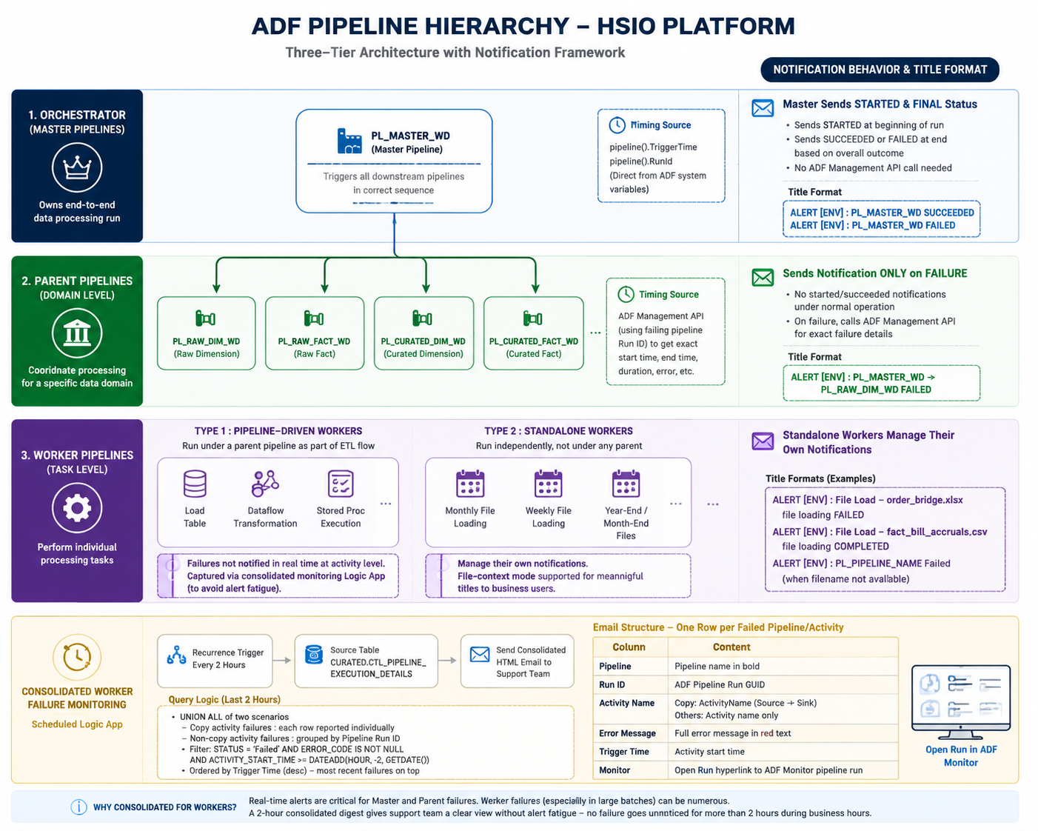

3.1 Orchestrator (Master) Pipelines
The top-level pipeline that owns an end-to-end data processing run. Also referred to as the master pipeline. PL_MASTER_WD is the primary example on this platform.
The orchestrator is responsible for triggering all downstream pipelines in the correct sequence. It sends a STARTED notification at the beginning of the run and a SUCCEEDED or FAILED notification at the end based on overall outcome.
Because the orchestrator knows its own trigger time and run ID directly via ADF system variables (pipeline().TriggerTime, pipeline().RunId), its notifications do not need to call the ADF Management API. All timing and identity fields are built inline from pipeline expressions.
Email title format:
ALERT [ENV] : PL_MASTER_WD SUCCEEDED
ALERT [ENV] : PL_MASTER_WD FAILED

3.2 Parent Pipelines
Mid-tier pipelines that belong to a specific data domain within the platform. Invoked by the orchestrator, they coordinate the processing of a particular subject area — for example raw dimension loading, curated fact loading, or file archiving.
Examples: PL_RAW_DIM_WD, PL_RAW_FACT_WD, PL_CURATED_DIM_WD, PL_CURATED_FACT_WD
Parent pipelines do not send their own started or succeeded notifications under normal operation. The orchestrator covers the overall run status. They only trigger a notification when they fail. For parent failures the notification framework calls the ADF Management API using the failing pipeline's run ID to retrieve exact failure details including start time, end time, duration, and error message.
The email title includes both the orchestrator and the failing parent pipeline so the on-call engineer immediately knows which domain failed and under which master run:
ALERT [ENV] : PL_MASTER_WD → PL_RAW_DIM_WD FAILED

3.3 Worker Pipelines
The lowest tier and the individual processing units that perform a specific task. There are two types of worker pipelines on this platform.

Type 1 : Pipeline-driven workers
Workers that run under a parent pipeline as part of the orchestrated ETL flow. These handle granular steps such as loading a specific table, running a dataflow transformation, or executing a stored procedure.
The failure of individual pipeline-driven workers is not captured in real time at the point of failure. Instead, failures are detected and reported through a separate consolidated monitoring Logic App described below. This is intentional as raising an individual alert for every worker step failure during a parent run would generate excessive noise, since the parent pipeline already raises its own failure alert covering the overall domain outcome

Type 2 : Standalone workers
Workers that run independently, not under any parent or orchestrator pipeline. Scheduled separately, they perform self-contained jobs such as Monthly, weekly, or yearly file loading (year-end files, month-end files)
Standalone workers manage their own notification lifecycle entirely. For file-loading workers the framework supports a file-context mode so the alert title is meaningful to business users rather than showing a technical pipeline name:
ALERT [ENV] : File Load – order_bridge.xlsx file loading FAILED
ALERT [ENV] : File Load – fact_bill_accruals.csv file loading COMPLETED
ALERT [ENV] : PL_PIPELINE_NAME Failed ( when filename not available)

Consolidated Worker Failure Monitoring : Scheduled Logic App

In addition to real-time notifications, a dedicated Logic App runs on a recurrence trigger every 2 hours to sweep for any worker pipeline failures logged in the last 2 hours and deliver a consolidated report only to the support team.
Source table for this is CURATED.CTL_PIPELINE_EXECUTION_DETAILS
The Logic App queries this table for all failed activities where an error code is present. The query handles two scenarios via UNION ALL:
Copy activity failures : each row is reported individually since a single pipeline run can have multiple copy activities, each with its own source, sink, and error
Non-copy activity failures : grouped by pipeline run ID so one pipeline run produces one summary row rather than one row per activity step
Both result sets filter on STATUS = 'Failed', ERROR_CODE IS NOT NULL, and ACTIVITY_START_TIME >= DATEADD(HOUR, -2, GETDATE()). Results are ordered by trigger time descending so the most recent failures appear at the top.

Email structure
When failures exist, a single HTML table email is sent containing one row per failed pipeline/activity with the following columns:
Column | Content
Pipeline | Pipeline name in bold
Run ID | ADF pipeline run GUID
Activity Name | For copy activities — ActivityName (SourceName → SinkName). For others — activity name only
Error Message | Full error message in red text
Trigger Time | Activity start time
Monitor | Open Run hyperlink linking directly to the ADF Monitor pipeline run

Why consolidated rather than real-time for workers
Real-time alerts are appropriate for orchestrator and parent pipelines where a failure is significant enough to warrant immediate attention. For worker pipelines, particularly those running as part of a large batch with many individual steps, a consolidated digest is more practical — it gives the support team a clear picture of what failed in a given window without flooding inboxes with individual alerts per step. The 2 hour schedule means no failure goes unnoticed for more than 2 hours during business hours.

3.4 Hierarchy Summary
Tier | Also called | Notifies on | pl_pipeline_type_prm | Title format
Orchestrator | Master pipeline | STARTED, SUCCEEDED, FAILED | ORCHESTRATOR | ALERT [ENV] : Master_PL_NAME STATUS
Parent | Domain pipeline | FAILED only | PARENT | ALERT [ENV] : Master_pipeline_name → Parent_PL_NAME FAILED
Worker (pipeline-driven) | Child pipeline | FAILED, SUCCEEDED | WORKER | ALERT [ENV] : Parent_PL_NAME → Worker_PL_NAME STATUS
Worker (standalone) | File loader, utility | FAILED, SUCCEEDED | WORKER | ALERT [ENV] : File Load – filename file loading STATUS

CTL_NOTIFICATION_CONFIG — Recipient Configuration Table
This table is the single source of truth for all notification recipients across the platform. No email addresses or Teams channel IDs are hardcoded in any pipeline or Logic App. Everything is driven from this table. All valid values for the current scenario are listed in the below screenshot.
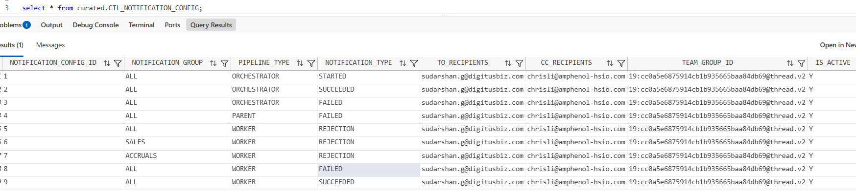

When a pipeline triggers a notification, the child pipeline PL_NOTIFY_CHILD_EXECUTION_DETAILS queries this table to find out who should receive the alert. The table answers three questions:
- Which email addresses should receive this notification?
- Which Teams channel should receive the card?
- Is there a specific configuration for this pipeline/subject area, or should the default be used?

4.2 Table Structure
Column | Type | Description
PIPELINE_TYPE | VARCHAR | Tier of the pipeline triggering the alert — ORCHESTRATOR, PARENT, WORKER
NOTIFICATION_TYPE | VARCHAR | Type of event — STARTED, SUCCEEDED, FAILURE, REJECTION
NOTIFICATION_GROUP | VARCHAR | Subject area or pipeline group this row applies to. Use ALL for a default that applies to everything not specifically configured
TO_RECIPIENTS | VARCHAR | Semicolon-separated list of TO email addresses
CC_RECIPIENTS | VARCHAR | Semicolon-separated CC list. Nullable
TEAM_GROUP_ID | VARCHAR | Microsoft Teams group chat thread ID for adaptive card delivery
IS_ACTIVE | CHAR(1) | Y to enable, N to disable without deleting the row

4.3 Notification Lookup:
The child pipeline queries the table using a priority-based pattern. It passes in the NOTIFICATION_GROUP for the current pipeline and the NOTIFICATION_TYPE. The query looks for two possible matches and returns the most specific one:
SELECT TOP 1 TO_RECIPIENTS, CC_RECIPIENTS, TEAM_GROUP_ID, CONFIG_STATUS
FROM (
SELECT
TO_RECIPIENTS, CC_RECIPIENTS, TEAM_GROUP_ID,
'FOUND' AS CONFIG_STATUS,
CASE WHEN NOTIFICATION_GROUP = '<specific_group>' THEN 0 ELSE 1 END AS match_priority
FROM CURATED.CTL_NOTIFICATION_CONFIG
WHERE PIPELINE_TYPE = '<pipeline_type>'
AND NOTIFICATION_TYPE = '<notification_type>'
AND IS_ACTIVE = 'Y'
AND NOTIFICATION_GROUP IN ('<specific_group>', 'ALL')
UNION ALL
SELECT
'<default_email>' AS TO_RECIPIENTS,
'<default_cc>' AS CC_RECIPIENTS,
'<default_teams>' AS TEAM_GROUP_ID,
'NOT_FOUND' AS CONFIG_STATUS,
2 AS match_priority
) AS ranked
ORDER BY match_priority
Priority resolution:
Priority | Condition | Result
0 (highest) | Row exists for specific NOTIFICATION_GROUP | Use specific recipients
1 | Only ALL row exists | Use default recipients
2 (lowest) | No matching row at all | Use hardcoded fallback, CONFIG_STATUS = NOT_FOUND
When CONFIG_STATUS = NOT_FOUND the Logic App renders a visible amber warning banner in the email body:
⚠ No notification config found. Please update the CTL_NOTIFICATION_CONFIG table.
This ensures the at least support people are notified even when configuration is missing, while making the gap visible so it can gets fixed.

Central Child Pipeline - PL_NOTIFY_CHILD_PIPELINE_EXECUTION_DETAILS
This pipeline is the engine of the notification framework. It is called by every other pipeline whenever a notification needs to be sent. It handles recipient lookup, payload construction, and Logic App invocation.

5.1 Parameters
Parameter | Type | Default | Description
pl_pipelineId_prm | string | — | Run ID of the pipeline to report on. For orchestrator cases this is pipeline().RunId. For parent/worker cases this is the child pipeline's own run ID
pl_pipeline_type_prm | string |  | Tier of the calling pipeline — ORCHESTRATOR, PARENT, WORKER
pl_notification_type_prm | string | FAILURE | Type of event — STARTED, SUCCEEDED, FAILURE
pl_notification_group_prm | string | ALL | Subject area or group name used to look up recipients in CTL_NOTIFICATION_CONFIG
pl_orchestrator_name_prm | string | — | Name of the master pipeline. Used in orchestrator notification titles and email body
pl_orchestrator_triggertime_prm | string | — | Trigger time of the master pipeline. Used to calculate execution duration for orchestrator cases
pl_is_file_prm | bool | false | When true the notification title uses file-context format rather than pipeline name
pl_filename_prm | string | — | Filename to include in the title when pl_is_file_prm = true

5.2 Activities
1. LKP_NotificationConfig: This runs immediately at pipeline start with no dependencies. Queries CTL_NOTIFICATION_CONFIG and returns TO_RECIPIENTS, CC_RECIPIENTS, TEAM_GROUP_ID, and CONFIG_STATUS. Runs in parallel with Switch1 preparation so no time is wasted.
2. Switch: This switches on concat(pl_pipeline_type_prm, '_', pl_notification_type_prm). This produces a composite key that uniquely identifies the notification scenario.
Cases:
Switch value | Activities | Management API called?
ORCHESTRATOR_STARTED | Started Email | No
ORCHESTRATOR_SUCCEEDED | Success Email | No
ORCHESTRATOR_FAILED | Failed Email | No
PARENT_FAILED | GetFailuredetails → Pl_child_pipeline | Yes
WORKER_FAILED | Wait1 → GetFailuredetails_worker → Pl_child_pipeline_copy1 | Yes
WORKER_SUCCEEDED | Wait1_copy1 → GetSucess_details_worker → Pl_worker_pipeline_SUCCEDED | Yes

The worker activity contains wait activity for 20 secends, because when ADF calls the Management API immediately after a pipeline completes, the run status may not yet be finalised and the API can return InProgress with zero duration. The wait gives ADF time to write the terminal state before the API is called. Orchestrator cases do not need this because they use pipeline system variables directly rather than the API.
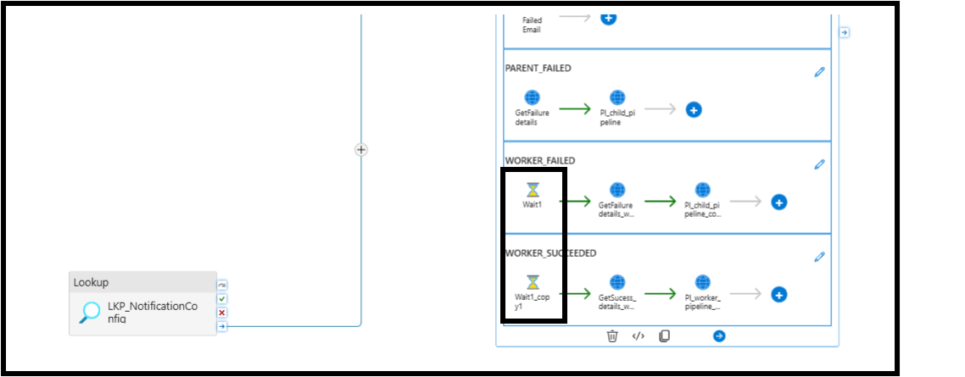
The Management API for parent and worker cases are used because the calling pipeline only has access to its own context (pipeline().RunId, pipeline().TriggerTime). To get the details of a child pipeline and its actual start time, end time, duration, and error message.The framework calls the ADF Management API using the child's run ID. This gives accurate timing and the full error detail regardless of where in the hierarchy the failure occurred.

Logic App : LA_NOTIFICATION_SERVICE
Single Logic App handling all notification scenarios for the platform. Accepts an HTTP POST and routes internally based on payload content.
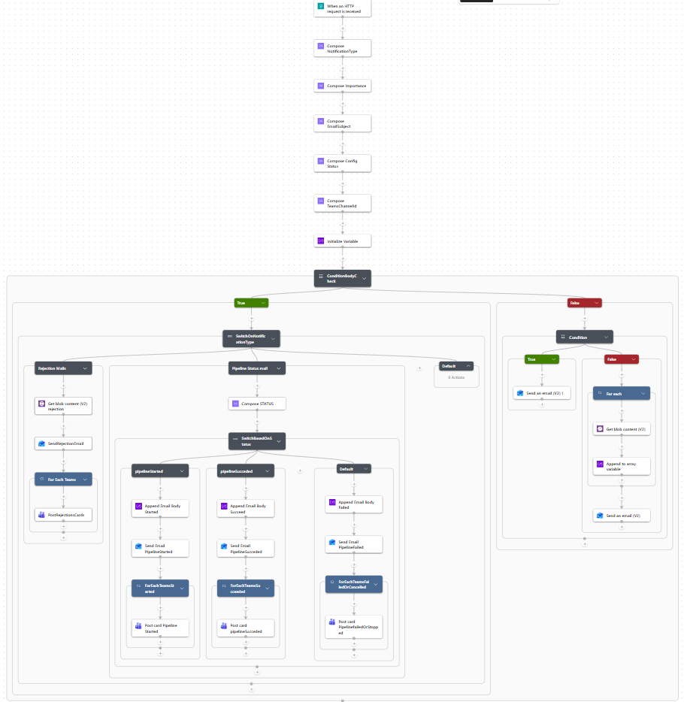

Entry Condition – ConditionBodyCheck
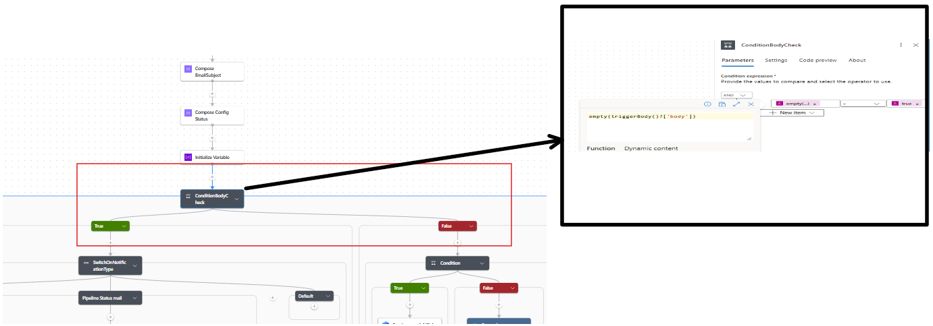

6.2 Initialisation Actions
Before the entry condition fires, four actions run in sequence:
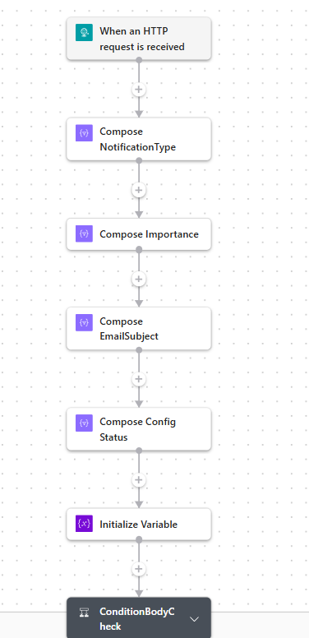
Compose_NotificationType: This makes the notificationType in upper case and defaults to INFO if not provided.
Compose_Importance : This resolves email importance, defaults to Normal.
Compose_EmailSubject: This builds the subject for the generic ad-hoc path only: [HSIO] [ENV] subject. Not used by PIPELINE_STATUS or REJECTION cases, which use title directly.
Compose_Config_Status :It evaluates configStatus and prepares the warning banner HTML string if NOT_FOUND. This output is referenced in all email body templates.
Initialize_Variable : This initialises two variables: EmailAttachments (array, for attachment path) & Email Body (string, appended to by each status case before sending).

6.3 SwitchOnNotificationType
Outer switch driven by Compose_NotificationType output.
- REJECTION case:
For file rejection alerts triggered by PL_EMAIL_BADFILES or similar pipelines.
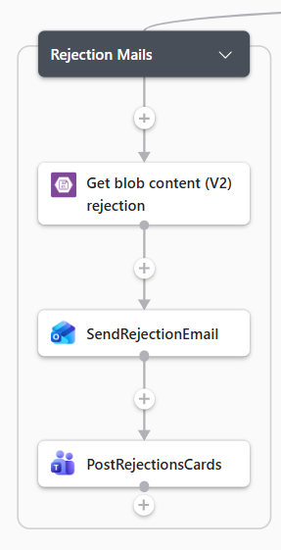
Image: Flow for rejected files
Flow of exceution:
- Get_blob_content_(V2) _rejection: It fetches the rejection file from blob storage using file path
- SendRejectionEmail: This sends an email with the file attached.
- PostRejectionsCards :This posts Teams warning card to teamsChannelId
The rejection email subject is built inline (not from title) as: [HSIO] [ENV] File Rejection Alert – SUBJECT_AREA
- PIPELINE_STATUS case :

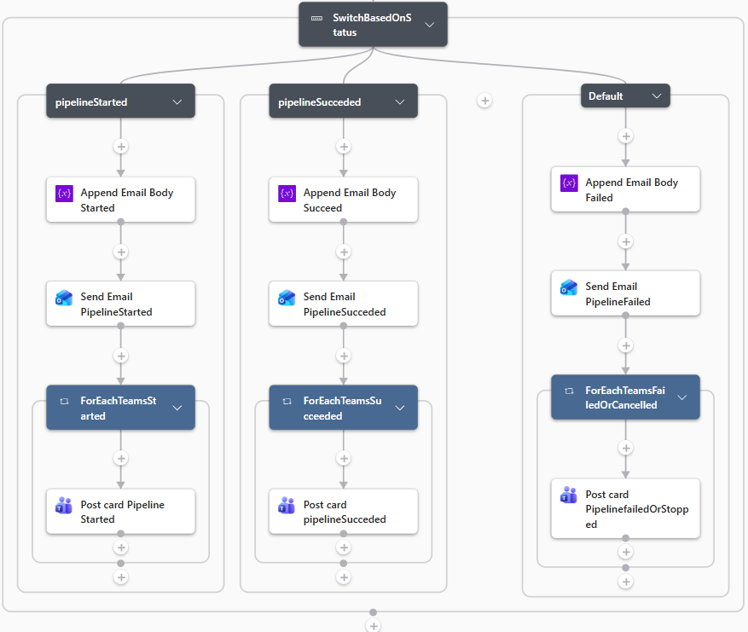

This is created for all pipeline lifecycle notifications. Contains an inner Compose_STATUS action that uppercases status, then flow called as SwitchBasedOnStatus, that routes the notification based on status of the pipeline.
Table: Table showing how notifications are routed based on statusof pipeline
Status | Case | Email importance | Teams card style | Monitor link shown
STARTED | pipelineStarted | Low | Accent — blue | No
SUCCEEDED | pipelineSucceeded | Normal | Good — green | No
Anything else (FAILED, CANCELLED, ) | Default | High | Attention — red failure | Yes

The default branch catches FAILED, CANCELLED, and any unknown status value. It always sends with High importance and includes the Open Pipeline Run hyperlink so support team can navigate directly to the ADF Monitor run without searching.

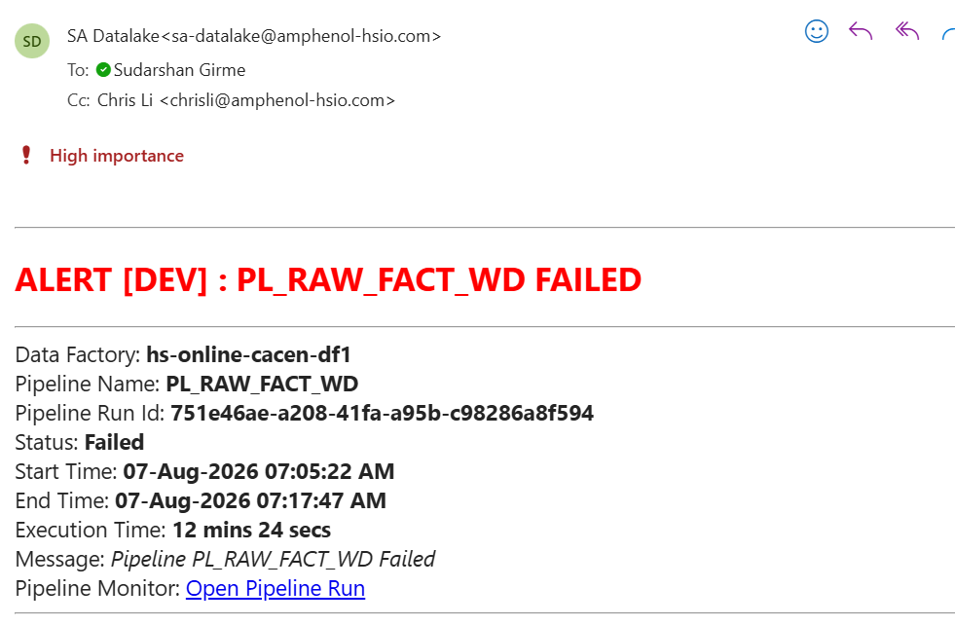
Each case appends its HTML to the Email Body variable, then sends the email, then posts the Teams card — always in that sequence.

6.4 Ad-hoc Email Path (body present)
When body is populated the Switch is bypassed. An inner condition checks whether attachments is empty:
- No attachments — sends email directly with body as HTML content
- Attachments present — loops through each path in the attachments array, fetches blob content, base64 encodes it, appends to EmailAttachments variable, then sends with all attachments
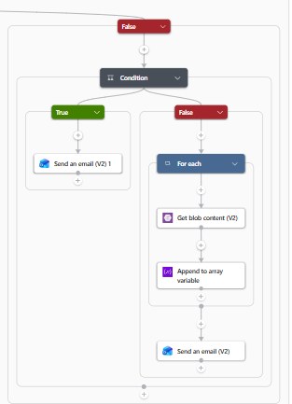
Image: Flow for routing notifications with body

Logic App Trigger Schema
The Logic App accepts a single JSON payload via HTTP POST. Not all fields are required for every notification type.
- Routing and Control :

Field | Required | Used by | Description
toRecipients | Always | All | Semicolon-separated TO list. Always sourced from LKP_NotificationConfig
ccRecipients | No | All | CC list. Nullable — coalesced to empty string to avoid connector errors
bccRecipients | No | Reserved | Declared in schema, not yet wired into any send action
notificationType | No | Router | Drives outer switch. Values: REJECTION, PIPELINE_STATUS. Defaults to INFO
body | No | Ad-hoc path | When present bypasses SwitchOnNotificationType activity and sends plain email directly
importance | No | Ad-hoc path | Email importance for generic emails only. Pipeline status cases hardcode importance per case
configStatus | No | All | FOUND or NOT_FOUND. Controls amber warning banner in all email bodies
teamsChannelId | No | All | Teams group chat thread ID for adaptive card delivery

- Email Subject and Display:

Field | Required | Used by | Description
title | No | PIPELINE_STATUS | Used for pre-built subject line only for pipelines sending status  Format: ALERT [ENV] : PipelineName STATUS
subject | No | Ad-hoc path | Subject for generic emails via Compose_EmailSubject. Ignored by PIPELINE_STATUS and REJECTION
environment | No | Ad-hoc path | Environment tag for generic email subject. Already embedded in title for pipeline cases
color | No | PIPELINE_STATUS | Used to drive colour for Title or for status in email body

- Pipeline Identity:

Field | Required | Used by | Description
dataFactoryName | No | PIPELINE_STATUS | ADF instance name. Sourced from pipeline().DataFactory
pipelineName | No | PIPELINE_STATUS | Pipeline name shown in email body. Overridden with filename for file-context worker cases
pipelineRunId | No | PIPELINE_STATUS | ADF run GUID shown in email body and used in ResourceUrl
PipelineType | No | Reserved | Declared in schema, not currently used in any action body
time | No | Reserved | UTC send timestamp. Declared but not rendered in any current email template

- Timing :

Field | Required | Used by | Description
PipelineStartTime | No | PIPELINE_STATUS | Start time in Eastern Standard Time. Shown in all three status emails
PipelineEndTime | No | SUCCEEDED, FAILED | End time in EST. Not sent for STARTED since run has not completed
ExecutionTimeMins | No | SUCCEEDED, FAILED | Human-readable duration — 0 hrs 0 mins 38 secs. Calculated in ADF

- Message and Error

Field | Required | Used by | Description
status | No | PIPELINE_STATUS | Execution status driving inner switch. Values: STARTED, SUCCEEDED, FAILED, CANCELLED
message | No | PIPELINE_STATUS | Contextual message in email body. For WORKER_FAILED populated with ADF error when status is Failed. For parent and orchestrator pipeline it is shown using generic message
ResourceUrl | No | FAILED | ADF Monitor deep link. Shown only when status is Failed or cancelled

- File Rejection Specific

Field | Required | Used by | Description
filepath | No | REJECTION | Blob path to the rejection file for attachment
filename | No | REJECTION, WORKER file-context | Attachment display name. Also used in worker title when pl_is_file_prm = true
subject_area | No | REJECTION | Business subject area shown in email subject and body. Uppercased
RejectionCount | No | REJECTION | Rejected record count shown in Teams card

Bad File Detection Pipeline — PL_EMAIL_BADFILES
Standalone worker pipeline that checks blob storage for a rejection file matching an expected filename prefix and modified after a given start time. When a matching file with at least one data row is found, it triggers a REJECTION notification via the Logic App.
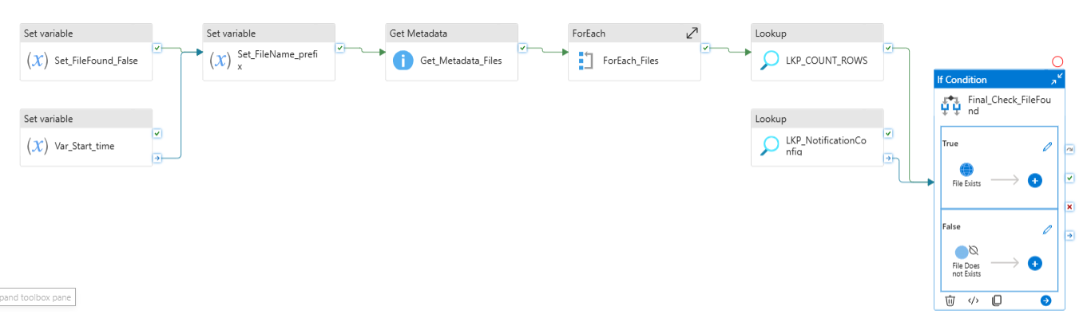
This pipeline is used to send a file containing rejected records from Dataflow processing to the relevant recipients. During Dataflow execution, any records that fail validation are written to a rejection file in blob storage. These files follow a standard naming convention where the filename starts with bad followed by the subject area name and the date the file was created, for example bad-order_bridge_comment-20260806.
The pipeline takes this filename prefix and a start time as inputs, scans the subject area's log folder in blob storage, and looks for a file whose name matches the prefix and was modified after the given start time. If a matching file is found and it contains at least one data row, the pipeline attaches the file to a rejection notification email and sends it via the Logic App. If no matching file is found or the file is empty, the pipeline ends silently with no notification sent. Recipients are resolved at runtime from CTL_NOTIFICATION_CONFIG so no email addresses are hardcoded in the pipeline

Parameters required for pipeline:
Parameter | Description
SubjectArea | Subject area name used as folder path and shown in notification
pl_bad_file_name_prm | Bad file name
pl_start_time | Time when pipeline started
pl_notification_group_prm | Notification group for recipient lookup. This is based on which group pipeline belongs to.

Making Changes

9.1 Adding a new pipeline to the notification framework
PL_NOTIFY_CHILD_PIPELINE_EXECUTION_DETAILS is designed as a plug-and-play notification pipeline. You do not need to create or modify any pipeline or Logic App — you simply call this child pipeline from your pipeline at the right point and pass the correct parameters based on your pipeline tier.

Step 1 : Determine your pipeline tier
Decide whether the pipeline you are onboarding is an Orchestrator, Parent, or Worker. This determines how many times you plug in the child pipeline and what parameters you pass.

Step 2 : Insert rows into CTL_NOTIFICATION_CONFIG
Before wiring up any pipeline, ensure the recipient configuration exists in CTL_NOTIFICATION_CONFIG for the relevant PIPELINE_TYPE and NOTIFICATION_TYPE combinations. If a matching row does not exist, the notification will still fire but will go to the default fallback recipients and the email body will show the configuration missing warning.

Step 3 : Plug in the child pipeline PL_NOTIFY_CHILD_PIPELINE_EXECUTION_DETAILS based on tier
- Orchestrator pipeline :
- Add two Execute Pipeline activities calling PL_LOG_CHILD_PIPELINE_EXECUTION_DETAILS. One on the success condition and one on the failure condition of the last activity in your orchestrator. Optionally add a third for the started notification at the very beginning of the pipeline.
- For each, set Wait on completion = False
- pass the following parameters:

pl_pipelineId_prm @pipeline().RunId
pl_pipeline_type_prm ORCHESTRATOR
pl_notification_type_prm STARTED / SUCCEEDED / FAILED
pl_orchestrator_name_prm @pipeline().Pipeline
pl_orchestrator_triggertime_prm @pipeline().TriggerTime
pl_notification_group_prm (Notification group for your pipeline or leave as ALL)
pl_is_file_prm (leave as default)
pl_filename_prm (leave as default)

- Parent pipeline
- Add one Execute Pipeline activity on the failure condition of the parent pipeline activity inside the orchestrator.
- Set Wait on completion = true only if it is called outside of the parent pipeline. This should be always called outside of parent pipeline and within the orchestrator pipeline
- The key difference here is pl_pipelineId_prm, it must be the run ID of the failing child activity output, not the orchestrator's own run ID. This allows the Management API to retrieve the exact failure details of the parent pipeline.

pl_pipelineId_prm @activity('YOUR_PARENT_PIPELINE').output.pipelineRunId
pl_pipeline_type_prm PARENT
pl_notification_type_prm FAILED
pl_orchestrator_name_prm @pipeline().Pipeline
pl_orchestrator_triggertime_prm @pipeline().TriggerTime
pl_notification_group_prm (your subject area)
pl_is_file_prm (leave as default)
pl_filename_prm (leave as default)

- Worker pipeline : standard (non-file)
- Add one Execute Pipeline activity on the failure condition inside the parent pipeline.
- Set Wait on completion = false so it fires and does not wait for completion of the child pipeline.

pl_pipelineId_prm @activity('YOUR_WORKER_ACTIVITY').output.pipelineRunId
pl_pipeline_type_prm WORKER
pl_notification_type_prm FAILED
pl_orchestrator_name_prm (leave as default)
pl_orchestrator_triggertime_prm (leave as default)
pl_notification_group_prm (your subject area)
pl_is_file_prm false
pl_filename_prm (leave as default)

- Worker pipeline : standalone file-loading
- Add two Execute Pipeline activities. One on success and one on failure.
- Set Wait on completion = false for both.
- Set pl_is_file_prm = true and pass the actual filename so the notification title shows the filename instead of the pipeline name.

pl_pipelineId_prm @pipeline().RunId
pl_pipeline_type_prm WORKER
pl_notification_type_prm SUCCEEDED / FAILED
pl_orchestrator_name_prm (leave as default)
pl_orchestrator_triggertime_prm (leave as default)
pl_notification_group_prm (your subject area)
pl_is_file_prm true
pl_filename_prm (actual filename e.g. order_bridge.xlsx)

If the filename is not known at design time, leave pl_filename_prm as it is.

Step 4 : Verify

Run the pipeline once in DEV and confirm the email and Teams card arrive with the correct recipients, correct title format, and correct pipeline details. If the email arrives with the configuration missing warning, add the missing row to CTL_NOTIFICATION_CONFIG and re-run.

