[NAME OF THE SCHOOL]
[City, State]

COMPUTER SCIENCE (083)
PROJECT REPORT
Session 2026–27

CARBON DATA LOGGER
Personal Carbon Footprint Tracking System
(Python and MySQL)

Submitted by:  [Student Name]  Class XII – [Section]  Roll No.: [Board Roll No.] | Under the guidance of:  [Teacher's Name]  PGT (Computer Science)

CERTIFICATE

This is to certify that [Student Name] of Class XII – [Section], [Name of the School], has successfully completed the Computer Science (083) project titled “Carbon Data Logger – Personal Carbon Footprint Tracking System” under my guidance during the academic session 2026–27, as prescribed by the Central Board of Secondary Education (CBSE).
The project is the original work of the student and has been carried out with sincerity and dedication.

____________________  Internal Examiner | ____________________  External Examiner | ____________________  Principal

ACKNOWLEDGEMENT

I would like to express my sincere gratitude to my Computer Science teacher, [Teacher's Name], for the valuable guidance, support and encouragement throughout this project.
I am also thankful to our Principal, [Principal's Name], for providing the facilities and an environment that made this work possible.
I thank my parents and friends for their constant support and for helping me test the program and collect sample data.

[Student Name]
Class XII – [Section]

INDEX
S. No. | Topic
1 | Introduction
2 | Objectives of the Project
3 | Features of the Project
4 | Hardware and Software Requirements
5 | Python Modules and Concepts Used
6 | Database Design
7 | Program Design and Functions
8 | Source Code
9 | Output Screenshots
10 | Testing
11 | Limitations and Future Scope
12 | Bibliography

1. Introduction
Every day we do things that release carbon dioxide (CO2) into the air. Electricity from coal-based power plants, petrol and diesel vehicles, cooking gas and air travel all add to our personal carbon footprint. Most people do not know how much CO2 their daily activities produce, because there is no simple way to keep track.
The Carbon Data Logger is a menu-driven terminal program written in Python with a MySQL database. It lets one person record everyday activities such as electricity use, travel by car, bus or train, LPG use and flights. For each activity the program estimates the CO2 released, using the formula:
CO2 emission (kg) = Quantity × Emission factor
The emission factor is the amount of CO2 released by one unit of the activity, for example 0.17 kg of CO2 for every kilometre travelled by car. The factors are stored in the database, so they can be changed without changing the program.
All records are stored in two related MySQL tables. The user can search, update and delete records, see overall, category-wise and monthly summaries, find the category with the highest emissions, get simple suggestions to reduce emissions, and export the data to a CSV file and a text report.
Note: The project is educational. The emission factors are illustrative values chosen for this project and are not official scientific data.

2. Objectives of the Project
- To create awareness about the carbon footprint of everyday activities.
- To build a working Python–MySQL application that stores and processes real-life data.
- To apply Class XII concepts: user-defined functions, exception handling, text and CSV file handling, SQL and Python–SQL connectivity.
- To demonstrate a relational database with a primary key, a foreign key and a join between two tables.
- To use SQL aggregate functions and GROUP BY to produce meaningful summaries.
- To validate user input so that wrong data does not crash the program or enter the database.

3. Features of the Project
The program is controlled from a main menu with 14 options:
Option | Feature | Description
1 | Add Carbon Record | Choose a category, enter the date, quantity and an optional note; the program shows the calculation and saves the record after confirmation.
2 | View All Records | Shows every record in a neat table, sorted by date.
3 | Search Records | Search by record ID, by category name (partial match), by a single date, or between two dates.
4 | Update Record | Change the date, category, quantity or note; the CO2 value is recalculated.
5 | Delete Record | Shows the record and deletes it only after the user confirms with Y.
6 | Carbon Footprint Summary | Total records, total, average, lowest and highest CO2, and the date range.
7 | Category-wise Summary | Number of records, total CO2 and percentage share of each category.
8 | Monthly Summary | Lists months that have data, then shows the summary of the chosen month.
9 | Highest Emission Category | Shows the highest and lowest categories and rule-based suggestions.
10 | Export Records to CSV | Writes all records to carbon_records.csv.
11 | Export Summary to Text File | Writes a full summary report to carbon_summary.txt.
12 | Manage/View Emission Factors | View factors, change a factor, or add a new category.
13 | Help | Shows short instructions for using the program.
14 | Undo Last Added Record | Removes the most recently added record of this session, using a stack (Last In, First Out).
0 | Exit | Closes the database connection and ends the program.

4. Hardware and Software Requirements

4.1 Hardware
Component | Minimum requirement
Processor | Intel Core i3 / AMD equivalent or better
RAM | 4 GB
Hard disk | 500 MB free space
Input / Output | Keyboard, monitor

4.2 Software
Software | Details
Operating system | Windows 10/11, Linux or macOS
Programming language | Python 3.8 or later
Database | MySQL Server 8.0 recommended (MariaDB also works)
Python package | mysql-connector-python
Editor | IDLE / Visual Studio Code

4.3 How to run the project
- Install Python 3 and MySQL Server.
- Install the connector: pip install mysql-connector-python
- In carbon_logger.py, set DB_PASSWORD to your MySQL password (it is "root" by default).
- Optional: run SOURCE database_setup.sql; once in the MySQL client to load sample data.
- Run the program: python carbon_logger.py

5. Python Modules and Concepts Used

5.1 Modules
Module | Use in the project
mysql.connector | Connects Python to MySQL and runs SQL queries (connect(), cursor(), execute(), commit(), fetchone(), fetchall(), rowcount).
csv | Exports records to a CSV file using writer(), writerow() and writerows().
datetime | Checks that dates are valid (strptime) and gives today's date.

5.2 Syllabus concepts demonstrated
Concept | Where it is used
User-defined functions | The whole program is divided into 45 small functions, called from main().
Parameters and return values | calculate_emission(quantity, emission_factor), validate_date(date_text), get_grand_total(rows).
Global and local scope | connect_database() uses the global keyword for connection and cursor.
Stack (data structure) | undo_stack is a list used as a stack, with push() and pop() functions, for Undo Last Added Record.
Lists, tuples, dictionaries | DEFAULT_CATEGORIES (list of tuples), MONTH_NAMES (tuple), SUGGESTIONS and menu_actions (dictionaries).
Exception handling | try–except–finally for invalid numbers, dates, MySQL errors (also inside the sub-menus), duplicate names, file errors, Ctrl+C (KeyboardInterrupt) and end of input (EOFError).
Text file handling | export_summary_to_text() uses open(), write() and close() in a finally block.
CSV file handling | export_to_csv() uses a with block and csv.writer.
SQL DDL | CREATE DATABASE, CREATE TABLE with PRIMARY KEY, FOREIGN KEY, NOT NULL and UNIQUE.
SQL DML | INSERT, SELECT, UPDATE, DELETE.
SQL clauses and operators | WHERE, BETWEEN, LIKE, DISTINCT, ORDER BY, aliases.
Aggregate functions | COUNT(), SUM(), AVG(), MIN(), MAX() with GROUP BY.
Joins | INNER JOIN (equi-join) between emission_records and categories.
Python–SQL connectivity | Parameterised queries with the %s format specifier.

6. Database Design
Database name: carbon_logger. It has two related tables. On MySQL 8 the default character set is utf8mb4, so notes can contain the rupee sign (₹) and Hindi text; older servers such as MySQL 5.7 default to latin1, which allows English letters only.

6.1 Table: categories
Stores each type of activity with its unit and emission factor.
Field | Data type | Constraint | Description
category_id | INT | PRIMARY KEY, AUTO_INCREMENT | Unique ID of the category
category_name | VARCHAR(30) | NOT NULL, UNIQUE | Name, e.g. Car Travel
unit | VARCHAR(10) | NOT NULL | Unit, e.g. km, kWh, kg
emission_factor | FLOAT | NOT NULL | kg CO2 per unit

6.2 Table: emission_records
Stores one row for every activity recorded by the user.
Field | Data type | Constraint | Description
record_id | INT | PRIMARY KEY, AUTO_INCREMENT | Unique ID of the record
record_date | DATE | NOT NULL | Date of the activity
category_id | INT | NOT NULL, FOREIGN KEY | Refers to categories(category_id)
quantity | FLOAT | NOT NULL | Amount, in the category's unit
co2_emission | FLOAT | NOT NULL | Calculated CO2 in kg
note | VARCHAR(100) | – | Optional note

6.3 Relationship between the tables
One category can have many records, and each record belongs to exactly one category (a one-to-many relationship). The column category_id in emission_records is a foreign key that refers to the primary key of categories. Because of this:
- a record cannot be saved with a category that does not exist;
- a category that still has records cannot be deleted;
- the category name and unit are stored only once and are fetched with an INNER JOIN whenever records are displayed.

6.4 Default data in the categories table
Degree of the table = 4, cardinality = 6 (before the user adds any category).
category_id | category_name | unit | emission_factor
1 | Electricity | kWh | 0.82
2 | Car Travel | km | 0.17
3 | Bus Travel | km | 0.10
4 | Train Travel | km | 0.04
5 | LPG | kg | 2.98
6 | Flight | km | 0.15
The emission factors are illustrative values for this project.

7. Program Design and Functions

7.1 Flow of the program
- The program starts by calling main().
- main() connects to MySQL, creates the database and tables if they do not exist, and adds the default categories if the table is empty. If the connection fails, a clear message is shown and the program stops.
- main() shows the main menu in a loop and reads the user's choice.
- The dictionary menu_actions links each choice to its function, which is then called.
- Database errors inside an option are caught, so the program returns to the menu instead of stopping.
- Choosing 0 ends the loop; the finally block always closes the cursor and the connection.

7.2 List of functions
Function | Purpose
connect_database() | Connects to MySQL and creates/selects the database.
create_tables() | Creates the two tables if they do not exist.
insert_default_categories() | Inserts the six default categories into an empty table.
get_integer(prompt) | Repeats the question until a whole number is entered.
get_positive_number(prompt) | Repeats the question until a number above 0 and at most MAX_VALUE (100000) is entered (used for quantities and emission factors).
validate_date(date_text) | Returns the date in YYYY-MM-DD form, or None if it is impossible, before the year 2000 or after today.
get_date(prompt) | Asks for a valid date from 2000 up to today; Enter gives today's date.
display_categories() | Shows all categories with their units and factors.
get_category(category_id) | Fetches one category from MySQL.
choose_category() | Lets the user pick a valid category.
calculate_emission(q, f) | Returns quantity × emission factor, rounded to 2 places.
add_record() | Adds a new record after showing the calculation.
print_records(records) | Prints records as a formatted table.
view_all_records() | Displays all records using an INNER JOIN.
get_record(record_id) | Fetches one record by its ID.
search_menu() and search_by_…() | Search by ID, category (LIKE), date, or date range (BETWEEN).
update_record() | Changes a record and recalculates its CO2.
delete_record() | Deletes a record after confirmation.
push(stack, item) | Adds an item to the top of the stack.
pop(stack) | Removes and returns the top item, or None if the stack is empty.
undo_last_record() | Pops the newest record ID and deletes that record after confirmation.
get_overall_totals() | Runs COUNT, SUM, AVG, MIN and MAX on all records.
get_category_totals() | Totals per category with GROUP BY, highest first.
get_grand_total(rows) | Adds the totals of all categories.
overall_summary() | Displays the overall summary.
category_summary() | Displays totals and percentage share by category.
show_available_months() | Lists months with records using DISTINCT.
monthly_summary() | Summary for one chosen month.
generate_suggestions(rows) | Rule-based tips for categories with 20% or more of total CO2.
highest_emission_category() | Shows the highest and lowest categories and suggestions.
export_to_csv() | Writes all records to carbon_records.csv.
export_summary_to_text() | Writes a summary report to carbon_summary.txt.
update_emission_factor() | Changes the factor of a category.
add_category() | Adds a new category with checks for length and duplicates.
manage_emission_factors() | Sub-menu for viewing and managing factors.
show_help() | Displays help text.
display_main_menu() | Prints the main menu.
main() | Starting point; runs the menu loop.

8. Source Code

8.1 database_setup.sql
-- ============================================================
-- Carbon Data Logger - Database Setup Script
-- Creates the database, both tables and the default categories.
-- Run ONCE in the MySQL client: SOURCE database_setup.sql;
-- (carbon_logger.py also creates these automatically if missing.)
-- ============================================================

CREATE DATABASE IF NOT EXISTS carbon_logger;
USE carbon_logger;

-- Table 1: activity categories with their unit and emission factor
CREATE TABLE IF NOT EXISTS categories (
category_id INT AUTO_INCREMENT PRIMARY KEY,
category_name VARCHAR(30) NOT NULL UNIQUE,
unit VARCHAR(10) NOT NULL,
emission_factor FLOAT NOT NULL
);

-- Table 2: one row for every activity recorded by the user
CREATE TABLE IF NOT EXISTS emission_records (
record_id INT AUTO_INCREMENT PRIMARY KEY,
record_date DATE NOT NULL,
category_id INT NOT NULL,
quantity FLOAT NOT NULL,
co2_emission FLOAT NOT NULL,
note VARCHAR(100),
FOREIGN KEY (category_id) REFERENCES categories(category_id)
);

-- Default categories.
-- NOTE: emission factors (kg CO2 per unit) are ILLUSTRATIVE project
-- values for learning purposes only. They can be changed from menu 12.
INSERT INTO categories (category_name, unit, emission_factor) VALUES
('Electricity', 'kWh', 0.820),
('Car Travel', 'km', 0.170),
('Bus Travel', 'km', 0.100),
('Train Travel', 'km', 0.040),
('LPG', 'kg', 2.980),
('Flight', 'km', 0.150);

-- Some sample records for testing (optional)
INSERT INTO emission_records (record_date, category_id, quantity, co2_emission, note) VALUES
('2026-08-02', 1, 12.50, 10.25, 'Daily home use'),
('2026-08-03', 2, 20.00, 3.40, 'Trip to market'),
('2026-08-05', 3, 15.00, 1.50, 'School bus'),
('2026-09-01', 5, 2.00, 5.96, 'Cooking gas'),
('2026-09-10', 6, 800.00, 120.00, 'Flight to Mumbai');

-- Useful queries for checking the data
SELECT * FROM categories;

SELECT r.record_id, r.record_date, c.category_name, r.quantity, c.unit, r.co2_emission
FROM emission_records r INNER JOIN categories c ON r.category_id = c.category_id
ORDER BY r.record_date;

SELECT c.category_name, COUNT(*), SUM(r.co2_emission)
FROM emission_records r INNER JOIN categories c ON r.category_id = c.category_id
GROUP BY c.category_name;

8.2 carbon_logger.py
# ============================================================
# CARBON DATA LOGGER - Personal Carbon Footprint Tracking System
# CBSE Class XII Computer Science Project (Python + MySQL)
#
# Records everyday activities (electricity, travel, LPG, flights),
# estimates their CO2 emissions and stores them in MySQL.
# Emission factors are ILLUSTRATIVE project values, not official data.
# ============================================================

import csv
import datetime
import mysql.connector

# MySQL connection settings - change the password to match your system
DB_HOST = "localhost"
DB_USER = "root"
DB_PASSWORD = "root"
DB_NAME = "carbon_logger"

# Largest quantity or emission factor that the program accepts
MAX_VALUE = 100000

# Output file names
CSV_FILE = "carbon_records.csv"
SUMMARY_FILE = "carbon_summary.txt"

# Default categories: (name, unit, illustrative kg CO2 per unit)
DEFAULT_CATEGORIES = [
("Electricity", "kWh", 0.82),
("Car Travel", "km", 0.17),
("Bus Travel", "km", 0.10),
("Train Travel", "km", 0.04),
("LPG", "kg", 2.98),
("Flight", "km", 0.15),
]

# Simple rule-based suggestions for each category
SUGGESTIONS = {
"Electricity": "Switch off unused lights/fans and prefer LED bulbs and efficient appliances.",
"Car Travel": "Consider public transport, car-pooling or cycling for suitable journeys.",
"Bus Travel": "Bus travel is already a good choice; walk or cycle for very short trips.",
"Train Travel": "Train travel is a low-emission option; keep using it where possible.",
"LPG": "Use lids while cooking and pressure cookers to save cooking gas.",
"Flight": "Flights add a lot of CO2; prefer trains for shorter distances when possible.",
}

MONTH_NAMES = ("January", "February", "March", "April", "May", "June", "July",
"August", "September", "October", "November", "December")

# Common SELECT used to show records with category name and unit (JOIN)
RECORD_QUERY = ("SELECT r.record_id, r.record_date, c.category_name, r.quantity, "
"c.unit, r.co2_emission, r.note "
"FROM emission_records r INNER JOIN categories c "
"ON r.category_id = c.category_id ")

connection = None
cursor = None

# Stack of record IDs added in this session, used by "Undo Last Added Record"
undo_stack = []

# ---------------- Database setup ----------------

# Connect to the MySQL server and select (or create) the database
def connect_database():
global connection, cursor
connection = mysql.connector.connect(host=DB_HOST, user=DB_USER, password=DB_PASSWORD)
cursor = connection.cursor()
cursor.execute("CREATE DATABASE IF NOT EXISTS " + DB_NAME)
cursor.execute("USE " + DB_NAME)

# Create both tables if they do not exist yet
def create_tables():
cursor.execute("""CREATE TABLE IF NOT EXISTS categories (
category_id INT AUTO_INCREMENT PRIMARY KEY,
category_name VARCHAR(30) NOT NULL UNIQUE,
unit VARCHAR(10) NOT NULL,
emission_factor FLOAT NOT NULL)""")
cursor.execute("""CREATE TABLE IF NOT EXISTS emission_records (
record_id INT AUTO_INCREMENT PRIMARY KEY,
record_date DATE NOT NULL,
category_id INT NOT NULL,
quantity FLOAT NOT NULL,
co2_emission FLOAT NOT NULL,
note VARCHAR(100),
FOREIGN KEY (category_id) REFERENCES categories(category_id))""")
connection.commit()

# Insert the default categories only when the table is empty
def insert_default_categories():
cursor.execute("SELECT COUNT(*) FROM categories")
count = cursor.fetchone()[0]
if count == 0:
query = "INSERT INTO categories (category_name, unit, emission_factor) VALUES (%s, %s, %s)"
for category in DEFAULT_CATEGORIES:
cursor.execute(query, category)
connection.commit()
print("Default categories added.")

# ---------------- Input helper functions ----------------

# Wait for the user before showing the menu again
def pause_program():
input("\nPress Enter to continue...")

def print_heading(title):
print("\n" + "=" * 60)
print(title.center(60))
print("=" * 60)

# Keep asking until the user types a whole number
def get_integer(prompt):
while True:
try:
return int(input(prompt))
except ValueError:
print("Invalid input! Please enter a whole number.")

# Keep asking until the user types a number above zero and not above MAX_VALUE
def get_positive_number(prompt):
while True:
try:
value = float(input(prompt))
# nan fails both comparisons and inf fails the second, so both are rejected
if value > 0 and value <= MAX_VALUE:
return value
print("The value must be greater than 0 and at most", MAX_VALUE)
except ValueError:
print("Invalid input! Please enter a numeric value.")

# Return the date as 'YYYY-MM-DD' if it is valid, otherwise None.
# Only dates from the year 2000 up to today are accepted.
def validate_date(date_text):
try:
date_value = datetime.datetime.strptime(date_text, "%Y-%m-%d").date()
except ValueError:
return None
if date_value.year < 2000 or date_value > datetime.date.today():
return None
return str(date_value)

# Ask for a date; an empty answer means today's date
def get_date(prompt):
while True:
date_text = input(prompt + " (YYYY-MM-DD, Enter for today): ").strip()
if date_text == "":
return str(datetime.date.today())
valid_date = validate_date(date_text)
if valid_date is None:
print("Invalid date! Use YYYY-MM-DD, from the year 2000 up to today.")
else:
return valid_date

def ask_yes_no(prompt):
answer = input(prompt + " (Y/N): ").strip().upper()
return answer == "Y"

# ---------------- Categories ----------------

# Display all categories in a table and return them as a list
def display_categories():
cursor.execute("SELECT category_id, category_name, unit, emission_factor "
"FROM categories ORDER BY category_id")
categories = cursor.fetchall()
print("\n{:<5}{:<16}{:<8}{:>22}".format("ID", "CATEGORY", "UNIT", "FACTOR (kg CO2/unit)"))
print("-" * 51)
for category in categories:
print("{:<5}{:<16}{:<8}{:>22.3f}".format(category[0], category[1],
category[2], category[3]))
return categories

# Fetch one category (id, name, unit, factor) from MySQL, or None
def get_category(category_id):
cursor.execute("SELECT category_id, category_name, unit, emission_factor "
"FROM categories WHERE category_id = %s", (category_id,))
return cursor.fetchone()

# Ask the user to pick a valid category ID
def choose_category():
display_categories()
while True:
category_id = get_integer("\nEnter category ID: ")
category = get_category(category_id)
if category is None:
print("No category with that ID. Try again.")
else:
return category

# ---------------- Carbon calculation ----------------

# Calculate carbon emission: CO2 = quantity x emission factor
def calculate_emission(quantity, emission_factor):
return round(float(quantity) * float(emission_factor), 2)

# ---------------- Add and view records ----------------

def add_record():
print_heading("ADD CARBON RECORD")
category = choose_category()
record_date = get_date("Enter date")
quantity = get_positive_number("Enter quantity in " + category[2] + ": ")
# Only the first 100 characters are kept because the note column is VARCHAR(100)
note = input("Enter a note (optional): ").strip()[:100]

# The emission factor comes from the categories table in MySQL
co2 = calculate_emission(quantity, category[3])
print("\nCalculation:", quantity, category[2], "x", category[3], "kg/" + category[2],
"=", co2, "kg CO2")

if ask_yes_no("Save this record?"):
query = ("INSERT INTO emission_records (record_date, category_id, quantity, "
"co2_emission, note) VALUES (%s, %s, %s, %s, %s)")
values = (record_date, category[0], quantity, co2, note)
cursor.execute(query, values)
connection.commit()
print("Record saved successfully with ID", cursor.lastrowid)
# Remember the new record so that it can be undone later
push(undo_stack, cursor.lastrowid)
else:
print("Record not saved.")

# Print a list of records as a neat table
def print_records(records):
if len(records) == 0:
print("\nNo records found.")
return
print("\n{:<5}{:<13}{:<15}{:>10} {:<6}{:>10} {}".format(
"ID", "DATE", "CATEGORY", "QUANTITY", "UNIT", "CO2 (kg)", "NOTE"))
print("-" * 80)
for record in records:
note = record[6] if record[6] else ""
print("{:<5}{:<13}{:<15}{:>10.2f} {:<6}{:>10.2f} {}".format(
record[0], str(record[1]), record[2], record[3], record[4], record[5], note))
print("-" * 80)
print("Records shown:", len(records))

# Display all stored records
def view_all_records():
print_heading("ALL CARBON RECORDS")
cursor.execute(RECORD_QUERY + "ORDER BY r.record_date, r.record_id")
records = cursor.fetchall()
print_records(records)

# Fetch one record by its ID, or None if it does not exist
def get_record(record_id):
cursor.execute(RECORD_QUERY + "WHERE r.record_id = %s", (record_id,))
return cursor.fetchone()

# ---------------- Search ----------------

def search_by_id():
record_id = get_integer("Enter record ID: ")
record = get_record(record_id)
if record is None:
print("No record found with ID", record_id)
else:
print_records([record])

def search_by_category():
name = input("Enter category name (or part of it): ").strip()
cursor.execute(RECORD_QUERY + "WHERE c.category_name LIKE %s ORDER BY r.record_date",
("%" + name + "%",))
print_records(cursor.fetchall())

def search_by_date():
record_date = get_date("Enter date")
cursor.execute(RECORD_QUERY + "WHERE r.record_date = %s", (record_date,))
print_records(cursor.fetchall())

def search_by_date_range():
start_date = get_date("Enter start date")
end_date = get_date("Enter end date")
if start_date > end_date:
print("Start date was after end date, so the dates have been swapped.")
start_date, end_date = end_date, start_date
cursor.execute(RECORD_QUERY + "WHERE r.record_date BETWEEN %s AND %s "
"ORDER BY r.record_date", (start_date, end_date))
print_records(cursor.fetchall())

def search_menu():
while True:
print_heading("SEARCH RECORDS")
print("1. Search by Record ID")
print("2. Search by Category")
print("3. Search by Date")
print("4. Search between two dates")
print("5. Return to Main Menu")
choice = input("\nEnter your choice: ").strip()
try:
if choice == "1":
search_by_id()
elif choice == "2":
search_by_category()
elif choice == "3":
search_by_date()
elif choice == "4":
search_by_date_range()
elif choice == "5":
return
else:
print("Invalid choice! Please enter 1 to 5.")
except mysql.connector.Error as error:
# Stay in this menu after a database error
print("Database error:", error)
pause_program()

# ---------------- Update and delete ----------------

def update_record():
print_heading("UPDATE RECORD")
record_id = get_integer("Enter record ID to update: ")
record = get_record(record_id)
if record is None:
print("No record found with ID", record_id)
return
print("\nCurrent details:")
print_records([record])

# The category ID is not part of RECORD_QUERY, so read it separately
cursor.execute("SELECT category_id FROM emission_records WHERE record_id = %s",
(record_id,))
category_id = cursor.fetchone()[0]
quantity = record[3]
new_date = str(record[1])
new_note = record[6]

print("\nPress Enter to keep the current value.")
date_text = input("New date (YYYY-MM-DD): ").strip()
if date_text != "":
valid_date = validate_date(date_text)
if valid_date is None:
print("Invalid date, keeping the old date.")
else:
new_date = valid_date

if ask_yes_no("Change the category?"):
category_id = choose_category()[0]

quantity_text = input("New quantity: ").strip()
if quantity_text != "":
try:
new_quantity = float(quantity_text)
if new_quantity > 0 and new_quantity <= MAX_VALUE:
quantity = new_quantity
else:
print("Quantity must be greater than 0 and at most", MAX_VALUE, "- keeping the old quantity.")
except ValueError:
print("Not a number, keeping the old quantity.")

note_text = input("New note: ").strip()[:100]
if note_text != "":
new_note = note_text

# Recalculate CO2 using the factor of the (possibly new) category
category = get_category(category_id)
new_co2 = calculate_emission(quantity, category[3])

query = ("UPDATE emission_records SET record_date = %s, category_id = %s, "
"quantity = %s, co2_emission = %s, note = %s WHERE record_id = %s")
cursor.execute(query, (new_date, category_id, quantity, new_co2, new_note, record_id))
connection.commit()
print("\nRecord updated. Recalculated CO2:", new_co2, "kg")
print_records([get_record(record_id)])

def delete_record():
print_heading("DELETE RECORD")
record_id = get_integer("Enter record ID to delete: ")
record = get_record(record_id)
if record is None:
print("No record found with ID", record_id)
return
print_records([record])
if ask_yes_no("Delete this record?"):
cursor.execute("DELETE FROM emission_records WHERE record_id = %s", (record_id,))
connection.commit()
print(cursor.rowcount, "record deleted.")
else:
print("Delete cancelled.")

# ---------------- Undo using a stack ----------------

# Add an item to the top of the stack
def push(stack, item):
stack.append(item)

# Remove and return the top item of the stack, or None if it is empty
def pop(stack):
if len(stack) == 0:
return None
return stack.pop()

# Remove the most recently added record (Last In, First Out)
def undo_last_record():
print_heading("UNDO LAST ADDED RECORD")
record_id = pop(undo_stack)
if record_id is None:
print("Nothing to undo. No records have been added in this session.")
return
record = get_record(record_id)
if record is None:
print("Record", record_id, "was already deleted.")
return
print_records([record])
if ask_yes_no("Remove this record?"):
cursor.execute("DELETE FROM emission_records WHERE record_id = %s", (record_id,))
connection.commit()
print("Record removed.", len(undo_stack), "more record(s) can be undone.")
else:
# Put the ID back so the user can undo it later
push(undo_stack, record_id)
print("Undo cancelled.")

# ---------------- Summaries ----------------

# Return (count, total, average, minimum, maximum) using aggregate functions
def get_overall_totals():
cursor.execute("SELECT COUNT(*), SUM(co2_emission), AVG(co2_emission), "
"MIN(co2_emission), MAX(co2_emission) FROM emission_records")
return cursor.fetchone()

# Return a list of (category, number of records, total CO2), highest first
def get_category_totals():
cursor.execute("SELECT c.category_name, COUNT(*), SUM(r.co2_emission) "
"FROM emission_records r INNER JOIN categories c "
"ON r.category_id = c.category_id "
"GROUP BY c.category_name ORDER BY SUM(r.co2_emission) DESC")
return cursor.fetchall()

# Add up the total CO2 of all categories
def get_grand_total(category_totals):
grand_total = 0
for row in category_totals:
grand_total = grand_total + float(row[2])
return grand_total

def overall_summary():
print_heading("CARBON FOOTPRINT SUMMARY")
count, total, average, lowest, highest = get_overall_totals()
if count == 0:
print("No records available yet.")
return
print("Total records :", count)
print("Total CO2 emissions : {:.2f} kg".format(total))
print("Average CO2 per record : {:.2f} kg".format(average))
print("Lowest individual emission : {:.2f} kg".format(lowest))
print("Highest individual emission: {:.2f} kg".format(highest))

cursor.execute("SELECT MIN(record_date), MAX(record_date) FROM emission_records")
first_date, last_date = cursor.fetchone()
print("Records from", first_date, "to", last_date)

def category_summary():
print_heading("CATEGORY-WISE SUMMARY")
rows = get_category_totals()
if len(rows) == 0:
print("No records available yet.")
return
grand_total = get_grand_total(rows)
print("{:<18}{:>10}{:>16}{:>12}".format("CATEGORY", "RECORDS", "TOTAL CO2", "SHARE"))
print("-" * 56)
for row in rows:
share = float(row[2]) / grand_total * 100 if grand_total > 0 else 0
print("{:<18}{:>10}{:>16.2f}{:>11.1f}%".format(row[0], row[1], row[2], share))
print("-" * 56)
print("{:<18}{:>10}{:>16.2f}".format("TOTAL", "", grand_total))

# Show which months have records, using DISTINCT
def show_available_months():
cursor.execute("SELECT DISTINCT YEAR(record_date), MONTH(record_date) "
"FROM emission_records ORDER BY 1, 2")
months = cursor.fetchall()
if len(months) > 0:
print("Months with records:")
for year, month in months:
print(" ", MONTH_NAMES[month - 1], year, "(" + str(month) + "/" + str(year) + ")")
return len(months)

def monthly_summary():
print_heading("MONTHLY SUMMARY")
if show_available_months() == 0:
print("No records available yet.")
return
month = get_integer("\nEnter month number (1-12): ")
if month < 1 or month > 12:
print("Invalid month! It must be between 1 and 12.")
return
year = get_integer("Enter year (e.g. 2026): ")

cursor.execute("SELECT COUNT(*), SUM(co2_emission), AVG(co2_emission) FROM emission_records "
"WHERE MONTH(record_date) = %s AND YEAR(record_date) = %s", (month, year))
count, total, average = cursor.fetchone()
print("\nCARBON SUMMARY -", MONTH_NAMES[month - 1].upper(), year)
if count == 0:
print("No records for this month.")
return
print("\nTotal records:", count)
print("Total estimated CO2: {:.2f} kg".format(total))
print("Average emission: {:.2f} kg".format(average))

# Category with the largest total in that month
cursor.execute("SELECT c.category_name, SUM(r.co2_emission) "
"FROM emission_records r INNER JOIN categories c "
"ON r.category_id = c.category_id "
"WHERE MONTH(r.record_date) = %s AND YEAR(r.record_date) = %s "
"GROUP BY c.category_name ORDER BY SUM(r.co2_emission) DESC", (month, year))
top = cursor.fetchall()[0]
print("Highest category:", top[0], "({:.2f} kg)".format(top[1]))

# Return a list of suggestion strings based on the recorded categories
def generate_suggestions(category_totals):
suggestions = []
grand_total = get_grand_total(category_totals)
for row in category_totals:
name = row[0]
share = float(row[2]) / grand_total * 100 if grand_total > 0 else 0
# Suggest only for categories contributing at least 20% of the total
if share >= 20:
if name in SUGGESTIONS:
advice = SUGGESTIONS[name]
else:
advice = "Try to reduce this activity where it is practical."
suggestions.append(name + " ({:.1f}% of total): ".format(share) + advice)
return suggestions

def highest_emission_category():
print_heading("HIGHEST EMISSION CATEGORY")
rows = get_category_totals()
if len(rows) == 0:
print("No records available yet.")
return
# Rows are ordered by total CO2 in descending order, so the first is the highest
print("Category with the highest emissions:", rows[0][0])
print("Total CO2 from this category: {:.2f} kg in {} record(s)".format(rows[0][2], rows[0][1]))
if len(rows) > 1:
print("Lowest category:", rows[-1][0], "({:.2f} kg)".format(rows[-1][2]))

print("\nSuggestions:")
for suggestion in generate_suggestions(rows):
print("-", suggestion)

# ---------------- Export ----------------

# Write all records to a CSV file using the csv module
def export_to_csv():
print_heading("EXPORT RECORDS TO CSV")
cursor.execute(RECORD_QUERY + "ORDER BY r.record_date, r.record_id")
records = cursor.fetchall()
if len(records) == 0:
print("No records to export.")
return
try:
with open(CSV_FILE, "w", newline="", encoding="utf-8") as file:
writer = csv.writer(file)
writer.writerow(["Record ID", "Date", "Category", "Quantity", "Unit",
"CO2 (kg)", "Note"])
writer.writerows(records)
print(len(records), "records exported to", CSV_FILE)
except IOError:
print("Error: could not write to", CSV_FILE, "(is it open in another program?)")

# Write an overall and category-wise summary to a text file
def export_summary_to_text():
print_heading("EXPORT SUMMARY TO TEXT FILE")
count, total, average, lowest, highest = get_overall_totals()
if count == 0:
print("No records available to summarise.")
return
category_rows = get_category_totals()
file = None
try:
file = open(SUMMARY_FILE, "w", encoding="utf-8")
file.write("CARBON DATA LOGGER\n")
file.write("PERSONAL FOOTPRINT SUMMARY\n")
file.write("Generated on: " + str(datetime.date.today()) + "\n\n")
file.write("Total Records: " + str(count) + "\n")
file.write("Total Estimated CO2: {:.2f} kg\n".format(total))
file.write("Average CO2: {:.2f} kg\n".format(average))
file.write("Lowest Emission: {:.2f} kg\n".format(lowest))
file.write("Highest Emission: {:.2f} kg\n\n".format(highest))
file.write("CATEGORY SUMMARY\n")
file.write("----------------\n")
for row in category_rows:
file.write("{}: {:.2f} kg ({} records)\n".format(row[0], row[2], row[1]))
file.write("\nSUGGESTIONS\n")
file.write("-----------\n")
for suggestion in generate_suggestions(category_rows):
file.write("- " + suggestion + "\n")
file.write("\nNote: emission factors are illustrative project values.\n")
print("Summary exported to", SUMMARY_FILE)
except IOError:
print("Error: could not write to", SUMMARY_FILE)
finally:
# The file is closed whether or not an error occurred
if file is not None:
file.close()

# ---------------- Manage emission factors ----------------

def update_emission_factor():
category = choose_category()
print("Current factor for", category[1], "is", category[3], "kg CO2 per", category[2])
new_factor = get_positive_number("Enter new emission factor: ")
cursor.execute("UPDATE categories SET emission_factor = %s WHERE category_id = %s",
(new_factor, category[0]))
connection.commit()
print("Emission factor updated. It will be used for new or edited records.")

def add_category():
name = input("Enter new category name: ").strip()
unit = input("Enter unit (e.g. kWh, km, kg): ").strip()
if name == "" or unit == "":
print("Name and unit cannot be empty.")
return
if len(name) > 30 or len(unit) > 10:
print("Name can have at most 30 characters and unit at most 10.")
return
factor = get_positive_number("Enter emission factor (kg CO2 per " + unit + "): ")
try:
cursor.execute("INSERT INTO categories (category_name, unit, emission_factor) "
"VALUES (%s, %s, %s)", (name, unit, factor))
connection.commit()
print("Category", name, "added.")
except mysql.connector.IntegrityError:
print("A category with this name already exists.")

def manage_emission_factors():
while True:
print_heading("MANAGE / VIEW EMISSION FACTORS")
print("Note: these factors are illustrative values for this project.")
print("1. View Emission Factors")
print("2. Update an Emission Factor")
print("3. Add a New Category")
print("4. Return to Main Menu")
choice = input("\nEnter your choice: ").strip()
try:
if choice == "1":
display_categories()
elif choice == "2":
update_emission_factor()
elif choice == "3":
add_category()
elif choice == "4":
return
else:
print("Invalid choice! Please enter 1 to 4.")
except mysql.connector.Error as error:
# Stay in this menu after a database error
print("Database error:", error)
pause_program()

# ---------------- Help and main menu ----------------

def show_help():
print_heading("HELP")
print("* Add a record for an activity, e.g. 15 kWh of electricity or 20 km by car.")
print("* CO2 is estimated as: quantity x emission factor of the category.")
print("* Dates are entered as YYYY-MM-DD, from 2000 up to today. Press Enter for today.")
print("* Use Search, Update and Delete with the record ID shown in the tables.")
print("* Summaries show totals overall, per category and per month.")
print("* Exports create", CSV_FILE, "and", SUMMARY_FILE, "in this folder.")
print("* Emission factors are illustrative and can be changed from option 12.")
print("* Option 14 removes records added in this session, newest first.")

def display_main_menu():
print("\n" + "=" * 50)
print("CARBON DATA LOGGER".center(50))
print("=" * 50)
print("1. Add Carbon Record")
print("2. View All Records")
print("3. Search Records")
print("4. Update Record")
print("5. Delete Record")
print("6. Carbon Footprint Summary")
print("7. Category-wise Summary")
print("8. Monthly Summary")
print("9. Highest Emission Category")
print("10. Export Records to CSV")
print("11. Export Summary to Text File")
print("12. Manage/View Emission Factors")
print("13. Help")
print("14. Undo Last Added Record")
print("0. Exit")

def main():
try:
# Connect to the MySQL database and prepare the tables
connect_database()
create_tables()
insert_default_categories()
except mysql.connector.Error as error:
print("Could not connect to MySQL:", error)
print("Check that MySQL is running and the password in DB_PASSWORD is correct.")
return

# Each menu number is linked to the function that handles it
menu_actions = {
"1": add_record, "2": view_all_records, "3": search_menu,
"4": update_record, "5": delete_record, "6": overall_summary,
"7": category_summary, "8": monthly_summary, "9": highest_emission_category,
"10": export_to_csv, "11": export_summary_to_text,
"12": manage_emission_factors, "13": show_help, "14": undo_last_record,
}

try:
while True:
display_main_menu()
choice = input("\nEnter your choice: ").strip()
if choice == "0":
print("Thank you for using Carbon Data Logger. Goodbye!")
break
elif choice in menu_actions:
try:
menu_actions[choice]()
except mysql.connector.Error as error:
print("Database error:", error)
# Sub-menus already pause after each action
if choice not in ("3", "12"):
pause_program()
else:
print("Invalid choice! Please enter a number from 0 to 14.")
except (KeyboardInterrupt, EOFError):
print("\nProgram stopped by the user.")
finally:
# Always close the cursor and connection when the program ends
cursor.close()
connection.close()

main()

9. Output Screenshots
The screenshots below were taken from an actual run of the program on the sample data.
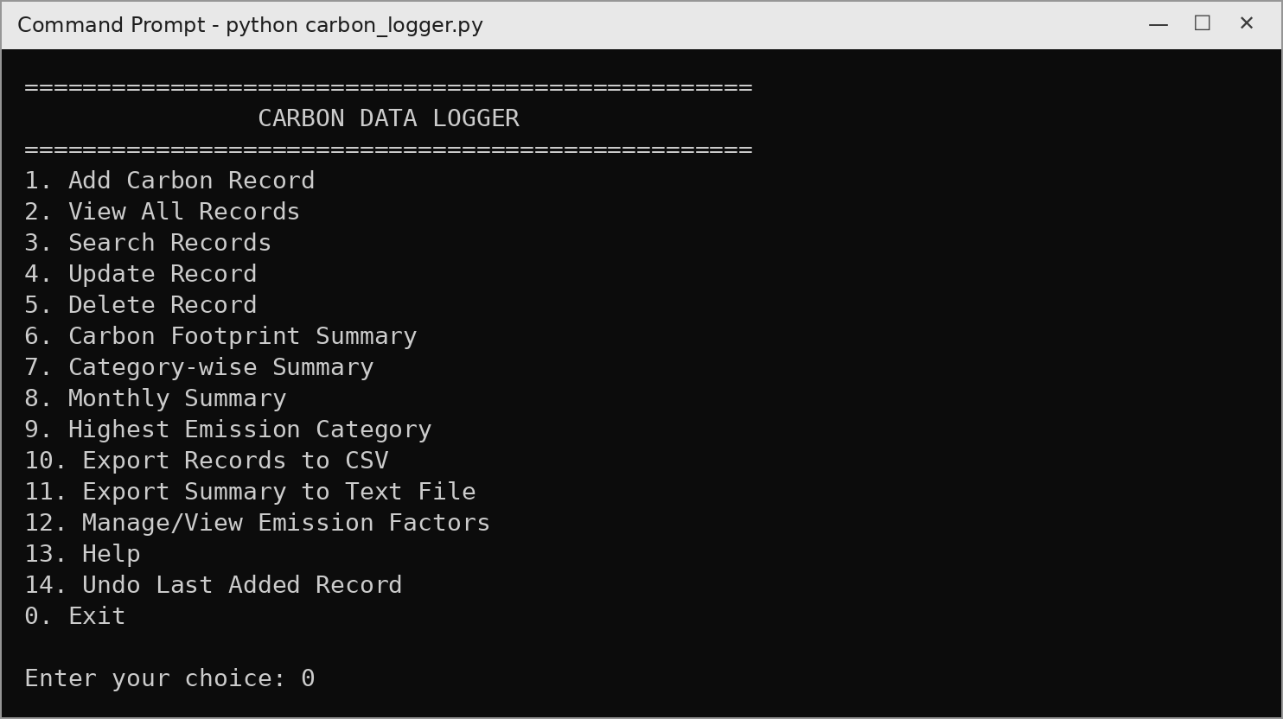
Figure 1: Main menu
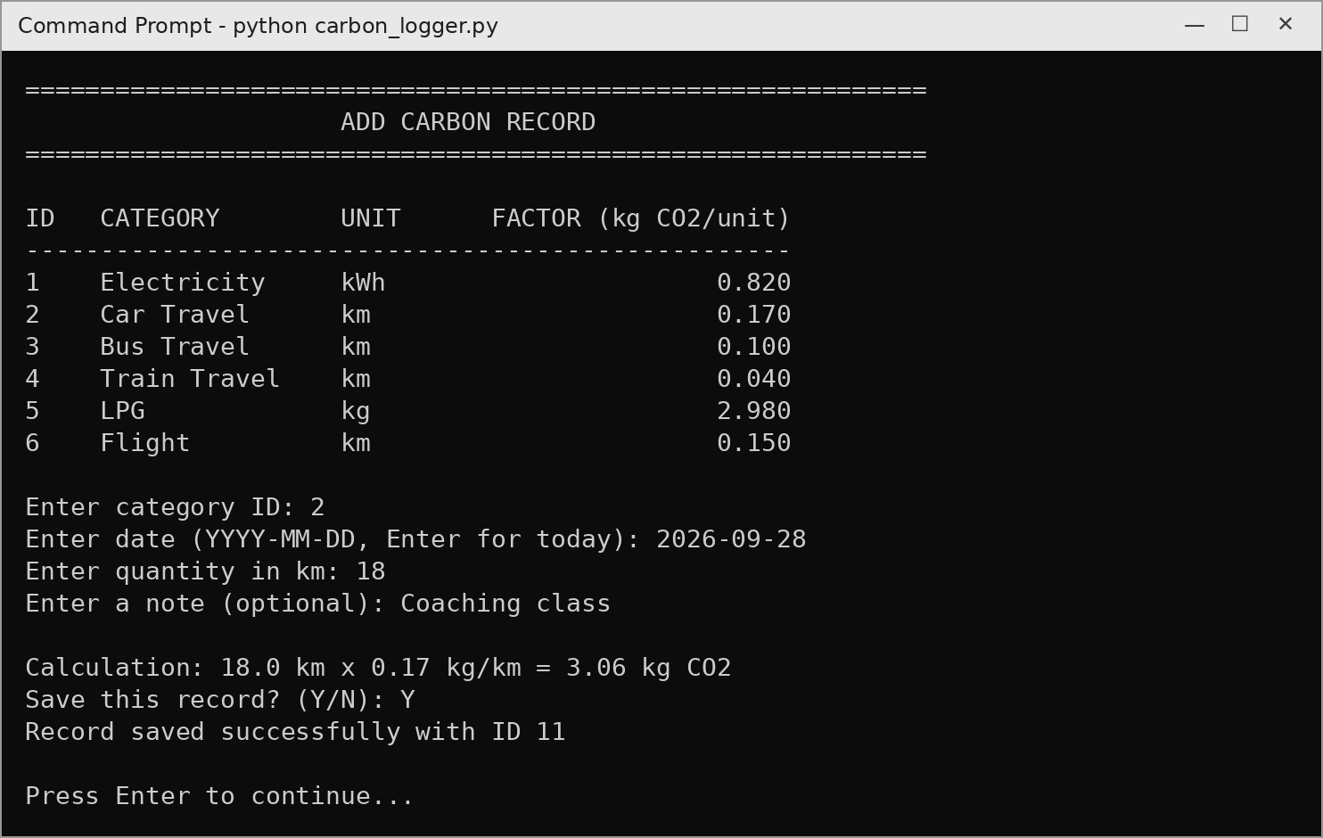
Figure 2: Adding a new record (option 1)
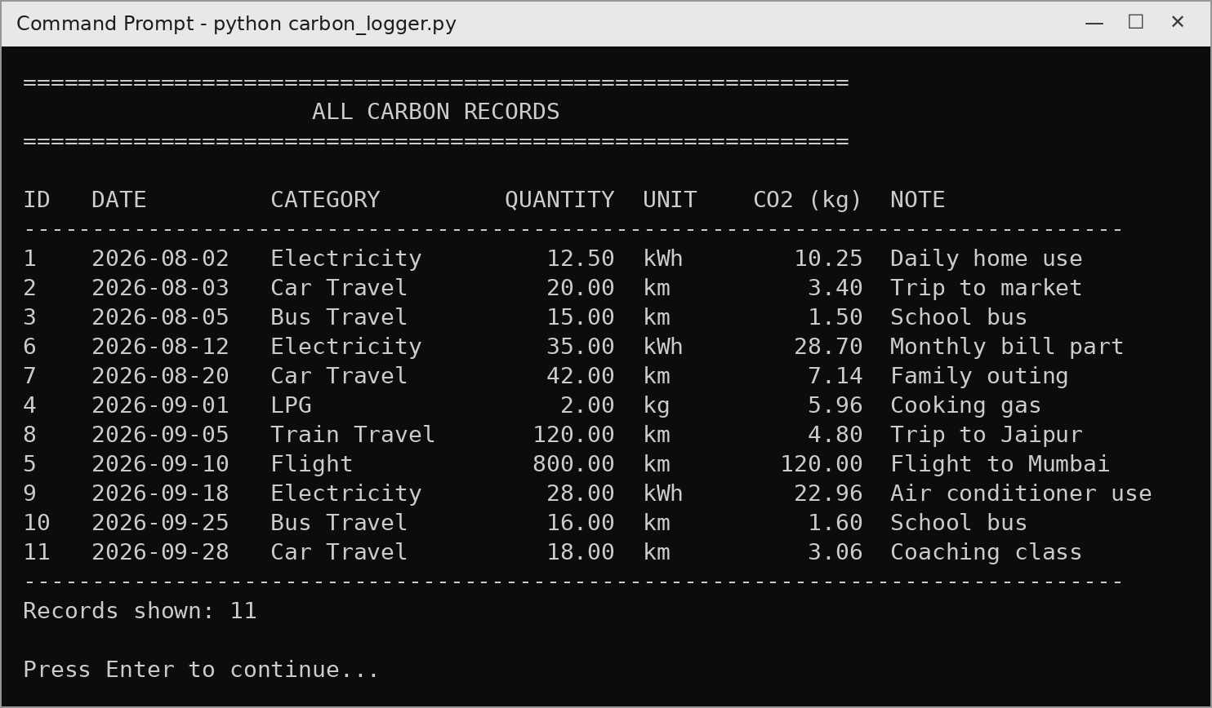
Figure 3: Viewing all records (option 2)
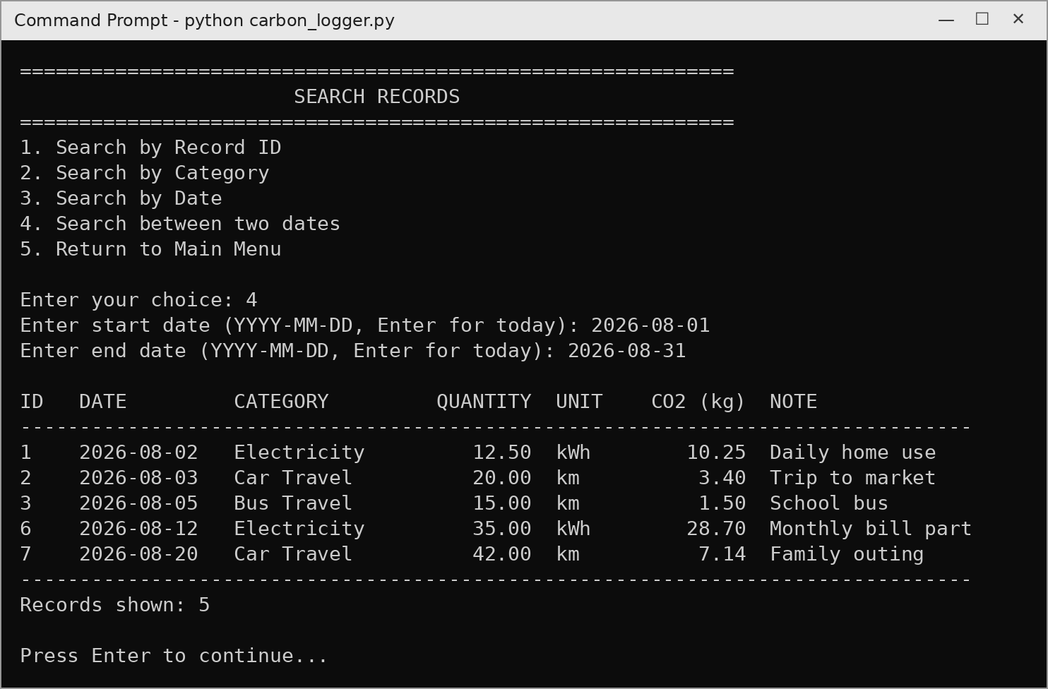
Figure 4: Searching between two dates using BETWEEN (option 3 → 4)
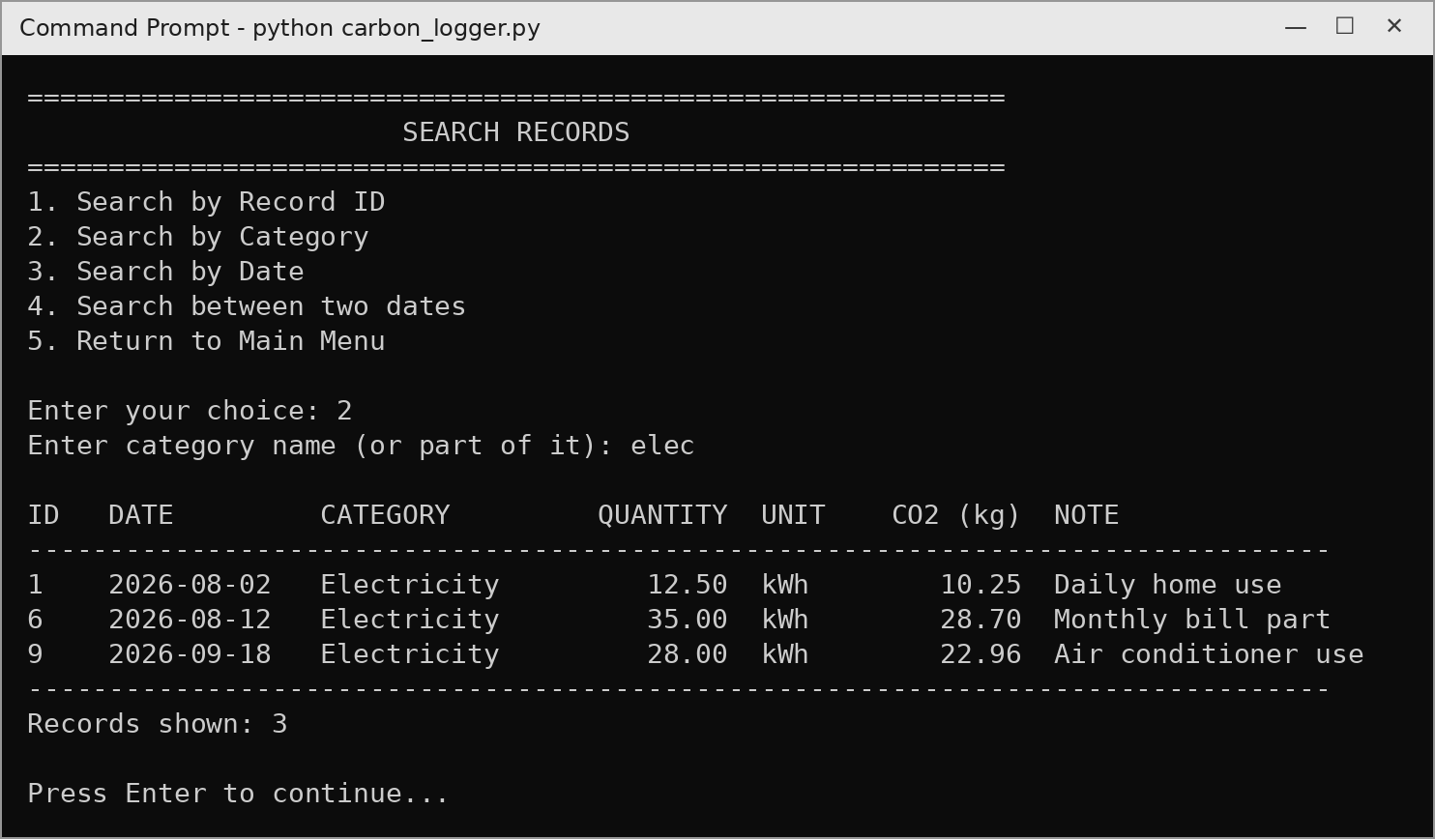
Figure 5: Searching by part of a category name using LIKE (option 3 → 2)
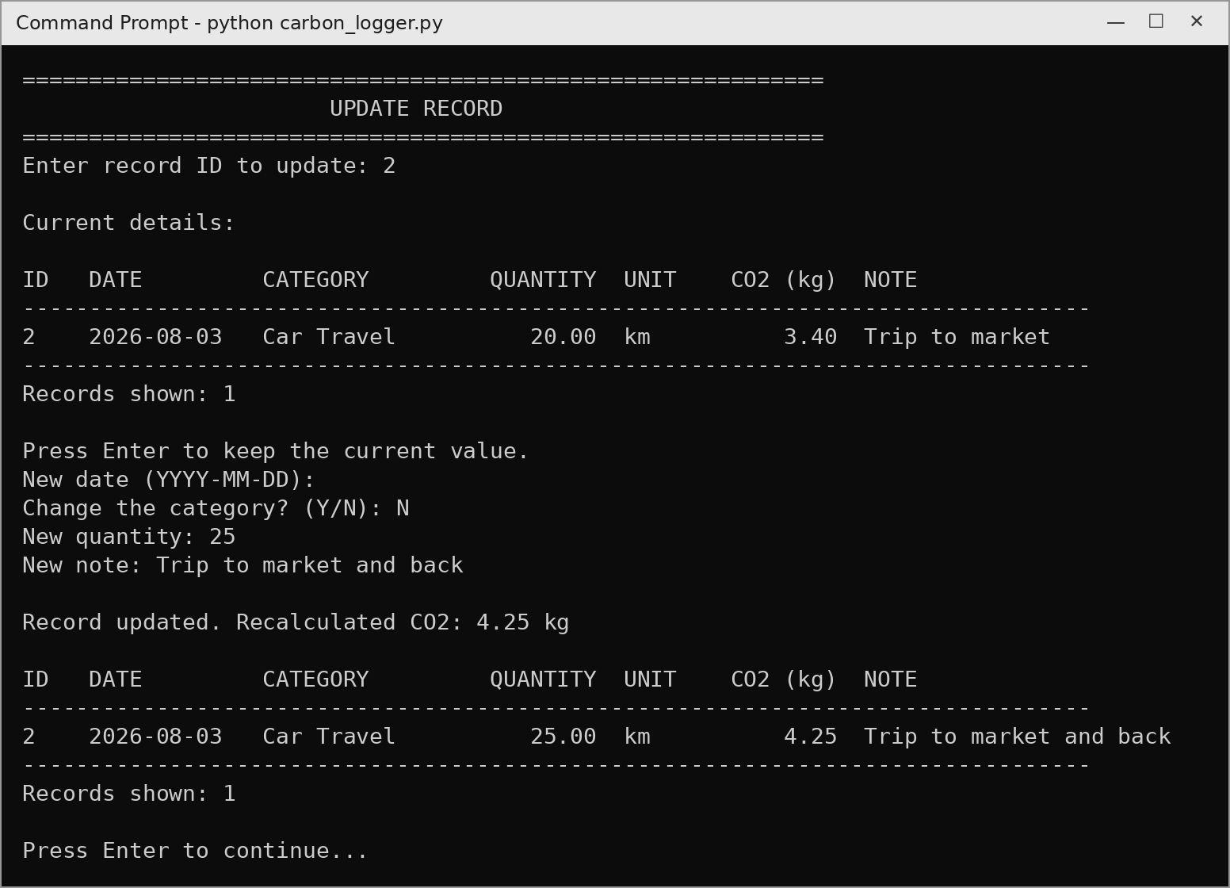
Figure 6: Updating a record; the CO2 value is recalculated (option 4)
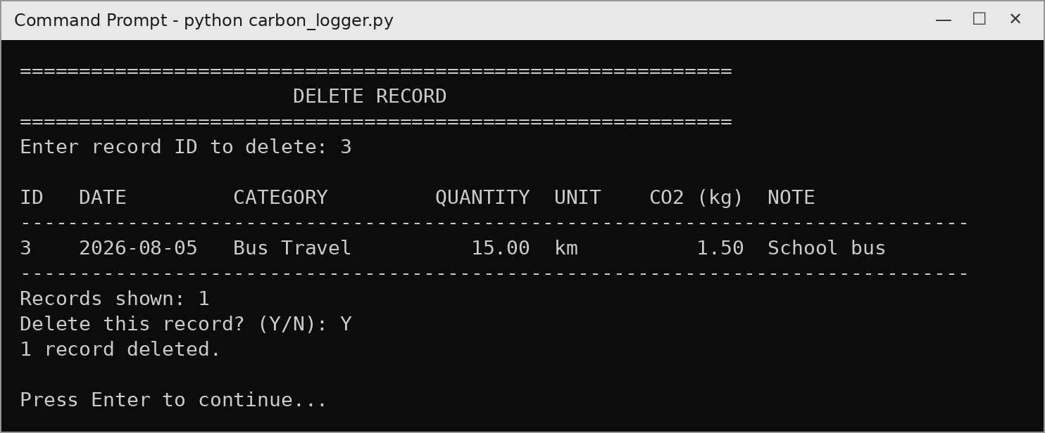
Figure 7: Deleting a record after confirmation (option 5)
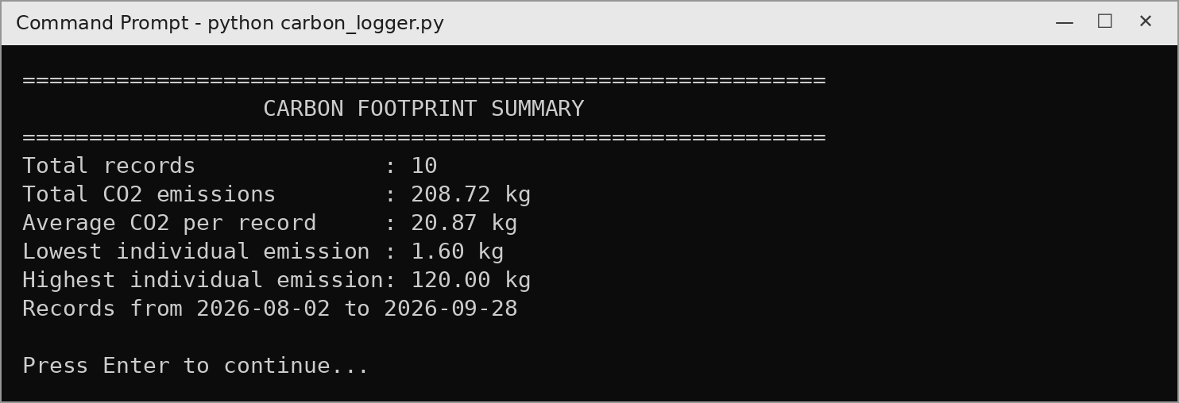
Figure 8: Overall carbon footprint summary (option 6)
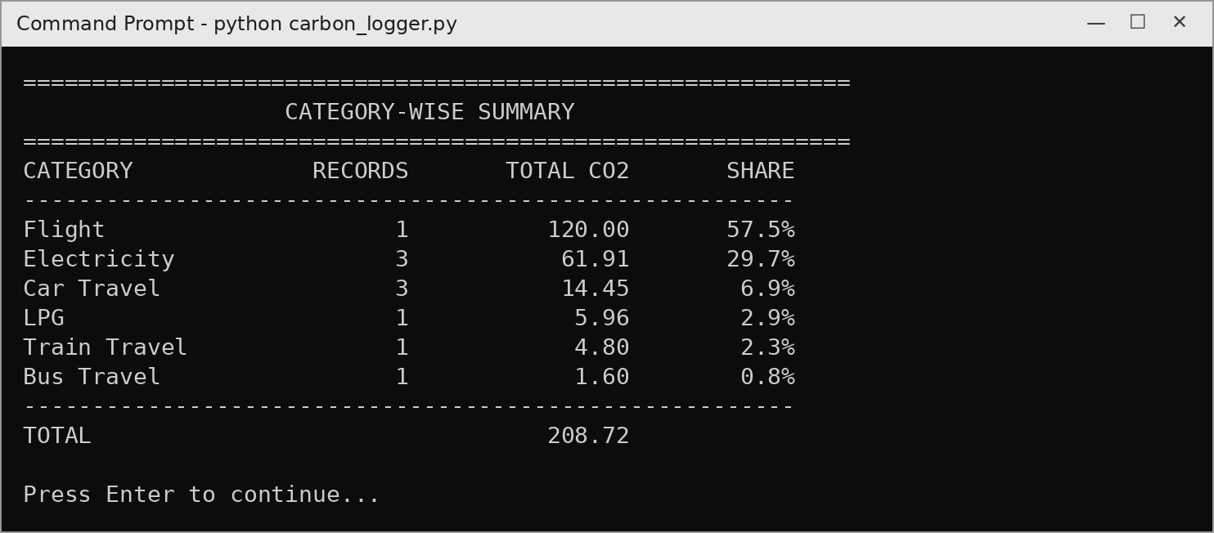
Figure 9: Category-wise summary with percentage share (option 7)
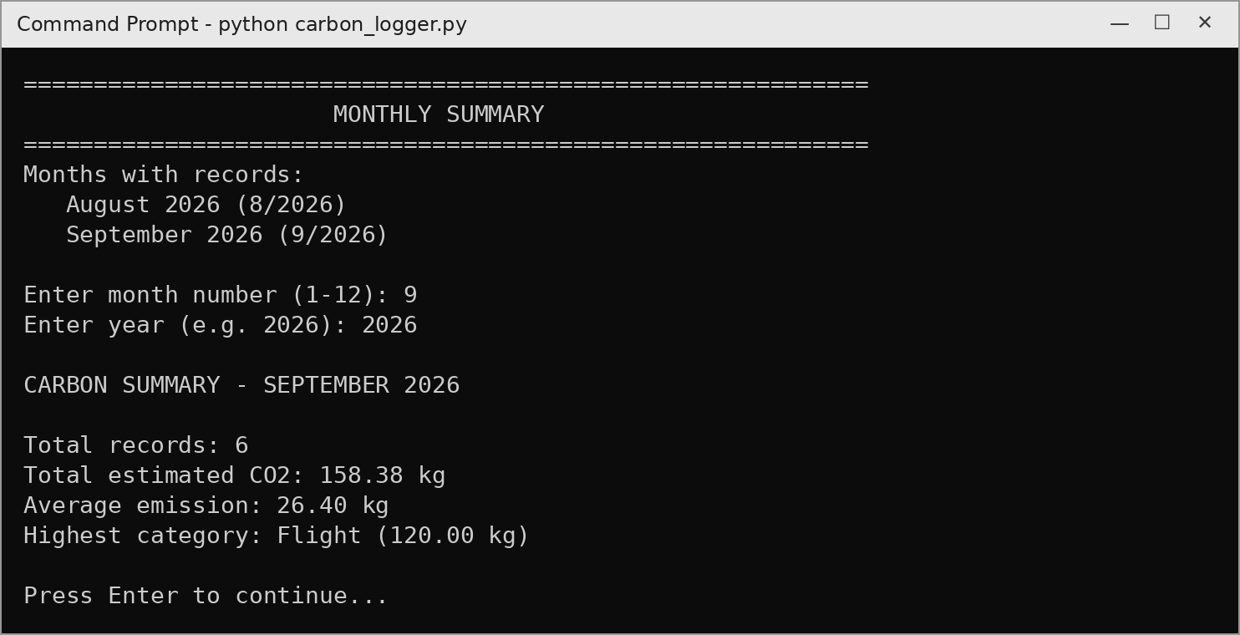
Figure 10: Monthly summary for September 2026 (option 8)
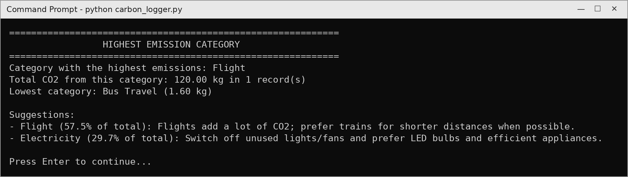
Figure 11: Highest emission category and suggestions (option 9)
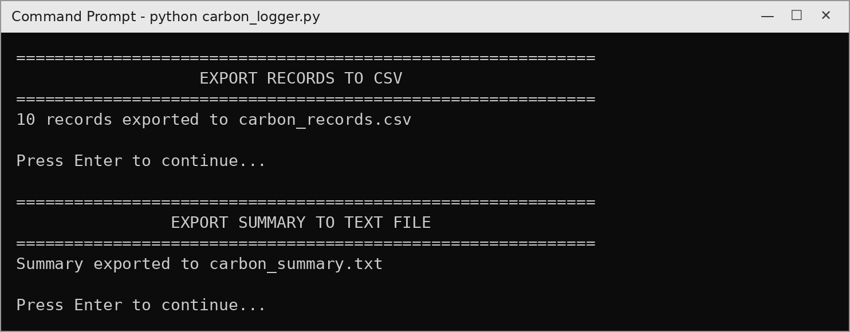
Figure 12: Exporting records to CSV and summary to a text file (options 10 and 11)
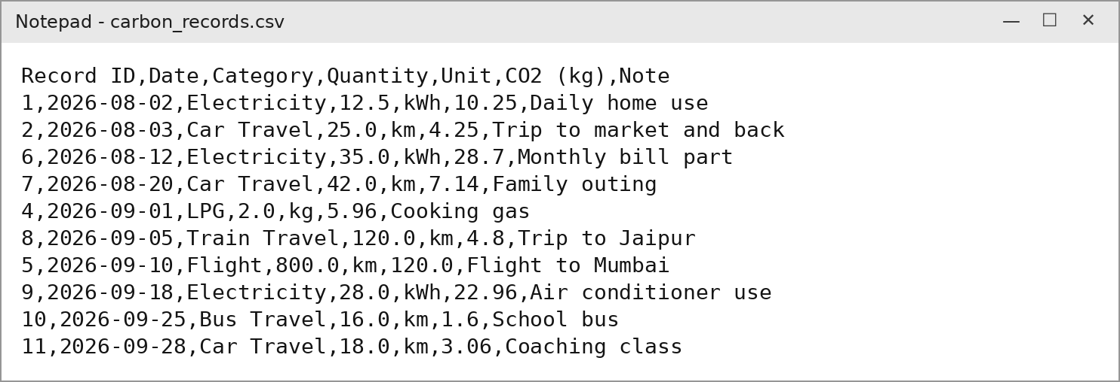
Figure 13: Contents of the exported carbon_records.csv
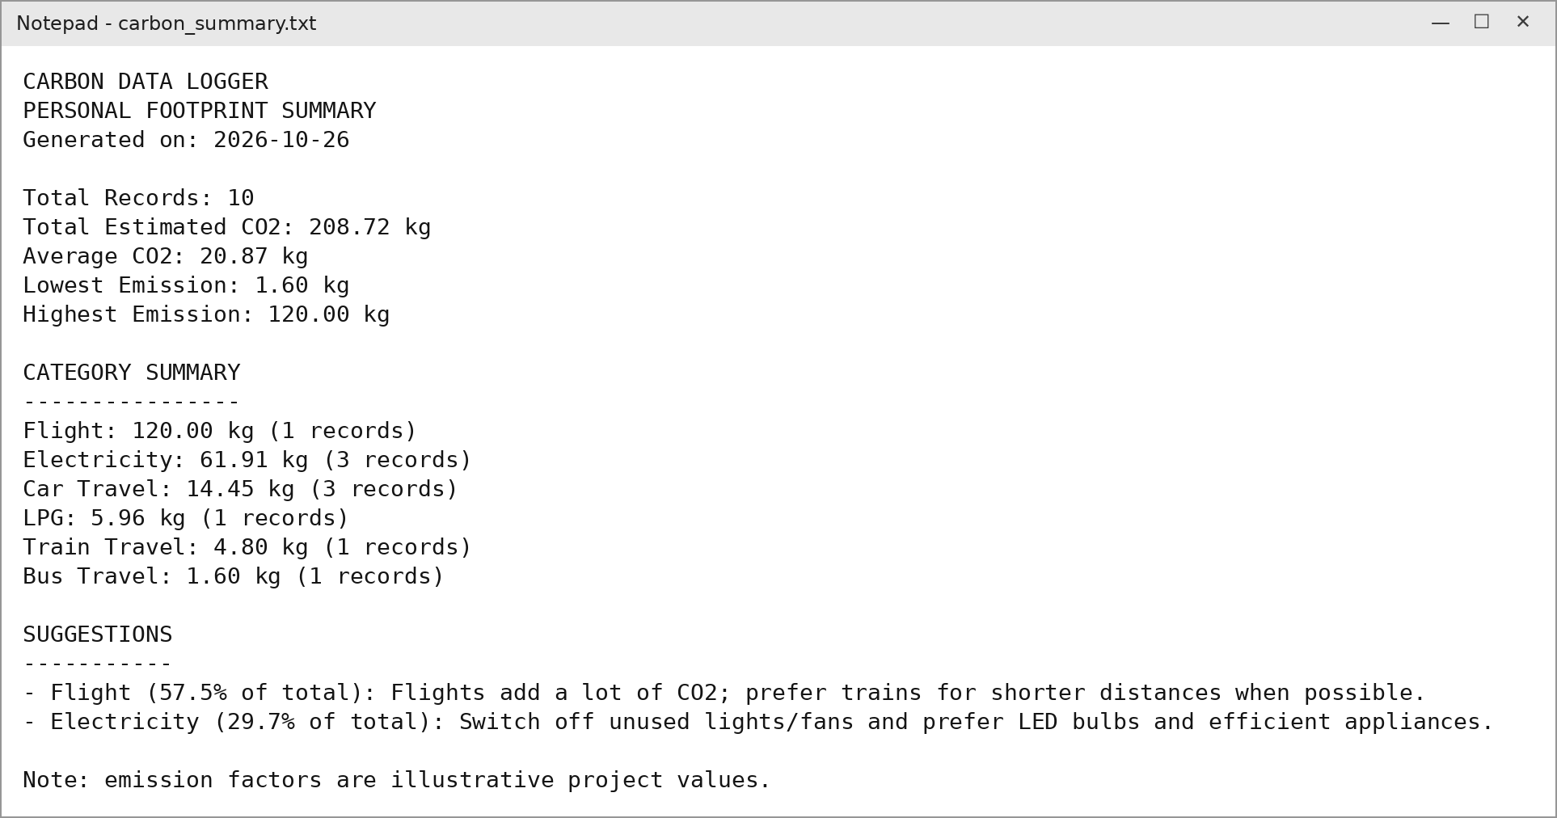
Figure 14: Contents of the exported carbon_summary.txt
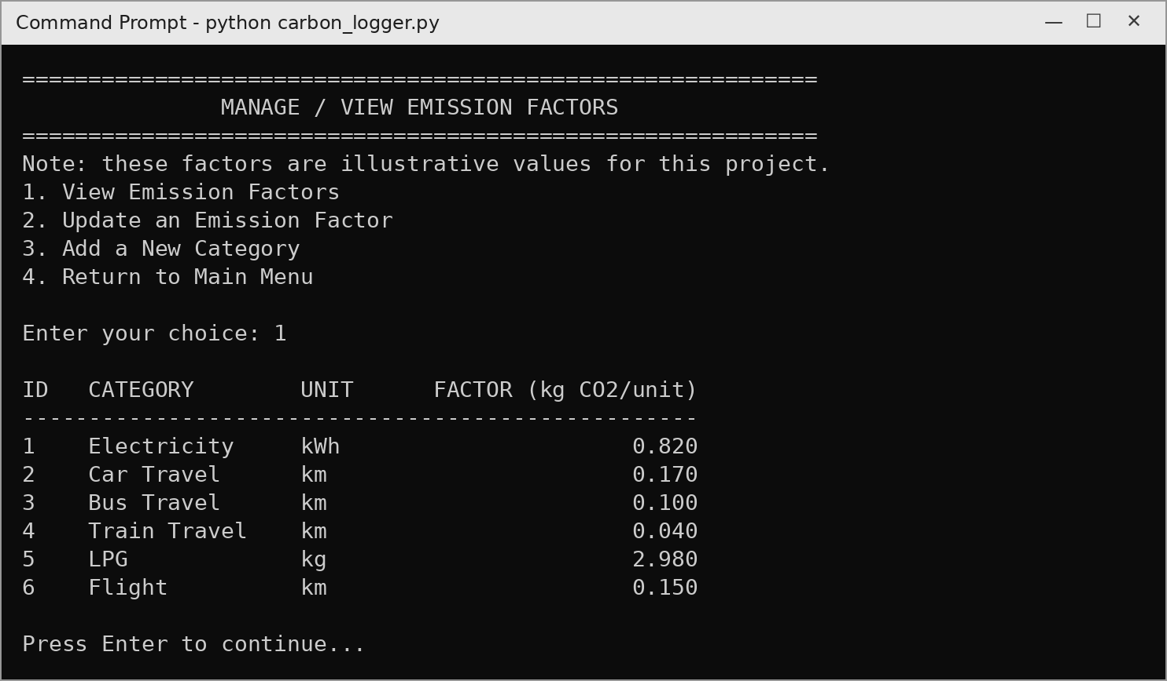
Figure 15: Viewing the emission factors (option 12)
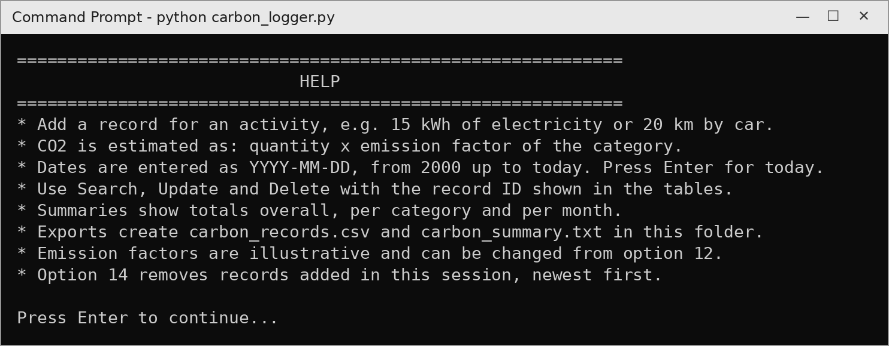
Figure 16: Help screen (option 13)
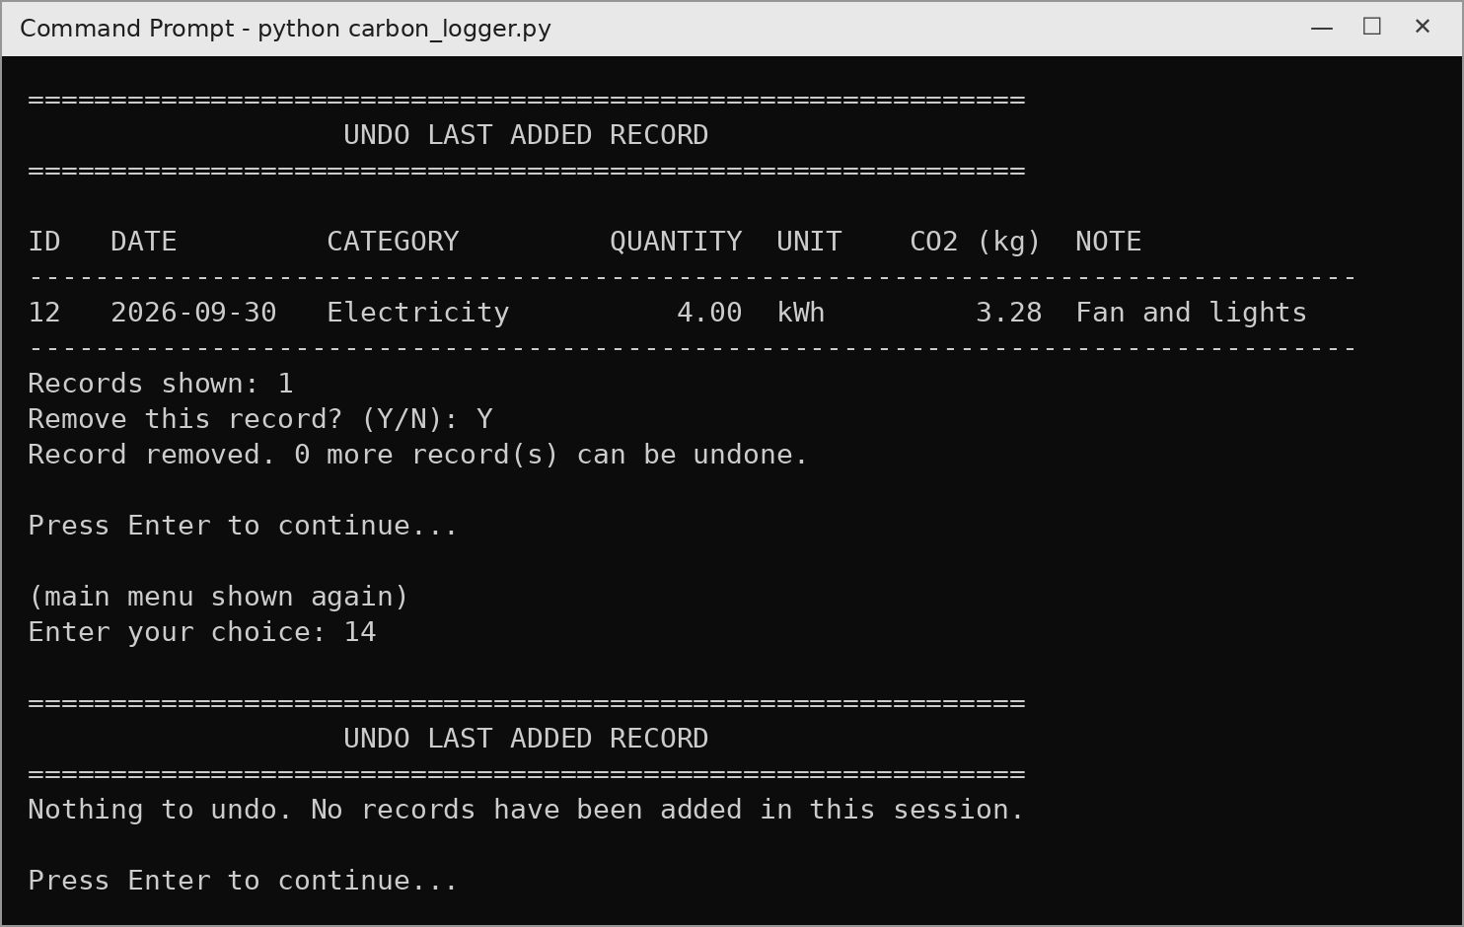
Figure 17: Undo Last Added Record using a stack, and the empty-stack message (option 14)
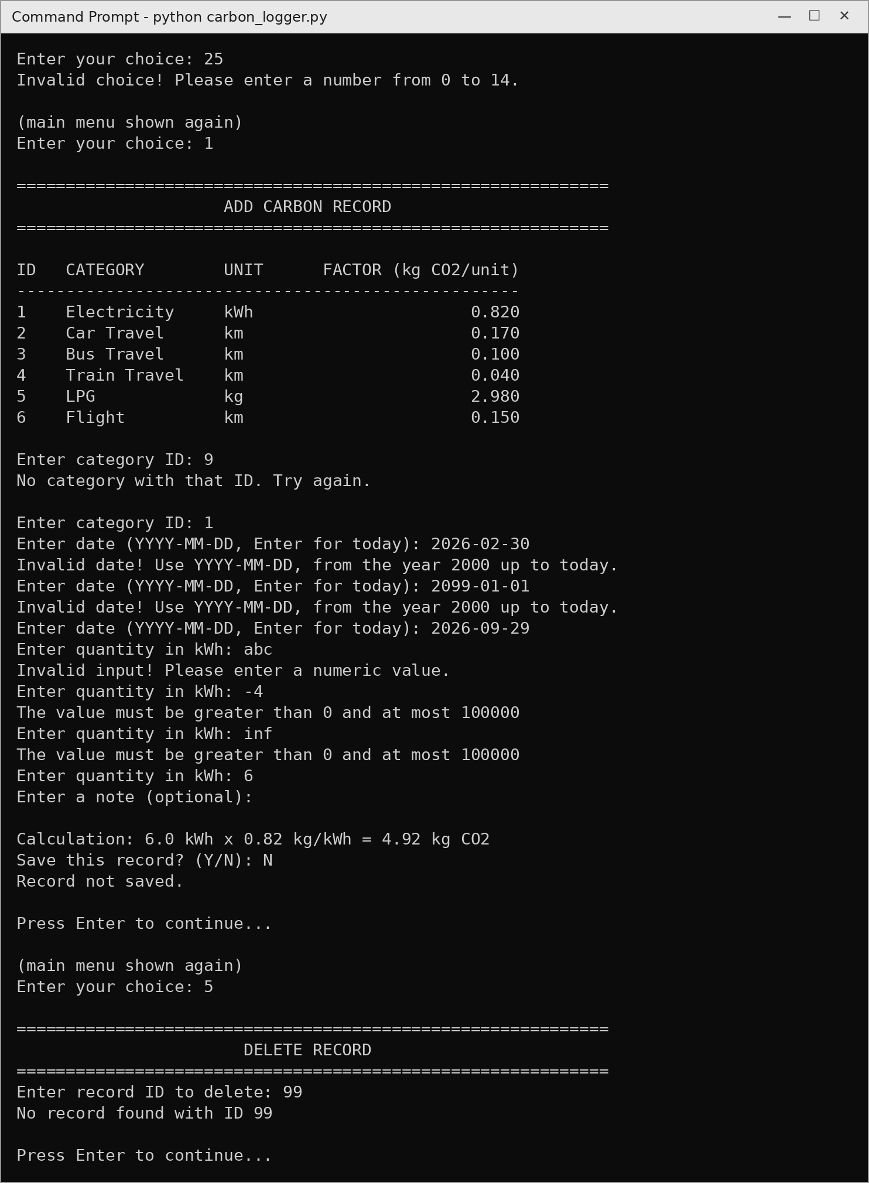
Figure 18: Error handling: invalid menu choice, category ID, date, quantity and record ID

10. Testing
The program was tested with both valid and invalid inputs. All the test cases below gave the expected result.
# | Test | Input | Expected result
1 | Invalid menu choice | 25 | "Invalid choice" message, menu shown again
2 | Invalid category ID | 9 | "No category with that ID", asks again
3 | Impossible date | 2026-02-30 | "Invalid date", asks again
4 | Text as quantity | abc | "Please enter a numeric value", asks again
5 | Negative quantity | -4 | "The value must be greater than 0 and at most 100000"
6 | Correct record | Car Travel, 18 km | 3.06 kg CO2 calculated and saved
7 | Search date range | 2026-08-01 to 2026-08-31 | Only August records shown
8 | Start date after end date | 2026-08-31, 2026-08-01 | Dates swapped, correct records shown
9 | Update quantity | Record 2: 20 → 25 km | CO2 recalculated from 3.40 to 4.25 kg
10 | Delete missing record | ID 99 | "No record found with ID 99"
11 | Cancel delete | N | "Delete cancelled", record kept
12 | Duplicate category | "cng car" after "CNG Car" | "Category already exists"
13 | Very long note | 150 characters | First 100 characters saved
14 | Note with ₹ / Hindi text | ₹500 bill – बिजली | Saved and exported correctly
15 | Wrong MySQL password | – | "Could not connect to MySQL" message
16 | Summaries on empty database | Options 6–9 | "No records available yet"
17 | Ctrl+C at the menu | Ctrl+C | "Program stopped by the user", connection closed
18 | Undo after adding 3 records | Option 14, Y | Newest record removed first (LIFO)
19 | Cancel undo | Option 14, N | "Undo cancelled", record can be undone later
20 | Undo a record already deleted | Delete with option 5, then option 14 | "Record … was already deleted"
21 | Undo with empty stack | Option 14 | "Nothing to undo"
22 | Future date | Tomorrow's date | "Invalid date", asks again
23 | Year before 2000 or typing mistake | 1999-12-31, 0026-09-15 | "Invalid date", asks again
24 | End of input at a prompt | Ctrl+D / Ctrl+Z then Enter | "Program stopped by the user", connection closed
25 | Unusable numbers as quantity | nan, inf, 1e39, 100001 | Rejected with the same message, asks again
26 | Database error inside menu 12 | Factor too large for the column | "Database error" shown, stays in menu 12

11. Limitations and Future Scope

11.1 Limitations
- The emission factors are illustrative and not official values.
- The program is meant for a single user and has no login system.
- It works in the terminal only and has no graphical interface.
- Changing an emission factor does not recalculate old records; each record keeps the estimate made when it was saved.
- Undo works only for records added since the program was started, because the stack is kept in memory.
- Quantities and emission factors are limited to 100000.
- On servers older than MySQL 8, notes can contain English letters only.

11.2 Future scope
- Use official emission factors, for example from the Central Electricity Authority for electricity.
- Show monthly emissions as graphs.
- Let the user set a monthly CO2 target and warn when it is crossed.
- Support several users, each with their own records.
- Build a graphical or mobile interface for easier use.

12. Bibliography
- Computer Science – Textbook for Class XII, NCERT, New Delhi.
- Computer Science Curriculum (Code 083), Class XII, Session 2026–27, Central Board of Secondary Education.
- Sumita Arora, Computer Science with Python – Class XII, Dhanpat Rai & Co.
- Python 3 Documentation – https://docs.python.org/3/
- MySQL 8.0 Reference Manual – https://dev.mysql.com/doc/refman/8.0/en/
- MySQL Connector/Python Developer Guide – https://dev.mysql.com/doc/connector-python/en/

