

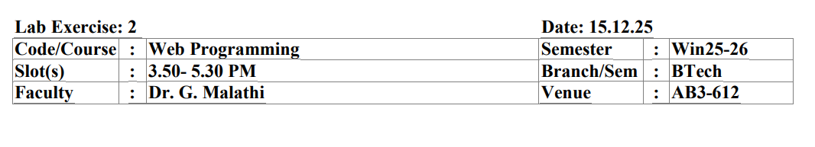

1.To the above given form, include
1. Telephone number with validation
2. Country the customer belongs to by allowing him/her to choose from the select
3. Header
4. Footer that has your mail id
5. Make use of section to include the profile photo
6. Should allow the customer to select age using range
7. Use progressbar, meter in appropriate places
8. Submit button Note: You can decorate the forms as you wish

Code:-
<html>
<head>
<title>HTML Forms Example</title>
</head>

<body>

<!-- Header -->
<h2 align="center">Customer Information Form</h2>

<form>

<table border="1" cellpadding="5" cellspacing="0" align="center">
<tr>
<th style="background-color: rgb(228, 184, 255);">Name</th>
<th style="background-color:rgb(228, 184, 255) ;"> Value</th>
</tr>
<tr>
<th >Name</th>
<td><input type="text" name="name"></td>
</tr>

<tr>
<th>Sex</th>
<td>
<input type="radio" name="sex"> Male
<input type="radio" name="sex"> Female
</td>
</tr>

<tr>
<th>Eye Color</th>
<td>
<select>
<option>Green</option>
<option>Blue</option>
<option>Brown</option>
<option>Black</option>
</select>
</td>
</tr>

<tr>
<th>Check all that apply</th>
<td>
<input type="checkbox"> Over 6 feet tall <br>
<input type="checkbox"> Over 200 pounds
</td>
</tr>

<tr>
<th>Describe your athletic ability</th>
<td>
<textarea rows="5" cols="30"></textarea>
</td>
</tr>

<!-- Telephone with validation -->
<tr>
<th>Telephone Number</th>
<td>
<input type="tel" pattern="[0-9]{10}" placeholder="10-digit number">
</td>
</tr>

<!-- Country -->
<tr>
<th>Country</th>
<td>
<select>
<option>India</option>
<option>USA</option>
<option>UK</option>
<option>Australia</option>
</select>
</td>
</tr>

<!-- Profile Photo -->
<tr>
<th>Profile Photo</th>
<td>
<input type="file" accept="image/*">
</td>
</tr>

<!-- Age using range -->
<tr>
<th>Age</th>
<td>
<input type="range" min="1" max="100">
</td>
</tr>

<!-- Progress bar -->
<tr>
<th>Form Completion</th>
<td>
<progress value="60" max="100"></progress>
</td>
</tr>

<!-- Meter -->
<tr>
<th>Fitness Level</th>
<td>
<meter value="0.7"></meter>
</td>
</tr>

<!-- Submit -->
<tr>
<td colspan="2" align="center">
<input type="submit" value="Enter my information">
</td>
</tr>

</table>

</form>

<!-- Footer -->
<footer align="center">
<p>Email: example@gmail.com</p>
</footer>

</body>
</html>

Output:-
