Cross-technology mouse-brain representation comparison
  - Matched evaluation of STEP and NicheCompass
Table of contents

1. Objective
This analysis evaluates joint representation-level alignment across MERFISH and STARmap PLUS for STEP and the published NicheCompass model. It tests preservation of coarse anatomical domains together with reduction of technology-associated separation. It does not compare cross-technology microarchitectures, because microarchitecture construction additionally depends on platform-specific spatial resolution, node definition, and physical graph construction.

2. Data and matched design
The published NicheCompass reference contains 9,471,568 cells measured over the same 432 genes: 8,380,288 MERFISH cells from 239 sections and 1,091,280 STARmap PLUS cells from 20 sections. STEP was trained on these exact cells, genes, section labels, and coordinates. Each section retained an independent spatial graph with ten non-self nearest neighbors. The STEP decoder used two hidden linear layers, with each hidden linear output modulated once by the learned batch representation through BatchAwareScale.
The comparison aligned STEP and NicheCompass by unchanged observation identifier. Public source-atlas annotations were joined only as evaluation metadata and were not used for training. Domain evaluation used 1,987,678 annotated cells from 50 MERFISH and 20 STARmap PLUS sections. MERFISH cells were assigned to coarse Allen CCFv3 major regions through their published three-dimensional CCF coordinates. STARmap PLUS cells used the published Main_molecular_tissue_region labels. A shared analysis retained five anatomical regions that could be harmonized without interpreting composite region labels. Evaluation samples were balanced at no more than 2,000 cells per domain and technology.

3. Evaluation
Anatomical structure was evaluated by domain ASW, ARI, NMI, and 90-nearest-neighbor domain purity. Technology or section mixing was evaluated with domain-conditioned batch ASW and scaled iLISI. All reported scores are oriented so that higher values are better.

4. Results
Evaluation | Method | Domain ASW | Domain ARI | Domain NMI | kNN domain purity | Batch ASW | Batch iLISI
MERFISH anatomical regions | STEP | 0.510 | 0.374 | 0.465 | 0.709 | 0.841 | 0.093
MERFISH anatomical regions | NicheCompass | 0.518 | 0.269 | 0.411 | 0.707 | 0.893 | 0.069
STARmap PLUS tissue regions | STEP | 0.556 | 0.442 | 0.624 | 0.764 | 0.877 | 0.119
STARmap PLUS tissue regions | NicheCompass | 0.540 | 0.516 | 0.680 | 0.751 | 0.932 | 0.092
Shared anatomical regions | STEP | 0.586 | 0.511 | 0.510 | 0.844 | 0.718 | 0.023
Shared anatomical regions | NicheCompass | 0.543 | 0.381 | 0.397 | 0.845 | 0.804 | 0.030
STEP recovered MERFISH anatomical regions with higher ARI and NMI and comparable local purity. On STARmap PLUS, STEP had higher domain ASW and local purity, while NicheCompass had higher ARI and NMI. Across five shared anatomical regions, STEP had higher domain ASW, ARI, and NMI, with nearly identical local purity. Technology iLISI remained low for both graph-aggregated representations, showing that substantial MERFISH-STARmap PLUS separation remained at the anatomical-domain level.
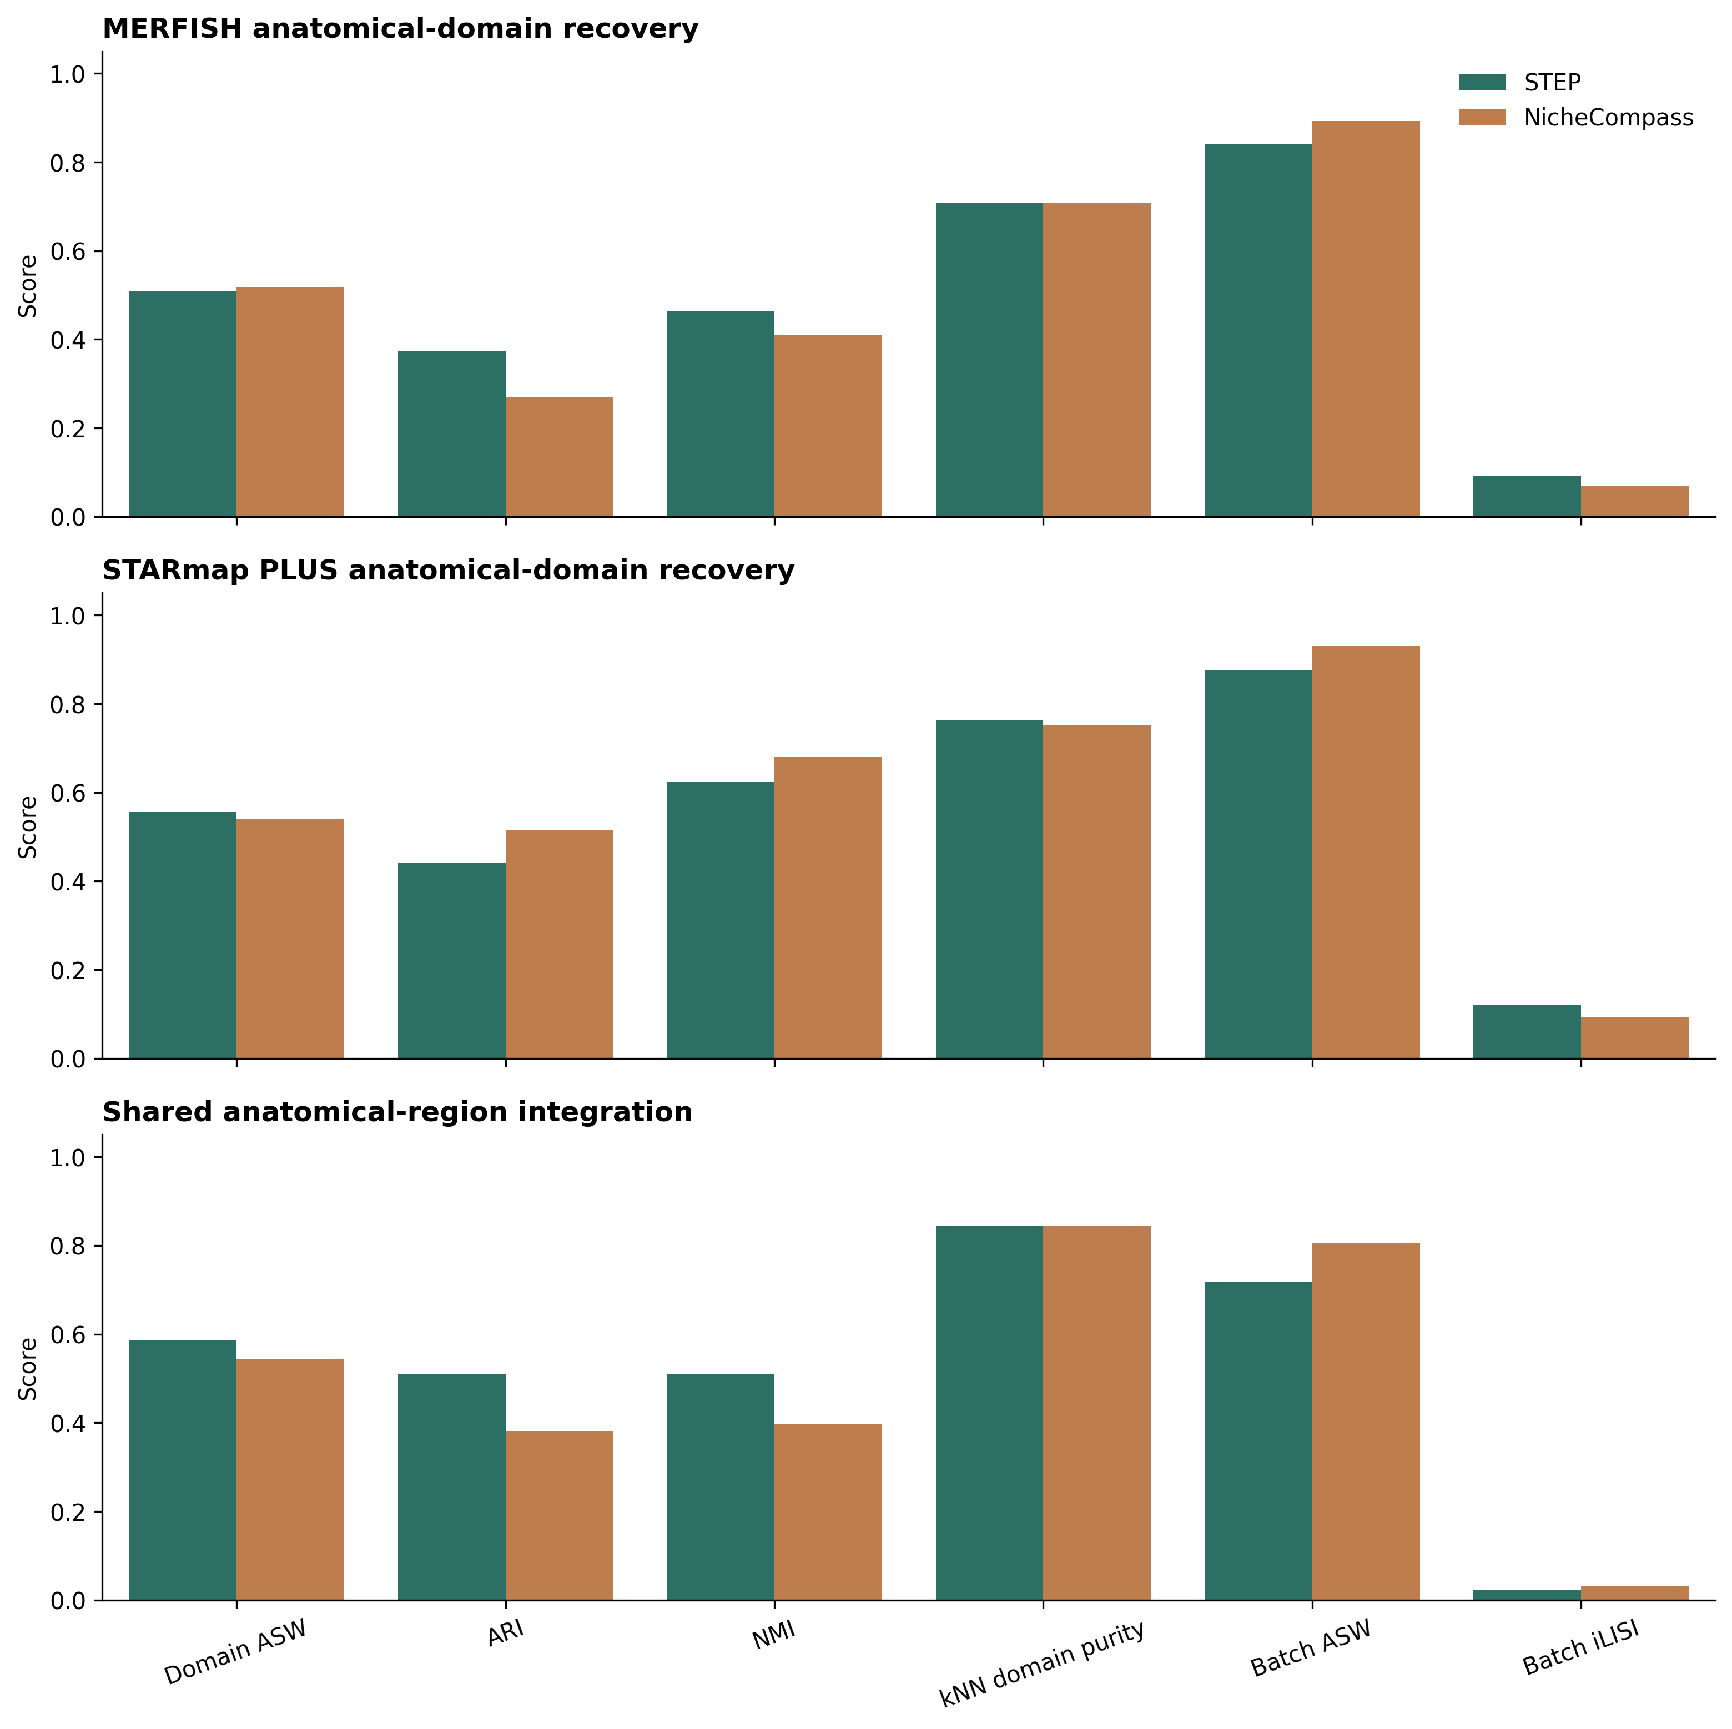
Matched anatomical-domain comparison. The first two panels evaluate domain recovery within MERFISH and STARmap PLUS using their public source-atlas region annotations. The third panel evaluates five unambiguously harmonized coarse anatomical regions across technologies.

5. Reproducibility
The complete workflow is stored under scripts/cross_platform_mouse_brain in the STEP-analysis repository. It includes preparation of the exact matched input, STEP training, Allen CCFv3 coordinate mapping, source-atlas domain annotation, observation-level alignment, metric calculation, and figure generation.

