|  |  |
| --- | --- |
| **Name:** | Lucy |
| **Age:** | 7 |
| **Species:** | Bird - Parrot |
| **Size:** | Medium - Large |
| **Colour:** | Blue |
| **Personality:** | Shy and intelligent |
| **Description:** | Lucy is a shy and quite for a parrot. She was abused in a testing facility from when she was a chick but after many therapy and training sessions has come a long way. She has to take a lot of getting to know someone before putting her trust into them. Although shy, she is very intelligent and can even speak certain French phrases. |

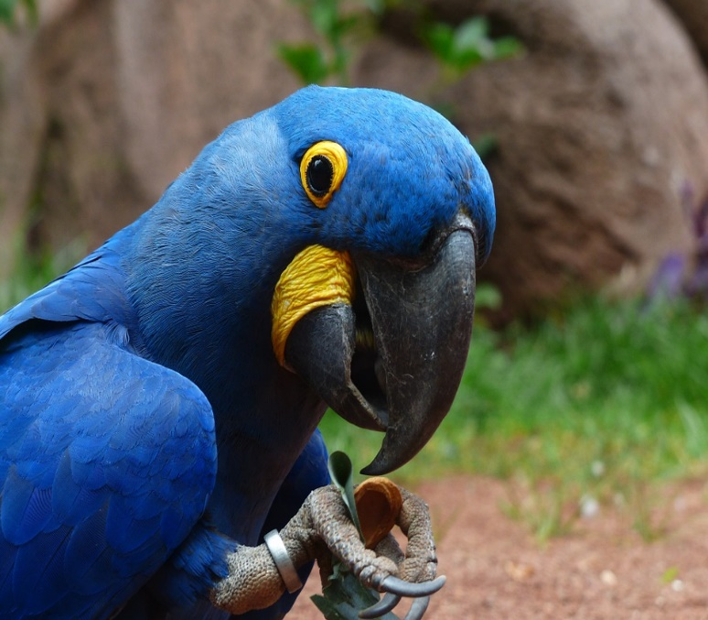

|  |  |
| --- | --- |
| **Name:** | Poppy |
| **Age:** | 2 |
| **Species:** | Dog - Poodle |
| **Size:** | Small - Medium |
| **Colour:** | White |
| **Personality:** | Bubbly and Happy |
| **Description:** | Poppy is a happy and energetic dog. Full of personality, she is always on the go. If something does not go her way, she will sit and sulk for the rest of the day. She is always the first dog demanding to get fed each morning and prioritises herself. Although she is stroppy she is very loyal and intelligent and is always up for a cuddle or two. |

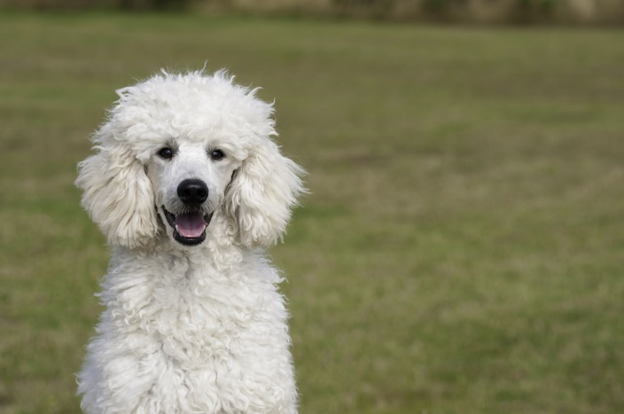

|  |  |
| --- | --- |
| **Name:** | Jones |
| **Age:** | 6 months |
| **Species:** | Guinea Pig |
| **Size:** | Tiny - Small |
| **Colour:** | White and Tan |
| **Personality:** | Nervous and Gentle |
| **Description:** | Jones is a young guinea pig that was found on the side of the road along with three others that have already been sold. He is a very wriggly and soft Guinea Pig and loves attention. He does get nervous around new people because of their unfamiliar scent, but only takes a few minutes, and he is all over you, literally! |

|  |  |
| --- | --- |
| **Name:** | Kirsten |
| **Age:** | 5 |
| **Species:** | Cat – Domestic Short Haired Cat |
| **Size:** | Medium |
| **Colour:** | Tan and Black |
| **Personality:** | Lazy and Mischievous |
| **Description:** | Kirsten is a very lazy cat that does nothing but lunge around and eat. A puurfect companion for an elderly or great first new pet. She loves getting her tummy rubbed or her fur brushed. .She will often climb onto your lap and fall asleep. |

