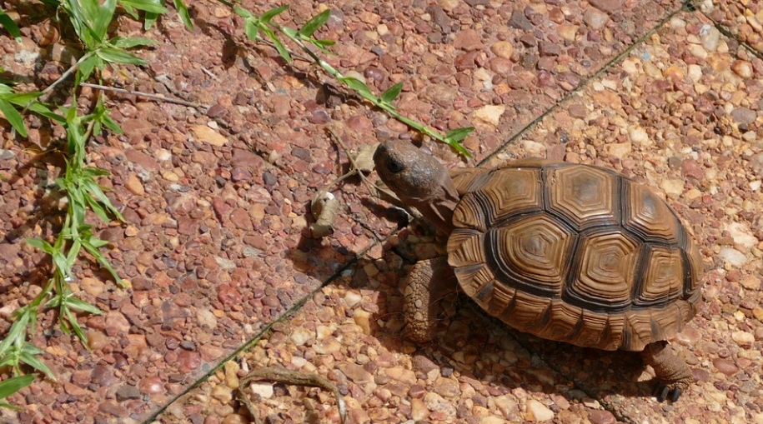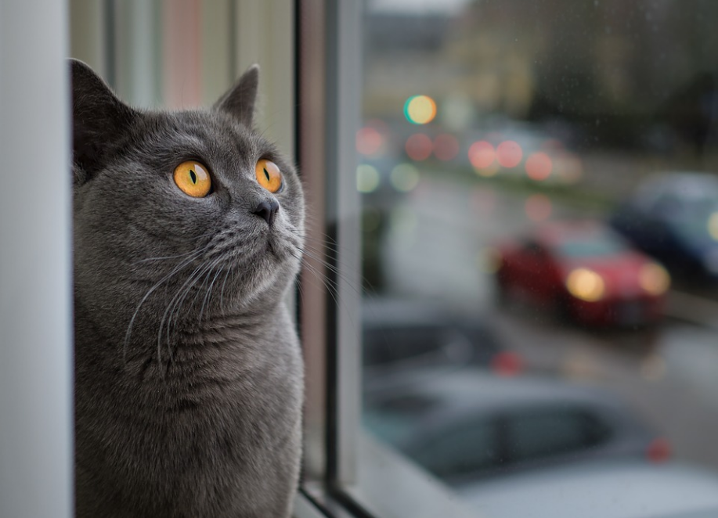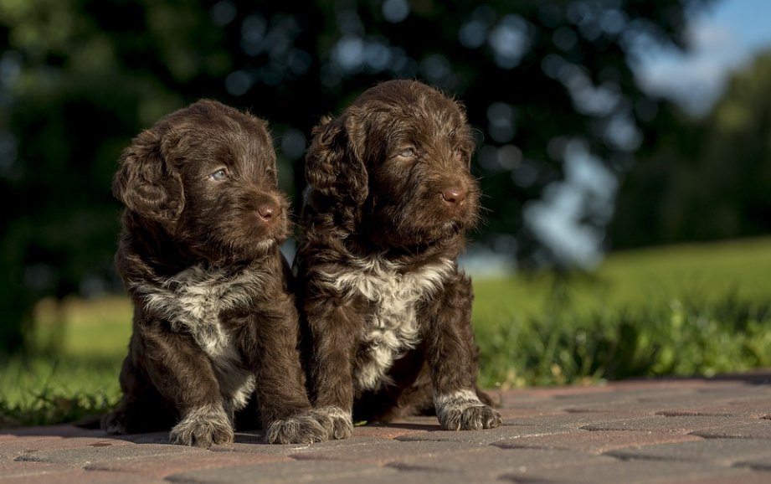

**Names:** Doris

**Age:** 2 months

**Species:** Turtle

**Size:** Small – but will continue to grow

**Colour:** Chocolate Brown

**Personality:** Care free and playful

**Description:** Tilly & Max are the perfect puppies for families. They are young, fun and love playing around with kids. They have both taken a liking to squeaky toys.

**Name:** Harry

**Age:** 1 year

**Species:** Cat

**Size:** Medium size

**Colour:** Grey

**Personality:** Casual and easy

**Description:** Harry is a very easy pet to have. He doesn’t demand any more than the necessities all animals need. Harry will sleep anywhere and eat any type of food. He is great with all ages, from kids to the elderly.

**Names:** Tilly & Max

**Age:** 6 months

**Species:** Dog

**Size:** Small – but will grow to a medium size

**Colour:** Chocolate Brown

**Personality:** Care free and playful

**Description:** Tilly & Max are the perfect puppies for families. They are young, fun and love playing around with kids. They have both taken a liking to squeaky toys.