|  |  |
| --- | --- |
| Name: | Emily |
| Job: | Veterinary Services Manager |
| Comment: | Emily is a confident leader which helps her excel at her management role. She is a great communicator and enjoys getting to work with veterinary students to improve the shelter and wellbeing of animals. |

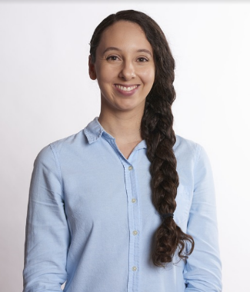



|  |  |
| --- | --- |
| Name: | Craig |
| Job: | Call Centre Manager |
| Comment: | Craig has been at the shelter for 4 years. His role requires him to manage people working at the call centre and deals with any issues that come from these calls. His favourite part about his job is being able to solve problems and communicate with people on a day to day basis. |

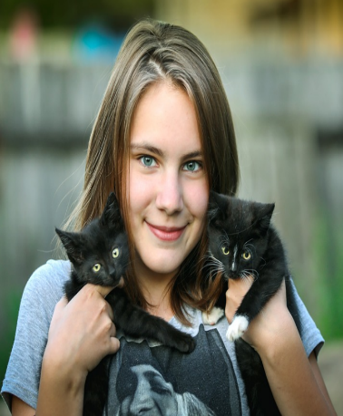

|  |  |
| --- | --- |
| Name: | Sophie |
| Job: | Volunteer |
| Comment: | Sophie is the youngest volunteer at the PAWS shelter. With dreams of becoming a vet in the future Sophie takes in everything she is taught. She enjoys walking the dogs, playing with all the animals, and loves to see the animals going to a good home. She is enthusiastic and committed to her work. |

|  |  |
| --- | --- |
| Name: | Karen |
| Job: | Veterinary Nurse |
| Comment: | Karen has been working as a veterinary nurse at PAWS for 5 years. She is passionate about helping animals and always puts 100% into her work. She loves seeing an animal recover to full health and to see the joy these animals bring to people. |

