EXPERIMENT-11
IP Spoofing Using GitHub Tool in Kali Linux
Step 1: Start Environment
Open Oracle VirtualBox and start Kali Linux.

Step 2: Prepare Tool
Download or clone an IP spoofing tool from GitHub and install required dependencies.

Step 3: Configure Parameters
Set the target IP address, spoofed source IP, and network interface in the tool.

Step 4: Execute Tool
Run the tool to send packets with a forged source IP address.

Step 5: Monitor Traffic
Observe the network traffic using monitoring tools to verify spoofed packets.

Output
Packets are transmitted with modified (spoofed) source IP addresses and reflected in network traffic.

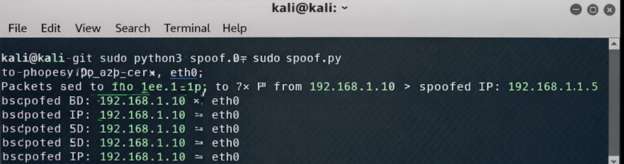
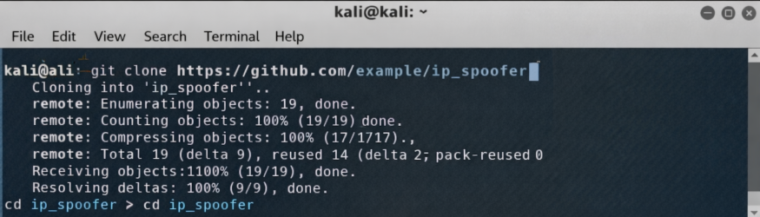

Result
IP spoofing was successfully demonstrated, showing how packet headers can be manipulated and emphasizing the need for strong network security measures.

