EXPERIMENT - 12
Camera Phishing Study in Kali Linux
Step 1: Start Environment
Open Oracle VirtualBox and start Kali Linux.

Step 2: Study Tool
Refer to an open-source repository on GitHub and understand how camera phishing works.

Step 3: Analyze Workflow
Study how fake permission prompts are created and how users are tricked into granting camera access.

Step 4: Simulated Demonstration
Perform a consent-based simulation and observe camera permission requests and user responses.

Step 5: Identify Risks and Prevention
Understand risks like privacy leakage and learn prevention methods such as permission control and user awareness.

Output
Understanding of camera phishing techniques and associated privacy risks.

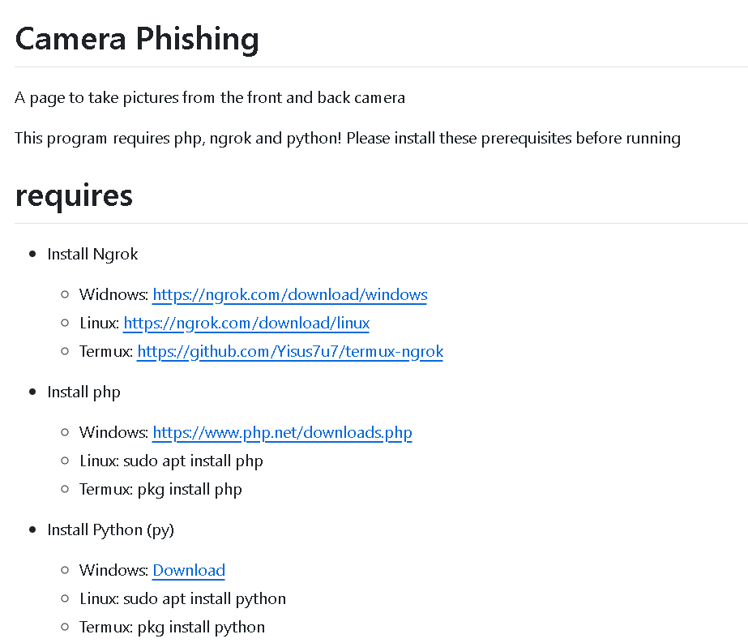

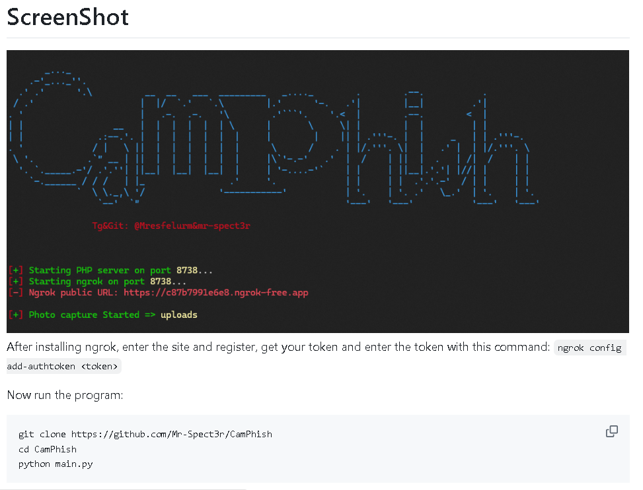

Result
Camera phishing concepts were successfully studied, highlighting the importance of user awareness and secure permission handling.

