EXPERIMENT - 14
Brute Force Attack Study in Kali Linux
Step 1: Start Environment
Open Oracle VirtualBox and start Kali Linux.

Step 2: Setup Test Environment
Use a local test account with dummy credentials in an isolated environment.

Step 3: Study Attack Concept
Understand how repeated login attempts are used to guess passwords.

Step 4: Simulated Demonstration
Observe multiple authentication attempts and system responses in a controlled setup.

Step 5: Analyze Risks and Prevention
Identify risks of weak passwords and study prevention methods like strong passwords, account lockout, and multi-factor authentication.

Output
Simulated login attempts demonstrate how weak passwords can be guessed.

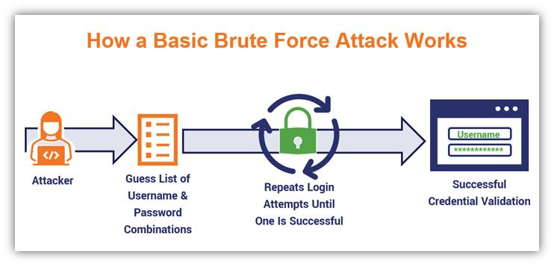
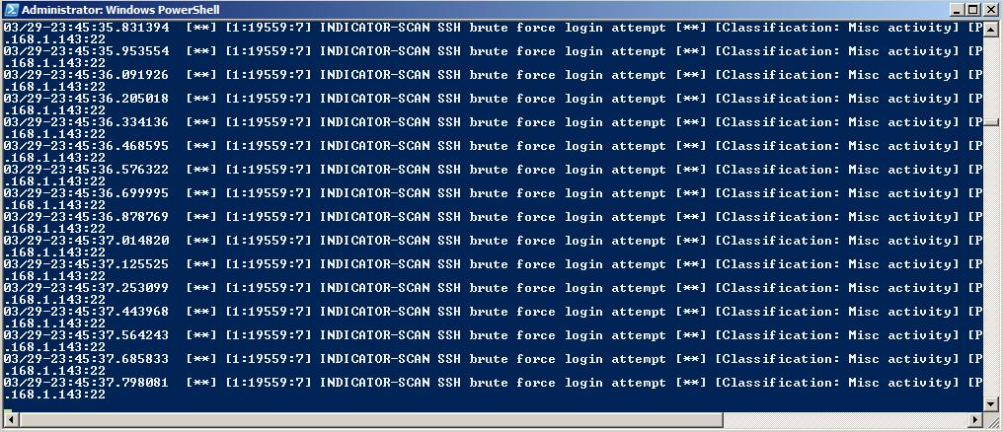
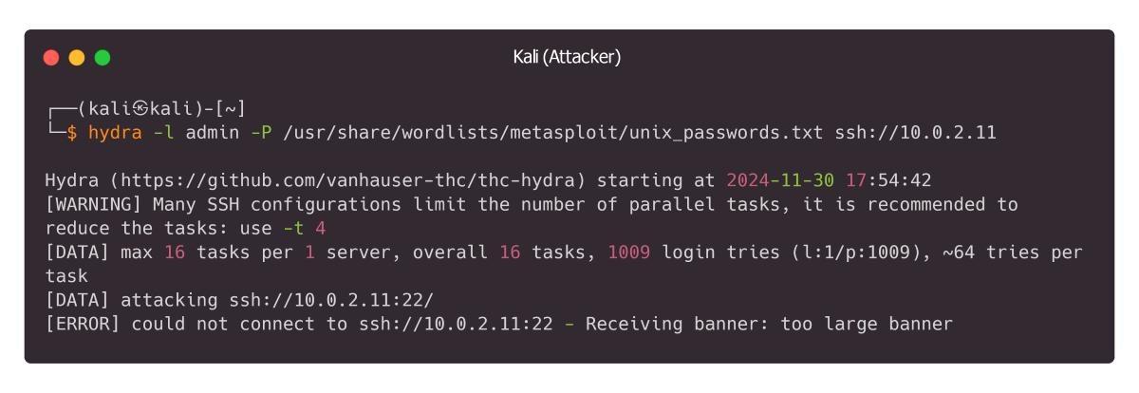
Result
Brute force attack concepts were successfully studied, highlighting the importance of strong authentication mechanisms.

