EXPERIMENT – 2

Encryption – Crypto 101 using TryHackMe

Step 1: Login to Platform
Open browser and go to TryHackMe.
Login using your account.

Step 2: Open Crypto 101 Room
Search for Crypto 101 and click Join Room.

Step 3: Start Environment
Click Start Machine / AttackBox to launch the virtual lab.

Step 4: Perform Cryptography Tasks

(a) Base64 Encoding/Decoding

(b) Hex Conversion

(c) Caesar Cipher

Step 5: Submit Answers
Enter the decoded results in the answer boxes and complete all tasks.
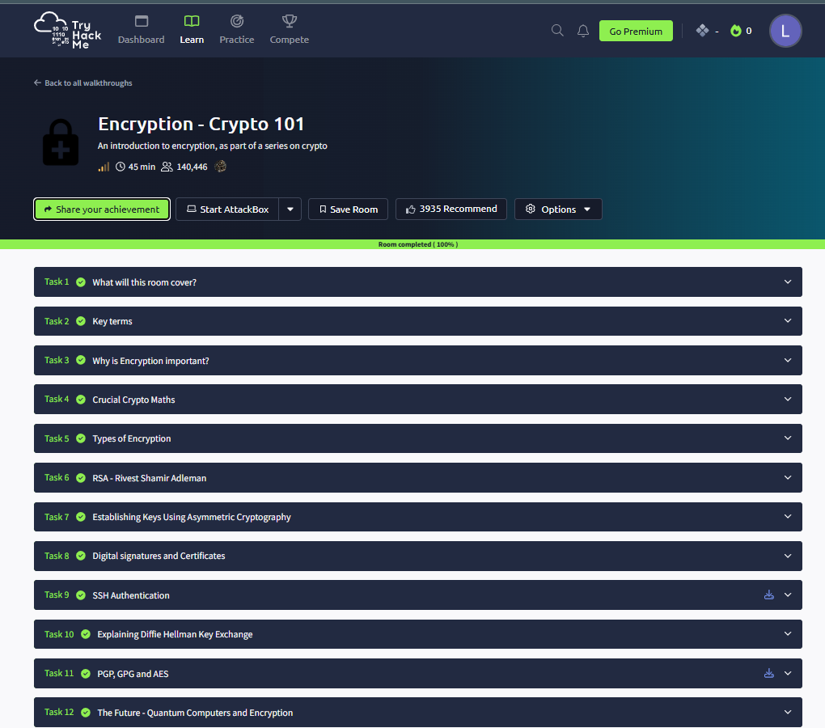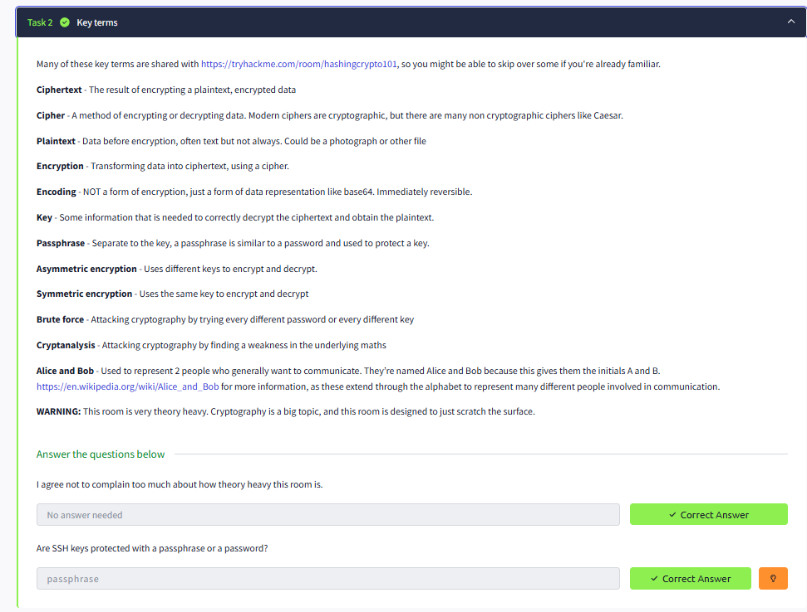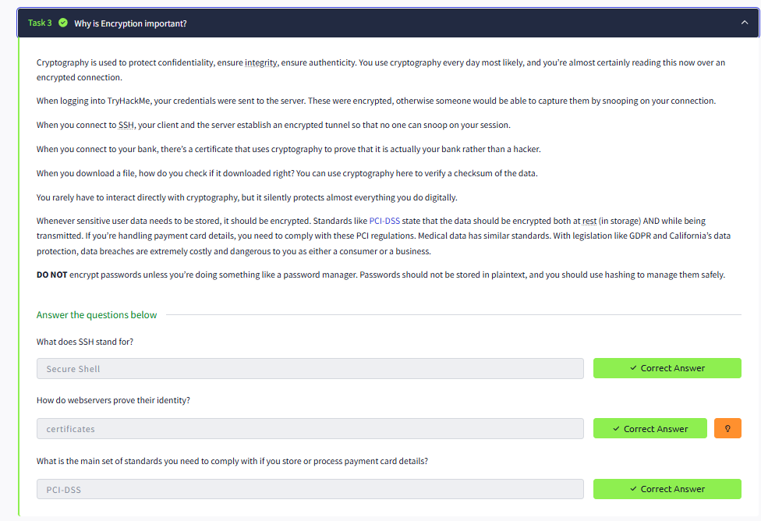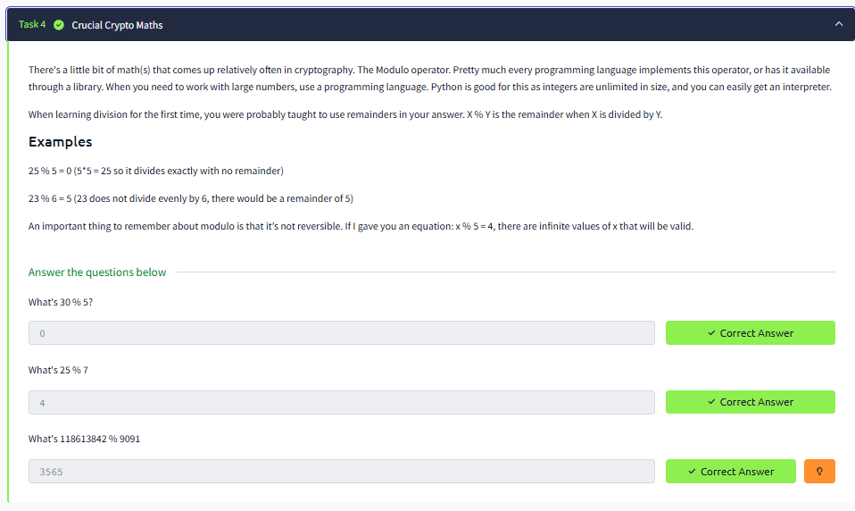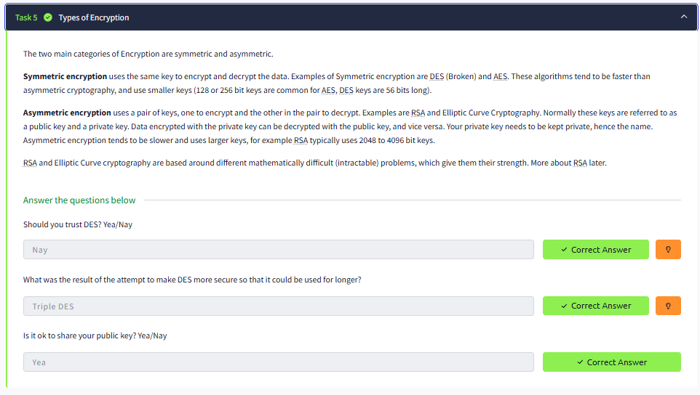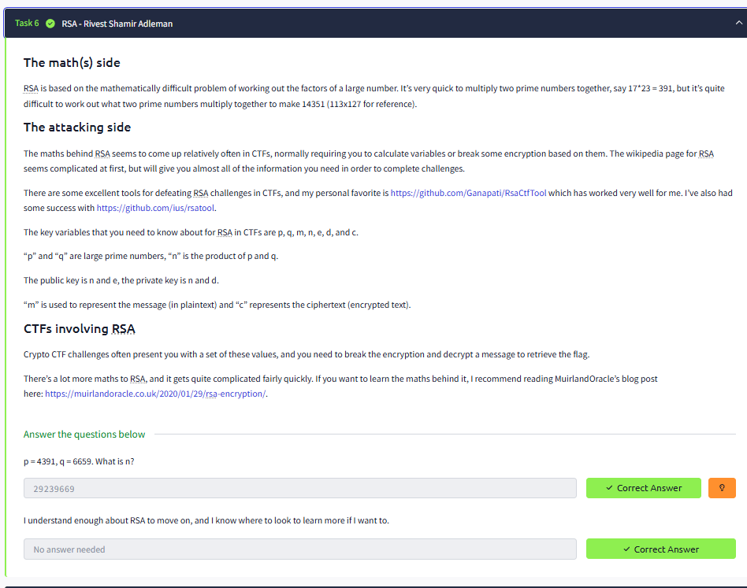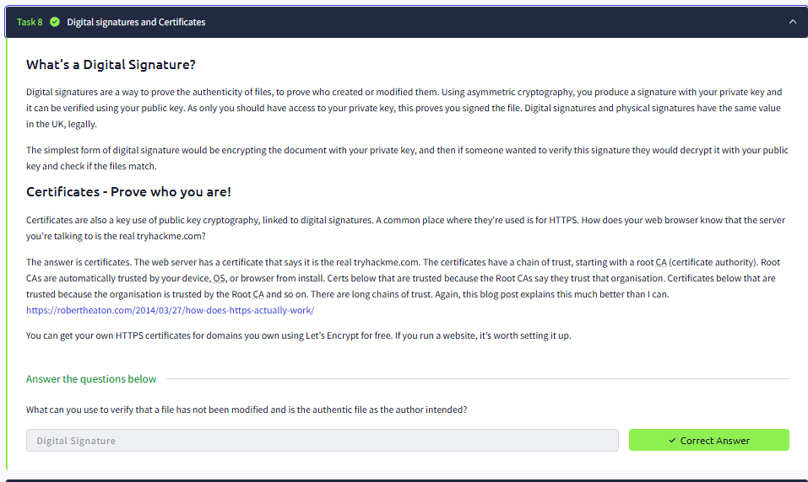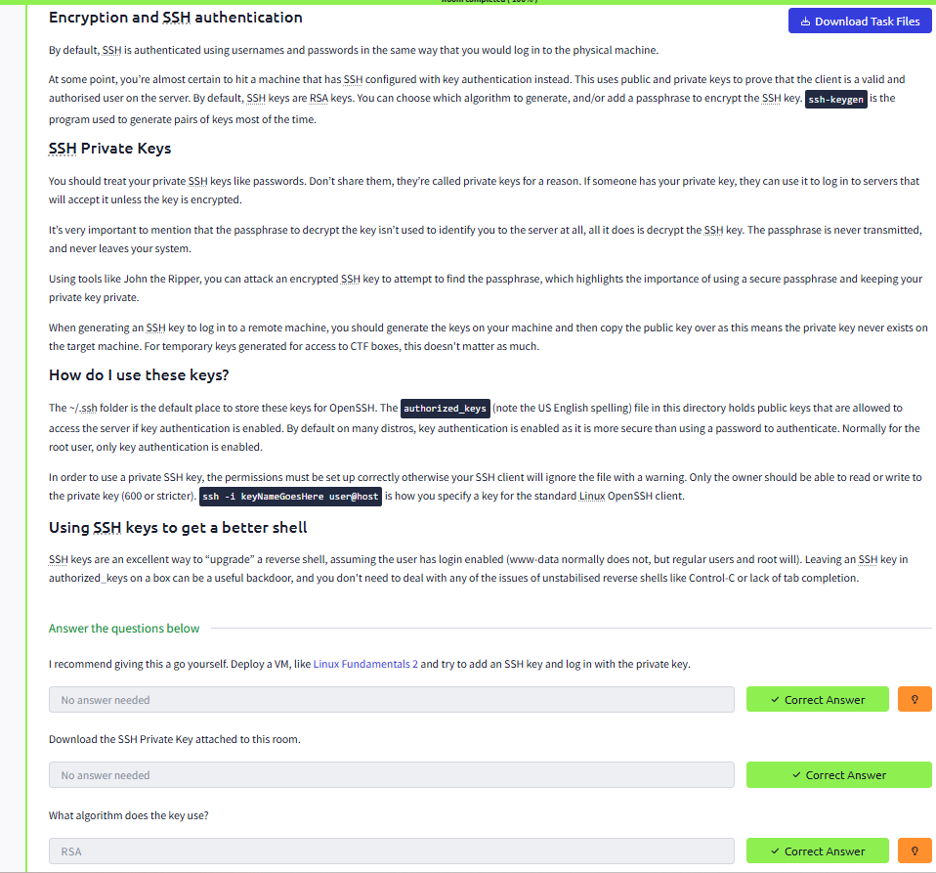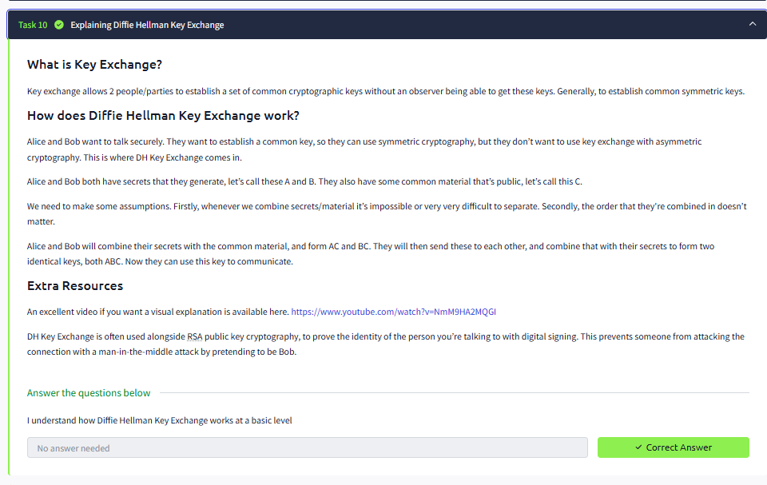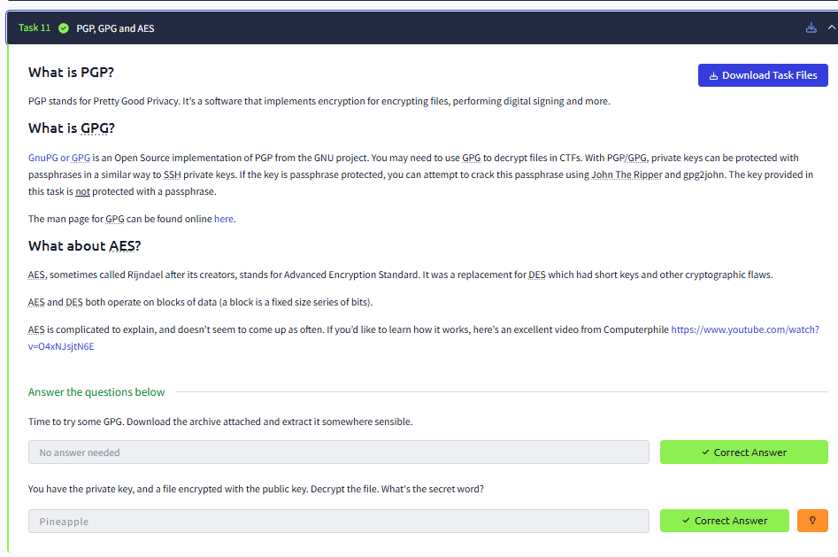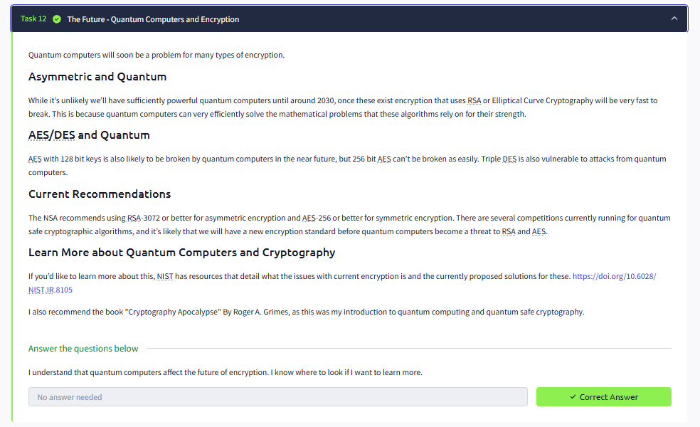

Result
Basic cryptography concepts such as encoding, decoding, hashing, and classical ciphers were successfully performed using TryHackMe.

