EXPERIMENT - 3

Performing MITM Attack Using Ettercap

Step 1: Start Environment
Open Oracle VirtualBox and start Kali Linux virtual machine.
Login to the system.

Step 2: Check Network

Open terminal and verify IP address:
ifconfig
Ensure the attacker and target systems are in the same network.

Step 3: Launch Tool
Start Ettercap in graphical mode:
ettercap -G

Step 4: Scan and Select Targets
- Choose Sniff → Unified Sniffing and select interface
- Scan for hosts
- Identify:
  - Target system
  - Gateway (router)

Step 5: Perform MITM and Monitor
- Configure MITM using ARP poisoning (conceptually)
- Start sniffing
- Observe intercepted network traffic in the tool

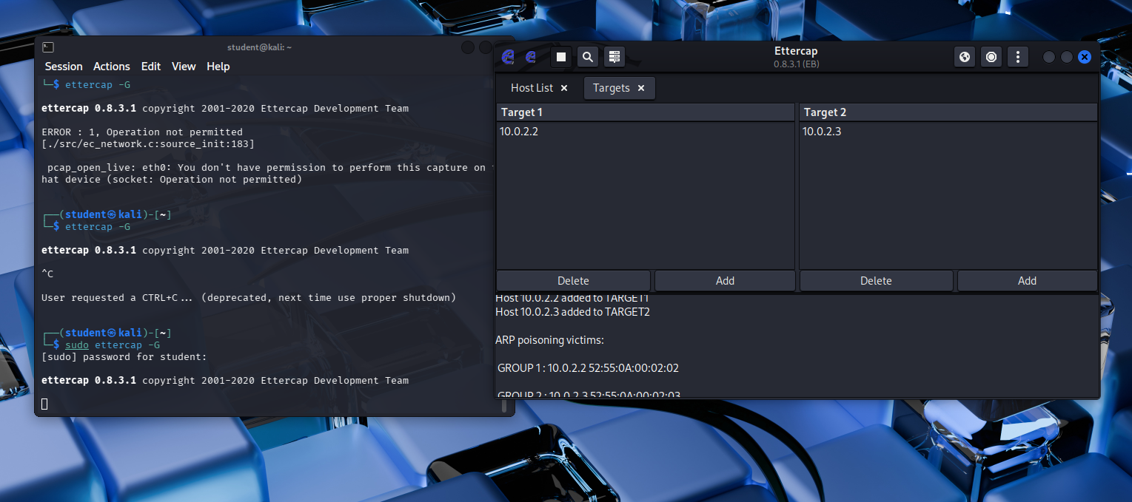

Result
The MITM attack was successfully demonstrated in a controlled environment, showing how unsecured communication can be intercepted and why encryption is important.

