EXPERIMENT - 4
Hash Cracking Using John the Ripper

Step 1: Start Environment
Open Oracle VirtualBox and start Kali Linux.
Login to the system.

Step 2: Open Terminal and Verify Tool
Open terminal and check if John the Ripper is installed:
john --version

Step 3: Create Hash File
Create a file and store a password hash:
nano hash.txt

Step 4: Run Hash Cracking
john hash.txt
The tool attempts to crack the hash using default wordlists.

Step 5: View Cracked Password
john --show hash.txt

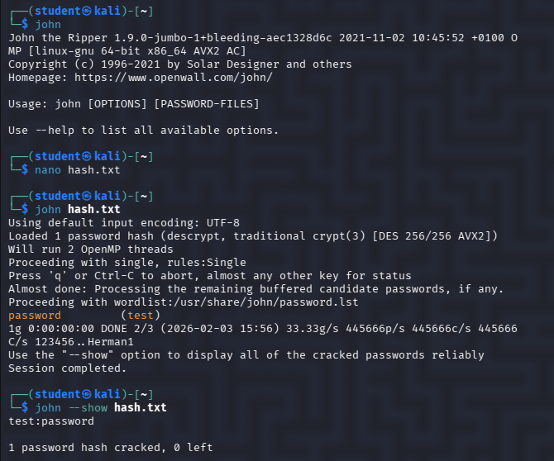

Result
Password hash cracking was successfully demonstrated, highlighting the need for strong passwords and secure hashing techniques.

