EXPERIMENT - 6

Snort IDS/IPS Using TryHackMe

Step 1: Login to Platform
Open TryHackMe in a browser and log in using your account.

Step 2: Open Snort Room
Search for a Snort-related room and join it to begin the experiment.

Step 3: Start AttackBox
Launch the AttackBox, which provides a ready-to-use Linux environment for performing the tasks.

Step 4: Verify Snort Installation
Open the terminal and confirm that Snort is installed and ready to use.

Step 5: Run Snort in IDS Mode
Start Snort in detection mode so that it monitors network traffic and generates alerts for suspicious activity.

Step 6: Detect Network Threats
Perform the tasks given in the room and observe how Snort identifies and reports potential threats in real time.

Step 7: Configure IPS Mode
Enable prevention mode to allow Snort to block malicious traffic based on predefined rules.

Step 8: Analyze Alerts
Review the alerts generated by Snort and identify different types of network attacks.

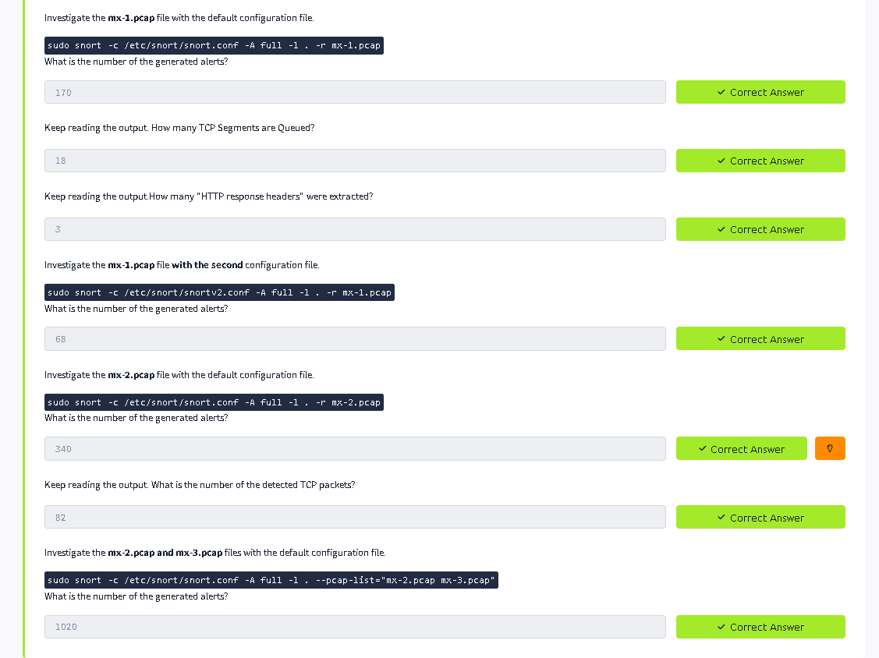
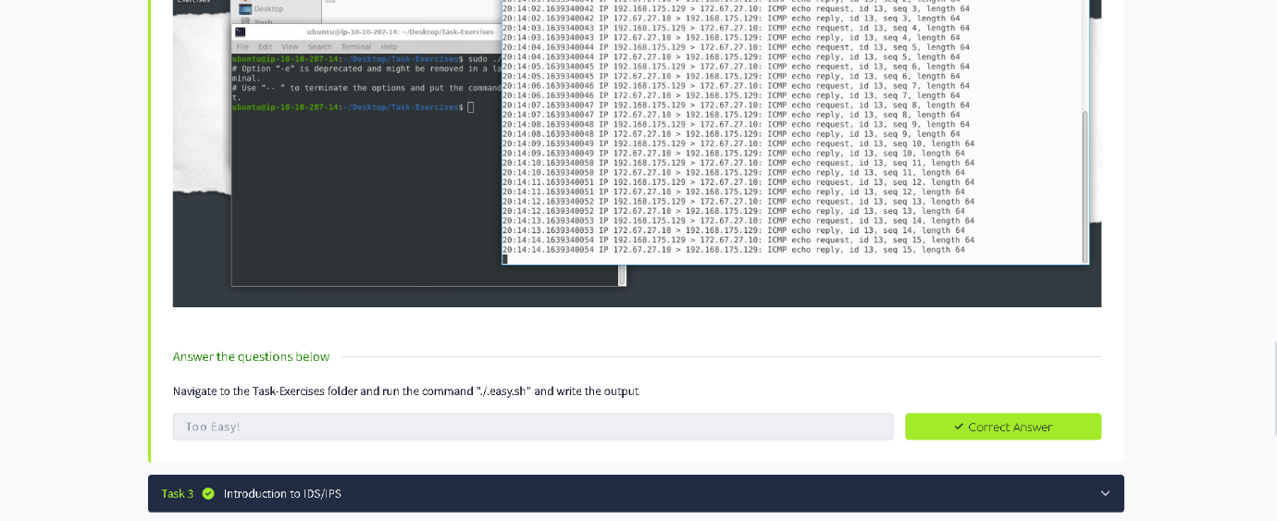
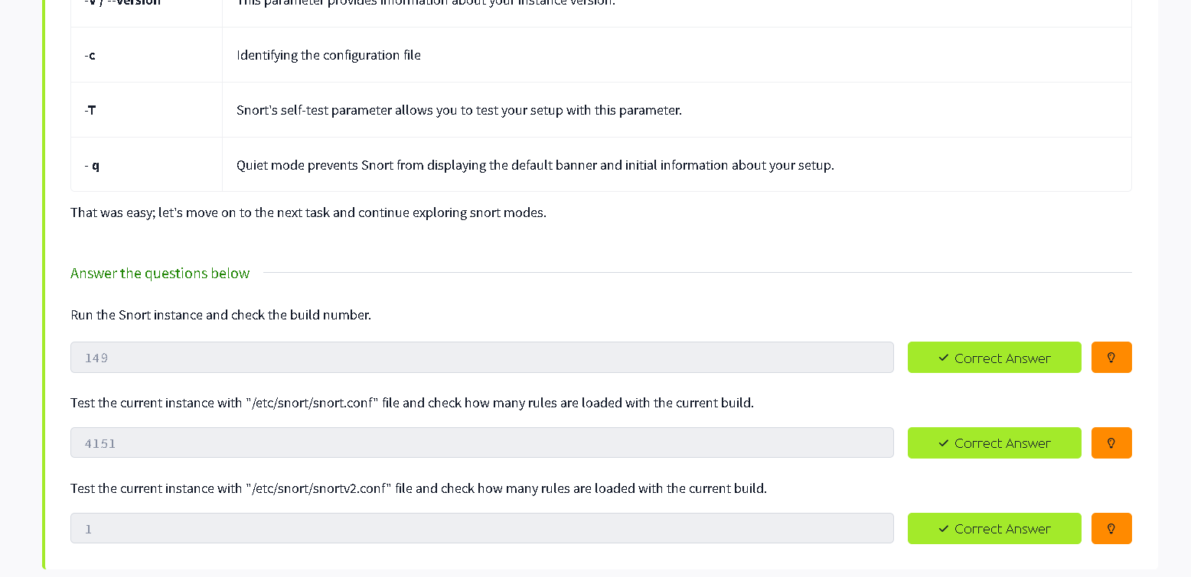
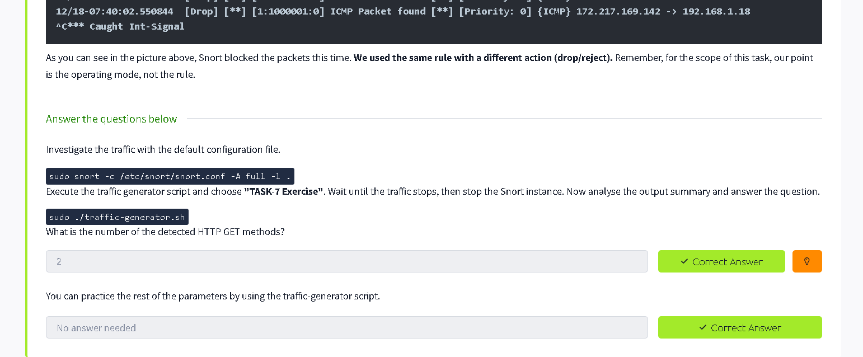


Result
Snort was successfully used as an IDS/IPS to detect and prevent network threats, demonstrating real-time network security monitoring in a controlled environment.

