Code Injection Using Ptrace in Kali Linux (Simple Steps)

Step 1: Start Environment
Open Oracle VirtualBox and start Kali Linux virtual machine. Log in to the system.

Step 2: Create Target Program
Create a simple C program that runs continuously. This program will act as the target process for testing.

Step 3: Run Target Application
Execute the target program and identify its Process ID (PID), which is required to interact with the running process.

Step 4: Create Injector Program
Write a C program that uses the ptrace system call to attach to the target process and access its internal state such as registers or memory.

Step 5: Compile Programs
Compile both the target and injector programs using a C compiler so they can be executed.

Step 6: Attach to Target Process
Run the injector program and connect it to the target process using the PID. This allows control over the target process.

Step 7: Modify Execution
Change the target process behavior by altering its execution flow or memory content using ptrace.

Step 8: Observe Changes
Resume the process and observe how its behavior is modified due to the injection.

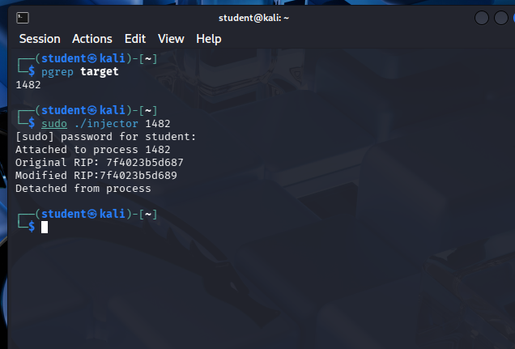

Result
Code injection using ptrace was successfully demonstrated, showing how process execution can be controlled and highlighting the importance of system-level security and process isolation.

