**MY SQL QUERIES**

**COFFEE SHOP SALES PROJECT**

CONVERT DATE (transaction_date) COLUMN TO PROPER DATE FORMAT

UPDATE coffee_shop_sales

SET transaction_date = STR_TO_DATE(transaction_date, &#39;%d-%m-%Y&#39;);

ALTER DATE (transaction_date) COLUMN TO DATE DATA TYPE

ALTER TABLE coffee_shop_sales

MODIFY COLUMN transaction_date DATE;

CONVERT TIME (transaction_time) COLUMN TO PROPER DATE FORMAT

UPDATE coffee_shop_sales

SET transaction_time = STR_TO_DATE(transaction_time, &#39;%H:%i:%s&#39;);

ALTER TIME (transaction_time) COLUMN TO DATE DATA TYPE

ALTER TABLE coffee_shop_sales

MODIFY COLUMN transaction_time TIME;

DATA TYPES OF DIFFERENT COLUMNS

DESCRIBE coffee_shop_sales;

CHANGE COLUMN NAME `ï»¿transaction_id` to transaction_id

ALTER TABLE coffee_shop_sales

CHANGE COLUMN `ï»¿transaction_id` transaction_id INT;

TOTAL SALES

Select MonthName(transaction_date) as 'Month' , Round(Sum(transaction_qty * unit_price),2) as Total_Sales

From coffee_shop

Group by MonthName(transaction_date);

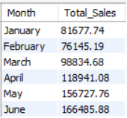

TOTAL SALES KPI - MOM DIFFERENCE AND MOM GROWTH

Select Month(transaction_date) as 'Month' ,

Round(Sum(transaction_qty * unit_price)) as Total_Sales ,

Round((Sum(transaction_qty * unit_price) - Lag(Sum(transaction_qty * unit_price),1)

Over(Order By Month(transaction_date))) / Lag(Sum(transaction_qty * unit_price),1)

Over(Order By Month(transaction_date)) * 100,2) as mom_increase_percentage

From coffee_shop

Group by Month(transaction_date);

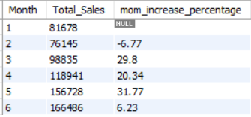

TOTAL ORDERS

Select MonthName(transaction_date) , Count(transaction_id) as Total_Orders

From coffee_shop

Group by MonthName(transaction_date);

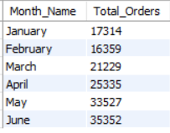

TOTAL ORDERS KPI - MOM DIFFERENCE AND MOM GROWTH

Select Month(transaction_date) as 'Month' , Count(transaction_id) as Total_Orders ,

Round((Count(transaction_id) - Lag(Count(transaction_id),1)

Over( Order By Month(transaction_date))) / Lag(Count(transaction_id),1)

Over( Order By Month(transaction_date)) * 100,2) as mom_increase_percentage

From coffee_shop

Group by 1;

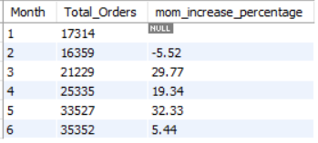

TOTAL QUANTITY SOLD

Select MonthName(transaction_date) as 'Month' ,

Sum(transaction_qty) as Total_qty

From coffee_shop

Group by MonthName(transaction_date);

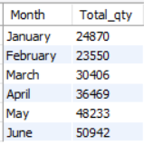

TOTAL QUANTITY SOLD KPI - MOM DIFFERENCE AND MOM GROWTH

Select Month(transaction_date) as 'Month' , Sum(transaction_qty) as Total_qty ,

Round((Sum(transaction_qty) - Lag(Sum(transaction_qty),1)

Over(Order by Month(transaction_date))) / lag(Sum(transaction_qty),1)

Over(Order by Month(transaction_date)) * 100,2) as mom_increase_percentage

From coffee_shop

Group by Month(transaction_date);

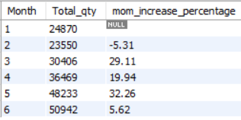

CALENDAR TABLE – TOTAL SALES, TOTAL QUANTITY and TOTAL ORDERS

Select Round(Sum(transaction_qty * unit_price),2) as Total_Sales ,

Sum(transaction_qty) as Total_qty_Sold ,

Count(transaction_id) as Total_Order

From coffee_shop

Where transaction_date = '2023-05-18'; -- For 18 May 2023



SALES BY WEEKDAY / WEEKEND

Select

Case When DayOfWeek(transaction_date) IN (1,7) Then 'WeekEnds'

Else 'WeekDays'

End As Day_Type , Round(Sum(transaction_qty * unit_price),2) as Total_Sales

From coffee_shop

Where MonthName(transaction_date) = 'March' -- March Month Sale

Group By Day_Type;

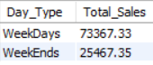

SALES BY STORE LOCATION

Select store_location , Round(Sum(transaction_qty * unit_price),2) as Total_Sales

From coffee_shop

Group by store_location

Order by store_location asc;

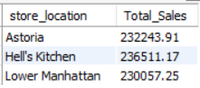

SALES TREND OVER PERIOD

SELECT AVG(total_sales) AS average_sales

FROM (

SELECT

SUM(unit_price * transaction_qty) AS total_sales

FROM

coffee_shop_sales

WHERE

MONTH(transaction_date) = 5 -- Filter for May

GROUP BY

transaction_date

) AS internal_query;

Query Explanation:

• This inner subquery calculates the total sales (unit_price * transaction_qty) for each date in

May. It filters the data to include only transactions that occurred in May by using the

MONTH() function to extract the month from the transaction_date column and filtering for

May (month number 5).

• The GROUP BY clause groups the data by transaction_date, ensuring that the total sales are

aggregated for each individual date in May.

• The outer query calculates the average of the total sales over all dates in May. It references

the result of the inner subquery as a derived table named internal_query.

• The AVG() function calculates the average of the total_sales column from the derived table,

giving us the average sales for May.



DAILY SALES FOR MONTH SELECTED

SELECT

DAY(transaction_date) AS day_of_month,

ROUND(SUM(unit_price * transaction_qty),1) AS total_sales

FROM

coffee_shop_sales

WHERE

MONTH(transaction_date) = 5 -- Filter for May

GROUP BY

DAY(transaction_date)

ORDER BY

DAY(transaction_date);

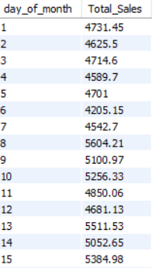 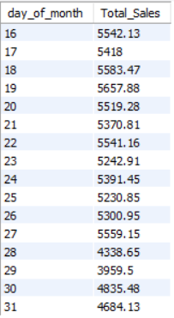

COMPARING DAILY SALES WITH AVERAGE SALES – IF GREATER THAN “ABOVE AVERAGE” and

LESSER THAN “BELOW AVERAGE”

Select day_of_month , Total_Sales , Avg_Sales ,

Case

When Total_sales > Avg_sales Then 'Above Average'

When Total_sales < Avg_sales Then 'Below Average'

Else 'Average'

End as Sales_Type

From (

Select Day(transaction_date) as day_of_month ,

Round(Sum(transaction_qty * unit_price),2) as Total_Sales ,

Round(AVG(SUM(unit_price * transaction_qty)) OVER (),2) AS avg_sales

From coffee_shop

Where Month(transaction_date) = 5

Group by Day(transaction_date) ) x

Order by day_of_month ;

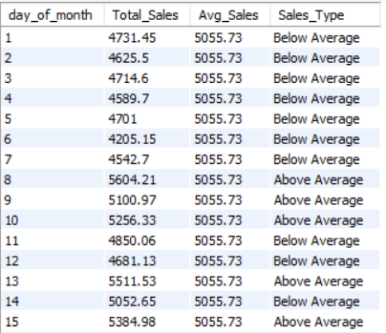 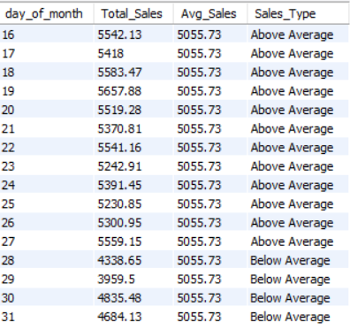

SALES BY PRODUCT CATEGORY

Select product_category , Round(Sum(transaction_qty * unit_price),2) as Total_Sales

From coffee_shop

Group by product_category

Order by Total_Sales Desc;

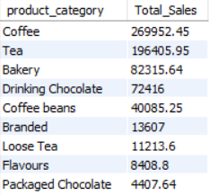

SALES BY PRODUCTS (TOP 10)

Select product_type , Round(Sum(transaction_qty * unit_price),2) as Total_Sales

From coffee_shop

Group by product_type

Order by Total_Sales Desc

Limit 10 ;

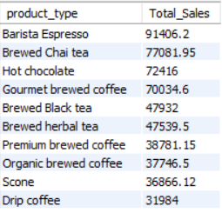

SALES BY DAY | HOUR

SELECT

ROUND(SUM(unit_price * transaction_qty)) AS Total_Sales,

SUM(transaction_qty) AS Total_Quantity,

COUNT(*) AS Total_Orders

FROM

coffee_shop_sales

WHERE

DAYOFWEEK(transaction_date) = 3 -- Filter for Tuesday (1 is Sunday, 2 is Monday, ..., 7 is Saturday)

AND HOUR(transaction_time) = 8 -- Filter for hour number 8

AND MONTH(transaction_date) = 5; -- Filter for May (month number 5)



TO GET SALES FROM MONDAY TO SUNDAY FOR MONTH OF MAY

SELECT

CASE

WHEN DAYOFWEEK(transaction_date) = 2 THEN 'Monday'

WHEN DAYOFWEEK(transaction_date) = 3 THEN 'Tuesday'

WHEN DAYOFWEEK(transaction_date) = 4 THEN 'Wednesday'

WHEN DAYOFWEEK(transaction_date) = 5 THEN 'Thursday'

WHEN DAYOFWEEK(transaction_date) = 6 THEN 'Friday'

WHEN DAYOFWEEK(transaction_date) = 7 THEN 'Saturday'

ELSE 'Sunday'

END AS Day_of_Week,

ROUND(SUM(unit_price * transaction_qty), 2) AS Total_Sales

FROM

coffee_shop_sales

WHERE

MONTH(transaction_date) = 5

GROUP BY

CASE

WHEN DAYOFWEEK(transaction_date) = 2 THEN 'Monday'

WHEN DAYOFWEEK(transaction_date) = 3 THEN 'Tuesday'

WHEN DAYOFWEEK(transaction_date) = 4 THEN 'Wednesday'

WHEN DAYOFWEEK(transaction_date) = 5 THEN 'Thursday'

WHEN DAYOFWEEK(transaction_date) = 6 THEN 'Friday'

WHEN DAYOFWEEK(transaction_date) = 7 THEN 'Saturday'

ELSE 'Sunday'

END

ORDER BY

FIELD(Day_of_Week, 'Monday', 'Tuesday', 'Wednesday', 'Thursday', 'Friday', 'Saturday', 'Sunday');

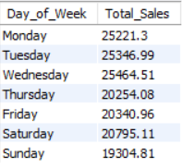

TO GET SALES FOR ALL HOURS FOR MONTH OF MAY

SELECT

HOUR(transaction_time) AS Hour_of_Day,

ROUND(SUM(unit_price * transaction_qty)) AS Total_Sales

FROM

coffee_shop_sales

WHERE

MONTH(transaction_date) = 5 -- Filter for May (month number 5)

GROUP BY

HOUR(transaction_time)

ORDER BY

HOUR(transaction_time);

