1 | Is there any inconsistency in the UI?    (buttonsdisabled)
2 | Is there any inconsistency in the UI?  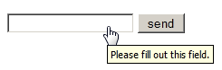
3 | Is there any inconsistency in the UI?  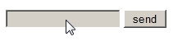
4 | How checkbox can be checked off?
5 | The gender selection is implemented on screen below. Please describe the weak points of this implementation and propose better way of implementation.
6 | Please, propose improvements for the part of the screen below.  Requirement: if ‘no thanks’ checkbox is checked off other fields should be disabled  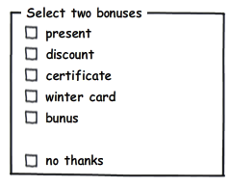
7 | Please provide your recommendations regarding improvements of the part of screen below.
8 | Would a radio button be a better choice? (select between Portrait and Landscape mode, Portrait uses by default )  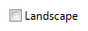
9 | Is radio button the best choice?  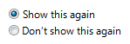
10 | Is it the best implementation of the part of screen?
11 | What is mixed-state for checkbox?
12 | Can we use checkboxes as a progress indicator?  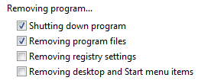
13 | Can we use the selection of a checkbox to perform commands?
14 | Can we use the selection of a checkbox to dynamically display other controls related to the selected control (screen readers cannot detect such events)?
15 | Can we use the selection of a checkbox to display other windows, such as a dialog box to gather more input?
16 | Are there any inconsistency in the relationship between radio buttons and checkboxes?  Requirement: when ‘Custom’ radio-button is selected all checkboxes are enabled.  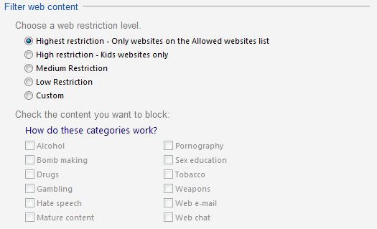
17 | Is it the best implementation of screen?  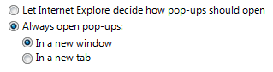
18 | How implementation of screen can be improved?  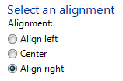
19 | Is it the best way of the controls’ location on the screen?  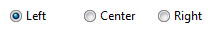
20 | Is it right to leave editable text boxes and drop-down lists enabled if they share the radio button's label?(See example). What requirement should be for the editable field?  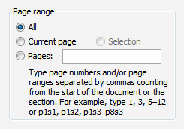
21 | What is list-box, drop-down list, combobox? What are the two types of combobox?
22 | There are numbers from 1 to 31 (day of month) in dropdown list. How we can select 5?
23 | There are numbers from 1 to 31 (day of month) in dropdown list. How we can change selection between 3, 30, 31 items?

