1 | Is there any inconsistency in the UI?    (buttons disabled) | The buttons are disabled. The user can’t interact with that part of the interface.  When cursor is over command button, the pointer must be changed to an arrow.
2 | Is there any inconsistency in the UI?  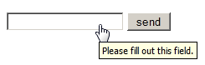 | When the cursor is over textbox, the pointer must be changed to a caret.  The placeholder may be used to explain the user what kind of data must be entered.
3 | Is there any inconsistency in the UI?   | The textbox is disabled.  When the cursor is over textbox, the pointer must be changed to a caret.
4 | How checkbox can be checked off? | Checkbox can be checked off by pressing the left-hand button of the mouse or the space button on the keyboard.
5 | The gender selection is implemented on screen below. Please describe the weak points of this implementation and propose better way of implementation. | It is impossible to select the right state of being male or female by using this implementation. The radio buttons are the better choice.
6 | Please, propose improvements for the part of the screen below.  Requirement: if ‘no thanks’ checkbox is checked off other fields should be disabled  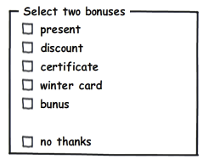 | There is a grammatical mistake in check box label - “bunus”, it should be corrected like “bonus”.  The instructional text is used as the label of group box and the control label “bonus” within the group box repeats the group box label. It should be corrected by changing the group box label from “Select two bonuses” to “Bonuses”. The check box “bonus” should be removed.  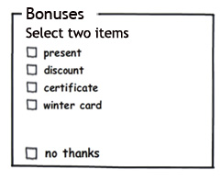
7 | Please provide your recommendations regarding improvements of the part of screen below. | Check boxes are suitable for turning a single option on or off. Better implementation: to use a single check box with the label “accept”.
8 | Would a radio button be a better choice? (select between Portrait and Landscape mode, Portrait uses by default )   | A radio button would be a better choice because the meaning of unchecked check box isn't completely clear.  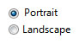
9 | Is radio button the best choice?  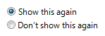 | Better implementation: to use a single check box. Check boxes are suitable for turning a single option on or off.  
10 | Is it the best implementation of the part of screen? | Horizontal alignment is harder to read. Better implementation: to align check boxes vertically.  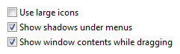
11 | What is mixed-state for checkbox? | Mixed-state for checkbox is the state for multiple selection to indicate that the option is set for some, but not all, objects.
12 | Can we use checkboxes as a progress indicator?  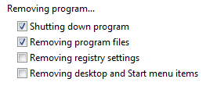 | Better implementation: to use a progress indicator control instead. For example:  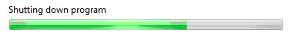
13 | Can we use the selection of a checkbox to perform commands? | No, we can’t. Check boxes are suitable for turning a single option on or off and to select or deselect an item.
14 | Can we use the selection of a checkbox to dynamically display other controls related to the selected control (screen readers cannot detect such events)? | No, we can’t. Check boxes are suitable for turning a single option on or off and to select or deselect an item.
15 | Can we use the selection of a checkbox to display other windows, such as a dialog box to gather more input? | No, we can’t. Check boxes are suitable for turning a single option on or off and to select or deselect an item.
16 | Are there any inconsistency in the relationship between radio buttons and checkboxes?  Requirement: when ‘Custom’ radio-button is selected all checkboxes are enabled.  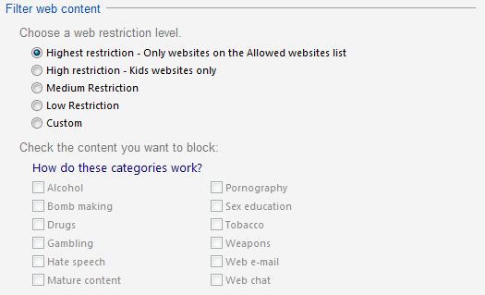 | Yes, there are . The subordinate check boxes must be selected, making their relationship to the selected option clear.  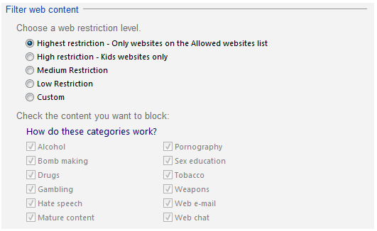
17 | Is it the best implementation of screen?  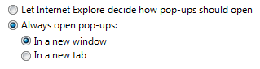 | Using nested options adds unnecessary complexity.  Better implementation: to keep all options at the same level.  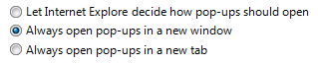
18 | How implementation of screen can be improved?  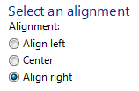 | The implementation of screen can be improved by removing the radio button group label( it is a duplicate of the main instruction).  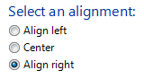
19 | Is it the best way of the controls’ location on the screen?   | No,it isn’t. Horizontal alignment is harder to read. Better implementation: to align radio buttons vertically.  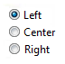
20 | Is it right to leave editable text boxes and drop-down lists enabled if they share the radio button's label?(See example). What requirement should be for the editable field?  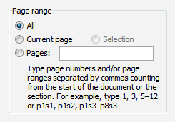 | Yes,it is. Doing so simplifies the interaction.  Requirement should be: entering a page number automatically selects Pages.
21 | What is list-box, drop-down list, combobox? What are the two types of combobox? | List-box is a type of box containing a list of items the user can select. Drop-down list box is the closed version of a list-box with an arrow next to it. Clicking the arrow opens the list. Combobox is the text box with a list box attached. The list is always visible. Users can type or select their choice. Another type of combobox is a drop-down combobox is a closed version of a combo box with an arrow next to it. Clicking the arrow opens the list.
22 | There are numbers from 1 to 31 (day of month) in dropdown list. How we can select 5? | We can select 5 by following steps : click the arrow to open the list, then :  – press the “5” button on the keyboard or  – select the 5 number from the list using the mouse pointer or  – select the 5 number from the list using up and down arrows on keyboard.
23 | There are numbers from 1 to 31 (day of month) in dropdown list. How we can change selection between 3, 30, 31 items? | We can change selection between 3, 30, 31 items by re-pressing the “3” button on the keyboard.

