Assignment 2: Neural Networks
Programming Part: Summary of Results
CS 4375
Shivesh Gupta
October 2026

Setup
I used the UCI Car Evaluation dataset (https://archive.ics.uci.edu/dataset/19/car+evaluation). It has 1,728 cars with six attributes each. The goal is to predict one of four classes: unacc, acc, good or vgood. About 70% of the cars are unacc, so a model that always guesses unacc is already 70% right.
I trained 24 networks, one for each mix of activation (logistic, tanh, relu), learning rate (0.01, 0.1), epochs (100, 200) and hidden layers (2, 3). Each hidden layer has 16 neurons. All the numbers are in results_table.csv.

Results
This table shows the test accuracy for each activation function over its 8 models.
Activation | Mean test accuracy | Best test accuracy | Best setting | Worst test accuracy
logistic | 83.71% | 97.69% | lr 0.1, 200 epochs, 2 layers | 70.14%
tanh | 97.80% | 99.54% | lr 0.1, 200 epochs, 3 layers | 95.14%
relu | 97.74% | 99.54% | lr 0.1, 200 epochs, 3 layers | 94.44%

This plot shows test accuracy as training goes on. Each panel is one activation function. The colors are the learning rate and the number of layers.
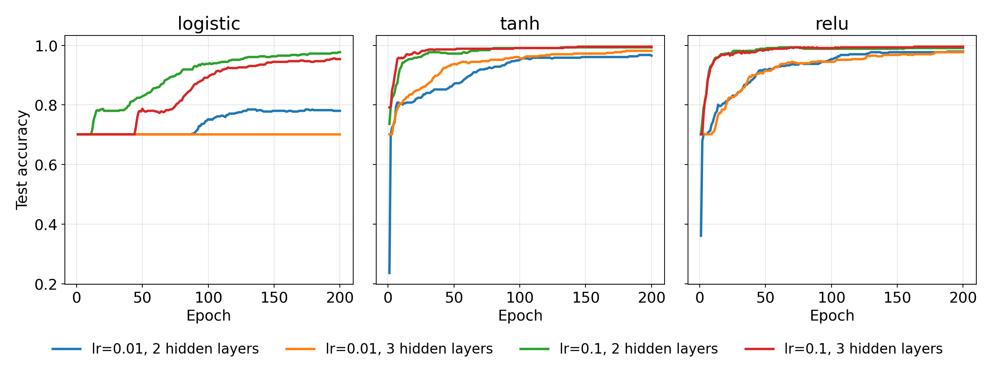
Test accuracy vs. epochs (200-epoch runs).

Full Results Table
Results for all 24 models, one row per combination of hyperparameters. Every hidden layer has 16 neurons. Accuracy and error are measured after the last epoch, on the training set (1,296 cars) and the test set (432 cars). Error is cross-entropy loss.
Activation | Learning rate | Epochs | Hidden layers | Train accuracy | Test accuracy | Train error | Test error
logistic | 0.01 | 100 | 2 | 74.92% | 75.23% | 0.6037 | 0.6143
logistic | 0.01 | 100 | 3 | 69.98% | 70.14% | 0.8366 | 0.8322
logistic | 0.01 | 200 | 2 | 79.86% | 78.01% | 0.4859 | 0.5063
logistic | 0.01 | 200 | 3 | 69.98% | 70.14% | 0.8346 | 0.8305
logistic | 0.1 | 100 | 2 | 93.98% | 93.75% | 0.1742 | 0.1705
logistic | 0.1 | 100 | 3 | 89.81% | 89.35% | 0.2675 | 0.2689
logistic | 0.1 | 200 | 2 | 98.84% | 97.69% | 0.0583 | 0.0733
logistic | 0.1 | 200 | 3 | 97.45% | 95.37% | 0.0986 | 0.1248
tanh | 0.01 | 100 | 2 | 95.76% | 95.14% | 0.1581 | 0.1709
tanh | 0.01 | 100 | 3 | 97.38% | 95.60% | 0.0966 | 0.1129
tanh | 0.01 | 200 | 2 | 98.46% | 96.53% | 0.0710 | 0.0937
tanh | 0.01 | 200 | 3 | 99.61% | 98.15% | 0.0300 | 0.0552
tanh | 0.1 | 100 | 2 | 99.92% | 99.07% | 0.0086 | 0.0284
tanh | 0.1 | 100 | 3 | 100.00% | 99.07% | 0.0016 | 0.0176
tanh | 0.1 | 200 | 2 | 100.00% | 99.31% | 0.0021 | 0.0174
tanh | 0.1 | 200 | 3 | 100.00% | 99.54% | 0.0006 | 0.0144
relu | 0.01 | 100 | 2 | 96.14% | 95.37% | 0.1194 | 0.1280
relu | 0.01 | 100 | 3 | 97.22% | 94.44% | 0.1005 | 0.1133
relu | 0.01 | 200 | 2 | 99.00% | 97.92% | 0.0466 | 0.0593
relu | 0.01 | 200 | 3 | 99.15% | 97.69% | 0.0341 | 0.0618
relu | 0.1 | 100 | 2 | 100.00% | 98.84% | 0.0051 | 0.0231
relu | 0.1 | 100 | 3 | 100.00% | 99.07% | 0.0011 | 0.0209
relu | 0.1 | 200 | 2 | 100.00% | 99.07% | 0.0015 | 0.0180
relu | 0.1 | 200 | 3 | 100.00% | 99.54% | 0.0003 | 0.0172

Best Activation Function
tanh and relu did about the same, and both did much better than logistic. Average test accuracy was 97.80% for tanh, 97.74% for relu and 83.71% for logistic. The best models were tanh and relu with learning rate 0.1, 200 epochs and 3 layers. Both got 99.54%, which is 430 of 432 test cars. Tanh had the lower test error (0.0144 vs. 0.0172), but the difference is small.
Logistic sometimes did not learn at all. With learning rate 0.01 and 3 layers it stayed at about 70% for all 200 epochs, which is the same as always guessing unacc. With 2 layers it only reached 75% to 78%. With learning rate 0.1 and 200 epochs it reached 95% to 98%, so it can learn this data. It just needs a bigger learning rate and more epochs.
I think the cause is vanishing gradients, but I did not test this. The slope of the logistic function is never more than 0.25. The gradient is multiplied by this slope at every layer on the way back, so it gets smaller, and a small learning rate then barely changes the weights. This matches the results, since logistic did worst with 3 layers and learning rate 0.01. Tanh has a slope up to 1, and relu has a slope of 1 for positive inputs, so their gradients stay bigger. Both learned fast even with learning rate 0.01.

Other things I noticed
- Learning rate: 0.1 was much better than 0.01 (97.47% vs. 88.70% average test accuracy). With only 100 or 200 epochs, 0.01 is often too small to finish learning.
- Epochs: 200 epochs was a little better than 100 (94.08% vs. 92.09%), mostly for the slower models. The models with learning rate 0.1 stopped improving around epoch 100.
- Hidden layers: 2 layers was a bit better than 3 on average (93.83% vs. 92.34%). This comes from logistic, where more layers made it worse. For tanh and relu, 2 and 3 layers were within about 1 point.
- Overfitting: the tanh and relu models with learning rate 0.1 got about 100% training accuracy and 98.8% to 99.5% test accuracy. The gap is small.

Assumptions
- Every hidden layer has 16 neurons. Training uses SGD with momentum 0.9 and batch size 200.
- The attributes are ordered categories, so I changed them to numbers in order and standardized them. I standardized on the whole dataset before splitting, so a tiny bit of test information leaks in. I expect the effect to be very small.
- I used one 75/25 split with seed 42 and ran each setting once. The test set has 432 cars, so one car is about 0.23 percentage points. The differences among the top models (98.8% to 99.5%) could just be noise. Only the gap between logistic and the other two, and the gap between the two learning rates, are clearly real.
- Error is cross-entropy loss. Accuracy is the share of cars classified correctly.

References
Claude (Anthropic), Sonnet 5.5, October 2026. Used to draft and assist with the theory solutions, the program, the README, and the report, and to assist with debugging and editing. I ran the code and checked the results.

