Forecasting S&P 500 Realized Volatility Using Machine Learning
Comparing HAR, elastic net and random forest on nested feature sets
Project Proposal · Advanced Machine Learning (QFGB-890H-001) · Fordham MSQF · Fall 2026
Team: James, Robin and Aryan Instructor: Prof. Dmitry Udler Implementation: MATLAB

Abstract
Realized volatility of the S&P 500 is central to pricing options and variance swaps, yet the standard econometric forecast—the heterogeneous autoregressive (HAR) model of Corsi (2009)—is famously hard to beat. We propose a focused comparison of three models—HAR, elastic net and random forest—against two simple benchmarks: a naive Persistence forecast (the latest realized variance) and the VIX-implied variance-swap strike. The main target is Risk Lab SPY realized variance from 5-minute subsampled trades from January 2005 to October 2026; VOLARE E-mini futures (ES) measures from October 2009 supply a second, full-session target and a block of jump, semivariance and quarticity features. Models are evaluated on four nested feature sets and three horizons (1, 5 and 22 days) under annual expanding-window walk-forward, with 2018–October 2026 locked as the final test. Losses are MSE and QLIKE; significance uses Diebold–Mariano tests and the Model Confidence Set. Every input is tested for unit roots and long memory, and non-stationary features are fractionally differentiated with the smallest order that passes a unit-root test, chosen inside each training window. An economic check asks whether better forecasts beat the VIX-implied variance-swap strike. HAR uses only the HAR lags (set A); the elastic net and random forest are run on all four sets, so the design can ask whether the random forest gains more from richer features than the elastic net does. The model set is kept small so that gains can be attributed to linearity versus non-linearity and to information, not to a large menu of algorithms.

1. Introduction and Motivation
Volatility sets the price of every option, the size of risk limits and how much a fund can safely invest. It is not observed directly, but can be measured after the fact by summing squared intraday returns—realized variance (RV) (Andersen, Bollerslev, Diebold & Labys, 2003). Five-minute sampling is the standard compromise between information and microstructure noise, and it is the frequency used by all three of our reference papers.
Forecasting S&P 500 realized volatility is crucial for volatility trading with S&P 500 options, including variance swaps. A one-month variance-swap strike is approximately ; anyone who forecasts realized variance better than that price knows when volatility looks cheap or expensive.
Two structural facts motivate a machine-learning comparison:
- HAR is a strong but linear baseline. Corsi’s (2009) heterogeneous autoregressive model predicts future RV from its daily, weekly and monthly averages. All three reference papers use it as the benchmark: Kılıç (2026) finds that ML sometimes improves on HAR but does not systematically beat a broader econometric set; Christensen, Siggaard & Veliyev (2023) find that ML does beat the HAR family, especially at longer horizons; and Rahimikia & Poon (2026) find that ML wins on most days but HAR does better on extreme-volatility days.
- Richer information is available, but only some of it is RV history. Option-implied volatility, rates, macro and financial-stress indices, and—from late 2009—VOLARE E-mini futures decompositions (jumps, semivariances, quarticity) can enter as features. Linear models struggle with many correlated inputs; trees can capture interactions and regimes.
Our contribution is deliberately narrow. The literature compares many algorithms; we keep three models—HAR, elastic net and random forest—on the same horizons and walk-forward design, plus a naive Persistence benchmark (tomorrow looks like today) that every forecast must beat. HAR is the fixed benchmark on its own lags (set A); the two ML models run on all four nested feature sets, so we can ask both whether they beat HAR and whether the non-linear model extracts more from implied-vol, macro/stress and ES features than the linear one. VOLARE ES is a second target and a feature source, not a reason to expand the model zoo into HAR-J, SHAR or HARQ as separate competitors.

2. Research Questions and Hypotheses
Research question | Hypothesis | How it is tested
RQ1. With volatility history alone (set A), do elastic net or random forest beat HAR (and the naive Persistence benchmark) out of sample? | At , gains are small; they grow at  and , consistent with Christensen et al. | Pairwise DM tests and MCS on set A (Persistence, HAR, EN, RF), by horizon, on the locked 2018–2026 test.
RQ2. Do Random Forest get more improvement from implied vol, macro/stress, and ES features than elastic nets? | The random forest's non-linearity and interactions let it extract more from the richer sets B–D than the elastic net, so its loss reduction from set A to B, C and D exceeds the elastic net's. | Per horizon and target, compare the change in out-of-sample QLIKE/MSE (A→B, A→C, A→D) for RF vs EN; DM tests on the difference-in-differences of losses; MCS.
RQ3. Does the full-session ES target change the economic conclusion versus SPY intraday RV? | ES captures ~95% of close-to-close variance (SPY RV ~56%), so ES-target forecasts should align better with a variance-swap payoff. | Repeat the pipeline on VOLARE ES (2010–2026) and run the variance-swap comparison on ES forecasts.

The three questions are separable: a null finding on any one of them is still useful for the report. In particular, we do not assume that implied volatility helps: whether implied-vol features add forecasting power is tested inside the project, by the set A → B comparison (set B adds VIX, the IV surface, short-dated IV and VVIX, together with return and rate features), and the set-B coefficients and importances show which part of the block does the work.

3. Data
The team's cleaned inputs are in place. No file is simply “five-minute data”: each delivers daily measures built from a stated intraday sampling frequency, or daily and weekly macro series. The free file features_daily.csv covers 9,258 NYSE sessions (2 January 1990 – 6 October 2026) with 51 data columns, a data dictionary and a QC report. The table gives each file's sampling, the measure it provides and its role.
File (source) | Sampling and measure | Coverage | Role in the project
risklab_SPY_daily_annualized_vol_1996-2026.csv (Risk Lab, Dacheng Xiu) | Daily annualized SPY volatility from intraday trades, regular session: rv5 (5-minute subsampled), rv15 (15-minute subsampled), QMLE | 2 Jan 1996 – 5 Oct 2026; 7,707 days | Main target (rv5); set-A lags; rv15 and QMLE as robustness
VOLARE_ES_realized_measures_2009-2026.csv (VOLARE) | Daily variances from 1-second ES mid-quotes over the Globex session (18:00–17:00 ET): RV, bipower, ±semivariances, quarticity, MedRV/MinRV at 1-minute, 5-minute and 5-minute subsampled; realized kernel on 1-second returns | 30 Sep 2009 – 30 Sep 2026; 4,397 rows | Second target (rv5); set D; rv1 and kernel as robustness
oxfordman_SPX_2000-01-03_2022-02-25.csv (Oxford-Man Realized Library, archived mirror) | Daily S&P 500 index measures, cash session: rv5 and rv5_ss (5-minute), rv10 (10-minute), bipower, negative semivariance, realized kernels | 3 Jan 2000 – 25 Feb 2022; 5,552 days | Cross-check of the SPY target (correlation 0.968 with Risk Lab rv5, 2005–2022); pre-2010 jump/semivariance robustness
iv_surface.mat (Bloomberg) | Daily SPX implied vol, 7 moneyness levels × 6 tenors (1–24 months) | 3 Jan 2005 – 1 Oct 2026; 5,471 days | Set B: ATM level, skew, term slope; fixes the 2005 sample start
vol_indices.mat (Cboe) | Daily closes: VIX, VIX9D, VIX3M, VIX6M, VIX1Y, SKEW | VIX from 1990; VIX3M 18 Sep 2009; VIX9D 4 Jan 2011; to 30 Sep 2026 | Set B (log VIX, VRP, term structure); VIX² is the variance-swap strike
features_daily.csv: market (Yahoo; Cboe) | Daily S&P 500 OHLC and returns; Hang Seng on HKEX sessions; VVIX, VXN, VXD, RVX closes | 1990 – 6 Oct 2026; VVIX from 6 Mar 2006 | Set B (returns, Parkinson range, VVIX, cross-market IV); Hang Seng in set C
features_daily.csv: rates (FRED) | Daily T10Y3M and DGS10 on bond-market days | 1990 – Oct 2026 | Set B
features_daily.csv: macro and stress (FRED, Philly Fed, ECB, SF Fed, Iacoviello) | Daily: EPU, CISS (business days), real-time ADS, news sentiment (weekly updates), GPR (classic weekly, AI-GPR monthly updates). Weekly: NFCI, STLFSI4 | 1990 – Oct 2026; real-time ADS from 8 Dec 2008 | Set C
features_daily.csv: Fama–French factors (Ken French) | Daily factor returns, published monthly with about a 1-month lag | to 31 Aug 2026 | Not used (not available in real time)
nyse_trading_calendar_1990_2026.csv | NYSE sessions and early closes | 9,318 sessions, 1990–2026 | Master calendar for alignment and FFD; early-close flag in set C

3.1 Sample design
The main sample starts in January 2005, when the implied-vol surface begins, and ends on 5 October 2026 (5,440 Risk Lab days). Development uses 2005–2017 (3,272 days). The locked test is 2 January 2018 – 5 October 2026 (2,201 sessions; 2,168 with a Risk Lab value). ES models and feature set D use development 2010–2017 (2,013 NYSE days) and the same locked test through 30 September 2026 (2,198 days). Pre-2005 Risk Lab data enter only a VIX-only robustness check.

3.2 Missing data, holidays and staggered starts
- Calendar. Every series is aligned to the NYSE trading-day calendar, and FFD (Section 4.3) is computed over NYSE sessions, so weekends and exchange holidays are not missing observations. Daily series sit on their observation date and are not forward-filled; weekly NFCI and STLFSI4 are placed on their release date and held until the next release.
- Late starts. A series that begins after the sample start has its features, and its FFD transform, only from its first date plus the FFD window ; earlier rows are unavailable for that feature. This applies to VVIX (6 Mar 2006), real-time ADS (8 Dec 2008), VIX3M (18 Sep 2009), the ES/set-D measures (30 Sep 2009) and VIX9D (4 Jan 2011). The start dates in Section 4.2 follow this rule, and comparisons across sets use common days only.
- Missing trading days. Risk Lab SPY lacks 33 of the 5,473 NYSE sessions from 3 Jan 2005 to 5 Oct 2026, all in the test period (5–9 Feb 2018 and 28 isolated days); development has none, and ES has no missing NYSE session. The table counts the affected test forecast origins. Within their coverage, inputs also lack values on some NYSE days (2005 – Oct 2026): Hang Seng 251 (Hong Kong holidays), T10Y3M and DGS10 39 (bond-market holidays), VVIX 61 (59 in 2006), RVX 7, VXD 3. Targets are never filled, and ES is never a stand-in for a missing SPY target. The treatment of missing days will be decided now that the counts are measured; the rule of dropping multi-day targets with more than 20% of the window missing is a proposal under discussion.
- ES holiday sessions. VOLARE has 121 rows on non-NYSE dates (abbreviated Globex holiday sessions; 55 in 2010–2017, 65 in 2018–2026). Currently their variance is rolled into the next NYSE day so each target spans one close-to-close interval, with dropping them as a robustness check; this handling is pending the professor's confirmation.
Affected Risk Lab SPY test forecast origins, by horizon:
Horizon | Test origins | Target window has a missing day | More than 20% of target window missing | 22-day lag window has a missing day
 | 2,200 | 33 | 33 | 531
 | 2,196 | 143 | 12 | 527
 | 2,179 | 532 | 19 | 510

Counts are computed from the Risk Lab file and the NYSE calendar: test origins are NYSE sessions from 2 Jan 2018 whose -day target ends by 5 Oct 2026; for each origin we count missing sessions among 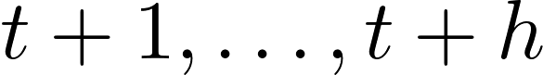 (target) and 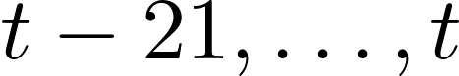 (HAR lags).

3.3 Limitations
VOLARE has no SPY or index series—only ES among S&P 500 instruments—and is refreshed monthly (ES ends 30 September 2026). The ES day is inferred as 18:00–17:00 ET from the data and the VOLARE paper’s session description; roll dates are not flagged. We lack limit-order-book and news-text features (central to Rahimikia & Poon) and OptionMetrics firm-level implied vol (used by Christensen et al.). SPY intraday RV omits the overnight move (~56% of close-to-close variance); ES captures about 95%, which is why it is the preferred target for the variance-swap check.

4. Methodology
Forecasts are produced daily for horizons 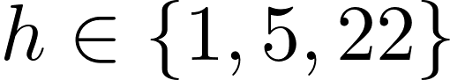 trading days. Figure 1 summarises the pipeline. Throughout,  denotes realized variance on day , built from  intraday returns 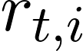 (Andersen, Bollerslev, Diebold & Labys, 2003):
 | 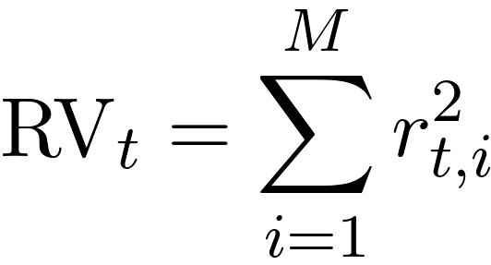 | (1)

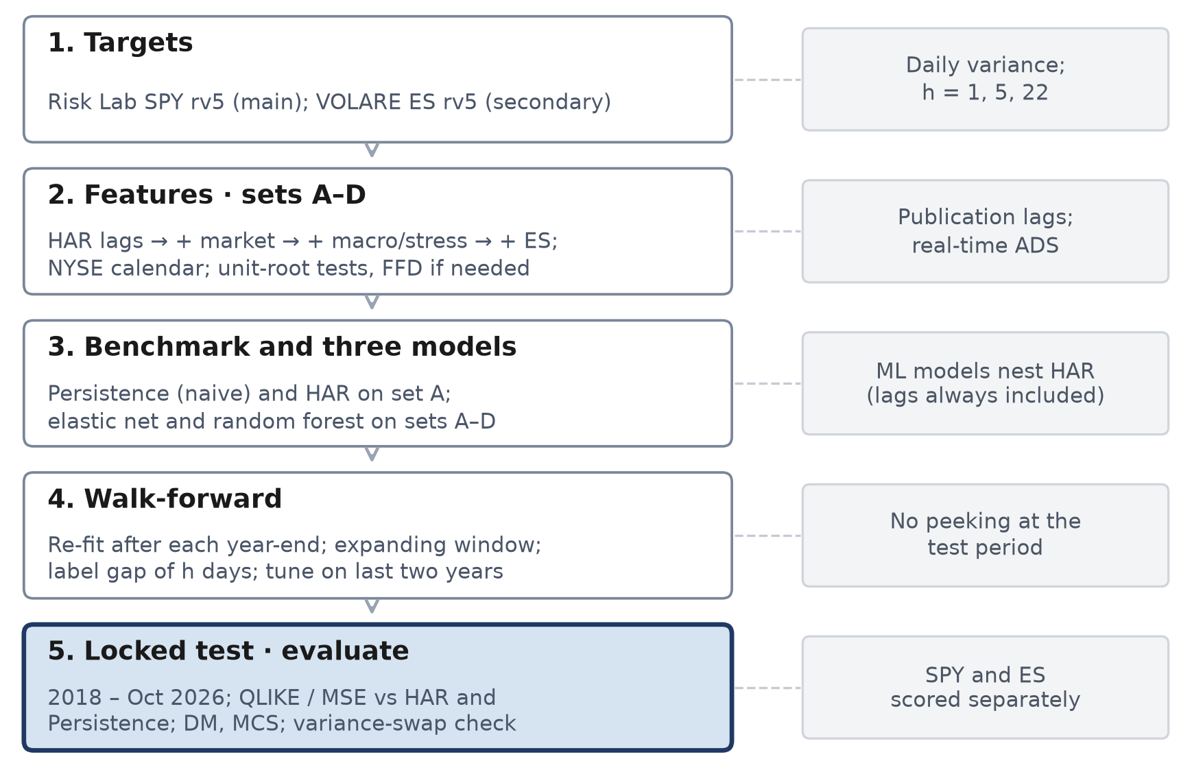
Figure 1. Forecasting pipeline. Persistence and the three models share targets, feature sets and the walk-forward engine; only the fitting step differs.

4.1 Targets
For SPY, Risk Lab reports an annualized volatility 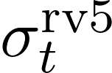; we convert it to daily variance and form horizon averages:
 | 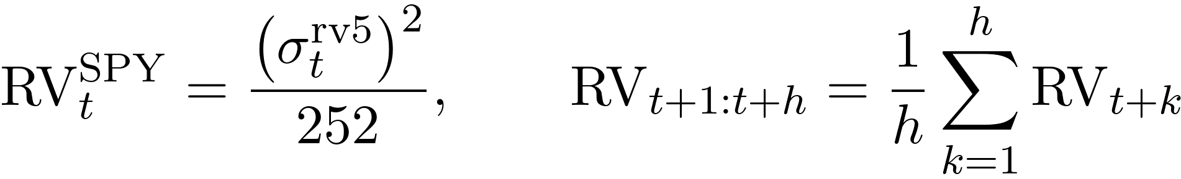 | (2)

For ES, VOLARE rv5 is already a daily variance of 5-minute mid-quote returns over the Globex session. Any linear forecast below the training-window minimum RV is floored at that minimum (Christensen et al., 2023).

4.2 Nested feature sets
Set | Contents | First date
A: HAR lags | Daily, weekly (5-day) and monthly (22-day) RV averages; optional 15-min RV and QMLE | Jan 2005
B: + market | A + negative-return averages, Parkinson range, log VIX, IV surface (ATM/skew/slope), VRP, rates; short-dated IV/VVIX when available | Jan 2005; VVIX, VIX3M, VIX9D from their start +
C: + macro/stress | B + ADS, EPU, news sentiment, GPR, CISS, NFCI, STLFSI4, Hang Seng, calendar flags | Jan 2005; real-time ADS from Dec 2008 +
D: + ES measures | C + ES continuous/jump averages, ±semivariances, √quarticity×RV, realized kernel, overnight variance max(ES−SPY,0) | Jan 2010 (+ where FFD applies)

HAR is estimated on set A only. On set A the elastic net is a regularized HAR; on sets B–D both ML models receive the HAR lags plus extras, so they nest HAR. Comparing each ML model's gain from A to B–D answers RQ2. Jump, semivariance and quarticity measures enter as features, not as separate HAR-J / SHAR / HARQ models. From the VOLARE bipower variation  and signed semivariances, the set-D jump and downside inputs are
(3)

4.3 Stationarity and long memory
Both ML models learn a mapping on the training window and apply it to later years, so their inputs must behave similarly in both. Many do not. VIX, rate and stress levels are close to unit-root processes, and RV and log RV are highly persistent, with autocorrelations that decay slowly (long memory). When an input drifts, test-period values can fall outside the training range: a random forest cannot extrapolate beyond the leaf values it has seen, and elastic-net coefficients fitted to trending, correlated levels change from one re-estimation to the next. Integer differencing restores stationarity but removes the memory: first differences of RV discard the slow persistence that HAR's weekly and monthly averages exploit. Fractional differencing (López de Prado, 2018, ch. 5) is the middle ground. With the lag operator , defined by 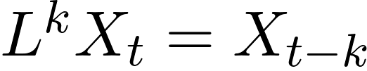, and order 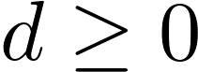,
(4)

For  the weights are  (ordinary differences); for  they decay slowly, so part of the memory survives. The fixed-width-window version (FFD) truncates the weights once they fall below a threshold , so every observation is built from the same window, and  is set to the smallest grid value that passes the ADF test at 95%:
(5)

- Diagnose. ADF (null: unit root) and KPSS (null: stationarity) on every target and input, in levels and in logs where relevant, on the development sample only (2005–2017; 2010–2017 for ES and set D). The two are read together: Bhatti (2026) notes that ADF usually declares stationarity after one difference even when long memory remains, while KPSS keeps rejecting under strong persistence, and that neither identifies the minimal .
- Memory of log RV. We estimate for log RV with a standard local Whittle estimator and with Bhatti's detectability-boundary estimator: a log–log regression of the ACF tail (lags 20–200) over a grid of . In his Monte Carlo the boundary sits below the true order by a resolution limit 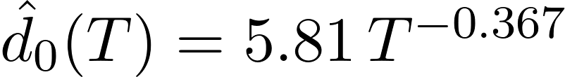 (0.30 at ), and short windows bias it downward (at least about 2,000 observations are needed to track the memory structure). For our 3,272-day SPY development sample the offset is therefore about 0.3, and the 2,013-day ES window is near his minimum. Estimates are reported with that caveat. He also finds that extended Whittle estimates collapse near 1 on equity log-prices, so frequency-domain estimates are treated as a cross-check, not as the choice of .
- Transform. Each input that fails the tests enters the ML models as FFD with its 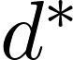, chosen on each training window's data only and re-chosen at every walk-forward re-fit, with and the grid  fixed in advance; weights run over NYSE sessions. We report and the correlation between 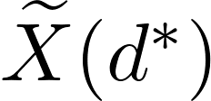 and the original series, i.e. the memory retained.
- What stays raw. The target is never transformed. HAR on raw RV lags remains the benchmark, and the same raw lags enter both ML models, so they still nest HAR. Inputs that pass both tests are left unchanged.
- Robustness. An FFD variant of sets A–D, in which the ML lag block is replaced by FFD log RV, is compared with the main specification. MATLAB: adftest and kpsstest; FFD weights are coded directly (the book's examples are in Python).

4.4 Benchmarks and comparison grid
Two simple benchmarks sit beside the three models; neither is estimated. Persistence is the naive benchmark: the coming -day average equals the latest -day average of realized variance, so for tomorrow's forecast is today's variance:
 | 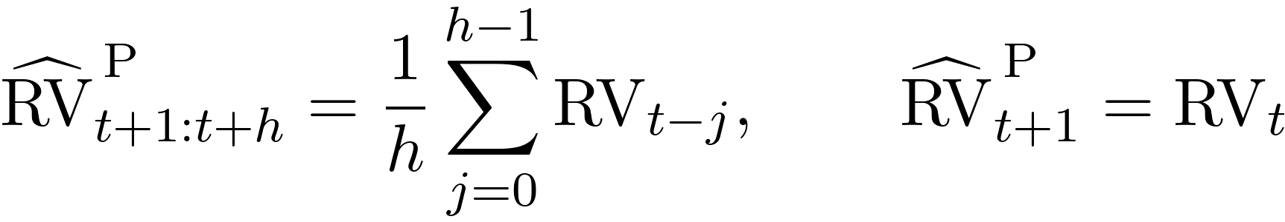 | (6)

It is the floor every forecast must clear, including HAR. The VIX-implied strike is the market benchmark, used only in the variance-swap check (Section 6).
Forecast | Type | Inputs | Estimation | Owner
Persistence | Naive benchmark | Latest RV only | None | James
HAR | Model 1 | Set A | OLS per horizon | James
Elastic net | Model 2 | Sets A–D | Penalized regression, tuned | Aryan
Random forest | Model 3 | Sets A–D | Bagged trees, tuned | Aryan
VIX² strike | Market benchmark | VIX | None; variance-swap check only | All

4.5 Model 1: HAR
One ordinary-least-squares specification per horizon, on the variance scale (Corsi, 2009):
 | 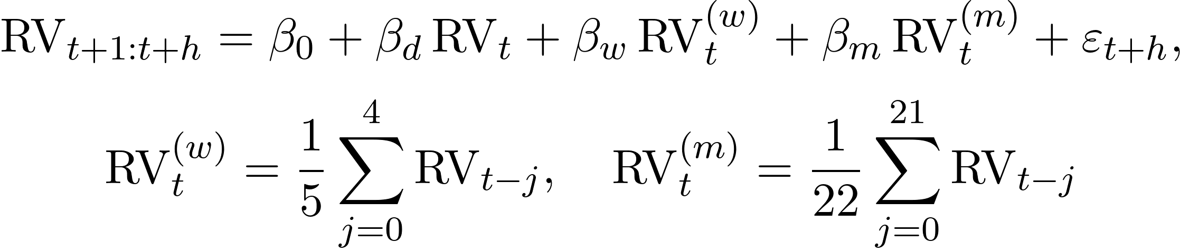 | (7)

Four parameters, estimated in milliseconds, and the literature’s standard benchmark.

4.6 Model 2: Elastic net
Penalized linear regression on the active feature set , with target 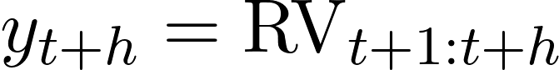:
 | 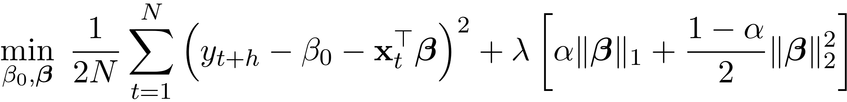 | (8)

The mixing parameter  blends ridge () and lasso (); and the overall penalty  are tuned, so ridge and lasso are special cases rather than separate models. Kılıç (2026) uses elastic net to select predictors; we report the selected coefficients as a result. MATLAB: fitrlinear / lasso with the Alpha option.

4.7 Model 3: Random forest
An average of many regression trees, each grown on a bootstrap sample and a random subset of features (MATLAB TreeBagger or fitrensemble with Bag). Trees capture interactions and regimes, need little tuning and supply impurity-based importance; Christensen, Siggaard & Veliyev (2023) find random forests among the best performers even with defaults. With  trees , the forecast is
 | 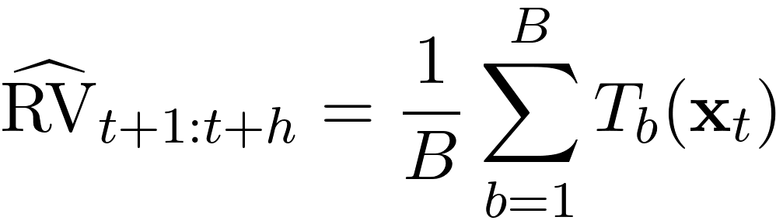 | (9)

4.8 What we do not estimate
LogHAR, LevHAR, HAR-X, HAR-J/CJ, SHAR, HARQ,  as a forecasting model, gradient boosting, neural nets, LSTMs and forecast combinations are out of scope. remains the market strike in the variance-swap test (Section 6), not a competing forecast. If time permits after the design is locked, one boosting run on the winning feature set may be added as an exploratory check.

5. Validation Design
Days are never shuffled, and every date below is an NYSE session.
- Boundaries. SPY: development origins 3 Jan 2005 – 29 Dec 2017; locked-test origins from 2 Jan 2018 to the last session whose -day target ends by 5 Oct 2026. ES and set D: development 4 Jan 2010 – 29 Dec 2017; test targets end by 30 Sep 2026.
- Re-estimation dates. After the close of the last session of year  (date ), every model is re-fitted on all data through (expanding window from 2005 for SPY, 2010 for ES / set D) and used unchanged for every origin in year . The locked test therefore has nine re-fits, at the last sessions of 2017 through 2025. Development pseudo-out-of-sample years use the same rule once the window holds five years (SPY 2010–2017, ES 2015–2017).
- Tuning. Hyperparameters are chosen by fitting on the window minus its last two years and validating on those two years; the model is then re-fitted on the whole window. and standardization use the training window only.
- Label gap. A row with origin  is used in the re-fit at only if its target has been observed, so the last origins of each window (1, 5 or 22 rows) are dropped, and the same gap separates the inner fit from the two tuning years:
(10)

A rolling 10-year window (8-year for ES) is the robustness check. Availability timing. The forecast origin is the end of NYSE day ; an input dated enters only if it is published by then, and later releases are shifted:
Input | Value for day t is known | Shift (sessions)
Risk Lab SPY RV; S&P 500 OHLC; Cboe VIX family, VVIX, VXN, VXD, RVX; Bloomberg IV surface | End of day t (built from day-t prices) | 0
VOLARE ES measures | 17:00 ET on t (Globex session close) | 0
Hang Seng | 16:00 HKT = 04:00 ET on t, before the NYSE open | 0
Treasury T10Y3M, DGS10 | Late afternoon / evening of t | 0
EPU | Morning of t+1 | 1
ECB CISS | About one business day later; recent tail revised | 2
SF Fed news sentiment; classic daily GPR | Weekly updates, up to about a week | 5
AI-GPR | Monthly updates | About 1 month (or use classic GPR)
ADS | Real-time vintage released strictly before t | Built in
NFCI, STLFSI4 | Weekly; placed on release date (week-ending Friday + 6 days) | Built in
Fama–French factors | About 1 month later | Not used

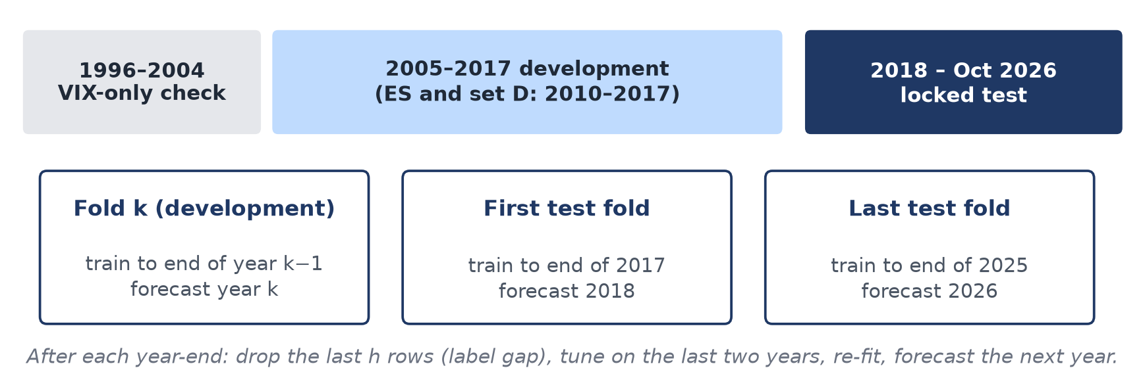
Figure 2. Expanding-window walk-forward. The 2018–2026 block is evaluated once, after every design choice is frozen.
The test period is examined once; anything changed afterwards is labelled exploratory.

6. Evaluation
All scores are strictly out of sample, computed on the same origins for every forecast, and reported for development pseudo-OOS and for the locked test.
Area | Metrics
Statistical accuracy | MSE and QLIKE on the variance scale (QLIKE primary; Patton, 2011); MAE; out-of-sample R² vs training mean
Significance | Diebold–Mariano tests with Newey–West variance and HLN correction, against HAR and against Persistence; Model Confidence Set at 10% over Persistence, HAR, EN and RF (Hansen, Lunde & Nason, 2011)
Attribution | Loss ratios vs HAR (set A) and vs Persistence by feature set and horizon; RF-minus-EN change in loss from set A to B, C and D (difference-in-differences, RQ2); calm vs high-RV regimes; stress episodes (Feb 2018, 2020, 2022, Apr 2025)
Economic value | Realized utility of a volatility-targeting rule (Bollerslev et al., 2018); stylized variance-swap P&L vs VIX² using ES-target forecasts
Robustness | Rolling window; Risk Lab 15-min and QMLE; ES rv1 / kernel / holiday-drop; Oxford-Man pre-2010 jump features; 1996 VIX-only start

With forecast 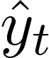 of realized variance  over  test days, the two losses are (Patton, 2011):
 | 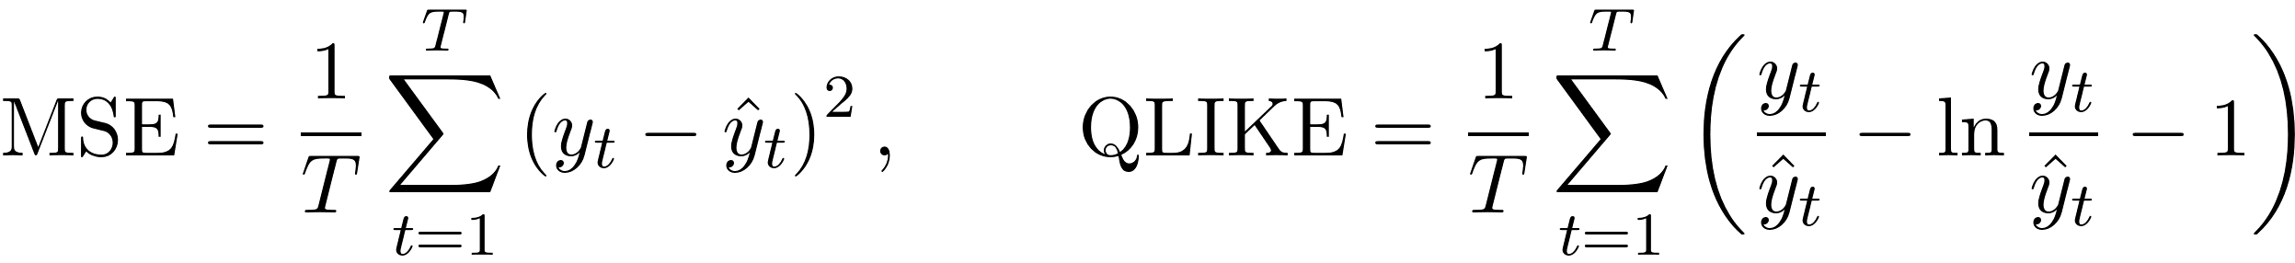 | (11)

For RQ2, with 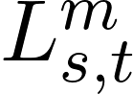 the daily loss of model  on feature set , the Diebold–Mariano test is applied to the difference-in-differences series
 | 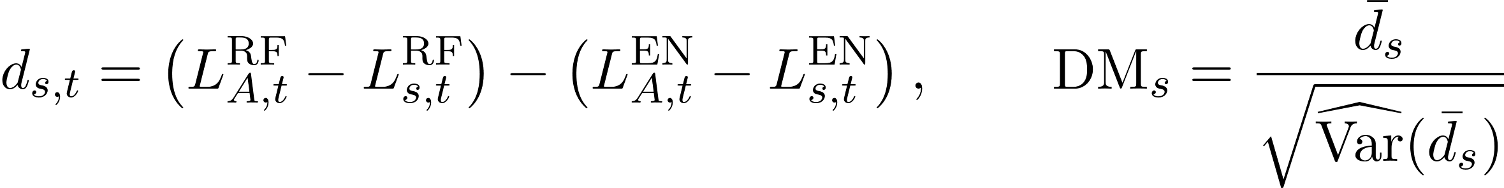 | (12)

where 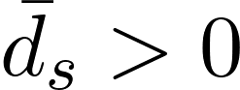 means the random forest gains more than the elastic net. The variance-swap check compares a one-month forecast with the strike 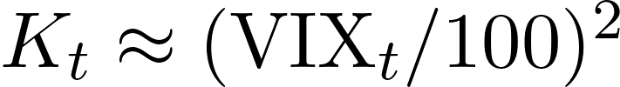; selling one unit of variance pays
(13)

Success criterion. On the locked test we treat the design as successful if elastic net or random forest delivers statistically lower QLIKE than HAR at at least one horizon, with the MCS including the winner, and if the variance-swap check is directionally consistent. For RQ2, the question is answered either way by the sign and significance of the RF-minus-EN gain from set A to B–D. A well-documented failure to beat HAR is also a legitimate outcome (aligned with Kılıç’s conclusion). Persistence is reported as the floor: a model that does not beat it is reported as uninformative at that horizon.

7. Risks and Mitigations
Risk | Why it matters | Mitigation
Look-ahead bias | Inflated accuracy from unpublished inputs | Publication-lag table; real-time ADS; train-only preprocessing; locked test
Overfitting a flexible model | HAR plus two ML models on four sets × three horizons still invite data mining | Nested sets; MCS/DM; freeze design before the test; exploratory label for later ideas
ES session and sample | Shorter history (no 2008 in set D); mid-quotes; inferred 18:00–17:00 day | SPY remains main target; Oxford-Man pre-2010 check; holiday-row robustness
Over-differencing or look-ahead in choosing d | Too large a d erases the memory HAR uses; choosing d on the full sample leaks test information; short windows bias d estimates downward (Bhatti, 2026) | Smallest d that passes ADF, re-chosen inside each training window; report retained correlation; raw HAR lags kept; FFD variant as robustness
Missing SPY days in test | 33 test sessions absent from Risk Lab, including the Feb 2018 week | Never impute targets; treatment decided from the measured counts (Section 3.2); score ES-target models on those days
Overnight mismatch | SPY RV understates close-to-close variance | ES secondary target for variance-swap payoff; rescale SPY forecasts in that check only
Scope for one semester | A large model menu would not finish | Three models plus two unestimated benchmarks; build Persistence and HAR end-to-end first, then elastic net on A, then expand

8. Implementation Plan
Work proceeds in thin slices: Persistence and HAR on set A end to end, then elastic net and random forest, then richer feature sets, so each phase leaves a runnable pipeline. Figure 3 shows the sequence; the locked test runs only after settings are frozen.
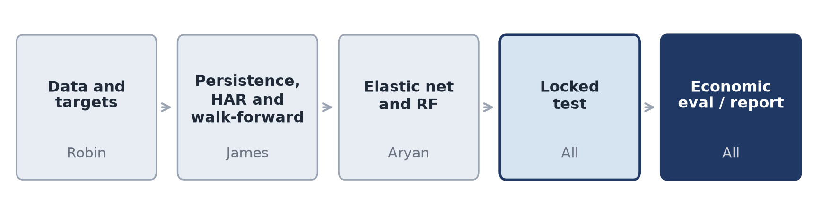
Figure 3. Sequence of work. Settings are locked after evaluation on the development period and before the final test.
Task | MATLAB tools
Targets, Persistence and HAR lags | Custom scripts; timetable alignment on the NYSE calendar
Stationarity and FFD | adftest / kpsstest; FFD weights and d search coded directly
Elastic net | fitrlinear / lasso (Alpha mixes ridge and lasso)
Random forest | TreeBagger or fitrensemble (Bag)
Tuning | bayesopt / OptimizeHyperparameters on the last two training years
Evaluation and explanation | Custom losses; Diebold–Mariano; MCS; shapley; ALE

Team member | Lead responsibility | Focus
Robin | Risk Lab and VOLARE ES targets, feature alignment and publication lags, data dictionary, QC | Data
James | Persistence and HAR; walk-forward engine; DM tests and Model Confidence Set | RQ1 benchmarks
Aryan | Elastic net and random forest, tuning, coefficients and feature importance | RQ1–RQ2 ML
All | Volatility-timing utility, variance-swap comparison, report and presentation | RQ3 / write-up

Outputs: MATLAB code that regenerates every table from the cleaned inputs; a final report on RQ1–RQ3; slides; and the data package (features_daily.csv, VOLARE ES file with README/QC), already largely complete. Tentative calendar: data lock mid-October; Persistence, HAR and first ML baseline by end-October; full sets A–D and ES runs by mid-November; locked test late November; economic checks and write-up through early December.

References
Andersen, T. G., Bollerslev, T., Diebold, F. X., & Labys, P. (2003). Modeling and forecasting realized volatility. Econometrica, 71(2), 579–625.
Aruoba, S. B., Diebold, F. X., & Scotti, C. (2009). Real-time measurement of business conditions. Journal of Business & Economic Statistics, 27(4), 417–427.
Baker, S. R., Bloom, N., & Davis, S. J. (2016). Measuring economic policy uncertainty. Quarterly Journal of Economics, 131(4), 1593–1636.
Bhatti, Angad singh (2026). Finite-Sample Long-Memory Estimation via Detectability Boundaries. Working paper, Fordham University, February 2026.
Bollerslev, T., Hood, B., Huss, J., & Pedersen, L. H. (2018). Risk everywhere: Modeling and managing volatility. Review of Financial Studies, 31(7), 2730–2773.
Bollerslev, T., Patton, A. J., & Quaedvlieg, R. (2016). Exploiting the errors: A simple approach for improved volatility forecasting. Journal of Econometrics, 192(1), 1–18.
Carr, P., & Wu, L. (2009). Variance risk premiums. Review of Financial Studies, 22(3), 1311–1341.
Christensen, K., Siggaard, M., & Veliyev, B. (2023). A machine learning approach to volatility forecasting. Journal of Financial Econometrics, 21(5), 1680–1727.
Cipollini, F., Cruciani, G., Gallo, G. M., Insana, A., Otranto, E., & Spagnolo, F. (2026). VOLatility Archive for Realized Estimates (VOLARE). arXiv:2602.19732.
Corsi, F. (2009). A simple approximate long-memory model of realized volatility. Journal of Financial Econometrics, 7(2), 174–196.
Diebold, F. X., & Mariano, R. S. (1995). Comparing predictive accuracy. Journal of Business & Economic Statistics, 13(3), 253–263.
Hansen, P. R., Lunde, A., & Nason, J. M. (2011). The model confidence set. Econometrica, 79(2), 453–497.
Kılıç, R. (2026). Linear and nonlinear econometric models against machine learning models: Realized volatility prediction (FEDS 2025-061r1). Board of Governors of the Federal Reserve System.
López de Prado, M. (2018). Advances in Financial Machine Learning. Hoboken, NJ: Wiley (Chapter 5: Fractionally Differentiated Features).
Lundberg, S. M., & Lee, S.-I. (2017). A unified approach to interpreting model predictions. Advances in Neural Information Processing Systems, 30.
Patton, A. J. (2011). Volatility forecast comparison using imperfect volatility proxies. Journal of Econometrics, 160(1), 246–256.
Patton, A. J., & Sheppard, K. (2015). Good volatility, bad volatility: Signed jumps and the persistence of volatility. Review of Economics and Statistics, 97(3), 683–697.
Rahimikia, E., & Poon, S.-H. (2026). Machine learning for realised volatility forecasting. SSRN Working Paper 3707796 (revised 22 January 2026).
Data sources: Dacheng Xiu, Risk Lab (research use); VOLARE (volare.unime.it), ES measures downloaded 4 October 2026 (research use); Oxford-Man Institute Realized Library (archived mirror); Cboe; FRED; Federal Reserve Bank of Philadelphia (ADS); ECB (CISS); SF Fed news sentiment; Caldara–Iacoviello GPR; Kenneth R. French Data Library; Yahoo Finance; Bloomberg; CRSP via WRDS.

