Pricing FN FS9548: Agency and Private-Label MBS Valuation
  - Fixed Income Securities (QFGB-8931), Final Project, Spring 2026 (revised edition)
James Huang
- Security: FN FS9548 Mtge (CUSIP 3140XRTE5), Fannie Mae UMBS conventional 15-year pool
- Valuation date: 30 April 2026 (Bloomberg BVAL, NY 4pm bid)
- Method: discrete monthly Monte Carlo, 10,000 interest-rate paths, implemented in Python (notebooks/) with a formula-by-formula Excel walk-through of one path (excel/)

Executive Summary
FN FS9548 is valued under two guarantee assumptions. In Part I the U.S. government guarantees timely payment of principal and interest, so the only risks are interest-rate and prepayment risk. In Part II the guarantor is a private financial institution rated A by S&P, so the cash flows also carry the guarantor’s credit risk.
The model simulates 10,000 monthly one-month Treasury rate paths. Their drift is calibrated so that the paths reprice the 30 April 2026 Treasury zero curve exactly, and their volatility (25.2 bp per month) comes from ten years of month-end 10-year Treasury yields. Prepayments follow Bloomberg’s projected 178 PSA, adjusted on each path for the simulated change in rates. Each path’s cash flows are discounted with that path’s own cumulative discount factors on the actual payment dates, and the security’s value is the average across paths.
 | Part I: agency | Part II: private label (A)
Model value, clean, per 100 | 98.198 | 98.090
Monte Carlo standard error | 0.0003 | 0.0003
BVAL bid, clean | 97.738 | 97.738
Model − market | +0.460 | +0.352
OAS implied by the bid | 25.7 bp | 19.7 bp
Part I. At a zero spread to Treasuries the model value is 0.46 points above the BVAL bid. Put differently, the market price implies an option-adjusted spread of about 26 bp, against 17.9 bp on Bloomberg’s own model (BAM TOAS). A positive OAS is normal for agency MBS, so the security is fairly priced to slightly cheap, not mispriced. That conclusion is not certain. Across 100–300 PSA the OAS ranges from 18 bp to 39 bp, so the verdict depends mainly on the prepayment assumption. Simulation noise is no longer a factor.
Part II. With a 0.10% annual default probability and 40% recovery for the A-rated guarantor, the expected cash-flow adjustment lowers the value by 0.11 points (about 6 bp of spread). The private-label value stays above today’s agency price unless the guarantor’s annual PD exceeds about 0.43%. Default probabilities implied by market credit spreads for A-rated financials typically exceed that level, so the credit adjustment shown here is a lower bound.
Revision note. This edition corrects the submitted report. The submitted model concluded the security was rich (model 97.49 vs. market 97.74). That conclusion came mainly from discounting at the 10-year Treasury yield instead of the Treasury curve over the pool’s 1.9-year average life, and from using only 100 random paths. The bridge in Section 5 reconciles the two results step by step.

1. Security Description and Data
Input | Value | Use in the model
Pass-through coupon | 3.000% | Investor interest
WAC | 3.448% | Borrowers’ scheduled payment
WAM (WARM) / WALA | 52 / 125 months | Projection horizon / PSA seasoning
Original / current balance | $5,238,307 / $2,986,518 | Factor 0.57013048
Payment delay | 54 days (paid on the 25th of the following month) | Payment-date discounting
Bloomberg projected prepayment | 178 PSA (10.68% CPR) | Base case
Realised speeds | 1m 27.0%, 3m 20.1%, 6m 17.1%, 1y 15.5% CPR | Sensitivity
BVAL price | 97-23⅝ bid / 97-25⅝ ask | 97.73828 (clean)
BVAL yield / WAL / I-spread | 4.184% / 1.9 yrs / 31 bp | Cross-check
Bloomberg BAM TOAS | 17.9 bp | Benchmark for the OAS
Treasury actives curve | 3m 3.655%, 6m 3.673%, 1y 3.704%, 2y 3.883%, 5y 4.021%, 10y 4.387% | Zero curve
The BVAL bid of 97-23⅝ converts to $97+23.625/32=97.73828$. BVAL prices are clean. Settlement on 30 April carries 29 days (30/360) of accrued interest, $3\%/12×29/30×100=0.2417$. The model value of the cash flows is therefore a full price, and accrued interest is subtracted before comparing with the quote. The pool is a Fannie Mae Super pool issued in October 2024 from 2015-vintage 15-year loans. The “original WAM” of 64 months on the screen refers to the Super pool at issue, not to the underlying loans.

2. Part I Methodology: Agency MBS

2.1 Interest-rate paths (Step 1)
Volatility. Month-end GT10 yields from May 2016 to April 2026 give 119 monthly changes. Their sample standard deviation is
$$σ_{monthly}=\text{stdev}(y_{t}−y_{t−1})=0.2521\% (25.2\text{ bp, or }87\text{ bp annualised}).$$
The 5 May 2026 print in the raw Bloomberg export is excluded because it falls after the valuation date and is not a month-end.
Treasury zero curve. Bills (3m, 6m, 1y) are treated as zero-coupon yields. From 1.5 to 5 years, par yields are linearly interpolated and discount factors are bootstrapped from the par-bond condition 1=yn2k<n​P(tk)+(1+yn2)P(tn). Monthly discount factors $P(0,t)$ come from linear interpolation of continuously compounded zero rates.
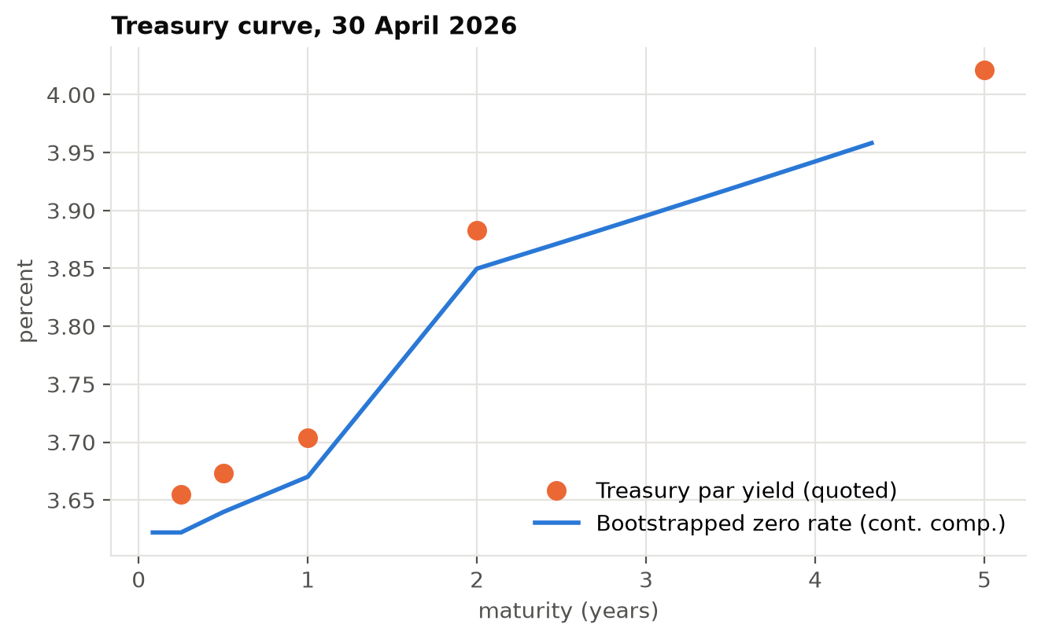
Treasury par yields and the bootstrapped zero curve
Short-rate model. Let $r_{k}$ be the annualised one-month rate from month $k$ to $k+1$:
$$r_{k}^{(i)}=max\left(0, θ_{k}+σW_{k}^{(i)}\right), W_{k}^{(i)}=\sum_{j=1}^{k}{ε_{j}^{(i)}}, ε∼N(0,1).$$
The starting rate $r_{0}$ is the one-month rate implied by the zero curve. Each drift term $θ_{k}$ is solved month by month so that the average simulated discount factor equals the Treasury discount factor, 1Ni​j=0k(1+rj(i)/12)−1=P(0,k+1). The maximum calibration error is ${10}^{−13}$. Without this calibration, a driftless random walk prices even a Treasury strip incorrectly. With it, the model is arbitrage-free against Treasuries, which is the adjustment Fabozzi describes for Monte Carlo MBS models. The simulation uses 10,000 paths (5,000 antithetic pairs) with a fixed random seed, and the same paths are used for every scenario.
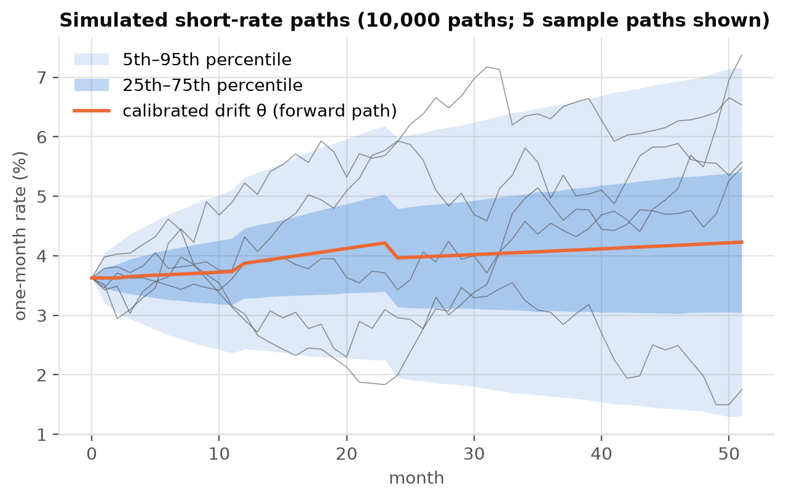
Simulated short-rate paths

2.2 Prepayment model (Step 2)
The PSA benchmark sets $CPR_{t}=6\%×min(age_{t},30)/30$ at 100 PSA, and the monthly rate is $SMM_{t}=1−(1−CPR_{t})^{1/12}$. At a WALA of 125 months the pool is fully seasoned, so 178 PSA gives a $10.68\%$ CPR and an SMM of $0.9368\%$.
Why 178 PSA. It is Bloomberg’s forward projection for this pool. Realised speeds have been faster (258 PSA over the past year). The pool’s 3.45% WAC, however, is far below current mortgage rates, so refinancing is uneconomic and prepayments come mainly from housing turnover. A forward projection below recent realised speeds is therefore reasonable, and 258 PSA is included as a sensitivity.
Refinancing overlay. A pure PSA model gives the same cash flows on every path. With Treasury-calibrated paths the Monte Carlo value then collapses to simple discounting on the zero curve, and the prepayment option is worth nothing. The assignment asks for cash flows along each path, so the speed in month $t$ responds to the simulated change in long rates, $Δ_{t}=σW_{t−1}$:
$$PSA_{t}=178\%×min\left(1.75, max\left(0.75, 1−β Δ_{t}/1\%\right)\right), β=0.20.$$
A 100 bp rally raises the speed to about 214 PSA, and a 100 bp sell-off slows it to about 142 PSA (lock-in). The response is deliberately modest because even a 150 bp rally leaves this pool out of the money.

2.3 Monthly cash flows (Step 3)
For each path $i$ and month $t=1,…,52$, with beginning balance $B_{t−1}$ and remaining term $n_{t}=53−t$:
Item | Formula
Scheduled payment | $PMT_{t}=B_{t−1} \frac{WAC/12}{1−(1+WAC/12)^{−n_{t}}}$
Investor interest | $B_{t−1}×3.00\%/12$
Scheduled principal | $PMT_{t}−B_{t−1} WAC/12$
Prepayment | $SMM_{t} (B_{t−1}−{\text{scheduled principal}}_{t})$
Cash flow to investor | investor interest + scheduled principal + prepayment
Ending balance | $B_{t}=B_{t−1}−{\text{scheduled principal}}_{t}−{\text{prepayment}}_{t}$
The 0.448% gap between the WAC and the coupon is the servicing and guarantee fee, retained before cash reaches investors. The Excel workbook rebuilds path 1 with these formulas. Its price matches the Python price exactly.
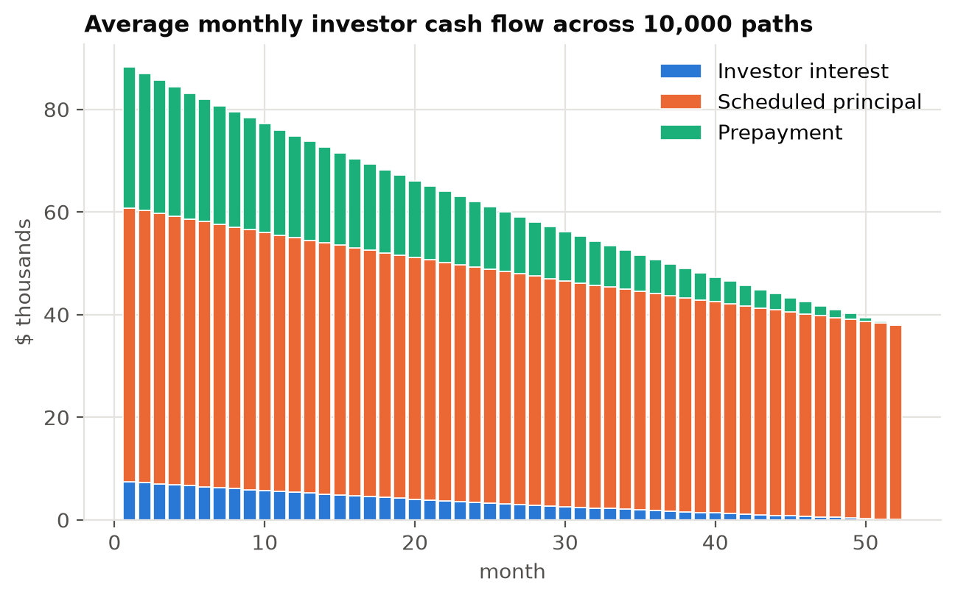
Average monthly investor cash flow by component

2.4 Discounting and valuation (Step 4)
Each path is discounted with its own cumulative short-rate discount factors, evaluated on the actual payment date: the 25th of the month after the accrual month, or $25/30$ of a month after the end of month $t−1$.
$$DF_{t}^{(i)}=\prod_{k=0}^{t−2}{\frac{1}{1+r_{k}^{(i)}/12}}×{\left(1+\frac{r_{t−1}^{(i)}}{12}\right)}^{−25/30}, PV^{(i)}=\sum_{t=1}^{52}{C}F_{t}^{(i)} DF_{t}^{(i)}, V=\frac{1}{N}\sum_{i=1}^{N}{P}V^{(i)}.$$
Value per 100 is $V/B_{0}×100$ (a full price). The clean price is that minus 0.2417 of accrued interest.

3. Part I Results
Result | Value
Model value, full / clean | 98.4397 / 98.1980
Standard error (95% interval) | 0.0003 (98.1975 – 98.1985)
BVAL bid / mid | 97.7383 / 97.7695
Model − bid / model − mid | +0.4597 / +0.4285
OAS at bid / at mid | 25.7 bp / 23.9 bp
Bloomberg BAM TOAS | 17.9 bp
Effective duration / convexity (±25 bp) | 1.79 years / +5.5
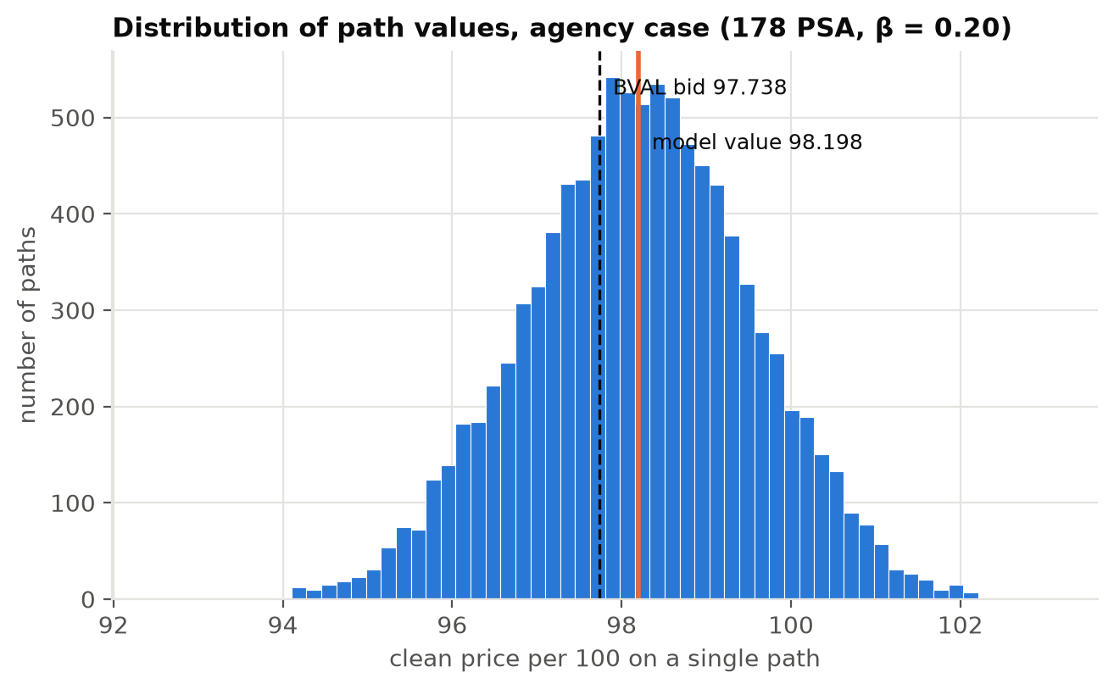
Distribution of single-path values
Sensitivity. All rows use the same 10,000 paths (common random numbers), so differences reflect only the assumption that changed:
Prepayment speed | Clean value | Model − bid | OAS at bid
100 PSA | 98.087 | +0.348 | 18.2 bp
150 PSA | 98.159 | +0.420 | 22.9 bp
178 PSA (base) | 98.198 | +0.460 | 25.7 bp
200 PSA | 98.229 | +0.490 | 27.9 bp
258 PSA (1-year realised) | 98.307 | +0.569 | 34.1 bp
300 PSA | 98.362 | +0.624 | 38.8 bp

Other assumption | Clean value | OAS at bid
β = 0 (pure PSA, no option) | 98.231 | 27.5 bp
β = 0.4 | 98.188 | 25.2 bp
Volatility × 0.5 / × 1.5 | 98.221 / 98.169 | 26.9 / 24.1 bp
The value rises monotonically with the prepayment speed. That is expected for a discount security (price below par): faster prepayments return principal at par sooner. The refinancing option costs about 3 cents (98.231 vs. 98.198), and a higher volatility lowers the value, which is consistent with the investor being short a prepayment option. Both effects are small because the pool is deeply out of the money.
Is the security fairly priced? Are we sure? At a zero spread to Treasuries the model value exceeds the market price by 0.46 points, so the security is cheap relative to Treasuries. That is normal for agency MBS. The spread compensates investors for liquidity, model risk and prepayment uncertainty, so the right comparison is the OAS against what similar pools earn. The market-implied OAS of about 26 bp is roughly 8 bp wider than Bloomberg’s own estimate, which points to fair to slightly cheap. We cannot be sure. The OAS spans 18–39 bp across plausible prepayment speeds, Bloomberg’s model differs from ours in its prepayment function and curve, and β and the volatility are assumptions. Simulation error, by contrast, is now negligible (standard error 0.0003).

4. Part II: Private-Label MBS

4.1 Credit inputs
The guarantor is a hypothetical A-rated financial institution. Its credit inputs:
- Annual PD: 0.10%. S&P’s long-run studies show ‘A’ issuers defaulting at roughly 0.05% over one year and about 0.4–0.5% cumulatively over five years. That is about 0.1% per year over this pool’s 52-month life.
- Recovery: 40%. This is the standard senior unsecured assumption.
- Hazard: constant, so survival is $S_{t}=(1−PD)^{t/12}$. The monthly PD is $0.008337\%$, and the cumulative PD over 52 months is $0.433\%$.

4.2 Expected cash flows
If the guarantor survives month $t$, the investor receives the promised cash flow. If it defaults during month $t$, the investor recovers $R$ times the outstanding principal claim and nothing afterwards:
$$E[CF_{t}]=S_{t} CF_{t}+(S_{t−1}−S_{t}) R B_{t−1}.$$
The expected cash flows on each path are discounted with the same path discount factors as in Part I. Correction: the submitted model used $CF_{t}(S_{t}+R q_{t})$, which applies recovery to a single month’s cash flow instead of to the outstanding balance. It also valued Part II on a different random draw from Part I, which is why its private-label price (97.5371) came out above its agency price. Here both parts use identical paths, so the private-label value is always below the agency value.

4.3 Results
Result | Value
Private-label value, clean | 98.0899
Agency value, clean | 98.1980
Credit discount | 0.108 points (≈ 6.0 bp of spread)
Private-label value − BVAL bid | +0.352
OAS at the BVAL bid | 19.7 bp
Break-even annual PD (value = BVAL bid) | 0.43%

Annual PD | R = 25% | R = 40% | R = 60%
0.05% | 98.130 | 98.144 | 98.162
0.10% | 98.062 | 98.090 | 98.127
0.25% | 97.859 | 97.928 | 98.020
0.50% | 97.522 | 97.659 | 97.842
1.00% | 96.851 | 97.125 | 97.489
2.00% | 95.527 | 96.069 | 96.791
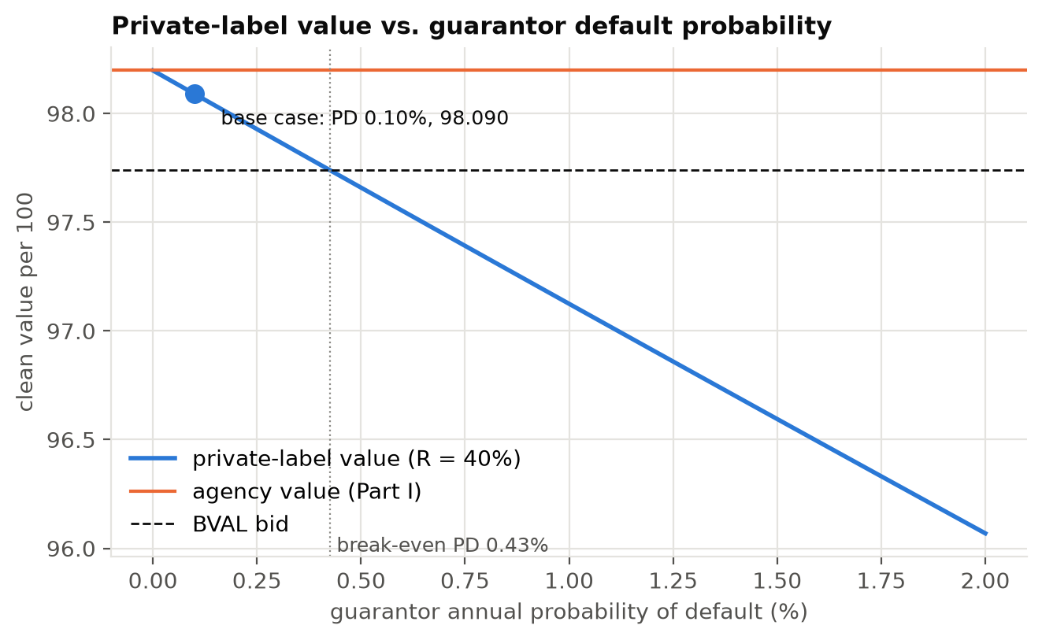
Private-label value against guarantor default probability
Comment. Using historical A-rated default rates, the credit adjustment is small: about 0.11 points. Two things keep it small. The pool’s remaining life is short (WAL 1.9 years), and 40% of the outstanding claim is recovered on default. On these assumptions a private-label version would still value above the agency’s market price. The conclusion is, however, very sensitive to the default probability. A PD of 0.43% a year or more is enough to push the value below 97.74. Market-implied PDs for A-rated financials, backed out from CDS or bond spreads, are usually well above that, because spreads also price default risk premia and illiquidity. The expected cash-flow approach also ignores wrong-way risk: a mortgage guarantor is most likely to fail in a housing downturn, which is exactly when its guarantee is needed. On a risk-neutral basis a private-label version of this pool should therefore trade at a discount to the agency pool of at least several tenths of a point.

5. Reconciliation with the Submitted Model
The submitted Excel model reported 97.49 (rich). Starting from that method run with 10,000 paths, the bridge below changes one element at a time:
Step | Value per 100
Submitted method: 10-year-yield random walk from 4.387%, $DF=(1+r_{t}/12)^{−t}$ | 97.511
+ path-wise cumulative discount factors | 97.488
+ short-rate paths calibrated to the Treasury zero curve | 98.419
+ actual payment dates (25th of following month) | 98.473
− accrued interest (clean compared with clean) | 98.231
+ refinancing overlay (path-dependent cash flows) = final | 98.198
The discount curve drives the change. The submitted model discounted every cash flow at rates drifting around the 10-year yield (4.39%). A security with a 1.9-year average life should be discounted on the 0–4 year part of the curve (3.6–4.0%), and that alone moves the value by about +0.9. Separately, 100 random paths are far too few. Rerunning the submitted method with 20 different seeds gives values from 97.08 to 98.04 (standard deviation 0.27). That is why the submitted sensitivity table alternated between “rich” and “cheap” from one PSA speed to the next, and why the submitted report quoted several inconsistent prices (97.5371, 97.4949). It also used RAND(), so the workbook changed on every recalculation.
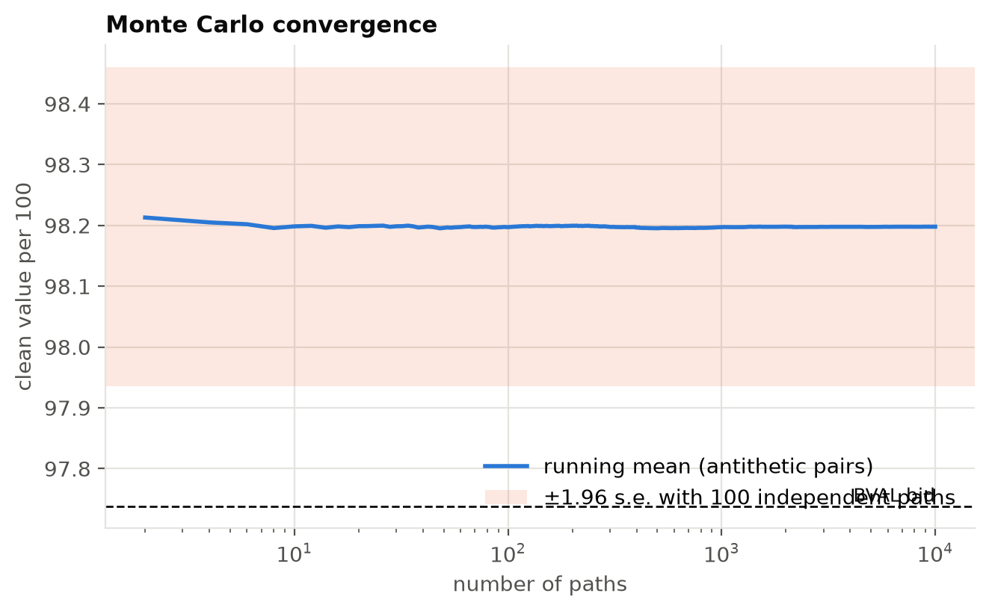
Monte Carlo convergence

6. Limitations
- One-factor rate model. One-month rate shocks also stand in for changes in mortgage rates, so the yield curve moves in parallel. Linear interpolation of zero rates gives a forward curve with small steps at the 1y and 2y knots.
- Volatility. The volatility is historical, from the 10-year yield, rather than implied from swaptions or caps.
- Prepayments. The prepayment function (PSA plus a linear refinancing overlay) is simple next to dealer models with burnout, seasonality, turnover and credit effects. β is a judgement, not a calibration.
- Credit inputs. The Part II credit inputs are illustrative because the guarantor is hypothetical. A real analysis would calibrate the PD to the guarantor’s CDS curve and model the correlation between guarantor default and mortgage losses.

7. Conclusion
As an agency MBS, FN FS9548 is worth 98.20 (clean) on a zero-spread Treasury basis, 0.46 points above its BVAL bid of 97.74. The market price implies an OAS of about 26 bp, close to but slightly above Bloomberg’s 17.9 bp, so the pool looks fairly priced to slightly cheap. The judgement depends mainly on the prepayment assumption. With an A-rated private guarantor and historical default rates, the value falls by only 0.11 points to 98.09. With market-implied default rates above about 0.43% a year, it would fall below today’s agency price, and wrong-way risk argues for a larger discount still.
Reproducibility. Every number in this report is produced by the notebooks in notebooks/ (seed 2026). The Excel workbook excel/FN_FS9548_MBS_Pricing_Model.xlsx shows one path with live formulas, and a check cell confirms that it matches Python exactly.

