Bipolar heat and model dependent estimates of lattice thermal conductivity across a thermoelectric corpus

Abstract
Lattice thermal conductivity is commonly estimated by subtracting a unipolar electronic contribution from measured total conductivity. Such a remainder includes bipolar heat when both carrier types contribute. We examine this distinction using joint simulation-based inference on published electrical conductivity, Seebeck coefficient and total thermal conductivity curves. A corrected two-band single-parabolic-band simulator is fitted through a full-covariance Gaussian conditional approximation, trained on 588,000 simulations with 12,000 validation examples. Independent simulations assess the final prior-restricted sampler. Of 13,256 frozen Starrydata curves, 7,379 pass a latent-curve fit screen; 4,312 provide positive endpoints for all four estimates over 400–750 K. Median per-curve slope shifts are 0.003 [0.002, 0.005] for replacement of the Kim Lorenz estimator, -0.165 [-0.184, -0.150] for replacement of that remainder by the model lattice term, and -0.182 [-0.201, -0.156] for additive removal of inferred bipolar heat relative to the conventional estimate. Brackets denote 95% paper-clustered bootstrap intervals. These are model-dependent associations, not audited errors in source publications. Independent coverage diagnostics and synthetic stress tests qualify the inference: agreement with three transport curves does not uniquely validate their thermal decomposition. The archive supplies the corrected solver, retrained checkpoint, matched draws, diagnostics and regenerated tables and figures. On independent base-model tests, nominal 95% parameter intervals covered only 84.4%–90.5% of truths, so they must not be treated as fully calibrated.

1. Introduction
The figure of merit zT = S²$σ$T/$κ$ combines measured electrical conductivity, Seebeck coefficient and total thermal conductivity. Separating lattice heat requires additional assumptions. A widely used approximation is $κ_{L}$ = $κ$ − L$σ$T, with L inferred from S. The single-parabolic-band estimator of Kim et al. [1] is L = [1.5 + exp(−|S|/116)] × 10⁻⁸ W Ω K⁻², where S is expressed in µV K⁻¹. Its applicability depends on the assumed carrier and scattering regime.
With two carrier types, the unipolar electronic contribution is $κ_{e}$ = (Lp$σ$p + Ln$σ$n)T, and an additional term is $κ_{bip}$ = [$σ$p$σ$n/($σ$p + $σ$n)](Sp − Sn)²T, using signed band Seebeck coefficients. Subtracting only $κ_{e}$ leaves $κ_{L}$ + $κ_{bip}$. An effective Lorenz number defined to include bipolar heat would instead absorb this term. Specifying the Lorenz convention is therefore essential.
Single-material studies already treat bipolar transport explicitly. Other mechanisms also affect subtraction: electrically resistive grain boundaries can produce an overestimate [8], and departures from simple scattering can alter the Lorenz number [9]. We quantify the results of applying one conventional subtraction uniformly to a frozen literature-derived corpus and compare them with a stated joint model. We do not establish which subtraction each source author used.
Amortised simulation-based inference [2,3] makes repeated approximate inference practical after training on simulator output. Its uncertainty must be checked against held-out simulations [4]. Here we distinguish tests of raw Gaussian ellipsoids from coverage of the constrained draws and derived heat channels used in the analysis.
The analysis provides a reproducible transport model, a corpus comparison of four thermal estimates, and conditional posterior summaries of an effective scattering exponent. Conclusions remain conditional on the prior, observation model, Gaussian approximation and imposed lattice form.

2. Methods

2.1 Corpus
The released analysis set contains 13,256 digitised transport curves from 2,754 source papers in Starrydata [5]. Each record contains $σ$(T), S(T), $κ$(T), a sample identifier, DOI and family label. The raw export was not supplied. We treat the frozen feature arrays and sample list as the operational corpus definition. Historical filtering counts are documented in the repository but were not independently rerun for this revision.
The documented reconstruction retains the first curve for each sample and property, uses conductivity when available and otherwise inverts resistivity, and requires a common analysis span of at least 200 K. It applies a 300 K lower floor and a 1250 K upper ceiling; retained windows begin at or below 500 K. A historical 407-record plausibility filter has lost its original implementation. Its retained sample identifiers are preserved, but its general selection rule cannot be recovered. Historical removal of 32 extreme Seebeck records is documented rather than newly verified.
The total thermal-conductivity field is distinguished from the separate lattice-conductivity field. Properties are linearly interpolated onto 16 uniformly spaced points within each recorded window. This creates dependence between neighbouring points; additional shared experimental errors are not represented in the simulator.
The 50 features are log10 $σ$, S in µV K⁻¹ and ln $κ$ at 16 temperatures, followed by Thi/1000 and Tlo/1000, in that order. Frozen numerical values preserve the downstream analysis against later database changes.

2.2 Forward model
The simulator is a two-band single parabolic band model. Carrier densities are solved from charge neutrality, $p(η_{p},T) - n(η_{n},T) = N_{net}$with $η_{n} = -η_{p} - E_{g}/k_{B}T$, by bisection at each temperature, so thermally activated behaviour in which $σ$ rises with temperature emerges from the physics rather than being imposed. The solver now expands its bracket and checks the neutrality residual. For Nnet = 10²¹ cm⁻³ and majority mass 10⁻¹·³ me at 300 K, η ≈ 281.43 is resolved rather than silently limited to 40. Forward inputs are promoted to double precision. Numerical carrier labels denote majority and minority populations; the sign head selects the p-type or n-type convention.
The corrected implementation uses unnormalised Fermi–Dirac integrals. Within −20 ≤ η ≤ 50, a quadrature table has spacing 0.01 in order and 0.025 in η, with cubic interpolation in order and linear interpolation in η on log integrals. Quadrature uses ε = u⁴ and 512 Gauss–Legendre nodes. Explicit Boltzmann and Sommerfeld expansions supply the tails; values are not clamped. Independent numerical integration on 63 selected order–η combinations gave a maximum relative integral discrepancy of 1.56 × 10⁻⁵. This finite check is not a uniform error bound over every parameter combination.
Relaxation time is $τ ∝ ε^{r}$. Mobility is $μ(η,T) = μ_{300}{\left(\frac{T}{300}\right)}^{p_{μ}} \left(\frac{F_{r+\frac{1}{2}}(η)}{F_{1/2}(η)}\right)\frac{ Γ(3/2)}{Γ(r+3/2)}$, the last factor making $μ₃₀₀$ the non-degenerate $300$ K mobility irrespective of r so that its prior can be set from literature values. Total thermal conductivity is $κ = κ_{e} + κ_{bip} + κ_{L}$ with $κ_{L}=κ_{min} + A{\left(\frac{300}{T}\right)}^{w}$. The model reproduces both analytic Lorenz limits to better than $5 × 10⁻³$ at $r = -1.0, 0.0$and $+2.0$, and $κ_{bip}$ peaks at equal channel conductivity when the total is held fixed.
The base simulator shares r, the mobility temperature exponent and the non-degenerate 300 K mobility between bands. Masses and Fermi levels may differ. Section 5 tests synthetic data with minority-to-majority mobility scales of 0.1 and 10 while fitting the shared-mobility model.

2.3 Prior
Ten continuous parameters and a binary majority-carrier sign are inferred. Uniform draws within Table 1 are independent except for the doping-dependent mobility interval; each sign has probability one half. Measurement endpoints are sampled within their bounds and rejected until Thi − Tlo ≥ 200 K. The prior also requires maximum zT ≤ 3.5 on the 16-point window grid. Bounds are inherited from the supplied study, rather than independently selected on a new real-data corpus.
For each simulated observation, 8–20 uniformly spaced temperature points are used. Independent factors exp(ε), with ε ∼ Normal(0, 0.02²), perturb each property before interpolation onto 16 feature temperatures. This induces interpolation correlations but lacks shared calibration errors, additive Seebeck error and property-specific uncertainty. It is not a complete experimental-error model.
Parameter | Lower | Upper | Units / note
$$log_{10}N_{net}$$ | $$16.0$$ | $$21.0$$ | $$cm⁻³$$
$$log₁₀ m_{\text{maj}}^{*}$$ | $$-1.3$$ | $$0.7$$ | $$m_{e}$$
$$log₁₀ m_{min}^{*}$$ | $$-1.7$$ | $$1.0$$ | $$m_{e}$$
$$log₁₀ μ₃₀₀$$ | $$c - 1.8$$ | $$c + 1.2$$ | $$cm² V⁻¹ s⁻¹; c = 3.1 - 0.5(log₁₀N - 17)$$
$$p_{μ}$$ | $$-3.5$$ | $$2.0$$ | $$μ ∝ T^{p_{μ}}$$  Non-degenerate prefactor; degenerate scaling also depends on r.
$$log_{10}E_{g}$$ | $$-1.5$$ | $$0.55$$ | $$eV (0.03 - 3.5)$$
$$log₁₀ A$$ | $$-1.0$$ | $$1.2$$ | $$W m⁻¹ K⁻¹$$
$$w$$ | $$0.0$$ | $$3.0$$ | $$κ_{L} =κ_{min } + A{\left(\frac{300}{T}\right)}^{ω}$$
$$r$$ | $$-1.0$$ | $$2.0$$ | $$τ ∝ ε^{r}$$
$$κ_{min}$$ | $$0.0$$ | $$0.70$$ | W m⁻¹ K⁻¹
$$T_{lo}$$ | $$285$$ | $$500$$ | K — measurement window, sampled
$$T_{hi}$$ | $$500$$ | $$1250$$ | K — with $T_{hi} - T_{lo} ≥ 200$ K
Table 1. Prior bounds. Masses are relative to the electron mass; mobility is in cm² V⁻¹ s⁻¹. Its temperature power is the non-degenerate prefactor, not the full degenerate dependence. Conditional mobility bounds and zT restriction are enforced at inference and simulation. The lattice floor is included in $κ_{L}$, total $κ$ and zT.

2.4 Amortised posterior
The network has three hidden layers of 256 SiLU units. It predicts ten standardised means, ten log diagonal and 45 off-diagonal entries of a lower-triangular precision factor A, plus a Bernoulli sign logit. Precision is AAᵀ; Gaussian draws solve Aᵀv = ε before restoring parameter scale. Continuous and sign heads factorise conditionally on the features. A single Gaussian cannot generally represent multimodal or strongly non-Gaussian posteriors.
The corrected run uses 600,000 simulations generated with seed 2001. A seed-3 permutation allocates 588,000 for training and 12,000 for validation. Normalisation uses training examples only. The architecture is retained for comparability; old architecture experiments from a different simulator are not evidence about this corrected checkpoint.
Quantity | Value
Training / validation | 588,000 / 12,000
Calibration / independent test | 6,000 / 6,000
Hidden layers | 3 × 256 SiLU
Continuous head | Full Gaussian precision
Optimiser / batch | AdamW / 1024
Best epoch / completed | 889 / 900
Best validation NLL | -7.1647
Stopping condition | epoch_cap
Table 2. Corrected training configuration and outcome. Validation selects the checkpoint; separate calibration and test simulations are not used for optimisation or checkpoint selection.
Training uses AdamW, initial learning rate 0.0015, weight decay 10⁻⁵, batches of 1024 and gradient clipping at norm 5. ReduceLROnPlateau has factor 0.5 and patience 6. The cap is 900 epochs; early stopping requires 50 epochs without an improvement of at least 10⁻⁴. The run stopped by epoch_cap after 900 epochs, selecting epoch 889 with validation negative log likelihood -7.1647 in standardised coordinates. Training seed is 0; device and library versions are archived.
The full precision factor represents correlations, but physical degeneracies remain, including density–mobility and lattice amplitude–floor trade-offs. The availability of a covariance estimate does not establish accurate uncertainty; independent diagnostics test selected consequences.

2.5 Calibration
Independent sets of 6,000 simulations each use seeds 2002 and 2003. The first estimates empirical Mahalanobis thresholds for a diagnostic rank map. The second tests these and raw Gaussian thresholds. This map relabels ellipsoid probabilities; it is not used to modify the constrained sampler.
The new run therefore stores 588,000 training, 12,000 validation, 6,000 diagnostic calibration and 6,000 independent test simulations: 612,000 base-model examples. This new accounting does not reinterpret the original release’s reuse of validation examples as an independent calibration experiment.
We also assess empirical coverage of nominal 95% marginal intervals for all continuous parameters and pointwise intervals for $κ_{L}$, $κ_{bip}$, the unipolar Lorenz number and total $κ$, using the final constrained draws. Rates are conditional on scored independent test curves, with unscored counts reported separately. These finite-sample checks are not full joint simulation-based rank calibration.
Ellipsoid threshold | 50% | 90% | 95% | 99%
Raw | 57.7% | 89.0% | 93.3% | 96.9%
Diagnostic rank map | 50.2% | 90.0% | 95.2% | 99.2%
Table 3. Independent coverage of raw Gaussian ellipsoids and diagnostic empirically relabelled ellipsoids. The second row does not describe the constrained draws used for corpus inference; their derived-channel coverage is reported separately.
Prior restriction changes the distribution, so ellipsoid coverage cannot certify the constrained sampler. Marginal or pointwise coverage also differs from simultaneous coverage of an entire curve. These tests characterise approximation error rather than declare calibration by construction. On 5,996 scored independent test curves out of 6,000, nominal 95% pointwise coverage was 94.2% for $κ_{L}$, 93.2% for $κ_{bip}$, 89.3% for Luni and 98.7% for total $κ$. Parameter coverages ranged from 84.4% to 90.5%.

2.6 Applicability domain and statistics
For each curve, up to 8,192 Gaussian proposals are considered in batches of 256 until 128 draws satisfy the conditional prior and 16-point zT restriction. At least 64 are needed for scoring. The sign is sampled from the Bernoulli head. Draws are propagated through the corrected training simulator. A nested-prefix draw-count check on 509 independent test cases with all 256 draws retained gave lattice coverage 94.4% with 128 draws and 95.0% with 256; bipolar coverage changed from 91.8% to 93.2%. The median absolute change in the lattice point estimate was 0.0030 W m⁻¹ K⁻¹. This finite subset check does not establish convergence for every real curve.
The fit screen counts how many of 48 observed values lie inside the pointwise 2.5th–97.5th percentile bands of latent simulated curves. Containment of at least 0.75 admits a curve. Observation noise is not added. This operational screen is not a calibrated significance test, and omission of noise does not make every downstream conclusion conservative.
Every accepted draw satisfies conditional mobility bounds and maximum zT ≤ 3.5 on the stated grid. Computationally unscored curves are distinguished from scored exclusions. Neither category alone identifies a physical cause of disagreement.
Main intervals use 2,000 percentile bootstrap resamples of source papers, seed 2024. Only papers represented in the finite reported subset are sampled. All curves of a sampled paper are retained, including multiplicity when it is selected more than once. The estimand is a median over curves, not an equal-paper-weighted median.
These intervals describe variation of posterior summaries across sampled papers, without full within-curve uncertainty. A nested analysis, seed 2025, also selects one matched posterior draw per unique curve in each paper resample. Repeated copies of a curve share that selected draw. Draw-specific non-positive endpoints are omitted from that resample’s logarithmic statistic and their counts are archived; the valid-draw population can therefore differ from the summary-based one.
For C − B, the nested 95% interval is [-0.183, -0.150], with bootstrap median -0.165; the summary-based estimate is -0.165 [-0.184, -0.150]. A slope of a median curve and a median of draw-specific slopes are distinct nonlinear estimands, not exact reconstructions of one another.
Headline slopes use 400–750 K. Of 4,338 admitted curves spanning it, 4,312 have positive finite endpoints for all four estimates (1,233 papers). The remaining 26 are excluded from logarithmic comparisons rather than floored. Counts for other analyses are stated separately.

3. Results

3.1 Operational fit screen
The corpus contains 13,256 eligible, 10,320 scored and 7,379 admitted curves; 4,312 enter the finite paired slope comparison. Admitted curves come from 2,067 papers.
There are 2,936 unscored curves and 2,941 scored exclusions. Low retained-draw counts can reflect prior mismatch or approximation limits; screen failure can reflect observation error or forward-model mismatch. Neither is a diagnosis of multi-band transport.
Selection on total containment necessarily increases containment within the admitted group. Table 4 is therefore descriptive, not independent evidence of calibration.
Screen category | σ | S | κ
Admitted | 0.954 | 0.867 | 0.957
Excluded | 0.528 | 0.393 | 0.698
Table 4. Observed-point containment in latent 95% bands, by property and screen category. These conditional descriptive rates are not calibration estimates.
Figure 1 reports outcomes by measurement ceiling among scored curves. Bins differ in composition, data quality and window coverage, so rates do not isolate the effect of temperature on physical validity.
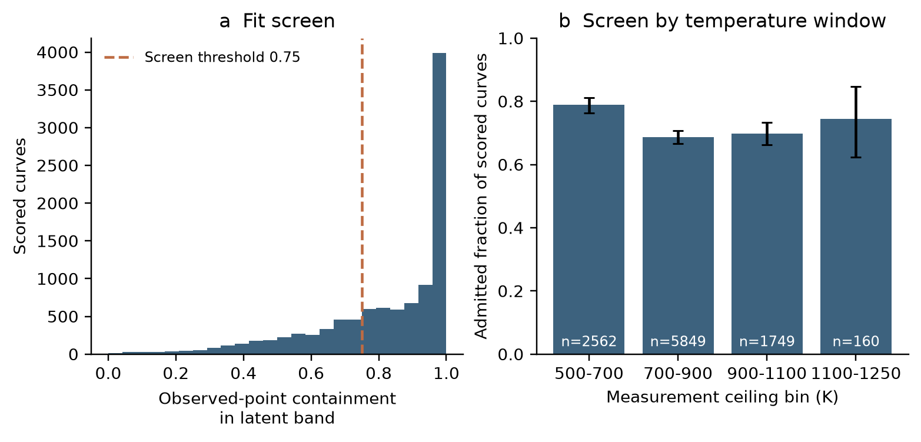
Figure 1. Fit-screen outcomes. (a) Containment for scored curves and threshold 0.75. (b) Admission fractions among scored curves in measurement-ceiling bins, with 95% paper-clustered bootstrap intervals and bin counts.

3.2 Comparison of four lattice estimates
We compare A = $κ$meas − LKim$σ$measT, B = $κ$meas − median(Luni)$σ$measT, C = median($κ_{L}$,model), and C′ = B − median($κ_{bip}$). Medians are pointwise over valid draws. A is a retrospective conventional estimate; B changes its Lorenz number; C uses the parametric lattice term; C′ subtracts inferred bipolar heat additively.
Luni = $κ_{e}$,model/($σ$modelT) excludes bipolar heat and is conductivity-weighted across bands. B applies this coefficient to measured conductivity, whereas the model total uses model conductivity. An effective Lorenz number that includes $κ_{bip}$/($σ$modelT) is a different convention.
B − C contains thermal-fit residuals and differences between measured and model conductivity as well as bipolar heat. Sums of marginal posterior medians need not equal the median total. Model-total diagnostics therefore propagate channels using matched parameter draws.
C′ compares an additive subtraction on measured total conductivity, but its inferred Lorenz number and bipolar term still depend on the lattice prior. Its median slope is -0.688 [-0.716, -0.661]; median per-curve shifts are -0.139 [-0.165, -0.116] relative to B and -0.182 [-0.201, -0.156] relative to A. Ratios of population medians cannot apportion the C − B shift into mechanistic fractions.
Estimate or per-curve shift | Median | 95% interval
A | -0.414 | [-0.441, -0.389]
B | -0.406 | [-0.433, -0.386]
C | -0.644 | [-0.665, -0.626]
C′ | -0.688 | [-0.716, -0.661]
B − A | 0.003 | [0.002, 0.005]
C − B | -0.165 | [-0.184, -0.150]
C − A | -0.180 | [-0.197, -0.167]
C′ − B | -0.139 | [-0.165, -0.116]
C′ − A | -0.182 | [-0.201, -0.156]
Table 5. Finite-window log slopes and per-curve differences on 4,312 paired curves. Slope is [ln $κ_{L}$(750 K) − ln $κ_{L}$(400 K)]/ln(750/400), not a local derivative. Intervals resample papers. Medians of differences need not equal differences of medians; successive median shifts need not add.
The Lorenz-replacement shift is 0.003 [0.002, 0.005]; C − B is -0.165 [-0.184, -0.150]. At the lowest measured temperature of each admitted curve, B − A has median -0.010 W m⁻¹ K⁻¹ and 10th–90th percentiles [-0.130, 0.046]. The sign follows B − A = (LKim − Lpost)$σ$measT.
Different Lorenz prescriptions change A. Agreement with a model slope alone cannot justify a constant Sommerfeld prescription, while disagreement with this model’s Lorenz number does not independently prove over-subtraction. External transport information is needed.
Inelastic scattering can change the Lorenz number beyond the present power-law relaxation-time model [9]. The corpus comparison does not show that Lorenz uncertainty is unimportant in every material or regime.

3.3 Association with inferred bipolar heat
Bipolar share | n | B slope | C slope | C − B [95% interval]
<2% | 1581 | -0.542 | -0.602 | -0.036 [-0.045, -0.029]
2–10% | 1015 | -0.436 | -0.622 | -0.122 [-0.130, -0.110]
10–100% | 1716 | -0.273 | -0.689 | -0.391 [-0.412, -0.360]
>100% | 0 | — | — | —
Table 6. Paired-set slopes stratified by posterior median bipolar heat divided by measured total at 750 K. Shares above 100% are reported separately. Both the stratum and the outcome depend on the model; this is an internal association rather than a causal control.
There are 0 paired curves with inferred median bipolar heat exceeding measured total, from 0 papers. Absence of such cases does not by itself validate the thermal decomposition.
Each model draw’s bipolar fraction relative to its own total lies between zero and one because all heat channels are positive. A ratio above one against measured total instead records a discrepancy with the measurement. Matched-draw total and fraction diagnostics are archived, without adding marginal channel medians.
A low inferred bipolar fraction is not an independent null control. Bias from the lattice form may vary with transport regime; a small shift in one inferred stratum does not bound bias in another.
C′ separates additive subtraction from replacement by a parametric curve. However, C′ − B is algebraically driven by inferred bipolar heat, so an association with that heat is partly built into the construction and cannot establish lattice-model independence.
Across their own windows, 2,462 admitted curves (33.4%) have A at the final grid point above A at index 8; B gives 2,530 (34.3%). These are two-point upturn indicators, not monotonicity tests. Genuine lattice conductivity can rise, as reported for cubic GeTe [7].
The model cannot represent a rising lattice term because w ≥ 0. Synthetic upturns are tested in Section 5; real-data attribution remains conditional on this restriction.
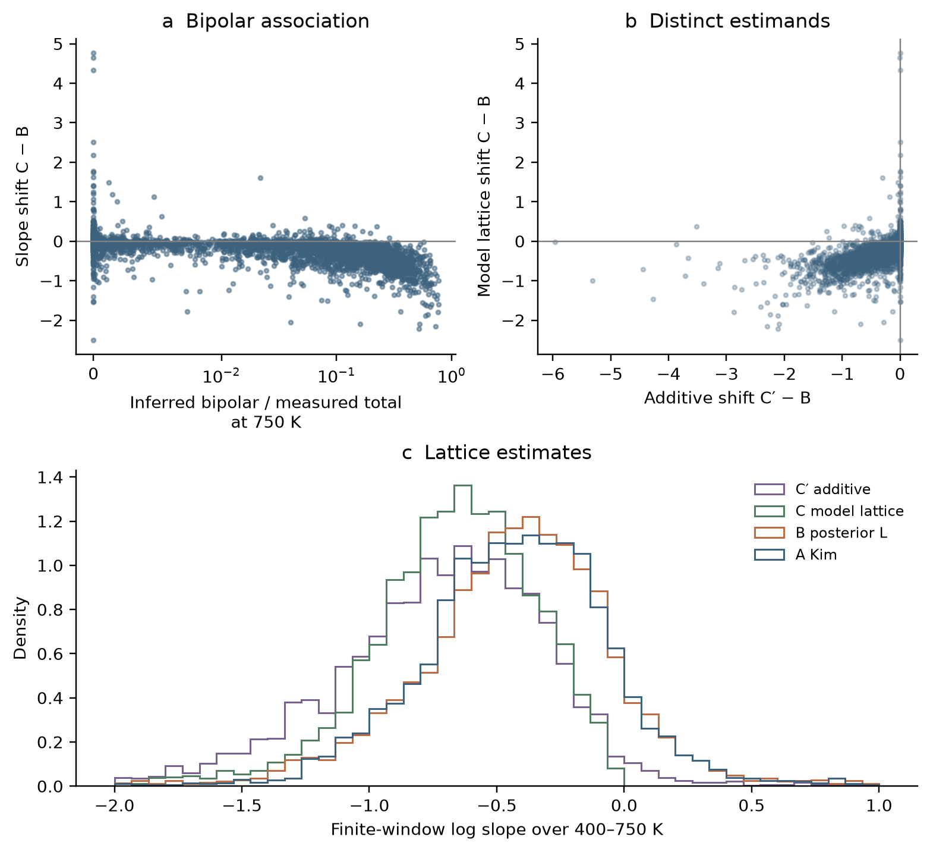
Figure 2. (a) Model-lattice slope shift versus inferred bipolar share, including shares above unity where present. (b) Model-lattice and additive shifts. (c) Four slope distributions; the displayed range −2 to 1 may omit tails. All panels use the paired set.

3.4 Within-family associations
Family | n | B | C | C − B [95% interval] | ρ
Cu2Se-type | 132 | -0.605 | -0.736 | -0.107 [-0.150, -0.068] | -0.479
Mg2X-type | 260 | -0.493 | -0.693 | -0.186 [-0.220, -0.138] | -0.755
PbX-type | 306 | -0.677 | -0.888 | -0.211 [-0.244, -0.169] | -0.515
SiGe | 122 | -0.211 | -0.316 | -0.069 [-0.125, -0.033] | -0.794
SnTe-type | 154 | -0.729 | -0.847 | -0.119 [-0.159, -0.054] | -0.479
Zn-Sb | 84 | -0.587 | -0.797 | -0.169 [-0.279, -0.085] | -0.656
filled-RE | 260 | -0.268 | -0.543 | -0.198 [-0.303, -0.104] | -0.637
half-Heusler | 385 | -0.394 | -0.686 | -0.266 [-0.301, -0.238] | -0.811
other | 1350 | -0.370 | -0.525 | -0.088 [-0.101, -0.073] | -0.640
skutterudite | 1142 | -0.364 | -0.666 | -0.319 [-0.367, -0.270] | -0.719
Table 7. Families with at least 80 paired curves. 100 papers contribute to more than one family, so these are not independent replications. Smaller families remain in the overall analysis. Spearman correlations are descriptive, without cluster-corrected significance tests.
Family differences may reflect carrier statistics, windows, selection and model adequacy. Chemistry does not guarantee absent minority transport. An interval containing zero is not an equivalence test or proof of no effect.
Superionic and structurally complex materials stress the transport assumptions. Family labels describe heterogeneity but cannot validate decompositions without additional measurements.

3.5 Stratification using measured Seebeck rollover
Rollover is the fractional decrease of |S| from its interior maximum to the final temperature. Curves without an interior maximum enter the “none” group. The network receives the same S(T) measurements; the descriptor is input-derived rather than withheld evidence.
Seebeck rollover | n | B | C | C − B [95% interval]
None | 2552 | -0.446 | -0.625 | -0.108 [-0.120, -0.096]
<5% | 1003 | -0.387 | -0.655 | -0.216 [-0.251, -0.189]
5–15% | 476 | -0.343 | -0.699 | -0.328 [-0.380, -0.285]
≥15% | 281 | -0.226 | -0.687 | -0.453 [-0.555, -0.378]
Table 8. Paired-set comparisons by measured rollover. Both B and C depend on the posterior, so the outcome is model-dependent despite the measurement-derived descriptor.
Rollover may be consistent with minority-carrier activation but is not unique to it; it can also be absent when a window ends before the maximum. Agreement supports internal consistency without uniquely establishing a decomposition.
Table 9 reports the conventional A upturn indicator by measured rollover among all admitted curves. Both descriptors are computable without the simulator, but selection is model-based and S enters both rollover and the Kim Lorenz number.
Seebeck rollover | n | A upturn rate [95% interval]
None | 4324 | 23.1% [20.9%, 25.3%]
<5% | 1598 | 39.0% [35.4%, 42.8%]
5–15% | 868 | 49.2% [44.3%, 53.8%]
≥15% | 589 | 69.6% [64.3%, 74.7%]
Table 9. Conventional-estimate upturn rates with 95% paper-clustered intervals. An upturn means A at grid index 15 exceeds A at index 8. It is a signature to explain, not physically impossible lattice conductivity.
These associations do not apportion an upturn between bipolar heat, genuine lattice effects, radiation, measurement error or other mechanisms. Causal interpretation requires evidence beyond the shared inputs.
These strata partition all admitted curves, not the smaller positive-endpoint paired set. “None” means no interior maximum on the sampled window, rather than absent bipolar transport.
External validation would withhold Hall measurements or independently measured gaps and compare predictions against them. That validation has not been performed.
Cross-classifying thermal upturns and Seebeck rollover does not isolate lattice-prior bias. Both descriptors are related to model inputs, and associations can persist under a biased model.
We therefore do not interpret these cross-classifications as a quantitative bound on lattice-model bias. Known-truth stress tests below address selected departures, while a flexible-lattice refit remains an additional experiment.
Explicit subset masks and matched draws are released so alternative cross-classifications need not be inferred from rounded table entries.
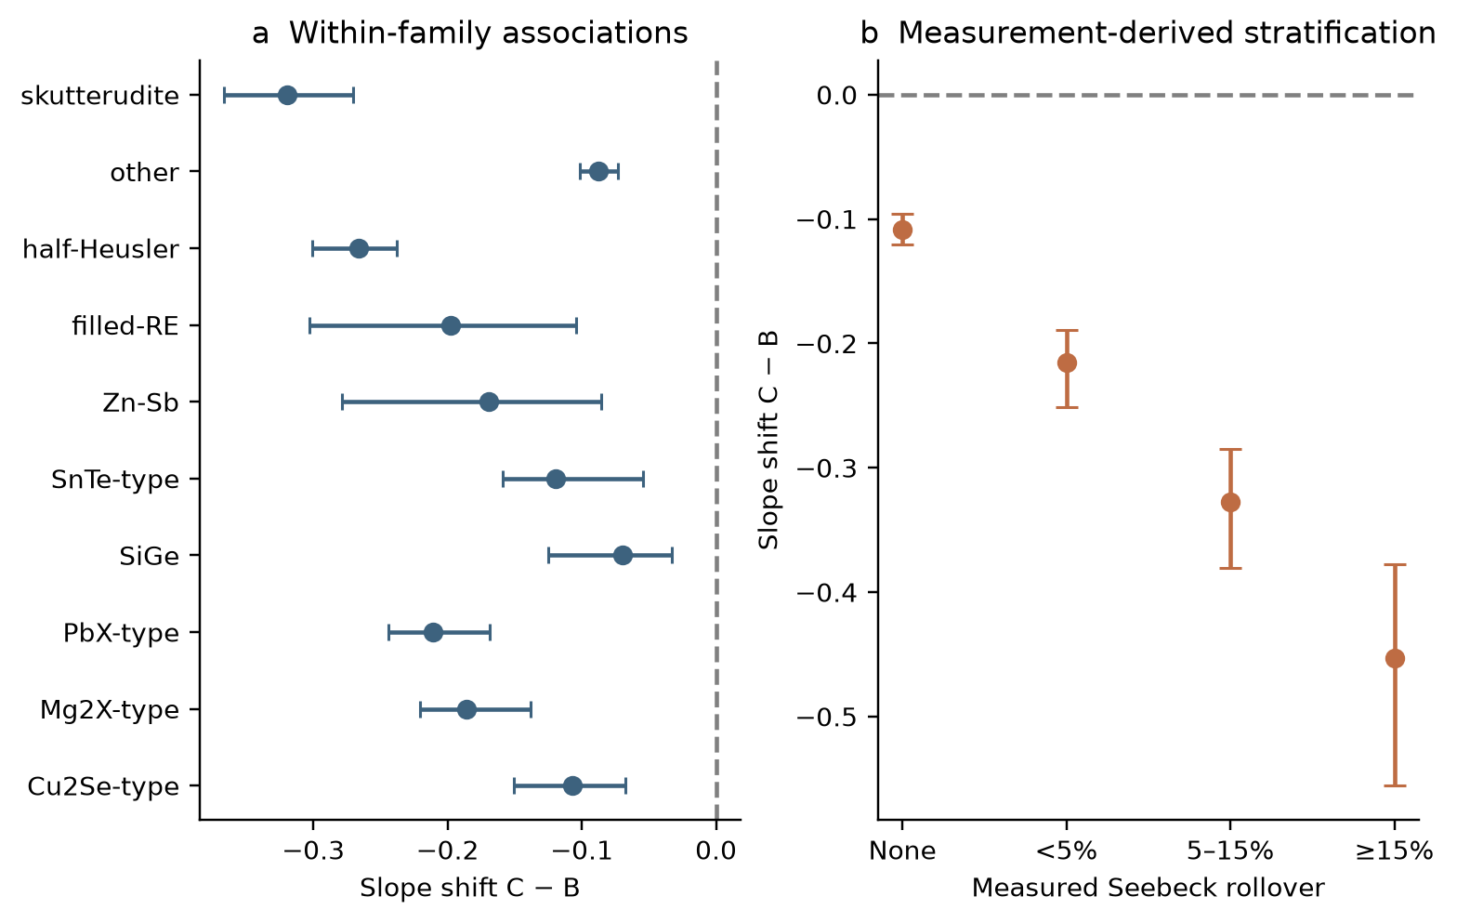
Figure 3. (a) Within-family shifts with paper-clustered intervals. (b) Shifts by measured rollover. An interval including zero does not establish equivalence; the rollover data were also inputs to inference.

3.6 Sensitivity to the fit-screen threshold
All scored curves are decomposed. Table 10 varies containment from zero to 0.95, applying the same fixed-window and positive-endpoint rules to all estimates. It describes selection sensitivity without making poorly fitted decompositions reliable.
Threshold | n | Papers | A | C | C − B [95% interval] | C − A
0 | 6186 | 1490 | -0.462 | -0.693 | -0.169 [-0.186, -0.154] | -0.191
0.3 | 6033 | 1475 | -0.460 | -0.690 | -0.169 [-0.185, -0.155] | -0.187
0.4 | 5844 | 1462 | -0.454 | -0.685 | -0.168 [-0.186, -0.154] | -0.187
0.5 | 5615 | 1436 | -0.448 | -0.678 | -0.167 [-0.185, -0.154] | -0.186
0.6 | 5216 | 1387 | -0.438 | -0.667 | -0.166 [-0.182, -0.151] | -0.184
0.7 | 4611 | 1290 | -0.426 | -0.655 | -0.166 [-0.184, -0.151] | -0.182
0.75 | 4312 | 1233 | -0.414 | -0.644 | -0.165 [-0.184, -0.150] | -0.180
0.8 | 3721 | 1118 | -0.394 | -0.628 | -0.166 [-0.188, -0.149] | -0.179
0.85 | 3336 | 1032 | -0.388 | -0.622 | -0.167 [-0.190, -0.149] | -0.181
0.9 | 2746 | 884 | -0.372 | -0.607 | -0.167 [-0.192, -0.150] | -0.181
0.95 | 2112 | 769 | -0.339 | -0.584 | -0.167 [-0.197, -0.147] | -0.187
Table 10. Threshold sensitivity over 400–750 K. The principal threshold is 0.75. Counts refer to finite paired endpoints at each threshold; only papers represented in each subset are resampled.
The scan should be assessed alongside changes in population and fit quality. Stability across thresholds, if observed, addresses this selection choice but does not remove misspecification, prior dependence or approximation error.
Non-positive endpoints have no real logarithmic slope and are explicitly excluded, not clipped to 10⁻⁶. Negative subtraction values remain in the archive for diagnostics. Positive model lattice heat is guaranteed by the prior, rather than evidence of a correct decomposition.

3.7 Effective scattering exponent across the corpus
The median posterior effective r among admitted curves is -0.356 [-0.378, -0.335]. P(r < 0.5) uses finite retained draws only; missing draws do not count as evidence above the threshold.
Class fractions are 77.2% phonon-like, 6.1% impurity-like and 16.7% ambiguous, using probabilities above 0.8, below 0.2 and between them. These effective-parameter labels do not independently identify microscopic mechanisms.
These are effective scattering exponents conditional on the forward model and the prior, not microscopic mechanisms established independently. A single r stands in for whatever combination of acoustic, polar-optical, alloy and ionised-impurity scattering a sample exhibits, and mixed scattering, band complexity or the sharing of r between electrons and holes can reproduce an intermediate value with no single mechanism dominating. The classes describe what three transport curves determine about an effective exponent, and are assigned per curve rather than per material: several curves from one study may share a composition.
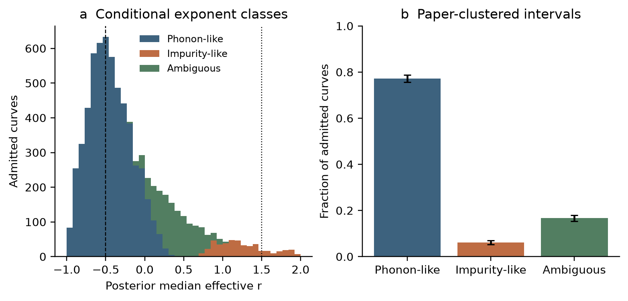
Figure 4. Effective scattering exponent among admitted curves. (a) Posterior medians by probability class, with r = −1/2 and +3/2 reference lines. (b) Class fractions and paper-clustered intervals. Counts refer to curves, not distinct materials.
Mobility contains both a temperature prefactor and a Fermi-integral ratio. In the strongly degenerate fixed-density limit, η ∝ T⁻¹ and mobility varies as temperature raised to $p_{μ}$ − r, rather than $p_{μ}$ alone. This helps explain an r–$p_{μ}$ trade-off. Activation supplies a different temperature shape, but improved identification requires empirical diagnostics.

3.8 Non-positive conventional remainders
Negative A indicates incompatibility between measured inputs and the chosen subtraction, rather than negative physical lattice conductivity. Counts are reported separately for the full corpus, admitted curves, scored exclusions and unscored curves. Negative/category counts are all: 381/13256, admitted: 20/7379, excluded: 40/2941, unscored: 321/2936.
A threshold such as 0.15 W m⁻¹ K⁻¹ is a diagnostic scale, not a universal lower physical bound. Nonnegative C follows from the prior and neither repairs incompatible measurements nor verifies a decomposition.

4. Discussion
Under a unipolar convention, bipolar heat remains in $κ$ − L$σ$T. This comparison quantifies how a specified model partitions that remainder and changes finite-window slopes; it does not establish bipolar heat as the only explanation.
One scoping point governs what follows. We apply a standard recipe to published $σ$, $S$ and $κ$; we do not read each source publication to establish whether its authors used that recipe, applied a bipolar correction, or reported $κ_{L} + κ_{bip}$ knowingly. The claim is about what the conventional recipe yields across the published record, not that any particular reported value is wrong.
High-temperature subtraction-based remainders may mix lattice and bipolar changes. Their interpretation should be checked with transport information and model sensitivity. This analysis offers conditional estimates and diagnostics rather than verified corrections to every source publication.
Genuine lattice upturns, radiation, sample changes, band complexity and imperfect error models challenge inference. Associations with inferred bipolar heat and measured rollover remain descriptive evidence, not independent validation.
Joint modelling exposes assumptions and tests agreement with several measured channels, at the cost of dependence on the full simulator, prior and approximation. Reproducibility is necessary for assessing these dependencies but insufficient for physical validation.

5. Limitations
The fit screen neither establishes calibration on real materials nor diagnoses exclusions. Publication, digitisation and historical selection effects also limit generalisation beyond this corpus.
Bootstrap intervals describe paper-sampling variation within selected subsets, not systematic measurement errors, uncertainty in the lost historical filter, all posterior approximation errors or choice of physical model.
Carrier-asymmetry tests generate 1,000 curves each at minority mobility multipliers 0.1 and 10 (seeds 2005 and 2006), then infer them using the shared-mobility model. They do not test unequal temperature exponents, different scattering laws or non-parabolic bands. For multiplier 0.1, 841 curves were scored and 765 admitted; $κ_{L}$ and $κ_{bip}$ pointwise coverage on scored curves was 90.9% and 73.6%. For multiplier 10, 696 curves were scored and 595 admitted; $κ_{L}$ and $κ_{bip}$ pointwise coverage on scored curves was 89.6% and 71.5%.
A separate 1,000-curve test (seed 2004) generates increasing lattice heat with w between −1.2 and −0.2 and gaps from 1.5 to approximately 3.55 eV, then infers with w ≥ 0. Where true bipolar heat is below 2% of true total at Thi, a false assignment means an inferred median above 10% of that total. This tests a known failure scenario; it does not replace a flexible-lattice refit of real curves. False assignments occurred in 13 of 214 eligible scored cases and 12 of 160 eligible admitted cases.
The lattice model remains a nonnegative floor plus a decreasing power law. Restrictions can transfer unexplained thermal structure into electronic channels or yield a poor fit. Flexible lattice and scattering models require fresh training and validation.
The inferred gap is not an independently validated measurement. Goldsmid–Sharp estimates [6] reuse Seebeck data already seen by the network. Gap and minority mass affect bipolar transport, so their uncertainty or bias can propagate into $κ_{L}$; the lattice result is not independent of them.
Multiplicative 2% noise preserves the sign of S and has vanishing absolute error near zero. It induces interpolation correlations but omits shared systematics and additive error. Larger digitisation or measurement errors affect screening and uncertainty interpretation.

6. Remaining validation needs
This revision corrects implementation and reporting and adds independent synthetic diagnostics. Open scientific limitations are distinguished from completed checks.
A flexible positive lattice model that permits rising or falling curves should be fitted to real data and known-truth simulations. The comparison should assess recovery of $κ_{L}$ and $κ_{bip}$, not fit quality alone. Success would still be conditional on the departures tested.
Further checks should examine joint rank calibration, simultaneous coverage, posterior approximation choices and larger draw counts. Carrier tests should vary scattering laws, temperature exponents and band shape. The current tests cover selected departures rather than every plausible mismatch.
External benchmarks should use matched specimens with Hall data, independent gaps or thermal-separation experiments. Model-assisted decompositions [10,11] and low-temperature high-field separation [9] are informative comparisons, but should not be treated as direct high-temperature ground truth without examining assumptions.
A source-paper audit must record which quantity and correction each publication reported before claiming errors in published lattice values. It was not performed here. These decomposition choices do not change measured zT = S²$σ$T/$κ$; they change its interpretation.

Data and code availability
The accompanying corrected archive contains the model, explicit prior and observation simulator, training and inference commands, retrained checkpoint, frozen observations, matched draws, independent validation and stress datasets, numerical summaries, figures and checksums. The training set is regenerated from its seed. Device and floating-point variation may prevent bitwise equality of retraining; released arrays and checkpoint define the reported results.
Source measurements are from Starrydata [5], with per-curve DOIs and 2,754 source publications listed in the archive. Historical metadata identify records through 15 July 2026, but the raw snapshot was not supplied for re-verification. Later exports may differ even at matching identifiers; frozen features preserve the analysed values. Author details and a public repository URL are omitted pending completion by the authors.

References
[1] Kim, H.-S., Gibbs, Z. M., Tang, Y., Wang, H. & Snyder, G. J. Characterization of Lorenz number with Seebeck coefficient measurement. APL Materials 3, 041506 (2015). doi:10.1063/1.4908244
[2] Papamakarios, G. & Murray, I. Fast ε-free inference of simulation models with Bayesian conditional density estimation. Advances in Neural Information Processing Systems 29 (2016).
[3] Cranmer, K., Brehmer, J. & Louppe, G. The frontier of simulation-based inference. PNAS 117, 30055–30062 (2020). doi:10.1073/pnas.1912789117
[4] Talts, S., Betancourt, M., Simpson, D., Vehtari, A. & Gelman, A. Validating Bayesian inference algorithms with simulation-based calibration. arXiv:1804.06788 (2018).
[5] Katsura, Y., Kumagai, M., Mato, T., Takada, Y., Ando, Y., Fujita, E., Hosono, F., Koyama, E., Mudasar, F., Phuong, T. N. T., Saito, N., Sakamoto, Y., Tanaka, A., Yana, D., Kimura, K., Tsuda, K. & Demura, M. Starrydata: from published plots to shared materials data. Science and Technology of Advanced Materials: Methods 5, 2506976 (2025). doi:10.1080/27660400.2025.2506976
[6] Goldsmid, H. J. & Sharp, J. W. Estimation of the thermal band gap of a semiconductor from Seebeck measurements. Journal of Electronic Materials 28, 869–872 (1999). doi:10.1007/s11664-999-0211-y
[7] Kielar, S., Li, C., Huang, H., Hu, R., Slebodnick, C., Alatas, A. & Tian, Z. Anomalous lattice thermal conductivity increase with temperature in cubic GeTe correlated with strengthening of second-nearest neighbor bonds. Nature Communications 15, 6981 (2024). doi:10.1038/s41467-024-51377-8
[8] Kuo, J. J., Wood, M., Slade, T. J., Kanatzidis, M. G. & Snyder, G. J. Systematic over-estimation of lattice thermal conductivity in materials with electrically-resistive grain boundaries. Energy & Environmental Science 13, 1250–1258 (2020). doi:10.1039/C9EE03921J
[9] Candolfi, C., Wiendlocha, B., Ohorodniichuk, V., Levinský, P., Migot, S., Steciuk, G., Terzi, I., Wieder, A., Dauscher, A., El Oualid, S. & Lenoir, B. Hidden in plain heat: anomalous Lorenz number in the thermoelectric alloy Bi0.4Sb1.6Te3. Nature Communications 16, 11528 (2025). doi:10.1038/s41467-025-66578-y
[10] Kim, H.-S., Lee, K. H., Yoo, J., Youn, J., Roh, J. W., Kim, S.-i. & Kim, S. W. Effect of substitutional Pb doping on bipolar and lattice thermal conductivity in p-type Bi0.48Sb1.52Te3. Materials 10, 763 (2017). doi:10.3390/ma10070763
[11] Wang, S., Yang, J., Toll, T., Yang, J., Zhang, W. & Tang, X. Conductivity-limiting bipolar thermal conductivity in semiconductors. Scientific Reports 5, 10136 (2015). doi:10.1038/srep10136

