**21.UNIVERSITY REGISTER OFFICE**

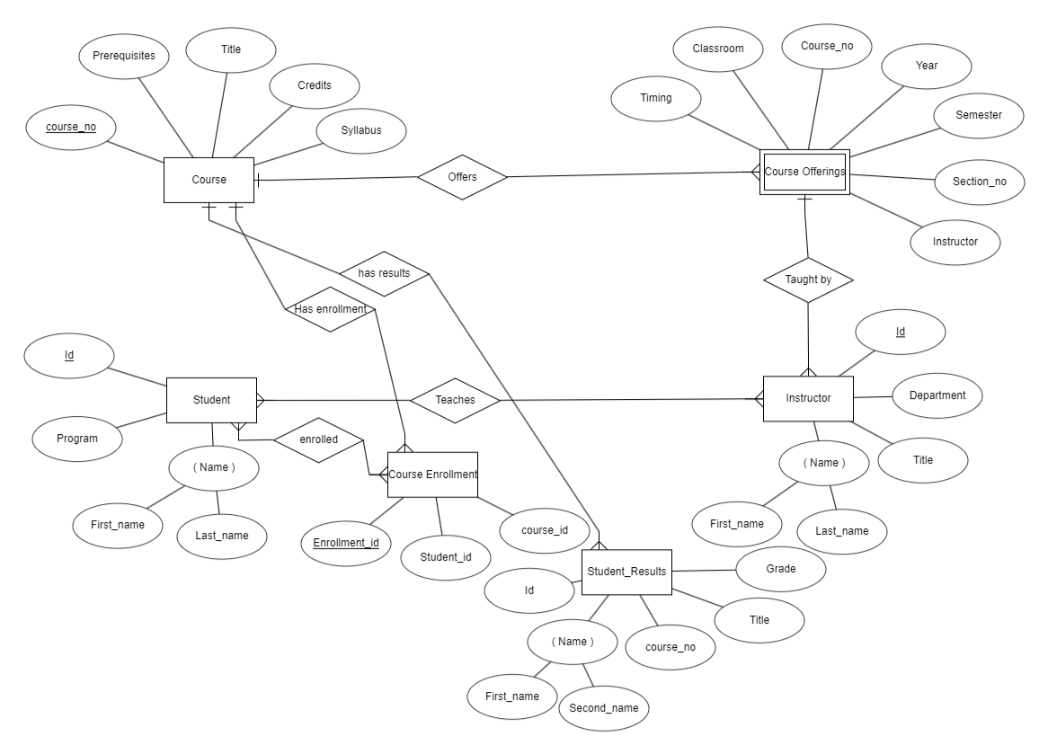

1. There are six entities ( Course , Course Offerings , Student , Instructor , Course Enrollment ,Student_results)

2. In course entity , course_no is the primary key

3. In course Enrolment , Enrollment_id is a primary key

4. In Student entity , Id is a primary key and Name is the composite key

5. In Instructor entity , Id is a primary key and Name is the composite key

6. Entity :

1.Student Relationship : Many to Many

2.Course Enrollment

Student can enroll in many course and a each course can have many students.

7. Entity :

1.Student Relationship : Many to Many

2.Instructor

Student can listern to many instructors and a each instructor can teach many students.

8. Entity :

1.Course Offering Relationship : One to Many

2.Instructor

A course can be taken by many instructors and a each instructor can teach only one course.

9. Entity :

1.Course Offering Relationship : One to Many

2.Course

A course can have multiple offerings .

10. Entity :

1.Course Relationship : One to Many

2.Course Enrolment

A course can have multiple enrolments and an enrolment can have only one subject.

**22.UNIVERSITY REGISTER OFFICE (TERNARY RELATIONSHIP)**

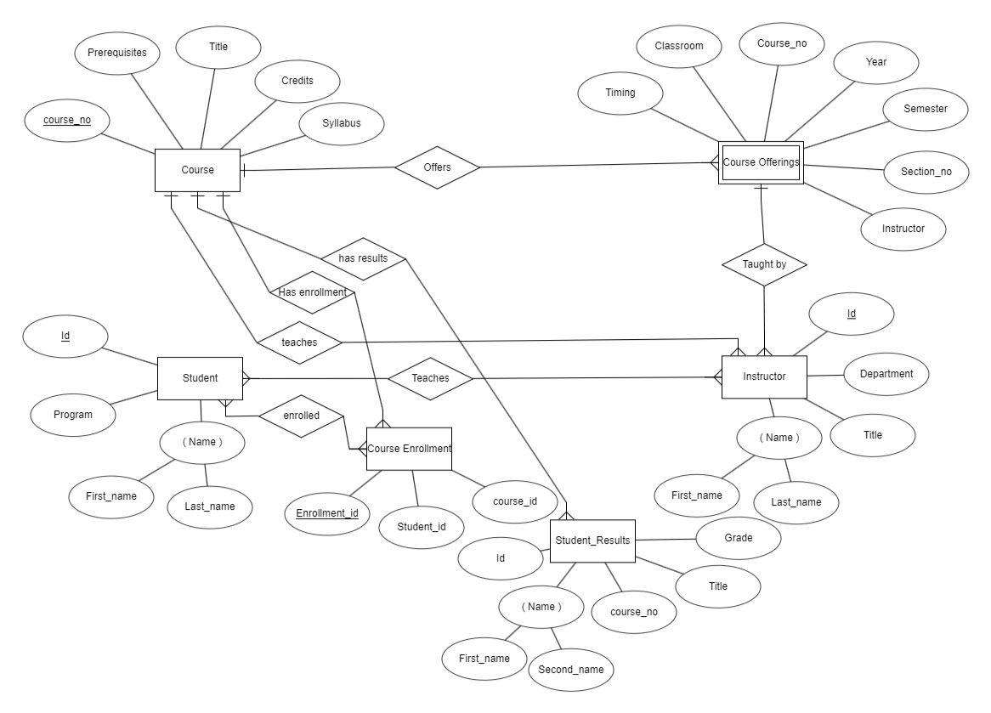

This shows ternary relationship between Instructor , course and student . Instructor teach students and course .

Instructor can teach only one course and a course can be taken by multiple instructors . The marks that students get in different exams of different exams of different offerings recorded in course enrolment entity.

**23.FAVOURITE SPORT’S TEAM**

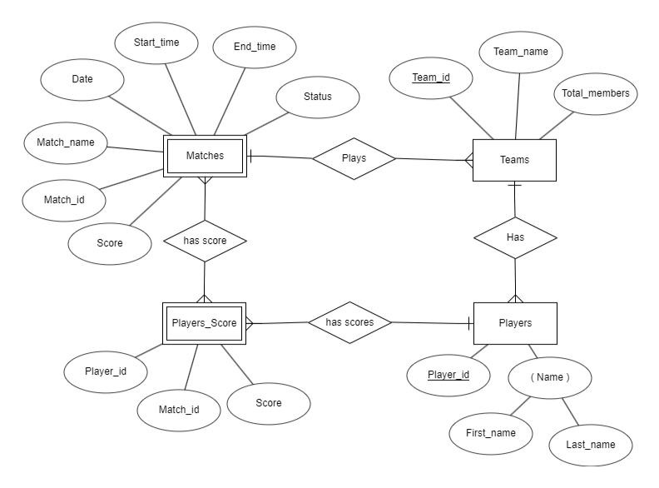

1.There are five entities ( Matches , Team , Players, Players_score , Team_score)

2.Matches entity is weak entity with no primary key

3.In team entity , Team_id is a primary key

4.In player entity , Player_id is a primary key , Name is a composite key

5.In a match many team can participate and a team can play only one match so , one to many relationship.

6.A team have many players and a player can be in only one team so, one to many relationship.

**28.TEAM IN A LEAGUE.**

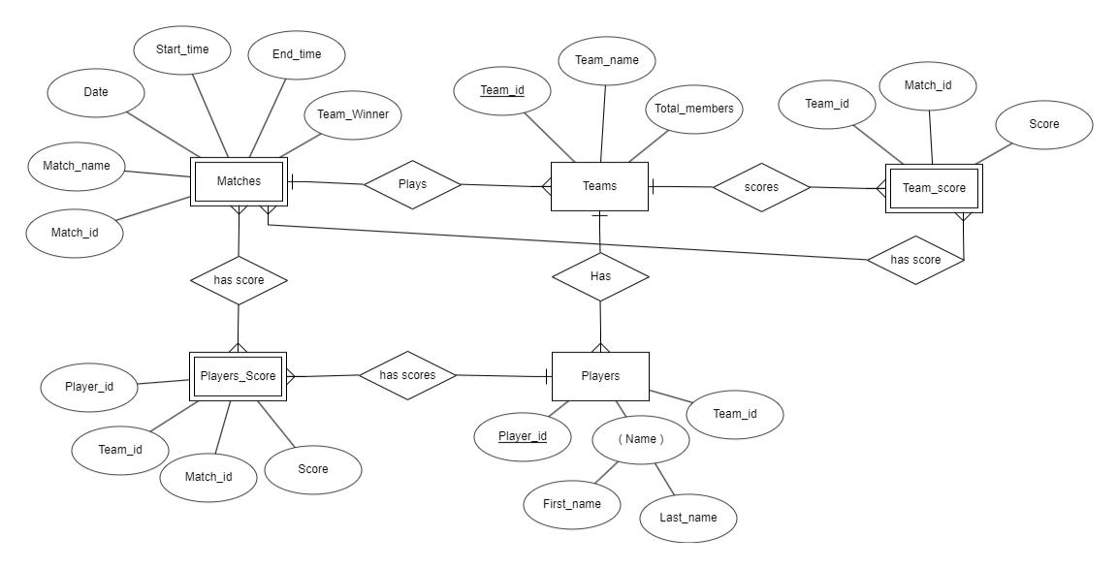

**30.**

**a.**

|  |  |
| --- | --- |
| **ENTITY** | **PRIMARY KEYS** |
| author | Name , address |
| publisher | name |
| book | ISBN |
| Shopping-basket | basketID |
| warehouse | code |
| customer | email |

