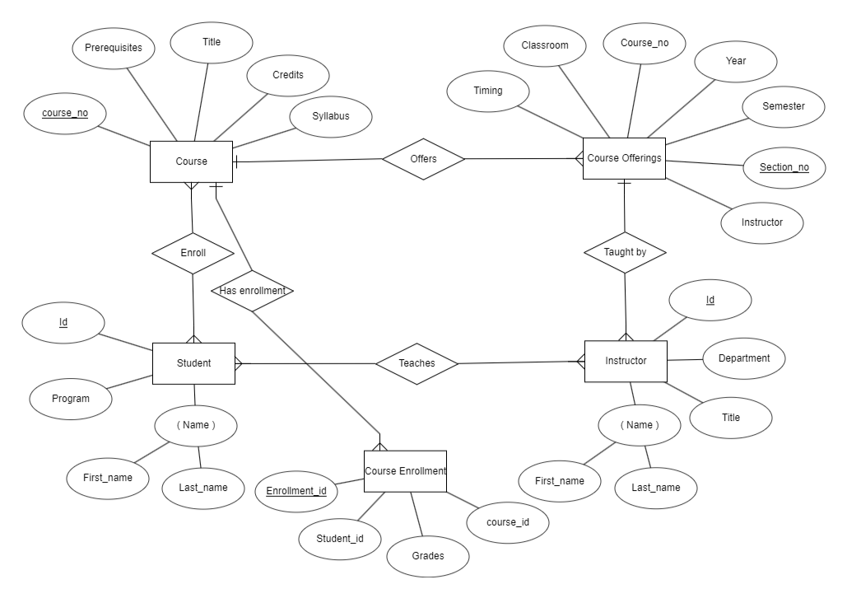
1. There are four entities ( Course , Course Offerings , Student , Instructor , Course Enrollment )
2. In course entity , course_no is the primary key
3. In course offering , section_no is a primary key
4. In course Enrolment , Enrollment_id is a primary key
5. In Student entity , Id is a primary key and Name is the composite key
6. In Instructor entity , Id is a primary key and Name is the composite key
7. Entity :
1.Student Relationship : Many to Many
2.Course
Student can enroll in many course and a each course can have many students.
8. Entity :
1.Student Relationship : Many to Many
2.Instructor
Student can listern to many instructors and a each instructor can teach many students.
9. Entity :
1.Course Offering Relationship : One to Many
2.Instructor
A course can be taken by many instructors and a each instructor can teach only one course.
10. Entity :
1.Course Offering Relationship : One to Many
2.Course
A course can have multiple offerings .
11. Entity :
1.Course Relationship : One to Many
2.Course Enrolment
A course can have multiple enrolments and an enrolment can have only one subject.

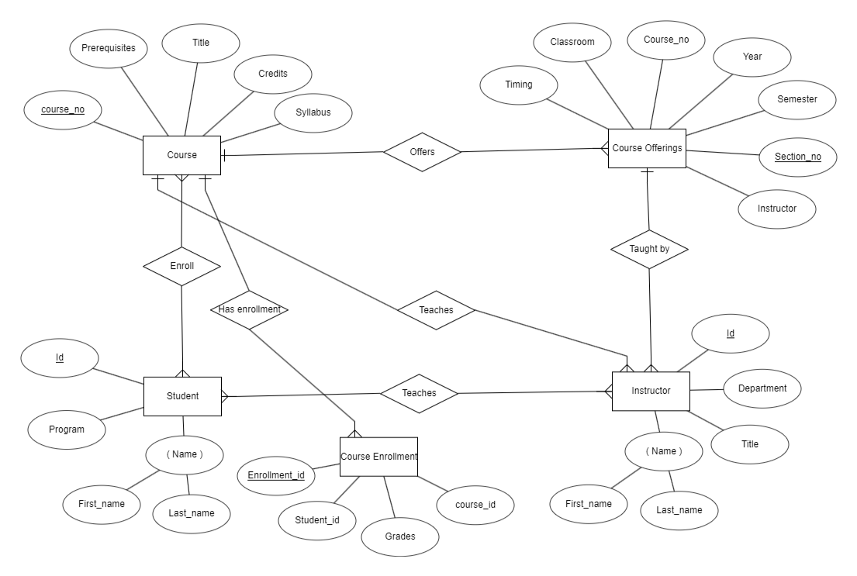
This shows ternary relationship between Instructor , course and student . Instructor teach students and course .
Instructor can teach only one course and a course can be taken by multiple instructors . The marks that students get in different exams of different exams of different offerings recorded in course enrolment entity.

