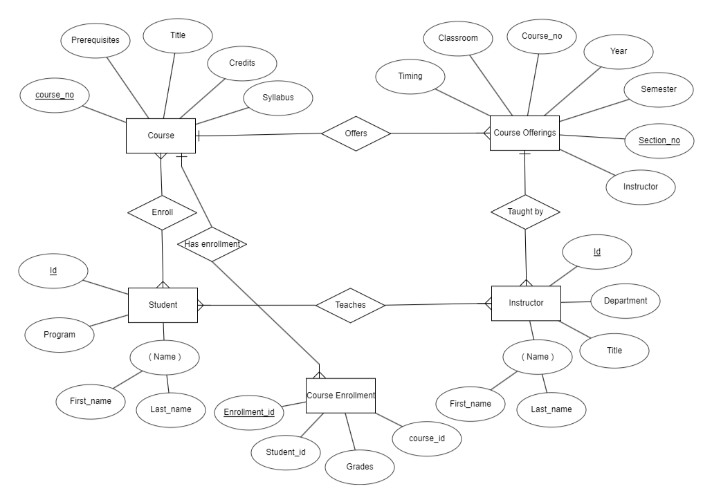

1. There are four entities ( Course , Course Offerings , Student , Instructor , Course Enrollment )

2. In course entity , course_no is the primary key

3. In course offering , section_no is a primary key

4. In course Enrolment , Enrollment_id is a primary key

5. In Student entity , Id is a primary key and Name is the composite key

6. In Instructor entity , Id is a primary key and Name is the composite key

7. Entity :

1.Student Relationship : Many to Many

2.Course

Student can enroll in many course and a each course can have many students.

8. Entity :

1.Student Relationship : Many to Many

2.Instructor

Student can listern to many instructors and a each instructor can teach many students.

9. Entity :

1.Course Offering Relationship : One to Many

2.Instructor

A course can be taken by many instructors and a each instructor can teach only one course.

10. Entity :

1.Course Offering Relationship : One to Many

2.Course

A course can have multiple offerings .

11. Entity :

1.Course Relationship : One to Many

2.Course Enrolment

A course can have multiple enrolments and an enrolment can have only one subject.

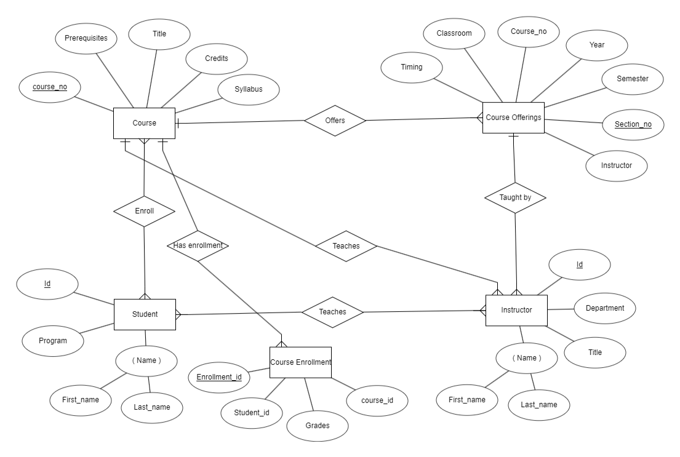

This shows ternary relationship between Instructor , course and student . Instructor teach students and course .

Instructor can teach only one course and a course can be taken by multiple instructors . The marks that students get in different exams of different exams of different offerings recorded in course enrolment entity.