**REAL-TIME RESEARCH PROJECT REPORT**

**on**

**HEALTHCARE SERVICE APPLICATION**

***Submitted in Partial fulfilment of the requirements for the award of the degree of***

**BACHELOR OF TECHNOLOGY**

**in**

**COMPUTER SCIENCE AND ENGINEERING**

**Submitted by**

**S. Greeshma 22D21A05H7**

**P. Ramya 22D21A05H8**

|  |  |
| --- | --- |
|  |  |



**ESTD: 2001**

***Department Of Computer Science and Engineering***

**SRIDEVI WOMEN’S ENGINEERING COLLEGE**

**(Approved by AICTE , Govt. TS, Affiliated to JNTUH, Hyderabad**

**An UGC Autonomous Institution Accredited by NBA and NAAC(A++)**

**With ISO 9001:2015 Certified Institution)**

**V.N. PALLY , GANDIPET, HYDERABAD -75**

**2023-2024**

***Department Of Computer Science and Engineering***

**SRIDEVI WOMEN’S ENGINEERINGCOLLEGE**

**(Approved by AICTE , Govt. TS, Affiliated to JNTUH, Hyderabad**

**An UGC Autonomous Institution Accredited by NBA and NAAC(A++)**

**With ISO 9001:2015 Certified Institution)**

**V.N. PALLY, Gandipet, Hyderabad-75**

**2023-2024**



**CERTIFICATE**

This is to certify that the Real-Time Research Project repo entitled **“HEALTHCARE SERVICE APPLICATION”** is being submitted by **S. Greeshma (22D21A05H7)** and P**. Ramya (22D21A05H8)** in partial fulfilment for the award of degree of **Bachelor of Technology** in **Computer Science and Engineering** is a record of bonafied work carried out by them.

**Coordinator Head of the Department**

**INDEX**

**S.No Title Page No**

1 Introduction 1

2 Hardware and Software Requirements 2

3 Functionality of The Application 3-4

4 Sample Code 5-14

5 Sample Output 15-17

6 Conclusion 18

**1. INTRODUCTION**

Online healthcare applications have revolutionized the way people access and manage their medical needs. These digital platforms offer a seamless and convenient way for patients to schedule appointments, consult with healthcare providers, and access their medical records from the comfort of their homes. By eliminating the need for traditional in-person visits and lengthy phone calls, online healthcare applications provide a more efficient and user-friendly experience. With just a few clicks, patients can access a wealth of information, including available healthcare services, provider availability, and appointment options, enabling them to make informed decisions and find the best care.

Moreover, online healthcare applications often come equipped with a variety of features designed to enhance the overall patient experience. Some applications also offer the ability to store medical records electronically, reducing the need for physical documents and streamlining the healthcare process.

The convenience of online healthcare applications extends beyond scheduling and consultations. Many apps also offer options for booking ancillary services such as lab tests, home healthcare creating a one-stop-shop for all medical-related needs. This comprehensive approach simplifies healthcare management and enhances patient satisfaction by providing a cohesive and integrated care experience.

Furthermore, the accessibility of online healthcare applications has significantly expanded the reach of medical services. With mobile compatibility, patients can manage their health and make last-minute changes on-the-go, ensuring flexibility and peace of mind. The user-friendly interfaces and intuitive design of these applications cater to a wide range of users, from tech-savvy individuals to those less familiar with digital tools.

**2. HARDWARE AND SOFTWARE REQUIREMENTS**

**i) Hardware Requirements**

The hardware requirements for running the above healthcare service application code are minimal, as it primarily relies on a web browser to function. Here are the general hardware requirements:

* **Processor:** Intel i5 or higher
* **RAM:** 8 GB or more
* **Hard disk:** 500 GB SSD

**ii) Software Requirements**

For the healthcare service application, here are three essential softwarerequirements:

* **Front-end Languages:** HTML, CSS, JavaScript
* **Back-end Languages:** Python
* **Frameworks:** React.js, Angular
* **IDE:** VS Code, PyCharm
* **Libraries:** Bootstrap (for responsive design), jQuery (for simplified JavaScript)
* **Version Control:** Git
* **Database:** SQLite/MySQL

**3. FUNCTIONALITY OF THE APPLICATION**

* **General Functionalities**

1.Responsive Design: The application uses Bootstrap for a responsive and mobile-friendly layout.

2.Navigation: The application has a navigation bar that allows users to switch between different sections such as About Us, Patients, Pay Online, Online Lab Reports, Careers, Feedback and Language selection.

* **Specific Functionalities**

1.Service Section

Buttons to navigate to pages for Doctors, Hospitals and Branches, Book an Appointment, Contact Us, and Login.

2.Welcome Section

Hospital Information: Displays an introductory of hospital with image and a welcome message.

* **Bookings Section**

Booking Form:

1.Patient Details: Basic details like name, email and phone number will be entered.

2.Date and Time: Drop-down menus to select date for booking an appointment.

3.Doctors: Drop-down menu to select preferred doctor.

4.Reason for appointment: Reason for the visit.

6.Submit Button: Submits the booking form and adds the booking to the booking history.

7.Confirmation Message: Displays a confirmation message after successfully booking an appointment and shows the history for the recent entered details.

* **Contact Us Section**

1.Contact Information: Provides the healthcare’s customer support contact details including address, phone number, and email address.

* **User Feedback**

1.Confirmation Messages: Displays success or error messages for booking and cancellation actions to provide feedback to the user.

* **Styling**

1.Bootstrap:

Uses Bootstrap for styling the navigation bar, forms, tables, and buttons.

* 2.Custom CSS:

Adds custom styles for the body, header, section, and footer to enhance the appearance and layout.

* **Specialities and Treatments**

A section listing various specialities offered in the hospital and “Learn More” button navigate to detailed pages about each speciality.

* **Why NovaHealth**

Highlights features like leading Doctors, Accreditations, and Awards & Certificates with images and buttons to know more.

* **Frequently Asked Questions (FAQ)**

Collapsible FAQ section divided into different categories such as Cardiac Sciences and Cardiac Rehabilitation.

* **Footer**

Social media icons for Twitter, Instagram and Facebook and Copyright notice.

**4. SAMPLE CODE**

<!DOCTYPE html>

<html lang="en">

<head>

<meta charset="UTF-8">

<meta name="viewport" content="width=device-width, initial-scale=1.0">

<link rel="stylesheet"href="https://cdnjs.cloudflare.com/ajax/libs/font-awesome/4.7.0/css/font-awesome.min.css">

<link rel="stylesheet" href="https://use.fontawesome.com/releases/v5.0.7/css/all.css">

<title>Healthcare Services</title>

<style>

.follow-us-icon-container {

display: flex;

justify-content: center;

align-items: center;

height: 10vh; /* adjust the height to your needs */

margin: 0 auto; /* center horizontally */

}

.icon {

font-size: 24px;

color: #337ab7;

margin: 0 10px; /* add some space between icons */

}

.icon:hover {

color: #23527c;

}

body {

font-family: Arial, sans-serif;

margin: 0;

padding: 0;

}

.logout {

position:20px;

top: 10px;

right: 20px;

text-decoration: none;

color: #fff;

padding: 10px 10px;

background-color: #007bff;

border-radius: 5px;

}

section {

padding: 80px;

padding-top: 30px;

text-align: center;

background-color: rgb(183, 245, 244); /* Transparent white background */

border-radius: 0px;

margin-top: 0px; /* Adjust this value to position the sections */

margin-bottom: 50px;

h1{

padding-right:600px;

font-size: 40px;

color:indigo;

}

img{

float: inline-end;

}

h3{

padding-right: 600px;

}

h2{

font-size:30px;

color: rgb(241, 7, 7);

}

}

.service{

text-align:center;

background-color:rgb(202, 239, 239);

padding: 10px;

}

.services {

display: flex;

align-items: center;

text-align:right;

}

.services img {

margin-left: 30px;

}

.services button {

margin: 5px;

padding: 10px 20px;

background-color: #0062ff;

color: #fff;

border: none;

border-radius: 5px;

cursor: pointer;

font-size: 16px;

}

section1{

h1{

color:blueviolet;

font-size: 40px;

}

h3{

text-align: center;

padding: 0%;

}

}

.serve {

display: flex;

flex-wrap: wrap;

}

.serves {

flex: 1;

margin: 0 20px;

padding: auto;

padding-top: 10px;

}

.serves img {

width: 250px;

height: 250px;

margin-bottom: 20px;

opacity: 0.8;

border-radius: 5%;

}

section2{

color: blueviolet;

font-size: 20px;

}

.servess {

flex: 1;

margin: 0 20px;

padding: auto;

padding-top: 10px;

}

.servess img {

width: 250px;

height: 250px;

margin-bottom: 20px;

border-radius: 5%;

}

.servee

{

display: flex;

flex-wrap: wrap;

background-color:rgb(223, 235, 246);

padding: 10px;

}

.faq {

background-color: #f7f7f7;

padding: 50px;

}

.faq h2 {

font-size: 24px;

margin-bottom: 20px;

}

.faq-columns {

display: flex;

flex-wrap: wrap;

justify-content: center;

}

.faq-column {

flex: 1;

margin: 0 20px;

}

.faq-column h3 {

font-size: 18px;

margin-bottom: 10px;

}

.faq ul {

list-style: none;

padding: 0;

margin: 0;

}

.faq li {

margin-bottom: 20px;

}

.faq a {

text-decoration: none;

color: #337ab7;

}

.faq a:hover {

color: #23527c;

}

.faq .collapse {

padding: 20px;

background-color: #fff;

border: 1px solid #ddd;

border-radius: 5px;

margin-bottom: 20px;

}

.faq .collapse p {

font-size: 16px;

margin-bottom: 20px;

}

.follow-us-icon-container {

margin: 0 10px;

}

.icon {

font-size: 24px;

color: #337ab7;

}

.icon:hover {

color: #23527c;

}

</style>

</head>

<body>

<div class="service">

<a class="nav" href='about us.html'">About Us</a>&nbsp;&nbsp;&nbsp;&nbsp;&nbsp;&nbsp;&nbsp;&nbsp;

<a class="nav" href='patients.html'">Patients</a>&nbsp;&nbsp;&nbsp;&nbsp;&nbsp;&nbsp;&nbsp;&nbsp;

<a class="nav" href='pay online.html'">Pay Online</a>&nbsp;&nbsp;&nbsp;&nbsp;&nbsp;&nbsp;&nbsp;&nbsp;

<a class="nav" href='lab reports.html'">Online Lab Reports</a>&nbsp;&nbsp;&nbsp;&nbsp;&nbsp;&nbsp;&nbsp;&nbsp;

<a class="nav" href='careers.html'">Careers</a>&nbsp;&nbsp;&nbsp;&nbsp;&nbsp;&nbsp;&nbsp;&nbsp;

<a class="nav" href='feedback.html'">Feedback</a>&nbsp;&nbsp;&nbsp;&nbsp;&nbsp;&nbsp;&nbsp;&nbsp;&nbsp;&nbsp;&nbsp;

<select id="language" name="language" >

<option value="">Select a language</option>

<option value="english">English</option>

<option value="telugu">Telugu</option>

<option value="hindi">Hindi</option>

</select>&nbsp;&nbsp;&nbsp;&nbsp;&nbsp;&nbsp;&nbsp;

</div>

<div class="services">

<img src="1.png" height="70" style="vertical-align: middle;">&nbsp;

<button onclick="location.href='doctors.html'">Doctors</button>

<button onclick="location.href='hbranch.html'">Hospitals and Branches</button>

<button onclick="location.href='appointment.html'">Book an Appointment</button>

<button onclick="location.href='contact us.html'">Contact Us</button>

<button type= "submit" , onclick="location.href='hcss.html'">Login</button>

</div>

<section>

<img src="2.jpg" height="300" width="500">

<h1>Welcome To NovaHealth!!</h1>

<h3> At Nova Health, your well-being is our priority. We offer top-tier healthcare services with cutting-edge technology and a compassionate team to ensure you receive the best care.From routine check-ups to specialized treatments, Nova Health is here to support all your health needs. Explore our site to learn more about our services and find resources to help you live a healthier life. Welcome to a brighter, healthier future with Nova Health.</h3>

</section>

<section1>

<h1><center>Speciality and Treatments</center></h1>

<h3>NovaHealth provides best-in-class treatment in over 40 medical specialties including cardiology, cardiac surgery, neurology, neurosurgery,...</h3>

</section1>

</div>

<div class="serve">

<div class="serves">

<img src="car.jpg" alt="Cardiology">

<h3>Cardiology</h3>

<p>NovaHealth offers cardiology services including...</p>

<button onclick="location.href='card.html'">Learn More</button>

</div>

<div class="serves">

<img src="Nep.jpg" alt="Nephrology">

</div>

<br>

<section2>

<h1><center>Why NovaHealth?</center></h1>

</section2>

<div class="servee">

<div class="servess">

<center><img src="doc.jpg" alt="Leading Doctors">

<p>Leading Doctors</p>

<button onclick="location.href='leadingd.html'">Know More</button></center>

</div>

</div>

<div class="faq">

<center><h2>Frequently Asked Questions</h2></center>

<div class="faq-columns">

<div class="faq-column">

<h3>Cardiac Sciences</h3>

<ul>

<li>

<a href="#" data-toggle="collapse" data-target="#faq-1">What is angioplasty?</a>

<div id="faq-1" class="collapse">

<p>Angioplasty is a minimally invasive procedure to open up blocked coronary arteries...</p>

</div>

</li>

</ul>

</div>

<div class="faq-column">

<h3>Cardiac Rehabilitation</h3>

<ul>

<li>

<a href="#" data-toggle="collapse" data-target="#faq-4">How long does cardiac rehabilitation last?</a>

<div id="faq-4" class="collapse">

<p>The duration of cardiac rehabilitation varies depending on the individual patient's needs...</p>

</div>

</li>

</ul>

</div>

</div>

</div>

<footer>

<div class="follow-us-icon-container">

<i class="fab fa-twitter icon" aria-hidden="true"></i>

<i class="fab fa-instagram icon" aria-hidden="true"></i>

<i class="fab fa-facebook icon" aria-hidden="true"></i>

</div>

<div class="col-12">

<center><p>&copy; 2023 NovaHealth. All rights reserved.</p></center>

</div>

</footer>

</body>

</html>

**5. SAMPLE OUTPUT**

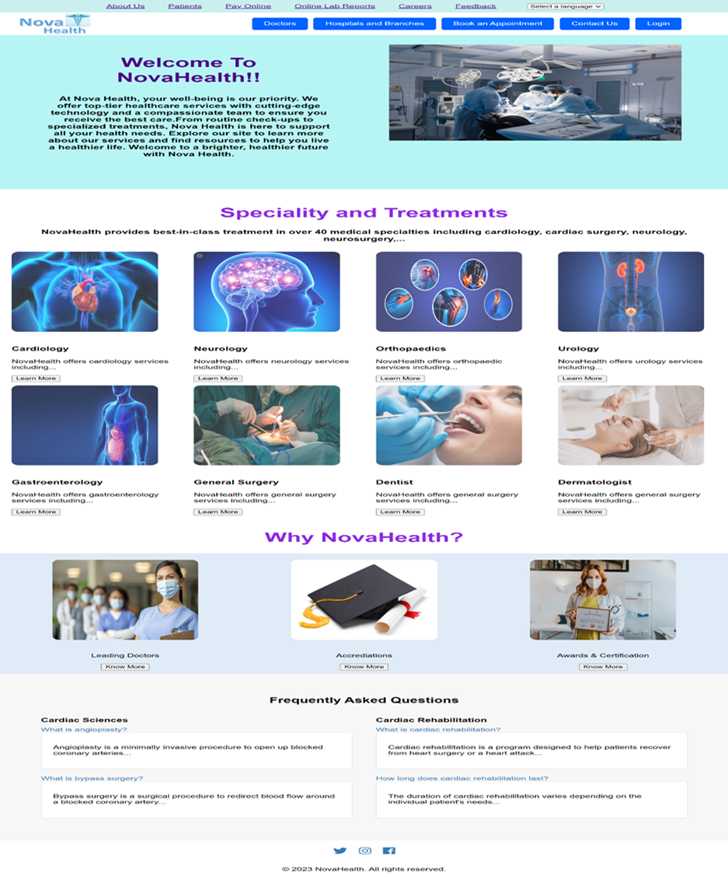

Figure 1: NovaHealth Homepage

* Here we can see first page which provide services, specialities, and key information.
* This page directs you to different pages according to user requirements like: Knowing

about doctors, booking an appointment, online payment etc.

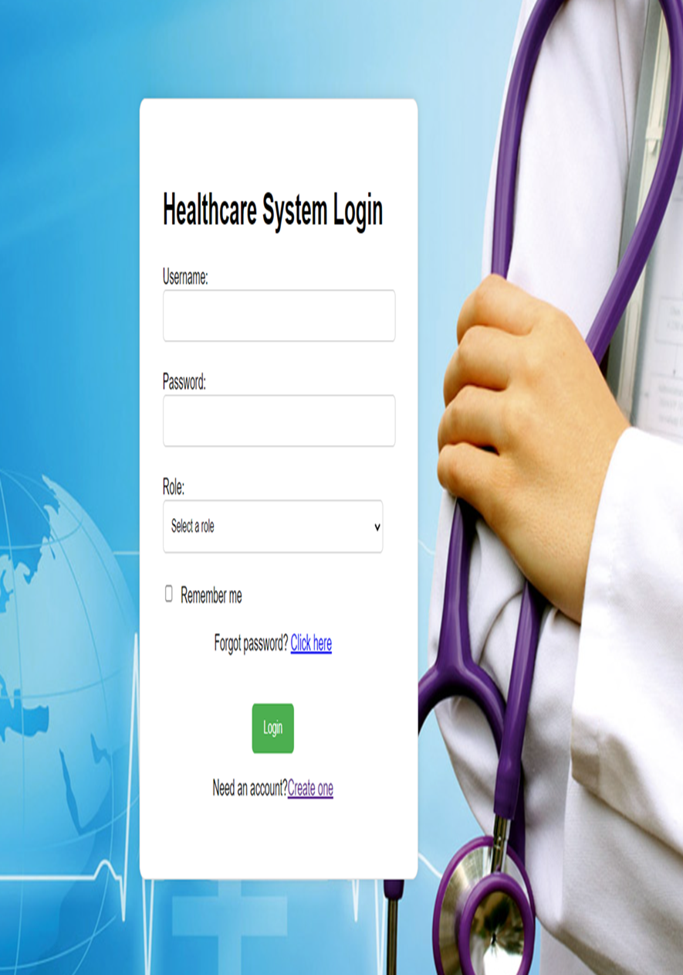

Figure 2: Login page

* Here people can login to this website in order claim specific features like booking an appointment etc.
* New customer can create their own account.

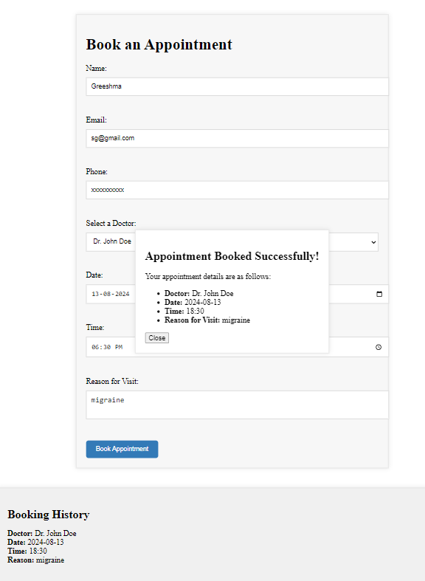

Figure 3: Booking for consultation

* Here you need to enter the details in order to book a consultation and see the record.
* Here you can select doctor, date, time accordingly and reason for visit.

**6. CONCLUSION**

Online healthcare applications have revolutionized medical services by offering unparalleled convenience, efficiency, and accessibility. They streamline the healthcare process, from appointment scheduling and virtual consultations to accessing medical records and personalized health advice, through user-friendly interfaces. These applications cater to diverse patient needs with advanced features like real-time notifications, secure payment processing, and personalized recommendations. Integrating services such as lab tests, home healthcare, and mental health support provides a comprehensive healthcare management solution. Robust security measures and efficient customer support foster a safe, reliable environment, enhancing user trust and satisfaction. As technology evolves, these applications will introduce more innovative features, further improving the patient experience. Meeting specific hardware and software requirements and focusing on key functionalities, online healthcare applications enhance efficiency, convenience, and user engagement, setting new standards in healthcare management and improving how we manage and experience our healthcare journeys.