
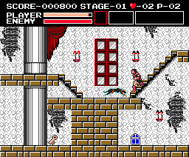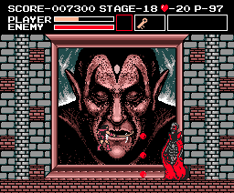
In the 1980s, using multipurpose home computers for the sole purpose of playing video games was all the rage. The most popular form of home computer, especially in the interest in the younger sect, was the Commodore 64, which was actually geared more toward games; if kids and game enthusiasts wanted to play any of their 8-bit favorites, all they had to do was pop in a floppy disk, load away and hope for the best. In Japan, it was the MSX and its successor, the MSX2, to which the video game-hungry populace flocked. The MSX computer systems were popular because they were home to some of the better-looking exclusive titles and arcade ports. More importantly, the MSX was Konami's early nesting ground, from which it created the firsts of what would go on to become some of its more popular game franchises. The one most relevant to us is Akumajou Dracula.
So before there was Castlevania on the Nintendo Entertainment System, a humble little title named Akumajou Dracula had debuted on the MSX2 Home Computer; this bizarre yet intriguing creation, while sharing its name with the Famicom Disk System title whose release was in direct proximity, is to the world outside of Japan the origin of the Castlevania series--this due to its release in Europe under the localized title Vampire Killer (the name to which we'll refer) and the MSX's very limited U.S. release before the FDS title was ever ported elsewhere. Due to the MSX's failure to catch on big outside of Japan, Vampire Killer has become a victim of and a part of its legacy. If there were ever plans to port it to the our consoles or home computer systems, all hopes were dashed when Konami decided that the FDS version of Akumajou Dracula better represented the company's vision for the trademark, whence they tossed Vampire Killer into the abyss of obscurity.
Regardless of its status, this lost title can be considered the series' genesis in more ways than one, since many of its ideas still lurk beneath the surface of even our more modern marvels. From gauging its screenshots, Vampire Killer may look to you exactly like Castlevania, but you'll soon learn that it has significant differences as you discover its true nature.
Vampire Killer is a one-player game that features six stages of action culminating with the final battle against Count Dracula. Rather than exploring stages in an action-focuses, straightforward manner, you move from screen to screen, each room an isolated exercise in danger. Each single stage is broken up into three screen-to-screen sections, which are confined and mostly looped. So, as strange as it may seem, plunging into a pit may inexplicably land the player on a section's upper portion or perhaps through a series of drops onto the top platform of the room he or she was already in; in essence, each stage is more or less a trap-filled maze, with a few instances of true bottomless pits.
Somewhere within each stage section you'll find a locked door. In order to open the door, you'll need a procure a big white key, which you'll find by searching the individual screens; these, the stages' most important items, are either found laying about in hard-to-reach spots or are more often hidden behind breakable walls. Naturally, you'll have to negotiate the stages' maze-like structure to solve the puzzles guarding most of them. Therein, you'll have to take chances and sometimes dive into what may only appear to be a bottomless pit. Once a white key is found through this means of exploration, the section door can be opened, and the next part of the stage can be accessed. At the end of the third such stage section will be a door that this time leads to the domain of a familiar stage boss.
Without question, you'll be guiding our perennial hero, the faceless Simon Belmont, through all of this madness. The game's story and its place in line, we understand, exist only as an iteration of Castlevania, since Konami doesn't supply Vampire Killer its own explanation beyond the usual premise of "Dracula has been waiting for you." Simon starts with just his weak leather whip, which will prove to be ineffective. At his command, eventually, will be many more weapons and magical items that will make a huge difference. He can find morning-star extensions to increase the whip's power, or, more unexpectedly, he can replace the whip with three other weapons: Throwing-daggers, which can be chucked one after another; a boomerang-like cross, which travels far but is fairly weak; or a boomerang-like axe, which can only be thrown a short distance but is greater in strength. (If a respective boomerang-like weapon isn't caught on the rebound, it'll be lost, and Simon will be again stuck with a leather whip.) Regardless of your choice, you lose all collected weaponry once a stage is cleared.
Furthermore, you can expect to find a bevy of magical items in Vampire Killer that are unique to this series, and there are generally three different types of them: First, there are the more typical items that when collected will remain in Simon's inventory box atop the screen for an entire stage. Such items--like sub-weapon-powering hearts, currency-boosting bibles, and scroll maps--will have a constant effect on the action. Most notably, you can equip two types of shields (a mechanic directly in the vein of the rib-bone power from Simon's Quest); one acts a projectile deflector while the other offers better overall defensive ability.
A second group features items that remain in the inventory box for shorter periods. For example: You have boots and wings that allow you jump higher and move faster, respectively, but are designed to last for only one screen apiece. Items from our third group are there to be collected for immediate use; it's in this category of item where you have the potions and crystals that restore energy, screen-clearing crosses, two types of invincibility icons, and still much, much more.
Simon will even collect two different sub-weapons to supplement this sizable arsenal: There are vials of holy water, which work as you'd anticipate, and an hour glass, which mimics the future stopwatch; by jumping and pushing down and left/right respectively, you can activate them. The sub-weapons, disappointingly, are not as defined or as useful as you'd expect within the game's context--that is, there are no obvious uses for them, and the means for activating them are troublesome--but you can have both equipped for use at the same time, which is definitely something out of the norm.
More so than in candelabras, the majority of magical items and sub-weapons are locked away in the treasure chests that are found laying everywhere; these chests can be opened using the small gold keys that are also scattered stage-wide. Since there are so many chests and only a limited number of these gold keys, it'll require a little bit of experimentation if you hope to attain the desired weaponry. The point is that you're never limited: Because of the number of options available, you're always presented the opportunity to change or upgrade your inventory at a moment's notice. As it is in the case of striking weapons, you should know, all magical items and sub-weapons are lost after a stage is cleared.
If you dig further into the game's design, you'll begin seeing even more of the seeds that spawned Castlevania II: Simon's Quest and its ilk. Noticeable is a goal-oriented system of gameplay (in this case the locating white keys) and, more obvious, the collection of hearts as both a power source and as currency. By collecting big and small hearts, you can build up the wealth needed to purchase new items and weapons from Vampire's Killer's merchants. Hidden throughout the castle in large number, the hermit-like merchants can be spotted either camping out all around or, more likely, found hiding behind large breakable structures. A merchant will sell you a specific weapon if you manage to get its attention and meet its asking price. It's important to utilize their services, because even though the larger selection of items is already available via candelabras, treasure chests and breakable walls, some of the more useful and thus rarer weapons and items can be purchased only from these merchants.
(Some important tips that may help: Whether or not you use a joystick, the keyboard will be a necessary component during your playing experience. Rather than "Enter," use F1 to pause the game. If at any time you find an area scroll map on a given stage, use F2 to view it; it'll show your current location and the area's exit. Be forewarned, though, that Vampire Killer will potentially crash on the map screen. Finally, if you want to exit gameplay, simply push F10.)
Graphically, Vampire Killer looks very similar to Castlevania, but it manages to one-up the NES classic with smoother textures and easier-to-look-at backgrounds; the MSX, as a computer system, is naturally better at handling memory and a larger palette, so this shouldn't come as a surprise. Though you may encounter some of those patented "ugly-looking" backgrounds, you'll find this to be a rare occurrence in what is a much cleaner game. True--the stages all resonate the same tone and exhibit the same graphical elements present in Castlevania plus they feature all of the same traps, the same enemies (with slimes as the only unique addition), and the same bosses (sans the second form of Dracula); but while virtually the same in tone, the presentation here is more spooky and haunting due to the more graphically defined haunt; the cleaner, more-hollow look works to better supply a sense of claustrophobia and dread, which works to differentiate this experience from Castlevania's more hurried, gritty presentation.
Thisis not to suggest that Vampire Killer's stages fully emulate the structure of those from in Castlevania. To the contrary, you'll find that Vampire Killer has some tricks up its sleeve. Individual stage sections are larger in all instances, for instance, with some exclusive terrain, noticed especially in the final stage, where the castle keep is actually its own section rather than a simple staircase leading to Dracula's throne room. Entailed, too, are some interesting gameplay mechanics that we haven't seen before, like Stage 4's use of room-connecting portals (which in Castlevania's Frankenstein cave are simply decoratory archwork). It's instead the enemies, we find, that more closely, more traditionally emulate Castlevania's selection. While a few enemies--like, say, axe knights--may employ atypical sprite designs, their jobs remain the same; this holds true for others, like zombies and bats, who if anything are just colored differently. Whatever the case, and while Vampire Killer's similarities to Castlevania are purely superficial, everything comes together nicely to define what turns out to be simply the more atmospheric of the two games.
Obviously, from this information, you shouldn't expect any new tunes on Vampire Killer's soundtrack. What you've heard in Castlevania is what you'll hear when you load up Vampire Killer. I won't tell you that its soundtrack is any better or worse than Castlevania's--it's just a different composition, more digital and a bit higher-toned. I tend to like this soundtrack more, because this particular musical style better complements the stages' engendered atmosphere, which is to say more representative of an investigation rather than a pure-action experience. The sound effects, in that respect, are about identical to those in Castlevania yet also higher-toned and more pronounced.
The controls, too, differ very little from the standard fare experienced in Castlevania and its sequels, but you can expect hell if you don't have a compatible joystick. Among such perils: They programmed it so that you have to push up on the keyboard to jump, so when trying to climb a flight of stairs, which also requires that you push upward, Simon must be placed perfectly at the stairway's base; this spells certain doom if you mess up the positioning while a wave of enemies is marching toward you. The deficient whip doesn't compensate, and hit-detection doesn't favor Simon in the least, so his health meter will feel the wrath. Also, you have to push down or right/left while jumping to toss your sub-weapons, which can cause annoying hiccups when you try to jump in certain directions; the problem here is that you keep using the holy water and the hourglass accidentally, which rapidly depletes your precious heart-total; the system of "pushing a direction" makes the sub-weapons useless while climbing because their use is dependent on an airborne Simon. So if you play with a keyboard, this is what you should expect; if you own a compatible joystick, it will make your life easier because "up" is instead solely used for climbing, and there's less of a chance of wasting hearts while using sub-weapons. Still, even with a control pad, it's not the smoothest or most convenient of configurations (there's no sub-weapon use on stairs), the control scheme having needed a bit of refinement.
And then there's the challenge: When playing Vampire Killer and Konami's other MSX offerings, you get the sense that Konami felt it was in the business of producing impossibly hard games. Even though I know what I'm getting into when I load up the MSX classic, I still pause frequently if not only to question the developers' sanity. Depth of challenge is what makes this franchise legendary, certainly, but even the NES games are somewhat fair. Vampire Killer's evil brewers supply you no continues, which means that you'll have to clear the game in one shot. This is easily imagined but not likely done. The main point of frustration can generally be attributed to what I call "rough spots"--these are certain points in a game where you're bound to lose most of your lives in one clump (read: in the catacombs), and it's always the same jumps that'll do you in over and over again. Then it's all for nothing, and you'll have to try again from the start. That such a fate is an expected outcome is sad, because the game is fun, and you'll want to play on. How can you, though? Take it from me, a veteran of this game-type: Hours of practice will be needed to conquer Vampire Killer, and I'd venture to guess that there are many who will never clear it at all without using the famous cheating device that allows for the manipulation of life-stock and stage selection.
In the end, I can say that Vampire Killer is a game that's difficult not to like. Its problems are indicative of the early years of gaming and the limitations lofted upon developers, true, but the game has a curious charm that can't be denied. Vampire Killer, somehow, is a game that gets better with age, its strongest attribute clearly its growing mystique; for anyone who loves Castlevania, it's almost eerie to discover the existence of its long-lost twin, to see an embedded classic exist in a more oddball, wacky form. The discoverer, though pleased to have found a new toy, will surely be overwhelmed by a fit of nostalgia created through the use of familiarity and similarity. You'll just know from the start that you're experiencing classic, haunted by the sense that this is "where it all began."
Drawbacks aside, any group that calls itself "diehard" is missing out on a big piece of history by ignoring this game. It's surely worth the effort to find it, play it, and delight in its aura. In the opinion of this hardened fan, Vampire Killer is a flawed game whose deficiencies can't be ignored, but it does everything else well enough to where it's worthy of your attention and certainly of three and half Medusa Heads.


The alignment of stages in this game is almost 100% identical to that in the first NES Castlevania, but they do differ somewhat, which warrants them being mentioned here. Use these descriptions with the maps on page 2 to find your way through with ease.
Stage 1: Main Hall

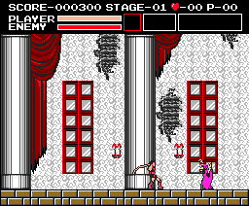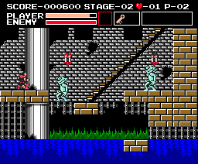  You'll start outside the castle and enter into the main hall. If you can avoid the zombies, and if you stay on the low path, you'll find a key hidden in part of an elevated platform housing two staircases. Area two has the unpassable wall with fishmen below; however, an extra area not appearing in Castlevania is located atop--nothing of importance rests there, though. Go down and look for a key on the third screen of the watery area, the bottom-right-most brickset. Go up the stairs and through the door. Area three is not unlike the first area; the key here can be found in the tallest wall supporting three or more staircases. Go down the first staircase you find afterwards and go through the door to face the boss.  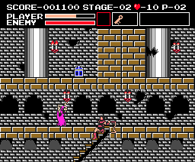 | Music Track(s)  Stage Track: Vampire Killer  Boss Track: Poison Mind
Boss(es)
End Boss: Phantom Bat

Lesser Enemies
Zombie | Bat | Leopard | Fishman | Slime

 | 
Stage 2: Torture Lab

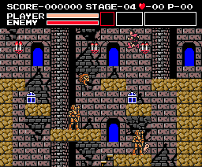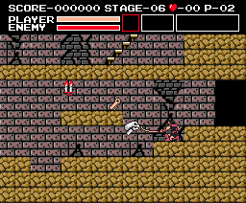  Go left upon starting and take the rightmost staircase on the image shown right. Travel along the top path while avoiding knights, bats and Medusa Heads until you come to a door. Drop down one screen and break some bricks to get a key; find the door again and escape. The next area is home to Medusa Heads and more knights. Get to the screen guarded by two knights; the key is in the topmost wall, where the knight leaves little room to move. Head left, ride the platforms and exit the door. In area three, the key is on the very first screen. Break the bricks that you were walking on while fighting off the skull heads. With the key in hand, finding your way through the rest of this area shouldn't be all that hard.  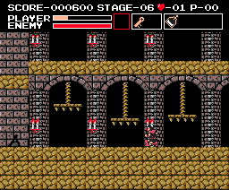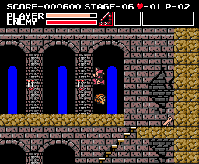 | Music Track(s)  Stage Track: Stalker  Boss Track: Poison Mind
Boss(es)
End Boss: Medusa

Lesser Enemies
Knight | Bat | Medusa Head | Skull Head | Bone Pillar | Slime

 | 
Stage 3: Castle Ruins

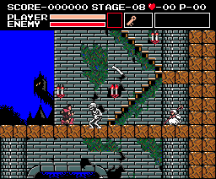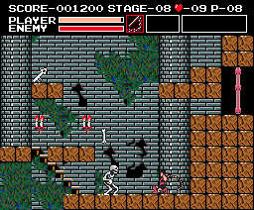  Hunchbacks, ravens and skeletons will attack you early on as you make your way upward. When you come to the screen with the door, go left and drop down. If you work your way around--going through the end of one screen, ending up back where you started, as in Mario Bros.--you'll get to a wall with a key in its top part. In area two, it's straightforward, with Medusa Heads and bone pillars blocking the path; the key will be in a hovering brickset, so don't speed along too quickly. Area three is like the first area, but the key is located early on in the stage. Skeletons, hunchbacks, bone pillars and others will only present an obstacle on this mostly-linear path.  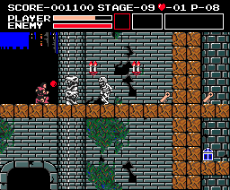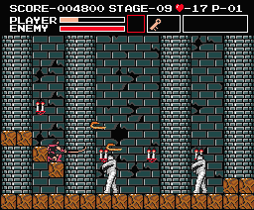 | Music Track(s)  Stage Track: Wicked Child  Boss Track: Poison Mind
Boss(es)
End Boss: The Mummies

Lesser Enemies
Skull Head | Hunchback | Skeleton | Raven | Bone Pillar | Medusa Head | Slime

 | 
Stage 4: The Catacombs

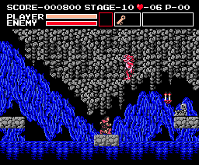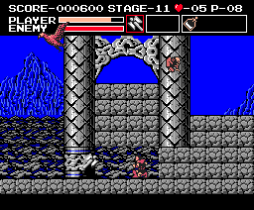  The beginning of the stage is all water, with fishmen and bats all around. It's all straight from here, as you'll have to ride platforms and duck under low cave ceilings. When you come to the end of the path, you'll find a key. You'll emerge into the courtyard where eagles drop hunchbacks. The key is hidden way atop the huge set of bricks. Go straight until you enter the basement through a door. In this third area, you'll have to move around by ducking near the dark semiscircular openings in the background while hitting a button. Go left as soon as you enter and use the first opening; when you emerge, go left again and use the first opening. From here, go one screen right and use that opening. The key and the door are both there, guarded by one skeledragon.  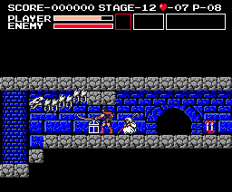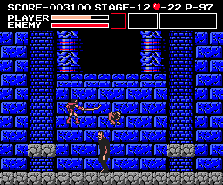 | Music Track(s)  Stage Track: Walking on the Edge  Second Half: Stalker  Boss Track: Poison Mind
Boss(es)
End Boss: Frankenstein and Igor

Lesser Enemies
Bat | Fishman | Eagle | Hunchback | Skeledragon | Slime

 | 
Stage 5: The Dungeon

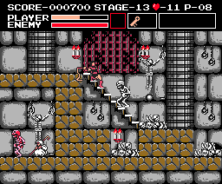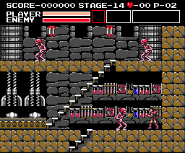  The swift blood skeletons will be the major obstacle early on. Get to the top of the image show right and go up the stairway. Go one screen left when you go up to find the key. The door isn't hard to find from here. The next area is the torture room and alchemy lab. Find a pit guarded by an axe knight and fall down it. The key is hidden in a out-of-place brickset atop a staircase. Go left and the door won't be far off. In the third area, a gallery with pictures of Drac, go all the way up and left until you get to the door guarded by a lone axe knight. Drop down the pit here to land atop a platform with two gaps on either side. Jump down the left gap to reach the key. Go all the way back up to the door to face Death.  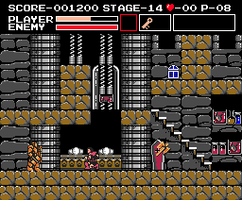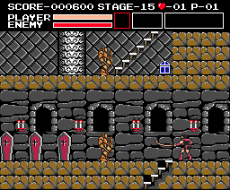 | Music Track(s)  Stage Track: Heart of Fire  Boss Track: Poison Mind
Boss(es)
End Boss: The Grim Reaper

Lesser Enemies
Hunchback | Skeleton | Red Skeleton | Axe Knight | Bone Pillar | Medusa Head | Slime

 | 
Stage 6: Castle Keep

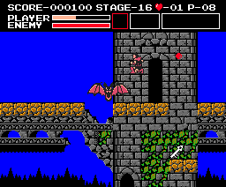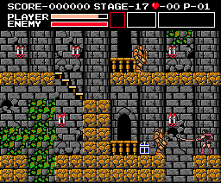  The first area, with several phantom bats, has a high road and a low road. The low road isn't necessary, since the key can be found by simply walking straight; however, a fake key is located on the low road to sucker you in to death. In the next area, the key is hidden on the first screen--but don't get it yet. Find a pit guarded by an axe knight and drop down. Kill a skeleton and break as much of the wall as you can. Go back and fall in that same pit again, get the key on the first screen, and head up through the clock tower to find the door. The final area is the Keep, centered around two staircases guarded by two hunchbacks; go up the leftmost stairway to get the key, go down, up the other staircase and to the door. Dracula awaits.  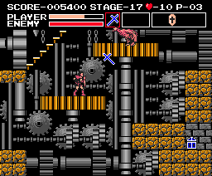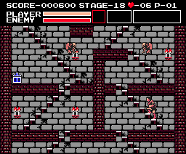 | Music Track(s)  Stage Track: Out of Time  Second Half: Walking on the Edge  Dracula Phase 1: Nothing to Lose  Dracula Phase 2: Black Knight
Boss(es)
End Boss: (1) Dracula, (2) Possessed Picture

Lesser Enemies
Phantom Bat | Skeleton | Eagle | Hunchback | Slime

 | 

Quick Tips
Awe-Filled Adversaries: On level 1, stage 3, before entering into the Phantom Bat's chamber, collect an hourglass if you can find one. Fight the Phantom Bat regularly until it's destroyed. When the energy-restoring, stage-clearing crystal appears thereafter, do not collect it quite yet. When you don't collect it for a while, the stage-ending music will play anyway and the next stage will begin. Once the stage-ending tune begins, wait about three seconds and then activate your hourglass (down while jumping). If done correctly, all of the enemies on the stages thereafter will be frozen in place. They will continue to be frozen until you die or until you again activate the hourglass. (Contributed by James C.)
Money Matters: The merchants that have set up shop castle-wide will do more than just sell you goods. When you see a merchant, it's common practice to whip it repeatedly until it offers you an item. Any whipping done thereafter will bring about a different result, which may not always be in your favor. The merchant's color at the time should give you a hint:
 | White: When a merchant is colored white, it can be struck without any consequence. It can be struck again and again until it turns purple and then red.
 | Purple: Before a merchant turns red, whence it'll sell an item, it turns purple. Depending on its mood when you whip it, it'll either supply you some hearts or take some from you.
 | Red: When a merchant has been struck enough times to the point where it's red, you've gotten its attention, and it'll offer you an item which you can buy or refuse.
 | Blue: After a merchant has sold you its specific item, you can uncover it again. However, whipping it now will cause it to turn blue; repeated whip strokes will destroy it for 5000 points.
Additionally, Vampire Killer has its own twisted version of the stock market. If during a given stage you collect a white bible, the value of hearts will increase; in this case, you can buy merchant-sold items for much cheaper prices. However, if you by accident collect a purple bible, the value of hearts will decrease, and merchants will now charge sometimes-unfair prices.

.
 | General Information
 | Date Released: 1986 |  | Heroes: Simon Belmont
 | Stage Number: 6 (18) |  | Size: 128KB
Original System(s)
MSX2 (Japan and Europe)
Alternate Names/Systems
Akumajou Dracula -- translation: Demon Castle Dracula (Japan)
Manual Story Description
N/A (click "manual scan" at page's bottom)
Objective/Overview
Vampire Killer is essentially the first series' title as far as its lineage in the western world. Your objective is to clear six screen-by-screen stages, each of which is made up of three separate areas. Hidden in the individual areas are white keys, which you must find if you hope to move on; after locating a key, and solving the puzzle usually entailed, you can enter into the next area and so on until you reach the final area of a stage, a boss room, where you'll face the stage's guardian.
While its style of play is wholly original, you will recognize elements anachronistically ripped directly out of the future Simon's Quest for the NES. For easiest reference, it's best to think of Vampire Killer as a hybrid of two future series' styles, an amalgamation of themes seen in Castlevania and Simon's Quest.
Once completed, the credits will roll, and you'll restart the game on the first stage for perhaps another go-around; though, this time, the challenge-level will now increase due to a larger selection of minor enemies, which is a trend that future games would follow. For more information, click on "review" at the bottom of the page.
Japanese/European Differences
Since the MSX2 and its predecessor were predominantly Japanese computer systems, Vampire Killer never showed up in the western world in any meaningful form. However, in contrast to limited U.S. release, MSX computers found their way to many parts of Europe as did our title in question, which was released under the localized name "Vampire Killer." This is the version that we recognize as most common due to its in-game use of the English language.
Soundtrack and Credits
Soundtrack
Opening and Ending Themes: 1 - Prologue | 2 - Ending
Stage Themes: 1 -Vampire Killer | 2 - Stalker | 3 - Wicked Child | 4 - Walking on the Edge | 5 - Heart of Fire | 6 - Out of time | 7 - Nothing to Lose
Battle Themes: 1 - Poison Mind | 2 - Black Night
Miscellaneous Themes: 1 - Death | 2 - Game Over
Links
Music Files: MP3
Soundtrack Release: Akumajou Dracula MIDI Collection and Castlevania Best Music Collections Box
Game Credits: Available
Other Characters
Lesser Enemies: Skeleton, Zombie, Vampire Bat, Fishman, Slime, Knight, Medusa Head, Hunchback, Skull Head, Skeledragon, Red Skeleton, Eagle, Raven, Leopard, Pillar of Bones and Axe Knight
Bosses: Phantom Bat, Medusa, The Mummies, Frankenstein and Igor, and The Grim Reaper
Dracula Forms: Dracula and Possessed Picture
Supporting Cast: Merchants
Character Lists
Lesser Enemies | Bosses | Dracula Forms | Supporting Cast
. | . |  |  | .
Main Arsenal
Hero Image | Statistics
 | Full Name: Simon Belmont
 | Main Weapon: Vampire Killer Whip
 | Weapon Power-Up: Morning Star Whip
 | Alternate Weapons: Dagger, Axe & Boomerang
 | Sub-Weapon Power-Up: None
 | Special Abilities: None
 | Armor: Projectile-blocking and defense-increasing shields

Limitations: Simon is equal to his Castlevania counterpart in both speed and jumping ability. The only time he can deviate from these attributes is when he's in possession of wings or boots. Simon's main problem is mobility while climbing on stairs--a recurring obstacle--because his weapons don't accommodate. His regular whip is too short-ranged, and it's difficult to make contact with enemies; the morning star is stronger, but it still doesn't cure his range deficiency. His three other equippable weapons, the dagger especially, offer a cure, affording him more range and power; though, two of these weapons can be lost quickly. His sub-weapons will be helpful, too, and both can reside in his inventory at the same time. Depending on the shield equipped, Simon's defense will increase, either by more pain tolerance or by the ability to block enemy projectiles.

Weapon Name | Weapon Image | Description
Vampire Killer |  | Standard family-created leather whip
Morning Star |  | Longer chain whip
Dagger |  | Small but weak knife that can be thrown repeatedly
Axe |  | A powerful axe that flies horizontally and returns to Simon
Cross |  | A boomerang-like cross that returns to Simon after thrown
Magical Items
Item Name | Image | Found In | Usage
Morning Star |  | Candle, Chest, Merchant | Whip Power-Up
Heart |  | Candle, Enemy | Powers Mystic Items/Currency
Big Heart |  | Candle, Enemy, Wall | Powers Mystic Items/Currency
Key |  | Laying All Around | Opens One Treasure Chest
White Key |  | Laying Around | Opens An Area Door
Master Key |  | Chest | Opens Many Treasure Chests
Treasure Chest |  | Laying All Around | Contains Any Range of Items
Money Bag |  | Candle, Enemy, Wall | Adds To Point Total
Ring |  | Candle, Chest | Renders Player Invincible
Yellow Shield |  | Chest, Merchant | Blocks Projectiles
Purple Shield |  | Chest, Merchant | Increases Defense
Red Crystal |  | Candle, Chest | Partial Energy Restore
Potion |  | Chest, Merchant | Full Energy Restore
Blue Crystal |  | Candle, Chest | Renders Invisible
Boots |  | Candle, Chest, Merchant | Wearer Moves Faster
Wings |  | Candle, Chest, Merchant | Wearer Jumps Higher
White Bible |  | Candle, Chest | Increases Heart Value
Purple Bible |  | Candle, Chest | Decreases Heart Value
White Cross |  | Candle, Chest | -
Yellow Cross |  | Candle | Clears Screen of All Enemies
Secret Candle |  | Chest, Merchant | Shows Breakable Bricks
Scroll |  | Candle, Chest, Merchant | Acts As Stage Map
Crystal |  | Boss Creature | Clears Stage of All Evil
Sub-Weapons
Weapon Name | Image | Heart Consumption | Comments
Holy Water |  | Five | -
Hourglass |  | Five | Similar to the Stopwatch
Screenshots & Media
Local Title Screens
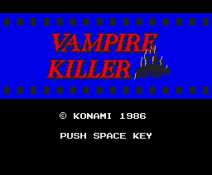 | 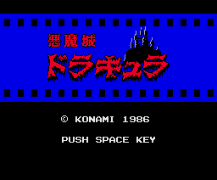

European Title Screen | . | Japanese Title Screen
Action Shots
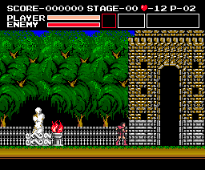 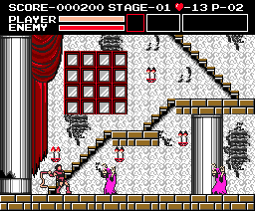
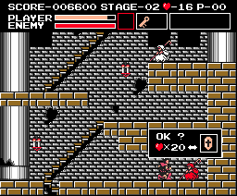
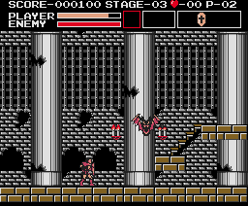
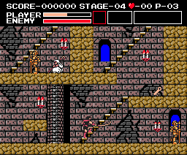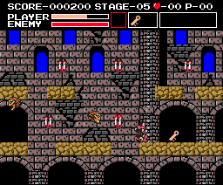
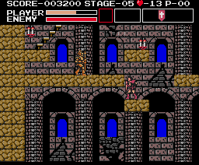
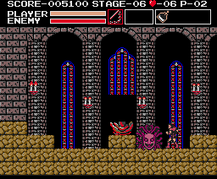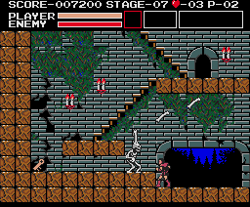
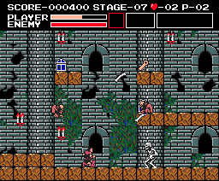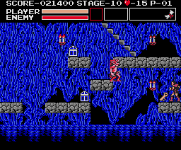
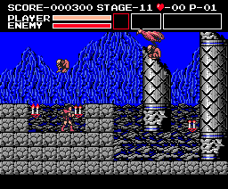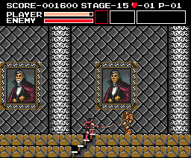
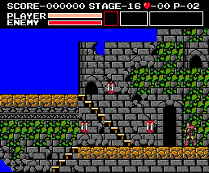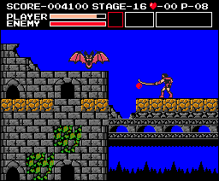
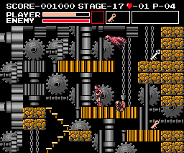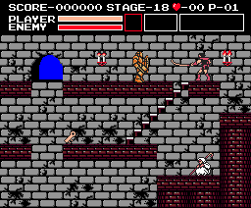
Quick-Reference Links
Category | Availability | What's Inside
Stages: | Available | Complete stage overview plus complete stage maps
Review: | Available | A look at how this MSX2 offering helped spawn our fine series
Codes: | Available | Freezing the lesser enemies | The routines of merchants

