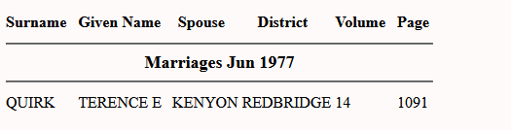
Terence E Quirk

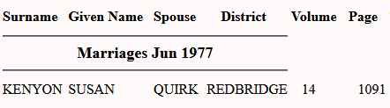

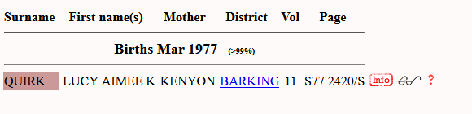
Lucy born in 1977

