TRIUN CONSTRUCTION & ENGINEERING · H2SEP · PRICED 13 AUG 2026
Domestic Water Booster Pump — Weighted Comparison
Home2 Suites by Hilton, Eagle Pass TX — 115 keys over four floors. Grundfos CMBE TWIN 10-54 against the A.Y. McDonald DuraMAC dual-mode duplex, scored on nine weighted criteria.
Recommendation
Grundfos — more pump, less money, sooner. But verify the sizing before either PO goes out.
8.55  Grundfos CMBE TWIN 10-54 | 6.13  A.Y. McDonald DuraMAC

Saves $1,908.56 (12.9%) · ~10 days sooner · +60% boost at 120 GPM · 24 mo warranty vs 12 · ~½ the floor area

1. The two quotes
 | Grundfos | A.Y. McDonald
Model | CMBE TWIN 10-54 | DuraMAC 17044C120PC2-D
SKU | 99503875 | AYM17044C120PC2-D (6011-002)
Price with tax | $12,922.39 (free freight) | $14,830.95
Availability | 10 in stock — 17–19 Aug 2026 | Ships within 2 weeks

2. The headline numbers are quoted from opposite ends of the curve
This is the single most important thing in this comparison, because the two listings invite a straight comparison that is flatly wrong.
- SupplyHouse advertises the Grundfos at 58 ft of head (≈25 psi). That is head at runout — the far right end of the curve, at maximum flow.
- A.Y. McDonald advertises 44 PSI. That is boost at zero flow — the far left end. Their own model nomenclature confirms it: in 17044C120PC2-D, the catalog defines the “044” field as “Water Pressure at 0 GPM”.
Read at face value, the DuraMAC looks roughly 75% stronger. Compared correctly, the opposite is true by a wide margin.

Boost against flow, both pumps running
Digitized from the vector geometry of each manufacturer’s published curve. Accurate to roughly ±1 psi on top of the makers’ own ISO 9906:2012 3B tolerance.
Flow (GPM) | Grundfos (psi) | A.Y. McDonald (psi) | Advantage
0 | 79.3 | 44.3 | +35.0 (79%)
20 | 76.5 | 41.9 | +34.6 (83%)
40 | 64.4 | 39.1 | +25.3 (65%)
60 | 54.4 | 35.7 | +18.7 (52%)
80 | 46.0 | 31.3 | +14.7 (47%)
100 | 38.7 | 26.0 | +12.7 (49%)
120 | 31.9 | 19.9 | +12.0 (60%)
The Grundfos delivers 47–83% more boost at every point on the curve, for $1,909 less. Cost per psi of boost at 120 GPM: $405 (Grundfos) against $745 (A.Y. McDonald).
One important asymmetry: the Grundfos trace is its full-speed envelope. Each pump carries an integrated variable frequency drive, so it holds any setpoint beneath that line at constant pressure. The DuraMAC is fixed-speed — its delivered pressure rides its curve as demand changes.

Figure 1 — Pressure boost against flow
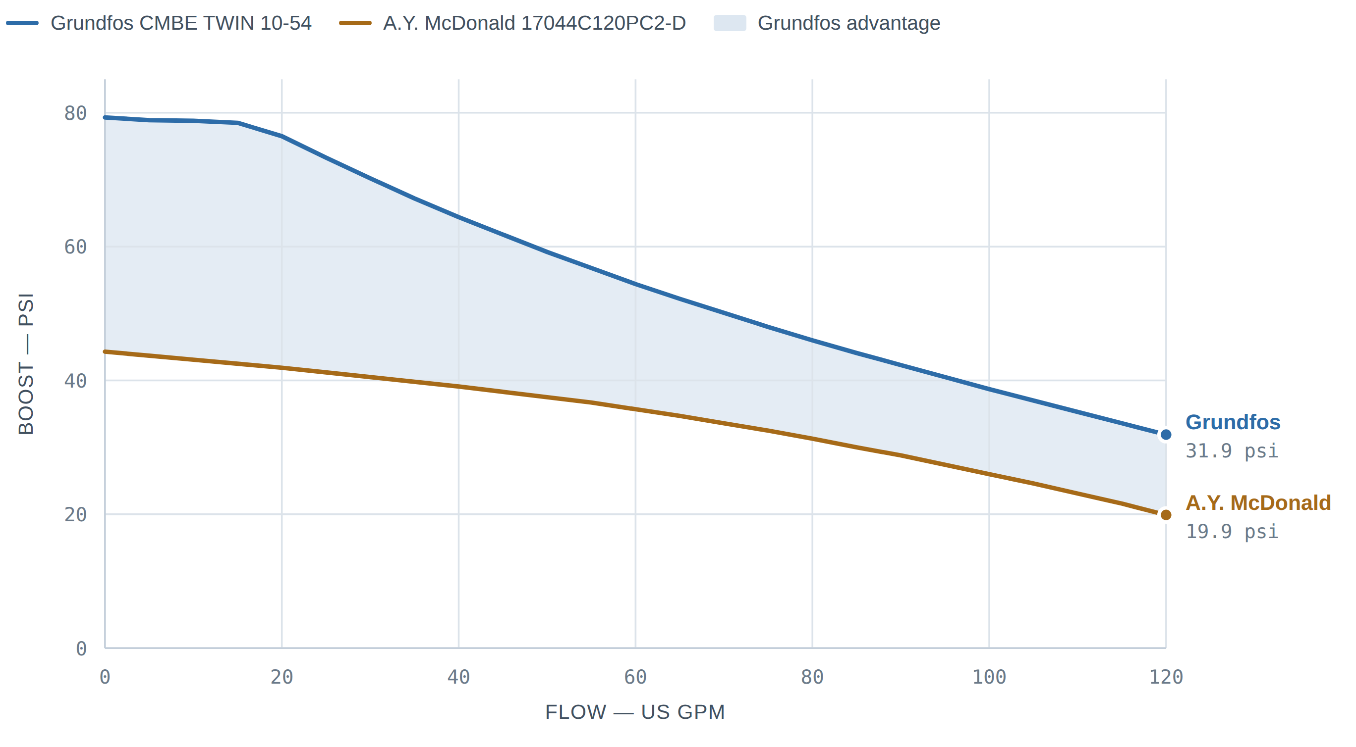
Curves digitized from the Grundfos CMBE / CMBE TWIN data booklet (60 Hz North America, ISO 9906:2012 3B) and the A.Y. McDonald DuraMAC catalog, rev. 11-15. Both published curves stop near 120 GPM.

3. Weighted decision matrix
Scores 1–10. Weights reflect operating-hotel cost: a booster that cannot hold pressure generates guest complaints for twenty years, while a $1,900 price delta is a rounding error on the FF&E budget. “Swing” is the weighted point contribution to the gap.
Criterion | Weight | Grundfos | A.Y. McD | Swing
Hydraulic capability at design flow  47–83% more boost across the curve | 25% | 9.0 | 6.0 | +0.75
Delivered pressure stability  VFD holds setpoint vs a 24 psi swing | 15% | 9.0 | 5.0 | +0.60
Reliability, redundancy, wear-sharing  Documented alternation vs simpler hardware | 15% | 8.0 | 6.5 | +0.23
Serviceability / local support  The DuraMAC’s one clear win | 12% | 6.5 | 7.5 | -0.12
Installed cost  $12,922 vs $14,831 delivered | 10% | 9.0 | 7.0 | +0.20
Lead time / schedule  In stock vs two weeks to ship | 8% | 9.0 | 6.0 | +0.24
Energy + operating cost  Part-load power falls with speed cubed | 7% | 9.0 | 5.0 | +0.28
Electrical & code fit  200–240 V band, UL packaged listing | 5% | 9.0 | 6.0 | +0.15
Footprint / installation  ≈3.0 sq ft vs ≈6.7 sq ft | 3% | 9.0 | 6.0 | +0.09
Weighted total | 100% | 8.55 | 6.13 | +2.42

Sensitivity — the result is not weight-sensitive
Reweighting | Grundfos | A.Y. McD
As scored above | 8.55 | 6.13
Serviceability tripled to 30% (paid out of hydraulics) | 8.10 | 6.41
Installed cost tripled to 30% (paid out of hydraulics) | 8.55 | 6.33
Price, schedule and energy deleted entirely | 8.18 | 6.36
There is no defensible set of weights under which the A.Y. McDonald wins.

4. Pros and cons

Grundfos CMBE TWIN 10-54
PROS
- 47–83% more boost at every flow point — a different capability class, not a marginal edge.
- True constant pressure. Integrated VFD per pump holds setpoint instead of riding the curve; guests get the same shower at 7 AM as at 3 AM.
- Automatic pump alternation is documented — starts whichever pump has the fewest running hours, so wear is shared and neither pump sits idle long enough to seize.
- $1,908.56 cheaper, and 10 units on the shelf for 17–19 Aug delivery.
- 200–240 V band explicitly covers a 208 V service — no buck-boost question.
- Cascade control, dry-running, thermal and overload protection built in; no external motor protection required.
- NSF/ANSI 61 & 372; UL Listed Packaged Pumping System; IP55; insulation class F.
- Rated to 131 °F ambient — documented, which matters in an Eagle Pass mechanical room.
- ≤58 dBA and quieter at reduced speed. 24-month warranty. Grundfos GO wireless for commissioning and BMS tie-in.
- Compact: 26.8" × 16.3" × 22.0", 180 lb, 2" NPT.
CONS
- Two VFDs are two electronic failure points. A drive failure around year 8–10 is the classic expense, is not a parts-house item, and is not a repair a hotel maintenance tech makes at 2 AM.
- Commissioning needs someone who knows drives; that skill is thinner in Eagle Pass than in San Antonio.
- Higher connected load — 18.2 A vs 14.0 A, so a larger branch circuit and breaker.
- Grundfos scopes the CMBE TWIN to “small hotels”. 115 keys over four floors sits at or past that edge.
- Small per-pump diaphragm tanks only — less buffer for tiny overnight draws.
- Drive electronics are more heat- and transient-sensitive than a TEFC motor and a relay.

A.Y. McDonald DuraMAC 17044C120PC2-D
PROS
- Mechanically simple and locally serviceable — fixed-speed TEFC motors, a pressure transducer and relay logic. Any plumber in Maverick County can troubleshoot it. This is its single strongest argument.
- No VFD to fail or replace, and no drive harmonics on the panel.
- 20-gallon tank included — absorbs small draws, handles thermal expansion, cuts pump starts.
- Lower connected load at 7.0 A per pump, 14.0 A total.
- TEFC motors shrug off heat and dust better than drive electronics.
- Flow Mode is genuinely useful if incoming city pressure swings — it starts on flow (≈5 GPM) regardless of pressure, tolerating a leaky or unstable main.
- All-stainless wetted path: 304 SS impellers and diffuser, 301 SS casings, silicon carbide seal faces, no-lead brass, 304 SS base. NSF 61 compliant.
CONS
- 33–45% less boost at matched flow — 19.9 psi vs 31.9 psi at 120 GPM.
- Fixed speed means the pressure swings. Delivered boost rides from 44 psi at night down to 20 psi at the morning peak — a 24 psi swing at the fixture, which is precisely the shower-pressure complaint pattern. The 20-gallon tank stops short cycling; it does not stabilize pressure under sustained flow.
- $1,908.56 more for materially less pump.
- Two weeks to ship against stock on the shelf.
- Lead-lag appears to be set by dialing two independent controllers to different start pressures. A.Y. McDonald’s literature says “designed for lead-lag” but documents no automatic alternation — which would mean the lead pump takes nearly all the hours while the lag pump sits. Confirm with the factory; distributor copy claims automatic alternation and the two sources disagree.
- Nameplate is 230 V. On a 208Y/120 service that sits at the bottom of tolerance — confirm service voltage or price a buck-boost transformer.
- Control is marked “for indoor use only”, and no ambient temperature rating is published.
- Roughly twice the floor area once the 20-gallon tank is set; PRV required if incoming pressure exceeds 36 psi.
- Base warranty 1 year from installation / 2 from manufacture; a 3-year tier exists for “certain booster pumps” — confirm which applies. Catalog literature dates to November 2015.

5. Side by side
 | Grundfos CMBE TWIN 10-54 | A.Y. McDonald 17044C120PC2-D
Configuration | 2 × CMBE (CM10) in parallel, integrated VFD each | 2 × 2 HP TEFC fixed-speed, digital PC2 control each
Control | Constant pressure, cascade control, automatic alternation | Pressure Mode (stops below 3 GPM) or Flow Mode; lead-lag
Boost at 0 / 60 / 120 GPM | 79.3 / 54.4 / 31.9 psi | 44.3 / 35.7 / 19.9 psi
Max head | 54 m ≈ 177 ft nominal (183 ft on curve) | 44 psi ≈ 102 ft at zero flow
Max system pressure | 145 psi (10 bar) | Not published; PRV above 36 psi inlet
Electrical | 1 × 200–240 V 60 Hz · 18.2 A both pumps · P1 3,404 W | 230 V 60 Hz 1φ · 7.0 A per pump (14.0 A total)
Tank | Diaphragm tank + sensor + gauge per pump | 20 gallon, included and required
Connections | 2" NPT | 2" NPT manifolds with ball valves
Dimensions / weight | 26.8" × 16.3" × 22.0" · 180 lb | approx. 36" × 34" × 28.5" incl. tank
Wetted materials | AISI 304 SS sleeve, impeller, shaft, nozzle; PP diffuser | 304 SS impellers & diffuser, 301 SS casings, no-lead brass
Environment | Liquid 32–140 °F · ambient to 131 °F · IP55 · ≤58 dBA | Control indoor use only; no ambient rating published
Certifications | NSF/ANSI 61 & 372 · UL Listed Packaged Pumping System | NSF 61 compliant · no-lead brass
Warranty | 24 months from installation (30 from manufacture) | 1 year from installation base; 3-year tier to confirm
Price delivered, with tax | $12,922.39 | $14,830.95
Availability | 10 in stock · 17–19 Aug 2026 | Ships within 2 weeks

6. The risk both units share
Neither pump may be big enough for this building.
Both published curves stop near 120 GPM, and both are single-phase, 2 HP-class packages. For 115 extended-stay keys over four floors — plus laundry, breakfast service, public restrooms and any pool make-up — a Hunter’s-curve peak lands somewhere around 150–190 GPM before diversity credits for low-flow fixtures. That estimate is not the engineer’s, and it is the assumption that decides this purchase.
Two supporting signals point the same way: Grundfos scopes the CMBE TWIN to “small hotels”, and A.Y. McDonald catalogues the DuraMAC family as “Residential | Light Commercial | Irrigation”. A 115-key hotel would normally be specified with a three-phase package — and the Grundfos Hydro MPC page already in the bookmarks is exactly that class of product.
Do not cut a PO on either unit until the plumbing engineer’s booster pump schedule is in hand. If the schedule calls for more than ≈120 GPM, or more than ≈32 psi of boost at design flow, both are undersized and this comparison is moot.

Verify before ordering
☐ Pull the booster pump schedule from the plumbing drawings — design GPM and required boost at that flow. This single document decides everything.
☐ Get Eagle Pass city static and residual pressure at the meter, in writing from the utility. Required boost is meaningless without it.
☐ Confirm the building service voltage. If 208Y/120, the Grundfos is rated through it and the A.Y. McDonald is not without checking.
☐ Confirm the approved submittal matches the model being bought. A substitution from a scheduled product needs the engineer’s stamp, not just a price comparison.
☐ Ask A.Y. McDonald directly whether the duplex auto-alternates — the literature and the distributor copy disagree, and it changes the reliability picture.
☐ Verify mechanical room ambient design temperature against the Grundfos 131 °F limit if the room is unconditioned.

Sources
- Grundfos Data Booklet, CMBE, CMBE TWIN — Horizontal multistage centrifugal pressure boosting pumps, 60 Hz North America (98647967 0219): performance curves p.13, operating and electrical data p.10, dimensions p.11, type key p.6, product numbers p.19.
- A.Y. McDonald, DuraMAC Booster Pumps catalog rev. 11-15: dual-mode duplex performance curve p.14, specifications, materials and control description p.15, model nomenclature p.4.
- Pricing, tax, stock and delivery as quoted by SupplyHouse and R.C. Worst, 13 Aug 2026. Warranty terms per Grundfos Pumps Corporation and the A.Y. McDonald limited warranty schedule.
Curve values were digitized from the vector geometry of the published charts, so they carry the manufacturers’ own ISO 9906:2012 3B tolerance plus a small digitizing error — treat them as accurate to about ±1 psi.

