**AMERICAN INTERNATIONAL UNIVERSITY-BANGLADESH**

Project Report Cover Page

|  |  |  |  |  |
| --- | --- | --- | --- | --- |
| **Assignment Title:** | Advance Database Midterm Project Report | |  |  |
| **Assignment No:** |  |  | **Date of Submission:** | 20 July 2022 |
| **Course Title:** | ADVANCE DATABASE MANAGEMENT SYSTEMS | | |  |
| **Course Code:** | CSC 4181 |  | **Section:** | A and C |
| **Semester:** | Summer | 2021-22 | **Course Teacher:** | REZWAN AHMED |

**Declaration and Statement of Authorship:**

1. I/we hold a copy of this Assignment/Case-Study, which can be produced if the original is lost/damaged.
2. This Assignment/Case-Study is my/our original work and no part of it has been copied from any other student’s work or from any other source except where due acknowledgement is made.
3. No part of this Assignment/Case-Study has been written for me/us by any other person except where such collaborationhas been authorized by the concerned teacher and is clearly acknowledged in the assignment.
4. I/we have not previously submitted or currently submitting this work for any other course/unit.
5. This work may be reproduced, communicated, compared and archived for the purpose of detecting plagiarism.

*\* Student(s) must complete all details except the faculty use part.*

** Please submit all assignments to your course teacher or the office of the concerned teacher.

**Group Name/No.:**

|  |  |  |  |  |
| --- | --- | --- | --- | --- |
| **No** | **Name** | **ID** | **Program** | **Signature** |
| 1 | S.M. SHAHRIAR | 19-39596-1 | BSc [CSE] |  |
| 2 | NUSRAT JAHAN MOU | 19-39583-1 | BSc [CSE] |  |
| 3 | SK. SHIHAB AHMED | 19-39575-1 | BSc [CSE] |  |
| 4 | MAJHARUL ISLAM SHANTO | 19-39585-1 | BSc [CSE] |  |
| 5 |  |  | **Choose an**  **item.** |  |

|  |  |  |
| --- | --- | --- |
| ***Faculty use only*** | | |
| FACULTYCOMMENTS | **Marks Obtained** |  |
|  |
|  |
|  | **Total Marks** |  |
|  |
|  |

1. **Table of contents**
2. System summary 3
3. ER diagram 3
4. Class diagrams of the system 4
5. Use case diagram of the system 4
6. Activity diagram of the system 5
7. A database schema diagram 5
8. Create all the tables 6
9. Screen shots of sample data 10
10. Questionnaires for demonstrate the database 16
11. **The system connecting to database Error! Bookmark not defined.**

# System summary

In Lazz pharma management system a patient may buy different types of drugs depending on their specific problem. A patient is identified by his/her National ID. The system also stores his/her name, address and gender. There are also few doctors with special abilities, who are available in the pharmacy to checkup the patients. That means if a patient has some issue regarding their health, he/she can make appointment with any specific doctor. The system also stores doctors name, doctor’s license and specialty so that any patient can make appointment for any specific doctors. The system also stores some data manufacture company name, address, ID, who make drugs. The system also stores pharmacy name, ID, address for who sell drugs. In that pharmacy There works a lot of employees who have their name and ID. The system stores their shifting time and contract date of all employees.

# ER diagram

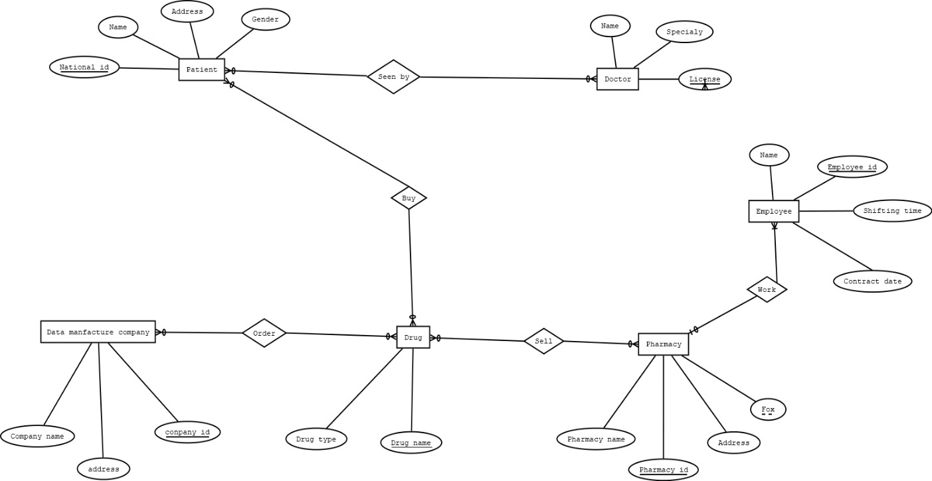

# Class diagrams of the system

# Use case diagram of the system

# Activity diagram of the system

# A database schema diagram

# Create all the tables

### seen by (National_ID, Name, Address, gender, Name, Speciality, License)

### 1NF: No multivalued attribute

### 2NF: National_ID, Name, Address, gender Name, Speciality, License

### A.ID, National_id, License

### 3NF: National_ID, Name, Address, gender Name, Speciality, License

### A.ID, National_id, License No transitive dependency

## Table: National_ID, Name, Address, gender Name, Speciality, License

## A.ID, National_id, License

### Have (Name, Speciality, Licence, Pharmacy_name, pharmacy_id, Address, fax)

### 1NF: Fax multivalued attribute 2NF: Licence, Name, Speciality

### Pharmacy_ID, Pharmacy_name, Address, Fax B.ID, licence, Pharmacy_id

### 3NF: Licence, Name, Speciality

### Pharmacy_ID, Pharmacy_name, Address, Fax, B.ID, licence, Pharmacy_id

### No transitive dependency

## Table: Licence, Name, Speciality

## Pharmacy_ID, Pharmacy_name, Address, Fax B.ID, licence, Pharmacy_id

### Work (name, employee_id, shifting time, contract date, pharmacy name, pharmacy_id, address, fax)

### 1NF: fax multivalued attribute

### 2NF: employee_id, name, shifting time, contract date, pharmacy_id pharmacy_id, pharmacy name, address, fax

### 3NF: employee_id, name, shifting time, contract date, pharmacy_id pharmacy_id, pharmacy name, address, fax

### No transitive dependency

## Table: employee_id, name, shifting time, contract date, pharmacy_id pharmacy_id, pharmacy name, address, fax

### Buy (National_id, Name, Address, Gender, Drug Name, Drug type)

### 1NF: No multivalued attribute

### 2NF: National_Id, Name, Address, Gender Drug name, Drug type

### National_Id, Drug name, NDID 3NF: National_id, Name, Address, Gender

### Drug name, Drug type National_Id, Drug name, NDID No transitive dependency

## Table: National_id, Name, Address, Gender

## Drug name, Drug type National_Id, Drug name, NDID

### Sell (Drug name, Drug type, pharmacy_name, pharmacy_id, Address, Fax)

### 1NF: Fax multivalued attribute 2NF: Drug name, Drug type

### Pharmacy_id, Pharmacy Name, Address, fax 3NF: Drug name, Drug type

### Pharmacy_id, Pharmacy Name, Address, fax Drug name, Pharmacy_id, DPID

### No transitive dependency

## Table: Drug name, Drug type

## Pharmacy_id, Pharmacy name, address, fax Drug name, Pharmacy_id, DPID

### Order (company name, address, company_id, drug type, drug name) 1NF: no multivalued attribute

### 2NF: company_id, address, company name Drug name, Drug type, company_id company_id, drug name, CDID

### 3NF: company_id, address, company name Drug name, Drug type, company_id company_id, drug name, CDID

### No transitive dependency

## Table: company_id, address, company name

## Drug name, Drug type, company_id company_id, drug name, CDID

**Total Table:**

## National_ID, Name, Address, gender Name, Specialy, License

## A.ID, National_id, License

## ~~Licence, Name, Speciality~~

## Pharmacy_ID, Pharmacy_name, Address, Fax B.ID, licence, Pharmacy_id

## employee_id, name, shifting time, contract date, pharmacy_id ~~pharmacy_id, pharmacy name, address, fax~~

## ~~National_id, Name, Address, Gender~~ ~~Drug name, Drug type~~

## National_Id, Drug name, NDID ~~Drug name, Drug type~~

## ~~pharmacy_id, Pharmacy name, address, fax~~ Drug name, Pharmacy_id, DPID company_id, address, company name

## Drug name, Drug type, company_id company_id, drug name, CDID

**Final Table:**

## National_ID, Name, Address, gender Name, Specialy, License

## A.ID, National_id, License

## Pharmacy_ID, Pharmacy_name, Address, Fax B.ID, licence, Pharmacy_id

## employee_id, name, shifting time, contract date, pharmacy_id National_Id, Drug name, NDID

## Drug name, Pharmacy_id, DPID company_id, address, company name Drug name, Drug type, company_id company_id, drug name, CDID

# Screen shots of sample data

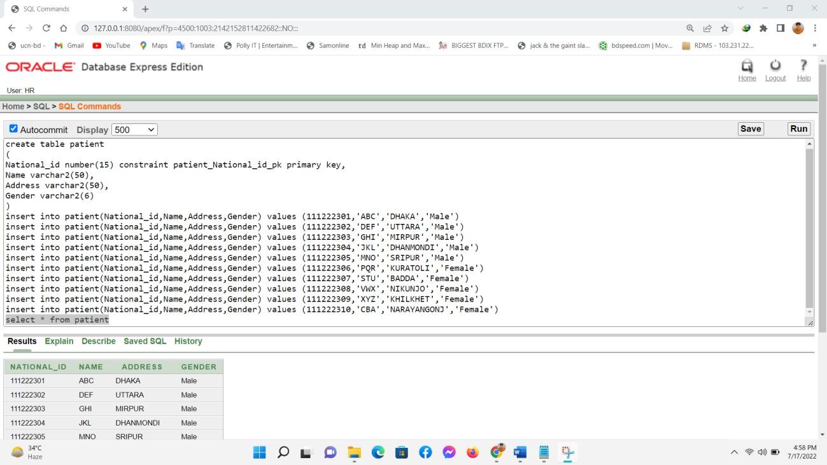

#### Patient Table

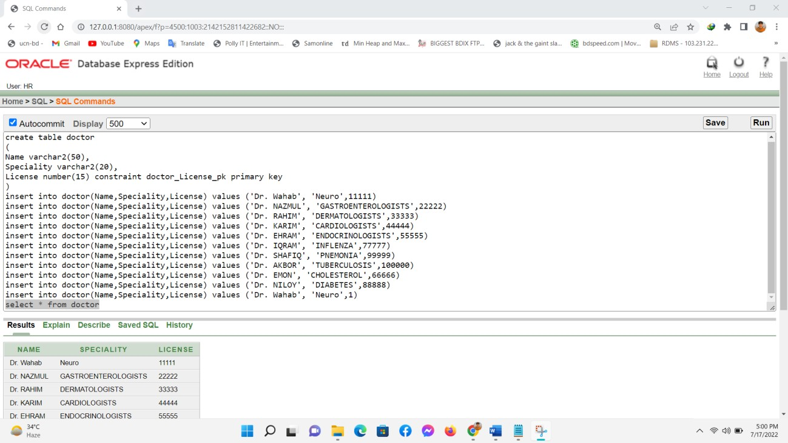

#### Doctor Table

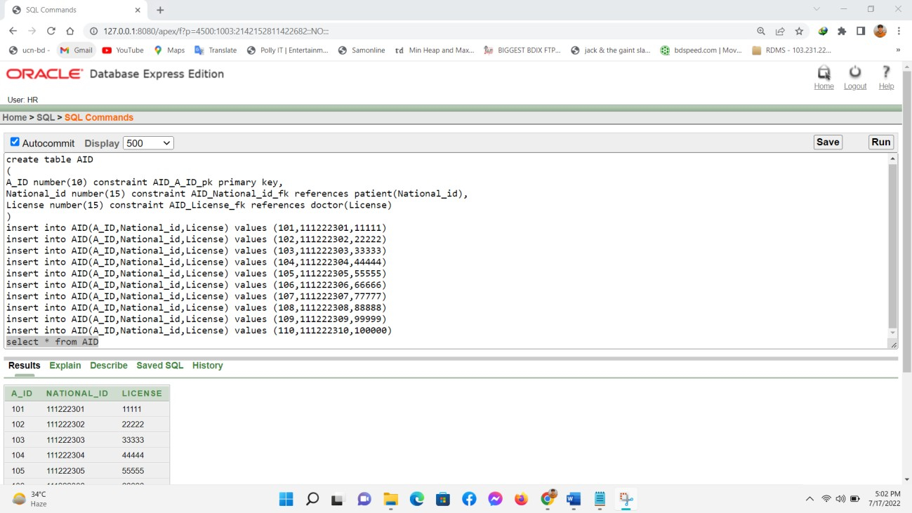

#### AID Table

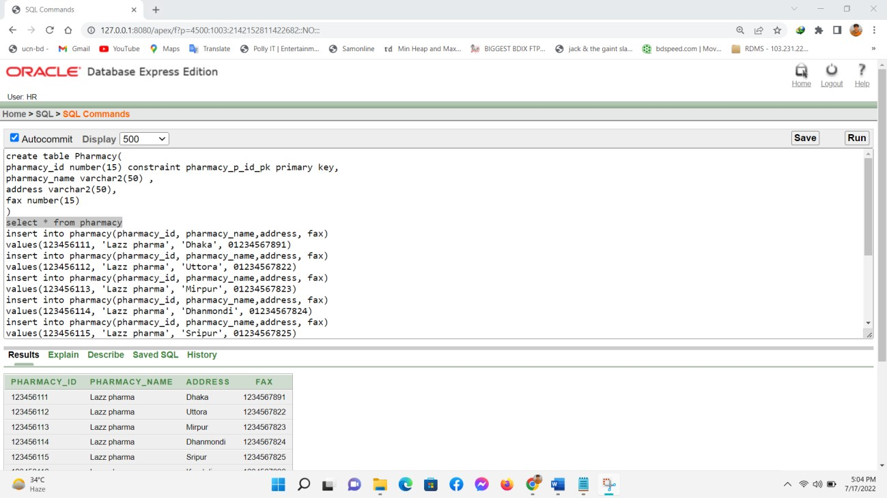

#### Pharmacy Table

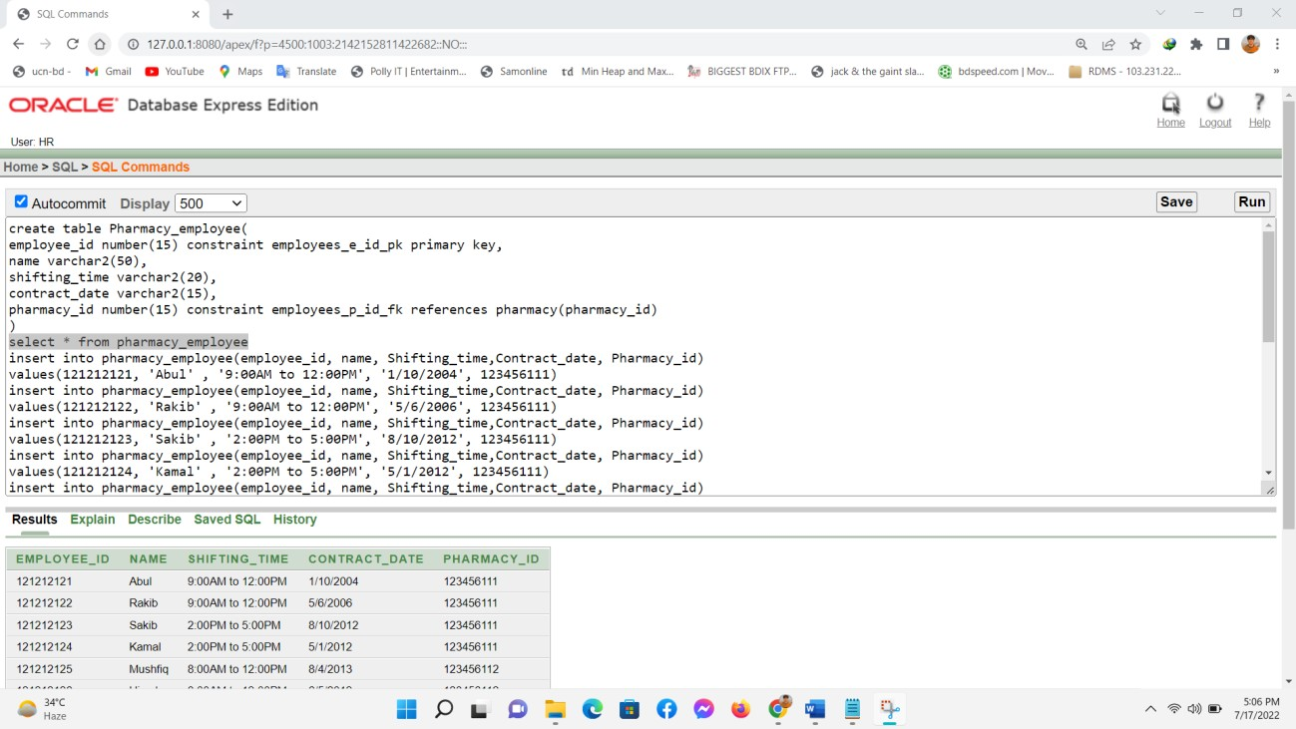

#### Pharmacy_employee Table

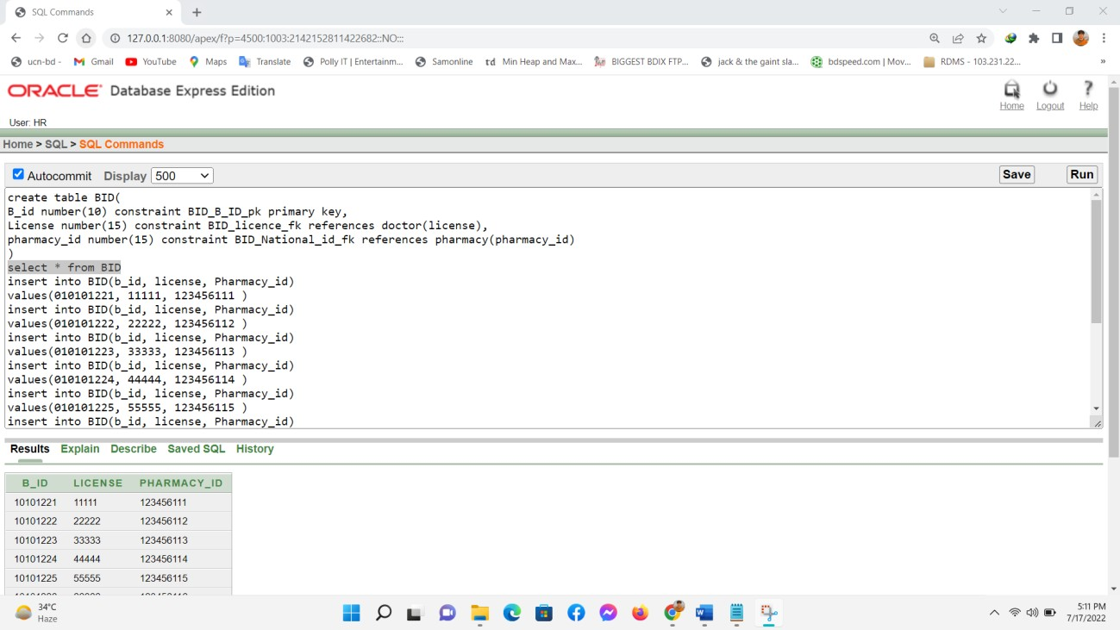

#### BID Table

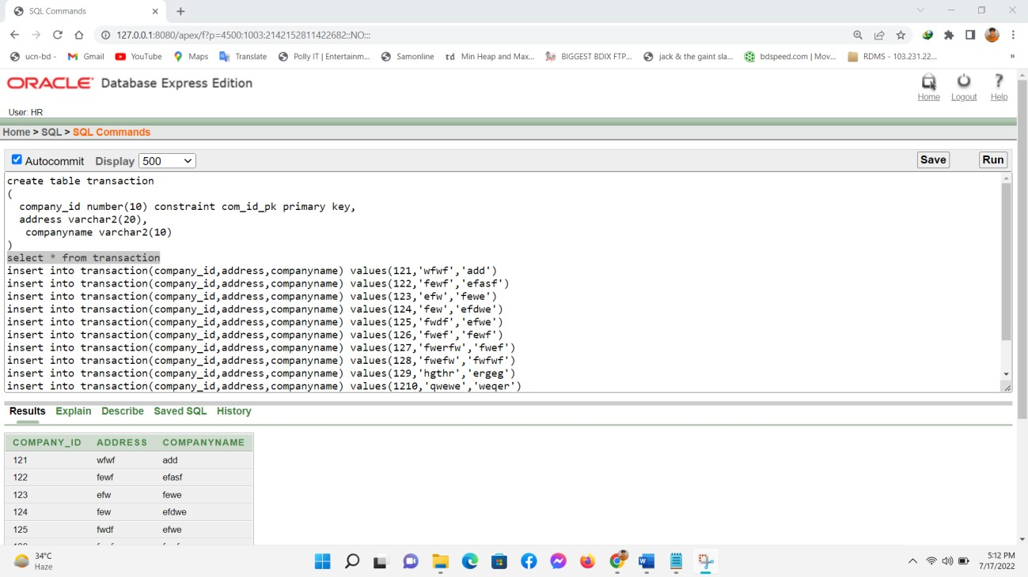

#### Transaction Table

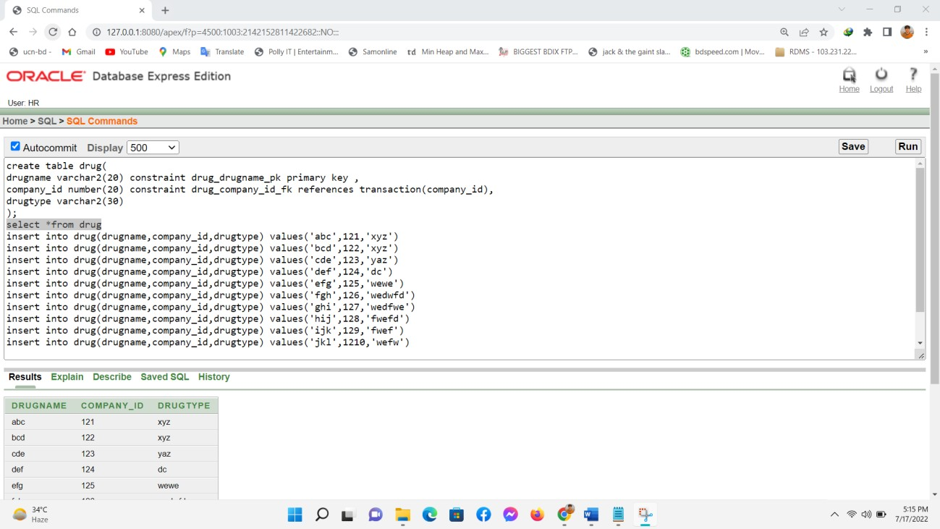

#### Drug Table

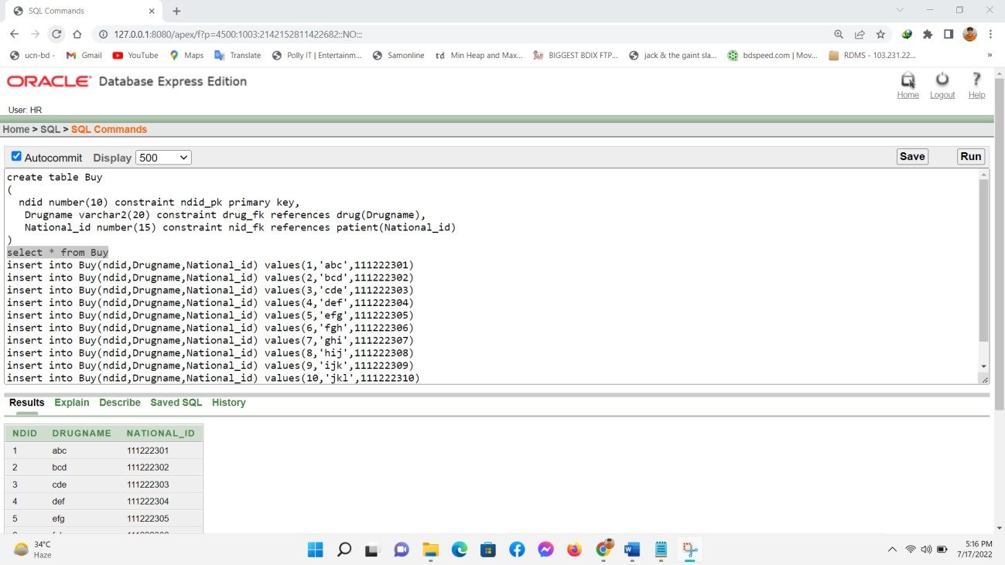

#### Buy Table

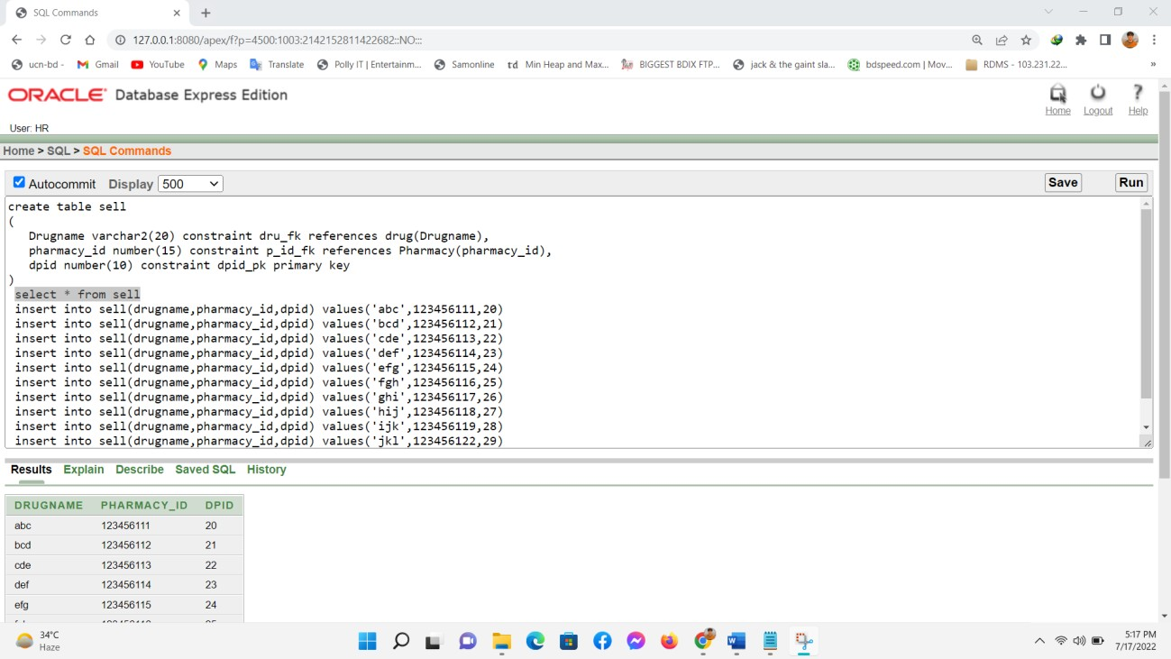

#### Sell Table

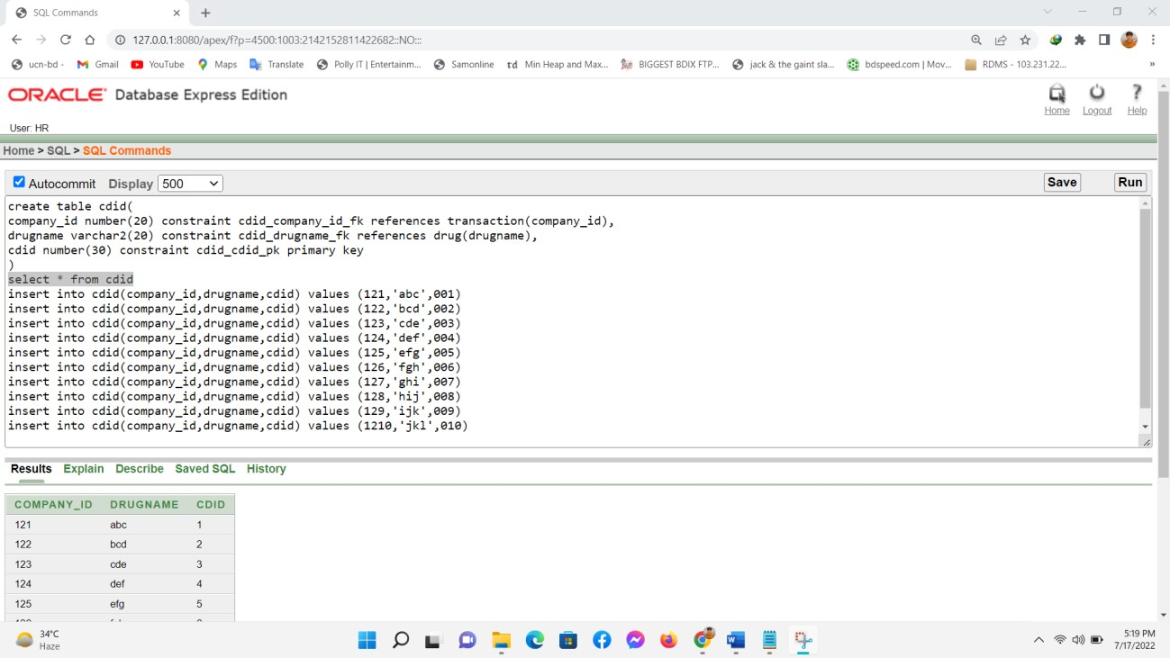

#### CDID Table

# Questionnaires for demonstrate the database

* 1. Ques: Find out the license of Dr. NAZMUL.

Ans: select License from doctor where License = (select license from doctor where Name='Dr. NAZMUL')

* 1. Ques: Find all the greatest license holder than Wahab.

Ans: select License from doctor where License >any (select license from doctor where Name='Dr. Wahab')

* 1. Ques: Find out the pharmacy_id wise number of employee we have. Ans: select count(name) from pharmacy_employee group by pharmacy_id
  2. Ques: Find out the pharmacy_id wise maximum and minimum contract date.

Ans: select min(contract_date), max(contract_date) from pharmacy_employee group by pharmacy_id

* 1. Ques: Find out the pharmacy name and address whose pharmacy id is 123456111.

Ans: select pharmacy_name, address from pharmacy where address=(select address from pharmacy where pharmacy_id=123456111)

* 1. Ques: Find the name and drugname whose national id is 111222301. Ans: select p.NAME, b.DRUGNAME from Patient p, Buy b where p.NATIONAL_ID=b.NATIONAL_ID and p.NATIONAL_ID='111222301'
  2. Ques: Show patient name, address, gender and drugname

Ans: select p.Name,p.Address,p.Gender,b.Drugname from patient p, Buy b where p.National_id=b.National_id

* 1. Find the drugname, drugtype where drugname is abc.

Ans: select d.DRUGTYPE, s.DRUGNAME from Drug d, Sell s where d.DRUGNAME=s.DRUGNAME and s.DRUGNAME='abc'

* 1. Ques: Display all the male gender’s name and drugname.

Ans: select p.NAME, b.DRUGNAME from Patient p, Buy b where p.NATIONAL_ID=b.NATIONAL_ID and p.GENDER='Male'

* 1. Ques: Display all the doctor name, their speciality and which phramacy they work for Ans: select Name, Speciality, pharmacy_name from doctor, BID, pharmacy where BID.License=doctor.License and pharmacy.pharmacy_id=BID.pharmacy_id