# Control Assignement

|  |  |  |
| --- | --- | --- |
| Name | SEC | BN |
| Menna Mohamed Abdelbaset | 2 | 26 |
| Sarah Bisheer Fekry | 1 | 18 |
| Fatma Ibrahim Sobhy | 2 | 1 |
| Rawan Mostafa Mahmoud | 1 | 17 |

## Requirement 1

## Requirement 2

**X1_U =**

**0.01 s^2 + 0.01 s + 0.0055  
--------------------------------------  
s^4 + 2 s^3 + 2.1 s^2 + 1.1 s + 0.0525**

**X2_U =**

**0.005  
--------------------------------------  
s^4 + 2 s^3 + 2.1 s^2 + 1.1 s + 0.0525**

## Requirement 3

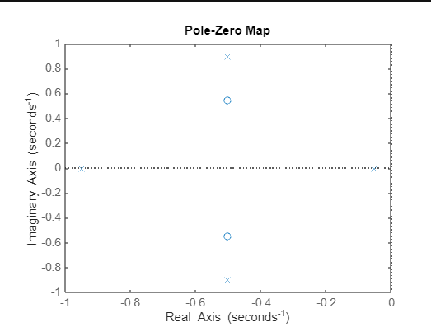

Comment :

In order for the system to be stable, all of its poles must have negative real parts, that is they must all lie within the left-half of the s-plane

And as it shown in the pole zero map all poles fall in the negative part of real axis

## Requirement 4

### X1

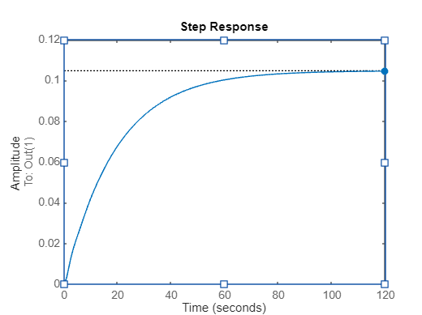

Steady-state value for Output 1 = 0.1047

### X2

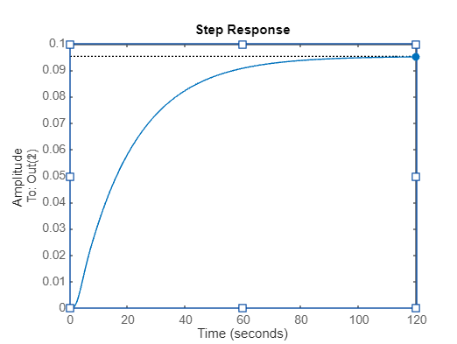

Steady-state value for Output 2 = 0.0952

## Requirement 5

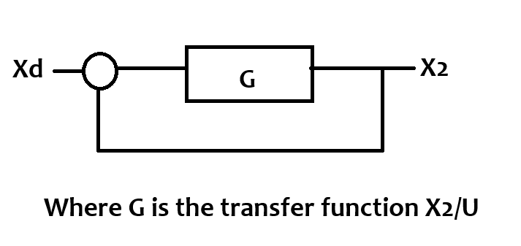

## Requirement 6

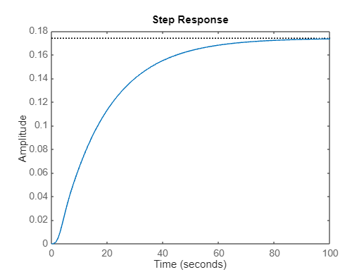

## Requirement 7

Response information

RiseTime: 37.4676  
TransientTime: 68.9668  
SettlingTime: 68.9668  
SettlingMin: 0.0784  
SettlingMax: 0.0869  
Overshoot: 0  
Undershoot: 0  
Peak: 0.0869  
PeakTime: 125.2935

## Requirement 8

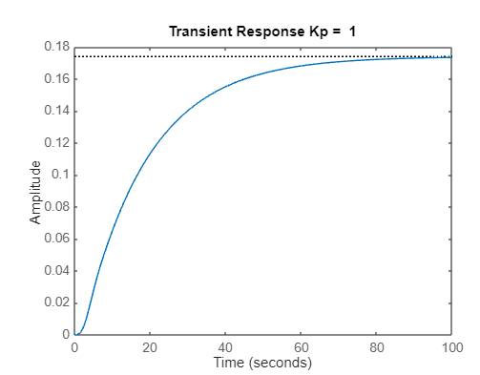

RiseTime: 37.4676  
TransientTime: 68.9668  
SettlingTime: 68.9668  
SettlingMin: 0.0784  
SettlingMax: 0.0869  
Overshoot: 0  
Undershoot: 0  
Peak: 0.0869  
PeakTime: 125.2935

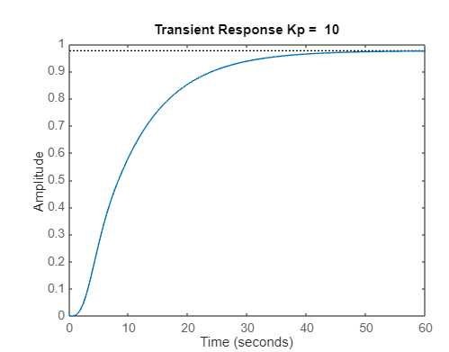

RiseTime: 18.8465  
TransientTime: 35.7815  
SettlingTime: 35.7815  
SettlingMin: 0.4393  
SettlingMax: 0.4873  
Overshoot: 0  
Undershoot: 0  
Peak: 0.4873  
PeakTime: 61.3895

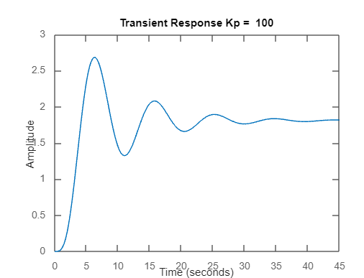

RiseTime: 2.2180  
TransientTime: 31.0141  
SettlingTime: 31.0141  
SettlingMin: 0.6622  
SettlingMax: 1.3416  
Overshoot: 48.2520  
Undershoot: 0  
Peak: 1.3416  
PeakTime: 6.3068

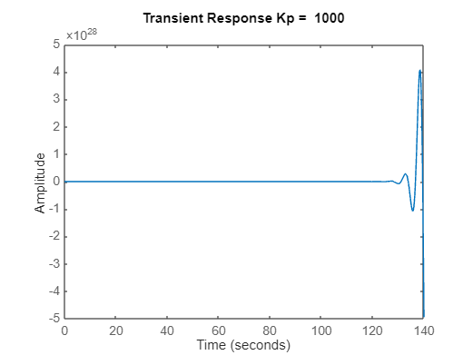

RiseTime: NaN  
TransientTime: NaN  
SettlingTime: NaN  
SettlingMin: NaN  
SettlingMax: NaN  
Overshoot: NaN  
Undershoot: NaN  
Peak: Inf  
PeakTime: Inf

## Requirement 9

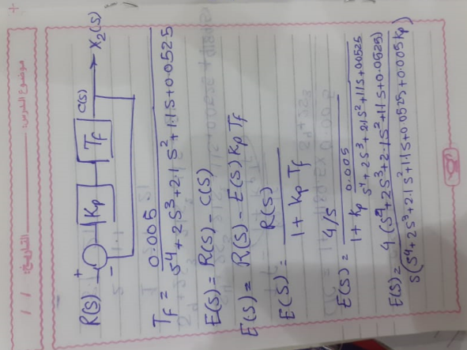

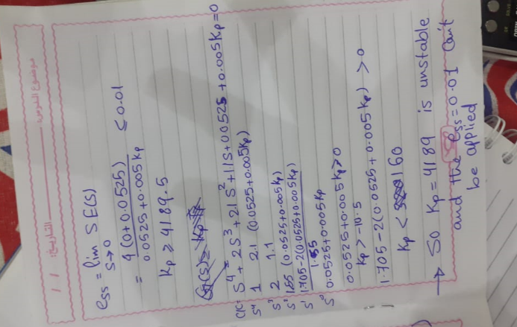

## Requirement 10

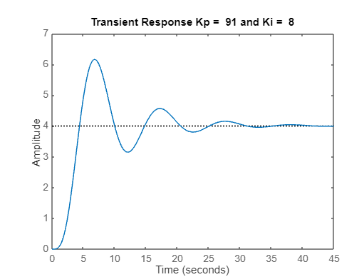

Using Kp = 91 and Ki = 8 in PI Controller we can reach with

Steady state error = 0.0013 wps 0.001

RiseTime: 2.3223  
TransientTime: 29.6248  
SettlingTime: 29.6248  
SettlingMin: 0.7874  
SettlingMax: 1.5398  
Overshoot: 53.9769  
Undershoot: 0  
Peak: 1.5398  
PeakTime: 6.8539