TABLE OF CONTENTS
CHAPTER ONE: INTRODUCTION 6
1.1 Background of the Study 6
1.2 Problem Statement 7
1.3 Objectives of the Study 8
1.3.1 General Objective 8
1.3.2 Specific Objectives 8
1.4 Research Questions 8
1.5 Significance of the Study 9
1.6 Scope and Limitations of the Study 9
1.6.1 Scope of the Study 9
1.6.2 Limitations of the Study 10
1.7 Definition of Terms 10
1.8 Organisation of the Study 12
CHAPTER TWO: LITERATURE REVIEW 13
2.1 Introduction 13
2.2 Theoretical Review 13
2.2.1 Protection Motivation Theory (PMT) 13
2.2.2 Technology Acceptance Model (TAM) 14
2.2.3 DeLone and McLean Information Systems Success Model 14
2.3 Conceptual Review 14
2.3.1 Cybersecurity 14
2.3.2 Phishing 15
2.3.3 Phishing Detection Systems 15
2.3.4 URL-Based Phishing Detection 15
2.3.5 Look-alike Domains and Brand Impersonation 16
2.3.6 Host- and Content-Based Detection 16
2.3.7 Heuristic (Rule-Based) Detection 16
2.3.8 Machine Learning in Phishing Detection 16
2.4 Related Studies 17
2.5 Existing Systems Analysis 18
2.6 Conceptual Framework 19
2.7 Research Gap 20
2.8 Chapter Summary 20
CHAPTER THREE: EXISTING SYSTEM ANALYSIS AND METHODOLOGY 22
3.1 Introduction 22
3.2 Historical Background of Liberia Telecommunications Corporation (LTC) 22
3.3 Geographical Location 23
3.4 Mission, Vision and Values 23
3.4.1 Mission Statement 23
3.4.2 Vision Statement 23
3.4.3 Value Statement 24
3.5 Description of the Existing System 24
3.6 Problem Analysis 25
3.7 Proposed Solution 25
3.8 Research Methodology 26
3.8.1 Research Design 26
3.8.2 Data Collection Methods 26
3.8.3 System Development Methodology 27
3.9 Feasibility Study 28
3.10 Chapter Summary 28
CHAPTER FOUR: SYSTEM ANALYSIS AND DESIGN 29
4.1 Introduction 29
4.2 Requirements Analysis 29
4.2.1 Functional Requirements 29
4.2.2 Non-Functional Requirements 30
4.2.3 Hardware and Software Requirements 31
4.3 System Architecture 32
4.4 Use Case Model 33
4.5 Context Diagram 34
4.6 Design of the Phishing Detection Model 34
4.6.1 Feature Set and Weights 35
4.6.2 Scoring and Classification 36
4.6.3 Detection Process 36
4.6.4 Worked Example 38
4.7 Report Investigation Workflow 38
4.8 Database Design 39
4.8.1 Data Dictionary 40
4.9 Interface Design 42
4.10 Security Design 42
4.11 Chapter Summary 43
CHAPTER FIVE: SYSTEM IMPLEMENTATION, TESTING AND EVALUATION 44
5.1 Introduction 44
5.2 Development Environment and Tools 44
5.3 Project Structure 45
5.4 Implementation of the Detection Engine 45
5.5 Implementation of System Modules 47
5.5.1 Public Scanner 47
5.5.2 Scan Result and Real-Time Alert 47
5.5.3 Awareness Module 50
5.5.4 Authentication 51
5.5.5 Staff Dashboard and Responsibilities 52
5.5.6 Assigned Investigations (My Tasks) 53
5.5.7 Administrator Console 54
5.5.8 Responsive Design 59
5.6 System Testing 61
5.6.1 Unit and Integration Testing 61
5.6.2 Functional Testing 63
5.6.3 Security Testing 64
5.7 Performance Evaluation 64
5.7.1 Dataset and Metrics 64
5.7.2 Results 65
5.7.3 Response Time 66
5.7.4 Discussion of Results 66
5.8 Achievement of Objectives 67
5.9 Installation and Deployment 67
5.10 Chapter Summary 68
CHAPTER SIX: SUMMARY, CONCLUSION AND RECOMMENDATIONS 69
6.1 Introduction 69
6.2 Summary of the Study 69
6.3 Summary of Findings 69
6.4 Conclusion 71
6.5 Recommendations 71
6.6 Suggestions for Further Research 72
6.7 Chapter Summary 72
REFERENCES 74
APPENDIX A: EVALUATION DATASET 76
APPENDIX B: RUNNING THE AUTOMATED TESTS 79

CHAPTER ONE: INTRODUCTION

1.1 Background of the Study
The rapid development of information and communication technology (ICT) has changed the way individuals, organisations and governments communicate and carry out their daily affairs. The Internet now enables people to bank, shop, learn, pay bills and access government services online with ease. However, the same technology has created room for cybercrime, and phishing has become one of the most widespread and damaging forms of it.
Phishing is a cyber-attack in which an attacker impersonates a trusted entity in order to trick a victim into disclosing sensitive information such as passwords, credit card details, mobile-money PINs and other personally identifiable information (PII). Attackers use spam emails, SMS messages, instant messaging, social media and, above all, fake websites that closely imitate legitimate ones. Because phishing exploits human trust and psychology rather than purely technical weaknesses, it remains effective despite the many security technologies that have been introduced to fight it.
With the growing use of online services, phishing has increased in both volume and sophistication. Newer techniques include phishing through shortened URLs, phishing sites protected by HTTPS certificates, QR-code phishing (quishing), look-alike domain names that replace letters with similar-looking characters (for example "paypa1" or "g00gle"), and phishing content generated with artificial intelligence. The consequences include financial loss, identity theft, damage to organisational reputation and loss of customer trust.
In developing countries such as Liberia, Internet use has grown quickly because of expanding mobile networks, broadband services and mobile money. Individuals increasingly depend on digital platforms for banking, payments, government services and education. However, cybersecurity awareness remains low and many users cannot distinguish a genuine website from a fraudulent one. Telecommunications providers are particularly attractive targets: attackers frequently impersonate them to steal customer account details, billing information and staff credentials.
Traditional security tools such as antivirus software, spam filters and firewalls provide some protection, but they are not efficient at detecting new phishing websites. Most rely on blacklists, which only contain sites that have already been identified and reported. A newly created phishing site is therefore not blocked until after it has claimed victims. Research has shown that analysing the characteristics of a website itself — its URL structure, domain, security certificate and page content — allows phishing sites to be identified in real time, even when they have never been seen before.
This study therefore designs and implements PhishGuard, a web-based phishing detection system for Liberia Telecommunications Corporation (LTC). PhishGuard analyses a website address and selected security features using a weighted, feature-based (heuristic) detection model, produces a risk score and verdict within seconds, and warns users before they enter sensitive information. The system also provides role-based dashboards through which LTC staff carry out assigned phishing investigations and administrators manage threats, users and detection performance. In doing so, the study aims to strengthen cybersecurity and cybersecurity awareness among LTC staff and customers.

1.2 Problem Statement
The growing dependence of individuals and businesses on Internet services has increased their exposure to phishing. Customers and employees of telecommunications companies use email, customer portals, billing platforms and mobile-money services daily, and attackers exploit this by creating emails, SMS messages and websites that imitate these services in order to harvest credentials and payment details.
Phishing is effective because it targets human behaviour. Phishing websites are often visually identical to genuine ones, and it is difficult for an average user to spot the subtle differences in a web address. As a result, victims lose money, suffer identity theft and have their accounts accessed without authorisation.
Existing anti-malware tools, spam filters and browser warnings are largely blacklist-based and therefore only detect phishing sites that are already known. Attackers now generate new phishing sites faster than blacklists can be updated. Many available tools are also not designed for ordinary users, do not explain why a site is dangerous, and offer no way for an organisation to collect reports from its own users, investigate them and share the results.
At Liberia Telecommunications Corporation, conventional controls such as firewalls, antivirus software, spam filters and SSL encryption are in place, but there is no dedicated mechanism for analysing suspicious websites in real time, no central channel through which staff and customers can report suspected phishing, and no structured process for assigning and tracking the investigation of such reports. There is therefore a need for an intelligent, easy-to-use phishing detection system that identifies phishing websites from their attributes, warns users before they disclose personal information, and supports the organisation in managing phishing incidents.

1.3 Objectives of the Study

1.3.1 General Objective
To design and implement a web-based phishing detection system for Liberia Telecommunications Corporation that accurately identifies phishing websites and warns users before they disclose sensitive information.

1.3.2 Specific Objectives
The study seeks to:
- Examine the characteristics and techniques used in phishing attacks, particularly those that can be observed in website addresses, hosting and page content.
- Design a weighted, feature-based phishing detection model that combines URL (lexical), host, page-content and reputation analysis to produce a risk score and verdict.
- Develop a web-based phishing detection system with separate interfaces for the public, LTC staff and administrators, including a phishing-report and investigation workflow.
- Implement a real-time alert mechanism that warns users of potential phishing threats before they enter sensitive information.
- Evaluate the performance of the developed system using accuracy, precision, recall and F1-score on a labelled dataset of phishing and legitimate URLs.

1.4 Research Questions
The study seeks to answer the following questions:
- What are the common characteristics of phishing websites?
- How can URL, host and page-content features be combined to detect phishing websites?
- How can a web-based system support users, staff and administrators in detecting, reporting and investigating phishing websites?
- How can users be warned in real time before they disclose sensitive information?
- What level of accuracy, precision and recall can the developed system achieve?

1.5 Significance of the Study
The study will benefit several groups. Customers and Internet users will be better protected from phishing websites because they receive clear, timely warnings and explanations before entering their details. Liberia Telecommunications Corporation will gain a tool that reduces the risk of credential theft among its staff, protects its brand from impersonation, and provides a structured way to receive, assign and resolve phishing reports. ICT and security staff will have a dashboard that shows their responsibilities and assigned investigations, making accountability clearer.
Educational institutions and trainers can use the system and its awareness module to teach people how to recognise phishing. Government agencies and regulators concerned with cybersecurity can use the findings as a reference when developing policies and projects. Researchers will find a documented, evaluated heuristic detection model suited to organisations with limited technical resources, and software developers can build on the design to create browser extensions or integrate phishing detection into existing services.

1.6 Scope and Limitations of the Study

1.6.1 Scope of the Study
The study covers the analysis, design, implementation and evaluation of a web-based phishing detection system for Liberia Telecommunications Corporation, headquartered in Monrovia. The system analyses a submitted website address using reputation lists (blacklist and trusted domains), lexical URL features, host features (DNS resolution and SSL certificate) and page-content features, and classifies the website as safe, suspicious or phishing. On every full scan it also verifies, like a browser would, that the domain really exists on the Internet, whether it is registered and how old it is, and whether its website responds, so that fake or non-existent links are never reported as safe.
The system includes a public scanner and awareness module, a staff area with a personal dashboard showing each user's position, responsibilities and assigned investigations, and an administrator console for monitoring threats, assigning and deciding on phishing reports, managing the blacklist and trusted domains, managing staff accounts and evaluating detection accuracy. It is developed with PHP 8.2, MySQL/MariaDB, HTML5, CSS3 and JavaScript, and runs on the Apache web server (XAMPP).
The study does not address other cyber threats such as malware or ransomware detection, distributed denial-of-service (DDoS) attacks or network intrusion detection.

1.6.2 Limitations of the Study
Several limitations affect the study. High-quality phishing datasets reflecting local Liberian threats are scarce, so the evaluation relies on a small labelled demonstration dataset; results should be confirmed on larger public datasets. The detection model is heuristic (rule-based) rather than trained by machine learning, so its accuracy depends on the selected features and weights, and some sophisticated zero-day phishing sites may evade detection. Deep-scan features require Internet connectivity and may be slowed by network conditions. Time and resource constraints limited testing to a local deployment. Finally, the system focuses on web-based phishing and does not analyse voice calls, SMS messages or social-media messages directly, although links received through these channels can be scanned and reported.

1.7 Definition of Terms
- Cybersecurity: The practice of protecting computer systems, networks and digital information from cyber threats, attacks and unauthorised access.
- Phishing: A cyber-attack in which attackers impersonate legitimate organisations or individuals to deceive users into revealing sensitive information.
- Phishing website: A fraudulent website designed to imitate a legitimate website in order to steal users' credentials or personal information.
- URL (Uniform Resource Locator): The web address used to access a resource on the Internet.
- Domain name: The human-readable name of a website (for example libtelco.com.lr); the registered domain identifies who owns the site.
- Heuristic (rule-based) detection: Detection that applies expert-defined rules and weights to observable features instead of relying only on lists of known threats.
- Feature: A measurable characteristic of a website, such as URL length, use of HTTPS or the presence of a password form.
- Risk score: A number from 0 to 100 calculated by PhishGuard from the weights of the features detected; higher scores indicate higher phishing risk.
- Blacklist: A database of known malicious domains that are always classified as phishing.
- Trusted list (whitelist): A database of verified legitimate domains; each may carry a brand keyword used to detect impersonation.
- Brand impersonation: The use of a trusted organisation's name inside a domain it does not own, for example "libtelco-billing-update.com".
- Look-alike domain (typosquatting): A domain that differs from a trusted domain by one or two characters or by visually similar characters, for example "g00gle.com".
- SSL/TLS certificate: A digital certificate that enables encrypted HTTPS connections and identifies the website to the browser.
- DNS-over-HTTPS (DoH): A way of looking up domain names through an encrypted HTTPS service (e.g. Google Public DNS), which cannot be tampered with by local network resolvers.
- RDAP (Registration Data Access Protocol): The modern replacement for WHOIS, used to find out whether a domain is registered and when it was created.
- Real-time detection: Identifying phishing attempts immediately as users check or access websites, allowing a warning before any information is submitted.
- False positive / false negative: A legitimate site wrongly flagged as phishing / a phishing site wrongly classified as safe.
- Precision, recall and F1-score: Measures of detection performance; precision is the share of flagged sites that are truly phishing, recall is the share of phishing sites that are caught, and F1 is their harmonic mean.
- Dashboard: A page that summarises information and tasks relevant to a particular user.

1.8 Organisation of the Study
This study is organised into six chapters. Chapter One introduces the study, stating the background, problem, objectives, research questions, significance, scope, limitations and key terms. Chapter Two reviews the literature, covering the theoretical framework, key concepts, related studies, existing phishing detection systems and the research gap. Chapter Three analyses the existing system at Liberia Telecommunications Corporation, identifies its problems, proposes the new system and describes the research and development methodology. Chapter Four presents the analysis and design of the proposed system, including requirements, architecture, the detection model, process models and database design. Chapter Five describes the implementation, testing and performance evaluation of the system. Chapter Six summarises the study, presents the findings and conclusion, and offers recommendations and suggestions for further research.

CHAPTER TWO: LITERATURE REVIEW

2.1 Introduction
This chapter reviews literature related to phishing detection systems and cybersecurity. It provides the theoretical and conceptual foundation of the study by examining established theories, key concepts, previous empirical studies and existing phishing detection systems. The review focuses on the cybersecurity challenges of the telecommunications sector and on detection techniques that are practical for organisations with limited technical resources. The chapter ends with a conceptual framework and the research gap that justifies the design and implementation of a phishing detection system for Liberia Telecommunications Corporation (LTC).

2.2 Theoretical Review
The theoretical review presents the theories that underpin this research. They explain users' security behaviour, technology adoption and information system success. Because phishing primarily exploits human behaviour and trust, these theories guided both the detection features and the design of warnings, dashboards and workflows in the proposed system.

2.2.1 Protection Motivation Theory (PMT)
Protection Motivation Theory, proposed by Rogers (1975), explains how individuals respond to perceived threats and adopt protective behaviour. Users evaluate a threat by considering its severity, their vulnerability to it, the effectiveness of the recommended protective measure (response efficacy) and their confidence in carrying it out (self-efficacy).
Employees and customers of telecommunications companies regularly use email, customer portals, billing platforms and mobile-money services, all of which are imitated by phishing sites. PMT suggests that users who understand the consequences of phishing and trust the available protective tools are more likely to avoid suspicious links. PhishGuard applies this theory directly: its result page communicates severity (a risk gauge and a clear verdict), vulnerability (the exact warning signs found in the URL), response efficacy (specific actions such as "close this website" or "change your password") and self-efficacy (an awareness page and quiz that teach users to recognise phishing themselves).

2.2.2 Technology Acceptance Model (TAM)
The Technology Acceptance Model, developed by Davis (1989), explains the factors that influence users' willingness to adopt a new technology. Two factors determine acceptance: perceived usefulness and perceived ease of use.
A phishing detection system must not only detect malicious websites accurately but also present its results in a simple, understandable way; confusing alerts are ignored. For this reason PhishGuard requires only a single input (the web address), gives a verdict in plain language within seconds, visually breaks down the address ("URL X-ray") to show why it is dangerous, and works on both desktop and mobile devices. For LTC staff, each person's dashboard shows only the responsibilities and tasks relevant to them, which increases perceived usefulness.

2.2.3 DeLone and McLean Information Systems Success Model
The DeLone and McLean Information Systems Success Model (DeLone & McLean, 2003) evaluates information systems using six dimensions: system quality, information quality, service quality, system use, user satisfaction and net benefits.
A successful phishing detection system must provide accurate threat identification (information quality), fast and reliable operation (system quality) and meaningful support to users (service quality). These dimensions informed the evaluation of PhishGuard in Chapter Five, where accuracy, precision, recall, response time and functional reliability are measured, and they explain the expected net benefit to LTC: fewer successful phishing attacks and greater trust in its digital services.

2.3 Conceptual Review

2.3.1 Cybersecurity
Cybersecurity refers to the protection of computer systems, communication networks, software and digital information against unauthorised access, cyber-attacks and data breaches. It encompasses technologies, policies, procedures and practices designed to maintain the confidentiality, integrity and availability of information. Telecommunications companies such as LTC rely heavily on secure digital infrastructure to provide Internet connectivity, voice communication and online customer services; cybersecurity is therefore essential for protecting both organisational assets and customer information.

2.3.2 Phishing
Phishing is a social-engineering attack in which cybercriminals impersonate trusted organisations or websites to trick users into revealing confidential information. Attackers use fake emails, cloned websites, SMS messages (smishing), voice calls (vishing), QR codes and social-media messages. The Anti-Phishing Working Group (APWG) reports that phishing remains one of the most frequently observed forms of cybercrime worldwide. The telecommunications industry is particularly exposed because attackers impersonate Internet service providers to obtain customer credentials, payment information and account details.

2.3.3 Phishing Detection Systems
A phishing detection system is a software solution that identifies phishing websites, suspicious URLs or fraudulent content before users disclose confidential information. Detection approaches fall into four broad categories: (i) list-based approaches that compare a site against blacklists or whitelists; (ii) heuristic or rule-based approaches that apply expert-defined rules to website features; (iii) visual-similarity approaches that compare the appearance of a page with that of the genuine site; and (iv) machine-learning approaches that learn to classify sites from labelled examples. Modern systems often combine several of these to balance speed, accuracy and resource requirements.

2.3.4 URL-Based Phishing Detection
URL-based detection analyses the characteristics of a web address to determine whether it is legitimate. Important features include URL length, the use of an IP address instead of a domain name, the "@" symbol (which causes browsers to ignore everything before it), multiple sub-domains, hyphens in the domain, the absence of HTTPS, uncommon or frequently abused top-level domains, URL shortening services and sensitive words such as "login", "verify" or "account". Because URL analysis requires no network access, it is extremely fast and can be performed while the user is still typing.

2.3.5 Look-alike Domains and Brand Impersonation
Attackers frequently register domains that closely resemble those of trusted organisations. This may involve inserting the brand name into an unrelated domain (brand impersonation, for example "libtelco-billing-update.com"), changing one or two characters (typosquatting, for example "linkedln.com"), replacing letters with similar-looking digits (homoglyphs, for example "g00gle.com" or "paypa1.com"), or using internationalised characters encoded as punycode ("xn--"). Such domains can be detected by comparing the registered domain with a list of trusted brands, measuring the edit (Levenshtein) distance between them (Levenshtein, 1966) and normalising homoglyphs before comparison.

2.3.6 Host- and Content-Based Detection
Host-based features describe how and where a website is hosted: whether its domain resolves in the Domain Name System (DNS), whether it presents a valid SSL/TLS certificate that matches the domain, and how recently the certificate was issued. Content-based features are extracted from the page's HTML: password fields, forms that submit data to a different domain, hidden iframes, meta-refresh redirects, the proportion of empty or external links, and page titles that claim a brand the domain does not belong to. Zhang, Hong and Cranor (2007) demonstrated with CANTINA that analysing page content substantially improves the detection of phishing pages that evade URL-only checks.

2.3.7 Heuristic (Rule-Based) Detection
Heuristic detection assigns each suspicious feature a weight reflecting its association with phishing and combines the weights into a score that is compared with thresholds. Its main advantages are that it detects previously unseen (zero-day) phishing sites, requires no training data, runs with very little computing power, and is explainable: every point in the score can be traced to a specific, human-readable warning sign. Mohammad, Thabtah and McCluskey (2014) showed that carefully selected rules extracted from website features can classify phishing websites with high accuracy. The main disadvantage is that weights must be chosen and maintained by experts.

2.3.8 Machine Learning in Phishing Detection
Machine learning enables computers to recognise patterns in large datasets and classify websites automatically. Algorithms such as Random Forest, Decision Tree, Support Vector Machine (SVM), Naïve Bayes and Logistic Regression have achieved high accuracy in phishing detection (Sahingoz et al., 2019). However, these approaches require large, representative and regularly updated training datasets, and their decisions can be difficult to explain to ordinary users. Given the scarcity of locally relevant datasets and the emphasis of this study on usability and practical deployment at LTC, this study adopts a heuristic, weighted-feature model and treats machine learning as a future enhancement (see Chapter Six).

2.4 Related Studies
Numerous studies have examined phishing detection using various computational approaches.
Garera, Provos, Chew and Rubin (2007) identified structural features of phishing URLs, such as obfuscation of the host with IP addresses or other domains, and showed that a small set of URL features can classify phishing URLs with high accuracy.
Zhang, Hong and Cranor (2007) proposed CANTINA, a content-based approach that analyses the text of web pages combined with heuristics such as suspicious URLs, the "@" symbol and the age of the domain. Their results showed that combining content with URL heuristics reduces false positives.
Mohammad, Thabtah and McCluskey (2014) developed an intelligent rule-based classification of phishing websites, extracting rules from features such as IP-address usage, URL length, sub-domains, SSL state and request URLs. Their work supports the use of weighted website features for phishing classification.
Jain and Gupta (2016) proposed a client-side approach based on an automatically updated whitelist of legitimate sites, demonstrating that trusted-domain lists combined with feature checks can protect users with low computational cost.
Bahnsen et al. (2017) developed a real-time phishing URL classification framework using recurrent neural networks, capable of classifying phishing websites with high accuracy while maintaining efficient processing speed.
Sahingoz et al. (2019) proposed a machine-learning model that analysed lexical URL features and word vectors, and showed that combining multiple feature extraction methods produced better results than relying on a single method.
Aljofey et al. (2022) developed a phishing detection framework that combined URL analysis with HTML feature extraction. Their findings showed that analysing multiple website characteristics significantly improved detection accuracy while reducing false positives.
Verma and Das (2023) compared several machine-learning algorithms for phishing website detection and found that Random Forest consistently outperformed other classifiers in accuracy and reliability.
Although these studies have advanced phishing detection research, most focus on generic web environments and are evaluated with datasets collected outside Africa. Few address the operational needs of telecommunications organisations in developing countries such as Liberia, and few combine detection with an organisational workflow for reporting and investigating phishing incidents.

2.5 Existing Systems Analysis
Several phishing detection solutions are available. Browser security services such as Google Safe Browsing and Microsoft Defender SmartScreen, and reputation services such as Norton Safe Web and the community-driven PhishTank, identify known phishing websites using blacklists and reputation data and warn users before they access malicious pages. Email providers use spam filtering that analyses message content, sender reputation and attachments. Within telecommunications organisations, conventional measures include firewalls, antivirus software, intrusion prevention systems, multi-factor authentication and secure protocols.
While these mechanisms provide an important first line of defence, they are mainly list-based and may not identify newly created or highly targeted phishing websites. They also rarely explain their decisions to users and do not give an organisation such as LTC control over its own trusted brands, reports and investigations. Table 2.1 compares typical existing solutions with the system proposed in this study.
Table 2.1: Comparison of existing phishing protection solutions with the proposed system
Capability | Browser blacklist services | Email spam filters | PhishTank (community) | Proposed PhishGuard
Detects known phishing sites | Yes | Partly | Yes | Yes (blacklist)
Detects new (zero-day) sites | Limited | Limited | No | Yes (heuristic features)
Detects look-alike LTC domains | No | No | No | Yes (brand & look-alike checks)
Explains why a site is dangerous | No | No | Partly | Yes (signals & URL X-ray)
Organisation-managed trusted list | No | Partly | No | Yes
Internal report & investigation workflow | No | No | Public only | Yes (assign, finding, decision)
Staff dashboards and responsibilities | No | No | No | Yes
Built-in accuracy evaluation | No | No | No | Yes

2.6 Conceptual Framework
The conceptual framework of this study links the observable characteristics of a website (independent variables) to the classification outcome and its effect on user protection (dependent variables), through the weighted scoring process of the detection model. Table 2.2 summarises the framework.
Table 2.2: Conceptual framework of the study
Independent variables (website features) | Process (detection model) | Dependent variables (outcomes)
Reputation: blacklist / trusted-domain membership  Lexical: URL structure, domain, TLD, keywords, brand and look-alike patterns  Host: domain existence (DNS), registration age, reachability, DNS resolution, SSL certificate validity and age  Content: forms, password fields, iframes, titles, redirects | Feature extraction  Assignment of risk points per feature  Summation and capping of the score (0–100)  Threshold classification: safe, suspicious or phishing  Real-time alert and organisational workflow | Detection accuracy, precision, recall and F1-score  Timely warning of users before disclosure  Reduced successful phishing incidents  Improved cybersecurity awareness and user trust

2.7 Research Gap
The literature shows that phishing detection has evolved from blacklist-based approaches to intelligent techniques based on heuristics, website feature extraction and machine learning. Nevertheless, many deployed solutions remain dependent on historical phishing databases and are less effective against zero-day attacks. Advanced machine-learning models require large training datasets and significant computing resources, limiting their use in organisations with constrained infrastructure, and their decisions are often not explained to users.
Furthermore, there is little research on phishing detection within the Liberian telecommunications sector, and existing tools do not support local brand protection (for example detecting domains that imitate LTC) or an organisational process for reporting, assigning and resolving phishing incidents. This study addresses these gaps by designing and implementing an explainable, lightweight, real-time phishing detection system tailored to LTC, with role-based dashboards for staff and administrators and a built-in facility for measuring detection accuracy.

2.8 Chapter Summary
This chapter reviewed the theories of protection motivation, technology acceptance and information system success, and showed how each informs the design of the proposed system. It discussed key concepts including URL-based, host- and content-based, heuristic and machine-learning detection, reviewed related studies, compared existing solutions with the proposed system, and presented the conceptual framework. Finally, it identified the research gap that justifies the development of a phishing detection system for Liberia Telecommunications Corporation. The next chapter analyses the existing system at LTC and presents the proposed solution and methodology.

CHAPTER THREE: EXISTING SYSTEM ANALYSIS AND METHODOLOGY

3.1 Introduction
This chapter analyses the existing system at Liberia Telecommunications Corporation (LTC) in relation to cybersecurity and phishing prevention. It aims to understand the environment in which online services are delivered, identify the strengths and weaknesses of existing security measures and examine the challenges posed by phishing. The chapter presents a brief history of LTC, its location, mission, vision and values, describes the existing system, analyses its problems, proposes the new system and finally describes the research and development methodology and the feasibility of the proposed solution.

3.2 Historical Background of Liberia Telecommunications Corporation (LTC)
Liberia Telecommunications Corporation (LTC) is one of Liberia's oldest telecommunications service providers. The corporation was established to provide reliable telecommunications services throughout the country and has played a significant role in the development of Liberia's communication infrastructure. Since its establishment, LTC has contributed to expanding telephone services, Internet connectivity and digital communication for individuals, businesses, educational institutions and government agencies.
Over the years, the corporation has evolved from traditional fixed-line telephone services to broadband Internet, fibre-optic connectivity, enterprise networking and other digital communication services. These advancements have enabled organisations and individuals to access online services more efficiently while supporting national economic and technological development.
The rapid growth of Internet usage has also exposed telecommunications providers such as LTC to increasing cybersecurity challenges. Customers and employees rely heavily on digital platforms for communication, online transactions, account management and Internet services. As cybercriminals develop more sophisticated phishing techniques, telecommunications companies have become attractive targets because they manage sensitive customer information, authentication credentials and communication networks.
Today, LTC continues to modernise its infrastructure to improve Internet access and digital services across Liberia. This growing dependence on online technologies requires stronger cybersecurity measures capable of protecting users from phishing, identity theft and unauthorised access to sensitive information.

3.3 Geographical Location
Liberia Telecommunications Corporation is headquartered in Monrovia, Montserrado County, the capital city of Liberia. Monrovia is the country's commercial, governmental and technological centre, making it an ideal location for providing nationwide telecommunications services. Through its communication infrastructure, LTC serves government institutions, private businesses, educational institutions, financial organisations and individual customers.
The strategic location of LTC allows it to support digital transformation initiatives across Liberia. However, the widespread availability of Internet services also increases users' exposure to cyber threats, particularly phishing attacks targeting users of online platforms. This context makes LTC an appropriate case study for the development of a phishing detection system.

3.4 Mission, Vision and Values
Every organisation is guided by a mission, vision and set of core values. As a telecommunications provider, LTC strives to deliver reliable communication services while promoting technological innovation and customer satisfaction. The proposed phishing detection system supports these objectives by strengthening cybersecurity and protecting digital communication.

3.4.1 Mission Statement
The mission of Liberia Telecommunications Corporation is to provide reliable, affordable and high-quality telecommunications and Internet services that meet the communication needs of individuals, businesses and government institutions throughout Liberia. Since phishing threatens the confidentiality of customer information, a phishing detection system supports this mission by adding protection against cyber threats and increasing customer confidence.

3.4.2 Vision Statement
The vision of Liberia Telecommunications Corporation is to become a leading telecommunications provider that delivers innovative communication technologies and contributes to Liberia's digital transformation. Achieving this vision requires continuous investment in modern technologies, including cybersecurity solutions capable of identifying malicious websites and protecting users from online fraud.

3.4.3 Value Statement
LTC is guided by core values that promote professionalism, integrity, innovation, customer satisfaction, accountability and excellence. These values relate directly to cybersecurity: integrity requires protecting customer information; innovation encourages the adoption of technologies that address emerging threats; accountability requires that digital services are delivered responsibly — reflected in the proposed system by clearly assigned staff responsibilities and traceable investigation decisions; and excellence emphasises continuous improvement in service quality and information security.

3.5 Description of the Existing System
The existing system at LTC comprises digital platforms that support communication, Internet services, customer management and internal operations. Employees use email, customer databases, network management applications and Internet-based services to perform their duties, while customers access services through the corporation's website and other digital channels.
To secure these services, LTC relies on conventional measures such as firewalls, antivirus software, spam filters, Secure Sockets Layer (SSL) encryption, password authentication and browser security features. These provide basic protection against common threats and unauthorised access.
However, the existing system does not include a dedicated mechanism for analysing suspicious websites or URLs in real time. The available tools depend largely on blacklists and traditional filtering, which are less effective against newly created phishing websites. There is also no central channel through which staff and customers can submit suspicious links, no structured way of assigning such reports to responsible staff, and no record of how each report was investigated and resolved. Consequently, users remain vulnerable to phishing attempts that exploit human error, and the organisation has limited visibility of the phishing threats targeting it.

3.6 Problem Analysis
The analysis of the existing system reveals several challenges in preventing phishing attacks. Although traditional measures provide a basic level of protection, they are designed mainly to detect known threats. Table 3.1 summarises the main problems and their effects.
Table 3.1: Problems of the existing system and their effects
Problem identified | Effect on LTC and its users | How the proposed system responds
Reliance on blacklists and filters that only know previously reported sites | New (zero-day) phishing sites are not detected | Heuristic analysis of URL, host and content features
No tool to check a suspicious link before opening it | Users must judge links themselves and are easily deceived | Public and staff scanner with instant verdict
No detection of domains imitating LTC or partner brands | Customers are lured to fake LTC billing and login pages | Trusted-brand list with impersonation and look-alike checks
Warnings, where present, do not explain the danger | Low awareness; warnings are ignored | Explained signals, URL X-ray and awareness module
No central reporting channel for suspicious links | Threats go unreported and repeat | Report-a-site form for customers and staff
No assignment or tracking of investigations | Unclear responsibility and no audit trail | Assignment to staff, findings, admin decisions and dashboards
No measurement of detection effectiveness | Security performance cannot be demonstrated or improved | Built-in evaluation of accuracy, precision, recall and F1

These limitations may lead to unauthorised access to sensitive information, identity theft, financial loss and reduced confidence in LTC's digital services. A more proactive, intelligent and organised approach to phishing detection is therefore required.

3.7 Proposed Solution
To address these challenges, this study proposes PhishGuard, a web-based phishing detection system for Liberia Telecommunications Corporation. The proposed system:
- Analyses a website address using four groups of features — reputation, lexical (URL), host and page content — and calculates a risk score from 0 to 100 that classifies the site as safe, suspicious or phishing.
- Provides live feedback while the user types and a full-screen warning when a site is classified as phishing, before any information is entered.
- Explains each result through a risk gauge, a colour-coded breakdown of the address (URL X-ray), a list of detection signals and recommended actions.
- Allows anyone to report a suspicious site; administrators can assign reports to staff, staff submit investigation findings from their dashboards, and administrators confirm (which blacklists the domain) or reject each report.
- Gives every staff member a personal dashboard showing their position, responsibilities, assigned investigations and scanning activity.
- Provides an administrator console for threat monitoring, blacklist and trusted-domain management, staff account management and detection accuracy evaluation.
- Runs in any modern browser on desktop and mobile devices without installing additional software.

The implementation of the proposed system is expected to strengthen cybersecurity, improve user awareness, protect sensitive information and enhance trust in the digital services provided by LTC.

3.8 Research Methodology

3.8.1 Research Design
The study adopted an applied, developmental research design based on the design-science approach, in which an artefact (the phishing detection system) is designed to solve an identified organisational problem and then evaluated. The problem was established through the analysis of the existing system (Sections 3.5 and 3.6), the artefact was designed and built (Chapters Four and Five), and its performance was measured against defined metrics (Chapter Five).

3.8.2 Data Collection Methods
The following methods were used to gather the information required for the study:
- Document review: Review of literature, published reports on phishing trends and documentation of existing phishing detection tools to identify phishing characteristics and detection features.
- Observation and system analysis: Examination of the security measures and online services described for LTC to identify gaps in phishing protection.
- Dataset analysis: Construction of a labelled dataset of phishing-style and legitimate URLs used to test and evaluate the detection model.

3.8.3 System Development Methodology
The system was developed using an iterative and incremental (prototyping) methodology. Rather than building the entire system at once, development proceeded in short cycles, each producing a working increment that was tested and refined before the next was added. This approach was chosen because the detection weights and user interface needed to be refined through repeated testing, and because it allowed feedback on usability — particularly layout, navigation and responsiveness — to be incorporated during development. The increments were:
- Detection engine: feature extraction, weighting and scoring, tested from the command line.
- Database and scanning interface: schema, scan API, public scanner, result page and alert.
- User management: registration, sign-in, dashboards and scan history.
- Administration: threat overview, blacklist and trusted lists, reports and evaluation module.
- Layouts and responsiveness: separate public, staff and administrator layouts with sidebar navigation and mobile support.
- Staff responsibilities and investigation workflow: positions, responsibilities, assignment of reports and submission of findings.

Each increment passed through the phases of requirements analysis, design, implementation and testing, and the complete system was finally subjected to unit, integration, functional, security and performance testing (Chapter Five).

3.9 Feasibility Study
A feasibility study was conducted to determine whether the proposed system could be successfully developed and adopted.
- Technical feasibility: The system uses mature, widely available open-source technologies (PHP, MySQL/MariaDB, Apache, HTML5, CSS3 and JavaScript) that run on ordinary computers. It requires no specialised hardware, GPU or training data, making it technically feasible for LTC.
- Economic feasibility: All development tools and the runtime stack (XAMPP) are free. The main costs are staff time for administration and, for production use, a server and domain certificate, which are modest compared with the potential financial and reputational losses from successful phishing attacks.
- Operational feasibility: Users need only a web browser. The single-field scanner, plain-language verdicts and role-specific dashboards require minimal training, and the report workflow fits naturally into the duties of ICT and customer-care staff.
- Schedule feasibility: The incremental methodology allowed a working system to be delivered within the project timeframe, with each increment usable on its own.

3.10 Chapter Summary
This chapter presented the background, location, mission, vision and values of Liberia Telecommunications Corporation, described its existing security measures and analysed their shortcomings in preventing phishing. It proposed PhishGuard as a solution, described the research design, data collection and incremental development methodology, and showed that the proposed system is technically, economically, operationally and schedule feasible. The next chapter presents the detailed analysis and design of the proposed system.

CHAPTER FOUR: SYSTEM ANALYSIS AND DESIGN

4.1 Introduction
This chapter presents the analysis and design of PhishGuard, the proposed phishing detection system for Liberia Telecommunications Corporation. It specifies the functional and non-functional requirements, describes the system architecture, users and processes using standard modelling notations, presents the design of the phishing detection model, and describes the database, interface and security design that guided the implementation described in Chapter Five.

4.2 Requirements Analysis
Requirements were derived from the problems identified in Chapter Three, the objectives in Chapter One and the literature reviewed in Chapter Two. Three categories of users were identified: guests/customers (unauthenticated members of the public), staff users (LTC employees with accounts) and administrators (ICT security personnel who manage the system).

4.2.1 Functional Requirements
Table 4.1: Functional requirements
ID | Requirement | User(s)
FR01 | The system shall accept a website address and analyse it for phishing indicators. | All users
FR02 | The system shall give live URL-only feedback while the address is being typed. | All users
FR03 | On every full scan the system shall verify that the domain exists, whether it is registered (and its age) and whether its website responds; it shall optionally perform a deep scan (SSL certificate and page content). | All users
FR03a | The system shall never classify a domain that does not exist or does not respond as safe, and shall optionally consult Google Safe Browsing. | All users
FR04 | The system shall calculate a risk score (0–100) and classify the site as safe, suspicious or phishing. | All users
FR05 | The system shall display a full-screen warning when a site is classified as phishing. | All users
FR06 | The system shall explain results with detection signals, a URL breakdown and recommended actions. | All users
FR07 | The system shall allow users to report a suspicious website. | All users
FR08 | The system shall provide phishing-awareness content and a self-test quiz. | All users
FR09 | The system shall allow users to register, sign in, sign out and change their password. | Guest, staff
FR10 | The system shall force users created by an administrator to replace their temporary password at first sign-in. | Staff
FR11 | The system shall show each staff user a dashboard with their position, responsibilities, assigned investigations and scan statistics. | Staff
FR12 | The system shall allow staff to submit a finding (phishing or legitimate, with a note) for an assigned report. | Staff
FR13 | The system shall keep a searchable history of each user's scans. | Staff
FR14 | The system shall show administrators organisation-wide threat statistics and charts. | Administrator
FR15 | The system shall allow administrators to assign reports to staff and confirm or reject them; confirming shall blacklist the domain. | Administrator
FR16 | The system shall allow administrators to manage the blacklist and trusted domains (with brand keywords). | Administrator
FR17 | The system shall allow administrators to create, edit, enable and disable staff accounts, and set positions and responsibilities. | Administrator
FR18 | The system shall evaluate detection accuracy on an uploaded labelled dataset and report accuracy, precision, recall, F1 and the confusion matrix. | Administrator
FR19 | The system shall list and export all scans as CSV. | Administrator

4.2.2 Non-Functional Requirements
Table 4.2: Non-functional requirements
ID | Category | Requirement
NFR01 | Performance | URL-only analysis shall complete in under 100 ms; a deep scan should normally complete within 10 seconds.
NFR02 | Usability | A scan shall require a single input field; verdicts shall be expressed in plain language with colour coding.
NFR03 | Responsiveness | All pages shall be usable on screens from 360 px (phones) to large desktop monitors without horizontal scrolling.
NFR04 | Security | Passwords shall be hashed; all state-changing forms shall be protected against CSRF; all output shall be escaped; database access shall use prepared statements.
NFR05 | Access control | Public, staff and administrator areas shall be separated; administrator functions shall be restricted to the administrator role.
NFR06 | Reliability | Failure of an external website or DNS lookup shall not stop a scan; the affected check shall be reported and skipped.
NFR07 | Safety | The server shall never fetch private or internal network addresses when analysing page content (SSRF protection).
NFR08 | Maintainability | Detection features, weights and thresholds shall be defined in one component; blacklist and trusted lists shall be editable without code changes.
NFR09 | Portability | The system shall run on the Apache/PHP/MySQL stack (XAMPP) on Windows or Linux and in any modern browser.

4.2.3 Hardware and Software Requirements
Table 4.3: Hardware requirements
Component | Minimum (server) | Recommended (server)
Processor | Dual-core 2.0 GHz | Quad-core 2.5 GHz or higher
Memory (RAM) | 4 GB | 8 GB or more
Storage | 2 GB free space | 20 GB SSD
Network | Internet connection (for deep scans) | Broadband connection
Client device | Any computer or smartphone with a modern browser | —

Table 4.4: Software requirements
Software | Version / purpose
Operating system | Windows 10/11 or Linux
Web server | Apache HTTP Server 2.4 (bundled with XAMPP)
Server-side language | PHP 8.2 with PDO MySQL, cURL, OpenSSL, DOM and mbstring extensions
Database | MySQL 8 or MariaDB 10.4+
Client-side | HTML5, CSS3 (custom properties, nesting, :has()), JavaScript ES2022
Browser | Current Chrome, Edge, Firefox or Safari
Development tools | Visual Studio Code, XAMPP Control Panel, phpMyAdmin, Git

4.3 System Architecture
PhishGuard follows a three-tier client–server architecture (Figure 4.1). The presentation tier runs in the user's browser and consists of three separate interfaces — the public site, the staff user area and the administrator console — each with its own navigation. The application tier runs on Apache with PHP 8.2 and contains the page controllers, the JSON scan API, the phishing detection engine and the security services. The data tier is a MySQL/MariaDB database of six tables. During a deep scan the detection engine also communicates with the external Internet to resolve DNS, inspect SSL certificates and download page HTML.
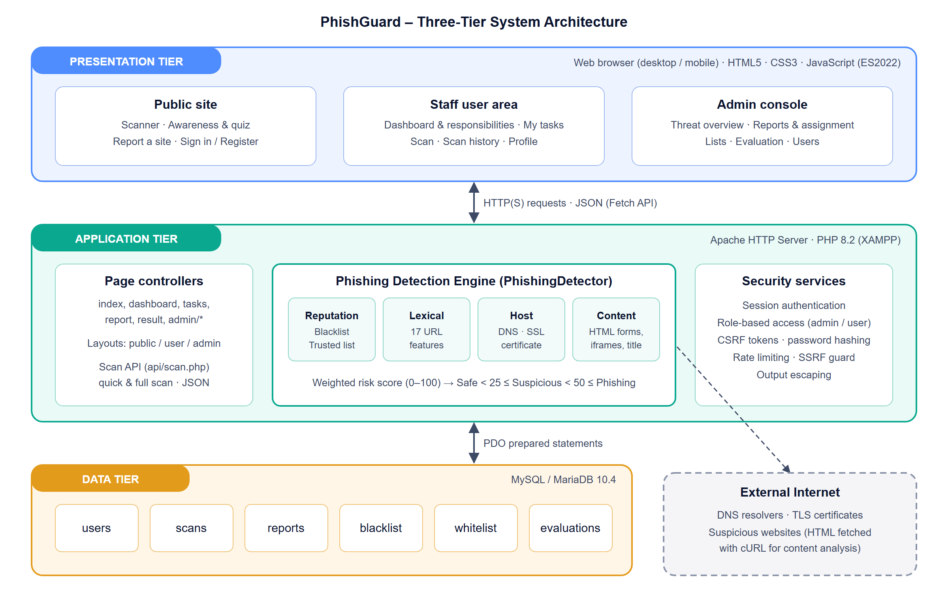
Figure 4.1: Three-tier architecture of PhishGuard

4.4 Use Case Model
Figure 4.2 shows the use case diagram. A staff user inherits all use cases available to a guest and additionally has a personal dashboard, assigned investigations and scan history. The administrator manages the system and makes the final decision on reports. Table 4.5 describes the actors.
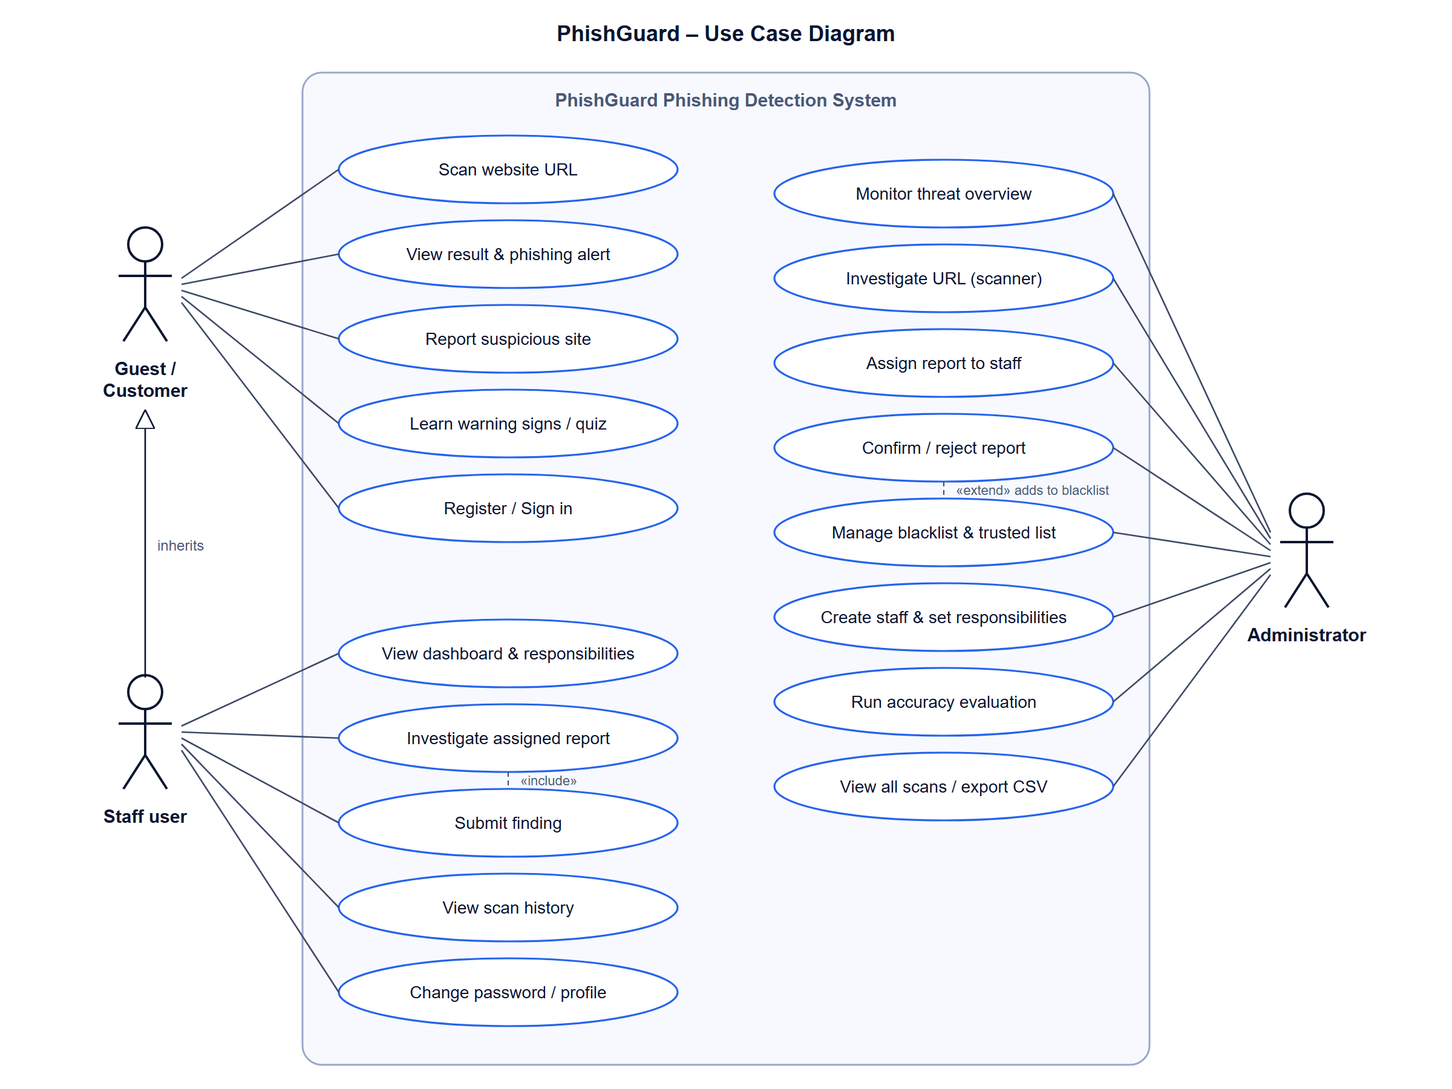
Figure 4.2: Use case diagram
Table 4.5: Description of actors
Actor | Description
Guest / Customer | Any member of the public. Can scan websites, read awareness content, take the quiz, report suspicious sites and register.
Staff user | An LTC employee with an account (created by an administrator or self-registered). Has a dashboard showing position and responsibilities, investigates reports assigned to them and submits findings.
Administrator | ICT security personnel. Monitors threats, assigns and decides reports, manages lists and staff accounts, and evaluates detection performance.

4.5 Context Diagram
The context diagram (Figure 4.3) shows PhishGuard as a single process and the data flowing between it and the four external entities: guests/customers, staff users, administrators and external websites.
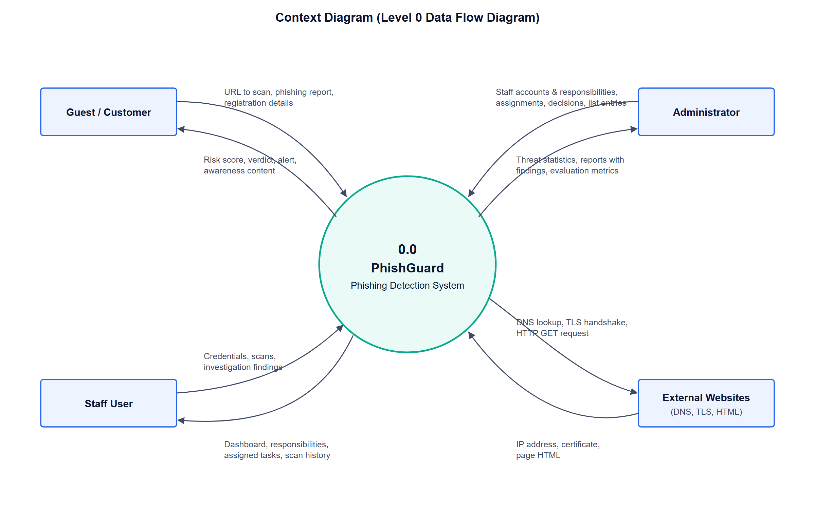
Figure 4.3: Context diagram (Level 0 DFD)

4.6 Design of the Phishing Detection Model
The core of the system is a weighted, feature-based detection model implemented in a single component (PhishingDetector). Each feature that indicates phishing adds a number of risk points; the points are summed, capped at 100 and compared with two thresholds. The weights were assigned according to how strongly each feature is associated with phishing in the literature reviewed in Chapter Two, and were refined iteratively during testing.

4.6.1 Feature Set and Weights
Table 4.6: Detection features and risk weights
Group | Feature | Condition flagged | Risk points
Reputation | Blacklist | Domain or parent domain is blacklisted | Score = 100
Reputation | Trusted list | Domain or parent domain is trusted | Score = 0
Reputation | Google Safe Browsing | URL is on Google's threat list (optional, needs API key) | Score = 100
Lexical | URL length | Longer than 54 / 75 characters | +4 / +8
Lexical | IP address host | Raw IP address used instead of a domain | +25
Lexical | "@" symbol | "@" in the authority part of the URL | +20
Lexical | Double-slash redirect | Extra "//" after the protocol | +10
Lexical | Hyphens in domain | One / two or more hyphens | +5 / +10
Lexical | Sub-domain depth | Two / three or more sub-domain levels | +6 / +12
Lexical | HTTPS | Connection not encrypted | +12
Lexical | Top-level domain | TLD frequently abused (e.g. .tk, .xyz, .top) | +10
Lexical | URL shortener | Known shortening service (e.g. bit.ly) | +15
Lexical | Sensitive keywords | login, verify, account, billing, momo, etc. | +5 each (max 20)
Lexical | Brand impersonation | Trusted brand name in a non-brand domain | +25
Lexical | Look-alike domain | Edit distance 1–2 or homoglyph match to a trusted domain | +30
Lexical | Punycode | Internationalised domain ("xn--") | +15
Lexical | Non-standard port | Port other than 80/443 | +8
Lexical | Digits in domain | Four or more digits | +6
Lexical | Random-looking domain | Label of 10+ characters with entropy above 3.5 | +6
Lexical | URL obfuscation | More than three percent-encoded characters | +5
Domain | Domain exists | Domain / sub-domain not found in DNS (via DNS-over-HTTPS) / points to no server | +40 / +30
Domain | Public address | Domain resolves to a private or internal IP address | +15
Domain | Registration | Domain not registered (RDAP): if DNS also failed / otherwise | +5 / +30
Domain | Domain age | Registered less than 30 days / 180 days / 1 year ago | +25 / +12 / +5
Domain | Website reachable | Domain exists but no website answers | +25
Host | SSL certificate | Invalid, self-signed or mismatched / unreadable | +15 / +5
Host | Certificate age | Issued less than 7 days ago | +5
Content | Page fetch | Page could not be downloaded | +3
Content | Cross-domain redirect | Final page is on a different domain | +8
Content | Password field | Page contains a password input | +8
Content | Form destination | Form submits to another domain or an e-mail address | +15
Content | Hidden iframe | Zero-size or hidden iframe | +6
Content | Meta refresh | Automatic redirect to another domain | +8
Content | Page title | Title claims a trusted brand on a non-brand domain | +15
Content | Link anchors | More than 80% of links empty or external | +6

4.6.2 Scoring and Classification
Let F be the set of features detected for a URL and w(f) the risk points of feature f. The risk score S and the verdict are computed as follows:
If domain ∈ Blacklist or Safe Browsing list: S = 100
Else if domain ∈ TrustedList: S = 0
Else: S = min(100, Σ w(f) for f ∈ F)
If domain does not exist or site does not respond: S = max(S, 25)

Verdict = Phishing if S ≥ 50
Suspicious if 25 ≤ S < 50
Safe if S < 25

The thresholds are configurable (THRESHOLD_SUSPICIOUS and THRESHOLD_PHISHING). The "suspicious" band warns users about sites that show some warning signs but not enough to be classified as phishing, which supports cautious behaviour without over-alarming users.

4.6.3 Detection Process
Figure 4.4 shows the detection process. Reputation lists are checked first because they give a definitive answer. Lexical analysis always runs. Every full scan then performs domain checks: the domain is resolved through DNS-over-HTTPS (Google, with Cloudflare as fallback) so that Internet providers that answer for non-existent names cannot hide a fake domain; its registration and creation date are obtained from the registry through RDAP; and a quick request confirms that a website actually responds. A domain that cannot be found or opened in a browser can therefore never be reported as safe. When the user selects a deep scan, the SSL certificate check and content analysis follow; content is only downloaded after confirming that the address is not a private or internal network address.
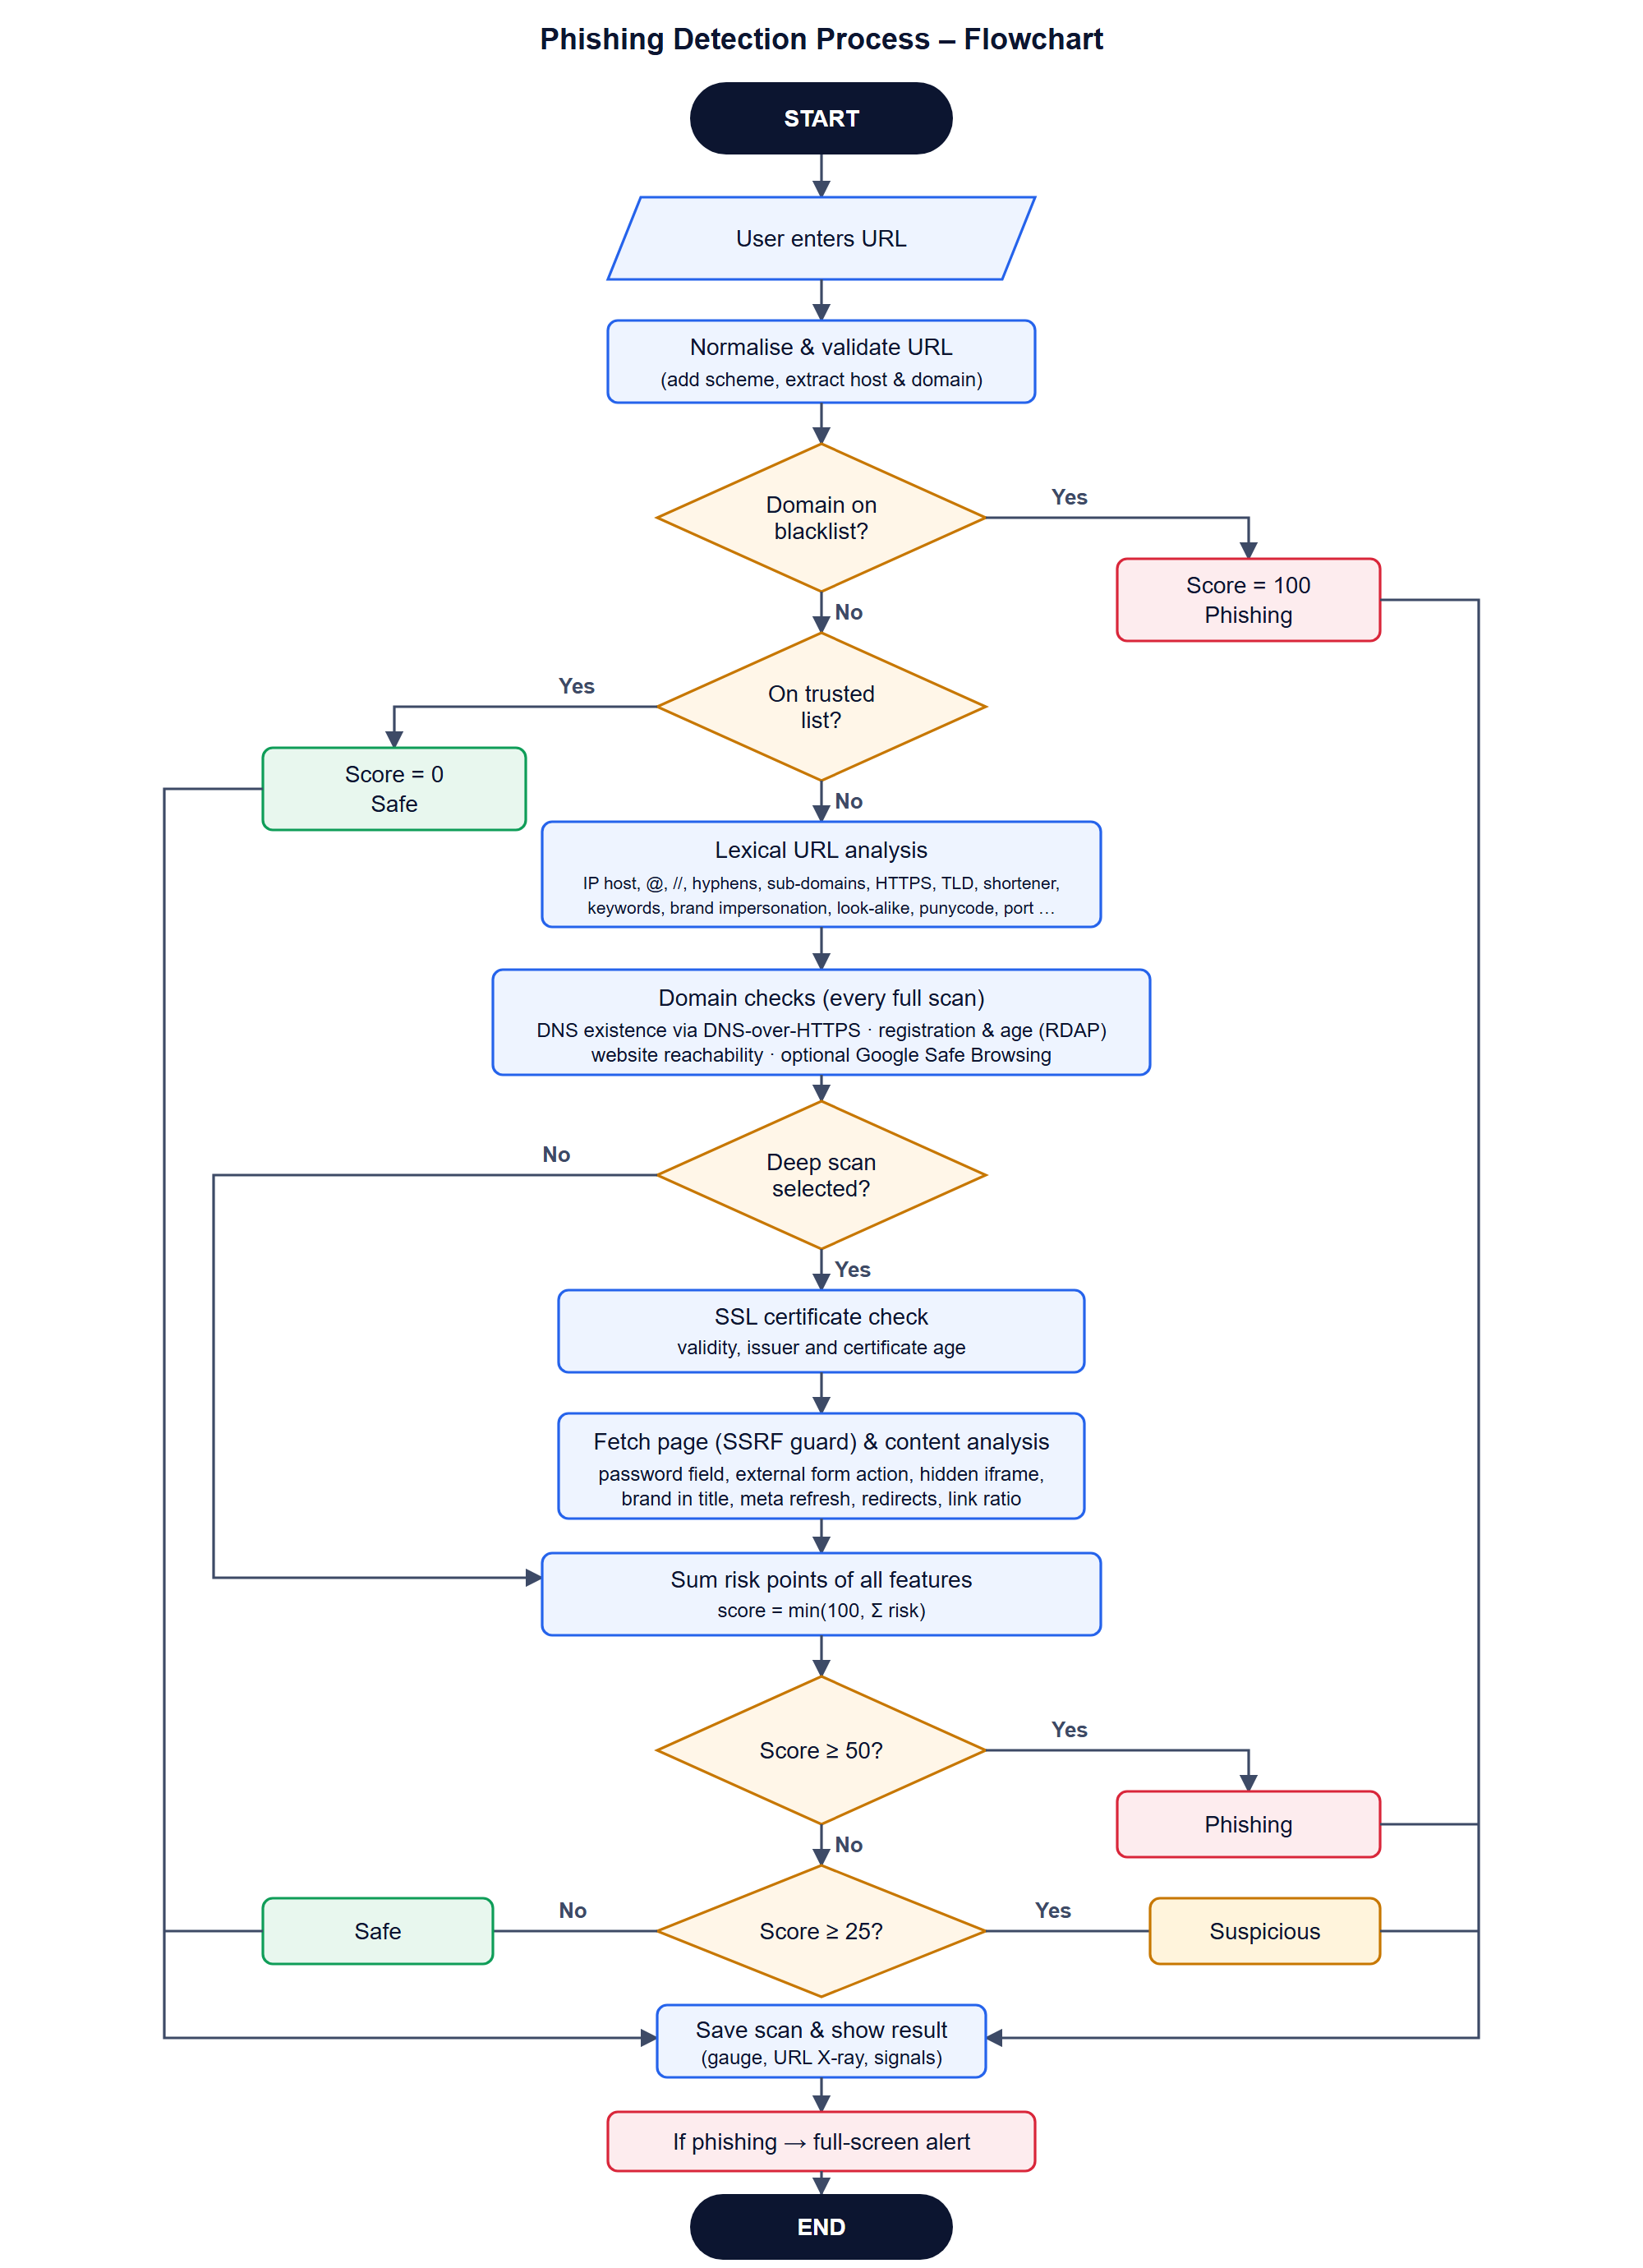
Figure 4.4: Flowchart of the phishing detection process

4.6.4 Worked Example
Consider the address http://libtelco.com.lr.account-suspend.xyz/pay, which is designed to look like an LTC page. Its registered domain is actually account-suspend.xyz; "libtelco.com.lr" is only a sub-domain chosen by the attacker. Table 4.7 shows the features detected by a URL-only scan.
Table 4.7: Worked example of risk scoring
Feature | Finding | Points
Hyphens in domain | 1 hyphen in account-suspend.xyz | +5
Sub-domain depth | 3 sub-domain levels (libtelco.com.lr) | +12
HTTPS | No HTTPS – data sent unencrypted | +12
Top-level domain | .xyz is frequently abused | +10
Sensitive keywords | account, suspend | +10
Brand impersonation | Mentions "libtelco" but is not libtelco.com.lr | +25
Total | Score 74 ≥ 50 → Phishing | 74

4.7 Report Investigation Workflow
Figure 4.5 models the workflow for handling phishing reports, which gives practical meaning to the responsibilities assigned to staff. A report starts as pending. The administrator may decide immediately or assign it to a staff member, whose dashboard then shows the task. The staff member scans the URL and submits a finding with a note; the administrator makes the final decision. Confirming a report adds its domain to the blacklist so that it is flagged instantly for all users.
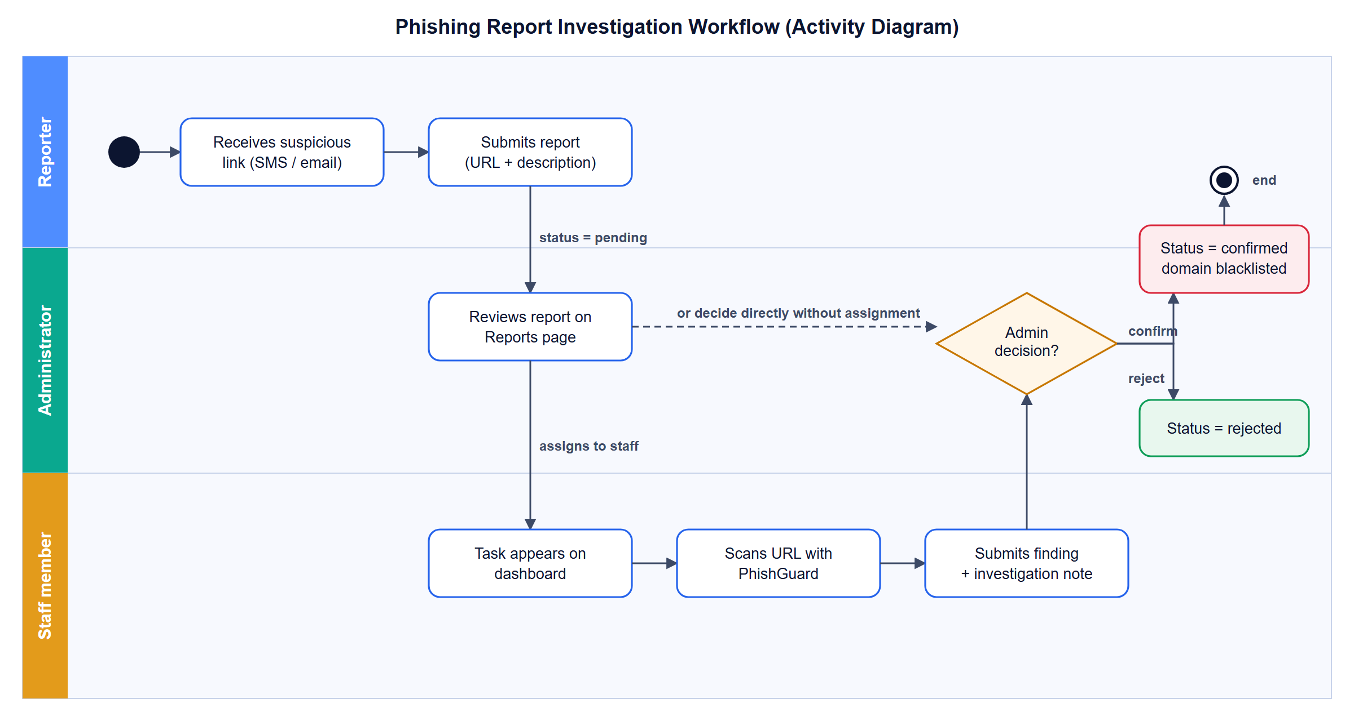
Figure 4.5: Activity diagram of the report investigation workflow

4.8 Database Design
The database consists of six related tables (Figure 4.6). The users table is central: it is referenced by scans, reports (as reporter, assigned staff member and reviewing administrator), list entries and evaluations. Detection details of each scan are stored as JSON in the features column, so new features can be added without changing the schema.
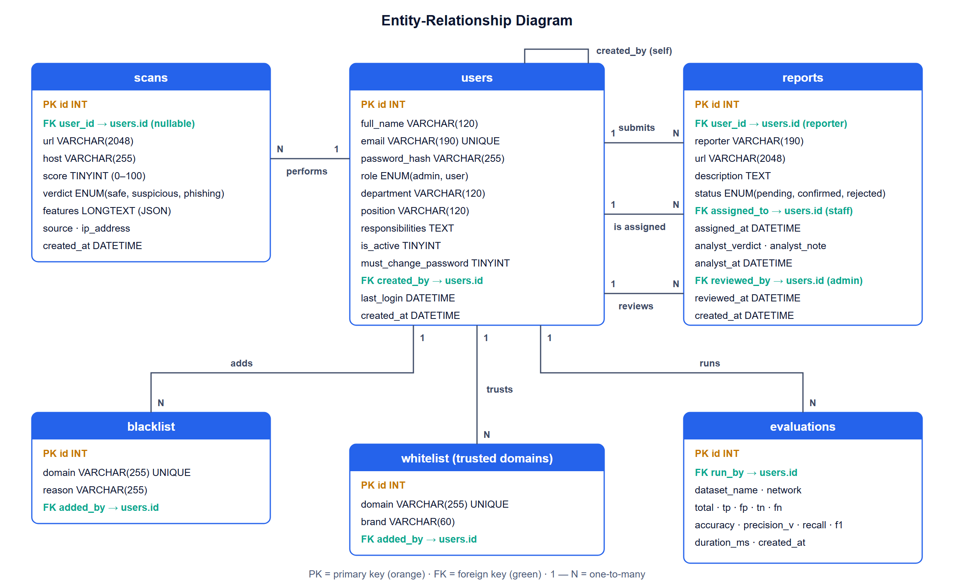
Figure 4.6: Entity-relationship diagram

4.8.1 Data Dictionary
Table 4.8: Data dictionary – users
Field | Type | Description
id | INT UNSIGNED, PK | Unique user identifier
full_name | VARCHAR(120) | User's full name
email | VARCHAR(190), UNIQUE | Sign-in e-mail address
password_hash | VARCHAR(255) | One-way password hash (bcrypt)
role | ENUM(admin, user) | Determines the area (admin console or staff area)
department / position | VARCHAR(120) | Organisational unit and job position
responsibilities | TEXT | Duties shown on the dashboard, one per line
is_active | TINYINT(1) | 1 = account enabled, 0 = disabled
must_change_password | TINYINT(1) | 1 = temporary password must be replaced
created_by | INT, FK → users.id | Administrator who created the account
last_login / created_at | DATETIME | Audit timestamps

Table 4.9: Data dictionary – scans
Field | Type | Description
id | INT UNSIGNED, PK | Unique scan identifier
user_id | INT, FK → users.id, NULL | User who scanned (NULL for guests)
url / host | VARCHAR(2048) / VARCHAR(255) | Normalised address and its host
score | TINYINT UNSIGNED | Risk score 0–100
verdict | ENUM(safe, suspicious, phishing) | Classification result
features | LONGTEXT (JSON) | All detection signals, list match, final URL and duration
source / ip_address | ENUM / VARCHAR(45) | Origin of the scan and client IP
created_at | DATETIME | Time of scan

Table 4.10: Data dictionary – reports
Field | Type | Description
id | INT UNSIGNED, PK | Unique report identifier
user_id / reporter | INT FK / VARCHAR(190) | Reporting user or e-mail of a guest
url / description | VARCHAR(2048) / TEXT | Suspicious address and how it was received
status | ENUM(pending, confirmed, rejected) | Administrator decision
assigned_to / assigned_at | INT FK → users.id / DATETIME | Staff member assigned to investigate
analyst_verdict / analyst_note / analyst_at | ENUM / TEXT / DATETIME | Staff finding and explanation
reviewed_by / reviewed_at | INT FK → users.id / DATETIME | Administrator who made the decision

The blacklist table stores blocked domains with a reason; the whitelist table stores trusted domains with an optional brand keyword; and the evaluations table stores the results of each accuracy evaluation (TP, FP, TN, FN, accuracy, precision, recall, F1 and duration).

4.9 Interface Design
The interface was designed around the Technology Acceptance Model's emphasis on usefulness and ease of use. Key design decisions were:
- Three separate layouts: the public site uses a top navigation bar; the staff area and the administrator console each use their own sidebar. Links never cross between areas, so each user sees only what is relevant to their role.
- Single-field scanner: a command-bar style input with a live risk meter and a sweeping animation while scanning.
- Explainable results: an animated risk gauge, a colour-coded "URL X-ray" separating the real domain from misleading sub-domains, a board of detection signals grouped by category, and recommended actions.
- Real-time alert: a modal dialog that blocks the page when a site is classified as phishing.
- Responsive design: the sidebar collapses to icons on desktop and becomes a slide-in drawer below 1024 px; tables become stacked cards on phones.
- Accessibility and comfort: dark and light themes, high-contrast status colours, keyboard support (Esc closes menus) and reduced motion for users who request it.

Input design consists of the scanner field, report form, sign-in and registration forms, staff finding form and administrator forms, all validated on the server. Output design consists of scan results, dashboards with statistics and charts, report cards, evaluation metrics and CSV exports.

4.10 Security Design
Because PhishGuard is itself a security system, its design includes the following controls, aligned with the OWASP Top 10 (OWASP Foundation, 2021):
Table 4.11: Security controls
Threat | Control implemented
SQL injection | All queries use PDO prepared statements with bound parameters
Cross-site scripting (XSS) | All output is escaped with htmlspecialchars; JSON embedded in pages is hex-encoded
Cross-site request forgery (CSRF) | Secret per-session token required on every state-changing request
Credential theft | Passwords hashed with bcrypt; temporary passwords must be changed at first sign-in
Brute-force sign-in | Sign-in locked for 5 minutes after 5 failed attempts per session
Session hijacking | HttpOnly, SameSite cookies; session ID regenerated at sign-in
Broken access control | Role checks on every protected page; administrators and staff have separate areas
Server-side request forgery (SSRF) | Content is never fetched from private, loopback or reserved IP ranges
Abuse of the scanner | Rate limit of 20 full scans per session per minute
Exposure of source and configuration | Web access to config, includes, database and tests folders denied

4.11 Chapter Summary
This chapter specified the functional and non-functional requirements of PhishGuard, presented its three-tier architecture, use case and context models, and described in detail the weighted feature-based detection model, including its features, weights, scoring formula, process flow and a worked example. It also presented the report investigation workflow, the database design and data dictionary, the interface design and the security design. The next chapter describes how this design was implemented, tested and evaluated.

CHAPTER FIVE: SYSTEM IMPLEMENTATION, TESTING AND EVALUATION

5.1 Introduction
This chapter describes how the design presented in Chapter Four was implemented as a working system. It presents the development environment and project structure, describes each module with screenshots of the running system, explains the testing strategy and results, and reports the performance evaluation of the detection model using accuracy, precision, recall and F1-score. The chapter closes with a discussion of the results against the objectives of the study and guidance on installing and deploying the system.

5.2 Development Environment and Tools
Table 5.1: Development environment and tools
Tool / technology | Use in the project
PHP 8.2.12 | Server-side logic, detection engine, page controllers and JSON API
MariaDB 10.4.32 (MySQL) | Relational database for users, scans, reports, lists and evaluations
Apache 2.4 (XAMPP) | Web server hosting the application locally
HTML5 | Page structure, semantic elements and the native <dialog> element used for the phishing alert
CSS3 | Design system with custom properties, native nesting, :has(), color-mix(), container and media queries, dark/light themes
JavaScript (ES2022) | Live checks, asynchronous scanning with the Fetch API, result rendering, charts (SVG), sidebar and responsive tables
PHP extensions | PDO MySQL (database), cURL (page download), OpenSSL (certificate inspection), DOM (HTML parsing)
Visual Studio Code | Source code editor
phpMyAdmin | Database administration
Microsoft Edge / Chrome | Testing, including mobile-width emulation

5.3 Project Structure
The source code is organised so that the detection model, shared services and each user area are clearly separated. Table 5.2 summarises the main folders and files.
Table 5.2: Main folders and files of the project
Path | Purpose
config/config.php | Database settings, detection thresholds, timeouts and rate limits
includes/Detector.php | PhishingDetector class – feature extraction, weighting, scoring and classification
includes/bootstrap.php, db.php, auth.php, functions.php | Session start-up, database connection, authentication, CSRF protection and helper functions
includes/header.php, footer.php | The three layouts (public, staff, admin) with their navigation
api/scan.php | JSON endpoint for quick (live) and full scans
index.php, awareness.php, report.php, result.php | Public scanner, awareness module, report form and result page
login.php, register.php, profile.php | Authentication and account management
dashboard.php, scan.php, tasks.php, history.php | Staff area: dashboard with responsibilities, scanner, assigned tasks and history
admin/*.php | Admin console: overview, scanner, scans, reports, lists, evaluation, users
assets/css/style.css, assets/js/app.js | Design system and front-end behaviour
database/schema.sql, migrate_v2.sql, demo_seed.php | Database schema, migration and demonstration data
data/sample_dataset.csv | Labelled evaluation dataset (url,label)
tests/run_tests.php | Automated unit, integration and performance tests
install.php | One-time installer that creates the database, tables and default administrator

5.4 Implementation of the Detection Engine
The detection model in Section 4.6 was implemented as the PhishingDetector class. Each check calls a small helper that records the feature and adds its risk points to a running total; the final score and verdict are then derived as shown in the following excerpt.
private function add(string $group, string $id, string $label, string $result, int $risk, string $status): void
{
$this->features[] = compact('group', 'id', 'label', 'result', 'risk', 'status');
$this->score += $risk;
}

// Example checks
$isIp ? $this->add('lexical', 'ip_host', 'IP address as host', 'Uses a raw IP address', 25, 'danger')
: $this->add('lexical', 'ip_host', 'IP address as host', 'Uses a domain name', 0, 'safe');

// Verdict
$score = match ($listMatch) { 'blacklist' => 100, 'whitelist' => 0, default => min(100, $this->score) };
$verdict = $score >= THRESHOLD_PHISHING ? 'phishing'
: ($score >= THRESHOLD_SUSPICIOUS ? 'suspicious' : 'safe');

Brand impersonation and look-alike detection compare the registered domain with every trusted domain that has a brand keyword. Before comparison, common homoglyphs are normalised (0→o, 1→l, 3→e, 5→s, "rn"→m, "vv"→w) and the Levenshtein edit distance is calculated, so that "paypa1.com", "g00gle.com" and "linkedln.com" are recognised as imitations. The registered domain is extracted with support for second-level suffixes such as ".com.lr", so that "libtelco.com.lr.account-suspend.xyz" is correctly identified as belonging to "account-suspend.xyz".
Domain verification runs on every full scan. Existence is checked with DNS-over-HTTPS queries to Google Public DNS (falling back to Cloudflare and then the system resolver); a response code of NXDOMAIN proves that the name does not exist anywhere on the Internet, even if the local provider's resolver would return an advertising address. Registration data is obtained with RDAP: the registry responsible for each top-level domain is found in the IANA bootstrap file (cached for seven days) and the result for each domain is cached in the domain_cache table for twelve hours. A "404 not found" from the registry shows that the domain is not registered; otherwise the registration event gives the domain's age. For country-code domains that do not publish RDAP data, such as .lr, the age is reported as unavailable. Finally, a lightweight HTTP request confirms that a website answers. When an API key is configured, the URL is also checked against Google Safe Browsing, the threat list used by the Chrome browser.
For deep scans, the SSL certificate is retrieved with a verified TLS connection. Page content is downloaded with cURL (maximum 1 MB, 5 redirects, 6-second timeout) only after the resolved IP address has been checked against private and reserved ranges, and is parsed with PHP's DOM extension.

5.5 Implementation of System Modules

5.5.1 Public Scanner
The home page (Figure 5.1) presents the scanner as a command bar. As the user types, a quick URL-only check runs in the background and a live risk meter shows the provisional score. Pressing Scan performs a full scan through the JSON API; a sweeping animation indicates progress. The page also shows organisation-wide statistics and a summary of the three detection layers.
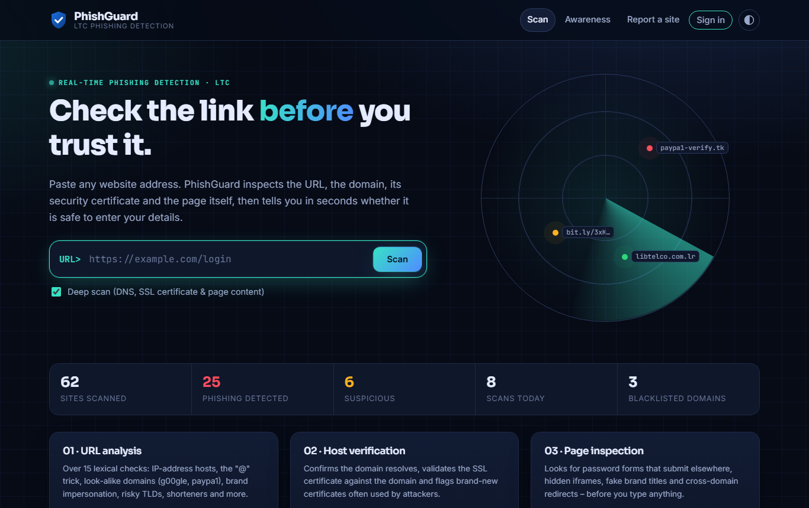
Figure 5.1: Public scanner (home page)

5.5.2 Scan Result and Real-Time Alert
When a site is classified as phishing, a modal warning is displayed immediately (Figure 5.2), instructing the user not to enter passwords, PINs, card or mobile-money details. Behind the warning, the result page (Figure 5.3) shows the animated risk gauge and verdict, the URL X-ray that highlights the real domain and risky patterns, recommended actions and the full board of detection signals grouped as reputation, URL analysis, host and certificate, and page content.
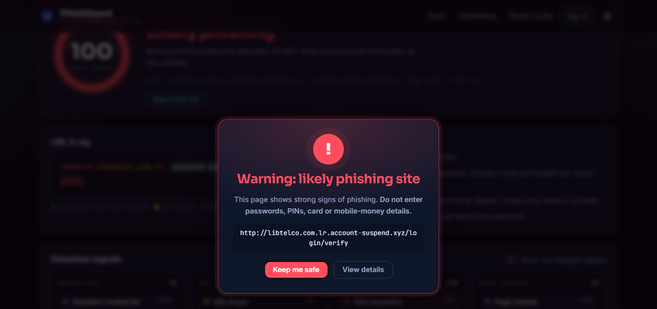
Figure 5.2: Real-time phishing alert
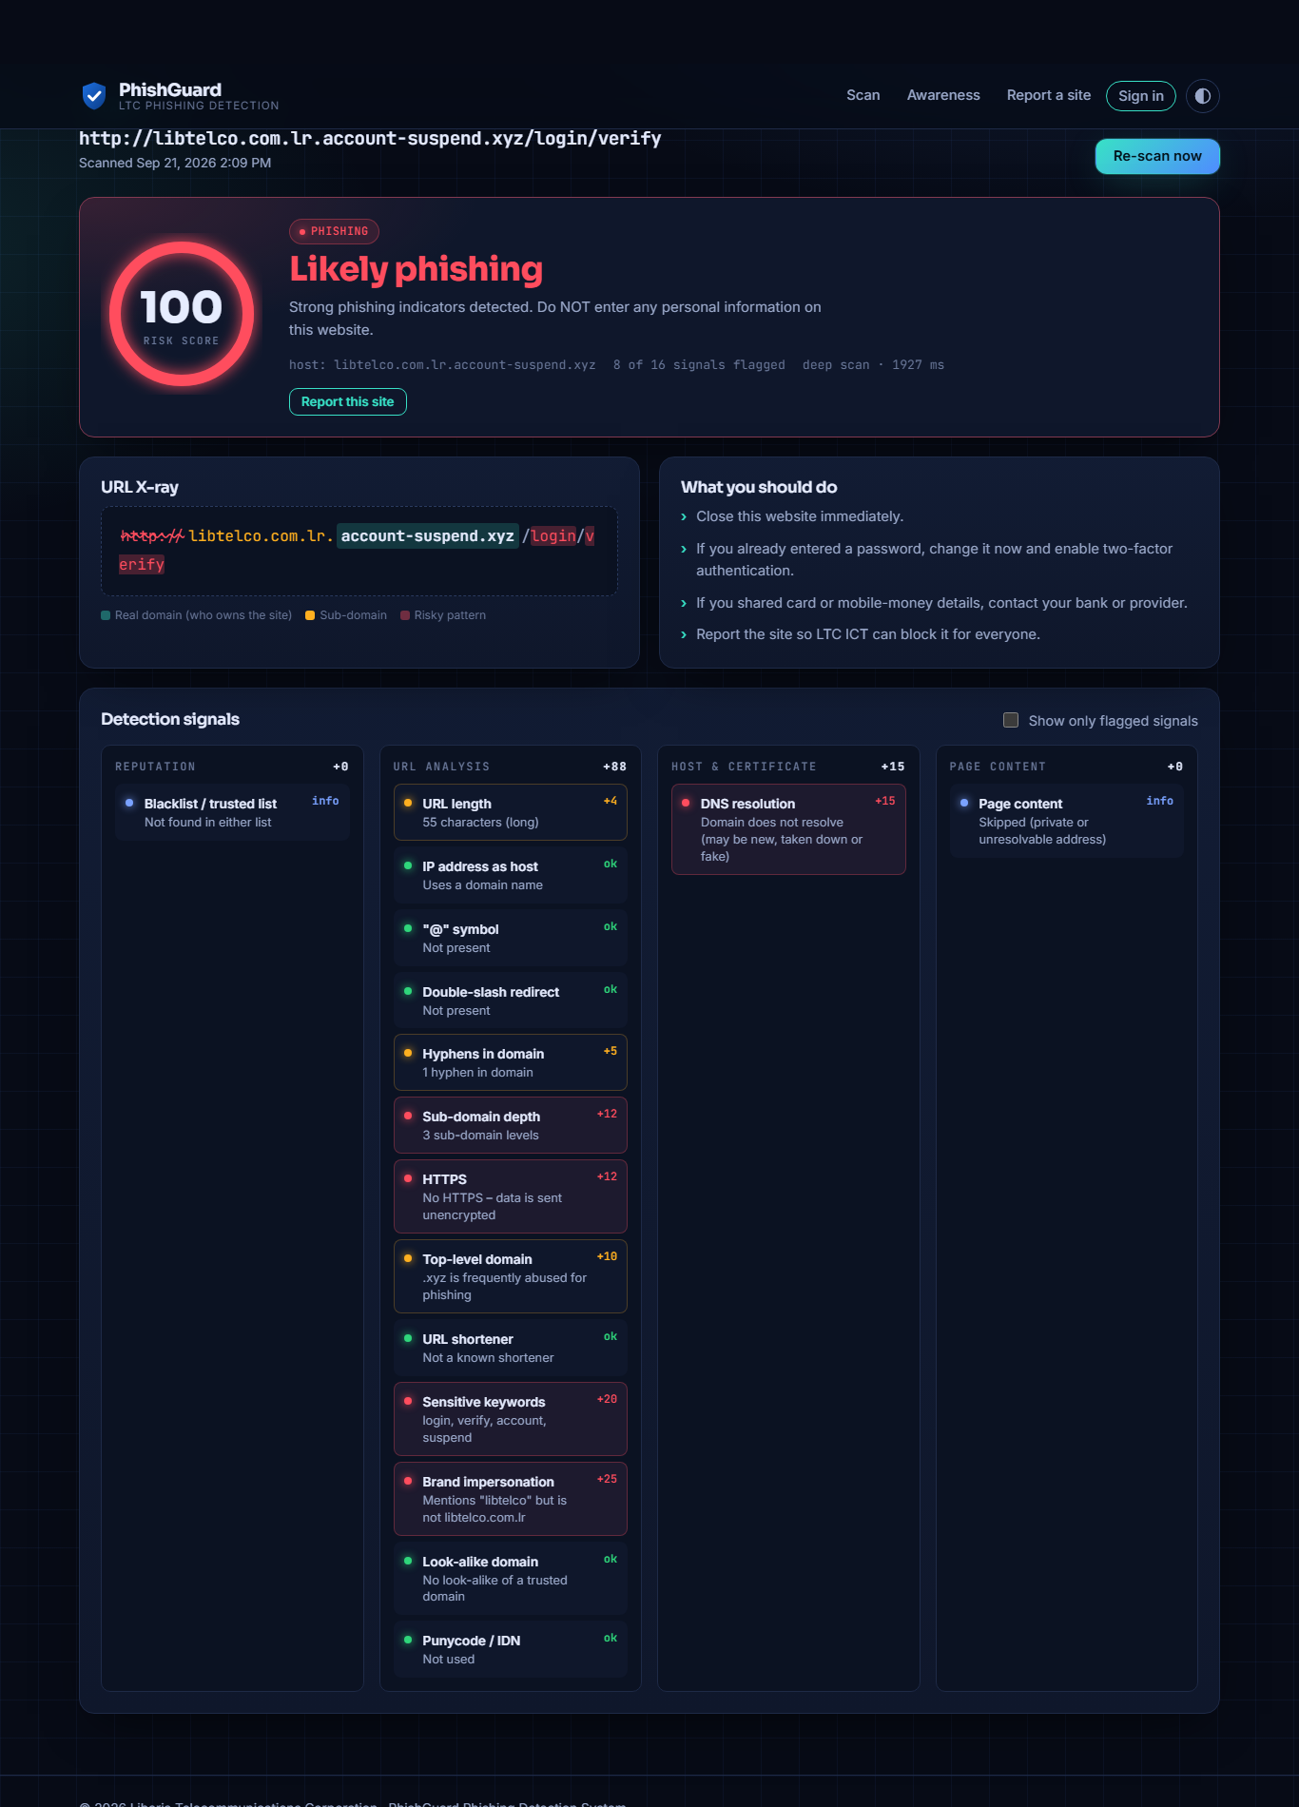
Figure 5.3: Detailed scan result with risk gauge, URL X-ray and detection signals
Every full scan also shows a Domain check panel (Figure 5.4) stating whether the domain exists on the Internet, whether and when it was registered, whether its website responds and, if configured, its Google Safe Browsing status. A link to a domain that does not exist — for example a made-up address — is reported as "Domain not found", with advice not to click, share or forward it, and is never classified as safe.
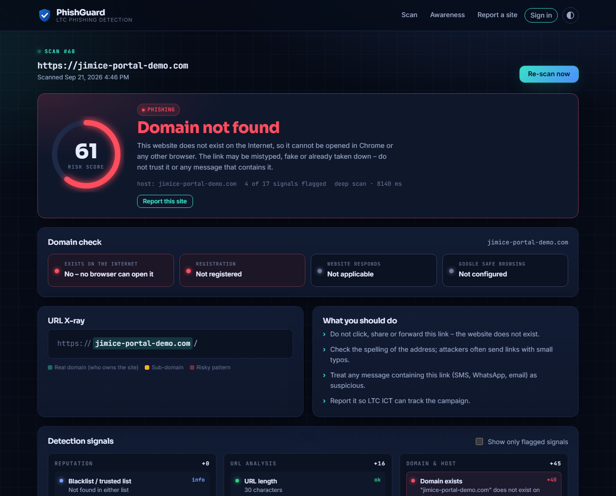
Figure 5.4: Result for a made-up domain showing the Domain check panel

5.5.3 Awareness Module
The awareness page (Figure 5.5) teaches six warning signs of phishing, compares genuine and fake addresses side by side and provides an interactive quiz with instant feedback, supporting the self-efficacy component of Protection Motivation Theory.
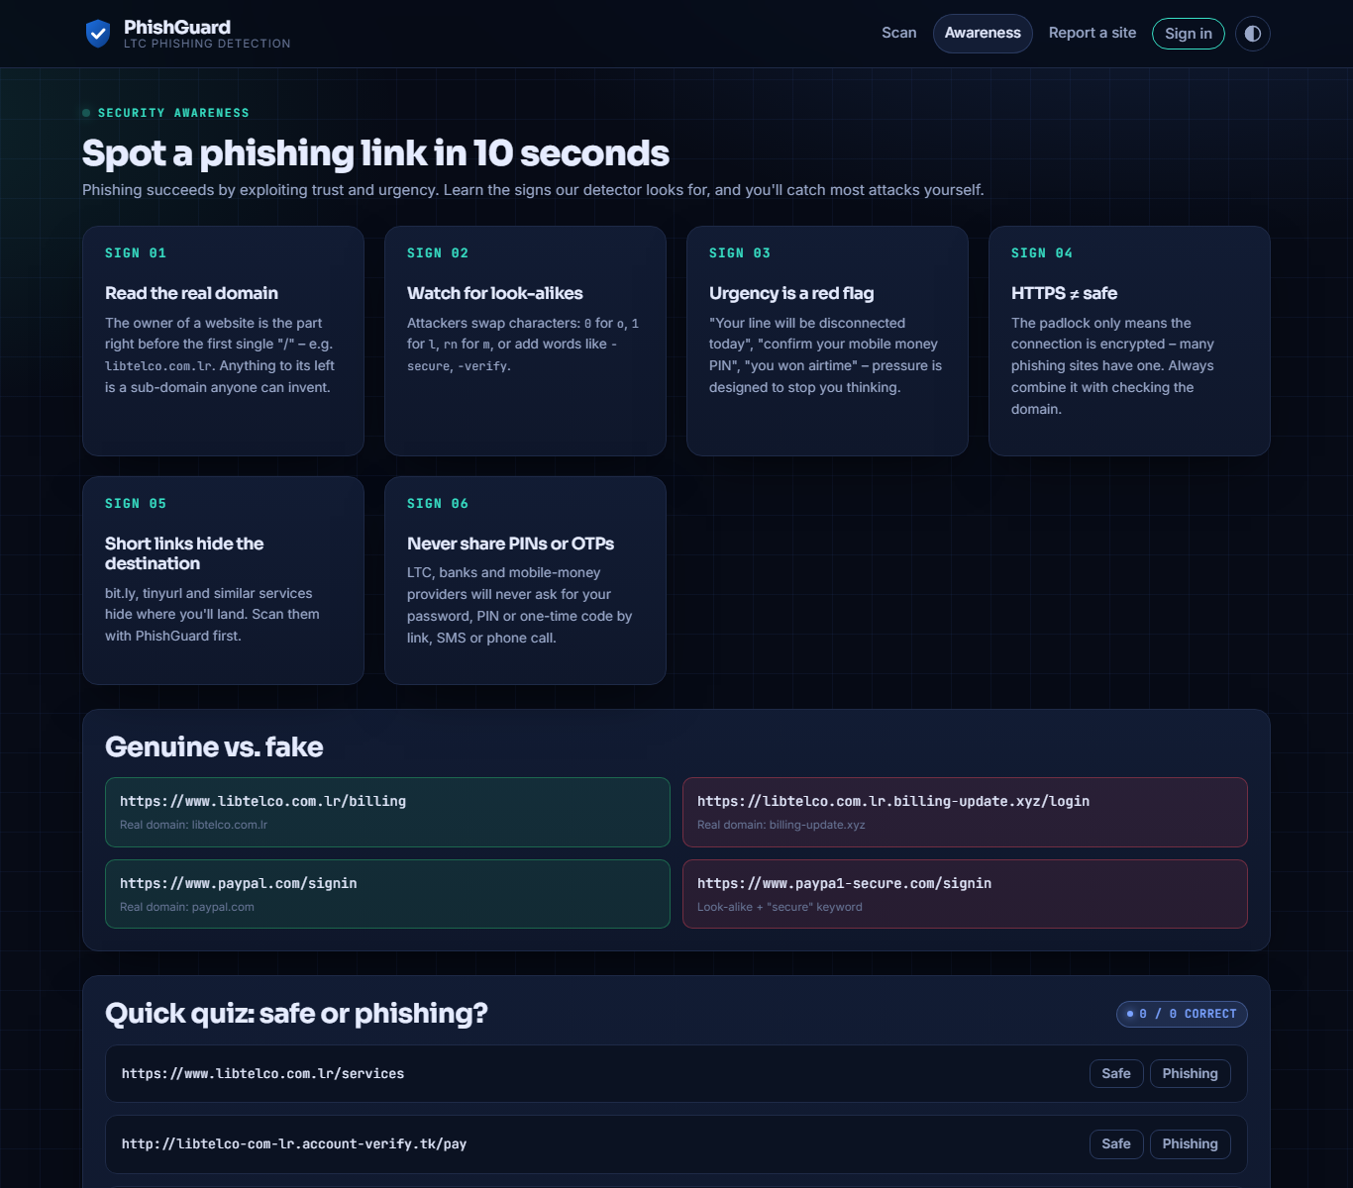
Figure 5.5: Phishing awareness module

5.5.4 Authentication
The sign-in page (Figure 5.6) uses a split-screen layout. After five failed attempts, sign-in is locked for five minutes. Staff accounts created by an administrator carry a temporary password; at first sign-in the user is redirected to the profile page and cannot use the system until the password has been replaced.
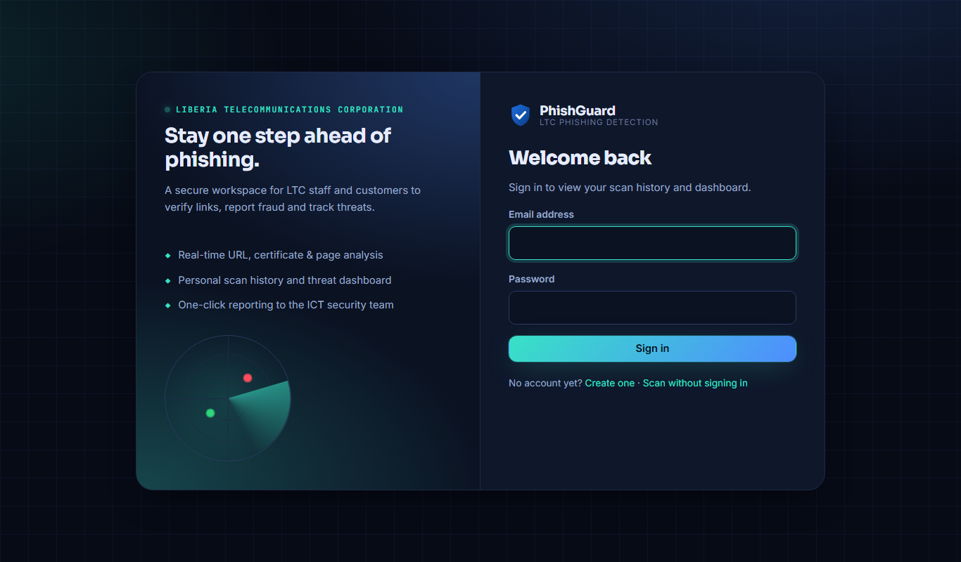
Figure 5.6: Sign-in page

5.5.5 Staff Dashboard and Responsibilities
Each staff member has a personal dashboard (Figure 5.7). The header shows the person's name, position and department, together with counts of open tasks, findings submitted and sites reported. The My responsibilities panel lists the duties set by the administrator for that person (pre-filled from standard LTC positions such as Cybersecurity Analyst, ICT Support Officer or Customer Care Officer, and editable per user). The Assigned investigations panel lists the reports the person must investigate, followed by the person's scanning statistics and history.
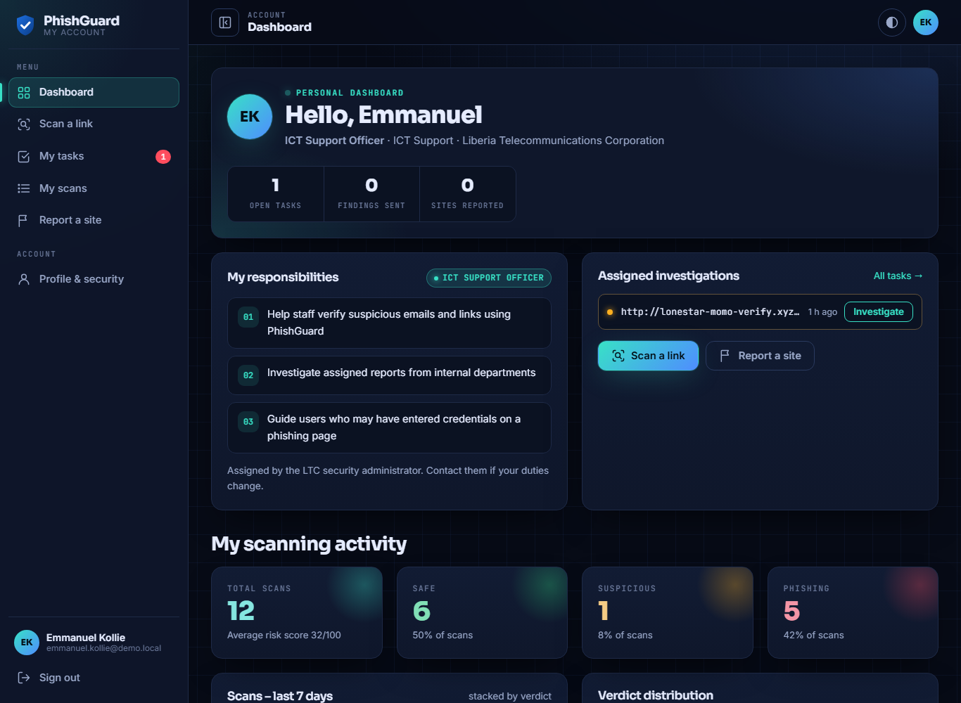
Figure 5.7: Staff dashboard showing position, responsibilities and assigned investigations

5.5.6 Assigned Investigations (My Tasks)
The My tasks page (Figure 5.8) shows each assigned report with the reporter's description, a button to scan the URL and a form for submitting a finding (phishing or legitimate) with an investigation note. Completed tasks are listed with the final decision made by the administrator.
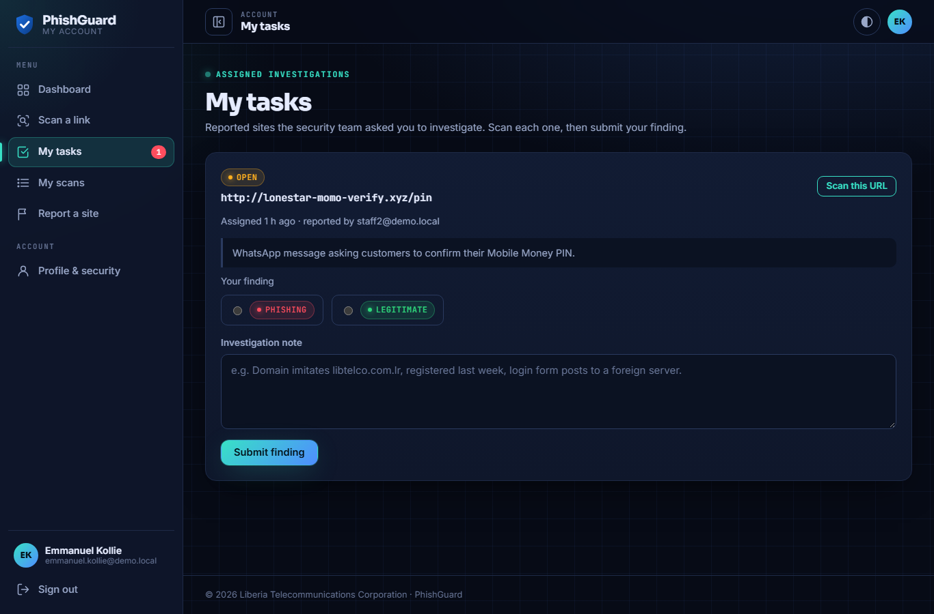
Figure 5.8: Staff task page for submitting investigation findings

5.5.7 Administrator Console
The administrator console has its own sidebar with Monitor, Threat intelligence and Administration sections; a red badge shows the number of pending reports. The overview (Figure 5.9) presents total, safe, suspicious and phishing scans, a stacked bar chart of the last seven days, a verdict distribution chart, the most-flagged hosts, user and report counts, the latest detection accuracy and the latest threats.
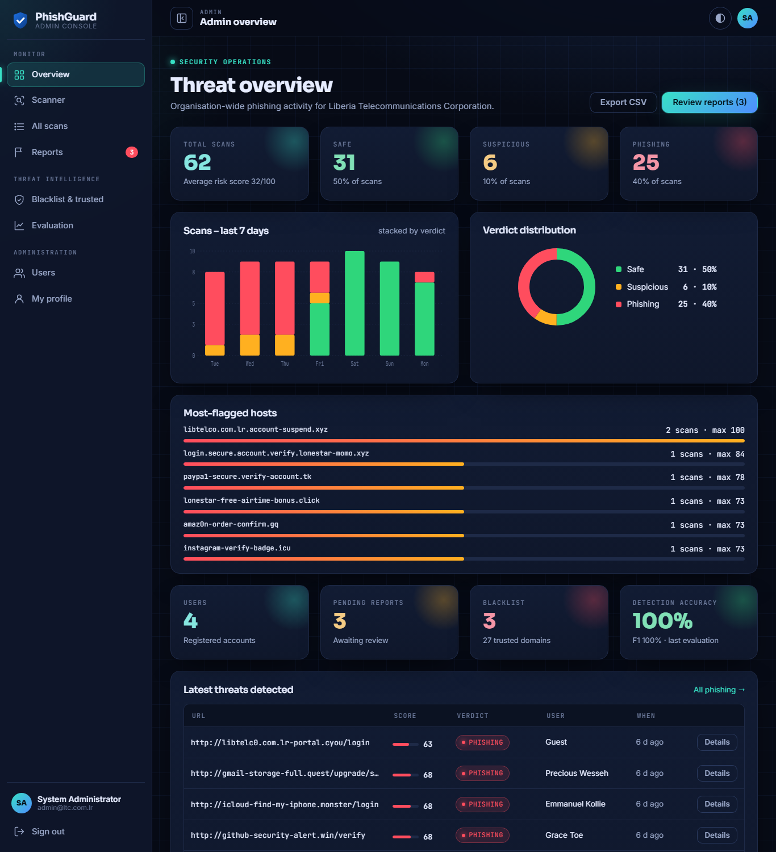
Figure 5.9: Administrator threat overview
On the Reports page (Figure 5.10) each report is shown as a card. The administrator can scan the URL, assign the report to a staff member, read the staff member's recommendation and finally confirm the report as phishing (which adds its domain to the blacklist) or reject it.
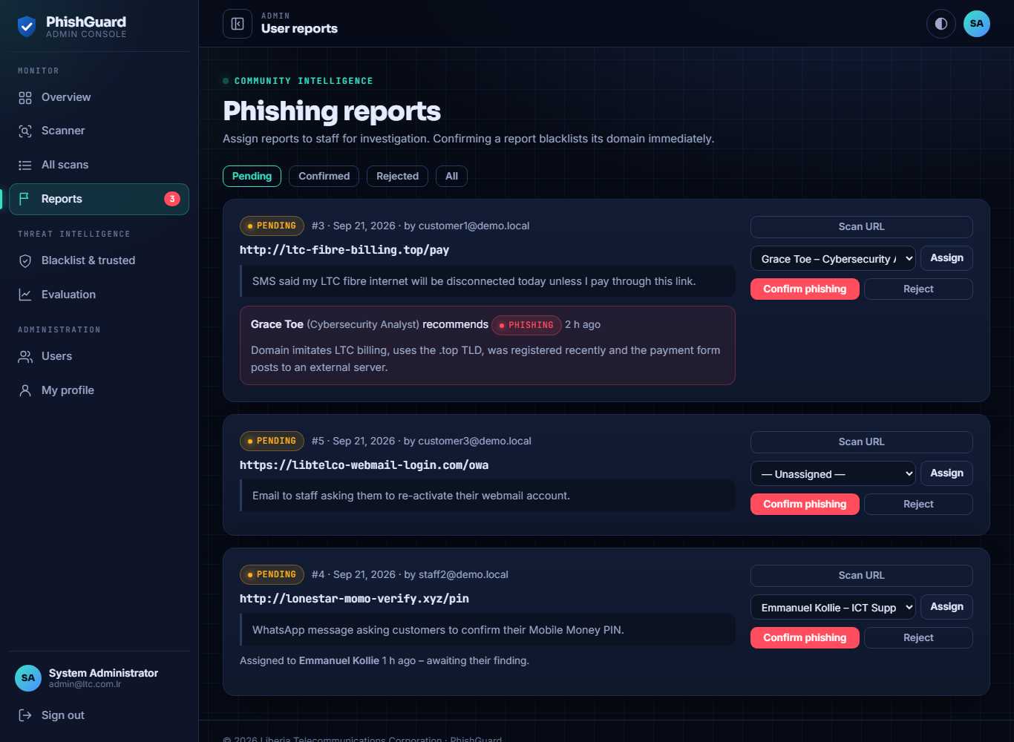
Figure 5.10: Report management with assignment and analyst findings
The Users page (Figure 5.11) lists all accounts with their position, role, number of scans and open tasks. Choosing a position when creating a staff member automatically fills in the standard responsibilities, which the administrator can edit. The Blacklist and trusted domains page (Figure 5.12) lets administrators block domains and register trusted domains with brand keywords that drive impersonation and look-alike detection.
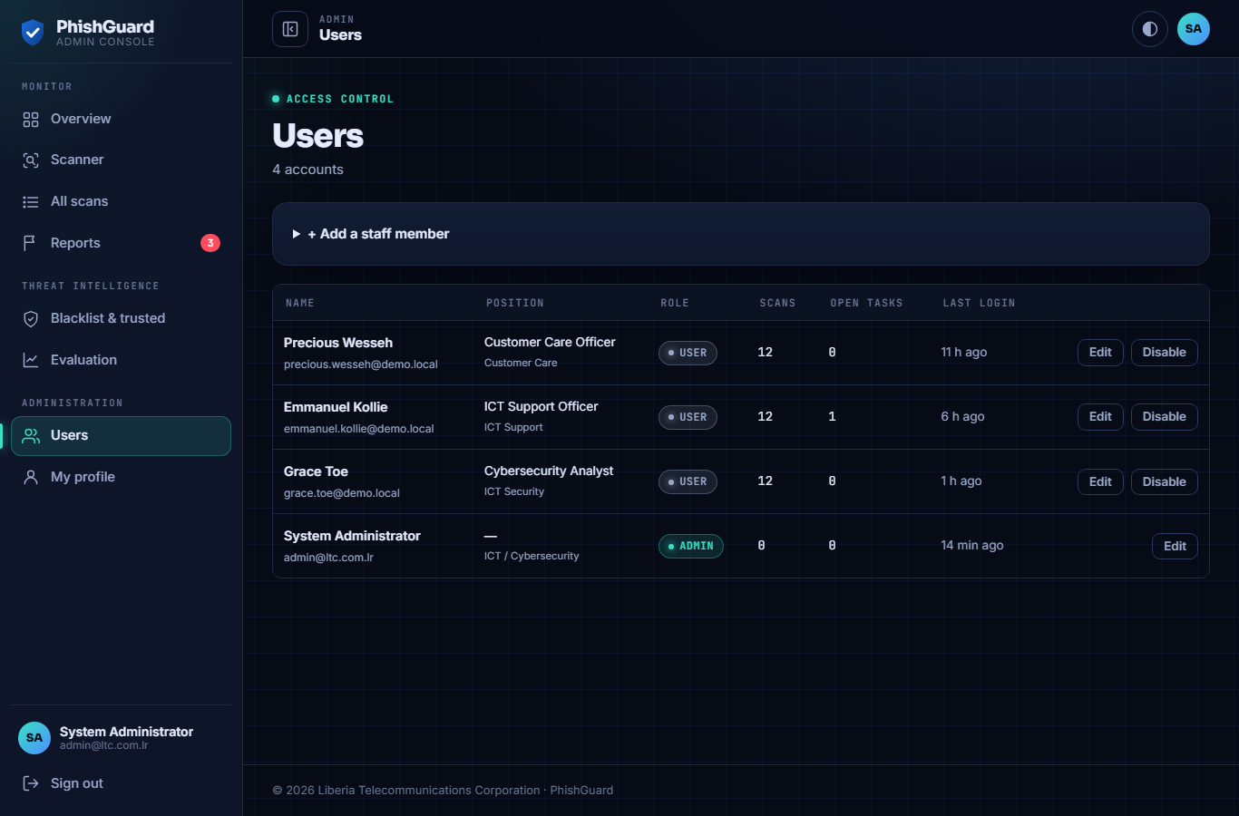
Figure 5.11: User management with positions and open tasks
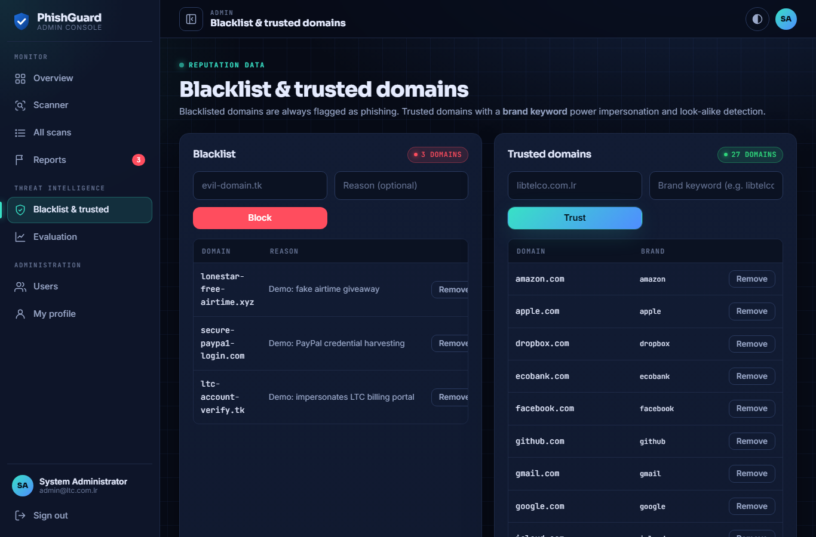
Figure 5.12: Blacklist and trusted domain management
The Evaluation page (Figure 5.13) runs the detector on the bundled or an uploaded labelled dataset and displays accuracy, precision, recall, F1-score, the confusion matrix, misclassified URLs and the history of previous evaluations.
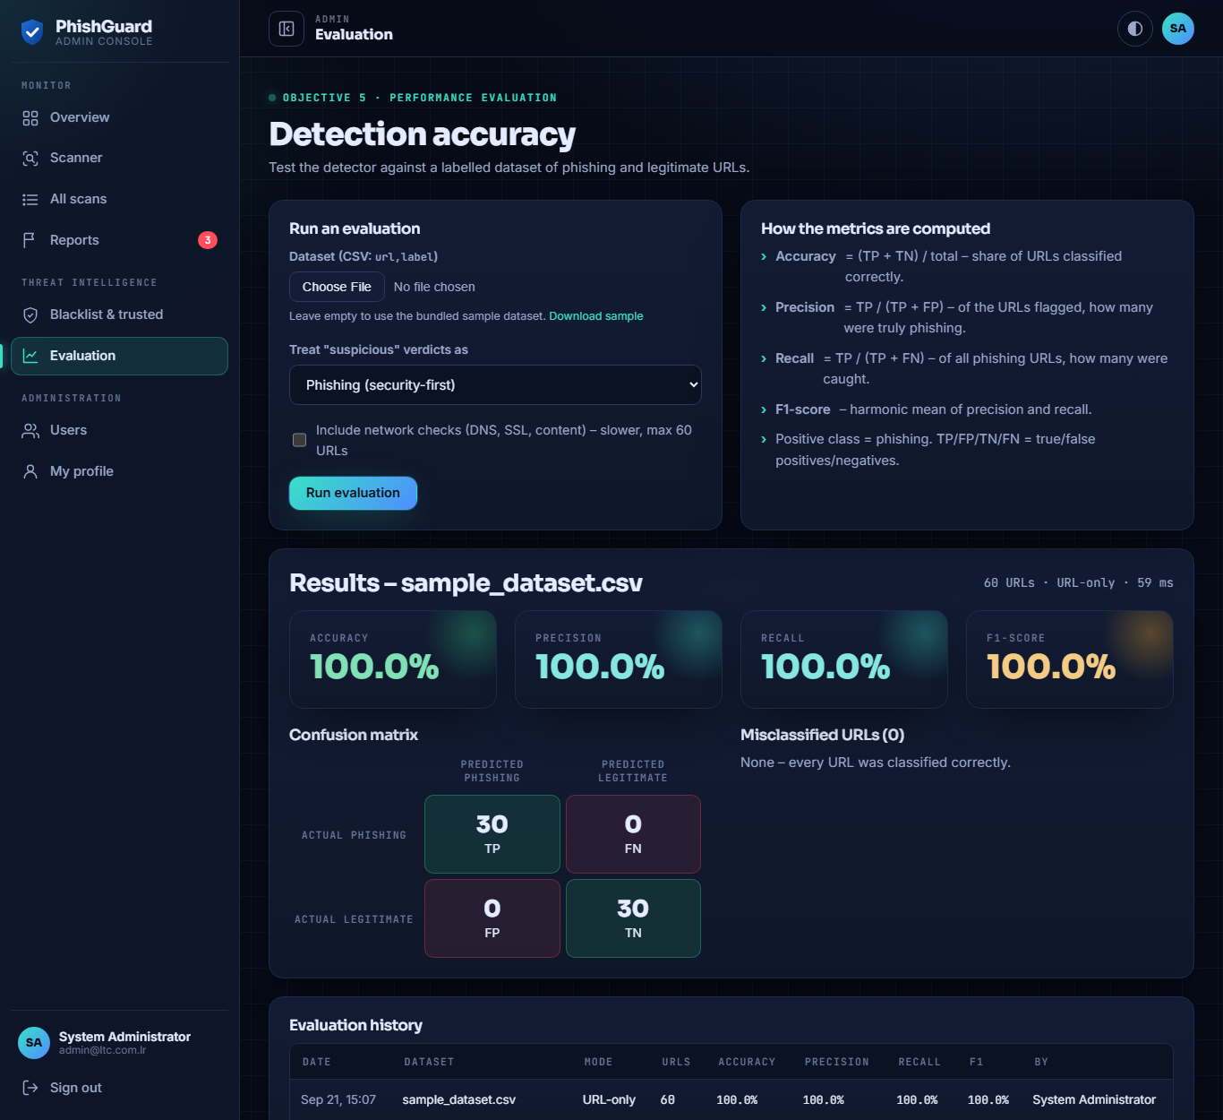
Figure 5.13: Detection accuracy evaluation module

5.5.8 Responsive Design
All pages adapt to small screens. On phones the scanner stacks vertically, the administrator and staff sidebars become slide-in drawers opened from a menu button, and tables and report lists become stacked cards (Figures 5.14 and 5.15).
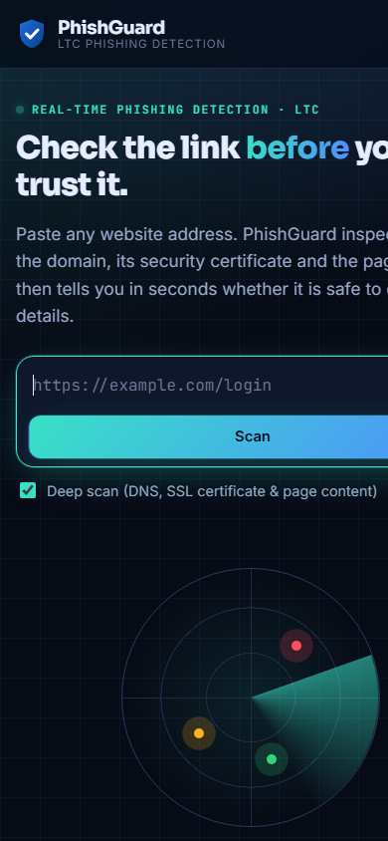
Figure 5.14: Mobile view of the public scanner (390 px wide)
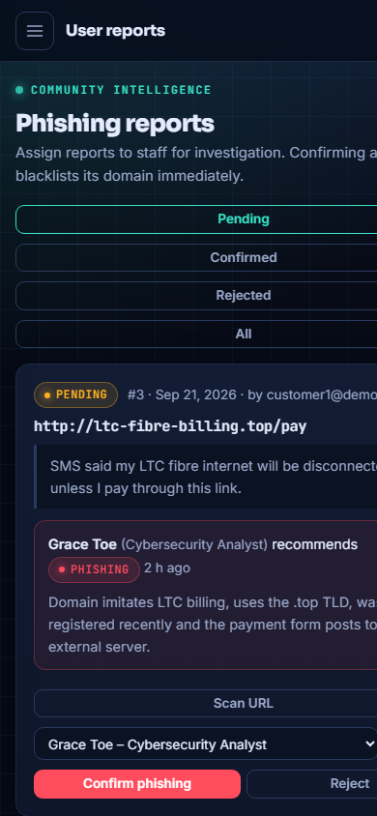
Figure 5.15: Mobile view of the administrator Reports page

5.6 System Testing
Testing was carried out at several levels to verify that the system meets the requirements specified in Section 4.2: unit testing of the detection features, integration testing of the engine with the database, functional (system) testing of user workflows, security testing, responsiveness testing and performance testing.

5.6.1 Unit and Integration Testing
An automated test script (tests/run_tests.php) was written to test each detection feature in isolation, the classification of representative URLs, input validation and the integration of the engine with the database. Six further tests verify the domain checks against the live Internet. All 33 automated tests passed (Table 5.3).
Table 5.3: Results of automated unit, integration and performance tests
ID | Test description | Observed | Result
UT01 | IP address host is flagged | +25 | Pass
UT02 | "@" symbol trick is flagged | +20 | Pass
UT03 | Missing HTTPS is flagged | +12 | Pass
UT04 | HTTPS site passes the HTTPS check | +0 | Pass
UT05 | Suspicious TLD (.tk) is flagged | +10 | Pass
UT06 | URL shortener is flagged | +15 | Pass
UT07 | Sensitive keywords are detected | +15 | Pass
UT08 | Brand impersonation is detected | +25 | Pass
UT09 | Look-alike domain (g00gle) is detected | +30 | Pass
UT10 | Look-alike domain (paypa1) is detected | +30 | Pass
UT11 | Punycode domain is flagged | +15 | Pass
UT12 | Deep sub-domain nesting is flagged | +12 | Pass
UT13 | Non-standard port is flagged | +8 | Pass
UT14 | Double-slash redirect is flagged | +10 | Pass
UT15 | Trusted domain (libtelco.com.lr) is classified safe | safe / 0 | Pass
UT16 | Legitimate sub-domain of a trusted site is safe | safe / 0 | Pass
UT17 | Fake LTC billing page is phishing | phishing / 74 | Pass
UT18 | Blacklisted domain is always phishing | phishing / 100 | Pass
UT19 | Plain unknown site is safe | safe / 0 | Pass
UT20 | Empty input is rejected with a validation error | Rejected | Pass
UT21 | Address without scheme is normalised | http:// added | Pass
UT22 | Score is capped between 0 and 100 | ≤ 100 | Pass
NT01 | Made-up domain is detected as non-existent | exists = false | Pass
NT02 | Non-existent domain is never classified safe | phishing / 67 | Pass
NT03 | Unregistered domain is identified via RDAP | registered = false | Pass
NT04 | Real domain (example.com) exists, is old and reachable | 1995 / HTTP 200 | Pass
NT05 | Real, established domain stays safe | safe / 0 | Pass
NT06 | Sub-domain with no server is not safe | suspicious / 30 | Pass
IT01 | Scan result is stored in the database | Stored | Pass
IT02 | Newly blacklisted domain is detected immediately | phishing | Pass
IT03 | Passwords are stored as one-way hashes | Hashed | Pass
IT04 | Staff responsibilities fall back to position presets | 4 duties | Pass
PT01 | URL-only analysis completes in under 100 ms | avg 0.6 ms | Pass

5.6.2 Functional Testing
Functional tests exercised complete user workflows through the application's request handlers and in the browser. Table 5.4 lists the test cases and results.
Table 5.4: Functional test cases
ID | Test case | Expected result | Result
FT01 | Scan a phishing-style URL on the home page | Verdict "Likely phishing", score shown and full-screen alert displayed | Pass
FT02 | Type a URL into the scanner | Live risk meter updates before submission | Pass
FT03 | Submit an empty address | Message "Please enter a website address to scan" | Pass
FT04 | Open the permalink of a saved scan | Result page re-renders gauge, X-ray and signals | Pass
FT05 | Submit a phishing report | Report stored as pending and visible to the administrator | Pass
FT06 | Administrator creates a staff account with a position | Account created with responsibilities; temporary password flagged | Pass
FT07 | New staff member signs in for the first time | Redirected to profile with request to replace the temporary password | Pass
FT08 | Administrator assigns a report to the staff member | Report appears on the staff dashboard with the person's responsibilities | Pass
FT09 | Staff member submits a finding | Finding and note shown to the administrator on the Reports page | Pass
FT10 | Administrator confirms the report | Status confirmed; domain blacklisted; re-scan returns phishing (100) | Pass
FT11 | Administrator exports scans | CSV file with id, date, url, host, score, verdict, user and ip | Pass
FT12 | Administrator runs an evaluation | Accuracy, precision, recall, F1 and confusion matrix displayed and saved | Pass
FT13 | Choose a position when creating a user | Responsibilities field pre-filled with that position's duties | Pass
FT14 | View pages at 375–417 px width | No horizontal scrolling; sidebar opens as drawer; tables become cards | Pass
FT15 | Scan a made-up domain (e.g. https://jimice-portal-demo.com) | "Domain not found"; Domain check shows not existing and not registered; not safe | Pass

5.6.3 Security Testing
Security tests were performed with HTTP requests against the running server and by submitting malicious input (Table 5.5). One defect was found during this phase: requests with a missing CSRF token returned HTTP status 500 because the web server did not recognise the non-standard status code 419 used by the application. The code was changed to return 403 (Forbidden) and the tests were repeated successfully.
Table 5.5: Security test results
ID | Test | Observed result | Result
ST01 | Guest requests admin/index.php, dashboard.php and tasks.php | 302 redirect to login page | Pass
ST02 | Signed-in staff user requests an admin page | "Access denied. Administrator role required." | Pass
ST03 | Direct web access to config, includes, tests and database folders | 403 Forbidden | Pass
ST04 | POST to scan API and sign-in without CSRF token | 403 Forbidden (after fix) | Pass
ST05 | Six sign-in attempts with a wrong password | Sixth attempt locked for 5 minutes | Pass
ST06 | Report containing <script> and <img onerror> payloads | Stored as text; displayed escaped; no script executed | Pass
ST07 | Password storage | bcrypt hash stored; plain text never stored | Pass

5.7 Performance Evaluation

5.7.1 Dataset and Metrics
The detection model was evaluated on the demonstration dataset bundled with the system, containing 60 labelled URLs: 30 legitimate URLs of well-known websites (including libtelco.com.lr, Google, Wikipedia and PayPal) and 30 phishing-style URLs constructed to reproduce common phishing techniques such as brand impersonation of LTC and Lonestar, look-alike domains (g00gle, paypa1, netfIix, linkedln), IP-address hosts, the "@" trick, punycode, abused TLDs and credential-related keywords. Phishing was treated as the positive class, and accuracy, precision, recall and F1-score were computed as defined in Chapter One.
Three configurations were evaluated: URL-only analysis with "suspicious" verdicts counted as phishing (security-first), URL-only analysis with "suspicious" counted as legitimate (strict), and deep analysis (URL, host and content) with "suspicious" counted as phishing.

5.7.2 Results
Table 5.6: Detection performance on the demonstration dataset (60 URLs)
Configuration | TP | FP | TN | FN | Accuracy | Precision | Recall | F1-score
URL-only, suspicious = phishing | 30 | 0 | 30 | 0 | 100% | 100% | 100% | 100%
URL-only, suspicious = legitimate | 24 | 0 | 30 | 6 | 90.0% | 100% | 80.0% | 88.9%
Standard scan (with domain checks) | 30 | 0 | 30 | 0 | 100% | 100% | 100% | 100%
Deep scan, suspicious = phishing | 30 | 0 | 30 | 0 | 100% | 100% | 100% | 100%

In URL-only mode the mean risk score was 61.4 for phishing URLs and 0.6 for legitimate URLs; the lowest phishing score was 30 and the highest legitimate score was 12. In deep mode the separation increased (mean 75.2 versus 2.1; lowest phishing score 47, highest legitimate score 20) because non-resolving domains and missing certificates added further evidence. In the strict configuration six phishing URLs scored between 30 and 47 — in the suspicious band — and were therefore counted as missed (Table 5.7).
Table 5.7: Phishing URLs classified as "suspicious" in URL-only mode
URL | Score | Main signals
http://192.168.10.45/libtelco/billing/login.html | 47 | IP host, no HTTPS, keywords
http://linkedln.com/login | 47 | Look-alike, no HTTPS
https://g00gle-accounts.com/signin | 46 | Brand, hyphen, keywords
http://netfIix-billing-update.com/account | 43 | Hyphens, no HTTPS, keywords
https://wallet-recover-kyc.cfd/validate | 40 | TLD, hyphens, keywords
https://xn--pypal-4ve.com/signin | 30 | Punycode, keyword

5.7.3 Response Time
URL-only analysis averaged 0.6 ms per URL over 100 runs, which allows it to run on every keystroke. A standard scan with domain checks averaged 2.0 s per URL for domains seen for the first time (registration results are then cached for twelve hours). Deep scans averaged 0.9 s per URL over the 60-URL dataset; individual deep scans of reachable websites took about 1.8–1.9 s, dominated by DNS, TLS and page download time. Both satisfy requirement NFR01.

5.7.4 Discussion of Results
The results show that the weighted feature model clearly separates the phishing techniques represented in the dataset from legitimate sites, with no false positives in any configuration. Treating "suspicious" as a warning (the default behaviour of the system) achieves full recall, while the strict configuration shows that a few phishing URLs relying on a single strong signal fall in the suspicious band; these would be escalated to phishing by a deep scan or by adding the affected brand (for example Netflix or LinkedIn look-alikes) and their weights to the trusted-brand list.
These figures must be interpreted with caution. The dataset is small and the phishing URLs were constructed for demonstration rather than collected from live phishing campaigns, so they represent known techniques that the model was designed to detect. Published studies report lower accuracy on large, real-world datasets. The evaluation module therefore allows LTC to repeat the evaluation at any time on larger public datasets such as PhishTank or OpenPhish exports, and this is recommended in Chapter Six before production use.

5.8 Achievement of Objectives
Table 5.8: Achievement of the specific objectives
Specific objective | How it was achieved
1. Examine phishing characteristics and techniques | Literature review (Chapter Two) identified URL, host, content and reputation features; these are taught in the awareness module.
2. Design a detection model | Weighted feature model with 35 features in four groups, including domain existence, registration age and reachability, scoring formula and thresholds (Section 4.6).
3. Develop a web-based system | Public site, staff area with responsibilities and tasks, and admin console implemented in PHP, MySQL, HTML5, CSS3 and JavaScript (Section 5.5).
4. Implement a real-time alert mechanism | Live risk meter while typing and full-screen phishing alert (Figures 5.1 and 5.2).
5. Evaluate performance and accuracy | Built-in evaluation module; results in Section 5.7.

5.9 Installation and Deployment
The system is installed on a computer running XAMPP as follows:
- Copy the PhishGuard folder into the XAMPP htdocs directory.
- Start Apache and MySQL from the XAMPP Control Panel.
- Open http://localhost/PhishGuard/install.php in a browser; the installer creates the database, tables, trusted domains and the default administrator account.
- Sign in as the administrator, change the default password immediately, verify the trusted domains with LTC ICT and create staff accounts with their positions and responsibilities.
- Delete or rename install.php.

For production use, the system should be hosted on an LTC server with a valid HTTPS certificate. A pilot changeover is recommended: the system is first introduced to the ICT and Customer Care departments, whose feedback is used to refine the trusted-brand list and weights before the scanner is offered to all staff and customers.

5.10 Chapter Summary
This chapter described the implementation of PhishGuard, including its development environment, project structure, detection engine and modules for the public, staff and administrators. Automated tests (33 of 33 passed), functional tests (15 of 15 passed) and security tests (7 of 7 passed after one defect was fixed) confirmed that the system meets its requirements. The performance evaluation on the demonstration dataset achieved 100% accuracy in the default configuration and 90% accuracy in the strict configuration, with no false positives, while URL-only analysis took under one millisecond. The next chapter summarises the study and presents conclusions and recommendations.

CHAPTER SIX: SUMMARY, CONCLUSION AND RECOMMENDATIONS

6.1 Introduction
This chapter summarises the study, presents the major findings in relation to the research questions, draws conclusions, and makes recommendations to Liberia Telecommunications Corporation and suggestions for further research.

6.2 Summary of the Study
The study set out to design and implement a web-based phishing detection system for Liberia Telecommunications Corporation that accurately identifies phishing websites and warns users before they disclose sensitive information. Chapter One established that phishing is a growing threat to Internet users in Liberia and that LTC's existing, largely blacklist-based controls do not detect new phishing sites, do not protect its brand from imitation and provide no structured way to report and investigate phishing.
Chapter Two reviewed Protection Motivation Theory, the Technology Acceptance Model and the DeLone and McLean IS Success Model, together with the concepts of URL-based, host- and content-based, heuristic and machine-learning detection, related studies and existing solutions, and identified a gap for an explainable, lightweight detection system tailored to a Liberian telecommunications organisation. Chapter Three analysed the existing system at LTC, proposed PhishGuard and described the design-science research approach, the incremental development methodology and the feasibility of the solution.
Chapter Four specified 19 functional and 9 non-functional requirements and presented the three-tier architecture, use case and context models, a weighted detection model of 35 features in four groups, the report investigation workflow, and the database, interface and security designs. Chapter Five described the implementation using PHP 8.2, MariaDB, HTML5, CSS3 and JavaScript, presented the modules for the public, staff and administrators, and reported the results of unit, integration, functional, security and performance testing and of the accuracy evaluation.

6.3 Summary of Findings
The findings are summarised below according to the research questions.
- What are the common characteristics of phishing websites? Phishing websites commonly use misleading domain structures (brand names in sub-domains or unrelated domains, look-alike characters, punycode), IP-address hosts, the "@" trick, abused top-level domains, URL shorteners, missing or newly issued certificates, credential-harvesting words such as "login", "verify" and "account", and pages with password forms that submit data to other domains.
- How can website features be combined to detect phishing? Assigning weighted risk points to features in four groups (reputation, lexical, host and content), summing them into a capped 0–100 score and classifying with two thresholds proved effective, fast and explainable. Brand-impersonation and look-alike checks driven by an organisation-managed trusted list were particularly effective for detecting domains imitating LTC and other trusted brands. Verifying that a domain actually exists, is registered and responds — using DNS-over-HTTPS and RDAP — ensures that made-up or taken-down links are never reported as safe, and reveals newly registered domains, a strong phishing indicator.
- How can a web-based system support users, staff and administrators? Separating the system into a public site, a staff area and an administrator console, each with its own navigation, allowed every user to see only what is relevant to them. Staff dashboards that show each person's position, responsibilities and assigned investigations, combined with the report–assign–finding–decision workflow, give LTC clear accountability and an audit trail for phishing incidents.
- How can users be warned in real time? A live URL-only check that runs as the user types (average 0.6 ms) and a full-screen alert on phishing verdicts warn users before any information is entered; explanations and recommended actions make the warnings actionable.
- What level of accuracy can the system achieve? On the 60-URL demonstration dataset the system achieved 100% accuracy, precision, recall and F1-score in its default configuration, and 90% accuracy with 100% precision and 80% recall in the strict configuration, with no false positives. These results are preliminary because the dataset is small and constructed; validation on large real-world datasets is required.

6.4 Conclusion
The study concludes that a lightweight, heuristic phishing detection system can effectively complement conventional security controls in an organisation such as Liberia Telecommunications Corporation. PhishGuard detects previously unseen phishing websites from their characteristics rather than relying solely on blacklists, identifies domains that imitate LTC and other trusted brands, warns users in real time and explains why a site is dangerous. Beyond detection, the system supports the organisation's response to phishing through a central reporting channel, staff dashboards with clearly defined responsibilities, an investigation workflow and built-in performance evaluation.
All five specific objectives of the study were achieved. The system runs on free, widely available technologies and ordinary hardware, making it technically, economically and operationally feasible for LTC. Its main limitations are the preliminary nature of the accuracy evaluation, the dependence of the heuristic model on expert-selected weights, and the focus on web-based phishing.

6.5 Recommendations
Based on the findings, the following recommendations are made to Liberia Telecommunications Corporation:
- Adopt the system through a pilot: deploy PhishGuard on an LTC server with HTTPS, first for the ICT and Customer Care departments, then for all staff and customers.
- Validate on real data: evaluate the system on large public datasets (for example PhishTank, OpenPhish or published academic datasets) and on phishing samples reported to LTC, and adjust weights and thresholds accordingly before full deployment.
- Maintain the trusted-brand list: keep LTC's own domains and those of partner banks, mobile-money providers and frequently imitated brands up to date, since they drive impersonation and look-alike detection.
- Define responsibilities formally: assign positions and responsibilities to all staff who handle phishing reports, and use the dashboards and report history to monitor response times.
- Promote awareness: link the scanner and awareness module from LTC's website, customer SMS and email communications, and include the quiz in staff induction and periodic training.
- Integrate with existing controls: feed confirmed phishing domains from PhishGuard into LTC's email filters, firewall and DNS filtering so that they are blocked across the network.
- Enable Google Safe Browsing: obtain a free Google Cloud API key and set it in the configuration so that every scan is also checked against the threat list used by Chrome.
- Protect the system itself: change the default administrator password, restrict administrator accounts, keep PHP and MySQL updated and back up the database regularly.

6.6 Suggestions for Further Research
The following areas are suggested for further research and development:
- Machine learning: train classifiers such as Random Forest on the features and scan history collected by PhishGuard, and compare or combine them with the heuristic model.
- Browser extension: check pages automatically as users browse, instead of requiring them to paste addresses.
- Other channels: extend detection to links in SMS, WhatsApp and email messages, and to QR codes, which are increasingly used in Liberia.
- Threat intelligence feeds: integrate external reputation services and domain-registration (WHOIS) age to strengthen host-based detection.
- Visual similarity: compare screenshots of suspicious pages with LTC's genuine pages to detect cloned login and billing pages.
- User studies: measure how PhishGuard's warnings and awareness module change the security behaviour of LTC staff and customers over time.

6.7 Chapter Summary
This chapter summarised the study, presented the findings for each research question, concluded that the objectives were achieved and that PhishGuard is a feasible and useful complement to LTC's existing security controls, and made recommendations for deployment, validation and further research.

REFERENCES
Aljofey, A., Jiang, Q., Rasool, A., Chen, H., Liu, W., Qu, Q., & Wang, Y. (2022). An effective detection approach for phishing websites using URL and HTML features. Scientific Reports, 12, 8842.
Anti-Phishing Working Group. (2024). Phishing activity trends report. APWG. https://apwg.org/trendsreports/
Bahnsen, A. C., Bohorquez, E. C., Villegas, S., Vargas, J., & González, F. A. (2017). Classifying phishing URLs using recurrent neural networks. In 2017 APWG Symposium on Electronic Crime Research (eCrime) (pp. 1–8). IEEE.
Davis, F. D. (1989). Perceived usefulness, perceived ease of use, and user acceptance of information technology. MIS Quarterly, 13(3), 319–340.
DeLone, W. H., & McLean, E. R. (2003). The DeLone and McLean model of information systems success: A ten-year update. Journal of Management Information Systems, 19(4), 9–30.
Garera, S., Provos, N., Chew, M., & Rubin, A. D. (2007). A framework for detection and measurement of phishing attacks. In Proceedings of the 2007 ACM Workshop on Recurring Malcode (pp. 1–8). ACM.
Jain, A. K., & Gupta, B. B. (2016). A novel approach to protect against phishing attacks at client side using auto-updated white-list. EURASIP Journal on Information Security, 2016, 9.
Levenshtein, V. I. (1966). Binary codes capable of correcting deletions, insertions, and reversals. Soviet Physics Doklady, 10(8), 707–710.
Mohammad, R. M., Thabtah, F., & McCluskey, L. (2014). Intelligent rule-based phishing websites classification. IET Information Security, 8(3), 153–160.
OWASP Foundation. (2021). OWASP Top 10: 2021. https://owasp.org/Top10/
Rogers, R. W. (1975). A protection motivation theory of fear appeals and attitude change. The Journal of Psychology, 91(1), 93–114.
Sahingoz, O. K., Buber, E., Demir, O., & Diri, B. (2019). Machine learning based phishing detection from URLs. Expert Systems with Applications, 117, 345–357.
Verma and Das (2023). [Complete this reference with the full author names, title, journal, volume and pages from the source used in the original draft.]
Zhang, Y., Hong, J. I., & Cranor, L. F. (2007). CANTINA: A content-based approach to detecting phishing web sites. In Proceedings of the 16th International Conference on World Wide Web (pp. 639–648). ACM.

APPENDIX A: EVALUATION DATASET
The labelled demonstration dataset (data/sample_dataset.csv) used in Section 5.7. The phishing URLs were constructed to reproduce common phishing techniques and do not refer to live websites.
No. | URL | Label
1 | https://www.google.com | legitimate
2 | https://mail.google.com/mail/u/0/ | legitimate
3 | https://www.libtelco.com.lr | legitimate
4 | https://www.lonestarcell.com | legitimate
5 | https://www.wikipedia.org | legitimate
6 | https://en.wikipedia.org/wiki/Liberia | legitimate
7 | https://github.com/login | legitimate
8 | https://www.paypal.com/signin | legitimate
9 | https://www.microsoft.com/en-us/security | legitimate
10 | https://login.microsoftonline.com | legitimate
11 | https://www.facebook.com | legitimate
12 | https://www.linkedin.com/feed/ | legitimate
13 | https://www.bbc.com/news | legitimate
14 | https://www.un.org/en/ | legitimate
15 | https://www.who.int | legitimate
16 | https://www.amazon.com/gp/cart | legitimate
17 | https://stackoverflow.com/questions | legitimate
18 | https://www.w3.org/TR/html52/ | legitimate
19 | https://www.php.net/manual/en/ | legitimate
20 | https://developer.mozilla.org/en-US/docs/Web/CSS | legitimate
21 | https://www.ecobank.com/personal-banking | legitimate
22 | https://www.netflix.com/browse | legitimate
23 | https://www.youtube.com/watch?v=abc123 | legitimate
24 | https://news.ycombinator.com | legitimate
25 | https://www.reuters.com/world/africa/ | legitimate
26 | http://example.org | legitimate
27 | https://www.nytimes.com | legitimate
28 | https://www.apple.com/iphone/ | legitimate
29 | https://drive.google.com/drive/my-drive | legitimate
30 | https://www.dropbox.com/home | legitimate
31 | http://paypa1-secure.verify-account.tk/login.php | phishing
32 | http://192.168.10.45/libtelco/billing/login.html | phishing
33 | https://libtelco-billing-update.com/confirm | phishing
34 | http://libtelco.com.lr.account-suspend.xyz/pay | phishing
35 | https://g00gle-accounts.com/signin | phishing
36 | http://www.faceb00k-login.ml/ | phishing
37 | http://secure-update-appleid.com/verify/account | phishing
38 | https://microsoft-office365-verify.top/owa/login | phishing
39 | http://lonestar-free-airtime-bonus.click/claim | phishing
40 | http://www.paypal.com@198.51.100.23/webscr | phishing
41 | https://ecobank-online-verify.support/banking/login | phishing
42 | http://netfIix-billing-update.com/account | phishing
43 | http://amaz0n-order-confirm.gq/invoice | phishing
44 | https://wallet-recover-kyc.cfd/validate | phishing
45 | http://login.secure.account.verify.lonestar-momo.xyz/ | phishing
46 | http://203.0.113.77:8080/orange/money/unlock | phishing
47 | https://xn--pypal-4ve.com/signin | phishing
48 | http://instagram-verify-badge.icu/confirm | phishing
49 | http://dropbox-shared-files.buzz/download/invoice | phishing
50 | http://whatsapp-gold-update.cam/install | phishing
51 | https://outlook-mail-suspend.sbs/password/reset | phishing
52 | http://yahoo-account-recovery.rest/login | phishing
53 | http://linkedln.com/login | phishing
54 | https://westernunion-transfer-confirm.work/track | phishing
55 | http://moneygram-payout.loan/claim-reward | phishing
56 | http://bank-secure-login-verify-account-update.com/signin?session=8f3a9%2F%2F%3D%3D%2Fx | phishing
57 | http://github-security-alert.win/verify | phishing
58 | http://icloud-find-my-iphone.monster/login | phishing
59 | http://gmail-storage-full.quest/upgrade/signin | phishing
60 | http://libtelc0.com.lr-portal.cyou/login | phishing

APPENDIX B: RUNNING THE AUTOMATED TESTS
The automated test suite is executed from the project folder with the XAMPP PHP interpreter:
C:\xampp\php\php.exe tests\run_tests.php

The script prints one line per test (identifier, PASS/FAIL, description and observed value), writes the results to tests/last_results.json and ends with a summary such as "27 of 27 tests passed". Demonstration data for presentations can be loaded and removed with:
C:\xampp\php\php.exe database\demo_seed.php
C:\xampp\php\php.exe database\demo_seed.php --remove

