[NAME OF UNIVERSITY / COLLEGE]
[NAME OF FACULTY / COLLEGE]
[DEPARTMENT]

DESIGN AND IMPLEMENTATION OF A WEB-BASED TOURISM MANAGEMENT SYSTEM FOR LIBERIA

BY
[STUDENT FULL NAME]
[STUDENT ID NUMBER]

A PROJECT REPORT SUBMITTED TO THE [DEPARTMENT], [UNIVERSITY], IN PARTIAL FULFILMENT OF THE REQUIREMENTS FOR THE AWARD OF THE [BACHELOR OF SCIENCE DEGREE IN ...]

SUPERVISOR: [SUPERVISOR’S NAME]

[MONTH, YEAR]

DECLARATION
I, [STUDENT FULL NAME], declare that this project report, titled “Design and Implementation of a Web-Based Tourism Management System for Liberia”, is my own work, that it has not been submitted to any other institution for the award of a degree or diploma, and that all sources used have been acknowledged in the references.

Signature: ______________________________ Date: ____________________
[STUDENT FULL NAME]
[STUDENT ID NUMBER]

APPROVAL
This project report has been read and approved as meeting the requirements of the [DEPARTMENT], [UNIVERSITY], for the award of the [DEGREE].

______________________________ ____________________
[SUPERVISOR’S NAME] Date
Project Supervisor

______________________________ ____________________
[HEAD OF DEPARTMENT’S NAME] Date
Head of Department

______________________________ ____________________
[EXTERNAL EXAMINER’S NAME] Date
External Examiner

DEDICATION
[STUDENT TO COMPLETE: This work is dedicated to ...]

ACKNOWLEDGEMENTS
[STUDENT TO COMPLETE: Thank those who supported the project, for example the supervisor, lecturers of the department, family, classmates and anyone who provided information during the study.]

ABSTRACT
Information about tourism in Liberia is scattered across unrelated websites, social media pages and personal contacts, while bookings and records are handled by telephone, notebooks and spreadsheets. As a result, visitors find it difficult to plan a trip, and those who manage tourism lack reliable records and reports. This project designed and implemented a web-based Tourism Management System for Liberia to address these problems. The Waterfall model of software development was followed through the phases of requirements analysis, design, implementation, testing, deployment and maintenance. The system was designed with a three-tier architecture and a normalised relational database of fifteen tables, and was built with HTML5, CSS3, JavaScript, PHP 8 and MySQL on a XAMPP server, using a mobile-first responsive layout. It provides a public website for browsing and searching destinations, hotels, tour packages, guides and events in the fifteen counties; registration, booking, simulated mobile money and cash payment, receipts and reviews for tourists; and an administration panel in which staff manage tourism content and bookings and the administrator manages user accounts, roles and every text and link on the site, and produces printable and exportable reports. Twenty-five functional, security and responsive test cases were executed and all passed. The study concludes that the system can make Liberia’s attractions easier to discover and book and can give tourism managers accurate information, and recommends its adoption, hosting on a public server and integration with live payment services.
Keywords: tourism management system, Liberia, eTourism, online booking, Waterfall model, PHP, MySQL, responsive web design.
TABLE OF CONTENTS
DECLARATION ii
APPROVAL iii
DEDICATION iv
ACKNOWLEDGEMENTS v
ABSTRACT vi
CHAPTER ONE INTRODUCTION 1
1.1 Background of the Study 1
1.2 Statement of the Problem 2
1.3 Aim and Objectives of the Study 2
1.4 Research Questions 3
1.5 Significance of the Study 3
1.6 Scope of the Study 4
1.7 Limitations of the Study 4
1.8 Definition of Terms 4
1.9 Organisation of the Study 5
CHAPTER TWO LITERATURE REVIEW 6
2.1 Introduction 6
2.2 Concept of Tourism and Tourism Management 6
2.3 Information and Communication Technology in Tourism 6
2.4 Tourism in Liberia 7
2.5 Review of Existing Tourism Information Systems 7
2.5.1 Online travel agencies 8
2.5.2 Destination management systems 8
2.5.3 National tourism portals 8
2.5.4 Comparison with the proposed system 8
2.6 Review of Technologies Used 9
2.6.1 Web-based applications 9
2.6.2 HTML5, CSS3 and JavaScript 9
2.6.3 PHP 9
2.6.4 MySQL and the relational model 9
2.6.5 Web application security 9
2.6.6 Usability 10
2.7 Theoretical Framework 10
2.8 Research Gap and Summary 10
CHAPTER THREE METHODOLOGY AND SYSTEM ANALYSIS 11
3.1 Introduction 11
3.2 Research Design 11
3.3 Software Development Model: The Waterfall Model 11
3.3.1 Reasons for choosing the Waterfall model 12
3.3.2 Application of the phases 12
3.3.3 Limitation of the model 13
3.4 Methods of Data Collection 13
3.5 Analysis of the Existing System 14
3.5.1 Problems of the existing system 14
3.6 The Proposed System 14
3.6.1 Advantages of the proposed system 14
3.7 Requirements Specification 15
3.7.1 Users of the system 15
3.7.2 Functional requirements 15
3.7.3 Non-functional requirements 16
3.8 Feasibility Study 16
3.9 Development Tools and System Requirements 17
CHAPTER FOUR SYSTEM DESIGN 18
4.1 Introduction 18
4.2 System Architecture 18
4.3 Use Case Diagram 19
4.4 Data Flow Diagrams 20
4.4.1 Context diagram (Level 0) 20
4.4.2 Level 1 data flow diagram 21
4.5 Database Design 22
4.5.1 Entity relationship diagram 22
4.5.2 Normalisation 23
4.5.3 Data dictionary 24
4.6 Process Design: Booking Flowchart 29
4.7 Interface Design 30
4.7.1 Site structure 30
4.7.2 Design principles 31
4.7.3 Input and output design 32
4.8 Security Design 32
CHAPTER FIVE SYSTEM IMPLEMENTATION AND TESTING 33
5.1 Introduction 33
5.2 Development Environment 33
5.3 Structure of the Source Code 33
5.4 Implementation of the Modules 34
5.4.1 Public website 34
5.4.2 Registration and authentication 35
5.4.3 Booking and payment 35
5.4.4 Tourist dashboard 37
5.4.5 Administration dashboard 37
5.4.6 Management of tourism content 38
5.4.7 Management of bookings 39
5.4.8 Content management 39
5.4.9 User accounts and roles 40
5.4.10 Reports 40
5.5 Sample Source Code 41
5.5.1 Database access with prepared statements 41
5.5.2 Sign-in with password verification 41
5.5.3 Role-based access control 42
5.5.4 Live search with the fetch API (JavaScript) 42
5.6 System Testing 42
5.6.1 Testing strategy 42
5.6.2 Test cases and results 43
5.6.3 Discussion of results 44
5.7 System Deployment 44
5.8 Maintenance 45
CHAPTER SIX SUMMARY, CONCLUSION AND RECOMMENDATIONS 46
6.1 Introduction 46
6.2 Summary of the Study 46
6.3 Achievement of the Objectives 46
6.4 Challenges Encountered 47
6.5 Conclusion 47
6.6 Recommendations 48
6.7 Suggestions for Further Work 48
REFERENCES 49
APPENDIX A: USER GUIDE 51
A.1 For tourists 51
A.2 For staff 51
A.3 For the administrator 51
APPENDIX B: SOURCE CODE AND DATABASE SCRIPT 52

CHAPTER ONE
INTRODUCTION

1.1 Background of the Study
Tourism is one of the largest service industries in the world. It creates jobs, brings in foreign exchange and encourages the protection of culture and nature. Because a tourism product cannot be inspected before it is bought, the industry depends heavily on information: a traveller decides where to go, where to sleep and which guide to hire on the basis of what can be found out in advance. For this reason tourism was among the first industries to be transformed by information and communication technology, a development that Buhalis (2003) describes as eTourism.
The Republic of Liberia lies on the Atlantic coast of West Africa and is bordered by Sierra Leone, Guinea and Côte d’Ivoire. It was founded in 1822, declared independence on 26 July 1847 and is the oldest republic in Africa. The country is divided into fifteen counties and has a coastline of about 580 kilometres. Its attractions include the surf beaches of Robertsport, Lake Piso, Kpatawee Waterfall in Bong County, the rainforest of Sapo National Park in Sinoe County, the highlands of the East Nimba Nature Reserve, and historic sites such as Providence Island in Monrovia, where the first settlers landed.
Despite these resources, information about Liberian tourism is scattered. A person planning a visit must search many unrelated websites, social media pages and telephone contacts to learn what there is to see, how much it costs and how to book. Tour operators, hotels and guides, for their part, keep records in notebooks and spreadsheets, and the officers responsible for tourism have no single place from which to see how many visitors are booking, which destinations are popular and how much revenue is being generated.
This project responds to that situation by designing and implementing a web-based Tourism Management System for Liberia. The system brings destinations, hotels, tour packages, tour guides and events together in one responsive website, allows tourists to register, book and pay online, and gives tourism staff an administration panel for managing content, bookings, users and reports.

1.2 Statement of the Problem
The management of tourism information and bookings in Liberia is largely manual and fragmented. The study identified the following specific problems:
- There is no single, up-to-date source of information on destinations, accommodation, tour packages, guides and events across the fifteen counties.
- Bookings are made by telephone, messaging applications or in person, which is slow, difficult for international visitors and leaves no reliable record.
- Records kept on paper or in separate spreadsheets are easily lost or duplicated, and are hard to search.
- Managers cannot quickly produce reports on bookings, revenue or the popularity of destinations, so planning decisions are made without data.
- Updating public information normally requires a technical person, so published details such as prices and contact numbers quickly go out of date.
- Visitors have no structured way to give feedback on the places they have visited.

1.3 Aim and Objectives of the Study
The aim of this study is to design and implement a responsive, web-based Tourism Management System that promotes tourism in Liberia and automates the management of tourism information, bookings and reports.
The specific objectives are to:
- study the existing manual method of managing tourism information and bookings and identify its weaknesses;
- design a centralised database for destinations, counties, hotels, tour packages, tour guides, events, bookings, payments, reviews and users;
- develop a responsive public website on which visitors can browse, search and filter tourism information from any device;
- implement online registration, booking, simulated payment and printable receipts for tourists;
- provide an administration panel through which authorised staff can manage all content, including every text and link on the home page, without writing code;
- enable the administrator to create user accounts and assign roles (administrator, staff or tourist) that control what each user can do;
- generate reports on bookings, revenue and popular destinations that can be printed or exported; and
- test the system to confirm that it meets its functional, usability and security requirements.

1.4 Research Questions
- What problems exist in the current manual method of managing tourism information and bookings in Liberia?
- How can a centralised database be designed to store Liberian tourism information accurately and without duplication?
- How can a web-based system make it easier for tourists to find information and to book tours and accommodation?
- How can tourism staff be enabled to keep public information up to date without technical assistance?
- To what extent does the developed system satisfy its stated requirements when tested?

1.5 Significance of the Study
- Tourists and the general public gain one reliable place to discover Liberian attractions, compare options, book and pay from a phone or computer at any time.
- Tourism authorities and managers obtain accurate, current records and instant reports to support planning and marketing.
- Hotels, tour operators and guides receive wider exposure and a steady, documented flow of bookings.
- Local communities benefit indirectly as more visitors reach attractions outside the capital.
- Students and researchers may use the work as a reference for developing similar management information systems.

1.6 Scope of the Study
The study covers the analysis, design, implementation and testing of a tourism management system for Liberia. The system includes the following modules: public information (destinations, counties, hotels, tour packages, tour guides and events), search and filtering, user registration and authentication, booking of tour packages and hotel rooms, payment recording, receipts, reviews and ratings, enquiries, content management, user and role management, and reporting. It was developed with HTML5, CSS3, JavaScript, PHP and MySQL and deployed on a local XAMPP server.

1.7 Limitations of the Study
- Payment is simulated. The system records the chosen method (MTN Mobile Money, Orange Money or cash) and a transaction reference, but it is not connected to a live payment gateway, because that requires a registered merchant account.
- The system was deployed and tested on a local server (localhost) rather than on a public hosting service.
- The system does not send email or SMS notifications; booking status is viewed in the tourist’s dashboard.
- Sample data were used for hotels, guides and prices, and the sample photographs are freely licensed images from Wikimedia Commons. Because the hotels are sample entries, their pictures show scenery of the area rather than the hotel. Real operational data and photographs would be entered by the tourism authority after adoption.
- Time and financial constraints limited the study to a web application; no native mobile application was developed.

1.8 Definition of Terms
Term | Meaning in this study
Tourism Management System | A software application used to publish tourism information and to manage bookings, users and reports.
Destination | A place of interest to tourists, such as a beach, park, waterfall or historic site.
Tour package | A pre-arranged trip with a fixed price per person, a duration and an assigned guide.
Booking | A reservation of a tour package or hotel room made by a tourist through the system.
Administrator | A user with full access to the system, including user accounts and site content.
Staff | A user who manages tourism content and bookings but not user accounts or site settings.
Responsive design | A design approach in which a web page adapts its layout to the screen size of the device.
CRUD | Create, Read, Update and Delete: the four basic operations on stored data.
XAMPP | A free software package that provides the Apache web server, MySQL/MariaDB database and PHP.
Waterfall model | A sequential software development model in which each phase is completed before the next begins.

1.9 Organisation of the Study
The report is organised in six chapters. Chapter One introduces the study. Chapter Two reviews literature on tourism, information technology in tourism and related systems. Chapter Three presents the methodology, including the Waterfall model, the analysis of the existing system and the requirements of the new one. Chapter Four presents the system design. Chapter Five describes the implementation and testing of the system. Chapter Six gives the summary, conclusion and recommendations.

CHAPTER TWO
LITERATURE REVIEW

2.1 Introduction
This chapter reviews literature relevant to the study. It covers the concept of tourism and tourism management, the role of information and communication technology in tourism, tourism in Liberia, the categories of existing tourism information systems, the technologies used to build the proposed system, and the theoretical framework that guided the work. The chapter ends by identifying the gap the study fills.

2.2 Concept of Tourism and Tourism Management
Tourism is commonly understood as the activities of people travelling to and staying in places outside their usual environment for leisure, business or other purposes. The tourism product is a combination of attractions, transport, accommodation, guiding and other services supplied by many independent organisations. Tourism management is the planning, organising, promotion and control of these services so that visitors are satisfied and the destination benefits.
Poon (1993) observed that tourism was moving from standardised mass packages towards flexible, individual travel, and argued that information technology was the main force making this change possible. Managing a destination therefore means, to a large extent, managing information: what is available, at what price, and who has booked it.

2.3 Information and Communication Technology in Tourism
Werthner and Klein (1999) described tourism as an information business in which products are sold before they are consumed and far from where they are consumed, so that the industry depends on the exchange of information between suppliers, intermediaries and travellers. Buhalis (2003) introduced the term eTourism for the digitisation of all the processes and value chains in tourism, travel and hospitality.
In a review of twenty years of research, Buhalis and Law (2008) concluded that the Internet had changed both how travellers search for and buy tourism products and how tourism organisations operate, giving consumers direct access to suppliers and making an effective online presence a condition of competitiveness. Law, Buhalis and Cobanoglu (2014) later confirmed that information technology had become a strategic resource rather than a support tool for hospitality and tourism organisations.
Travellers also increasingly rely on the opinions of other travellers. Xiang and Gretzel (2010) showed that social media and review content make up a substantial share of the results people see when searching for travel information. A modern tourism system should therefore allow visitors to rate and review destinations. More recently, Gretzel, Sigala, Xiang and Koo (2015) discussed smart tourism, in which data collected from many sources are used to improve the visitor experience and the management of destinations. Reliable, structured data, of the kind a tourism management system collects, are the foundation of such developments.

2.4 Tourism in Liberia
Liberia has considerable natural and cultural tourism resources. Sapo National Park in Sinoe County protects a large area of Upper Guinean rainforest and is home to species such as the pygmy hippopotamus. The coast offers long sandy beaches, and Robertsport in Grand Cape Mount County is known among surfers. Inland attractions include Kpatawee Waterfall, Lake Piso, Blue Lake in Bomi County and the Nimba highlands. Monrovia holds much of the nation’s heritage, including Providence Island and the National Museum.
The development of the sector was interrupted by the civil conflicts that ended in 2003 and by the Ebola outbreak of 2014 to 2016. Responsibility for tourism at national level rests with the Ministry of Information, Cultural Affairs and Tourism. Two conditions make a web-based system practical in Liberia today: the growing use of mobile phones to access the Internet, and the wide acceptance of mobile money services such as MTN Mobile Money and Orange Money for everyday payments. A system for Liberia must therefore work well on small screens and offer mobile money as a payment option.

2.5 Review of Existing Tourism Information Systems
Existing systems related to this study fall into three broad categories.

2.5.1 Online travel agencies
Online travel agencies are commercial websites on which travellers search for and book flights, hotels and activities from many suppliers. They offer powerful search, instant confirmation and customer reviews. Their weakness from the point of view of a developing destination is coverage: small local hotels, community guides and lesser-known attractions are often absent, and the agencies charge commission.

2.5.2 Destination management systems
A destination management system is operated by, or on behalf of, a destination. It holds a database of the attractions and services in an area and makes it available to visitors and to the destination’s managers (Buhalis, 2003). Such systems present the destination as a whole and include suppliers of every size, but they are costly to develop and require continuous updating by staff.

2.5.3 National tourism portals
Many countries publish an official tourism website that describes attractions and gives travel advice. These portals are useful for promotion, but many are informational only: the visitor cannot book, and the content can be changed only by a web developer.

2.5.4 Comparison with the proposed system
Table 2.1: Comparison of existing categories of system with the proposed system
Feature | Online travel agency | Informational portal | Proposed system
Focus on one country’s attractions | No | Yes | Yes
Includes small local suppliers and guides | Limited | Sometimes | Yes
Online booking | Yes | No | Yes
Local payment methods (mobile money) | Rarely | No | Yes (simulated)
Content editable by non-technical staff | Not applicable | Rarely | Yes
Reports for tourism managers | No | No | Yes
Visitor reviews | Yes | Rarely | Yes

2.6 Review of Technologies Used

2.6.1 Web-based applications
A web-based application runs on a server and is used through a browser. It needs no installation on the user’s device, can be reached from anywhere and is updated in one place. Sommerville (2016) notes that web-based systems have become the usual way of delivering business software for these reasons.

2.6.2 HTML5, CSS3 and JavaScript
HTML5 defines the structure and meaning of a web page, CSS3 controls its appearance and JavaScript adds behaviour in the browser. Marcotte (2011) introduced responsive web design, which combines fluid grids, flexible images and media queries so that one page adapts to phones, tablets and desktop screens. This approach was adopted for the proposed system because many of its users will use mobile phones.

2.6.3 PHP
PHP is an open-source server-side scripting language designed for web development. It runs on all common operating systems, is supported by almost every hosting provider and works closely with MySQL. Its PHP Data Objects (PDO) extension supports prepared statements, which separate SQL commands from user data.

2.6.4 MySQL and the relational model
MySQL (and its compatible fork MariaDB, which is supplied with XAMPP) is a relational database management system. In the relational model, data are stored in tables linked by keys, and normalisation is used to remove redundancy and protect integrity (Connolly & Begg, 2015; Elmasri & Navathe, 2016). The model suits tourism data, in which counties, destinations, packages, bookings and payments are clearly related.

2.6.5 Web application security
The Open Web Application Security Project publishes a list of the most serious risks to web applications, including broken access control, injection and authentication failures (OWASP, 2021). The design of the proposed system addresses these risks through role checks on every protected page, prepared statements, password hashing, output escaping and anti-forgery tokens.

2.6.6 Usability
Nielsen (1994) defined usability in terms of learnability, efficiency, memorability, errors and satisfaction. These principles guided the interface design: consistent navigation, clear labels, visible feedback after each action and helpful error messages.

2.7 Theoretical Framework
The study is guided by the Technology Acceptance Model (Davis, 1989). The model holds that a person’s intention to use a technology is determined mainly by its perceived usefulness, the degree to which the person believes it will improve performance, and its perceived ease of use, the degree to which using it is free of effort. Applied to this study, tourists will adopt the system if it helps them find and book what they want more quickly than existing methods, and staff will adopt it if it makes their records and reports easier to manage. The system was therefore designed to be both useful (search, booking, reports) and easy to use (simple forms, responsive layout, content editing without code).

2.8 Research Gap and Summary
The literature shows that information technology is central to modern tourism and that travellers expect to find, compare and book services online. The systems reviewed either do not focus on Liberia and its small local suppliers, or provide information without booking and without tools for local managers. No integrated system was identified that combines Liberian destination information, online booking with local payment options, content management by non-technical staff and management reports. The present study fills this gap by developing such a system.

CHAPTER THREE
METHODOLOGY AND SYSTEM ANALYSIS

3.1 Introduction
This chapter describes how the study was carried out. It presents the research design, the software development model adopted, the methods of collecting facts, the analysis of the existing system, the proposed system and its requirements, the feasibility study and the tools used.

3.2 Research Design
The study used a design-and-development approach: a real problem was studied, a software solution was designed and built, and the solution was evaluated by testing. Qualitative information about the existing situation was gathered and analysed to derive requirements, and the resulting system was then verified against those requirements.

3.3 Software Development Model: The Waterfall Model
The system was developed with the Waterfall model, the classical sequential life-cycle model first described by Royce (1970). In this model the work passes through a fixed series of phases, and the output of each phase is the input to the next (Pressman & Maxim, 2015; Sommerville, 2016). Figure 3.1 shows the phases as applied in this project.
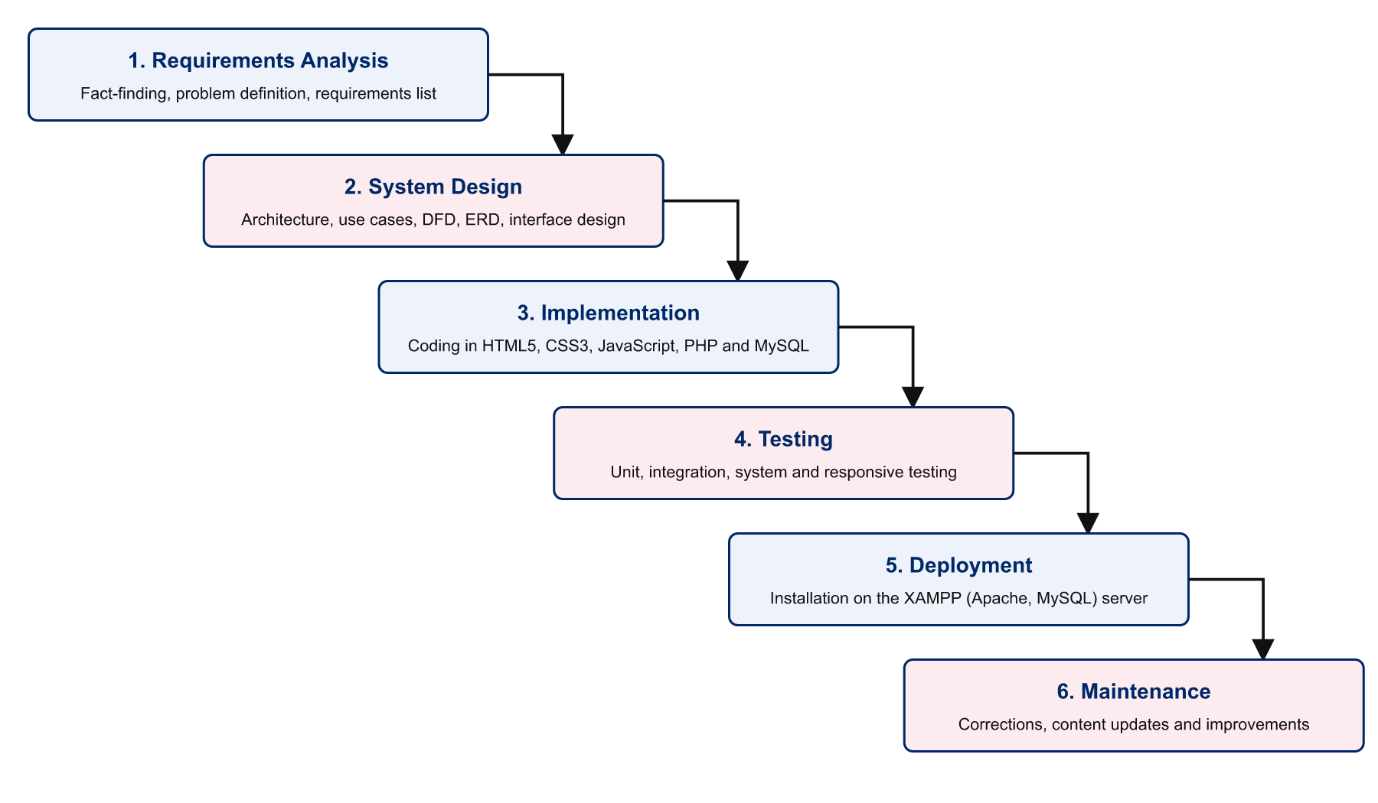
Figure 3.1: The Waterfall model as applied in this project

3.3.1 Reasons for choosing the Waterfall model
- The requirements of the system were clear and stable from the beginning, which is the condition under which the model works best (Sommerville, 2016).
- The project was carried out by one developer within a fixed academic schedule; the model’s distinct phases made progress easy to plan and to supervise.
- Each phase produces documentation, which corresponds directly to the chapters of this report.
- The model is simple to understand and to explain.

3.3.2 Application of the phases
Table 3.1: Waterfall phases, activities and outputs in this project
Phase | Activities carried out | Output | Reported in
1. Requirements analysis | Study of the existing method; fact-finding; definition of users, functional and non-functional requirements; feasibility study. | Requirements specification | Chapter Three
2. System design | Architecture; use case, data flow and entity relationship diagrams; data dictionary; process and interface design. | Design specification | Chapter Four
3. Implementation | Creation of the database; coding of the public site, tourist module and administration panel. | Working source code and database | Chapter Five
4. Testing | Unit, integration, system, security and responsive testing against the requirements. | Test cases and results | Chapter Five
5. Deployment | Installation on the XAMPP server and import of the database. | Running system and installation guide | Chapter Five
6. Maintenance | Correction of defects found after testing; content updates by the administrator. | Maintenance plan | Chapters Five and Six

3.3.3 Limitation of the model
The main weakness of the Waterfall model is that it is difficult to return to an earlier phase when requirements change. This risk was reduced by defining the requirements carefully before design began and by building the administration panel from a single configuration file, so that new data fields or sections can be added later with little rework.

3.4 Methods of Data Collection
The following fact-finding methods were used to understand the existing situation and to determine requirements.
- Observation and review of existing websites. Websites and social media pages that present tourism in Liberia and in other countries were examined to see what information they offer, how bookings are made and what is missing.
- Document review. Published material on Liberia’s counties, attractions and public holidays, and literature on tourism information systems, was studied to determine the data the system must hold.
- Interviews. [STUDENT TO COMPLETE: state who was interviewed (for example tourism officers, hotel staff, tour guides and tourists), how many people, when, and summarise what they said about how bookings and records are handled at present.]

3.5 Analysis of the Existing System
At present, a person who wishes to visit an attraction in Liberia finds information by asking friends, searching social media or contacting a hotel or guide directly. Prices and availability are obtained by telephone or messaging application. A booking is agreed verbally or by message, and payment is made in cash or by mobile money directly to the supplier. The supplier writes the booking in a notebook or spreadsheet. Tourism officers who need figures must request them from each supplier separately.

3.5.1 Problems of the existing system
- Information is scattered, incomplete and often out of date.
- Booking is slow and depends on reaching the right person by telephone.
- There is no proof of booking that both sides can refer to.
- Records are kept in different places and formats and cannot be combined easily.
- Reports on visitor numbers and revenue are difficult and time-consuming to prepare.
- There is no organised way to collect visitor feedback.

3.6 The Proposed System
The proposed system is a web-based Tourism Management System with a public website, a tourist area and an administration panel that share one database. Visitors browse and search tourism information. Registered tourists book tour packages and hotel rooms, choose a payment method, receive a receipt with a unique reference, cancel bookings and review destinations. Staff manage tourism content and bookings. The administrator additionally manages user accounts, roles and every piece of content on the public site.

3.6.1 Advantages of the proposed system
- One central, searchable source of tourism information for all fifteen counties.
- Booking at any time from any device, with an automatic total and a printable receipt.
- Accurate, permanent records of bookings and payments.
- Instant reports that can be printed or exported to a spreadsheet.
- Content that staff can update themselves, so information stays current.
- Controlled access: each user sees only what their role permits.

3.7 Requirements Specification

3.7.1 Users of the system
Table 3.2: Users of the system
User | Description
Visitor | Any member of the public who has not signed in. Can browse, search, send an enquiry and register.
Tourist | A registered user. Can do everything a visitor can, and also book, pay, cancel bookings, write reviews and edit a profile.
Staff | An employee account created by the administrator. Manages tourism content, bookings, reviews, enquiries, pages and reports.
Administrator | Has full access: everything staff can do, plus user accounts and roles, home page content, menu links and site settings.

3.7.2 Functional requirements
Table 3.3: Functional requirements
No. | Requirement | User
FR1 | The system shall display destinations, hotels, tour packages, events and tour guides. | All
FR2 | The system shall allow searching and filtering by keyword, county, category, length of trip and price. | All
FR3 | The system shall provide a live search that suggests matching items as the user types. | All
FR4 | The system shall allow a visitor to register an account and sign in and out. | Visitor, Tourist
FR5 | The system shall allow a tourist to book a tour package or hotel room and shall calculate the total cost. | Tourist
FR6 | The system shall record a payment by MTN Mobile Money, Orange Money or cash and issue a transaction reference. | Tourist
FR7 | The system shall produce a printable receipt with a unique booking reference. | Tourist, Staff
FR8 | The system shall allow a tourist to view and cancel their own bookings. | Tourist
FR9 | The system shall allow a tourist to rate and review a destination; reviews appear after approval. | Tourist, Staff
FR10 | The system shall accept enquiries through a contact form and list them for staff. | All, Staff
FR11 | The system shall allow staff to add, edit, delete and hide destinations, counties, hotels, packages, guides and events, with photographs. | Staff, Admin
FR12 | The system shall allow staff to confirm, complete or cancel bookings and to record cash received. | Staff, Admin
FR13 | The system shall allow the administrator to create user accounts, assign roles and suspend accounts. | Admin
FR14 | The system shall allow the administrator to change all home page text, images, buttons, menu links, contact details and information pages. | Admin
FR15 | The system shall generate reports for a chosen period that can be printed or exported to CSV. | Staff, Admin

3.7.3 Non-functional requirements
Table 3.4: Non-functional requirements
Category | Requirement
Usability | The interface shall be consistent and understandable without training; every form shall show clear error messages.
Responsiveness | Every page shall adapt to phone, tablet and desktop screens without horizontal scrolling.
Security | Passwords shall be hashed; all database queries shall use prepared statements; forms shall be protected against cross-site request forgery; pages shall check the user’s role.
Performance | Pages shall load within a few seconds on an ordinary connection; no heavy frameworks shall be required.
Reliability | Data integrity shall be protected by primary keys, foreign keys and validation on the server.
Maintainability | Source code shall be organised in modules and commented; new administration sections shall be added through configuration.
Portability | The system shall run on any server that provides Apache, PHP 8 and MySQL/MariaDB, and in any modern browser.
Accessibility | Pages shall use semantic HTML, labelled form fields, keyboard focus styles and sufficient colour contrast.

3.8 Feasibility Study
- Technical feasibility. The system uses mature, widely available technologies (HTML5, CSS3, JavaScript, PHP and MySQL) that run on ordinary computers. The developer had the skills required. The project was technically feasible.
- Economic feasibility. All software used is free and open source. The only costs were a computer, electricity and Internet access. The expected benefits in time saved and better information outweigh these costs.
- Operational feasibility. Users need only a browser. The interface follows familiar conventions, and staff can manage content through simple forms, so the system can be operated without specialist training.
- Schedule feasibility. The Waterfall phases were planned to fit within the period allowed for the project, and the work was completed within that period.

3.9 Development Tools and System Requirements
Table 3.5: Development tools
Tool | Purpose
HTML5 | Structure and content of pages (semantic elements, form validation attributes).
CSS3 | Presentation and responsive layout (Grid, Flexbox, custom properties, media queries).
JavaScript (ES6) | Browser behaviour: mobile menu, live search using the fetch API, booking price calculator, confirmations.
PHP 8.2 | Server-side logic: authentication, validation, bookings, reports, content management.
MySQL / MariaDB 10.4 | Relational database storing all system data.
XAMPP | Local server package providing Apache, PHP and MariaDB.
phpMyAdmin | Creating and inspecting the database.
Visual Studio Code | Source code editor.
Web browser developer tools | Testing layouts at different screen sizes and checking for errors.

Table 3.6: Minimum hardware and software requirements
Component | Server (development computer) | Client (user device)
Processor | Dual-core, 2.0 GHz or better | Any smartphone, tablet or computer
Memory | 4 GB RAM | 2 GB RAM
Storage | 1 GB free disk space | None required
Operating system | Windows, Linux or macOS | Android, iOS, Windows, Linux or macOS
Software | XAMPP with Apache, PHP 8 and MariaDB/MySQL | A modern web browser with JavaScript enabled
Network | Local network or Internet connection | Access to the server over the network or Internet

CHAPTER FOUR
SYSTEM DESIGN

4.1 Introduction
This chapter presents the design of the Tourism Management System, the second phase of the Waterfall model. It translates the requirements of Chapter Three into a blueprint for construction: the system architecture, the behaviour of the system as seen by its users, the flow of data, the structure of the database, the main process and the user interface.

4.2 System Architecture
The system follows a three-tier client-server architecture, shown in Figure 4.1. The presentation tier is the user’s web browser, which displays pages written in HTML5, CSS3 and JavaScript. The application tier is the Apache web server running PHP, which receives each request, checks the user’s permission, applies the business rules and builds the response. The data tier is the MySQL database, together with a folder that stores uploaded photographs. The application tier communicates with the database only through PDO prepared statements.
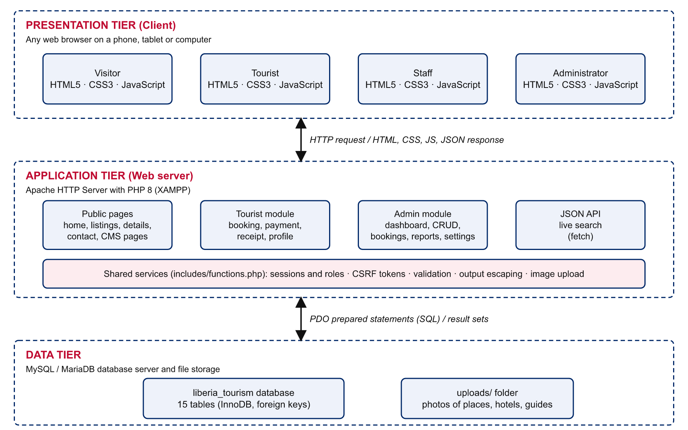
Figure 4.1: Three-tier architecture of the system
Separating the tiers means that the appearance of the site can be changed without touching the database, and that the database can be moved to a different server by changing one configuration file.

4.3 Use Case Diagram
A use case diagram shows the actors who interact with a system and the functions available to each. Figure 4.2 identifies four actors. A Tourist inherits all the abilities of a Visitor, and an Administrator inherits all the abilities of Staff.
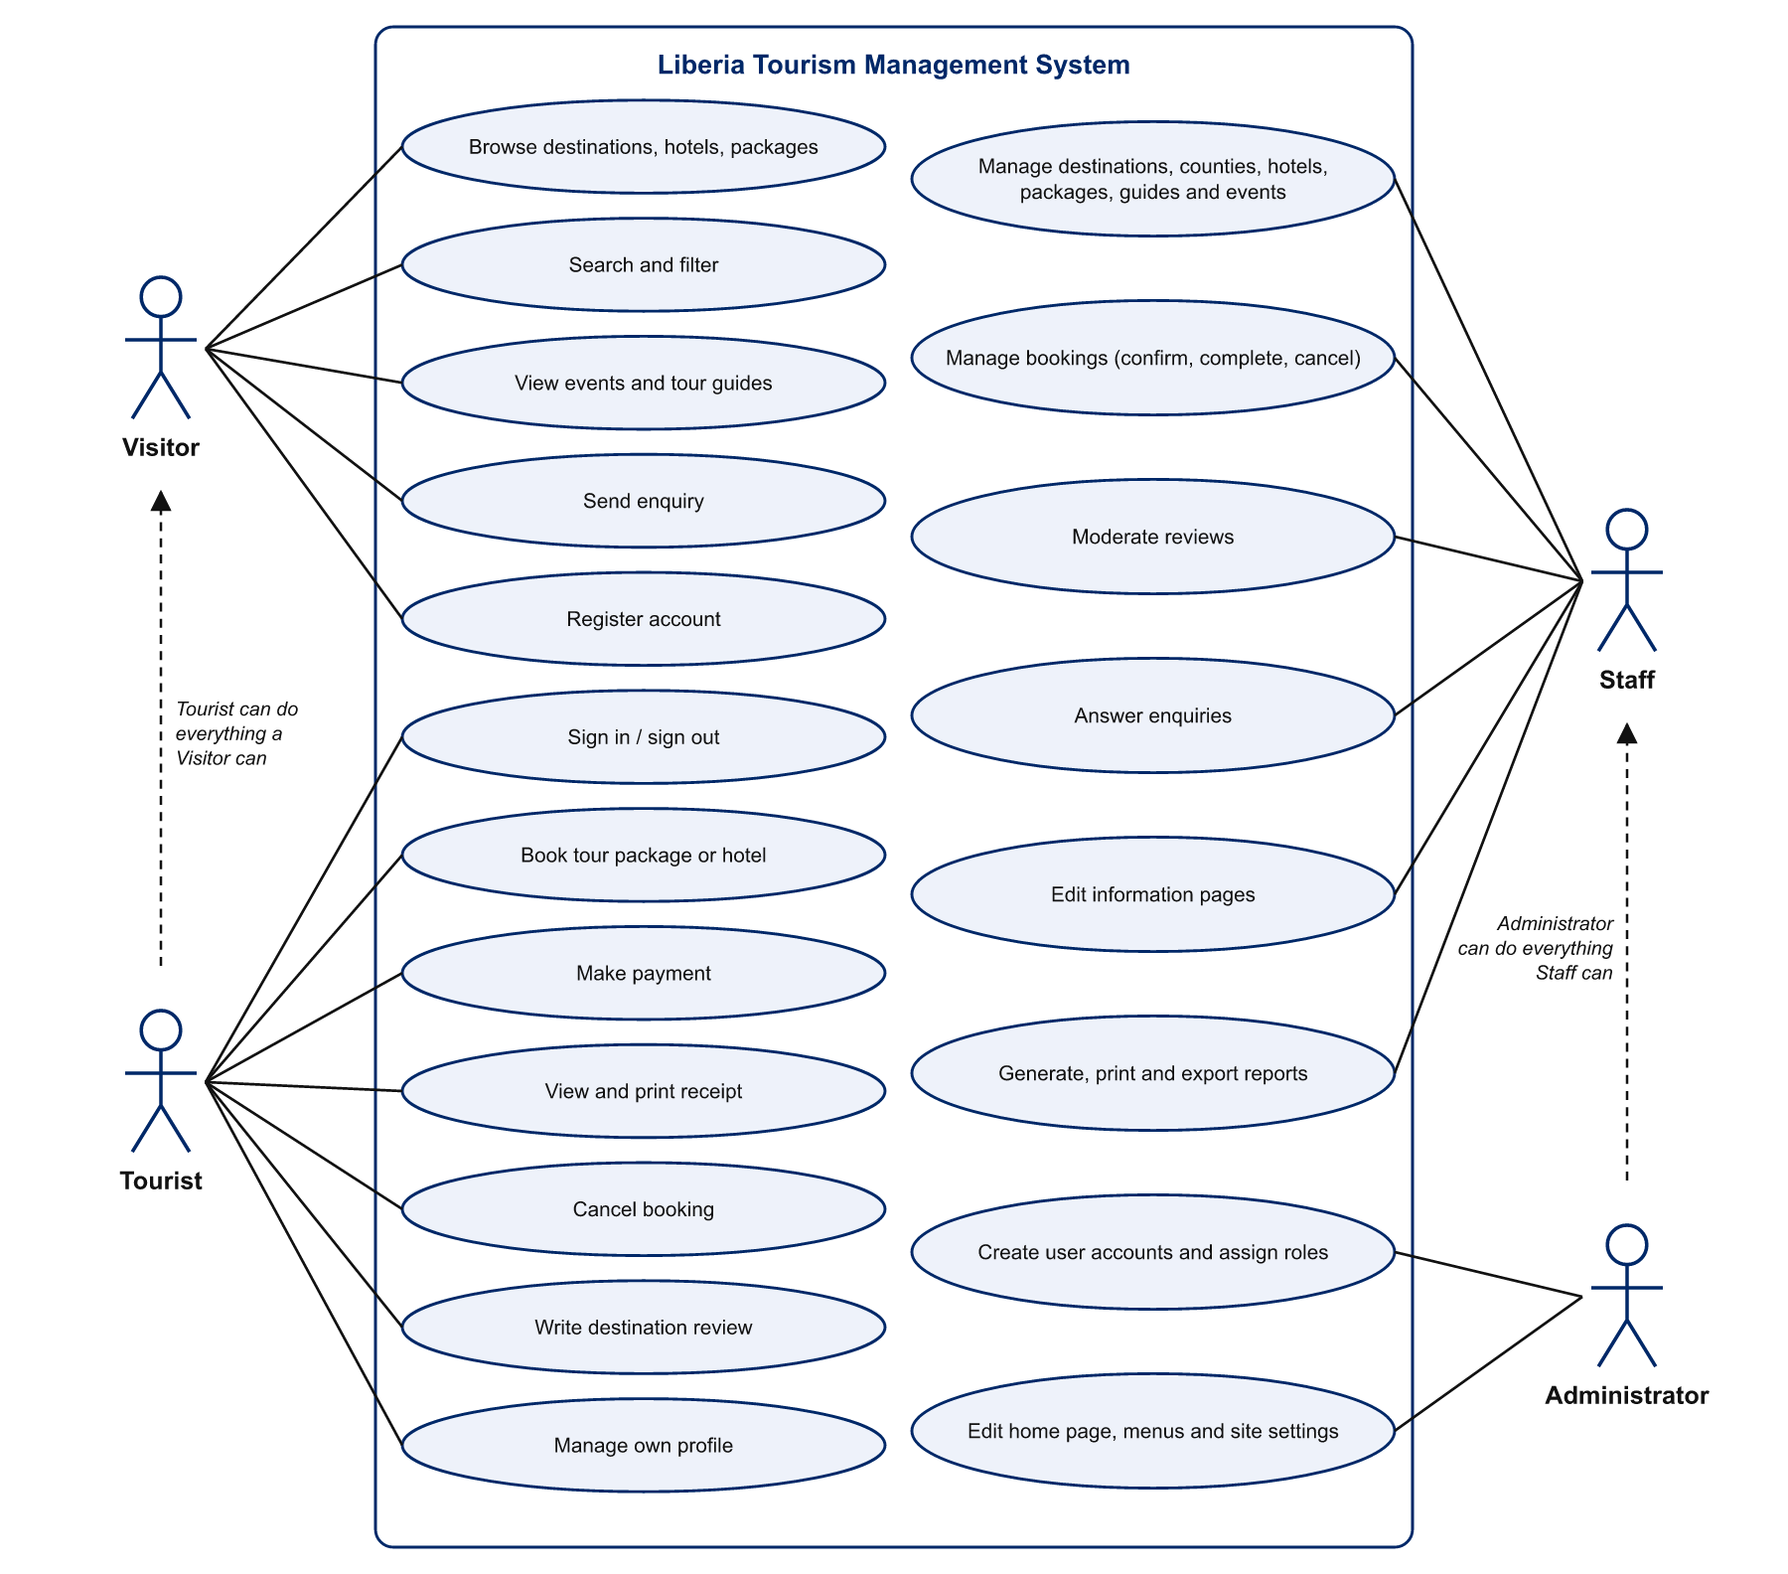
Figure 4.2: Use case diagram
Table 4.1: Description of the use case “Book tour package or hotel”
Item | Description
Actor | Tourist
Pre-condition | The tourist is signed in and has opened an active tour package or hotel.
Main flow | 1. The tourist enters the date, the number of people (and rooms and check-out date for a hotel). 2. The browser displays the running total. 3. The tourist submits the form. 4. The system validates the details and recalculates the total on the server. 5. The system saves the booking with status Pending and a unique reference. 6. The system opens the payment page.
Alternative flow | If the date is in the past, the group is larger than allowed or more rooms are requested than are available, the system shows an error message and returns to the form.
Post-condition | A booking record exists and is visible to the tourist and to staff.

4.4 Data Flow Diagrams
Data flow diagrams show how data move between external entities, processes and data stores.

4.4.1 Context diagram (Level 0)
The context diagram in Figure 4.3 treats the whole system as one process and shows the data exchanged with the four external entities.
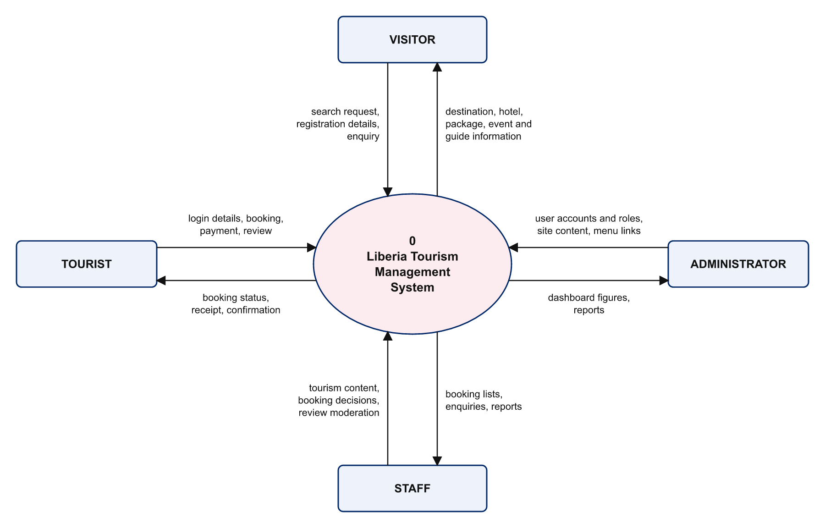
Figure 4.3: Context diagram (Level 0 data flow diagram)

4.4.2 Level 1 data flow diagram
Figure 4.4 breaks the system into ten processes. Processes 1.0 to 5.0 serve visitors and tourists; processes 6.0 to 10.0 serve staff and the administrator. Both groups of processes share five data stores.
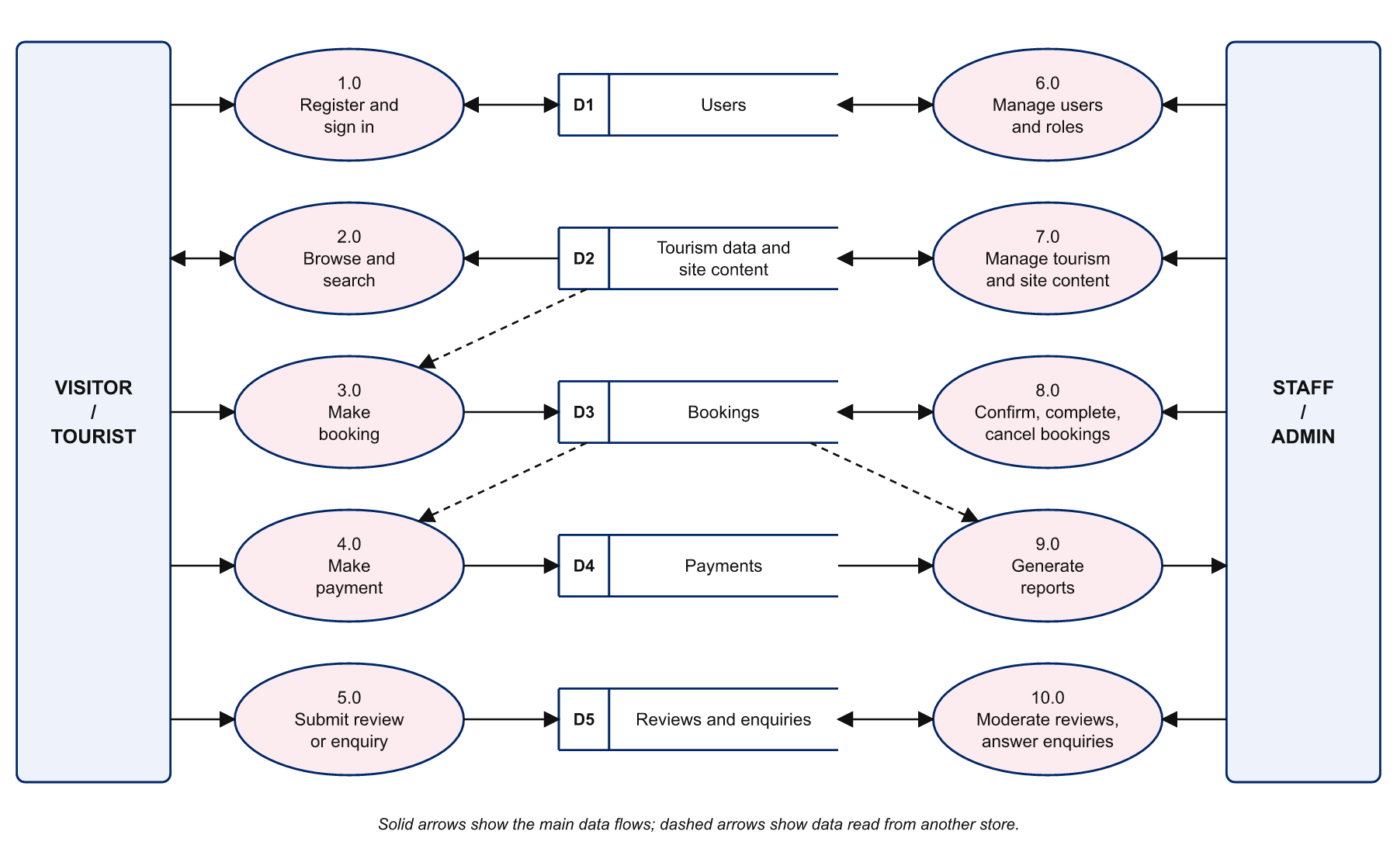
Figure 4.4: Level 1 data flow diagram

4.5 Database Design

4.5.1 Entity relationship diagram
The database consists of fifteen tables. Figure 4.5 shows the eleven related tables with their primary keys (PK), foreign keys (FK) and main attributes; “1” and “N” mark the one and many sides of each relationship. Four further tables (enquiries, settings, pages and menu_links) stand alone.
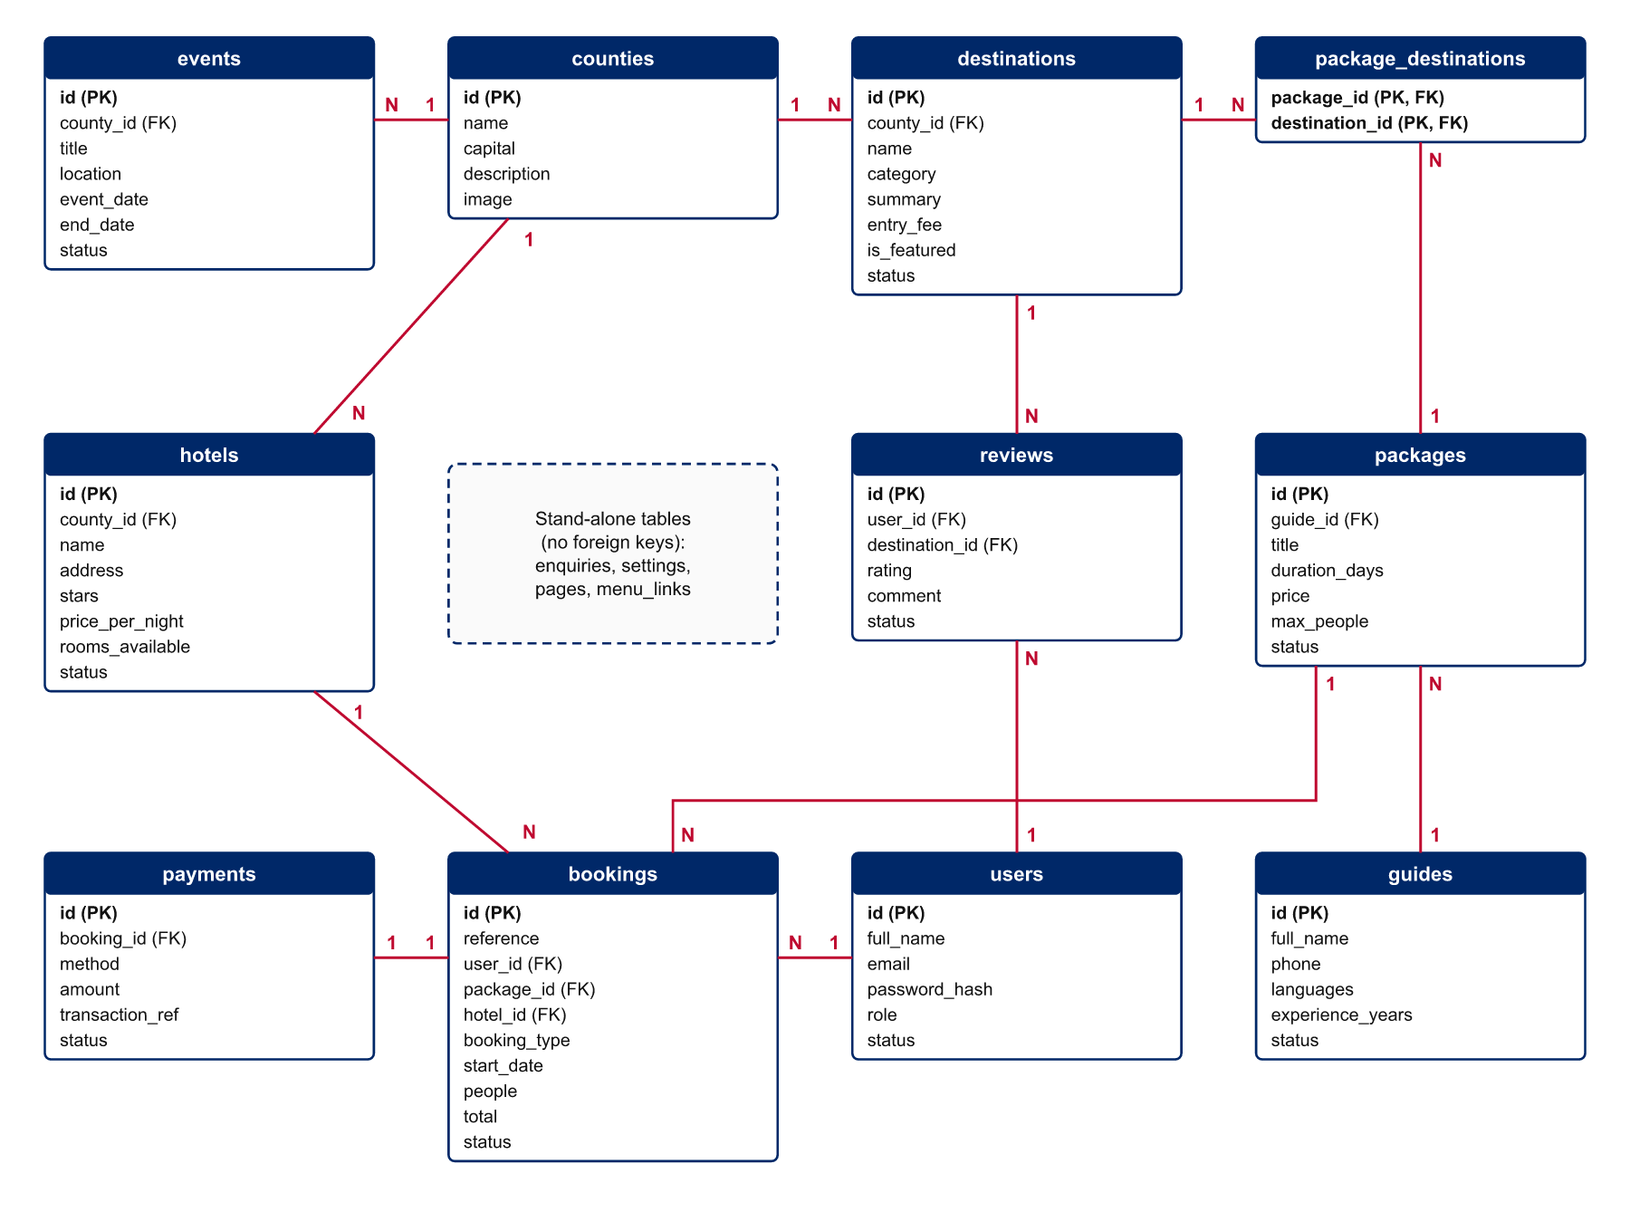
Figure 4.5: Entity relationship diagram
The main relationships are as follows:
- A county has many destinations, hotels and events; each of these belongs to one county.
- A tour package visits many destinations and a destination can appear in many packages. This many-to-many relationship is resolved by the table package_destinations.
- A guide leads many packages; each package has at most one assigned guide.
- A user (tourist) makes many bookings; each booking is for exactly one package or one hotel.
- A booking has at most one payment.
- A user writes many reviews; each review concerns one destination.

4.5.2 Normalisation
The tables were designed to third normal form. Every table has a primary key and holds only single values in each field (first normal form). Every non-key attribute depends on the whole key; the only table with a composite key, package_destinations, has no other attributes (second normal form). No non-key attribute depends on another non-key attribute: for example, the name of a county is stored once in the counties table and referred to by its identifier elsewhere (third normal form).

4.5.3 Data dictionary
Tables 4.2 to 4.16 describe every field of the database as implemented.
Table 4.2: users (Accounts of administrators, staff and tourists)
Field | Data type | Key | Null | Description
id | int(10) unsigned | PK | No | Unique identifier
full_name | varchar(120) | – | No | Full name
email | varchar(150) | Unique | No | Email address
phone | varchar(30) | – | Yes | Telephone number
country | varchar(80) | – | Yes | Country of residence
password_hash | varchar(255) | – | No | Password stored as a one-way hash
role | enum('admin', 'staff', 'tourist') | – | No | Role that controls access
status | enum('active', 'suspended') | – | No | Current status of the record
created_at | datetime | – | No | Date and time the record was created

Table 4.3: counties (The fifteen counties of Liberia)
Field | Data type | Key | Null | Description
id | int(10) unsigned | PK | No | Unique identifier
name | varchar(80) | Unique | No | Name
capital | varchar(80) | – | Yes | Capital city of the county
description | text | – | Yes | Full description
image | varchar(255) | – | Yes | Path of the uploaded photograph

Table 4.4: destinations (Tourist attractions)
Field | Data type | Key | Null | Description
id | int(10) unsigned | PK | No | Unique identifier
county_id | int(10) unsigned | FK | No | Reference to the counties table
name | varchar(150) | – | No | Name
category | enum('Beach', 'Nature & Wildlife', 'Historical', 'Cultural', 'Waterfall') | – | No | Type of attraction
summary | varchar(255) | – | Yes | One-sentence summary shown on cards
description | text | – | Yes | Full description
location | varchar(200) | – | Yes | Where it is
best_time | varchar(120) | – | Yes | Best time of year to visit
entry_fee | decimal(10, 2) | – | No | Entry fee in US dollars
image | varchar(255) | – | Yes | Path of the uploaded photograph
is_featured | tinyint(1) | – | No | Shown first on the home page (1 = yes)
status | enum('active', 'hidden') | – | No | Current status of the record
created_at | datetime | – | No | Date and time the record was created

Table 4.5: hotels (Accommodation)
Field | Data type | Key | Null | Description
id | int(10) unsigned | PK | No | Unique identifier
county_id | int(10) unsigned | FK | No | Reference to the counties table
name | varchar(150) | – | No | Name
address | varchar(200) | – | Yes | Street address
description | text | – | Yes | Full description
amenities | varchar(255) | – | Yes | Comma-separated list of facilities
stars | tinyint(3) unsigned | – | No | Star rating, 1 to 5
price_per_night | decimal(10, 2) | – | No | Price per room per night in US dollars
rooms_available | int(10) unsigned | – | No | Number of rooms that can be booked
phone | varchar(30) | – | Yes | Telephone number
image | varchar(255) | – | Yes | Path of the uploaded photograph
is_featured | tinyint(1) | – | No | Shown first on the home page (1 = yes)
status | enum('active', 'hidden') | – | No | Current status of the record

Table 4.6: guides (Tour guides)
Field | Data type | Key | Null | Description
id | int(10) unsigned | PK | No | Unique identifier
full_name | varchar(120) | – | No | Full name
phone | varchar(30) | – | Yes | Telephone number
email | varchar(150) | – | Yes | Email address
languages | varchar(200) | – | Yes | Languages spoken
experience_years | tinyint(3) unsigned | – | No | Years of guiding experience
bio | text | – | Yes | Short biography
image | varchar(255) | – | Yes | Path of the uploaded photograph
status | enum('active', 'hidden') | – | No | Current status of the record

Table 4.7: packages (Tour packages)
Field | Data type | Key | Null | Description
id | int(10) unsigned | PK | No | Unique identifier
guide_id | int(10) unsigned | FK | Yes | Reference to the guides table
title | varchar(150) | – | No | Title
summary | varchar(255) | – | Yes | One-sentence summary shown on cards
description | text | – | Yes | Full description
includes | text | – | Yes | What the price includes, one item per line
duration_days | tinyint(3) unsigned | – | No | Length of the tour in days
price | decimal(10, 2) | – | No | Price per person in US dollars
max_people | tinyint(3) unsigned | – | No | Largest group accepted
image | varchar(255) | – | Yes | Path of the uploaded photograph
is_featured | tinyint(1) | – | No | Shown first on the home page (1 = yes)
status | enum('active', 'hidden') | – | No | Current status of the record

Table 4.8: package_destinations (Destinations visited by each package)
Field | Data type | Key | Null | Description
package_id | int(10) unsigned | PK, FK | No | Reference to the packages table
destination_id | int(10) unsigned | PK, FK | No | Reference to the destinations table

Table 4.9: events (Festivals and national celebrations)
Field | Data type | Key | Null | Description
id | int(10) unsigned | PK | No | Unique identifier
county_id | int(10) unsigned | FK | Yes | Reference to the counties table
title | varchar(150) | – | No | Title
location | varchar(200) | – | Yes | Where it is
event_date | date | – | No | Start date
end_date | date | – | Yes | End date (optional)
description | text | – | Yes | Full description
image | varchar(255) | – | Yes | Path of the uploaded photograph
status | enum('active', 'hidden') | – | No | Current status of the record

Table 4.10: bookings (Bookings of packages and hotels)
Field | Data type | Key | Null | Description
id | int(10) unsigned | PK | No | Unique identifier
reference | varchar(20) | Unique | No | Unique booking reference shown to the tourist
user_id | int(10) unsigned | FK | No | Reference to the users table
booking_type | enum('package', 'hotel') | – | No | Whether a package or a hotel is booked
package_id | int(10) unsigned | FK | Yes | Reference to the packages table
hotel_id | int(10) unsigned | FK | Yes | Reference to the hotels table
start_date | date | – | No | Tour start or hotel check-in date
end_date | date | – | Yes | Tour end or hotel check-out date
people | smallint(5) unsigned | – | No | Number of people
rooms | smallint(5) unsigned | – | No | Number of hotel rooms
total | decimal(10, 2) | – | No | Total cost in US dollars, calculated by the server
notes | varchar(500) | – | Yes | Special requests
status | enum('pending', 'confirmed', 'cancelled', 'completed') | – | No | Current status of the record
created_at | datetime | – | No | Date and time the record was created

Table 4.11: payments (Payments recorded against bookings)
Field | Data type | Key | Null | Description
id | int(10) unsigned | PK | No | Unique identifier
booking_id | int(10) unsigned | FK, Unique | No | Reference to the bookings table
method | enum('mtn_momo', 'orange_money', 'cash') | – | No | Payment method chosen
payer_phone | varchar(30) | – | Yes | Mobile money number
amount | decimal(10, 2) | – | No | Amount paid in US dollars
transaction_ref | varchar(30) | – | No | Generated transaction reference
status | enum('paid', 'pending') | – | No | Current status of the record
paid_at | datetime | – | No | Date and time of payment

Table 4.12: reviews (Ratings and reviews of destinations)
Field | Data type | Key | Null | Description
id | int(10) unsigned | PK | No | Unique identifier
user_id | int(10) unsigned | FK | No | Reference to the users table
destination_id | int(10) unsigned | FK | No | Reference to the destinations table
rating | tinyint(3) unsigned | – | No | Rating from 1 to 5
comment | text | – | No | Text of the review
status | enum('pending', 'approved', 'rejected') | – | No | Current status of the record
created_at | datetime | – | No | Date and time the record was created

Table 4.13: enquiries (Messages from the contact form)
Field | Data type | Key | Null | Description
id | int(10) unsigned | PK | No | Unique identifier
name | varchar(120) | – | No | Name
email | varchar(150) | – | No | Email address
phone | varchar(30) | – | Yes | Telephone number
subject | varchar(200) | – | No | Subject of the message
message | text | – | No | Text of the message
reply | text | – | Yes | Reply or note recorded by staff
status | enum('new', 'replied') | – | No | Current status of the record
created_at | datetime | – | No | Date and time the record was created

Table 4.14: settings (Editable site content (key and value))
Field | Data type | Key | Null | Description
skey | varchar(60) | PK | No | Name of the setting
svalue | text | – | Yes | Value of the setting
label | varchar(120) | – | No | Label shown to the administrator
type | enum('text', 'textarea', 'image', 'number', 'url') | – | No | Kind of input used to edit the value
grp | varchar(40) | – | No | Group (tab) in the settings screen
sort_order | smallint(6) | – | No | Display position

Table 4.15: pages (Editable information pages)
Field | Data type | Key | Null | Description
id | int(10) unsigned | PK | No | Unique identifier
slug | varchar(80) | Unique | No | Short name used in the page address
title | varchar(150) | – | No | Title
content | mediumtext | – | Yes | Text of the page
status | enum('active', 'hidden') | – | No | Current status of the record

Table 4.16: menu_links (Editable navigation links)
Field | Data type | Key | Null | Description
id | int(10) unsigned | PK | No | Unique identifier
label | varchar(60) | – | No | Label shown to the administrator
url | varchar(255) | – | No | Address the link opens
location | enum('header', 'explore', 'footer') | – | No | Where it is
sort_order | smallint(6) | – | No | Display position
is_active | tinyint(1) | – | No | Whether the link is shown (1 = yes)

4.6 Process Design: Booking Flowchart
The most important process in the system is the booking of a tour package or hotel. Figure 4.6 shows its logic from the moment the tourist opens an item to the final status of the booking.
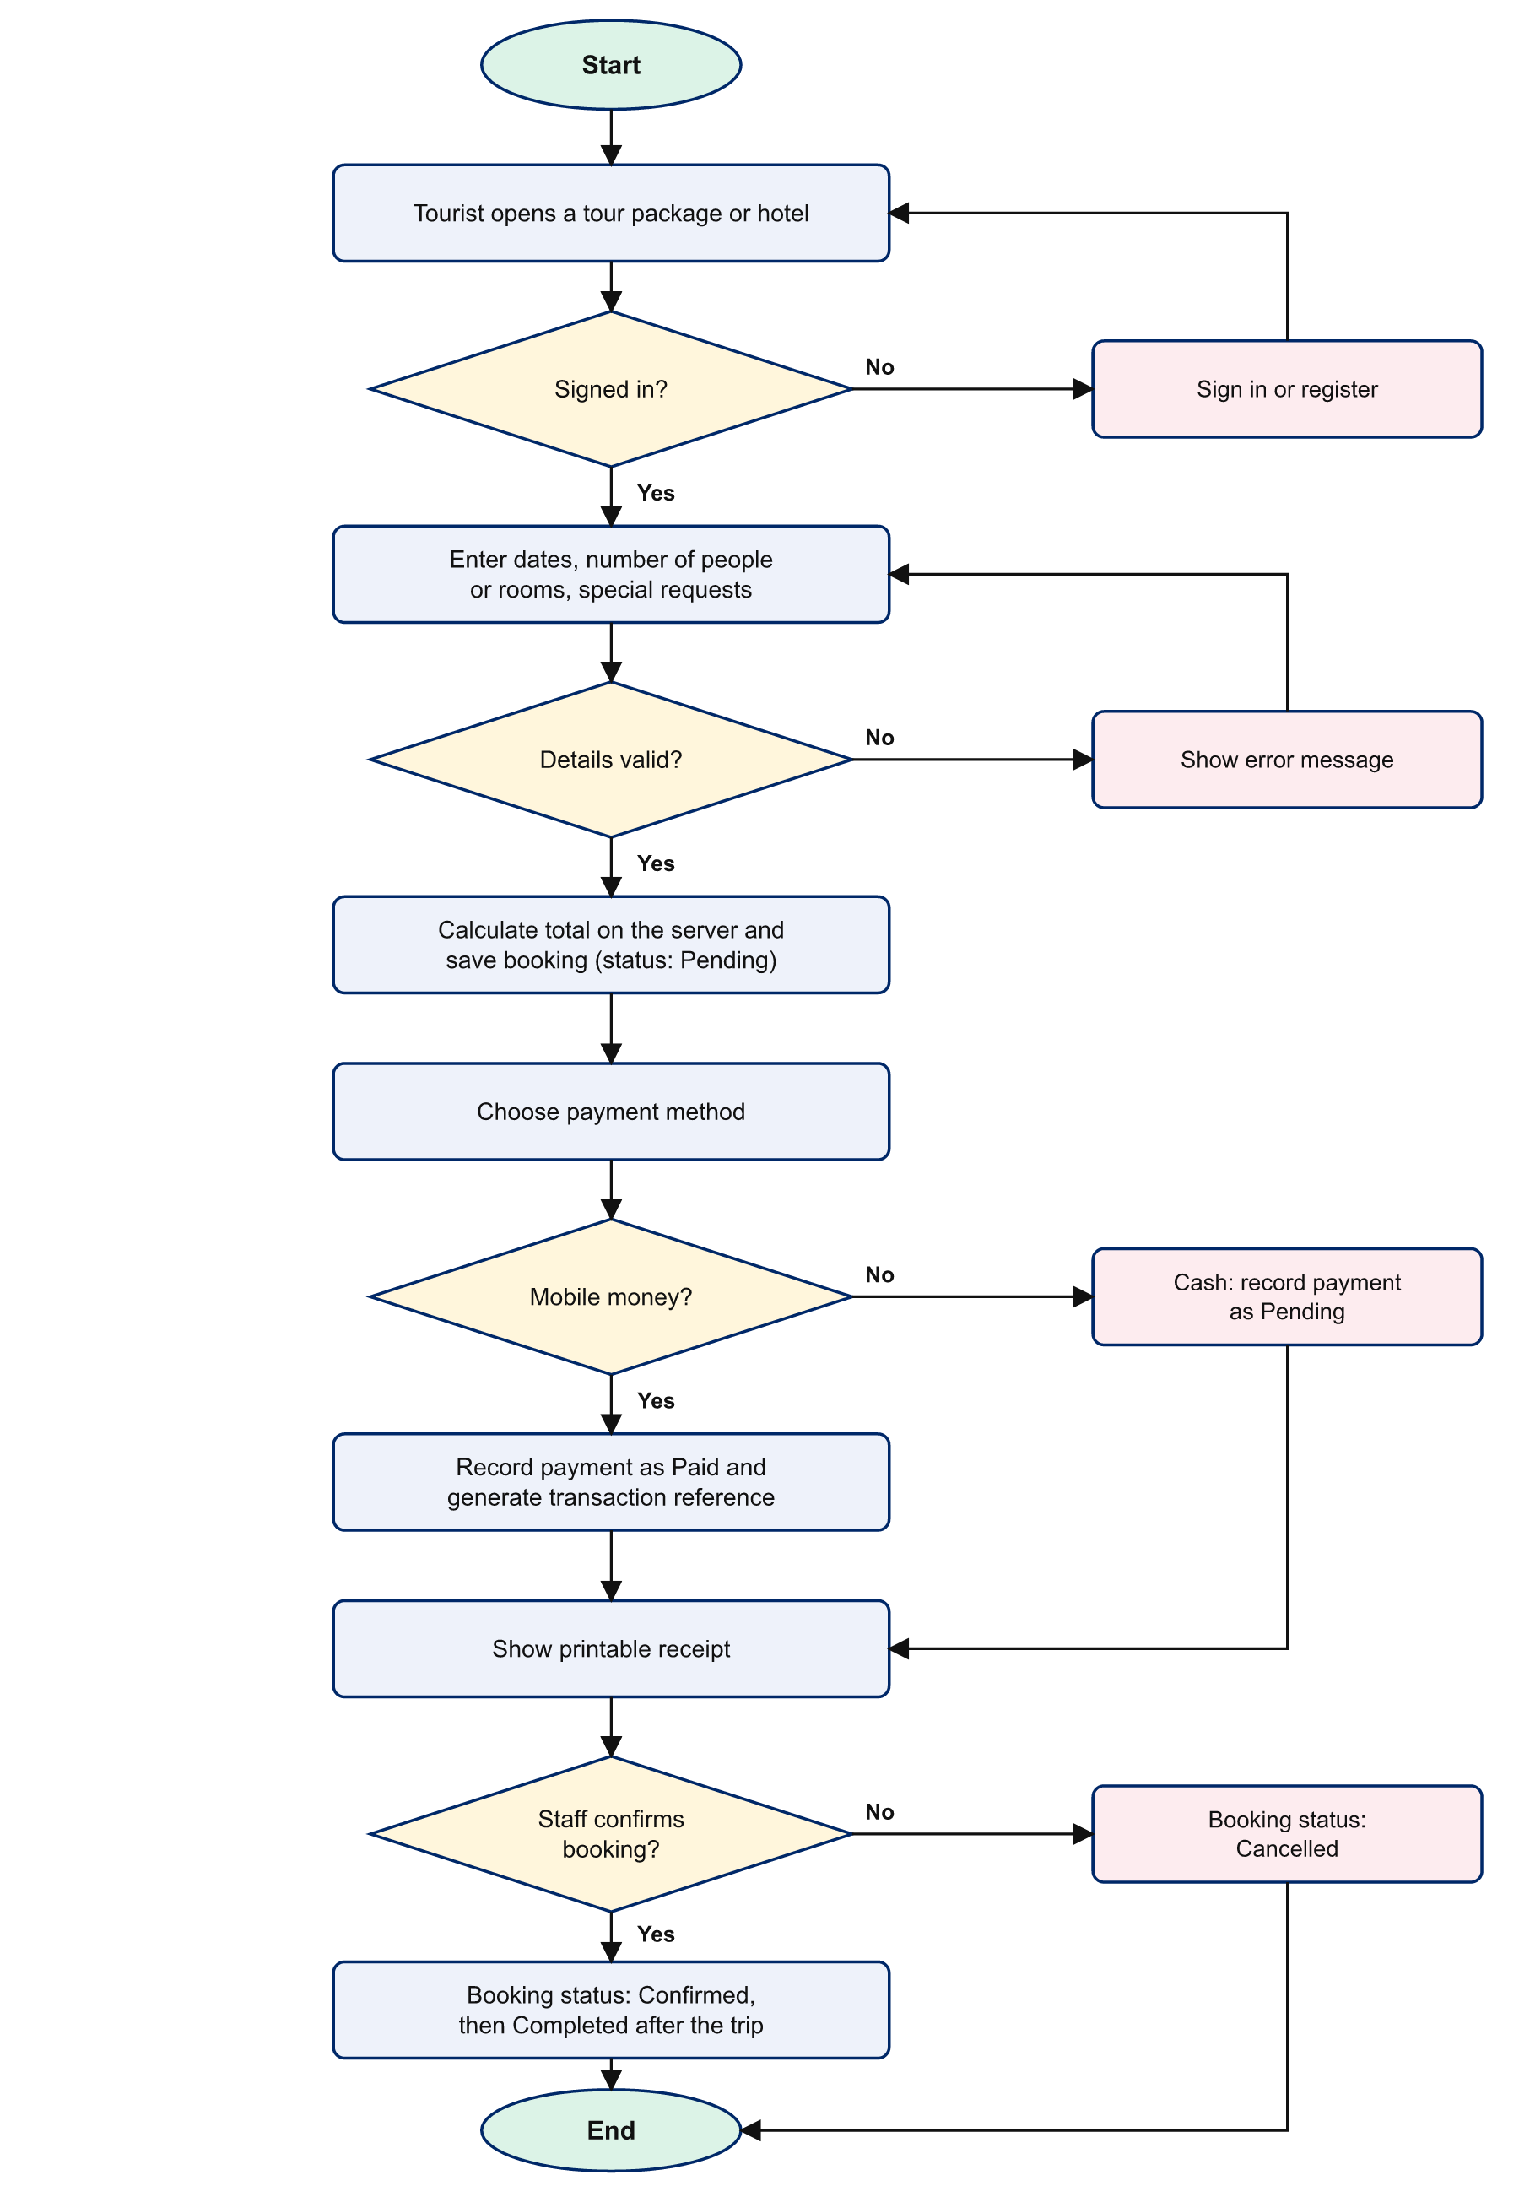
Figure 4.6: Flowchart of the booking and payment process
A booking can only move between states in the directions allowed by the system: Pending to Confirmed or Cancelled, and Confirmed to Completed or Cancelled. A tourist may cancel a booking that is Pending or Confirmed; only staff may confirm or complete one.

4.7 Interface Design

4.7.1 Site structure
Figure 4.7 shows how the pages of the system are organised. The public pages are open to everyone, the tourist area requires a tourist account, and the administration panel requires a staff or administrator account.
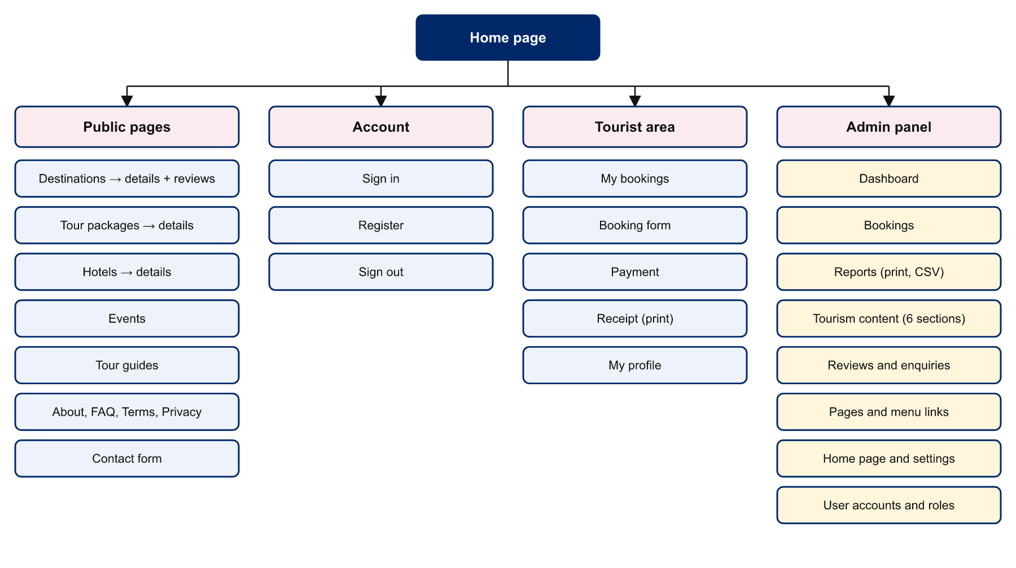
Figure 4.7: Site map

4.7.2 Design principles
- Mobile-first responsive layout. Styles are written first for small screens and extended with media queries for larger ones. Card grids rearrange themselves automatically, the main menu becomes a “hamburger” menu on phones, and wide tables scroll inside their own container.
- National identity. The colour scheme uses the red, white and blue of the Liberian flag, and the Lone Star is used as the site emblem.
- Consistency. Every public page shares one header and footer; every administration page shares one sidebar. Buttons, forms, badges and tables look and behave the same everywhere.
- Feedback. Each action produces a visible message, and destructive actions such as delete and cancel ask for confirmation.
- Accessibility. Pages use semantic elements, every input has a label, there is a “skip to content” link, keyboard focus is clearly visible and animation is reduced for users who request it.

4.7.3 Input and output design
Inputs are collected through forms that are validated twice: in the browser, using HTML5 attributes for immediate feedback, and again on the server, which is the authoritative check. Outputs include listing pages, detail pages, the tourist dashboard, printable receipts, the administration dashboard, on-screen charts, printable reports and CSV files that open in a spreadsheet program.

4.8 Security Design
Table 4.17: Security threats and the measures designed against them
Threat | Measure in the system
Stolen passwords | Passwords are never stored. Only a salted one-way hash produced by password_hash() is kept, and it is checked with password_verify().
SQL injection | Every query is executed as a PDO prepared statement, so user input is never part of the SQL text.
Cross-site scripting (XSS) | All data are escaped with htmlspecialchars() when displayed. Administrator-written pages use a restricted plain-text format rather than raw HTML.
Cross-site request forgery (CSRF) | Every form carries a secret token tied to the user’s session; requests without the correct token are rejected.
Session fixation | The session identifier is regenerated when a user signs in; the session cookie is marked HttpOnly.
Unauthorised access | Each protected page checks the user’s role before doing anything. Tourists can only see their own bookings and receipts.
Malicious file upload | Uploads are accepted only if their real content type is JPG, PNG, WEBP or GIF and they are under 3 MB; files are renamed randomly and scripts cannot run from the uploads folder.
Price tampering | The total of a booking is always calculated on the server from the stored price, never taken from the browser.
Exposure of system files | The configuration and include folders and the database script are blocked from being opened in a browser.

CHAPTER FIVE
SYSTEM IMPLEMENTATION AND TESTING

5.1 Introduction
This chapter covers the third, fourth and fifth phases of the Waterfall model: implementation, testing and deployment. It describes how the design was turned into a working system, presents the main screens, reports the tests carried out and their results, and explains how the system is installed and maintained.

5.2 Development Environment
The system was developed and tested on a Windows computer using XAMPP, with Apache as the web server, PHP 8.2 and MariaDB 10.4. The project folder is placed in the XAMPP htdocs directory and opened in a browser at http://localhost/liberia-tourism/. No frameworks or external libraries were used, so the system works without an Internet connection once installed.

5.3 Structure of the Source Code
Table 5.1: Organisation of the source code
Folder or file | Contents
index.php and other root pages | Public pages: home, destinations, packages, hotels, events, guides, contact, information pages, sign in, register and the booking handler.
tourist/ | My bookings, payment, receipt and profile pages.
admin/ | Dashboard, bookings, reports, site settings, and one generic add/edit/delete screen (crud.php) driven by a configuration file (entities.php).
api/search.php | Returns search results in JSON for the live search box.
includes/ | Shared functions (database access, security, formatting, image upload), header, footer and card layouts.
config/db.php | Database connection settings.
assets/css, assets/js | Stylesheets and JavaScript.
uploads/ | Photographs uploaded by staff.
database.sql | Script that creates the database, its tables and sample data.

A notable feature of the implementation is the generic administration screen. Instead of writing separate add, edit, list and delete pages for each of eleven tables, a single program reads a description of each table (its fields, their types and their rules) and builds the list, the form and the validation automatically. This removed a large amount of repeated code and makes the system easy to extend.

5.4 Implementation of the Modules

5.4.1 Public website
The home page (Figure 5.1) presents a hero section with a live search box, key statistics, featured destinations, tour packages, hotels, upcoming events and visitor reviews. Every heading, paragraph, button and link on the page is read from the database, so the administrator can change it at any time. Listing pages provide filters, and detail pages show full information with related items. Destinations, hotels and tour packages are illustrated with photographs; the sample photographs supplied with the system are freely licensed images from Wikimedia Commons, and a Photo Credits page linked in the footer names the author and licence of each, as those licences require.
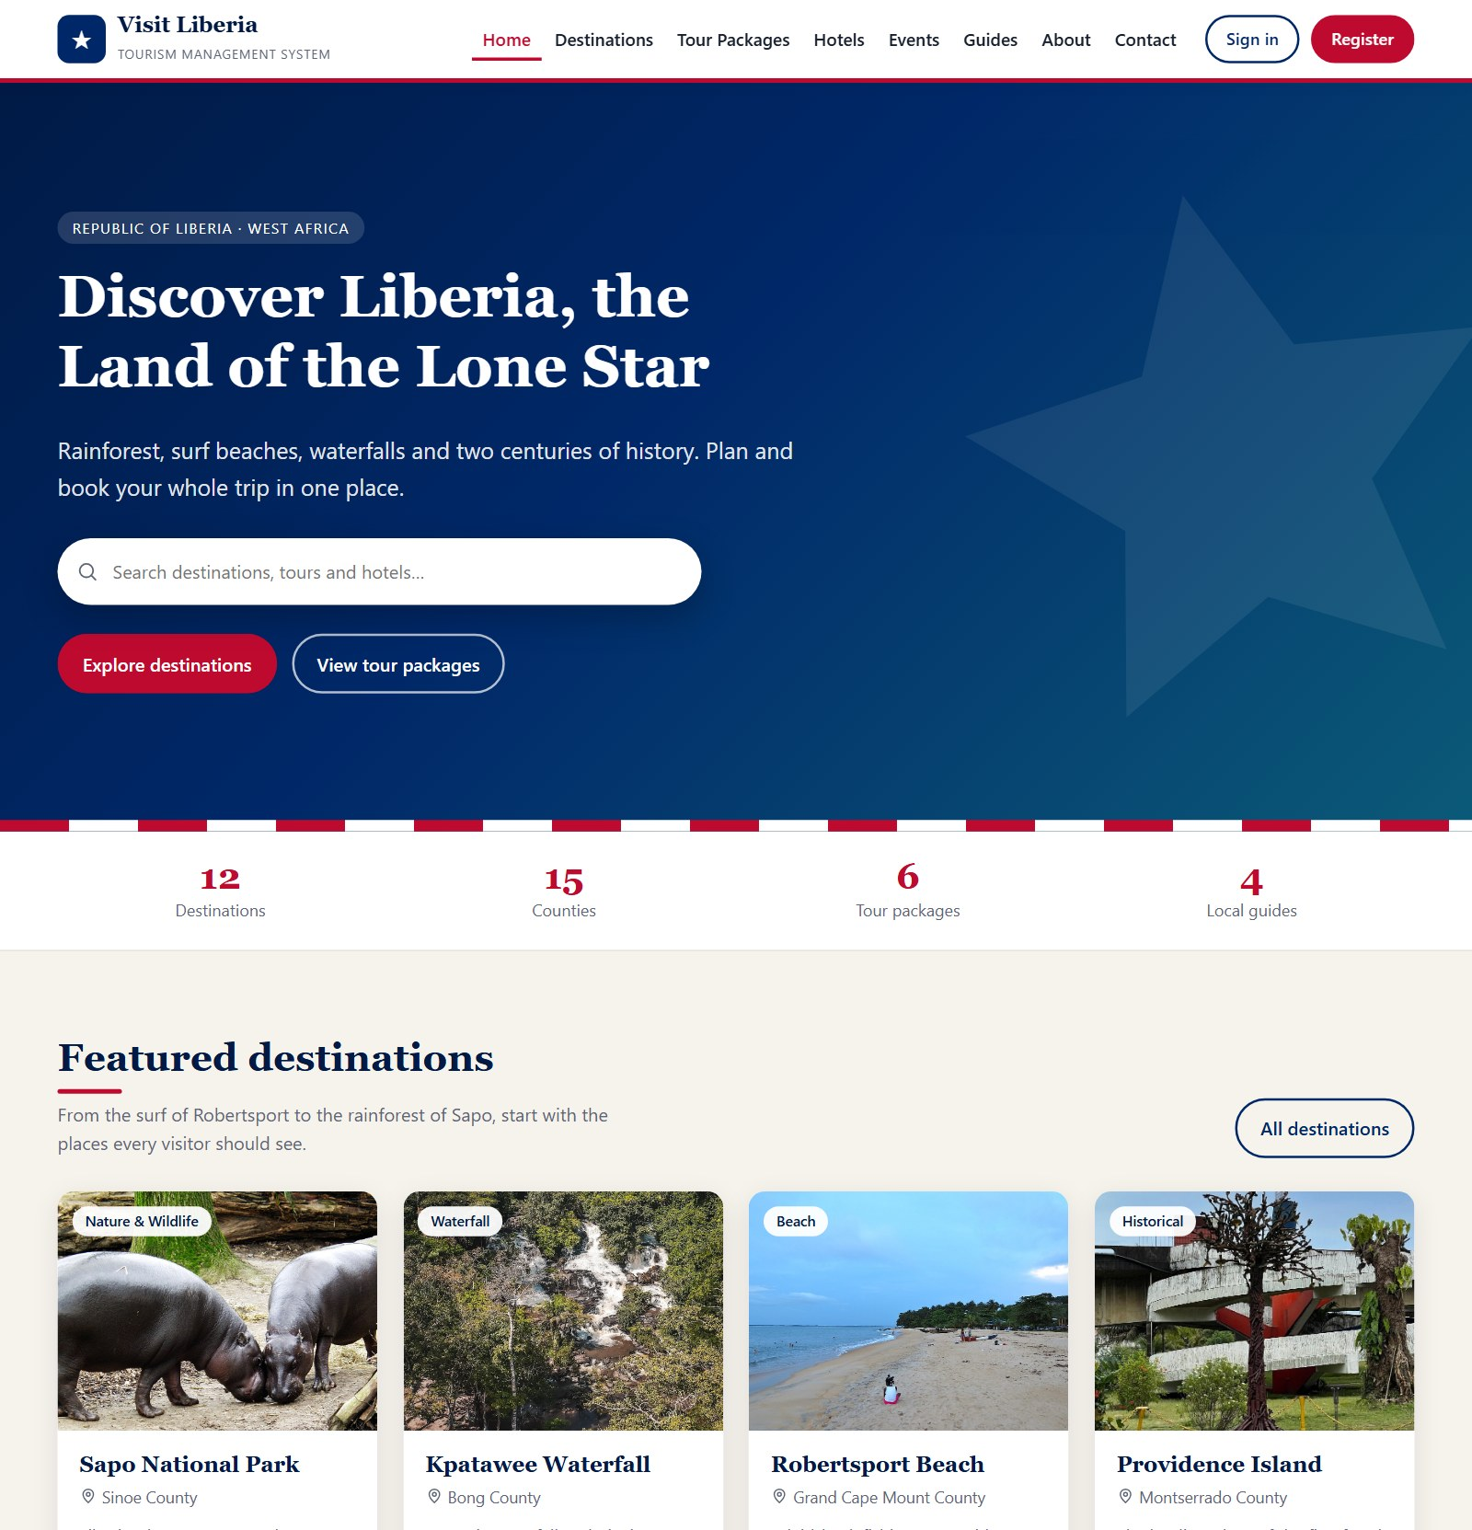
Figure 5.1: Home page

5.4.2 Registration and authentication
Visitors register with their name, email address, telephone number, country and a password of at least eight characters. A single sign-in page serves all roles: after signing in, tourists are taken to their bookings and staff and administrators to the administration panel. Suspended accounts cannot sign in.

5.4.3 Booking and payment
A signed-in tourist books from the detail page of a package or hotel (Figure 5.2). JavaScript shows the total as the tourist types; the server recalculates it before saving. The tourist then chooses a payment method (Figure 5.3). Mobile money payments are recorded as paid with a generated transaction reference; cash payments remain pending until staff record that the cash was received. A receipt that can be printed is then displayed (Figure 5.4).
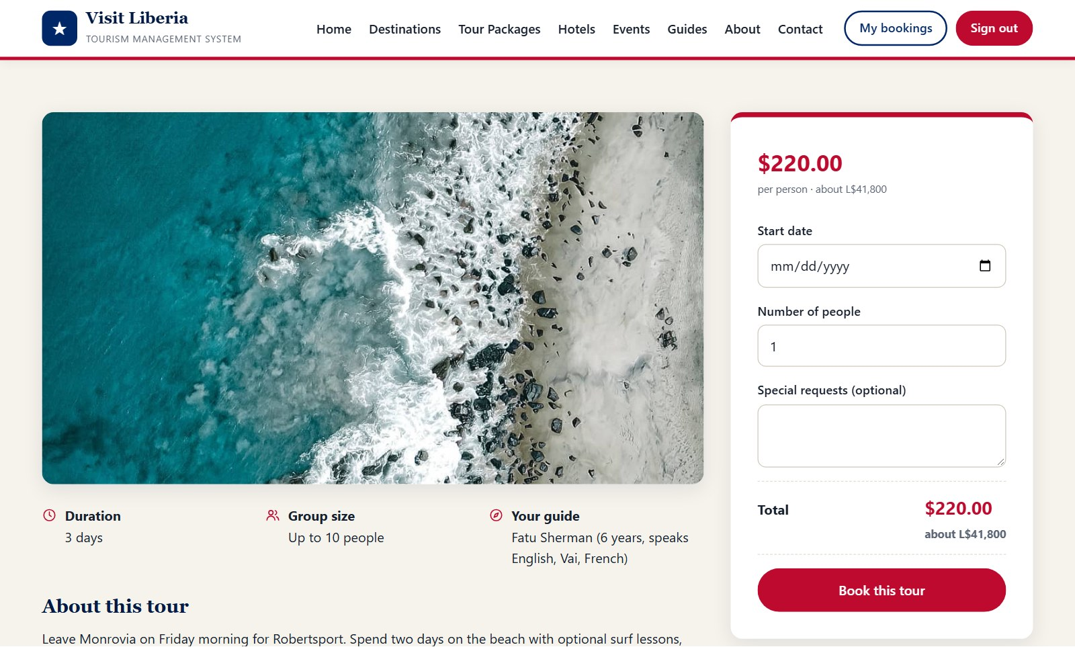
Figure 5.2: Tour package page with booking form
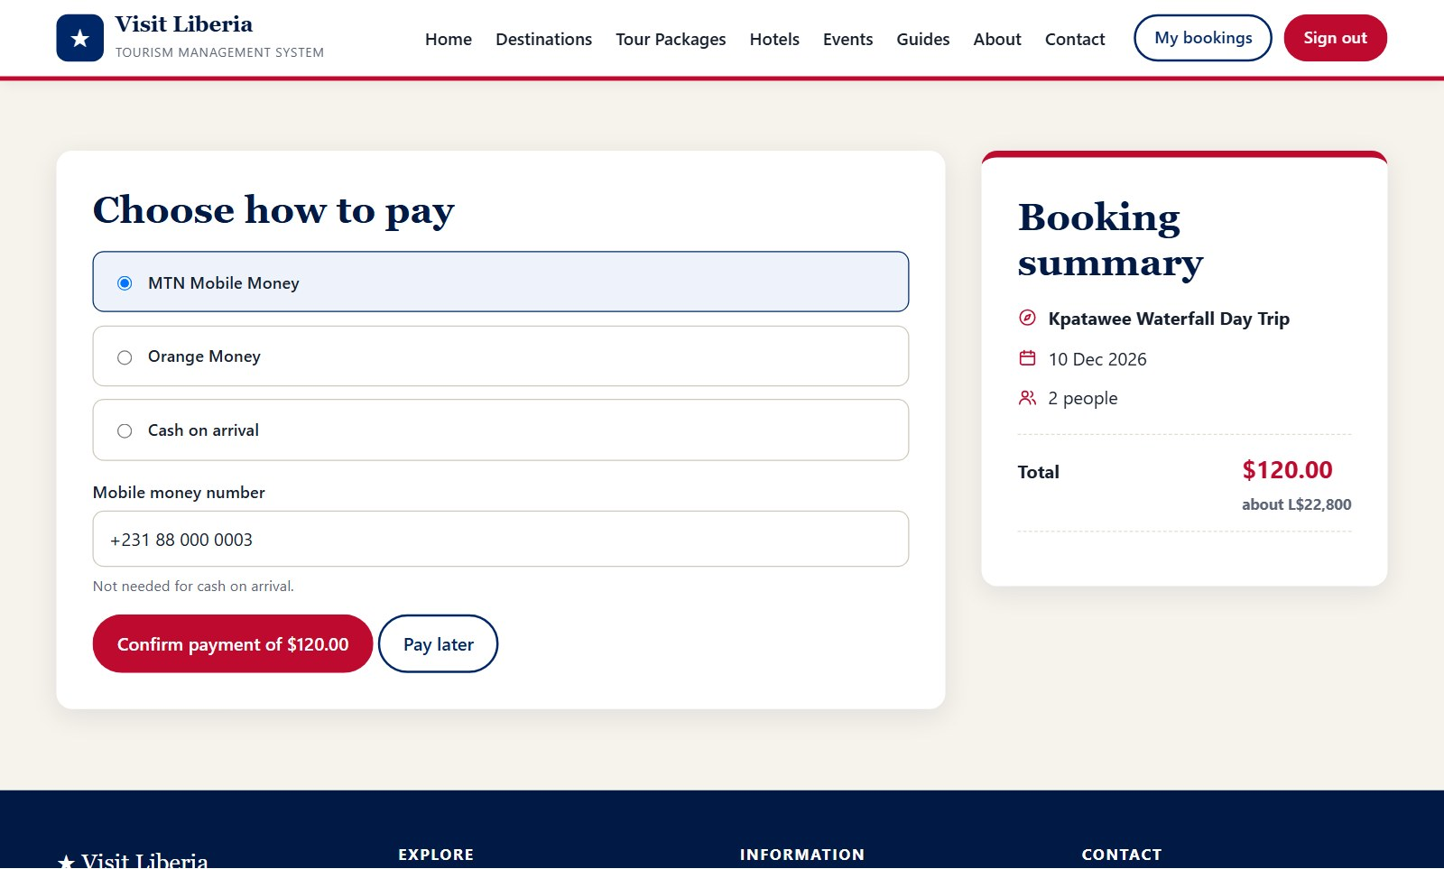
Figure 5.3: Payment page
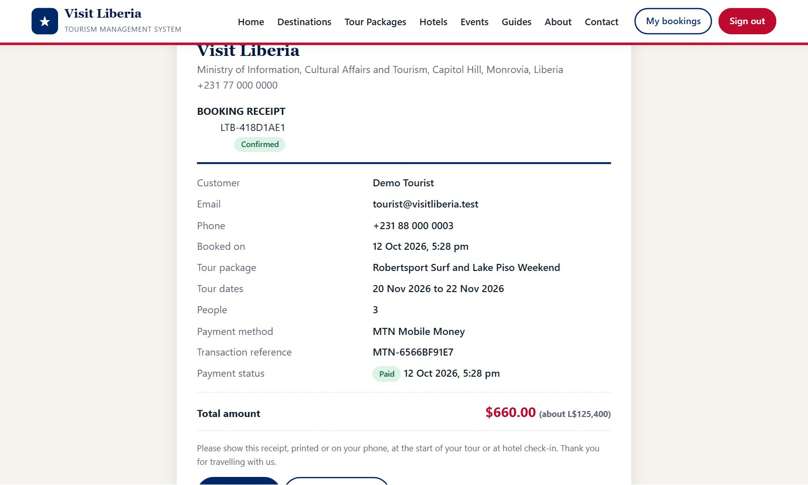
Figure 5.4: Booking receipt

5.4.4 Tourist dashboard
The tourist dashboard (Figure 5.5) summarises the tourist’s bookings and lists each one with its dates, total, payment status and booking status. From here the tourist can pay for an unpaid booking, open a receipt or cancel a booking, and can update personal details or change the password on the profile page.
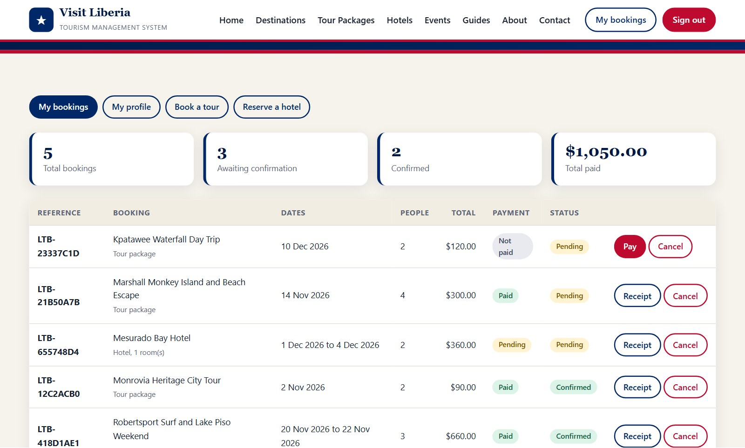
Figure 5.5: Tourist dashboard (My bookings)

5.4.5 Administration dashboard
The administration dashboard (Figure 5.6) shows the number of registered tourists, total and pending bookings, revenue received, destinations and new enquiries, together with the latest bookings and the most booked items. The sidebar shows only the sections the signed-in user is allowed to open, with counters for bookings, reviews and enquiries that need attention.
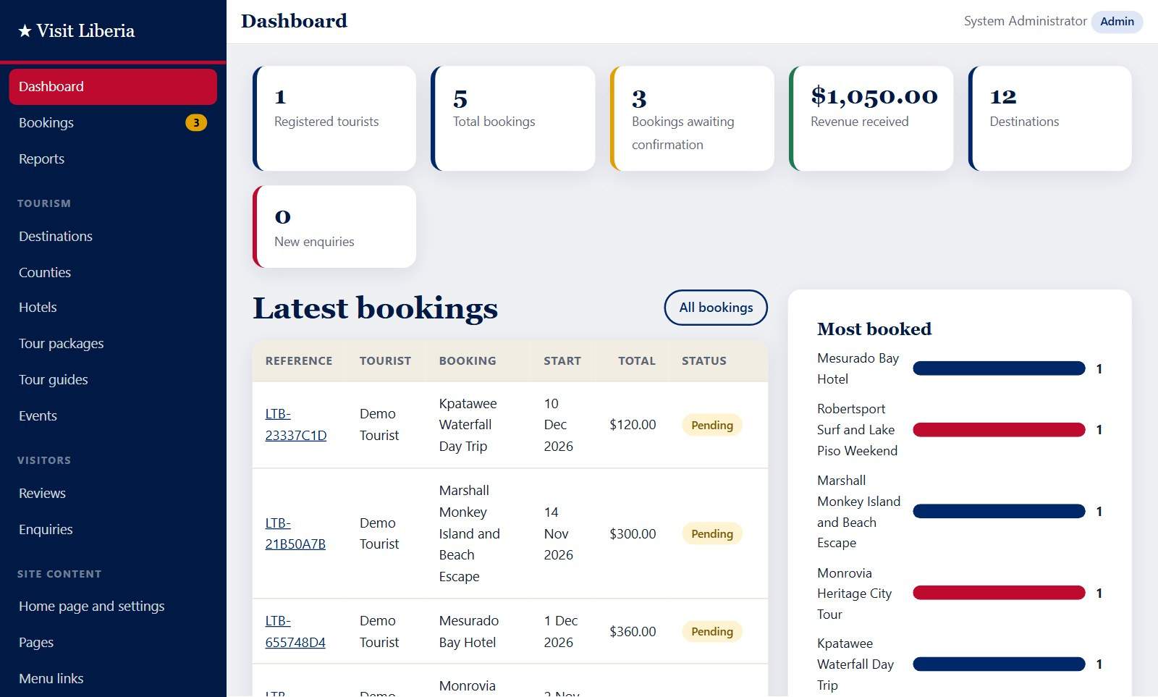
Figure 5.6: Administration dashboard

5.4.6 Management of tourism content
Staff manage destinations, counties, hotels, tour packages, tour guides and events through list screens with search, and forms with validation and photograph upload (Figure 5.7). A record that is linked to bookings cannot be deleted; it can be hidden from the public instead, which protects the integrity of past records.
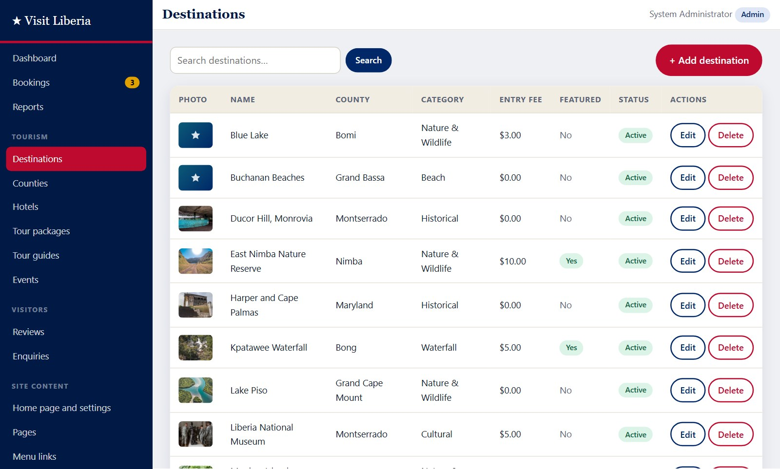
Figure 5.7: Management of destinations

5.4.7 Management of bookings
The bookings screen (Figure 5.8) lists all bookings with filters by status and by reference, name or email. Staff confirm, complete or cancel a booking with one click and record cash payments. Only the status changes permitted by the design are offered.
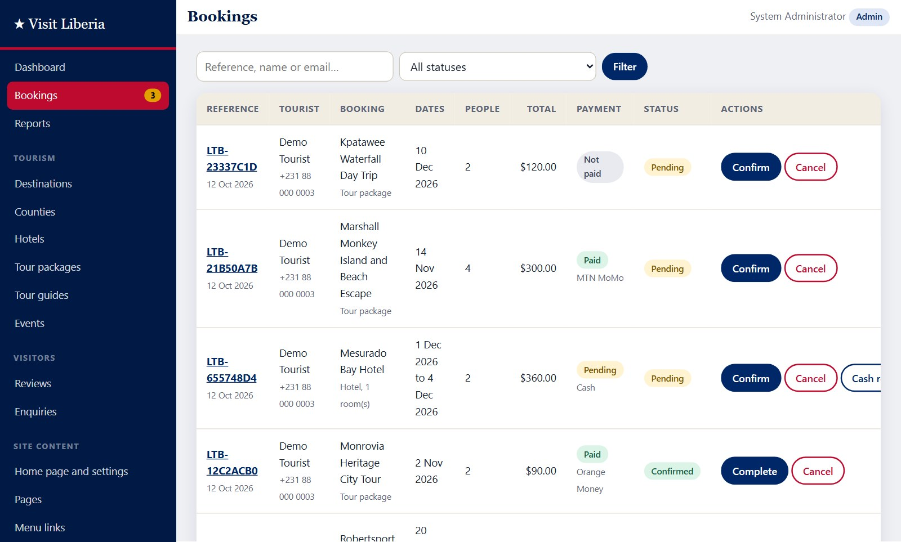
Figure 5.8: Management of bookings

5.4.8 Content management
The administrator edits the content of the public site in three places. “Home page and settings” (Figure 5.9) holds every text, image and button link of the home page, the contact details, the exchange rate and the footer. “Menu links” controls each link in the top navigation and the footer: its label, address, position and whether it is shown. “Pages” holds complete information pages such as About, Frequently Asked Questions and Terms, and new pages can be added.
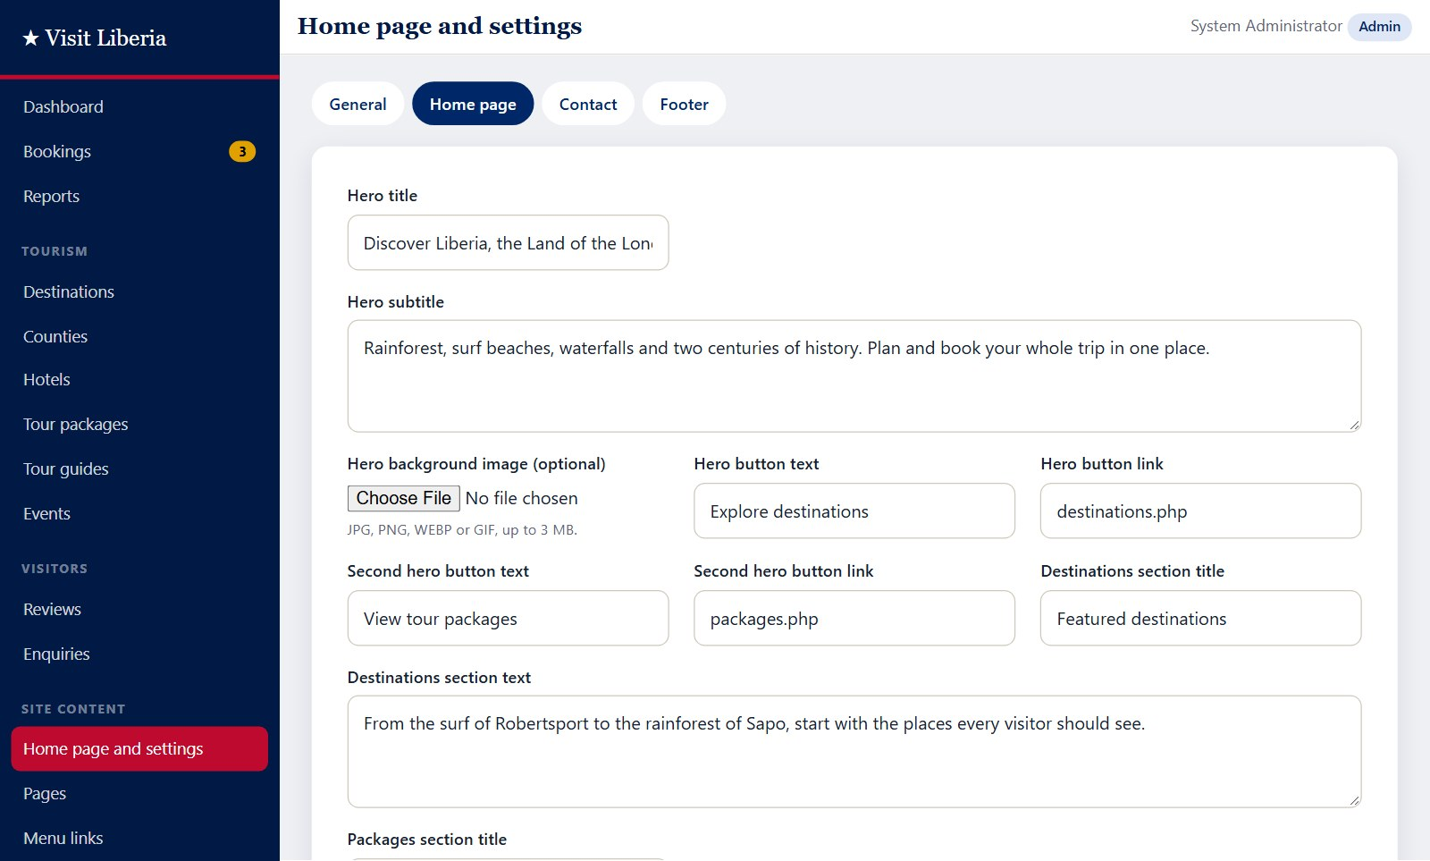
Figure 5.9: Editing home page content

5.4.9 User accounts and roles
The administrator creates accounts for staff, other administrators or tourists and assigns each a role (Figure 5.10). The role decides what the person can do after signing in. Accounts can be suspended, and passwords can be reset. As a safeguard, an administrator cannot delete, demote or suspend the account they are signed in with.
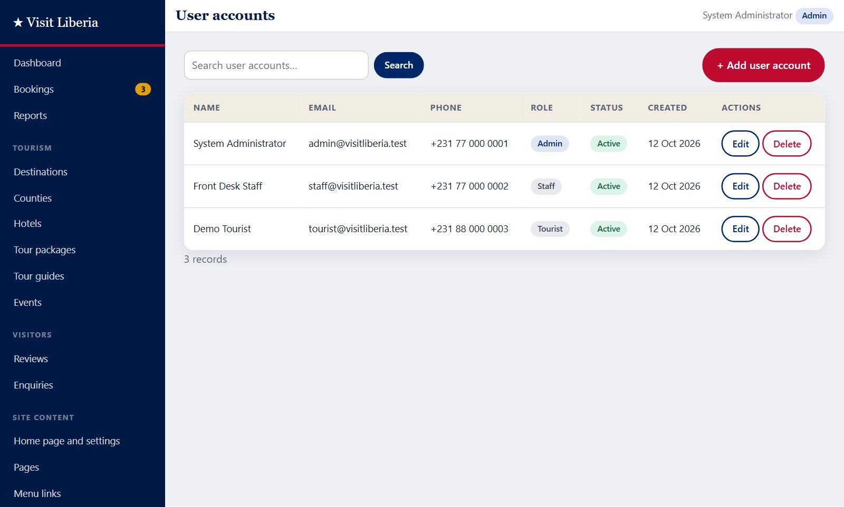
Figure 5.10: User accounts and roles

5.4.10 Reports
The reports screen (Figure 5.11) covers any chosen period and shows the number of bookings, revenue received, confirmed and cancelled bookings and new registrations, with bar charts of revenue by month, the most booked items, the most visited destinations and payment methods, followed by a detailed list. The report can be printed or exported as a CSV file.
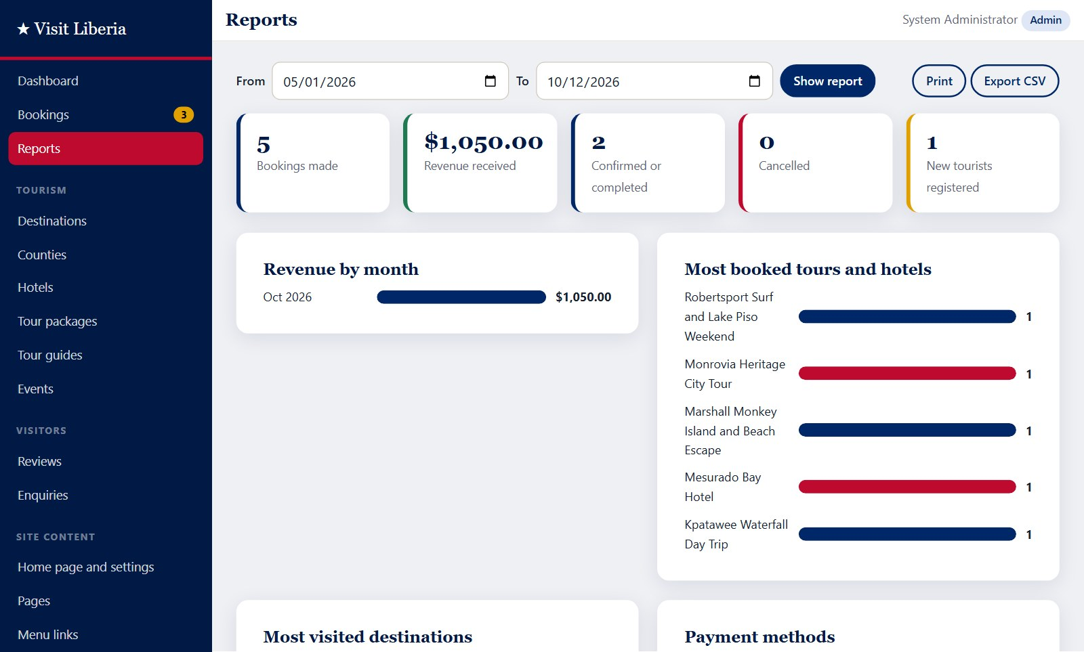
Figure 5.11: Reports

5.5 Sample Source Code
The following extracts illustrate how key security requirements were implemented.

5.5.1 Database access with prepared statements
function db_run(string $sql, array $params = []): PDOStatement
{
$stmt = db()->prepare($sql); // SQL text with ? placeholders
$stmt->execute($params); // user data sent separately
return $stmt;
}

$user = db_one('SELECT * FROM users WHERE email = ?', [$email]);

5.5.2 Sign-in with password verification
if (!$user || !password_verify($_POST['password'], $user['password_hash'])) {
$error = 'The email address or password is incorrect.';
} elseif ($user['status'] !== 'active') {
$error = 'This account has been suspended.';
} else {
session_regenerate_id(true); // prevents session fixation
$_SESSION['user_id'] = $user['id'];
redirect(home_for($user)); // tourist or admin area
}

5.5.3 Role-based access control
function require_role(string ...$roles): void
{
require_login();
if (!has_role(...$roles)) {
http_response_code(403);
exit('Access denied.');
}
}

require_role('admin', 'staff'); // first line of every admin page

5.5.4 Live search with the fetch API (JavaScript)
async function runSearch(term, box) {
const response = await fetch(
`${window.APP_BASE}api/search.php?q=${encodeURIComponent(term)}`);
const results = await response.json();
box.replaceChildren();
results.forEach(item => {
const link = document.createElement('a');
link.href = item.url;
link.textContent = item.title;
box.append(link);
});
}

5.6 System Testing

5.6.1 Testing strategy
- Unit testing. Each page and function was run on its own as it was written, and all PHP files were checked for syntax errors.
- Integration testing. Complete sequences that cross several modules were executed, for example register, sign in, book, pay, view receipt, confirm as staff and view the report.
- System testing. The finished system was tested against the functional requirements of Chapter Three using the test cases in Table 5.2.
- Security testing. Attempts were made to open protected pages without permission, to submit forms without a valid token and to open protected files directly.
- Responsive testing. Pages were checked at phone width (375 pixels) and desktop width (1366 pixels).

5.6.2 Test cases and results
Table 5.2: Test cases and results
No. | Test | Expected result | Result
1 | Open every public page (home, listings, details, events, guides, information page, contact, sign in, register). | Each page loads with no error message. | Pass
2 | Type “beach” in the live search box. | Matching destinations, packages and hotels are listed. | Pass
3 | Sign in as a tourist with correct details. | Tourist is taken to My bookings. | Pass
4 | Sign in as administrator with correct details. | Administrator is taken to the dashboard. | Pass
5 | Book a 3-day package at $220 for 3 people. | Booking saved as Pending; total $660.00; end date two days after start. | Pass
6 | Pay for the booking by MTN Mobile Money. | Payment recorded as Paid; reference beginning “MTN-” shown on receipt. | Pass
7 | Reserve 2 hotel rooms at $65 for 3 nights. | Booking saved; total $390.00. | Pass
8 | Submit a booking with a past date and 99 people. | Booking rejected; user returned to the form with error messages. | Pass
9 | Submit a form without the security token. | Request refused (HTTP 403). | Pass
10 | Submit a 5-star review as a tourist. | Review saved as Pending and not yet shown publicly. | Pass
11 | Approve the review as administrator. | Review status becomes Approved and it appears on the destination page. | Pass
12 | Open the administration panel while signed in as a tourist. | Access denied (HTTP 403). | Pass
13 | Open the administration panel without signing in. | User is redirected to the sign-in page. | Pass
14 | Open every administration list and edit screen. | Each screen loads with no error message. | Pass
15 | Create a user account with the role Staff. | Account created; the new user can sign in. | Pass
16 | Create a second account with the same email address. | Rejected with a message that the value is already in use. | Pass
17 | Sign in as staff and open User accounts, Settings and Menu links. | Access denied (HTTP 403) for all three; tourism sections open normally. | Pass
18 | Create a tour package linked to two destinations. | Package saved with both destinations recorded. | Pass
19 | Delete a package that has bookings. | Deletion refused with an explanation; record remains. | Pass
20 | Change the hero title in Home page and settings. | New title appears on the public home page. | Pass
21 | Confirm a pending booking as administrator. | Booking status becomes Confirmed. | Pass
22 | Send a message through the contact form. | Enquiry saved and listed for staff as New. | Pass
23 | Open reports and export CSV. | Report displays; CSV file is produced. | Pass
24 | Open config/db.php, includes/functions.php and database.sql directly in the browser. | Access forbidden (HTTP 403). | Pass
25 | View 13 public pages and the administration list at a width of 375 pixels. | No horizontal scrolling; menu collapses to a toggle button. | Pass

5.6.3 Discussion of results
All twenty-five test cases passed. Three defects were found and corrected during testing: a variable name used on the settings screen clashed with one used by the page layout and caused a warning; a form submitted without any session was not being rejected by the token check; and the search icon overlapped the text in the search box. After correction the tests were repeated and passed. Testing was carried out by the developer in a Chromium-based browser; acceptance testing with a group of real tourists and tourism officers, and testing in other browsers, are recommended before the system is put into public use.

5.7 System Deployment
The system is installed as follows:
- Install XAMPP and copy the folder liberia-tourism into C:\xampp\htdocs.
- Open the XAMPP Control Panel and start Apache and MySQL.
- Open http://localhost/phpmyadmin, choose Import, select the file database.sql from the project folder and click Go. This creates the database liberia_tourism with its tables and sample data.
- Open http://localhost/liberia-tourism/ in a browser.
- Sign in with the default administrator account listed in the README file and change its password.
To place the system on the Internet, the same files are uploaded to a hosting account that provides PHP 8 and MySQL, the database script is imported, and the connection details are entered in config/db.php. HTTPS should be enabled on a public server.

5.8 Maintenance
- Corrective maintenance: fixing any defect reported by users.
- Adaptive maintenance: updating the system for new versions of PHP, the database or browsers.
- Perfective maintenance: adding features such as those recommended in Chapter Six.
- Routine tasks: regular backup of the database and the uploads folder, review of user accounts, and updating of prices, events and the exchange rate by the administrator.

CHAPTER SIX
SUMMARY, CONCLUSION AND RECOMMENDATIONS

6.1 Introduction
This chapter summarises the study, states how far its objectives were achieved, notes the challenges met, draws a conclusion and makes recommendations for the use and further development of the system.

6.2 Summary of the Study
The study set out to design and implement a web-based Tourism Management System for Liberia. Chapter One established that tourism information in the country is scattered and that bookings and records are handled manually. Chapter Two reviewed literature showing that information technology is central to modern tourism and that no integrated system combines Liberian tourism information, online booking and management tools. Chapter Three adopted the Waterfall model, analysed the existing method and specified the requirements. Chapter Four produced the design: a three-tier architecture, use case and data flow diagrams, a normalised database of fifteen tables and the booking process. Chapter Five described the implementation in HTML5, CSS3, JavaScript, PHP and MySQL, and reported twenty-five test cases, all of which passed.

6.3 Achievement of the Objectives
Table 6.1: Objectives of the study and how they were achieved
Objective | How it was achieved
1. Study the existing method and identify its weaknesses | The existing method was analysed and six problems were identified (Sections 1.2 and 3.5).
2. Design a centralised database | A normalised relational database of fifteen tables with foreign keys was designed and implemented (Section 4.5).
3. Develop a responsive public website | A mobile-first website with search and filters was built and verified at phone and desktop widths (Sections 5.4.1 and 5.6).
4. Implement registration, booking, payment and receipts | Tourists can register, book packages and hotels, record a payment and print a receipt (Sections 5.4.2 to 5.4.4).
5. Provide an administration panel for all content | Staff manage all tourism data; the administrator edits every home page text, link, menu and page without code (Sections 5.4.6 and 5.4.8).
6. Enable the administrator to create accounts and assign roles | The administrator creates accounts and assigns the role of administrator, staff or tourist (Section 5.4.9).
7. Generate reports | Reports for any period can be viewed, printed and exported to CSV (Section 5.4.10).
8. Test the system | Twenty-five functional, security and responsive test cases were executed and passed (Section 5.6).

6.4 Challenges Encountered
- A live mobile money gateway could not be integrated, because it requires a registered merchant account; payment was therefore simulated.
- Verified, current data on hotels, guides and prices across the counties were not available, so sample data were used.
- Freely licensed photographs could be found for ten of the twelve sample destinations but for none of the hotels. The hotels are therefore illustrated with scenery of their area, and the system displays a placeholder wherever no photograph has been uploaded.
- Designing one administration screen that serves many different tables required careful planning but greatly reduced the amount of code.

6.5 Conclusion
The study has shown that the problems of scattered information, slow manual booking, unreliable records and the absence of reports can be addressed with a web-based system built entirely from free, widely available technologies. The Tourism Management System developed provides a single source of information on Liberia’s attractions, allows tourists to book and pay from any device, gives staff simple tools to keep information current, lets the administrator control users and all site content, and produces management reports on demand. The system met all its stated requirements when tested. If adopted and kept up to date, it can make Liberia easier to discover and to visit, and can give those responsible for tourism the information they need to plan.

6.6 Recommendations
- The Ministry responsible for tourism, or another suitable body, should consider adopting the system and assigning staff to keep its content current.
- The system should be hosted on a public server with HTTPS and a registered domain name so that it is reachable worldwide.
- The sample photographs and details should be replaced with the tourism authority’s own photographs and verified details of destinations, hotels and guides before public launch.
- Acceptance testing should be carried out with tourists, hotel operators, guides and tourism officers, and their feedback used to refine the system.
- The database and uploaded files should be backed up regularly.
- Staff who will use the administration panel should receive a short orientation.

6.7 Suggestions for Further Work
- Integration with live MTN Mobile Money and Orange Money payment services, and with card payments.
- Email and SMS notifications when a booking is made, confirmed or cancelled.
- An interactive map showing destinations and hotels by county.
- Accounts for hotel owners and tour operators so that they can manage their own listings and availability.
- Support for additional languages, such as French, for visitors from neighbouring countries.
- A mobile application or installable progressive web application with offline access to saved trips.
- Photo galleries with several images for each destination and hotel.

REFERENCES
Buhalis, D. (2003). eTourism: Information technology for strategic tourism management. Pearson Education.
Buhalis, D., & Law, R. (2008). Progress in information technology and tourism management: 20 years on and 10 years after the Internet—The state of eTourism research. Tourism Management, 29(4), 609–623.
Connolly, T., & Begg, C. (2015). Database systems: A practical approach to design, implementation, and management (6th ed.). Pearson.
Davis, F. D. (1989). Perceived usefulness, perceived ease of use, and user acceptance of information technology. MIS Quarterly, 13(3), 319–340.
Elmasri, R., & Navathe, S. B. (2016). Fundamentals of database systems (7th ed.). Pearson.
Gretzel, U., Sigala, M., Xiang, Z., & Koo, C. (2015). Smart tourism: Foundations and developments. Electronic Markets, 25(3), 179–188.
Law, R., Buhalis, D., & Cobanoglu, C. (2014). Progress on information and communication technologies in hospitality and tourism. International Journal of Contemporary Hospitality Management, 26(5), 727–750.
Marcotte, E. (2011). Responsive web design. A Book Apart.
Nielsen, J. (1994). Usability engineering. Morgan Kaufmann.
OWASP. (2021). OWASP Top 10: 2021. Open Web Application Security Project. https://owasp.org/Top10/
Poon, A. (1993). Tourism, technology and competitive strategies. CAB International.
Pressman, R. S., & Maxim, B. R. (2015). Software engineering: A practitioner’s approach (8th ed.). McGraw-Hill Education.
Royce, W. W. (1970). Managing the development of large software systems. Proceedings of IEEE WESCON, 26, 1–9.
Sommerville, I. (2016). Software engineering (10th ed.). Pearson.
Werthner, H., & Klein, S. (1999). Information technology and tourism: A challenging relationship. Springer.
Xiang, Z., & Gretzel, U. (2010). Role of social media in online travel information search. Tourism Management, 31(2), 179–188.

APPENDIX A: USER GUIDE

A.1 For tourists
- Open the website and browse Destinations, Tour Packages or Hotels, or type in the search box on the home page.
- Click Register, complete the form and submit it. You are signed in automatically.
- Open a tour package or hotel, enter your dates and the number of people, and click Book this tour or Reserve now.
- Choose MTN Mobile Money, Orange Money or Cash on arrival and confirm.
- Print or save the receipt. Your booking appears under My bookings, where you can follow its status or cancel it.
- To review a destination, open its page while signed in, choose a star rating, write your comment and submit.

A.2 For staff
- Sign in with the account given to you by the administrator. The administration panel opens.
- Use Bookings to confirm, complete or cancel bookings and to record cash received.
- Use the Tourism sections to add or edit destinations, counties, hotels, tour packages, guides and events. Upload a photograph where possible.
- Use Reviews to approve or reject reviews, and Enquiries to record replies.
- Use Reports to view, print or export figures for any period.

A.3 For the administrator
- Use User accounts to create an account, choose its role (Tourist, Staff or Administrator) and set a password. Use the same screen to suspend an account or reset a password.
- Use Home page and settings to change any text, image or button on the home page, the contact details, the exchange rate and the footer.
- Use Menu links to add, rename, reorder or hide links in the top menu and footer.
- Use Pages to edit information pages or to add a new page, then add a menu link to it.

APPENDIX B: SOURCE CODE AND DATABASE SCRIPT
The complete source code and the database script (database.sql) are submitted with this report in electronic form. The README file in the project folder lists the folder structure, the installation steps and the default accounts.

