**Chicago Crime Data Analysis**

**By S Shabin**

**DS November 2023**

**Objective Questions**

1. *In analysing the provided dataset with Power BI, ensure data cleaning to address inconsistencies and missing values before further analysis.*

**Answer**: Before analysing the dataset, Data cleaning was done by changing data types, deleting rows with missing values and removing duplicates. New data tables named district, ward, community were added to existing data to address inconsistencies and better visualization.

1. ***Crime Type Analysis:*** *Assess the frequency of each crime type to identify the most prevalent crimes occurring in the area.*

**Answer:** Given below is the list of crime type with number of crimes recorded (those with a crime id) in Chicago city

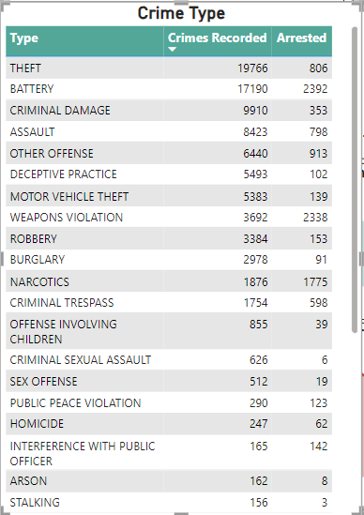

1. ***Arrest Rate Evaluation:*** *Analyse the percentage of reported incidents that have resulted in an arrest to gauge law enforcement.*

**Answer:** Out of 89709 total reported Crimes, 12.4% (11157) of crime resulted in arrest.

This can be easily visualised in chart below:

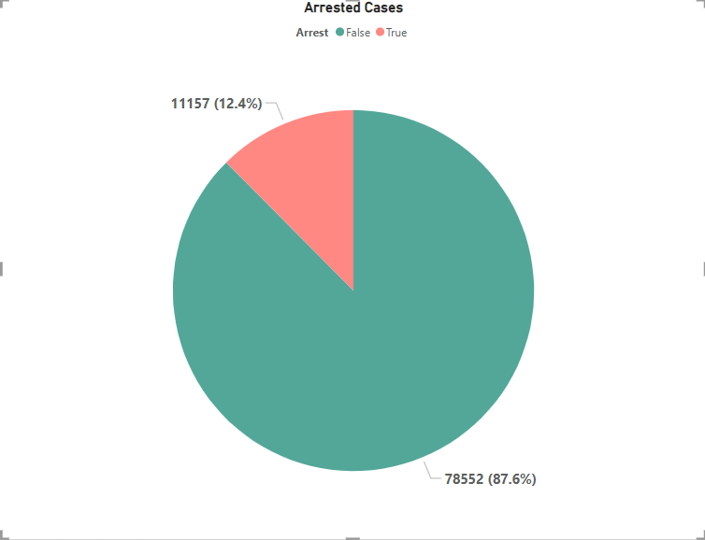

1. ***District Crime Distribution Assessment:*** *Calculate the number of crimes in each district to understand how crime is distributed across the city and identify high-crime areas.*

**Answer:** In this chart you can see the crimes recorded distribution in each police districts in Chicago city.

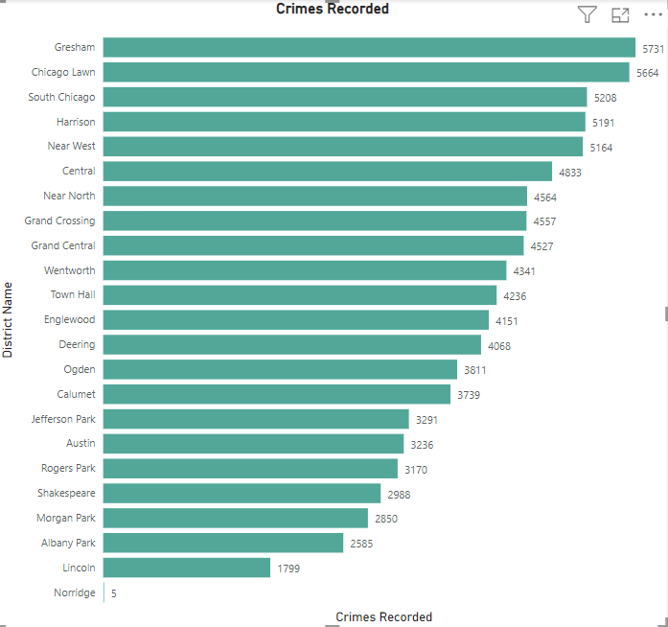

The table below shows District Name corresponding to each District Number-

1. ***Domestic Crime Proportion Analysis:*** *Analyze the ratio of domestic-related crimes to other types of crimes to understand the prevalence of domestic incidents.*

**Answer:** Approximately 20% of crime incidents were domestic incidents out of total. This can be visualized in the chart below.

1. *Is there any “****Location Description****” where the number of crimes is higher than expected? Come up with a table or visualization in which one can judge the frequency of crimes at each Location Description type.*

**Answer:**  The below given chart gives an idea about the frequency of crimes corresponding to the location description. The first chart gives the list of top 15 locations with the highest crimes and the second chart gives the list of 15 locations with the least crimes.

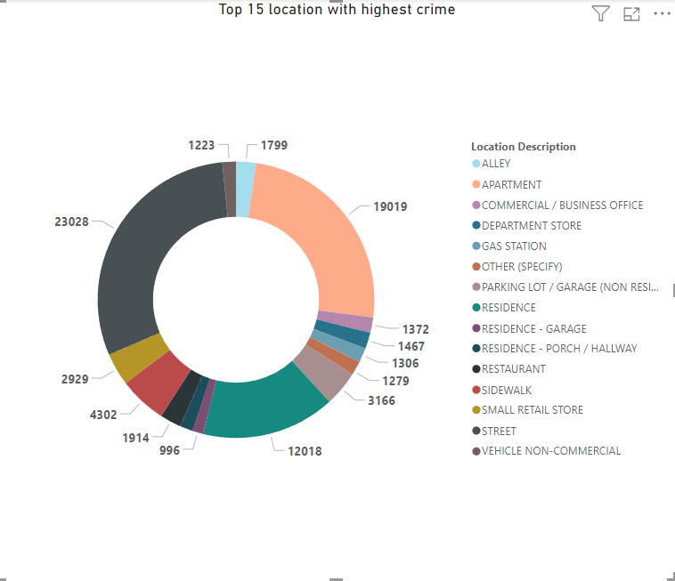

1. *What is the average time between reporting and solving a case as per the data?*

**Answer:** **9.01 days** is Average case solving time according to the Data. This result is obtain Averaging the time difference between Incident reporting date and Incident Update on date.

1. *In order to reward the patrol officers, find the patrol area where the crimes reported were under control.*

**Answer:** the Beat area number **1655**, **1652** and **1654** has the least reported crimes **55**, **57** and **91** respectively. The patrol officers from these patrol area have significantly contributed in keeping the crimes low.

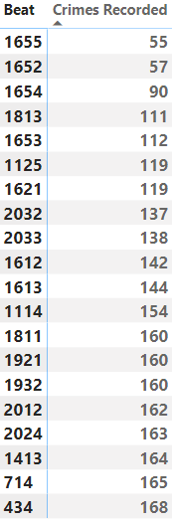

**Subjective Questions:**

1. *Is there any* ***month-wise*** *change in crime rates? If not, what could be the mistake in that operation?*

**Answer:** From the data and visualisations it is understood that the initial days of the operations had brought small reduction but in later months there was significant increase in crime rate .But eventually the crime rate decreased drastically in the month of may-june.

This gives us an idea that the special operation finally had a great impact on the crime rate in Chicago even though it took some time to attain required output. This result can be deduced by the column chart below.

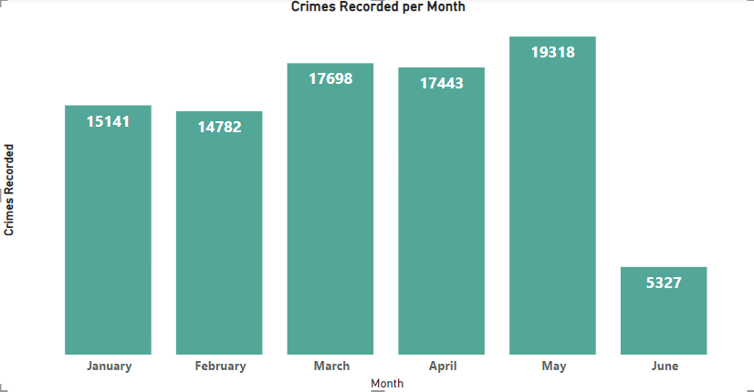

1. *How can we reduce the no. of crimes, and which types of crime should we focus on to achieve improvement in overall number of crimes?*

**Answer:** The chart given below shows the crime distribution across various Crime Types. It is clear from the data that focus needs to be given on the top 10 crimes such as THEFT,BATTERY,CRIMINAL DAMAGE,ASSAULT,DECEPTIVE PRACTICE,MOTOR VEHICLE THEFT,WEAPONS VIOLATION,ROBBERY,BURGLARY as they have more than 2500 cases recorded in each category.

Steps to reduce crime are:

* **Reduce Demand for Law Enforcement**
* **Making Crime Attractors Less Appealing**
* **Scientific Supports for Law Enforcement**
* **Fund Community-Based Violence Interruption**
* **Tackle the Causes and Consequences of Poverty**

1. *Which localities experience higher crime rates, and what measures can we ensure to reduce these numbers?*

**Answer:** Crimes sometimes are location specific due to various reasons. The below given chart gives idea about the localities which experiences higher crime rates. These are the top 15 localities which require more attention to crack down on the crimes.



To reduce these numbers, certain measures can be taken such as:

*Increasing the police patrol in localities where crime rates are high.

*Establishing efficient monitoring and surveillance mechanism.

* Make sentencing fit the crime, not the criminal: Punishment should be usual, even-handed, determinate, prompt, shorter, more severe (though not cruel) and served in full.

1. *Can you suggest wards where security improvements should be made to reduce crime?*

**Answer:** A Ward is an administrative division of a city that typically elects and is represented by a councillor or councillors. There are 50 wards in Chicago. The chart given below shows top 20 wards with the highest crime recorded. These wards have more than 1700 crimes recorded and hence require the most attention. the security arrangement in these wards needs to be improved significantly to reduce the crime.

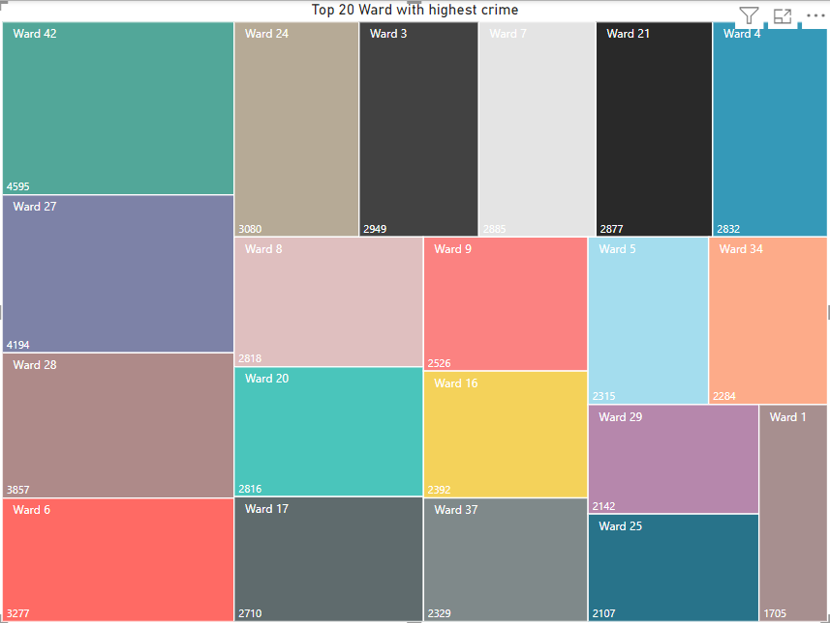

1. ***Crime Rate Trend Analysis:*** *Monitor changes in crime rates over time to detect any discernible patterns or trends*.

**Answer:**  The chart given below gives details about the number of crimes recorded for each month over a period of six months. This helps us visualise the change in crime rate over a period of six months. The bar chart shows a reduction in crime from January to February, then an increase in march and again decrease in April and finally reaches the highest value in may . There is a steep decline in crimes in June.



1. As per the previous reports, most of the domestic crimes do not result in arrest due to public hesitation and family pressure, is this trend also visible in our data?

**Answer:** In the charts given below the first chart shows the total number of domestic cases out of total number of cases. Which shows that almost 20 % of total cases recorded are domestic in nature.

The second chart show the number of arrested cases among total domestic cases. this show that out of total domestic cases only 12.6 % of cases are such where arrest has been made. This shows that very small number of domestic cases are there where arrest is made. Thus, a trend is visible in the data.

1. *Could you generate a visual representation that emphasizes the frequently occurring terms within the* ***"Description"*** *column?*

**Answer:** the visual given below shows the recorded crimes corresponding to the crime description data given. The frequently occurring terms are SIMPLE, DOMESTIC BATTERY SIMPLE, $500 AND UNDER ,OVER $500, TO PROPERTY,TO AUTOMOBILE,TO VEHICLE having recorded crimes greater than 4000 cases.

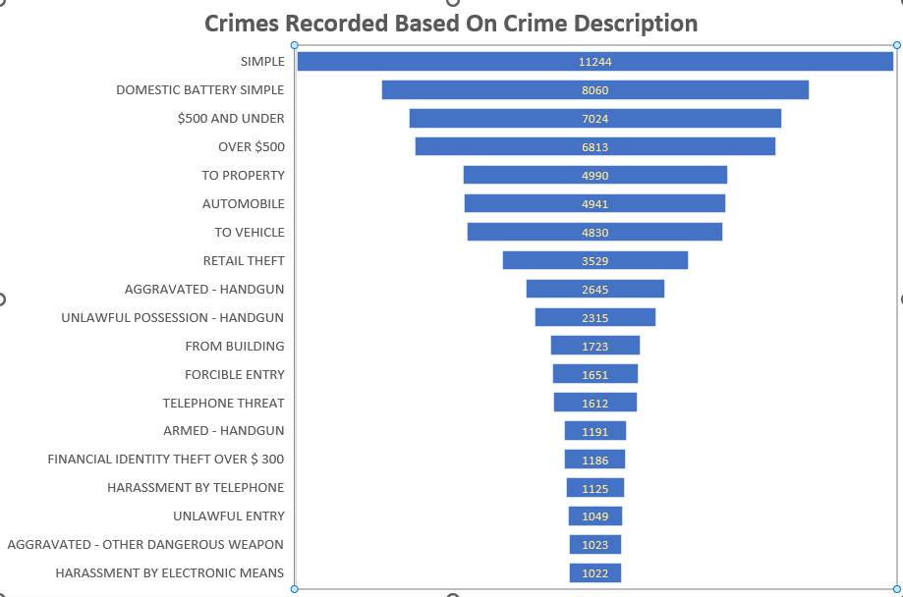

1. *Are there any particular region as per the data where the number of domestic crimes reported is very high?*

**Answer:** The chart given below shows the top 10 community areas with the highest number of domestic crimes recorded. The chart also gives the data of the domestic crimes arrested.

There is total 77 community areas in chicago. The names of each community area corresponding to the community area number has been shown in the second chart.

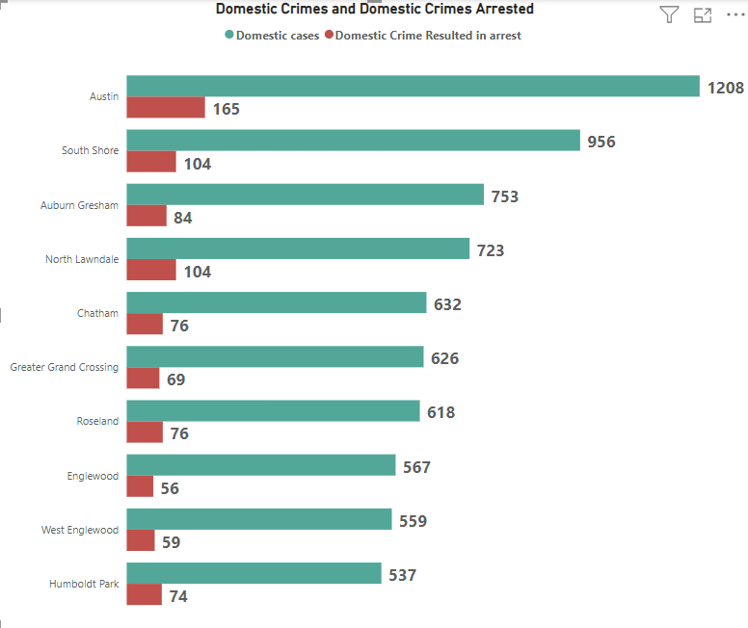

1. *Is the solving time of cases also dependent upon type and locality of crime?*

**Answer:**

From the chart given below it is evident that case solving time depends on the type of crime. The crimes like human trafficking, obscenity , sex offense etc are taking the maximum time.

But in case of the locality of crime, no such dependency could be inferred.

