Customer Shopping Behavior Analysis
1. Project Overview
This project analyses customer shopping behavior using transactional data from 3,900 customer purchase records. The project aims to understand customer spending patterns, subscription behavior, product preferences, and purchasing trends using Excel, SQL (PostgreSQL), and Power BI. The insights generated from this analysis can support data-driven business decisions, customer segmentation, and marketing strategies.
2. Dataset Summary
- Rows: 3,900
- Columns: 18
- Key Features:
  - Customer ID
  - Age
  - Gender
  - Category
  - Item Purchased
  - Purchase Amount (USD)
  - Review Rating
  - Subscription Status
  - Previous Purchases
  - Shipping Type
  - Discount Applied
  - Frequency of Purchases
- Missing Data:
  - 37 missing values in the Review Rating column

3. Data Cleaning and Preparation using Excel
The raw dataset was cleaned and prepared entirely in Microsoft Excel before being loaded into PostgreSQL, using formulas and PivotTables rather than a scripting language.
- Initial Data Quality Checks: Reviewed all categorical columns using column filters to check for inconsistent values (spacing, casing, typos) — none were found. Checked for exact duplicate rows using a TEXTJOIN formula to build a per-row fingerprint, then counted repeated fingerprints with COUNTIF — confirmed 0 duplicate rows.
- Missing Value Detection: Used COUNTBLANK across every column to confirm all 37 missing values were isolated to the Review Rating column.
- Missing Value Handling: Filled missing Review Ratings using the median rating for each product category, calculated with an array-based MEDIAN(IF(...)) formula and matched back to each row using XLOOKUP.
- Column Standardization: Renamed all column headers to lowercase, snake_case format for consistency.
- Feature Engineering:
  - Created an age_group column by splitting Age into four equal-sized quartiles (QUARTILE function) and labelling them Young Adult, Adult, Middle-Aged, and Aged.
  - Converted frequency_of_purchases into a numerical purchase_frequency_days field using an XLOOKUP against a mapping table (e.g. Weekly → 7, Monthly → 30, Annually → 365).
- Data Consistency Check: Used EXACT and COUNTIF to confirm promo_code_used duplicated discount_applied in every row, and removed the redundant column.
- Exploratory PivotTable: Built a PivotTable summarising total and average purchase amount by category. Average order value was found to be consistent across categories (roughly $57–$60), meaning Clothing's higher total revenue is driven by purchase volume rather than higher spending per transaction — an insight used to inform the business recommendations below.
- Export & Database Load: Exported the cleaned dataset as a CSV and loaded it into the PostgreSQL customer table for SQL analysis.

4. Data Analysis using SQL (Business Transactions)
The following SQL queries were used to answer key business questions:
- Revenue by Gender – Calculated the total revenue generated by male and female customers.
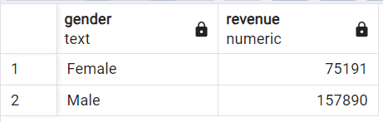
- High-Spending Discount Customers – Identified customers who used discounts but still spent above the average purchase amount.
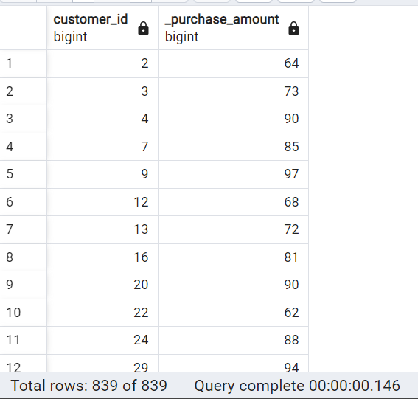
- Top 5 Highest Rated Products – Ranked products based on average review ratings.
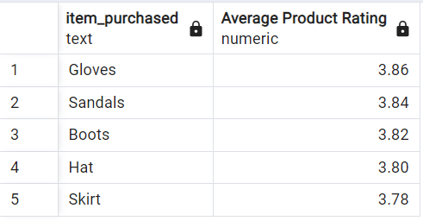
- Shipping Type Comparison – Compared average purchase amounts between Standard and Express shipping.
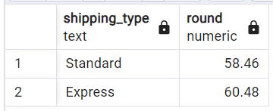
- Subscribers vs Non-Subscribers – Compared customer count, average purchase amount, and total revenue by subscription status.
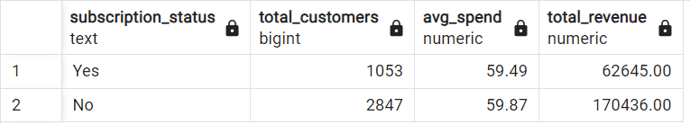

- Products with Highest Discount Usage – Identified the five products with the highest percentage of discounted purchases.
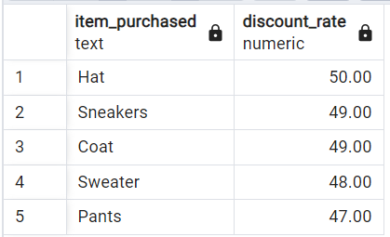
- Customer Segmentation – Classified customers into New, Returning, and Loyal segments based on previous purchases.
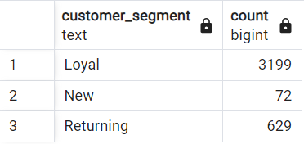
- Top 3 Products by Category – Used SQL window functions to identify the three most purchased products within each category.
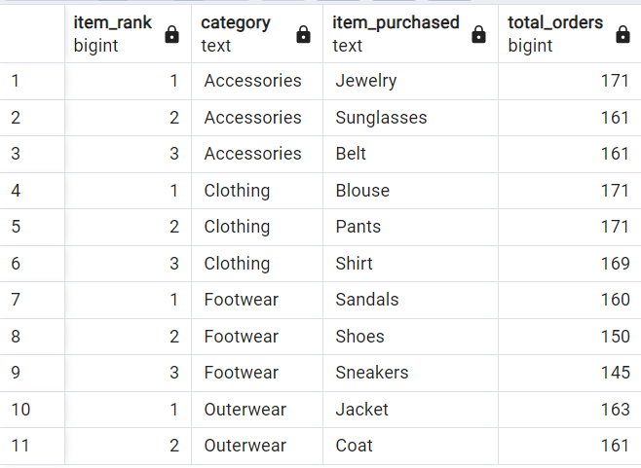
- Repeat Buyers and Subscription Status – Analysed whether repeat buyers were more likely to subscribe.
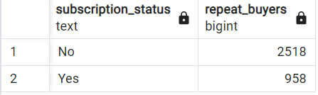
- Revenue by Age Group – Calculated total revenue generated by each customer age group.
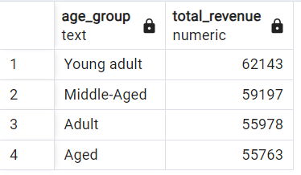

5. Dashboard in Power BI
An interactive Power BI dashboard was developed to visualise customer behaviour and business performance.
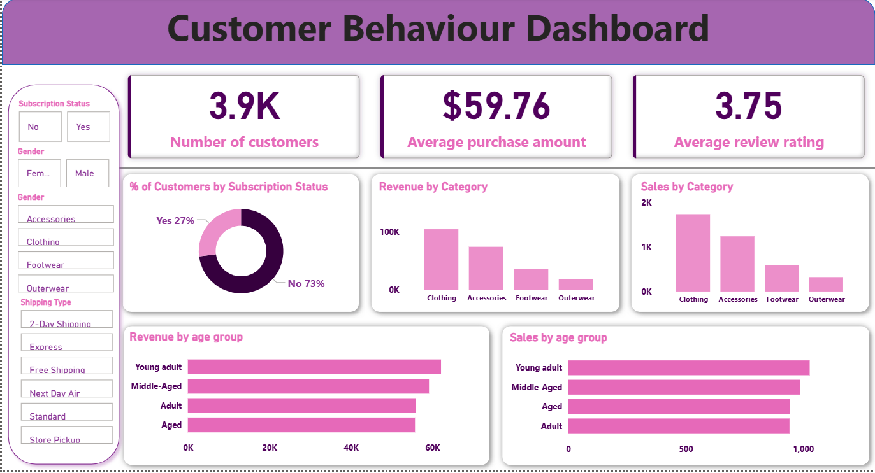
The dashboard includes:
- KPI Cards (Total Customers, Average Purchase Amount, Average Review Rating)
- Revenue by Category
- Sales by Category
- Subscription Status Distribution
- Revenue by Age Group
- Sales by Age Group
- Interactive slicers for Gender, Category, Subscription Status, and Shipping Type
6. Business Recommendations
- Promote subscription programmes to increase customer retention.
- Reward loyal customers with personalised offers and loyalty benefits.
- Focus marketing campaigns on high-revenue customer age groups.
- Promote top-rated and best-selling products to improve sales performance.
- Review discount strategies for products that rely heavily on promotional pricing, particularly the categories flagged in the Excel PivotTable analysis.
- Optimise inventory levels for high-demand product categories.

