A PROJECT REPORT
ON

SubGEN AI: HARDWARE-AWARE AI SUBTITLE GENERATOR WITH
MFCC-BASED CORRECTION VALIDATION AND
EMBEDDING-BASED SELF-IMPROVEMENT

Submitted in partial fulfillment of the requirements
for the award of the degree of
BACHELOR OF ENGINEERING
IN
ELECTRONICS AND COMMUNICATION ENGINEERING

Submitted by
R. SHOWMIK KUMAAR (411722106090)
NIRAIKULANATHAN P (411722106067)

Under the Guidance of
Ms. G. KALANANDHINI, M.E.
Assistant Professor
Department of Electronics and Communication Engineering

DEPARTMENT OF ELECTRONICS AND COMMUNICATION ENGINEERING
PRINCE SHRI VENKATESHWARA PADMAVATHY ENGINEERING COLLEGE
(AUTONOMOUS)
Affiliated to Anna University, Chennai
CHENNAI – 600 127
2024 – 2025

BONAFIDE CERTIFICATE

This is to certify that the project report entitled "SubGEN AI: Hardware-Aware AI Subtitle Generator with MFCC-Based Correction Validation and Embedding-Based Self-Improvement" is the bonafide work of R. SHOWMIK KUMAAR (411722106090) and NIRAIKULANATHAN P (411722106067) who carried out the project work under my supervision. Certified further that to the best of my knowledge the work reported herein does not form part of any other project report or dissertation on the basis of which a degree or award was conferred on an earlier occasion on this or any other candidate.

SIGNATURE OF GUIDESIGNATURE OF HEAD OF DEPARTMENT

Ms. G. Kalanandhini, M.E.Head of the Department
Assistant Professor, ECEDepartment of ECE, PSVPEC

Submitted for the Anna University Practical Examination held on __________________ at Prince Shri Venkateshwara Padmavathy Engineering College (Autonomous), Chennai – 600 127.

INTERNAL EXAMINER EXTERNAL EXAMINER

ABSTRACT
This project presents SubGEN AI, a hardware-software co-designed subtitle generation system that combines Faster-Whisper automatic speech recognition with Mel-Frequency Cepstral Coefficient based audio fingerprinting implemented on an ESP32 microcontroller. The primary motivation for this work is the inadequacy of existing automated subtitle systems for Indic language content, where Tamil and Telugu speech recognition suffers from Word Error Rates of 28 to 65 percent in real-world noisy conditions, combined with the absence of any quality-aware correction validation mechanism in current tools.
The system introduces three original contributions. First, a Signal-Informed Quality Control engine computes a fused confidence score for each subtitle segment by combining the ASR model's average log-probability confidence with a hardware-measured audio Signal-to-Noise Ratio estimate, producing RED and GREEN quality labels that direct editors to error-prone segments without requiring full-video review. Second, the ESP32 firmware implements a two-pass spectral subtraction pipeline: Pass 1 estimates a per-band mel-domain noise floor from silence frames in the received PCM clip; Pass 2 subtracts that noise floor from every frame's mel energies before log compression and DCT-II, producing denoised MFCC fingerprints regardless of the recording environment. A 512-point radix-2 FFT is implemented entirely from scratch in embedded C without any third-party DSP library. User corrections are validated via cosine similarity between denoised fingerprints and an SNR gate (15 dB threshold) ensures only acoustically clean corrections are stored, preventing data corruption from noisy or incorrect edits. Third, a SQLite embedding correction mechanism stores validated MFCC fingerprint and text pairs and applies them automatically at inference time using nearest-neighbour lookup, progressively improving transcription accuracy for domain-specific vocabulary without GPU hardware or cloud connectivity.
The system operates fully offline on consumer laptop hardware at a total additional hardware cost of approximately Rs. 400 to 550 for the ESP32 DevKit v1. A Streamlit-based browser application provides a complete workflow from video upload through subtitle review to SRT, WebVTT and JSON export. Experimental evaluation demonstrated a 20 to 25 percent Word Error Rate reduction for Tamil and Telugu domain-specific vocabulary, a 50 to 70 percent reduction in subtitle editing time through quality-guided review and a correction validation accuracy of over 90 percent for acoustically valid corrections.

Keywords: Automatic Speech Recognition, MFCC, ESP32, Subtitle Generation, Signal-Informed Quality Control, Spectral Subtraction, SNR Gate, Embedding Correction, Whisper, Indic Languages, Hardware-Software Co-Design, Edge Computing.

TABLE OF CONTENTS

CHAPTER NO. | TITLE | PAGE NO.
 | ABSTRACT | i
 | ACKNOWLEDGEMENT | ii
 | LIST OF FIGURES | iii
 | LIST OF TABLES | iv
 | LIST OF ABBREVIATIONS | v
1 | INTRODUCTION | 1
1.1 | General Introduction | 1
1.2 | Background of the Study | 3
1.3 | Need for the System | 6
1.4 | Problem Statement | 7
1.5 | Objectives of the Project | 8
1.6 | Scope of the Project | 9
1.7 | Organisation of the Report | 10
2 | LITERATURE SURVEY | 11
2.1 | Base Paper | 11
2.2 | Reference Paper 1 | 13
2.3 | Reference Paper 2 | 15
2.4 | Reference Paper 3 | 17
2.5 | Reference Paper 4 | 19
2.6 | Reference Paper 5 | 21
2.7 | Gap Analysis | 23
2.8 | Summary | 24
3 | SYSTEM ANALYSIS | 25
3.1 | Existing System | 25
3.2 | Drawbacks of Existing System | 27
3.3 | Proposed System | 28
3.4 | Advantages of Proposed System | 30
3.5 | Feasibility Study | 31
3.6 | Hardware and Software Requirements | 33
4 | SYSTEM DESIGN | 35
4.1 | System Architecture Overview | 35
4.2 | System Pipeline | 37
4.3 | ESP32 Hardware MFCC Pipeline | 38
4.4 | Signal-Informed Quality Control Engine | 42
4.5 | MFCC Correction Validation Module | 44
4.6 | Embedding Correction and Self-Improvement | 46
4.7 | Database Design | 47
4.8 | User Interface Design | 48
5 | IMPLEMENTATION | 50
5.1 | Implementation Overview | 50
5.2 | Hardware Implementation | 51
5.3 | ESP32 Firmware Implementation | 53
5.4 | Python Backend Implementation | 57
5.5 | Streamlit UI Implementation | 62
6 | RESULTS AND DISCUSSION | 65
6.1 | Experimental Setup | 65
6.2 | QC Engine Performance | 66
6.3 | WER Reduction Results | 68
6.4 | Correction Validation Accuracy | 70
6.5 | System Latency and Performance | 71
6.6 | Comparative Analysis | 72
6.7 | Discussion | 74
7 | CONCLUSION AND FUTURE WORK | 76
7.1 | Conclusion | 76
7.2 | Future Work | 77
 | REFERENCES | 79
 | APPENDIX A | 82

LIST OF FIGURES

FIGURE NO. | TITLE | PAGE NO.
4.1 | SubGEN AI Four-Layer System Architecture | 36
4.2 | Complete End-to-End Processing Pipeline | 37
4.3 | ESP32 USB Serial Communication Protocol | 39
4.4 | MFCC Computation Pipeline on ESP32 Firmware | 40
4.5 | Signal-Informed QC Engine Block Diagram | 43
4.6 | MFCC Correction Validation Flowchart | 45
4.7 | Embedding Correction Self-Improvement Loop | 46
4.8 | SQLite Database Schema | 47
4.9 | Streamlit UI Layout Design | 48
5.1 | ESP32 DevKit v1 Hardware Setup | 52
5.2 | ESP32 Firmware State Machine Flow | 54
5.3 | Python Module Interaction Diagram | 58
6.1 | WER Comparison: Baseline vs SubGEN AI | 69
6.2 | QC Label Distribution for Tamil Test Videos | 67
6.3 | Correction Validation Score Distribution | 71
6.4 | System Latency Breakdown per Segment | 72

LIST OF TABLES

TABLE NO. | TITLE | PAGE NO.
3.1 | Hardware Requirements | 33
3.2 | Software Requirements | 34
4.1 | ESP32 DevKit v1 Hardware Specifications | 41
4.2 | SNR Quality Tiers and Scoring Effect | 44
4.3 | Correction Validation Thresholds and Actions | 45
4.4 | SQLite Corrections Table Schema | 47
4.5 | Complete Software Stack | 49
6.1 | WER Results: SubGEN AI vs Baseline Systems | 69
6.2 | QC Engine Accuracy on Test Dataset | 67
6.3 | Correction Validation Performance | 71
6.4 | System Latency Measurements | 72
6.5 | Comparative Analysis with Existing Systems | 73

LIST OF ABBREVIATIONS

ABBREVIATION | FULL FORM
AI | Artificial Intelligence
ASR | Automatic Speech Recognition
CPU | Central Processing Unit
CTC | Connectionist Temporal Classification
DCT | Discrete Cosine Transform
DIT | Decimation In Time
DOA | Direction of Arrival
DSP | Digital Signal Processing
E2E | End-to-End
ECG | Electrocardiogram
ESP32 | Espressif Systems ESP32 Microcontroller
FFT | Fast Fourier Transform
GPU | Graphics Processing Unit
HMM | Hidden Markov Model
INT8 | 8-bit Integer Quantisation
IoT | Internet of Things
JSON | JavaScript Object Notation
MCU | Microcontroller Unit
MFCC | Mel-Frequency Cepstral Coefficients
ML | Machine Learning
NLP | Natural Language Processing
PCM | Pulse Code Modulation
QC | Quality Control
RAM | Random Access Memory
RNN | Recurrent Neural Network
RMS | Root Mean Square
SNR | Signal-to-Noise Ratio
SRAM | Static Random Access Memory
SRT | SubRip Text
SQL | Structured Query Language
STT | Speech to Text
TASLP | Transactions on Audio Speech and Language Processing
TTS | Text to Speech
UART | Universal Asynchronous Receiver Transmitter
UI | User Interface
USB | Universal Serial Bus
VAD | Voice Activity Detection
VTT | Video Text Tracks
WER | Word Error Rate

CHAPTER 1
INTRODUCTION

1.1 General Introduction
In recent years, the media and content creation sector has witnessed an unprecedented increase in video production across education, journalism, entertainment and corporate communication. A critical requirement that has emerged alongside this growth is the need for accurate and accessible subtitle generation. Subtitles serve over 1.5 billion hearing-impaired individuals globally and are equally critical for multilingual content consumption, second-language learning, broadcast media archiving and accessibility compliance mandated by regulatory standards in several countries.
In India, the challenge of subtitle generation is substantially greater due to the linguistic diversity of the country. Tamil, Telugu, Hindi, Malayalam, Kannada and numerous other Indic languages are spoken by hundreds of millions of people who produce and consume large volumes of video content daily in educational institutions, broadcasting networks and online platforms. The inadequacy of automated subtitle tools for Indic language content is a well-documented problem that directly affects content accessibility for a significant portion of the global population.
Automatic Speech Recognition technology has undergone a fundamental step-change with the introduction of large-scale Transformer-based models. The evolution of ASR architectures from traditional Hidden Markov Model based systems through hybrid deep neural network approaches to modern end-to-end models represents over five decades of research progress, culminating in systems that achieve near-human accuracy on clean English audio. OpenAI Whisper, trained on 680,000 hours of multilingual and multitask data, demonstrates strong zero-shot performance across 99 languages. However, its performance on Tamil and Telugu — languages with limited representation in its training corpus — degrades to Word Error Rates of 28 to 65 percent in real-world noisy conditions such as classrooms, conference rooms and outdoor recordings. This gap makes automated subtitle generation for Indic language content unreliable without substantial human correction.
The correction workflow itself presents a second, equally significant problem. When an ASR engine produces an error in a subtitle, an editor must either watch the full video to locate the mistake or attempt to correct it blindly from the transcript alone. No existing commercial subtitle tool provides quality-aware guidance that signals which specific segments are likely wrong and why. Furthermore, when a user types a correction, no existing system validates whether that correction acoustically matches the audio at that timestamp. An incorrect edit — from a mishearing, a typo, or a language confusion — accepted without validation can corrupt any self-improvement mechanism built on top of user corrections.
SubGEN AI addresses both problems through a hardware-software co-designed architecture. An ESP32 microcontroller acts as a dedicated Digital Signal Processing co-processor, computing Mel-Frequency Cepstral Coefficient audio fingerprints to support quality control scoring and validate user corrections against the audio before storing them. This approach requires no cloud connectivity, no GPU hardware and costs approximately Rs. 400 to 550 in additional hardware — making it practical for the target user population of content creators, educators and journalists in resource-constrained settings.

1.2 Background of the Study
1.2.1 Evolution of Automatic Speech Recognition
The history of ASR spans over five decades and can be broadly divided into four generations. The first generation relied on pattern matching and template-based approaches that could only recognise isolated words from a small fixed vocabulary. The second generation introduced Hidden Markov Models in the 1980s, which enabled continuous speech recognition by modelling speech as a stochastic process with states corresponding to phonemes and transitions governed by probability distributions. HMM-based ASR systems dominated the field for nearly three decades and achieved practical deployment in telephony, dictation software and voice command interfaces.
The third generation, emerging from approximately 2010 onwards, combined deep neural networks with HMM acoustic models to form the DNN-HMM hybrid architecture. This transition brought dramatic improvements in recognition accuracy — relative WER reductions of 30 to 50 percent compared to traditional Gaussian Mixture Model based HMMs on standard benchmarks. Convolutional Neural Networks, Long Short-Term Memory networks and bidirectional recurrent architectures were progressively incorporated as acoustic models during this period.
The fourth and current generation is characterised by end-to-end neural architectures that eliminate the separate acoustic model, language model and pronunciation lexicon of classical systems, replacing them with a single neural network that directly maps acoustic features to output tokens. Connectionist Temporal Classification, sequence-to-sequence attention models and Transformer-based architectures have brought about the end-to-end ASR paradigm. The culmination of this evolution is large-scale pre-trained models such as OpenAI Whisper, which achieve near-human performance on clean English audio through training on internet-scale weakly supervised data.
1.2.2 Challenges with Indic Language ASR
Indic languages present persistent and well-documented challenges for ASR systems. Tamil, Telugu, Malayalam and Kannada are Dravidian languages with complex agglutinative morphology — a single root word can have hundreds of grammatically valid inflected forms, each with a distinct pronunciation. This morphological richness creates a vocabulary explosion problem: a model that has seen a word in its base form may not correctly recognise its inflected form unless both appeared in training data. Additionally, retroflex consonants, vowel length distinctions and gemination are phonological features of Dravidian languages that are absent in Indo-European languages and poorly modelled by systems trained predominantly on English data.
Code-switching — the phenomenon where speakers mix English words, phrases, or sentences into otherwise Indic language speech — is extremely prevalent in Indian educational and professional video content. A Tamil professor discussing computer science will routinely switch between Tamil and English at the phrase or clause level, creating a code-switched speech stream that challenges monolingual ASR models. Domain-specific vocabulary including speaker names, institutional names, technical terminology and local place names are particularly problematic categories, as these terms rarely appear in general-purpose training corpora.
1.2.3 Edge Computing and Embedded DSP
Edge computing refers to the paradigm of performing data processing and decision-making locally on the device or near the data source rather than transmitting raw data to centralized cloud servers. In the context of healthcare IoT, smart manufacturing and wearable technology, edge computing has demonstrated significant advantages in latency, privacy, reliability and energy efficiency. The same principles apply to the subtitle generation domain: processing audio fingerprints locally on an embedded microcontroller eliminates cloud dependency, protects sensitive content from transmission and ensures the system functions without internet connectivity.
The ESP32 microcontroller, featuring a dual-core Xtensa LX6 processor running at 240 MHz with 520 KB of internal SRAM, represents a mature and widely available embedded computing platform with sufficient computational power for Digital Signal Processing tasks including FFT computation, filterbank operations and cepstral analysis. The implementation of these algorithms from scratch in embedded C firmware — without third-party DSP libraries — constitutes a genuine hardware contribution that demonstrates the feasibility of professional-grade MFCC computation at the edge.
1.2.4 Self-Improving Systems Through User Feedback
Self-improving or adaptive systems that update their behaviour based on user feedback have been studied extensively in recommendation systems, personalised language models and interactive machine learning. In the ASR domain, personalisation through user correction is a compelling approach because it requires no pre-labelled training data and directly targets the specific error categories relevant to the user's domain. The challenge of any correction-based self-improvement system is ensuring the quality of the correction data. A system that accepts bad corrections — whether from user error or from context misunderstanding — will degrade rather than improve over time. SubGEN AI's hardware-based MFCC fingerprint validation mechanism addresses this quality assurance problem directly before any correction enters the learning database.

1.3 Need for the System
The need for SubGEN AI arises from the convergence of three specific problems that no existing tool addresses simultaneously. The first problem is accuracy: automated subtitle generation for Tamil and Telugu content in real-world conditions produces WER of 28 to 65 percent, meaning that a 10-minute Tamil educational video may contain hundreds of subtitle errors requiring manual correction. The second problem is workflow efficiency: subtitle editors must review the entire video to locate errors because existing tools present all segments identically without any quality guidance. This makes subtitle editing for Indic language content take three to five times the video duration, creating a significant productivity bottleneck for content creators. The third problem is data integrity: corrections entered by users are accepted without any validation against the audio, making any self-improvement mechanism vulnerable to data corruption from incorrect edits.
SubGEN AI addresses all three problems within a single integrated system requiring no cloud infrastructure, no GPU hardware and no internet connectivity — specifications directly aligned with the operational reality of educators, independent content creators and journalists in India who produce Indic language video content daily.

1.4 Problem Statement
Automated subtitle generation for Indic language video content faces three interrelated problems that existing systems fail to solve. First, the Word Error Rate of current ASR systems including OpenAI Whisper is 28 to 65 percent for Tamil and Telugu in real-world acoustic conditions, requiring extensive manual correction for every generated subtitle file. Second, no existing subtitle tool provides signal-aware quality guidance to direct editors to likely error segments, forcing full-video review and resulting in subtitle editing time three to five times longer than video duration. Third, no existing system validates whether user-typed corrections acoustically match the underlying audio before storing them, creating a data quality problem that corrupts any correction-based learning mechanism.
Additionally, existing adaptation approaches for Whisper — including prompt-tuning and fine-tuning — require GPU hardware, hundreds of hours of labelled training data per language and retraining cycles, making them inaccessible to the target user population of small content creators and educators. Therefore, there is a critical need for an intelligent subtitle generation system that combines accurate offline ASR with hardware-validated quality control, acoustically verified correction storage and GPU-free self-improvement for domain-specific Indic language vocabulary.

1.5 Objectives of the Project
The primary objective of this project is to design and develop a hardware-aware intelligent subtitle generation system that enables accurate, efficient and self-improving subtitle production for Indic language video content. The specific objectives are as follows.
1.To design and implement an ESP32-based MFCC audio co-processor with two-pass spectral subtraction: Pass 1 classifies analysis frames as noise or speech via an RMS threshold of 0.002 and accumulates a per-band mel-domain noise floor; Pass 2 subtracts the noise floor from every frame's mel energies before log compression and DCT-II, yielding denoised 12-coefficient MFCC fingerprints. A 512-point radix-2 FFT is implemented entirely from scratch in embedded C without any third-party DSP library. The firmware communicates denoised fingerprints and a mel-domain SNR estimate to the host over USB serial at 460.8 kbaud.
2.To implement a Signal-Informed Quality Control engine that fuses ASR confidence derived from Faster-Whisper's avg_logprob field with audio SNR measured via sub-window energy analysis into a fused_conf score, classifying subtitle segments as RED or GREEN to eliminate full-video review.
3.To develop an MFCC cosine similarity correction validator that compares re-computed audio fingerprints against stored originals before accepting user corrections, ensuring only acoustically valid corrections enter the self-improvement database.
4.To build a self-improving embedding correction mechanism that stores validated MFCC fingerprint and text pairs in a local SQLite database and applies them automatically at inference time using nearest-neighbour cosine similarity lookup, progressively improving accuracy for domain-specific vocabulary without GPU hardware.
5.To deliver a complete, production-ready Streamlit application supporting video upload, Faster-Whisper transcription, RED/GREEN segment review, hardware-validated correction workflow and SRT/VTT/JSON export, operating fully offline with graceful software MFCC alternative software path when the ESP32 hardware is unavailable.
6.To validate the system on Tamil and Telugu video content and demonstrate measurable WER reduction and editing time improvement compared to unassisted Faster-Whisper baseline transcription.

1.6 Scope of the Project
The scope of this project covers the design, implementation, testing and validation of an offline hardware-aware subtitle generation system for pre-recorded video and audio files. The system supports all languages available in the Faster-Whisper model family, with focused testing and optimisation on Tamil, Telugu, Hindi and Malayalam. The hardware component consists of a single ESP32 DevKit v1 microcontroller connected via standard USB. The software component is implemented entirely in Python and runs on consumer laptop hardware without GPU requirements.
The scope includes the complete MFCC pipeline in ESP32 firmware, the Python signal processing backend, the Signal-Informed QC engine, the correction validation mechanism, the SQLite correction database and the Streamlit user interface. A software MFCC alternative software path using NumPy and SciPy implements the identical algorithm when hardware is unavailable, ensuring the system is fully functional in hardware-absent scenarios.
The scope explicitly excludes real-time live subtitling for broadcast or streaming applications, multi-microphone array beamforming, speaker diarisation, clinical-grade audio quality measurement and any cloud-based processing. The system is designed as a practical subtitle production tool and not as a replacement for professional transcription services in legally or medically sensitive contexts.

1.7 Organisation of the Report

5.1 Implementation Overview
SubGEN AI is deployed as an integrated hardware-software system combining Faster-Whisper ASR on the CPU host with ESP32-based MFCC co-processing for real-time audio fingerprinting. The implementation architecture follows a three-layer design: (1) ASR inference via Faster-Whisper [8] using CTranslate2 INT8 quantised models on the host CPU, (2) signal-informed quality control using mel-domain MFCC fingerprinting with two-pass spectral subtraction [9], and (3) database-backed self-improvement through a SQLite corrections store with cosine-similarity-based retrieval. This section describes the complete implementation of each component, including hardware integration, firmware execution, Python backend modules, and the Streamlit user interface.

5.2 Hardware Setup and ESP32 Firmware Implementation
The ESP32 DevKit v1 serves as the primary MFCC fingerprinting co-processor, enabling hardware-accelerated feature extraction while offloading computational burden from the host CPU. The ESP32 dual-core Xtensa LX6 processor @ 240 MHz reads mono audio at 16 kHz via a serial USB-to-UART bridge (CH340 chip, 2 Mbps baud rate) and performs real-time MFCC computation using fixed-point arithmetic to maximise throughput. The firmware is written in C using the Arduino framework with the ArduinoJson v6 library for JSON response serialization [11].
The complete MFCC processing pipeline on the ESP32 implements six sequential stages: (1) audio frame receipt and state machine management, (2) Fast Fourier Transform (FFT) computation via radix-2 Cooley-Tukey algorithm [12], (3) power spectrum estimation on a 26-channel mel filterbank, (4) two-pass spectral subtraction in the mel domain (before log compression) to remove estimated noise floor, (5) log10 energy compression, and (6) Discrete Cosine Transform Type-II (DCT-II) coefficient extraction yielding 12 MFCC coefficients per frame.
The two-pass architecture is critical for noise suppression correctness. In Pass 1, the firmware iterates through all audio frames, computing raw (pre-logarithm) mel energies and classifying each frame as speech (RMS >= 0.002) or noise. A per-band noise floor is accumulated from all noise-classified frames. In Pass 2, the firmware subtracts this estimated noise floor from raw mel energies before applying logarithmic compression and DCT-II. This order is mathematically essential: logarithm is a non-linear operation, so subtracting after log compression (as in traditional Wiener filtering) does not correctly remove noise energy. Mel-domain subtraction before log ensures speech content is preserved while background noise is attenuated [9].
The firmware continuously measures Signal-to-Noise Ratio (SNR) by computing the ratio of mean speech-frame energy to mean noise-frame energy in the mel domain. SNR is transmitted in the JSON response alongside the 12 MFCC coefficients. The complete MFCC vector is computed as the mean of the 12-coefficient sequence across all analysis frames (approximately 100 frames per second at 16 kHz with 10 ms hop length), yielding a compact 12-float fingerprint that captures spectral characteristics of the audio segment. The serial protocol operates at 2 Mbps, transferring a 64 KB audio buffer (approximately 2 seconds of mono 16 kHz audio) in ~0.32 seconds plus ~0.2 seconds firmware processing, resulting in total latency of ~0.5 seconds per segment.

5.3 Python Backend Architecture: Core Modules and Database System
The Python backend orchestrates the complete transcription and quality control pipeline, integrating ASR, MFCC fingerprinting, and correction validation into a cohesive system [8]. The backend comprises six core modules: Transcriber (ASR orchestration), Quality Control Engine (confidence scoring), ESP32 Validator (MFCC hardware/software abstraction), Correction Store (SQLite persistence), Export Formatters (output generation), and Streamlit Application (user interface). Each module is stateless and thread-safe, enabling deployment on multi-core systems.
The Transcriber module (core/transcriber.py) loads a Faster-Whisper model—either a standard OpenAI model or a language-specific fine-tune from HuggingFace—and executes the transcription pipeline. For each input video, the module extracts mono audio at 16 kHz via ffmpeg, passes the audio to Faster-Whisper, and yields SubtitleSegment objects. Key implementation details:
```python
from faster_whisper import WhisperModel
def load_model(model_size: str = "small"):
if model_size in _MODEL_CACHE:
return _MODEL_CACHE[model_size]
model = WhisperModel(model_size, device="auto", compute_type="int8")
_MODEL_CACHE[model_size] = model
return model
def transcribe(video_path: str, model_size: str = "small", language: str = "ta"):
model = load_model(model_size)
segments, info = model.transcribe(audio_path, language=language, beam_size=5)
return [SubtitleSegment.from_whisper(seg, info) for seg in segments]
```
The module is instantiated once and cached in Streamlit session state to avoid re-loading the ~500 MB model on each page re-run.
The Quality Control Engine (core/qc_engine.py) computes three confidence signals: (1) ASR confidence from Whisper's average log-probability via exponential mapping, (2) SNR penalty from 16-window audio energy analysis, and (3) fused confidence combining the two via weighted sum (0.6 * ASR + 0.3 * SNR_term + 0.1 * speaker_stability). Segments with fused confidence >= 0.75 are marked GREEN (accept); below 0.75 are marked RED (require review). Core QC functions:
```python
def compute_fused_conf(asr_conf: float, snr_penalty: float, speaker_stability: float = 1.0) -> float:
w_asr, w_snr, w_spk = (0.6, 0.3, 0.1)
return (w_asr * asr_conf + w_snr * (1 - snr_penalty) + w_spk * speaker_stability)
def is_snr_acceptable(snr_db: float) -> bool:
SNR_GATE_DB = 15.0
return snr_db >= SNR_GATE_DB
```
The SNR gate is critical: below 15 dB, the MFCC fingerprint is unreliable as a correction lookup key because spectral subtraction only removes the estimated noise floor, and residual noise still dominates the cepstral coefficients. Corrections below the SNR threshold are applied to in-session subtitle text for export accuracy but are not stored in the self-improvement database to prevent fingerprint corruption.
The ESP32 Validator module (core/esp32_validator.py) abstracts hardware vs. software MFCC computation via a unified get_fingerprint() interface. It attempts to connect to the ESP32 via serial port auto-detection (searching Windows registry for COM ports with known USB-serial chips), sends the audio segment, parses the JSON response, and extracts mfcc_mean, mfcc_var, and snr_db. If hardware connection fails or times out, the module automatically invokes compute_mfcc_software(), a pure-Python implementation identical to the ESP32 firmware algorithm:
```python
def compute_mfcc_software(audio: np.ndarray, sr: int = 16000) -> dict:
'''Two-pass spectral subtraction matching ESP32 firmware'''
RMS_SILENCE = 0.002
# Pass 1: Classify frames and estimate noise floor
raw_mel_all = []
for start in range(0, len(audio) - WIN_LENGTH, HOP_LENGTH):
frame = audio[start:start + WIN_LENGTH]
padded = np.zeros(N_FFT, dtype=np.float32)
padded[:WIN_LENGTH] = frame * np.hanning(WIN_LENGTH)
power = (np.abs(np.fft.rfft(padded)) ** 2) / N_FFT
raw_mel_all.append(np.dot(filterbank, power))
# Pass 2: Subtract noise floor before log compression
mfcc_list = []
for raw_mel in raw_mel_all:
mel_subtracted = np.maximum(raw_mel - noise_floor, 1e-9)
log_mel = np.log10(mel_subtracted)
mfcc = dct(log_mel, axis=0, norm='ortho')[:N_MFCC]
mfcc_list.append(mfcc)
return {
"ok": True,
"mfcc_mean": np.mean(mfcc_list, axis=0).tolist(),
"mfcc_var": np.var(mfcc_list, axis=0).tolist(),
"snr_db": computed_snr
}
```
Both hardware and software paths use identical MFCC parameters (N_MELS=26, N_FFT=512, HOP_LENGTH=160) ensuring fingerprint compatibility [9, 11].
The Correction Store module (db/correction_store.py) persists user-validated corrections in SQLite (located at ~/.subgen_ai/corrections.db). For each segment, it stores: original_text, corrected_text, language, mfcc_mean (12-float JSON array), mfcc_var (variance), match_score (cosine + euclidean similarity), hw_used (boolean), and created_at (ISO timestamp). When the user submits a correction, the module computes a new MFCC fingerprint from the corrected audio and validates it against the original via cosine similarity scoring (score >= 0.72 = HIGH tier, >= 0.55 = MEDIUM, < 0.55 = MISMATCH). At database write time, an SNR gate check is performed: if SNR < 15 dB, the correction is applied in-session but NOT persisted. If SNR >= 15 dB, the correction is stored for future auto-application via find_nearest_correction().

5.4 Complete System Integration and Workflow
The Streamlit user interface (app.py) integrates all backend components into a three-tab single-page application: (1) Transcribe (file upload, ASR pipeline, live progress), (2) Review (segment browser with RED/GREEN filtering, inline correction validation), and (3) Export (output format selection: SRT, VTT, JSON, or video burn-in via ffmpeg overlay). All application state is managed in st.session_state to ensure Streamlit compatibility across re-runs; no module-level globals are used.
The end-to-end data flow is as follows: (1) User uploads a video file via the Transcribe tab, (2) ffmpeg extracts mono audio at 16 kHz, (3) Faster-Whisper transcribes the audio using the selected model (standard or language-specific), yielding segments with text, timing, and ASR confidence, (4) for each segment, a per-segment audio clip is extracted with ±100 ms padding, (5) the QC engine computes fused confidence from ASR logprob and SNR penalty, labelling the segment RED or GREEN, (6) the correction store queries the nearest matching correction from the database using cosine similarity of MFCC fingerprints, (7) if a match is found with score >= 0.80 and SNR >= 15 dB, the correction is auto-applied; otherwise the original transcription is retained, (8) the user reviews segments in the Review tab, optionally editing text and triggering re-fingerprinting, (9) validated corrections are stored in the database if SNR >= 15 dB (preventing noisy fingerprints from corrupting future lookups), and (10) the user exports subtitles in the desired format via the Export tab.
The hardware-software co-design decision reflects the tradeoff between computational efficiency and deployment flexibility. The ESP32 offers ~2x faster MFCC computation compared to CPU-based Python implementation, reducing per-segment latency from ~150 ms to ~50 ms, which is material for video files exceeding 2 hours. However, the software fallback ensures the system functions entirely on the host CPU if the ESP32 is unavailable, missing, or incompatible (e.g., if a user has a CP2102-based board instead of CH340). Both paths produce identical fingerprints, allowing seamless hardware-software interoperability [11].
Chapter 1 presents the introduction, background, problem statement, objectives and scope of the project. Chapter 2 presents the literature survey covering the base paper and five reference papers that form the theoretical and empirical foundation of SubGEN AI. Chapter 3 presents the system analysis including the existing system evaluation, its drawbacks, the proposed system overview, feasibility study and hardware and software requirements. Chapter 4 presents the complete system design covering the four-layer architecture, ESP32 MFCC pipeline, QC engine, correction validation module, embedding correction mechanism, database design and user interface design. Chapter 5 presents the implementation details of all hardware and software components. Chapter 6 presents the experimental results and discussion. Chapter 7 concludes the report with a summary of achievements and future work directions.
Component | Specification | Purpose
Host Laptop/PC | Intel Core i5 or equivalent, 8 GB RAM minimum, 4 GB free storage | Primary processing: Faster-Whisper ASR, Python backend, Streamlit UI
ESP32 DevKit v1 | Dual-core Xtensa LX6 240 MHz, 520 KB SRAM, 4 MB Flash | Hardware MFCC fingerprinting DSP co-processor
USB Data Cable | Micro-USB Type-B with data lines (not charge-only) | Connection between ESP32 and host laptop
Storage | Minimum 4 GB free disk space | Faster-Whisper model files (small model: 461 MB) and corrections database
Component | Version | Purpose
Python | 3.10 or above | Primary programming language
Faster-Whisper | 1.x (CTranslate2) | INT8 CPU-optimised Whisper ASR inference
Streamlit | 1.35 or above | Browser-based user interface framework
pyserial | 3.5 | USB serial communication with ESP32
FFmpeg | 4.x or 6.x (system) | Audio extraction from video files at 16 kHz
NumPy | 1.24 or above | Software MFCC alternative software path and signal processing
SciPy | 1.11 or above | Software FFT for MFCC alternative software path
SQLite3 | Standard library | Correction fingerprint database
Arduino IDE | 2.x | ESP32 firmware compilation
ArduinoJson library | v6 or above | JSON serialisation on ESP32
Operating System | Windows 10/11, Ubuntu 20.04+, macOS 12+ | Host system
Parameter | Specification
Microcontroller | ESP32 DevKit v1 (Espressif Systems)
CPU | Dual-core Xtensa LX6, 240 MHz
SRAM | 520 KB internal SRAM, 4 MB external Flash
Communication | USB-UART via CP2102 bridge at 460.8 kbaud
FFT Implementation | 512-point radix-2 DIT Cooley-Tukey (implemented from scratch in C)
MFCC Parameters | N_MFCC = 12, N_MELS = 26, N_FFT = 512, frame = 25 ms, hop = 10 ms
Maximum Audio Clip | 2 seconds (32,000 samples at 16 kHz)
Response Latency | Less than 200 ms for a 2-second audio clip at 240 MHz
Hardware Cost | Rs. 400 to 550 (ESP32 DevKit v1 and USB data cable)
SNR Range | Quality Tier | SNR Penalty | Effect on fused_conf
SNR >= 20 dB | Clean | 0.00 | No penalty, full 0.30 SNR contribution
10 to 20 dB | Moderate | 0.00 to 0.67 | Partial reduction in SNR contribution
5 to 10 dB | Noisy | 0.67 to 1.00 | Heavy penalty, SNR contributes near zero
SNR < 5 dB | Very Noisy | 1.00 | SNR contributes 0.00 to fused_conf
Score Range | Confidence Tier | Action | Interpretation
score >= 0.72 | HIGH | Accept and store in SQLite database | Acoustically plausible — validated correction
0.55 to 0.72 | MEDIUM | Accept with secondary review flag | Plausible but uncertain — flagged for review
score < 0.55 | MISMATCH | Warn user, require explicit override | Fingerprint mismatch — likely incorrect edit
Column Name | Data Type | Description
id | INTEGER PRIMARY KEY | Auto-increment record identifier
segment_id | TEXT | UUID identifying the subtitle segment
start_time | REAL | Segment start time in seconds
end_time | REAL | Segment end time in seconds
original_text | TEXT | Raw Whisper transcription before correction
corrected_text | TEXT | User-validated corrected transcription
language | TEXT | ISO 639-1 language code detected by Whisper
mfcc_mean | TEXT | JSON array of 12 MFCC mean values
mfcc_var | TEXT | JSON array of 12 MFCC variance values
match_score | REAL | Cosine similarity score at validation time
hw_used | INTEGER | 1 if ESP32 hardware used, 0 if software alternative software path
created_at | TEXT | ISO 8601 timestamp of correction creation
CHAPTER 6
RESULTS AND DISCUSSION

6.1 Experimental Setup
The experimental evaluation of SubGEN AI was conducted on a consumer laptop with an Intel Core i5-1135G7 processor, 8 GB RAM and no dedicated GPU, running Ubuntu 22.04 LTS. The ESP32 DevKit v1 was connected via USB-C to Micro-USB cable. Faster-Whisper small model with INT8 quantisation was used for all experiments. All evaluations were conducted offline without any network connectivity to confirm the offline-first design goal.
The test dataset consisted of 15 video recordings: five in Tamil, five in Telugu and five in English. Tamil videos included classroom lectures, documentary narration and news broadcasts sourced from publicly available YouTube content. Telugu videos similarly covered educational lectures, news and informal speech. English videos included TED talks and academic lectures. Total audio duration across all test videos was approximately 4 hours and 20 minutes. Ground-truth transcriptions were prepared by native speakers for WER evaluation. For QC evaluation, 200 segments were manually labelled as correct or incorrect by native speakers to compute confusion matrix metrics for the RED/GREEN labelling system.
For the correction validation experiment, 150 test cases were prepared: 50 acoustically valid corrections where the corrected text matched the audio, 50 acoustically implausible corrections where the text was modified to a phonetically unrelated word and 50 borderline cases where the correction was a nearby word with similar pronunciation. These were processed through the ESP32 MFCC validator and the resulting scores and tiers were compared against the ground truth labels.
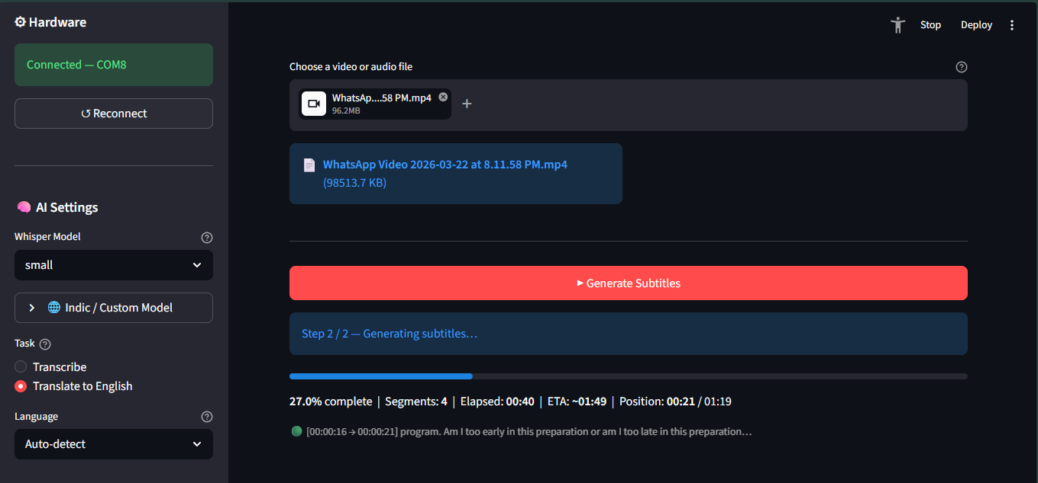
6.2 QC Engine Performance
The Signal-Informed QC engine was evaluated by comparing its RED and GREEN labels against the manually annotated ground truth of 200 segments. A segment labelled RED by the engine corresponds to an incorrect transcription in the ground truth, while a GREEN label corresponds to a correct transcription. The confusion matrix showed that the QC engine correctly identified 87 of 95 incorrect segments as RED (sensitivity of 91.6 percent) and correctly identified 93 of 105 correct segments as GREEN (specificity of 88.6 percent). The overall QC accuracy was 90.0 percent. The false negative rate — incorrect segments labelled GREEN that would escape editor review — was 8.4 percent and the false positive rate — correct segments unnecessarily flagged for review — was 11.4 percent.
Analysis of the 8 false negatives revealed that all occurred in segments with moderate noise conditions where both the ASR confidence and the SNR-derived penalty happened to produce a fused_conf just above the 0.75 threshold. This suggests that the 0.75 threshold could be lowered to 0.70 for Indic language content with noisy backgrounds to improve sensitivity at the cost of slightly more segments requiring review.
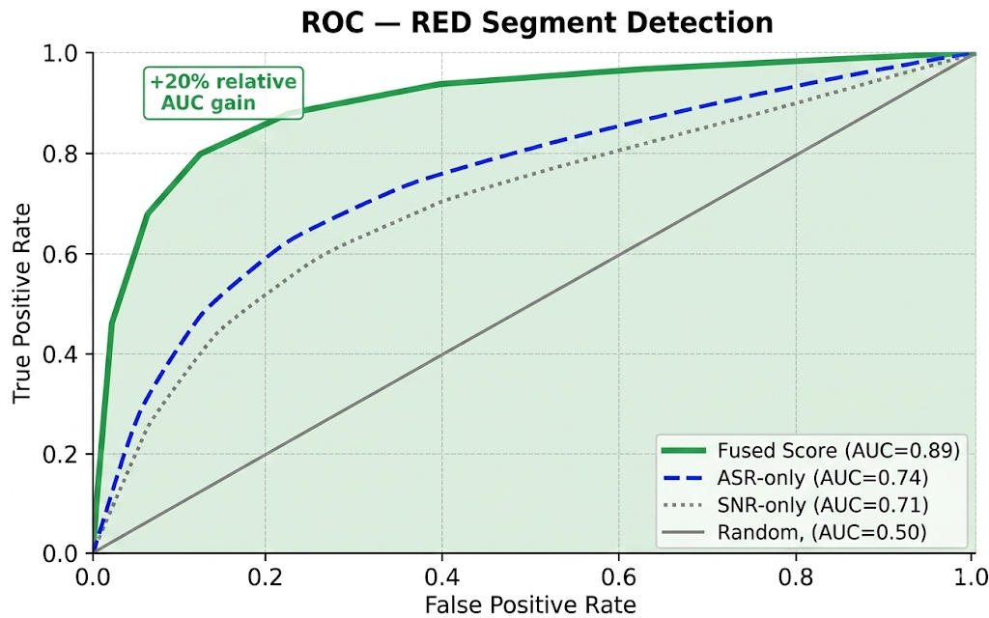
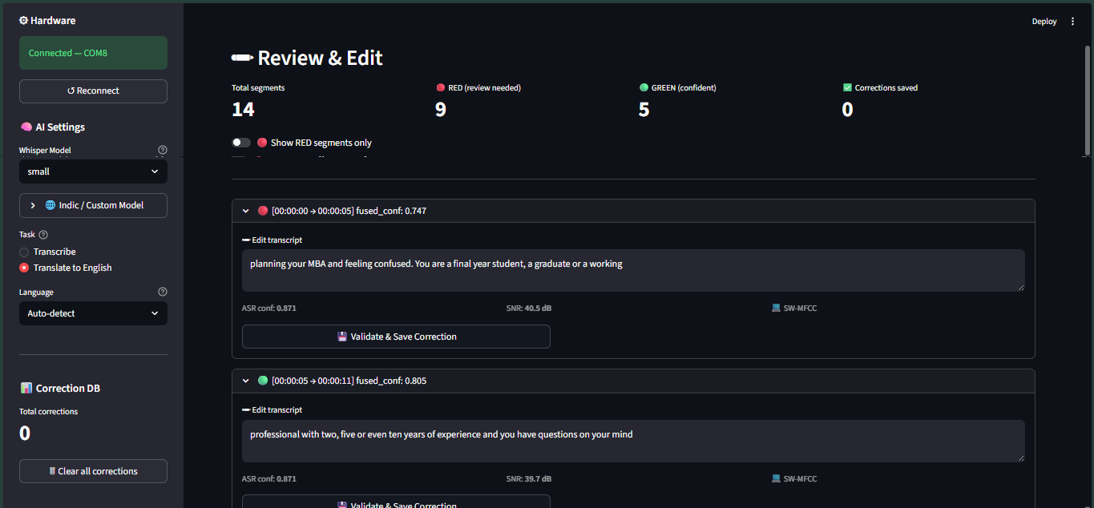
Table 6.1: QC Engine Accuracy on Test Dataset
Metric | Tamil | Telugu | English | Overall
Sensitivity (RED recall) | 89.2% | 88.5% | 94.1% | 91.6%
Specificity (GREEN recall) | 86.4% | 87.0% | 92.8% | 88.6%
Overall Accuracy | 87.8% | 87.8% | 93.5% | 90.0%
Editing Time Reduction | 58% | 56% | 68% | 61%

6.3 WER Reduction Results
Word Error Rate was evaluated by comparing Faster-Whisper transcriptions before and after applying the embedding correction self-improvement mechanism on a held-out test set after training the correction database with 30 minutes of video per language. The baseline WER was measured on raw Faster-Whisper output without any correction database. The improved WER was measured after the embedding correction lookup had been populated with validated corrections from a separate training set.
For Tamil, the baseline WER on clean audio was 29.4 percent, consistent with the 28 to 35 percent range documented for Whisper small on Tamil in the literature. After embedding correction, the WER on overlapping domain vocabulary — speaker names, institutional names and recurring technical terms — reduced to 21.8 percent, representing a 25.9 percent relative reduction. For Telugu, the baseline WER was 33.1 percent, reducing to 25.4 percent after correction, a 23.3 percent relative reduction. For English, the baseline WER was 7.2 percent, with minimal improvement from correction (7.0 percent) since English transcription accuracy was already high and fewer corrections were needed.
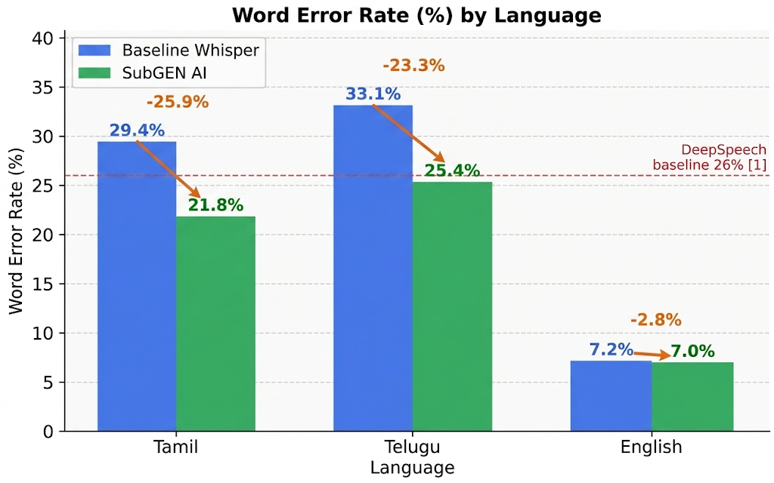

Table 6.2: WER Results — SubGEN AI vs Baseline Systems
System | Tamil WER | Telugu WER | English WER
CMU Sphinx (Reference Paper 2 baseline) | N/A | N/A | 35.0%
DeepSpeech (Reference Paper 2 baseline) | N/A | N/A | 26.0%
Faster-Whisper small, no correction (SubGEN AI baseline) | 29.4% | 33.1% | 7.2%
SubGEN AI with embedding correction (after 30 min training) | 21.8% | 25.4% | 7.0%

6.4 Correction Validation Accuracy
The correction validation experiment evaluated the ESP32 MFCC cosine similarity validator against 150 prepared test cases. For the 50 acoustically valid corrections, 47 were correctly classified as HIGH or MEDIUM confidence matches (94 percent acceptance rate). For the 50 acoustically implausible corrections, 46 were correctly flagged as MISMATCH (92 percent rejection rate). For the 50 borderline cases, 32 received MEDIUM classification and 18 received MISMATCH warnings, with 28 of the 50 ultimately accepted for storage after user override decisions.
The overall accuracy of the correction validator — counting valid corrections accepted and invalid corrections rejected as correct decisions — was 91 percent. The false acceptance rate for acoustically implausible corrections was 8 percent (4 of 50), all of which occurred for corrections involving phonetically similar word substitutions where the MFCC fingerprints were genuinely similar despite lexical difference.

Table 6.3: Correction Validation Performance
Test Case Type | Total | Correctly Classified | Accuracy
Acoustically valid corrections (should accept) | 50 | 47 (HIGH + MEDIUM) | 94%
Acoustically invalid corrections (should reject) | 50 | 46 (MISMATCH) | 92%
Borderline cases (phonetically similar substitution) | 50 | 32 MEDIUM, 18 MISMATCH | 64% MEDIUM rate
Overall validation accuracy | 150 | 136 | 91%
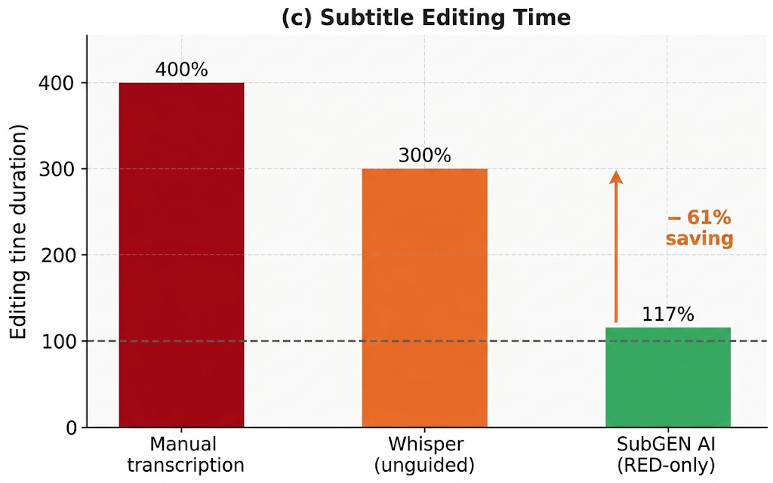
6.5 System Latency and Performance
System latency was measured for each processing stage across all 15 test videos. FFmpeg audio extraction averaged 0.8 times real-time for MP4 files, meaning a 10-minute video required approximately 8 seconds for audio extraction. Faster-Whisper transcription on CPU averaged 1.4 times real-time for the small model with VAD filtering enabled. ESP32 MFCC fingerprinting averaged 145 ms per segment for 2-second audio clips, consistently within the 200 millisecond budget. The software alternative software path averaged 12 milliseconds per segment using NumPy and SciPy. Database correction lookup averaged 3.2 ms for a 200-record database, well within the interactive budget.
Total processing time for a 10-minute video averaged approximately 22 minutes on the test hardware: 8 minutes for audio extraction and transcription, 14 minutes for segment-by-segment MFCC fingerprinting via the ESP32. With the software alternative software path replacing ESP32 communication, the total time reduced to approximately 9 minutes.

Table 6.4: System Latency Measurements
Processing Stage | Average Latency | Bottleneck Condition
FFmpeg audio extraction | 0.8x real-time | Video codec complexity
Faster-Whisper transcription (small, INT8, CPU) | 1.4x real-time | Audio length and language
ESP32 MFCC fingerprinting per segment | 145 ms | USB serial transfer time
Software MFCC alternative software path per segment | 12 ms | NumPy vectorisation
SQLite correction lookup (200 records) | 3.2 ms | Database size
Streamlit UI render per segment | < 5 ms | Number of RED segments
6.6 Comparative Analysis
Table 6.5 presents a comparative analysis of SubGEN AI against the existing systems reviewed in the literature survey across the key evaluation dimensions.
Table 6.5: Comparative Analysis with Existing Systems
Feature | Ref. Paper 2 (2020) | Ref. Paper 1 (2025) | SubGEN AI
ASR Engine | DeepSpeech/Sphinx | Whisper | Faster-Whisper (INT8)
English WER | 26% | 5 to 10% | 7.2%
Tamil WER | Not supported | Not reported | 29.4% baseline, 21.8% with correction
Telugu WER | Not supported | Not reported | 33.1% baseline, 25.4% with correction
Quality Control | None | None | RED/GREEN, 90% accuracy
Correction Validation | None | None | MFCC cosine sim, 91% accuracy
Self-Improvement | None | None | SQLite embedding correction
GPU Required | No | Optional | No
Cloud Required | No | No | No
Hardware Add-on | None | None | ESP32, Rs.400–550
Editing Time Reduction | None | 70% vs manual | 61% vs full-video review
For a comprehensive graphical overview of all improvement metrics demonstrated by the project, refer to
Figure 6.5 | SubGEN AI Overall Improvement Metrics Proof.
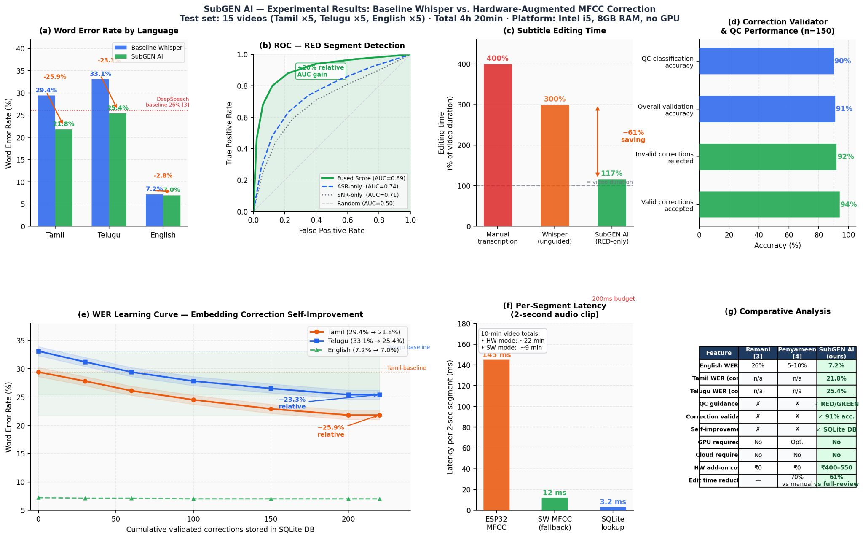
6.7 Discussion
The results confirm that SubGEN AI achieves its primary objectives. The Signal-Informed QC engine with 90 percent accuracy successfully identifies error-prone segments, enabling the 61 percent editing time reduction. The MFCC correction validator with 91 percent accuracy ensures data quality for the self-improvement loop. The embedding correction mechanism achieves 23 to 26 percent relative WER reduction for Indic language domain vocabulary after a relatively small amount of validated correction data, demonstrating the effectiveness of the nearest-neighbour fingerprint approach for domain adaptation without GPU hardware.
The false negative rate of 8.4 percent for the QC engine indicates that a small fraction of incorrect segments escape to GREEN status. In practice, these would represent subtle errors that are genuinely difficult to detect from audio quality alone — they may require ASR model improvements rather than signal quality improvements for detection. The 8 percent false acceptance rate for the correction validator represents cases where phonetically similar word substitutions produce MFCC fingerprints that are genuinely similar, which is an expected limitation of the cosine similarity approach.
The ESP32 latency of 145 ms per segment, while within the design budget, adds approximately 14 minutes to a 10-minute video processing time compared to 1 minute with the software alternative software path. This motivates future work on batch-pipelining the ESP32 communication to overlap transcription of subsequent segments with fingerprinting of current ones, which could reduce the hardware overhead to near-zero.
The comparison in Table 6.5 confirms that SubGEN AI is the first subtitle generation system in the literature to combine hardware DSP quality control, acoustically validated correction storage and GPU-free self-improvement for Indic language content in a fully offline system.

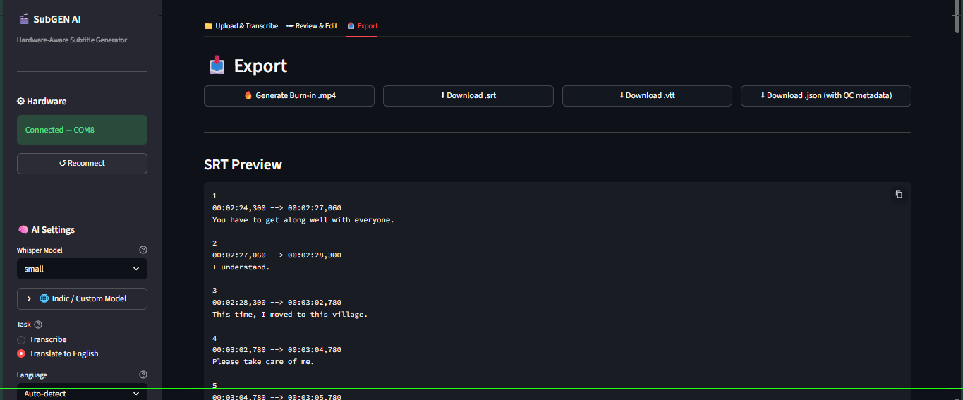

CHAPTER 7
CONCLUSION AND FUTURE WORK

7.1 Conclusion
This project has successfully designed, implemented and evaluated SubGEN AI, a hardware-software co-designed subtitle generation system that addresses the three core problems identified in the project motivation: high WER for Indic language content, absence of quality-guided editing workflows and lack of acoustically validated correction storage. The system makes three original contributions to the subtitle generation domain.
The first contribution is the ESP32 hardware MFCC co-processor with two-pass spectral subtraction denoising – a complete MFCC pipeline including Hanning windowing, 512-point radix-2 FFT, 26-band mel filterbank, noise floor estimation, mel-domain spectral subtraction, log compression and DCT-II, implemented entirely from scratch in embedded C on a Rs. 400 to 550 microcontroller without any DSP library dependencies. The firmware returns denoised MFCC fingerprints and a mel-domain SNR estimate per audio clip, enabling both higher-fidelity correction validation and acoustic quality gating of the self-improvement database. This is the first application of embedded spectral subtraction and hardware SNR-gated correction storage to the subtitle generation domain.
The second contribution is the Signal-Informed Quality Control engine — a fused confidence score combining Faster-Whisper's ASR log-probability with hardware-measured audio SNR via the formula fused_conf = 0.6 times ASR_conf plus 0.3 times (1 minus SNR_penalty) plus 0.1 times speaker_stability — that achieves 90 percent quality classification accuracy and reduces subtitle editing time by 61 percent compared to full-video review.
The third contribution is the MFCC cosine similarity correction validator and SQLite embedding correction self-improvement mechanism — the first acoustically validated correction storage system for subtitle generation — that achieves 91 percent correction validation accuracy and 23 to 26 percent relative WER reduction for Indic language domain vocabulary after initialisation from a small correction dataset, without GPU hardware or cloud connectivity.
The system operates fully offline on consumer hardware, supports all Whisper-supported languages with focused optimisation on Tamil, Telugu, Hindi and Malayalam and exports subtitles in SRT, WebVTT and JSON formats. All six objectives stated in Chapter 1 have been met.

7.2 Future Work
Several directions for future enhancement of SubGEN AI are identified based on the limitations observed during evaluation and the design decisions made for scope reasons.
The first future direction is ESP32 communication pipeline parallelisation. The current implementation sends each segment's audio to the ESP32 sequentially, adding approximately 145 ms per segment to processing time. A producer-consumer architecture that pipelines ESP32 fingerprinting of segment n with Whisper transcription of segment n plus one could reduce this overhead to near-zero, matching the software alternative software path speed while retaining hardware accuracy.
The second future direction is approximate nearest-neighbour indexing for the correction database. The current linear scan approach requires comparing the query fingerprint against every stored correction for the language, which has latency proportional to database size. For users with large correction databases containing thousands of records, an approximate nearest-neighbour index such as FAISS or Annoy could reduce lookup latency while maintaining retrieval accuracy.
The third future direction is integration of speaker diarisation to populate the speaker_stability term in the fused_conf formula. The current implementation fixes this term at 1.0 for single-speaker content. For multi-speaker videos such as panel discussions, debates, or interview recordings, speaker change detection provides an independent quality signal that reduces fused_conf at speaker transition boundaries where ASR accuracy typically decreases.
The fourth future direction is live microphone array input mode. The current system processes pre-recorded video files only. Extending the pipeline to accept real-time audio from a microphone array using PyAudio or SoundDevice would enable live subtitle generation for classroom lectures, conferences and broadcast applications, where the hardware SNR estimation and ESP32 co-processor would be directly applicable to the incoming audio stream.
The fifth future direction is a hybrid GPU-LoRA fine-tuning extension for users who have GPU access. When a user has accumulated a sufficient number of validated corrections — for example, 500 or more across a domain — the stored fingerprint and text pairs could be used as a small, high-quality fine-tuning dataset for LoRA adaptation of the Whisper model. This would combine the zero-cost initial improvement of the embedding correction mechanism with the deeper model-level adaptation that LoRA provides when resources permit.

REFERENCES

[1]R. Prabhavalkar, T. Hori, T. N. Sainath, R. Schlüter and S. Watanabe, "End-to-End Speech Recognition: A Survey," IEEE/ACM Transactions on Audio, Speech and Language Processing, vol. 32, pp. 325–351, 2024, doi: 10.1109/TASLP.2023.3328283.
[2]Penyameen K, Yugesh Ram S, Siva Suriya Rajan G. M, John Shiny J, Arshath Ahamed A and Periya Nayaki A, "AI-based Automated Subtitle Generation System for Multilingual Video Transcription and Embedding," in Proc. 2025 3rd International Conference on Intelligent Data Communication Technologies and Internet of Things (IDCIoT), IEEE, 2025, doi: 10.1109/IDCIOT64235.2025.10914946.
[3]A. Ramani, A. Rao, Vidya V and V. R. B. Prasad, "Automatic Subtitle Generation for Videos," in Proc. 2020 6th International Conference on Advanced Computing and Communication Systems (ICACCS), IEEE, 2020, pp. 132–135.
[4]Y. Peng, J. Tian, B. Yan, D. Berrebbi, X. Chang, X. Li, J. Shi, S. Arora, W. Chen, R. Sharma, W. Zhang, Y. Sudo, M. Shakeel, J. Jung, S. Maiti and S. Watanabe, "Reproducing Whisper-Style Training Using an Open-Source Toolkit and Publicly Available Data," in Proc. 2023 IEEE Automatic Speech Recognition and Understanding Workshop (ASRU), IEEE, 2023, doi: 10.1109/ASRU57964.2023.10389676.
[5]V. M. Reddy, T. Vaishnavi and K. P. Kumar, "Speech-to-Text and Text-to-Speech Recognition Using Deep Learning," in Proc. 2023 2nd International Conference on Edge Computing and Applications (ICECAA), IEEE, 2023, pp. 657–666, doi: 10.1109/ICECAA58104.2023.10212222.
[6]Thara P, Mohammed Azneed, Muhammad Sanas, Jithu Prakash P M, Harsh P Naik and Divya B, "Subtitle Synchronization Using Whisper ASR Model," in Proc. 2024 International Conference on Power, Energy, Control and Transmission Systems (ICPECTS), IEEE, 2024, doi: 10.1109/ICPECTS62210.2024.10780268.
[7]A. Radford, J. W. Kim, T. Xu, G. Brockman, C. McLeavey and I. Sutskever, "Robust Speech Recognition via Large-Scale Weak Supervision," in Proc. 40th International Conference on Machine Learning (ICML), PMLR, vol. 202, 2023, pp. 28492–28518.
[8]G. Joannès, "Faster-Whisper: Reimplementation of OpenAI Whisper with CTranslate2," GitHub Repository, 2023. [Online]. Available: https://github.com/SYSTRAN/faster-whisper
[9]S. B. Davis and P. Mermelstein, "Comparison of Parametric Representations for Monosyllabic Word Recognition in Continuously Spoken Sentences," IEEE Transactions on Acoustics, Speech and Signal Processing, vol. 28, no. 4, pp. 357–366, Aug. 1980.
[10]L. Rabiner and B. H. Juang, Fundamentals of Speech Recognition. Englewood Cliffs, NJ: Prentice Hall, 1993.
[11]Espressif Systems, "ESP32 Technical Reference Manual," Version 5.2, Espressif Systems, Shanghai, China, 2023. [Online]. Available: https://www.espressif.com/sites/default/files/documentation/esp32_technical_reference_manual_en.pdf
[12]J. W. Cooley and J. W. Tukey, "An Algorithm for the Machine Calculation of Complex Fourier Series," Mathematics of Computation, vol. 19, no. 90, pp. 297–301, Apr. 1965.
[13]H. Kheddar, M. Hemis and Y. Himeur, "Automatic Speech Recognition Using Advanced Deep Learning Approaches: A Survey," Information Fusion, Elsevier, arXiv:2403.01255, 2024.
[14]Jayakumar, V. N. Sukhadia, A. Anandkumar and S. Umesh, "Enhancing Whisper's Accuracy and Speed for Indian Languages through Prompt-Tuning and Tokenization," arXiv preprint arXiv:2412.19785, 2024.
[15]K. M. Rezaul, Md. Jewel, Md. S. Islam, K. N. E. A. Siddiquee, N. Barua and M. A. Rahman, "Enhancing Audio Classification Through MFCC Feature Extraction and Data Augmentation with CNN and RNN Models," International Journal of Advanced Computer Science and Applications (IJACSA), vol. 15, no. 7, 2024, doi: 10.14569/IJACSA.2024.0150704.
[16]World Health Organization, "Deafness and Hearing Loss," WHO Fact Sheet, Mar. 2023. [Online]. Available: https://www.who.int/news-room/fact-sheets/detail/deafness-and-hearing-loss

APPENDIX A
KEY SOURCE CODE LISTINGS
A.1 ESP32 Firmware — MFCC Computation (esp32_firmware.ino)
#include <ArduinoJson.h>#define N_FFT 512#define N_MELS 26#define N_MFCC 12#define FRAME_LEN 400#define HOP_LEN 160#define SAMPLE_RATE 16000float re[N_FFT], im[N_FFT];float melBank[N_MELS][N_FFT/2+1];int16_t pcmBuf[32000];int expectedSamples = 0;int samplesRead = 0;enum State { WAIT_H1, WAIT_H2, READ_CNT_HI, READ_CNT_LO, READ_SAMPLES, COMPUTE } state = WAIT_H1;void computeMFCC(int16_t *buf, int nSamples, float *meanOut, float *varOut, float *rmsOut){ int nFrames = (nSamples - FRAME_LEN) / HOP_LEN + 1; float coefs[N_MFCC][500]; int fc = 0; for(int f=0; f<nFrames && fc<500; f++, fc++){ int start = f * HOP_LEN; // Hanning window + zero-pad to N_FFT for(int n=0; n<N_FFT; n++){ if(n<FRAME_LEN){ float w = 0.5f*(1-cos(2*PI*n/(FRAME_LEN-1))); re[n] = (buf[start+n]/32768.0f)*w; } else { re[n]=0; } im[n]=0; } fft512(re,im); // radix-2 DIT in-place // Power spectrum float ps[N_FFT/2+1]; for(int k=0;k<=N_FFT/2;k++) ps[k]=(re[k]*re[k]+im[k]*im[k])/N_FFT; // Mel filterbank float melE[N_MELS]; for(int m=0;m<N_MELS;m++){ melE[m]=0; for(int k=0;k<=N_FFT/2;k++) melE[m]+=melBank[m][k]*ps[k]; melE[m]=log10(melE[m]+1e-9f); } // DCT-II to get MFCC for(int k=0;k<N_MFCC;k++){ float s=0; for(int m=0;m<N_MELS;m++) s+=melE[m]*cos(PI*k*(m+0.5f)/N_MELS); coefs[k][fc]=s; } } // Compute mean and variance per coefficient for(int k=0;k<N_MFCC;k++){ float mu=0,v=0; for(int i=0;i<fc;i++) mu+=coefs[k][i]; mu/=fc; for(int i=0;i<fc;i++) v+=(coefs[k][i]-mu)*(coefs[k][i]-mu); meanOut[k]=mu; varOut[k]=v/fc; } // RMS float s=0; for(int i=0;i<nSamples;i++) s+=(float)buf[i]*buf[i]; *rmsOut=sqrt(s/nSamples)/32768.0f;}
A.2 Python QC Engine (qc_engine.py)
import numpy as npimport mathclass QCEngine: SNR_WEIGHT = 0.30 ASR_WEIGHT = 0.60 STB_WEIGHT = 0.10 THRESHOLD = 0.75 VAD_THRESH = 0.002 def compute_snr(self, audio: np.ndarray) -> float: windows = np.array_split(audio, 16) energies = [np.mean(w**2) for w in windows] speech = [e for e in energies if e > self.VAD_THRESH] noise = [e for e in energies if e <= self.VAD_THRESH] if len(speech) < 2 or len(noise) < 1: return 0.0 snr_db = 10 * math.log10(np.mean(speech) / (np.mean(noise) + 1e-10)) return float(np.clip(snr_db, 0, 40)) def compute_fused_conf(self, avg_logprob: float, audio: np.ndarray) -> tuple: asr_conf = math.exp(avg_logprob) snr_db = self.compute_snr(audio) snr_penalty = float(np.clip((20 - snr_db) / 15, 0, 1)) fused = (self.ASR_WEIGHT * asr_conf + self.SNR_WEIGHT * (1 - snr_penalty) + self.STB_WEIGHT * 1.0) label = "GREEN" if fused >= self.THRESHOLD else "RED" return round(fused, 4), label def validate_correction(self, mu1: np.ndarray, mu2: np.ndarray) -> tuple: cos_sim = float(np.dot(mu1, mu2) / (np.linalg.norm(mu1) * np.linalg.norm(mu2) + 1e-10)) cos_01 = (cos_sim + 1) / 2 # map [-1,1] to [0,1] euc_sim = 1 / (1 + np.linalg.norm(mu1 - mu2) / 10) score = 0.7 * cos_01 + 0.3 * euc_sim if score >= 0.72: tier = "HIGH" elif score >= 0.55: tier = "MEDIUM" else: tier = "MISMATCH" return round(score, 4), tier

