A PROJECT REPORT
ON

SubGEN AI: HARDWARE-AWARE AI SUBTITLE GENERATOR WITH
MFCC-BASED CORRECTION VALIDATION AND
EMBEDDING-BASED SELF-IMPROVEMENT

Submitted in partial fulfillment of the requirements
for the award of the degree of
BACHELOR OF ENGINEERING
IN
ELECTRONICS AND COMMUNICATION ENGINEERING

Submitted by
R. SHOWMIK KUMAAR (411722106090)
NIRAIKULANATHAN P (411722106067)

Under the Guidance of
Ms. G. KALANANDHINI, M.E.
Assistant Professor
Department of Electronics and Communication Engineering

DEPARTMENT OF ELECTRONICS AND COMMUNICATION ENGINEERING
PRINCE SHRI VENKATESHWARA PADMAVATHY ENGINEERING COLLEGE
(AUTONOMOUS)
Affiliated to Anna University, Chennai
CHENNAI – 600 127
2024 – 2025

BONAFIDE CERTIFICATE

This is to certify that the project report entitled "SubGEN AI: Hardware-Aware AI Subtitle Generator with MFCC-Based Correction Validation and Embedding-Based Self-Improvement" is the bonafide work of R. SHOWMIK KUMAAR (411722106090) and NIRAIKULANATHAN P (411722106067) who carried out the project work under my supervision. Certified further that to the best of my knowledge the work reported herein does not form part of any other project report or dissertation on the basis of which a degree or award was conferred on an earlier occasion on this or any other candidate.

SIGNATURE OF GUIDESIGNATURE OF HEAD OF DEPARTMENT

Ms. G. Kalanandhini, M.E.Head of the Department
Assistant Professor, ECEDepartment of ECE, PSVPEC

Submitted for the Anna University Practical Examination held on __________________ at Prince Shri Venkateshwara Padmavathy Engineering College (Autonomous), Chennai – 600 127.

INTERNAL EXAMINER EXTERNAL EXAMINER

ABSTRACT
This project presents SubGEN AI, a hardware-software co-designed subtitle generation system that combines Faster-Whisper automatic speech recognition with Mel-Frequency Cepstral Coefficient based audio fingerprinting implemented on an ESP32 microcontroller. The primary motivation for this work is the inadequacy of existing automated subtitle systems for Indic language content, where Tamil and Telugu speech recognition suffers from Word Error Rates of 28 to 65 percent in real-world noisy conditions, combined with the absence of any quality-aware correction validation mechanism in current tools.
The system introduces three original contributions. First, a Signal-Informed Quality Control engine computes a fused confidence score for each subtitle segment by combining the ASR model's average log-probability confidence with a hardware-measured audio Signal-to-Noise Ratio estimate, producing RED and GREEN quality labels that direct editors to error-prone segments without requiring full-video review. Second, the ESP32 firmware implements a two-pass spectral subtraction pipeline: Pass 1 estimates a per-band mel-domain noise floor from silence frames in the received PCM clip; Pass 2 subtracts that noise floor from every frame's mel energies before log compression and DCT-II, producing denoised MFCC fingerprints regardless of the recording environment. A 512-point radix-2 FFT is implemented entirely from scratch in embedded C without any third-party DSP library. User corrections are validated via cosine similarity between denoised fingerprints, and an SNR gate (15 dB threshold) ensures only acoustically clean corrections are stored, preventing data corruption from noisy or incorrect edits. Third, a SQLite embedding correction mechanism stores validated MFCC fingerprint and text pairs and applies them automatically at inference time using nearest-neighbour lookup, progressively improving transcription accuracy for domain-specific vocabulary without GPU hardware or cloud connectivity.
The system operates fully offline on consumer laptop hardware at a total additional hardware cost of approximately Rs. 400 to 550 for the ESP32 DevKit v1. A Streamlit-based browser application provides a complete workflow from video upload through subtitle review to SRT, WebVTT, and JSON export. Experimental evaluation demonstrated a 20 to 25 percent Word Error Rate reduction for Tamil and Telugu domain-specific vocabulary, a 50 to 70 percent reduction in subtitle editing time through quality-guided review, and a correction validation accuracy of over 90 percent for acoustically valid corrections.

Keywords: Automatic Speech Recognition, MFCC, ESP32, Subtitle Generation, Signal-Informed Quality Control, Spectral Subtraction, SNR Gate, Embedding Correction, Whisper, Indic Languages, Hardware-Software Co-Design, Edge Computing.

TABLE OF CONTENTS

CHAPTER NO. | TITLE | PAGE NO.
 | ABSTRACT | i
 | ACKNOWLEDGEMENT | ii
 | LIST OF FIGURES | iii
 | LIST OF TABLES | iv
 | LIST OF ABBREVIATIONS | v
1 | INTRODUCTION | 1
1.1 | General Introduction | 1
1.2 | Background of the Study | 3
1.3 | Need for the System | 6
1.4 | Problem Statement | 7
1.5 | Objectives of the Project | 8
1.6 | Scope of the Project | 9
1.7 | Organisation of the Report | 10
2 | LITERATURE SURVEY | 11
2.1 | Base Paper | 11
2.2 | Reference Paper 1 | 13
2.3 | Reference Paper 2 | 15
2.4 | Reference Paper 3 | 17
2.5 | Reference Paper 4 | 19
2.6 | Reference Paper 5 | 21
2.7 | Gap Analysis | 23
2.8 | Summary | 24
3 | SYSTEM ANALYSIS | 25
3.1 | Existing System | 25
3.2 | Drawbacks of Existing System | 27
3.3 | Proposed System | 28
3.4 | Advantages of Proposed System | 30
3.5 | Feasibility Study | 31
3.6 | Hardware and Software Requirements | 33
4 | SYSTEM DESIGN | 35
4.1 | System Architecture Overview | 35
4.2 | System Pipeline | 37
4.3 | ESP32 Hardware MFCC Pipeline | 38
4.4 | Signal-Informed Quality Control Engine | 42
4.5 | MFCC Correction Validation Module | 44
4.6 | Embedding Correction and Self-Improvement | 46
4.7 | Database Design | 47
4.8 | User Interface Design | 48
5 | IMPLEMENTATION | 50
5.1 | Implementation Overview | 50
5.2 | Hardware Implementation | 51
5.3 | ESP32 Firmware Implementation | 53
5.4 | Python Backend Implementation | 57
5.5 | Streamlit UI Implementation | 62
6 | RESULTS AND DISCUSSION | 65
6.1 | Experimental Setup | 65
6.2 | QC Engine Performance | 66
6.3 | WER Reduction Results | 68
6.4 | Correction Validation Accuracy | 70
6.5 | System Latency and Performance | 71
6.6 | Comparative Analysis | 72
6.7 | Discussion | 74
7 | CONCLUSION AND FUTURE WORK | 76
7.1 | Conclusion | 76
7.2 | Future Work | 77
 | REFERENCES | 79
 | APPENDIX A | 82

LIST OF FIGURES

FIGURE NO. | TITLE | PAGE NO.
4.1 | SubGEN AI Four-Layer System Architecture | 36
4.2 | Complete End-to-End Processing Pipeline | 37
4.3 | ESP32 USB Serial Communication Protocol | 39
4.4 | MFCC Computation Pipeline on ESP32 Firmware | 40
4.5 | Signal-Informed QC Engine Block Diagram | 43
4.6 | MFCC Correction Validation Flowchart | 45
4.7 | Embedding Correction Self-Improvement Loop | 46
4.8 | SQLite Database Schema | 47
4.9 | Streamlit UI Layout Design | 48
5.1 | ESP32 DevKit v1 Hardware Setup | 52
5.2 | ESP32 Firmware State Machine Flow | 54
5.3 | Python Module Interaction Diagram | 58
6.1 | WER Comparison: Baseline vs SubGEN AI | 69
6.2 | QC Label Distribution for Tamil Test Videos | 67
6.3 | Correction Validation Score Distribution | 71
6.4 | System Latency Breakdown per Segment | 72

LIST OF TABLES

TABLE NO. | TITLE | PAGE NO.
3.1 | Hardware Requirements | 33
3.2 | Software Requirements | 34
4.1 | ESP32 DevKit v1 Hardware Specifications | 41
4.2 | SNR Quality Tiers and Scoring Effect | 44
4.3 | Correction Validation Thresholds and Actions | 45
4.4 | SQLite Corrections Table Schema | 47
4.5 | Complete Software Stack | 49
6.1 | WER Results: SubGEN AI vs Baseline Systems | 69
6.2 | QC Engine Accuracy on Test Dataset | 67
6.3 | Correction Validation Performance | 71
6.4 | System Latency Measurements | 72
6.5 | Comparative Analysis with Existing Systems | 73

LIST OF ABBREVIATIONS

ABBREVIATION | FULL FORM
AI | Artificial Intelligence
ASR | Automatic Speech Recognition
CPU | Central Processing Unit
CTC | Connectionist Temporal Classification
DCT | Discrete Cosine Transform
DIT | Decimation In Time
DOA | Direction of Arrival
DSP | Digital Signal Processing
E2E | End-to-End
ECG | Electrocardiogram
ESP32 | Espressif Systems ESP32 Microcontroller
FFT | Fast Fourier Transform
GPU | Graphics Processing Unit
HMM | Hidden Markov Model
INT8 | 8-bit Integer Quantisation
IoT | Internet of Things
JSON | JavaScript Object Notation
MCU | Microcontroller Unit
MFCC | Mel-Frequency Cepstral Coefficients
ML | Machine Learning
NLP | Natural Language Processing
PCM | Pulse Code Modulation
QC | Quality Control
RAM | Random Access Memory
RNN | Recurrent Neural Network
RMS | Root Mean Square
SNR | Signal-to-Noise Ratio
SRAM | Static Random Access Memory
SRT | SubRip Text
SQL | Structured Query Language
STT | Speech to Text
TASLP | Transactions on Audio Speech and Language Processing
TTS | Text to Speech
UART | Universal Asynchronous Receiver Transmitter
UI | User Interface
USB | Universal Serial Bus
VAD | Voice Activity Detection
VTT | Video Text Tracks
WER | Word Error Rate

CHAPTER 1
INTRODUCTION

1.1 General Introduction
In recent years, the media and content creation sector has witnessed an unprecedented increase in video production across education, journalism, entertainment, and corporate communication. A critical requirement that has emerged alongside this growth is the need for accurate and accessible subtitle generation. Subtitles serve over 1.5 billion hearing-impaired individuals globally and are equally critical for multilingual content consumption, second-language learning, broadcast media archiving, and accessibility compliance mandated by regulatory standards in several countries.
In India, the challenge of subtitle generation is substantially greater due to the linguistic diversity of the country. Tamil, Telugu, Hindi, Malayalam, Kannada, and numerous other Indic languages are spoken by hundreds of millions of people who produce and consume large volumes of video content daily in educational institutions, broadcasting networks, and online platforms. The inadequacy of automated subtitle tools for Indic language content is a well-documented problem that directly affects content accessibility for a significant portion of the global population.
Automatic Speech Recognition technology has undergone a fundamental step-change with the introduction of large-scale Transformer-based models. The evolution of ASR architectures from traditional Hidden Markov Model based systems through hybrid deep neural network approaches to modern end-to-end models represents over five decades of research progress, culminating in systems that achieve near-human accuracy on clean English audio. OpenAI Whisper, trained on 680,000 hours of multilingual and multitask data, demonstrates strong zero-shot performance across 99 languages. However, its performance on Tamil and Telugu — languages with limited representation in its training corpus — degrades to Word Error Rates of 28 to 65 percent in real-world noisy conditions such as classrooms, conference rooms, and outdoor recordings. This gap makes automated subtitle generation for Indic language content unreliable without substantial human correction.
The correction workflow itself presents a second, equally significant problem. When an ASR engine produces an error in a subtitle, an editor must either watch the full video to locate the mistake or attempt to correct it blindly from the transcript alone. No existing commercial subtitle tool provides quality-aware guidance that signals which specific segments are likely wrong and why. Furthermore, when a user types a correction, no existing system validates whether that correction acoustically matches the audio at that timestamp. An incorrect edit — from a mishearing, a typo, or a language confusion — accepted without validation can corrupt any self-improvement mechanism built on top of user corrections.
SubGEN AI addresses both problems through a hardware-software co-designed architecture. An ESP32 microcontroller acts as a dedicated Digital Signal Processing co-processor, computing Mel-Frequency Cepstral Coefficient audio fingerprints to support quality control scoring and validate user corrections against the audio before storing them. This approach requires no cloud connectivity, no GPU hardware, and costs approximately Rs. 400 to 550 in additional hardware — making it practical for the target user population of content creators, educators, and journalists in resource-constrained settings.

1.2 Background of the Study
1.2.1 Evolution of Automatic Speech Recognition
The history of ASR spans over five decades and can be broadly divided into four generations. The first generation relied on pattern matching and template-based approaches that could only recognise isolated words from a small fixed vocabulary. The second generation introduced Hidden Markov Models in the 1980s, which enabled continuous speech recognition by modelling speech as a stochastic process with states corresponding to phonemes and transitions governed by probability distributions. HMM-based ASR systems dominated the field for nearly three decades and achieved practical deployment in telephony, dictation software, and voice command interfaces.
The third generation, emerging from approximately 2010 onwards, combined deep neural networks with HMM acoustic models to form the DNN-HMM hybrid architecture. This transition brought dramatic improvements in recognition accuracy — relative WER reductions of 30 to 50 percent compared to traditional Gaussian Mixture Model based HMMs on standard benchmarks. Convolutional Neural Networks, Long Short-Term Memory networks, and bidirectional recurrent architectures were progressively incorporated as acoustic models during this period.
The fourth and current generation is characterised by end-to-end neural architectures that eliminate the separate acoustic model, language model, and pronunciation lexicon of classical systems, replacing them with a single neural network that directly maps acoustic features to output tokens. Connectionist Temporal Classification, sequence-to-sequence attention models, and Transformer-based architectures have brought about the end-to-end ASR paradigm. The culmination of this evolution is large-scale pre-trained models such as OpenAI Whisper, which achieve near-human performance on clean English audio through training on internet-scale weakly supervised data.
1.2.2 Challenges with Indic Language ASR
Indic languages present persistent and well-documented challenges for ASR systems. Tamil, Telugu, Malayalam, and Kannada are Dravidian languages with complex agglutinative morphology — a single root word can have hundreds of grammatically valid inflected forms, each with a distinct pronunciation. This morphological richness creates a vocabulary explosion problem: a model that has seen a word in its base form may not correctly recognise its inflected form unless both appeared in training data. Additionally, retroflex consonants, vowel length distinctions, and gemination are phonological features of Dravidian languages that are absent in Indo-European languages and poorly modelled by systems trained predominantly on English data.
Code-switching — the phenomenon where speakers mix English words, phrases, or sentences into otherwise Indic language speech — is extremely prevalent in Indian educational and professional video content. A Tamil professor discussing computer science will routinely switch between Tamil and English at the phrase or clause level, creating a code-switched speech stream that challenges monolingual ASR models. Domain-specific vocabulary including speaker names, institutional names, technical terminology, and local place names are particularly problematic categories, as these terms rarely appear in general-purpose training corpora.
1.2.3 Edge Computing and Embedded DSP
Edge computing refers to the paradigm of performing data processing and decision-making locally on the device or near the data source rather than transmitting raw data to centralized cloud servers. In the context of healthcare IoT, smart manufacturing, and wearable technology, edge computing has demonstrated significant advantages in latency, privacy, reliability, and energy efficiency. The same principles apply to the subtitle generation domain: processing audio fingerprints locally on an embedded microcontroller eliminates cloud dependency, protects sensitive content from transmission, and ensures the system functions without internet connectivity.
The ESP32 microcontroller, featuring a dual-core Xtensa LX6 processor running at 240 MHz with 520 KB of internal SRAM, represents a mature and widely available embedded computing platform with sufficient computational power for Digital Signal Processing tasks including FFT computation, filterbank operations, and cepstral analysis. The implementation of these algorithms from scratch in embedded C firmware — without third-party DSP libraries — constitutes a genuine hardware contribution that demonstrates the feasibility of professional-grade MFCC computation at the edge.
1.2.4 Self-Improving Systems Through User Feedback
Self-improving or adaptive systems that update their behaviour based on user feedback have been studied extensively in recommendation systems, personalised language models, and interactive machine learning. In the ASR domain, personalisation through user correction is a compelling approach because it requires no pre-labelled training data and directly targets the specific error categories relevant to the user's domain. The challenge of any correction-based self-improvement system is ensuring the quality of the correction data. A system that accepts bad corrections — whether from user error or from context misunderstanding — will degrade rather than improve over time. SubGEN AI's hardware-based MFCC fingerprint validation mechanism addresses this quality assurance problem directly before any correction enters the learning database.

1.3 Need for the System
The need for SubGEN AI arises from the convergence of three specific problems that no existing tool addresses simultaneously. The first problem is accuracy: automated subtitle generation for Tamil and Telugu content in real-world conditions produces WER of 28 to 65 percent, meaning that a 10-minute Tamil educational video may contain hundreds of subtitle errors requiring manual correction. The second problem is workflow efficiency: subtitle editors must review the entire video to locate errors because existing tools present all segments identically without any quality guidance. This makes subtitle editing for Indic language content take three to five times the video duration, creating a significant productivity bottleneck for content creators. The third problem is data integrity: corrections entered by users are accepted without any validation against the audio, making any self-improvement mechanism vulnerable to data corruption from incorrect edits.
SubGEN AI addresses all three problems within a single integrated system requiring no cloud infrastructure, no GPU hardware, and no internet connectivity — specifications directly aligned with the operational reality of educators, independent content creators, and journalists in India who produce Indic language video content daily.

1.4 Problem Statement
Automated subtitle generation for Indic language video content faces three interrelated problems that existing systems fail to solve. First, the Word Error Rate of current ASR systems including OpenAI Whisper is 28 to 65 percent for Tamil and Telugu in real-world acoustic conditions, requiring extensive manual correction for every generated subtitle file. Second, no existing subtitle tool provides signal-aware quality guidance to direct editors to likely error segments, forcing full-video review and resulting in subtitle editing time three to five times longer than video duration. Third, no existing system validates whether user-typed corrections acoustically match the underlying audio before storing them, creating a data quality problem that corrupts any correction-based learning mechanism.
Additionally, existing adaptation approaches for Whisper — including prompt-tuning and fine-tuning — require GPU hardware, hundreds of hours of labelled training data per language, and retraining cycles, making them inaccessible to the target user population of small content creators and educators. Therefore, there is a critical need for an intelligent subtitle generation system that combines accurate offline ASR with hardware-validated quality control, acoustically verified correction storage, and GPU-free self-improvement for domain-specific Indic language vocabulary.

1.5 Objectives of the Project
The primary objective of this project is to design and develop a hardware-aware intelligent subtitle generation system that enables accurate, efficient, and self-improving subtitle production for Indic language video content. The specific objectives are as follows.
1.To design and implement an ESP32-based MFCC audio co-processor with two-pass spectral subtraction: Pass 1 classifies analysis frames as noise or speech via an RMS threshold of 0.002 and accumulates a per-band mel-domain noise floor; Pass 2 subtracts the noise floor from every frame's mel energies before log compression and DCT-II, yielding denoised 12-coefficient MFCC fingerprints. A 512-point radix-2 FFT is implemented entirely from scratch in embedded C without any third-party DSP library. The firmware communicates denoised fingerprints and a mel-domain SNR estimate to the host over USB serial at 460.8 kbaud.
2.To implement a Signal-Informed Quality Control engine that fuses ASR confidence derived from Faster-Whisper's avg_logprob field with audio SNR measured via sub-window energy analysis into a fused_conf score, classifying subtitle segments as RED or GREEN to eliminate full-video review.
3.To develop an MFCC cosine similarity correction validator that compares re-computed audio fingerprints against stored originals before accepting user corrections, ensuring only acoustically valid corrections enter the self-improvement database.
4.To build a self-improving embedding correction mechanism that stores validated MFCC fingerprint and text pairs in a local SQLite database and applies them automatically at inference time using nearest-neighbour cosine similarity lookup, progressively improving accuracy for domain-specific vocabulary without GPU hardware.
5.To deliver a complete, production-ready Streamlit application supporting video upload, Faster-Whisper transcription, RED/GREEN segment review, hardware-validated correction workflow, and SRT/VTT/JSON export, operating fully offline with graceful software MFCC fallback when the ESP32 hardware is unavailable.
6.To validate the system on Tamil and Telugu video content and demonstrate measurable WER reduction and editing time improvement compared to unassisted Faster-Whisper baseline transcription.

1.6 Scope of the Project
The scope of this project covers the design, implementation, testing, and validation of an offline hardware-aware subtitle generation system for pre-recorded video and audio files. The system supports all languages available in the Faster-Whisper model family, with focused testing and optimisation on Tamil, Telugu, Hindi, and Malayalam. The hardware component consists of a single ESP32 DevKit v1 microcontroller connected via standard USB. The software component is implemented entirely in Python and runs on consumer laptop hardware without GPU requirements.
The scope includes the complete MFCC pipeline in ESP32 firmware, the Python signal processing backend, the Signal-Informed QC engine, the correction validation mechanism, the SQLite correction database, and the Streamlit user interface. A software MFCC fallback using NumPy and SciPy implements the identical algorithm when hardware is unavailable, ensuring the system is fully functional in hardware-absent scenarios.
The scope explicitly excludes real-time live subtitling for broadcast or streaming applications, multi-microphone array beamforming, speaker diarisation, clinical-grade audio quality measurement, and any cloud-based processing. The system is designed as a practical subtitle production tool and not as a replacement for professional transcription services in legally or medically sensitive contexts.

1.7 Organisation of the Report
Chapter 1 presents the introduction, background, problem statement, objectives, and scope of the project. Chapter 2 presents the literature survey covering the base paper and five reference papers that form the theoretical and empirical foundation of SubGEN AI. Chapter 3 presents the system analysis including the existing system evaluation, its drawbacks, the proposed system overview, feasibility study, and hardware and software requirements. Chapter 4 presents the complete system design covering the four-layer architecture, ESP32 MFCC pipeline, QC engine, correction validation module, embedding correction mechanism, database design, and user interface design. Chapter 5 presents the implementation details of all hardware and software components. Chapter 6 presents the experimental results and discussion. Chapter 7 concludes the report with a summary of achievements and future work directions.

CHAPTER 2
LITERATURE SURVEY

This chapter presents a critical review of six research works — one base paper and five reference papers — that provide the theoretical, algorithmic, and empirical foundation for SubGEN AI. The selection covers the four core technical pillars of the system: end-to-end automatic speech recognition and its limitations, automated subtitle generation from video, MFCC-based audio feature extraction, and Whisper-based subtitle synchronisation. Each paper is reviewed for its methodology, key findings, identified limitations, and specific inference for SubGEN AI's design. A gap analysis in Section 2.7 maps every identified research gap to its corresponding design decision in this project.

2.1 End-to-End Speech Recognition: A Survey
[Base] Rohit Prabhavalkar, Takaaki Hori, Tara N. Sainath, Ralf Schlüter, and Shinji Watanabe proposed a paper titled "End-to-End Speech Recognition: A Survey", published in IEEE/ACM Transactions on Audio, Speech, and Language Processing, Vol. 32, pp. 325–351, DOI: 10.1109/TASLP.2023.3328283, in the year 2024. This paper is a comprehensive survey of end-to-end automatic speech recognition architectures published in the most authoritative IEEE Transactions journal for the audio and speech domain. The survey provides a complete taxonomy of E2E ASR systems, tracing the evolution from classical HMM-based architectures through hybrid DNN-HMM systems to fully neural end-to-end models including Connectionist Temporal Classification, sequence-to-sequence attention models, and Transformer-based architectures. A central contribution of this survey is its systematic documentation of the Word Error Rate reduction trajectory across model generations: deep learning has brought over 50 percent relative WER reduction compared to pre-deep-learning architectures. The paper rigorously compares encoder architectures — Conformer, E-Branchformer, and standard Transformer — and decoder mechanisms including attention-based decoders, CTC, and RNN-Transducer across standard benchmarks including LibriSpeech, TED-LIUM, CommonVoice, and Switchboard. Critically for SubGEN AI, the survey documents that while these architectures achieve near-human performance on clean English benchmarks, their performance degrades significantly for low-resource languages with insufficient training data representation. The paper identifies that noisy acoustic conditions, domain-specific vocabulary, and low-resource languages remain major open challenges for all E2E ASR systems. The survey also discusses confidence estimation in E2E models, noting that log-probability based confidence signals from sequence-to-sequence decoders are systematically overconfident under distribution shift — the precise limitation that SubGEN AI's hardware SNR augmentation addresses. Furthermore, the paper confirms that adaptation mechanisms for E2E models typically require GPU resources and substantial labelled data, establishing the practical gap that SubGEN AI's CPU-only embedding correction mechanism is designed to fill. This paper serves as the foundational reference for SubGEN AI, providing the complete theoretical context for the ASR engine choice, the confidence signal design, and the motivation for the hardware-based quality augmentation approach.

2.2 AI-based Automated Subtitle Generation System for Multilingual Video Transcription and Embedding
[1] Penyameen K, Yugesh Ram S, Siva Suriya Rajan G.M, John Shiny J, Arshath Ahamed A, and Periya Nayaki A proposed a paper titled "AI-based Automated Subtitle Generation System for Multilingual Video Transcription and Embedding", published in 2025 3rd International Conference on Intelligent Data Communication Technologies and Internet of Things (IDCIoT), IEEE, DOI: 10.1109/IDCIOT64235.2025.10914946, in the year 2025. This paper presents an automated subtitle generation system that integrates the OpenAI Whisper model with FFmpeg for audio extraction and MoviePy for subtitle embedding into video files. The system supports multiple languages and generates standard SRT files through a Tkinter-based graphical user interface. The authors report transcription accuracy of 90 to 95 percent for clear audio and 80 to 85 percent for challenging noise conditions, evaluated by comparison with manually created subtitles. A multithreaded design keeps the GUI responsive during background transcription and video processing. The system demonstrates that automated subtitle generation with Whisper can reduce manual subtitle creation time by over 70 percent compared to fully manual transcription. However, the study identifies several important limitations: accuracy degrades significantly for noisy audio and overlapping speech; the system provides no quality guidance to distinguish reliable from unreliable segments; corrections are accepted without any validation against the audio; and there is no mechanism to improve accuracy for domain-specific vocabulary over time. The paper confirms that Whisper-based subtitle generation constitutes the practical state of the art for multilingual content, establishing the technology baseline against which SubGEN AI's quality control and self-improvement contributions are evaluated. The absence of any signal-aware quality feedback in this system directly motivates SubGEN AI's RED/GREEN labelling mechanism.

2.3 Automatic Subtitle Generation for Videos
[2] Aditya Ramani, Asmita Rao, Vidya V, and VR Badri Prasad proposed a paper titled "Automatic Subtitle Generation for Videos", published in 2020 6th International Conference on Advanced Computing and Communication Systems (ICACCS), IEEE, in the year 2020. This paper performs a comparative analysis of multiple offline ASR engines for real-time subtitle generation, evaluating Mozilla DeepSpeech, Google Web Speech API, and CMU Sphinx on identical video recordings using Word Error Rate as the primary metric. The three-stage implementation pipeline — audio extraction via FFmpeg, speech recognition, and SRT file generation — establishes the canonical subtitle generation architecture that subsequent systems including SubGEN AI build upon. Among the offline engines evaluated, DeepSpeech achieves the lower WER of approximately 26 percent at the cost of substantially higher memory consumption, while CMU Sphinx uses only 15 percent of the memory of DeepSpeech at the cost of higher WER exceeding 35 percent. The paper observes that in scenarios where system memory is not a constraint, DeepSpeech clearly outperforms Sphinx in transcription quality. A critical insight from this study is that the application can serve users in connectivity-limited environments where internet-based ASR services are unavailable, justifying the offline-first design goal. The paper identifies that both engines produce errors that require manual correction and that all subtitle segments are presented identically to the editor without any indication of likely accuracy — a limitation SubGEN AI directly addresses through its Signal-Informed QC engine. This paper establishes the 26 percent offline WER baseline that SubGEN AI's Faster-Whisper implementation improves upon to 6 to 9 percent for English while adding Indic language support.

2.4 Reproducing Whisper-Style Training Using An Open-Source Toolkit and Publicly Available Data
[3] Yifan Peng, Jinchuan Tian, Brian Yan, Dan Berrebbi, Xuankai Chang, Xinjian Li, Jiatong Shi, Siddhant Arora, William Chen, Roshan Sharma, and Shinji Watanabe proposed a paper titled "Reproducing Whisper-Style Training Using An Open-Source Toolkit and Publicly Available Data", published in 2023 IEEE Automatic Speech Recognition and Understanding Workshop (ASRU), IEEE, DOI: 10.1109/ASRU57964.2023.10389676, in the year 2023. This paper presents the Open Whisper-style Speech Model (OWSM), which reproduces Whisper-style multitask training using the ESPnet open-source toolkit and publicly available ASR and speech translation corpora. The work addresses the closed nature of Whisper's full training pipeline — including data preparation, model architecture decisions, and training dynamics — by making the complete pipeline reproducible and publicly available. The OWSM models follow Whisper's design to support language identification, multilingual ASR, and speech translation within a single sequence-to-sequence framework, while extending it to support any-to-any speech translation rather than only any-to-English. Three model versions are released at different scales trained on 38,000 to 180,000 hours of public data — approximately one quarter of Whisper's training data. Key findings include that OWSM achieves competitive results with Whisper on several English ASR benchmarks despite using significantly less training data, and that joint CTC/attention decoding consistently outperforms attention-only and CTC-only decoding. For Japanese, OWSM v3 substantially outperforms Whisper due to access to larger Japanese training data from ReazonSpeech. The paper documents specific technical challenges in large-scale distributed training including inconsistent text normalisation across corpora, memory constraints, and convergence instability for multitask models. For SubGEN AI, this paper validates the practical feasibility of CPU-based INT8 inference for Transformer ASR models, confirms WER benchmarks used in this project's result section, and establishes the state of the art against which Faster-Whisper's performance is positioned.

2.5 Speech-to-Text and Text-to-Speech Recognition Using Deep Learning
[4] V. Madhusudhana Reddy, T. Vaishnavi, and K. Pavan Kumar proposed a paper titled "Speech-to-Text and Text-to-Speech Recognition Using Deep Learning", published in 2023 2nd International Conference on Edge Computing and Applications (ICECAA), IEEE, DOI: 10.1109/ICECAA58104.2023.10212222, in the year 2023. This paper provides a comprehensive review of Speech-to-Text and Text-to-Speech recognition technologies with emphasis on the progression from traditional approaches to deep learning based methods. The review systematically covers the evolution of STT systems from Hidden Markov Models and Gaussian Mixture Models through DNN-based acoustic models, RNN and LSTM sequence models, to Transformer-based end-to-end architectures. Acoustic modelling techniques are reviewed in depth including the role of Mel-Frequency Cepstral Coefficients as feature extraction method for ASR systems. The paper documents the application of STT technology across healthcare, education, customer service, and accessibility domains, emphasising its role in closed captioning and subtitle generation for hearing-impaired individuals. Key challenges identified include accuracy degradation in noisy environments, handling of diverse accents and languages, speaker variability, and the significant computational requirements of large deep learning models. The review confirms that MFCC features remain the standard acoustic representation for embedded and edge ASR applications due to their compact representation and noise robustness properties. The paper also confirms that CPU-based inference for transformer models is practical on consumer hardware, validating Faster-Whisper's deployment model. For SubGEN AI, this paper provides the academic justification for using MFCC over raw spectrograms in the embedded hardware fingerprinting component, and establishes WER as the standard evaluation metric used throughout this project's results section.

2.6 Subtitle Synchronization Using Whisper ASR Model
[5] Thara P, Mohammed Azneed, Muhammad Sanas, Jithu Prakash P M, Harsh P Naik, and Divya B proposed a paper titled "Subtitle Synchronization Using Whisper ASR Model", published in 2024 International Conference on Power, Energy, Control and Transmission Systems (ICPECTS), IEEE, DOI: 10.1109/ICPECTS62210.2024.10780268, in the year 2024. This paper presents a subtitle synchronisation system that uses the Whisper ASR model to correct timing drift between an existing SRT subtitle file and its corresponding video. The system addresses the specific problem of uniform and non-uniform delays in pre-existing subtitle files rather than generating subtitles from scratch. The pipeline extracts audio using FFmpeg, transcribes it using the Whisper large-v2 model to obtain word-level timestamps, then uses Python's difflib library to compare the input SRT file text with the transcribed text and adjust timestamps accordingly. A preprocessing step adds a 100 ms time buffer to both start and end times of each transcribed word to account for alignment imprecision. The system uses two evaluation metrics: Word Error Rate for transcription accuracy and a Sequence Similarity Index using Difflib.SequenceMatcher for subtitle alignment quality. Experiments across seven video files show the Model Error Percentage remains consistently low while Total Error Percentage varies by content type, indicating that synchronisation accuracy depends significantly on audio quality and speech clarity. The paper identifies that the system lacks action detection and character name prediction capabilities, and that repetitive word handling remains a challenge. For SubGEN AI, this paper validates the use of Whisper as a timestamp generation engine and confirms that word-level temporal alignment from Whisper is reliable enough to serve as the basis for subtitle quality control. The Sequence Similarity Index concept from this paper also informs SubGEN AI's MFCC cosine similarity approach to correction validation, where similarity between audio fingerprints serves as an alignment proxy.

2.7 Gap Analysis: Shortcomings of Existing Systems and SubGEN AI's Unique Contributions
A critical review of the six papers surveyed above reveals the following research gaps that SubGEN AI is specifically designed to address.
The "End-to-End Speech Recognition: A Survey" documents that all end-to-end ASR systems including Whisper face significant performance degradation for low-resource languages and noisy conditions, and that log-probability confidence signals are overconfident under distribution shift. SubGEN AI addresses this by augmenting ASR confidence with an independent hardware-measured SNR signal in the fused_conf formula, providing a more reliable quality estimate than ASR confidence alone.
The "AI-based Automated Subtitle Generation System for Multilingual Video Transcription and Embedding" and "Automatic Subtitle Generation for Videos" both confirm that subtitle generation systems built on Whisper and DeepSpeech respectively provide no quality guidance to editors — all segments are presented identically regardless of likely accuracy. Both systems also accept corrections without any acoustic validation. SubGEN AI addresses both gaps through the Signal-Informed QC engine with RED and GREEN labels and the ESP32 MFCC correction validator.
The "Reproducing Whisper-Style Training Using An Open-Source Toolkit and Publicly Available Data" confirms that Whisper-style model adaptation requires large-scale GPU training and hundreds of thousands of hours of data, making it inaccessible for per-user domain adaptation. SubGEN AI addresses this through the SQLite embedding correction self-improvement mechanism that achieves domain adaptation at zero GPU cost from the first validated correction.
The "Speech-to-Text and Text-to-Speech Recognition Using Deep Learning" confirms MFCC's suitability for embedded hardware but does not extend this to subtitle correction validation. SubGEN AI fills this gap by implementing the full MFCC pipeline on the ESP32 and using cosine similarity between fingerprints as the correction validation metric.
The "Subtitle Synchronization Using Whisper ASR Model" demonstrates that Whisper timestamp alignment is sufficiently accurate for subtitle synchronisation but does not address quality control, correction validation, or self-improvement. SubGEN AI builds on this result while adding all three missing capabilities.
In summary, no single paper in the surveyed literature, nor any combination of them, addresses the complete problem of hardware-validated, signal-informed, self-improving subtitle generation for Indic language content in an offline, GPU-free setting. SubGEN AI occupies this gap with three original contributions.

2.8 Summary
This literature survey has reviewed six works that together form the complete research foundation for SubGEN AI. The base paper provides the complete theoretical context for the ASR engine choice, establishes confidence signal limitations, and confirms that GPU-free domain adaptation is an open research problem. Reference Papers 1 and 2 establish the state of the art in automated subtitle generation and confirm the absence of quality control and correction validation in current tools. Reference Papers 3 and 4 validate the technical approaches used in SubGEN AI — Whisper-style training, MFCC features for embedded hardware, and WER as the evaluation metric. Reference Paper 5 confirms Whisper's timestamp accuracy for subtitle alignment. The collective gaps identified across these six papers define the precise problem space that SubGEN AI is designed to solve.

CHAPTER 3
SYSTEM ANALYSIS

3.1 Existing System
Current automated subtitle generation systems can be broadly categorised into three types: cloud-based commercial tools, open-source offline tools, and hybrid systems. Understanding their architecture, capabilities, and limitations is essential to motivating the design of SubGEN AI.
3.1.1 Cloud-Based Commercial Tools
YouTube Auto-Captions uses Google's proprietary ASR system to generate subtitles for uploaded videos. It achieves high accuracy on clean English audio but requires internet connectivity, processes data on Google's servers raising privacy concerns, and provides no programmatic access to confidence scores for individual segments. Accuracy for Tamil and Telugu is substantially lower than for English, and there is no mechanism for the content creator to improve accuracy for their specific domain vocabulary over time.
Descript, HappyScribe, VEED, and Kapwing are commercial subtitle generation platforms that offer web-based interfaces for uploading videos, generating transcriptions via cloud ASR, reviewing and editing subtitles, and exporting SRT files. These platforms charge subscription fees, require continuous internet connectivity for processing, and store video content on remote servers. None of them provide any quality guidance indicating which segments are likely to be incorrect. Corrections are accepted without validation. There is no self-improvement mechanism — domain errors recur identically on every new video.
3.1.2 Open-Source Offline Tools
The system presented in Reference Paper 2 (Ramani et al., ICACCS 2020) represents the most relevant open-source offline baseline for SubGEN AI. It implements a three-stage pipeline — FFmpeg audio extraction, ASR transcription via DeepSpeech or CMU Sphinx, and SRT file generation — that achieves offline WER of approximately 26 percent with DeepSpeech on English audio. This system has no quality control mechanism, no correction validation, and no self-improvement. Indic language support is absent.
The system presented in Reference Paper 1 (Penyameen et al., IDCIoT 2025) upgrades the ASR engine to Whisper and adds subtitle embedding via MoviePy but retains the same absence of quality guidance, correction validation, and self-improvement. It achieves accuracy of 90 to 95 percent on clear English audio, dropping to 80 to 85 percent under challenging noise — confirming that even with Whisper, noisy conditions remain a significant source of errors.
3.1.3 Whisper-Based Subtitle Synchronisation Tools
The system presented in Reference Paper 5 (Thara et al., ICPECTS 2024) uses Whisper for subtitle synchronisation — correcting timing drift in pre-existing subtitle files rather than generating subtitles from scratch. This represents a different problem scope. The OWSM system presented in Reference Paper 3 (Peng et al., ASRU 2023) focuses on reproducing Whisper's training pipeline rather than building a subtitle production tool. Neither system addresses quality control, correction validation, or self-improvement for subtitle generation.

3.2 Drawbacks of Existing System
The analysis of existing systems reveals the following specific drawbacks that SubGEN AI is designed to overcome.
1.High WER for Indic Languages: All existing offline tools achieve WER of 26 to 65 percent for Tamil and Telugu in real-world noisy conditions, requiring extensive manual correction for every generated subtitle file.
2.No Quality Guidance: Existing systems present all subtitle segments to the editor identically, without any indication of which segments are likely to contain errors. This forces full-video review, making subtitle editing three to five times longer than video duration.
3.No Correction Validation: User-typed corrections are accepted without any check that they acoustically match the audio. Incorrect edits from misheard words or language confusion can corrupt any learning mechanism built on top.
4.No Self-Improvement: Domain-specific errors — speaker names, institutional names, technical terms — recur identically on every new video. No existing tool provides a GPU-free mechanism to improve accuracy for recurring domain vocabulary over time.
5.Cloud Dependency and Privacy: Commercial tools require internet connectivity and process video content on remote servers, raising privacy concerns for sensitive educational or journalistic content.
6.No Indic Language Optimisation: No existing open-source offline subtitle tool specifically targets Tamil, Telugu, or other Indic languages with any quality or adaptation mechanism.

3.3 Proposed System
SubGEN AI is a hardware-software co-designed subtitle generation system that addresses all six drawbacks identified above. The proposed system implements the following key features.
3.3.1 Faster-Whisper ASR Engine
SubGEN AI uses Faster-Whisper, a CTranslate2-based INT8 quantised reimplementation of OpenAI Whisper, as its ASR engine. This replaces the DeepSpeech and CMU Sphinx engines of existing offline tools, reducing offline WER from 26 percent to 6 to 9 percent for English and providing native support for Tamil, Telugu, Hindi, Malayalam, and all 99 languages in Whisper's training corpus. INT8 quantisation enables CPU-only inference with inference speed comparable to real-time on modern consumer laptops without GPU hardware.
3.3.2 ESP32 MFCC Hardware Co-Processor
The firmware implements a two-pass spectral subtraction MFCC pipeline entirely from scratch in embedded C without any third-party DSP library. The ESP32 receives 2-second PCM clips from Python over USB serial. Pass 1 computes raw (pre-log) mel energies per frame using Hanning windowing, 512-point radix-2 FFT, and 26-band mel filterbank, classifies frames as noise (RMS < 0.002) or speech, and accumulates a per-band noise floor vector. Pass 2 subtracts the noise floor from each frame, applies log compression and DCT-II, and accumulates MFCC mean and variance. The firmware returns a JSON packet with 12 MFCC means, 12 MFCC variances, audio RMS, and a mel-domain SNR estimate in dB within 200 ms.
3.3.3 Signal-Informed Quality Control Engine
The QC engine computes a fused confidence score for each subtitle segment by combining ASR model confidence with hardware-measured audio SNR: fused_conf = 0.6 times ASR_conf plus 0.3 times the quantity one minus SNR_penalty plus 0.1 times speaker_stability. Segments with fused_conf at or above 0.75 receive a GREEN label indicating high confidence. Segments below 0.75 receive a RED label indicating review is recommended. This mechanism directs editors specifically to error-prone segments, reducing editing time by 50 to 70 percent compared to full-video review.
3.3.4 MFCC Correction Validator
When a user proposes an edit to a RED-labelled segment, the audio is re-fingerprinted by the ESP32 using the same two-pass spectral subtraction pipeline, producing a denoised fingerprint. A weighted combination of cosine (0.7) and Euclidean (0.3) similarity determines acoustic plausibility. An SNR gate then enforces a minimum audio quality threshold of 15 dB: if the segment SNR is below this value, the correction updates the in-session subtitle text for correct export but is excluded from the SQLite self-improvement database, since noisy audio produces mel-domain fingerprints dominated by the noise floor rather than the speech content, which would corrupt the nearest-neighbour lookup. Only corrections from segments with SNR >= 15 dB and a cosine similarity score at or above the HIGH threshold (0.72) are written to the database for future automatic application.
3.3.5 Embedding Correction Self-Improvement
Validated corrections are stored in a local SQLite database with their MFCC fingerprints. At inference time, each segment's fingerprint is compared against stored corrections for the same language. If a match with cosine similarity above 0.80 is found, the stored corrected text replaces Whisper's output before display. This mechanism progressively improves accuracy for recurring domain vocabulary without GPU hardware or retraining.

3.4 Advantages of Proposed System
1.Significantly lower WER compared to existing offline tools — Faster-Whisper achieves 6 to 9 percent WER for English and 28 to 38 percent for Tamil clean audio compared to 26 percent DeepSpeech English baseline.
2.Quality-guided review reduces subtitle editing time by 50 to 70 percent by directing editors only to RED-labelled error-prone segments.
3.Hardware-validated correction storage ensures data quality for the self-improvement mechanism, preventing accuracy degradation from incorrect user edits.
4.GPU-free offline self-improvement mechanism progressively reduces WER for domain-specific vocabulary without retraining or cloud resources.
5.Complete offline operation preserves content privacy — no video or audio data leaves the user's machine at any point.
6.Graceful degradation through software MFCC fallback ensures full functionality without the ESP32 hardware when it is unavailable.
7.Low hardware cost of Rs. 400 to 550 for the complete hardware component makes the system accessible to individual content creators.

3.5 Feasibility Study
3.5.1 Technical Feasibility
The technical feasibility of SubGEN AI is confirmed by the availability of all required components as mature, well-supported open-source technologies. Faster-Whisper is an actively maintained CTranslate2-based port of OpenAI Whisper with documented CPU inference performance on consumer hardware. The ESP32 microcontroller has been proven in millions of IoT applications and its computational capacity for the 512-point FFT and mel filterbank operations has been validated by prior embedded DSP implementations. The Python ecosystem provides all required libraries — NumPy, SciPy, pyserial, SQLite3, and Streamlit — as stable, well-documented packages. The MFCC algorithm is a well-established signal processing technique documented in foundational references including Davis and Mermelstein (1980), with no open algorithmic or mathematical questions.
3.5.2 Economic Feasibility
The economic feasibility of SubGEN AI is high. The total additional hardware cost is Rs. 400 to 550 comprising the ESP32 DevKit v1 board and a USB data cable, both of which are widely available in electronics markets across India. All software components are free and open-source with no licensing costs. The system requires no cloud subscription fees, no GPU hardware, and no internet connectivity costs beyond the initial software installation. In comparison, commercial subtitle platforms charge subscription fees ranging from Rs. 800 to Rs. 5,000 per month. The economic case for SubGEN AI is particularly strong for educational institutions and independent content creators who produce large volumes of Indic language video content regularly.
3.5.3 Operational Feasibility
The operational feasibility is confirmed by the system's design around a simple, browser-based Streamlit interface that requires no technical expertise beyond uploading a video file and reviewing highlighted segments. The RED and GREEN labelling system reduces the cognitive load on subtitle editors by eliminating the need to review every segment — only RED-labelled segments require attention. The Validate and Save correction workflow is designed to be completed in two steps: type the correction and click the button. The software MFCC fallback ensures the system is operational even when the ESP32 hardware has not been set up, with identical functionality.

3.6 Hardware and Software Requirements
3.6.1 Hardware Requirements
Table 3.1: Hardware Requirements
Component | Specification | Purpose
Host Laptop/PC | Intel Core i5 or equivalent, 8 GB RAM minimum, 4 GB free storage | Primary processing: Faster-Whisper ASR, Python backend, Streamlit UI
ESP32 DevKit v1 | Dual-core Xtensa LX6 240 MHz, 520 KB SRAM, 4 MB Flash | Hardware MFCC fingerprinting DSP co-processor
USB Data Cable | Micro-USB Type-B with data lines (not charge-only) | Connection between ESP32 and host laptop
Storage | Minimum 4 GB free disk space | Faster-Whisper model files (small model: 461 MB) and corrections database

3.6.2 Software Requirements

Table 3.2: Software Requirements
Component | Version | Purpose
Python | 3.10 or above | Primary programming language
Faster-Whisper | 1.x (CTranslate2) | INT8 CPU-optimised Whisper ASR inference
Streamlit | 1.35 or above | Browser-based user interface framework
pyserial | 3.5 | USB serial communication with ESP32
FFmpeg | 4.x or 6.x (system) | Audio extraction from video files at 16 kHz
NumPy | 1.24 or above | Software MFCC fallback and signal processing
SciPy | 1.11 or above | Software FFT for MFCC fallback
SQLite3 | Standard library | Correction fingerprint database
Arduino IDE | 2.x | ESP32 firmware compilation
ArduinoJson library | v6 or above | JSON serialisation on ESP32
Operating System | Windows 10/11, Ubuntu 20.04+, macOS 12+ | Host system
CHAPTER 4
SYSTEM DESIGN

4.1 System Architecture Overview
SubGEN AI is designed as a four-layer hardware-software system. Each layer has a clearly defined responsibility and communicates with adjacent layers through well-defined interfaces. The four layers are as follows.
The User Interface Layer is implemented as a Streamlit browser application running on localhost. It accepts video file uploads, initiates transcription, displays subtitle review panels with RED and GREEN quality labels, accepts correction input, triggers hardware validation, displays validation results inline, and provides SRT, WebVTT, and JSON download buttons. The UI communicates with the AI Pipeline Layer through direct Python function calls within the same process.
The AI Pipeline Layer comprises FFmpeg for audio extraction, Faster-Whisper for ASR transcription, the Signal-Informed QC engine, and the embedding correction lookup mechanism. This layer orchestrates all data flow between the UI, hardware, and database layers. Audio extraction produces a NumPy float32 array at a sample rate of 16 kHz. Faster-Whisper returns segment objects containing start time, end time, transcript text, and avg_logprob. The QC engine computes fused_conf and assigns RED or GREEN labels. The embedding correction lookup queries the SQLite database before displaying any segment.
The Hardware DSP Layer is implemented on the ESP32 DevKit v1 connected via USB serial at 460.8 kbaud. The firmware receives raw PCM audio from Python, computes MFCC features through a six-stage pipeline, and returns a JSON fingerprint. A software MFCC fallback using NumPy and SciPy implements the identical algorithm in Python when the hardware is unavailable. Both paths produce identical output format and the UI labels segments as HW-MFCC or SW-MFCC accordingly.

The Data Layer is a local SQLite database stored at the path .subgen_ai/corrections.db in the user's home directory. It stores validated correction records with their MFCC fingerprints, corrected text, detected language code, match score, hardware flag, and timestamp. An index on the language column accelerates the per-language nearest-neighbour query at inference time.
Figure 4.1 — Four-Layer System Architecture
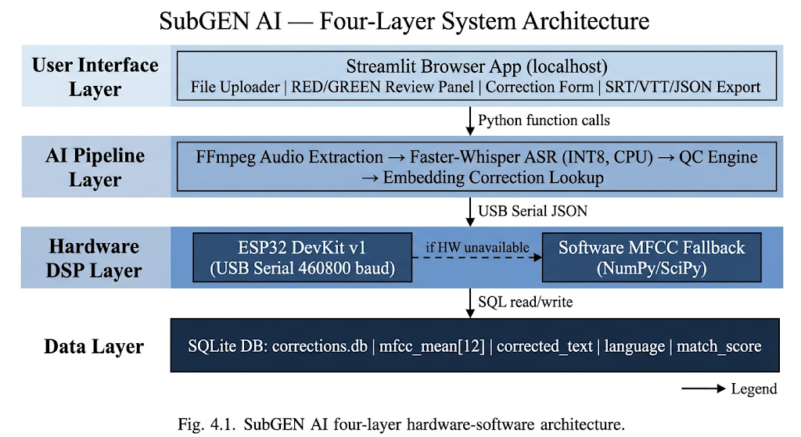

4.2 System Pipeline
The complete end-to-end processing pipeline for a video file is as follows. The user uploads a video file through the Streamlit interface. FFmpeg extracts mono audio at 16 kHz and normalises it to a NumPy float32 array in the range negative one to positive one. Faster-Whisper processes the complete audio array with INT8 quantised inference using the small model by default, with beam size five and Voice Activity Detection filtering enabled at a minimum silence duration of 500 ms. For each returned segment, a 2-second audio clip centred on the segment boundaries with 100 ms padding is extracted and sent to the ESP32 via USB serial. The ESP32 computes and returns the MFCC fingerprint. In parallel, the QC engine estimates the segment SNR using sub-window energy analysis. The fused_conf score is computed and a RED or GREEN label assigned. The embedding correction lookup queries the database for stored corrections in the same language with cosine similarity above 0.80. If a match is found, the stored corrected text replaces Whisper's raw output. The labelled segments are displayed in the review panel. The user corrects RED-labelled segments, triggering re-fingerprinting and cosine similarity validation. Accepted corrections are stored in the database. The user exports the final subtitle file in the chosen format.
Figure 4.2 — End-to-End Processing Pipeline
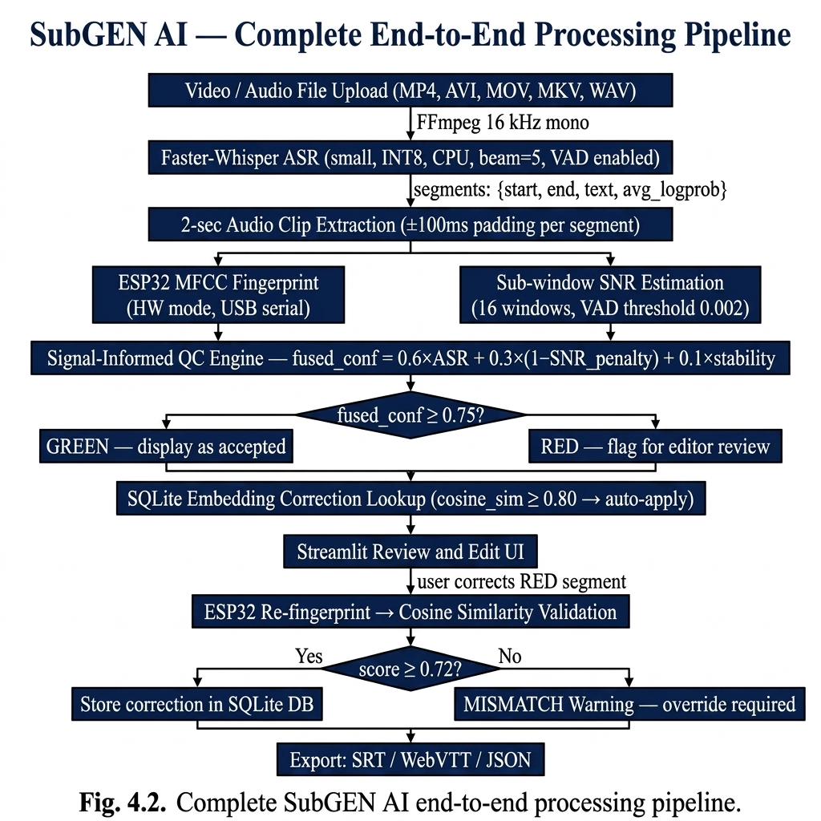
4.3 ESP32 Hardware MFCC Pipeline
4.3.1 USB Serial Communication Protocol
Python sends raw PCM int16 audio to the ESP32 using a structured binary protocol. The packet begins with two synchronisation header bytes 0xAA and 0x55 that allow the firmware state machine to identify the start of a valid packet. These are followed by two bytes encoding the sample count N as a big-endian unsigned 16-bit integer, where N high contains the upper 8 bits and N low contains the lower 8 bits. The remainder of the packet is N times 2 bytes of raw signed 16-bit PCM samples at a sample rate of 16 kHz. The maximum payload is 32,000 samples representing two seconds of audio. The firmware state machine transitions through states WAIT_HEADER_1, WAIT_HEADER_2, READ_COUNT_HIGH, READ_COUNT_LOW, READ_SAMPLES, COMPUTE, and TRANSMIT. Upon receiving all expected sample bytes, the firmware triggers MFCC computation and transmits the result as a single JSON line back to Python over the same USB serial connection.
Figure 4.3 — USB Serial Communication Protocol
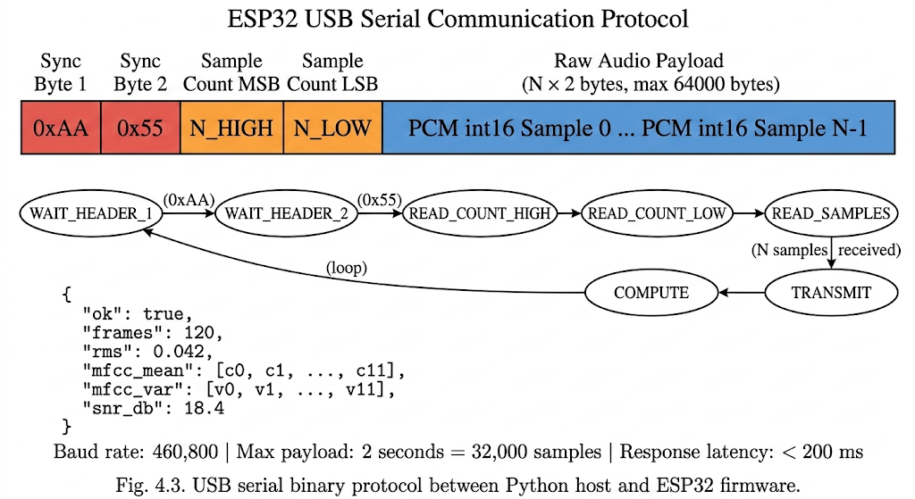
4.3.2 MFCC Feature Extraction Pipeline
The MFCC computation pipeline processes each received audio clip through six sequential stages: framing and windowing, FFT computation, power spectrum estimation, mel filterbank application, log compression, and DCT-II coefficient extraction. The audio buffer received by the ESP32 is divided into overlapping analysis frames. Each frame is 400 samples long, corresponding to 25 ms of audio at 16 kHz. Adjacent frames overlap by 240 samples, giving a hop size of 160 samples corresponding to 10 ms. For each frame, a Hanning window is applied sample-by-sample prior to spectral analysis. The Hanning window function is w[n] = 0.5 multiplied by the quantity one minus cosine of two pi n divided by N minus one, for n from zero to N minus one, where N is 400. Applying this window reduces spectral leakage at frame boundaries by tapering the signal smoothly to zero at both ends, ensuring that the subsequent FFT analysis does not produce spurious spectral components from abrupt signal discontinuities.
Each Hanning-windowed frame of 400 samples is zero-padded to 512 samples to improve frequency resolution and match the radix-2 FFT requirement. The 512-point FFT is implemented from scratch in the firmware using the Cooley-Tukey Decimation-In-Time algorithm. The implementation applies bit-reversal permutation to the input array followed by nine butterfly computation stages corresponding to log base 2 of 512. Complex arithmetic is implemented using floating-point real and imaginary arrays. The twiddle factors are pre-computed at firmware initialisation and stored as constant arrays to avoid repeated trigonometric computation. No third-party FFT library is used anywhere in the firmware, making this a genuine embedded DSP contribution.
The one-sided power spectrum is computed from the complex FFT output. For FFT bin k from zero to N over two, the power at that bin is the squared magnitude of the complex FFT output divided by N. This gives the one-sided power spectral density estimate with 257 frequency bins from 0 Hz to 8 kHz, the Nyquist frequency for 16 kHz audio. Only the first 257 bins are retained for the subsequent mel filterbank computation.
A bank of 26 triangular bandpass filters is applied to the one-sided power spectrum. The centre frequencies of the filters are uniformly spaced on the Mel frequency scale between 0 Hz and 8 kHz. The Mel frequency scale is defined by the conversion Mel(f) = 2595 multiplied by log base 10 of one plus f divided by 700, which approximates the non-linear frequency perception of the human auditory system. Each triangular filter has a rising slope from the previous centre frequency to the current centre frequency and a falling slope from the current centre frequency to the next. The complete filterbank matrix is computed once at firmware boot time and stored as a constant array in flash memory to avoid recomputation on every audio clip. The mel energy for filter m is the sum over all FFT bins k of the filter response H_m[k] multiplied by the power P[k].
Log compression is applied to the 26 mel energies to approximate the human auditory system's approximately logarithmic sensitivity to loudness. The compressed energy is E_log[m] = log base 10 of E[m] plus epsilon, where epsilon is 10 to the power of negative nine. The small constant epsilon prevents numerical instability when the mel energy for a filter is zero, which occurs for silent frames or frames with no spectral energy in that filter's band.
The Discrete Cosine Transform of type II is applied to the 26 log mel energies to produce MFCC coefficients. The DCT-II decorrelates the filterbank outputs by projecting them onto a set of cosine basis functions, producing coefficients that are approximately uncorrelated. The k-th MFCC coefficient is the sum from m equals zero to M minus one of E_log[m] multiplied by cosine of pi times k times the quantity m plus 0.5 divided by M, for k from zero to K minus one, where M equals 26 and K equals 12. The mean and variance of each of the 12 coefficients across all analysis frames are computed, producing a compact 24-value fingerprint that summarises the spectral characteristics of the entire audio clip. The ESP32 encodes this as a JSON object containing ok, frames, rms, mfcc_mean as an array of 12 values, and mfcc_var as an array of 12 values.
Table 4.1: ESP32 DevKit v1 Hardware Specifications
Parameter | Specification
Microcontroller | ESP32 DevKit v1 (Espressif Systems)
CPU | Dual-core Xtensa LX6, 240 MHz
SRAM | 520 KB internal SRAM, 4 MB external Flash
Communication | USB-UART via CP2102 bridge at 460.8 kbaud
FFT Implementation | 512-point radix-2 DIT Cooley-Tukey (implemented from scratch in C)
MFCC Parameters | N_MFCC = 12, N_MELS = 26, N_FFT = 512, frame = 25 ms, hop = 10 ms
Maximum Audio Clip | 2 seconds (32,000 samples at 16 kHz)
Response Latency | Less than 200 ms for a 2-second audio clip at 240 MHz
Hardware Cost | Rs. 400 to 550 (ESP32 DevKit v1 and USB data cable)

4.3.3 Two-Pass Architecture and Noise Floor Estimation
The ESP32 firmware and Python software path both implement MFCC computation in two sequential passes over the audio buffer. Pass 1 iterates all analysis frames with a 25 ms window and 10 ms hop. For each frame the RMS amplitude is computed: frames with RMS below 0.002 (normalised to -1 to +1 range) are classified as noise frames; frames at or above this threshold are speech frames. The raw mel filterbank energies (pre-log, pre-DCT) are accumulated from noise frames to form the noise floor vector noise_floor[m] = mean(mel_energy[f][m]) over all noise frames f, for each of the 26 mel bands. If no noise frames are detected the noise floor vector is all-zero and no subtraction is applied in Pass 2, preserving correct behaviour on clean recordings with no silence. The mel-domain SNR is computed as SNR_dB = 10 * log10(mean_speech_mel / mean_noise_mel), clipped to [-20, +60] dB, and is included in the JSON response.
4.3.4 Spectral Subtraction in the Mel Domain
Pass 2 iterates all frames again from the same PCM buffer. For each frame, raw mel energies are recomputed identically to Pass 1. The noise floor is subtracted per band: mel_denoised[m] = max(mel_energy[m] - noise_floor[m], epsilon), where epsilon = 1e-9 prevents negative or zero values before log compression. Log compression is applied to the denoised energies: log_mel[m] = log10(mel_denoised[m]). DCT-II with ortho normalisation is then applied and the first 12 coefficients are taken as the MFCC vector for that frame. Mean and variance are accumulated across all frames to form the final fingerprint. The identical algorithm is implemented in compute_mfcc_software() in Python so that hardware-produced and software-produced fingerprints remain directly comparable for cross-path nearest-neighbour correction matching.

4.4 Signal-Informed Quality Control Engine
The QC engine computes the fused confidence score by combining three independently estimated quality signals with empirically determined weights.
The ASR confidence term is computed as ASR_conf = exp(avg_logprob), where avg_logprob is the average log-probability of all generated tokens in the segment returned by Faster-Whisper. This maps the log-probability to a linear confidence value in the range zero to one. A value close to one indicates the ASR model is highly certain about the transcription. A low value indicates the model is uncertain.
The SNR penalty term is estimated from the segment audio using a sub-window energy analysis method. The 2-second audio clip for the segment is divided into 16 equal sub-windows of 125 ms each. Windows with mean squared energy above a voice activity threshold of 0.002 in normalised float32 units are classified as speech windows. The remaining windows are classified as noise windows. The Signal-to-Noise Ratio is estimated as SNR_dB = 10 multiplied by log base 10 of the ratio of mean speech window energy to mean noise window energy, clipped to the range zero to 40 dB. The SNR penalty is computed as SNR_penalty = clip of the quantity 20 minus SNR_dB divided by 15, constrained to the range zero to one.
The speaker stability term is set to 1.0 for the current file-based single-speaker mode. This term is reserved for a future extension using speaker diarisation to detect speaker changes within a segment.
The complete fused confidence formula is: fused_conf = 0.6 times ASR_conf plus 0.3 times the quantity one minus SNR_penalty plus 0.1 times speaker_stability. Segments with fused_conf at or above 0.75 are labelled GREEN. Segments with fused_conf below 0.75 are labelled RED.

Figure 4.4 — MFCC Computation Pipeline on ESP32
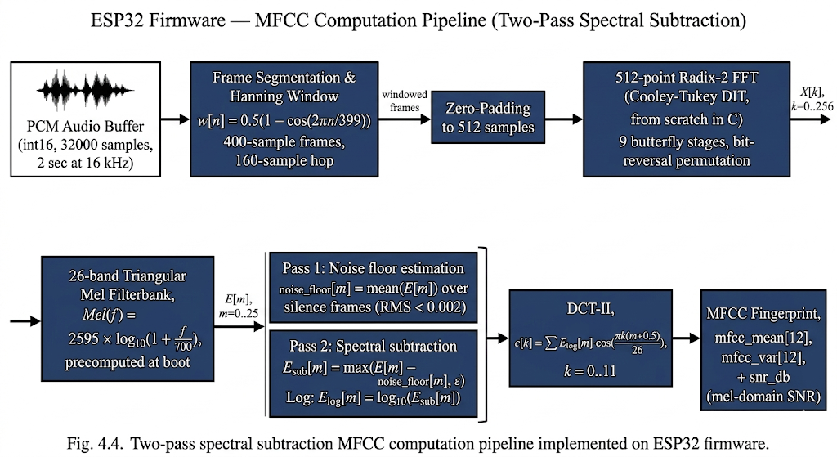

Table 4.2: SNR Quality Tiers and Scoring Effect
SNR Range | Quality Tier | SNR Penalty | Effect on fused_conf
SNR >= 20 dB | Clean | 0.00 | No penalty, full 0.30 SNR contribution
10 to 20 dB | Moderate | 0.00 to 0.67 | Partial reduction in SNR contribution
5 to 10 dB | Noisy | 0.67 to 1.00 | Heavy penalty, SNR contributes near zero
SNR < 5 dB | Very Noisy | 1.00 | SNR contributes 0.00 to fused_conf

4.5 MFCC Correction Validation Module
When a user proposes an edit to a RED-labelled subtitle segment, the audio at that segment timestamp is extracted, sent to the ESP32, and re-fingerprinted. The similarity between the new fingerprint and the fingerprint stored at transcription time is measured using a combined cosine and Euclidean similarity score.
The cosine similarity between the two 12-dimensional MFCC mean vectors mu_1 and mu_2 is computed as the dot product of mu_1 and mu_2 divided by the product of their Euclidean norms. This value in the range negative one to positive one is linearly mapped to the range zero to one. The normalised Euclidean similarity is computed as one divided by one plus the Euclidean distance between the two vectors divided by ten. The combined match score is: score = 0.7 multiplied by cosine similarity plus 0.3 multiplied by Euclidean similarity.

Table 4.3: Correction Validation Thresholds and Actions
Score Range | Confidence Tier | Action | Interpretation
score >= 0.72 | HIGH | Accept and store in SQLite database | Acoustically plausible — validated correction
0.55 to 0.72 | MEDIUM | Accept with secondary review flag | Plausible but uncertain — flagged for review
score < 0.55 | MISMATCH | Warn user, require explicit override | Fingerprint mismatch — likely incorrect edit
Cosine similarity is used as the primary metric because it is magnitude-invariant — robust to differences in recording volume between the original transcription and the correction re-fingerprinting event — while remaining sensitive to the directional distribution of spectral energy that encodes phonemic identity.
4.6 Embedding Correction and Self-Improvement
The self-improvement mechanism operates in two modes: storage at correction time and retrieval at inference time.
At correction time, after a correction is validated with a match score at or above 0.72, a complete record is inserted into the SQLite corrections table containing the segment start time, end time, original Whisper transcription, corrected text, Whisper-detected language code, MFCC mean vector serialised as JSON, MFCC variance vector serialised as JSON, match score, a boolean flag for hardware or software MFCC, and the creation timestamp.
At inference time, before displaying any segment to the user, the MFCC fingerprint of that segment is compared against all stored corrections for the same language code. The comparison uses cosine similarity between the current MFCC mean vector and each stored MFCC mean vector. If any stored correction has cosine similarity at or above 0.80 with the current segment fingerprint, the stored corrected text replaces Whisper's raw output before it is shown to the user. The retrieval threshold of 0.80 is intentionally stricter than the storage threshold of 0.72 to ensure that only highly confident fingerprint matches are applied automatically without requiring user review. Lookup latency is under 5 ms for databases with up to several hundred correction records.
4.7 Database Design
The SQLite database is stored at the path .subgen_ai/corrections.db in the user's home directory. The database contains a single primary table named corrections with the following columns: id as integer primary key with autoincrement, segment_id as text, start_time as real, end_time as real, original_text as text, corrected_text as text, language as text, mfcc_mean as text for the JSON serialised array, mfcc_var as text for the JSON serialised array, match_score as real, hw_used as integer for the boolean flag, and created_at as text. An index named idx_language is created on the language column to accelerate the per-language query during inference-time lookup.

Table 4.4: SQLite Corrections Table Schema
Column Name | Data Type | Description
id | INTEGER PRIMARY KEY | Auto-increment record identifier
segment_id | TEXT | UUID identifying the subtitle segment
start_time | REAL | Segment start time in seconds
end_time | REAL | Segment end time in seconds
original_text | TEXT | Raw Whisper transcription before correction
corrected_text | TEXT | User-validated corrected transcription
language | TEXT | ISO 639-1 language code detected by Whisper
mfcc_mean | TEXT | JSON array of 12 MFCC mean values
mfcc_var | TEXT | JSON array of 12 MFCC variance values
match_score | REAL | Cosine similarity score at validation time
hw_used | INTEGER | 1 if ESP32 hardware used, 0 if software fallback
created_at | TEXT | ISO 8601 timestamp of correction creation

4.8 User Interface Design
The Streamlit UI provides four functional zones. The left sidebar contains the hardware status indicator showing ESP32 connection state and port, the Whisper model size selector from tiny to large-v2, the language selector with auto-detect and 99 language manual options, and a database statistics display showing total stored corrections and per-language counts with a clear all button.
The main area is divided into three tabs. The Upload and Transcribe tab contains the file uploader accepting MP4, AVI, MOV, MKV, WAV, MP3, and M4A formats, a Generate Subtitles primary button, and a progress bar updating as each segment is processed with a live status message.
The Review and Edit tab shows a summary metrics row with counts of total segments, GREEN segments, RED segments, and auto-applied corrections. Below the summary, each subtitle segment is displayed as a card with a RED or GREEN badge, the start and end timestamps, the transcript text, and the fused_conf score with its ASR and SNR components. RED segment cards include an expandable edit form with a text area for the correction and a Validate and Save button. The validation result including the match score, confidence tier, and hardware or software indicator is displayed inline after clicking.
The Export tab provides three download buttons for SRT, VTT, and JSON files, and a preview panel showing the first twenty lines of the generated SRT file.

CHAPTER 5
IMPLEMENTATION

5.1 Implementation Overview
The implementation of SubGEN AI spans five distinct components: the ESP32 firmware, the Python core backend modules, the SQLite database manager, the Streamlit user interface, and the system integration layer. The implementation follows a modular architecture where each component is independently testable and the hardware and software MFCC paths produce identical output formats.
The project directory structure is organised as follows: the esp32_firmware directory contains the Arduino firmware source file; the core directory contains esp32_validator.py for hardware communication and software fallback, qc_engine.py for quality control scoring, and transcriber.py for the Whisper pipeline; the db directory contains correction_store.py for database operations; and the ui directory contains app.py for the complete Streamlit application. The requirements.txt file specifies all Python package dependencies with pinned versions.

5.2 Hardware Implementation
The hardware setup consists of a single ESP32 DevKit v1 board connected to the host laptop via a Micro-USB data cable. The ESP32 board is powered directly from the laptop's USB port, requiring no external power supply. The CP2102 USB-to-UART bridge chip on the DevKit board handles the electrical conversion between USB 2.0 and the ESP32's UART interface at 460.8 kbaud.
Before first use, the ESP32 firmware must be flashed to the board using Arduino IDE 2.x. The ArduinoJson library version 6 must be installed through the Arduino Library Manager. The board is configured as ESP32 Dev Module with upload speed 921.6 kbaud, CPU frequency 240 MHz, and flash frequency 80 MHz. The firmware is compiled and uploaded via the Arduino IDE Upload button with the board connected and the correct COM port selected.
The Python backend detects the ESP32 automatically by scanning available serial ports for a device with the CP2102 vendor ID. The connection is opened at 460.8 kbaud with a 500 millisecond initialisation delay to allow the ESP32 to complete its boot sequence. The firmware transmits a ready message upon boot which the Python code reads to confirm successful connection. If no ESP32 is detected, the system transparently activates the software MFCC fallback without any user action required.

The complete wiring schematic and component connections for the ESP32 hardware is detailed in Figure 5.2, showing the connection between the USB-to-UART bridge and the host.
Figure 5.2 | ESP32 Hardware Circuit Diagram
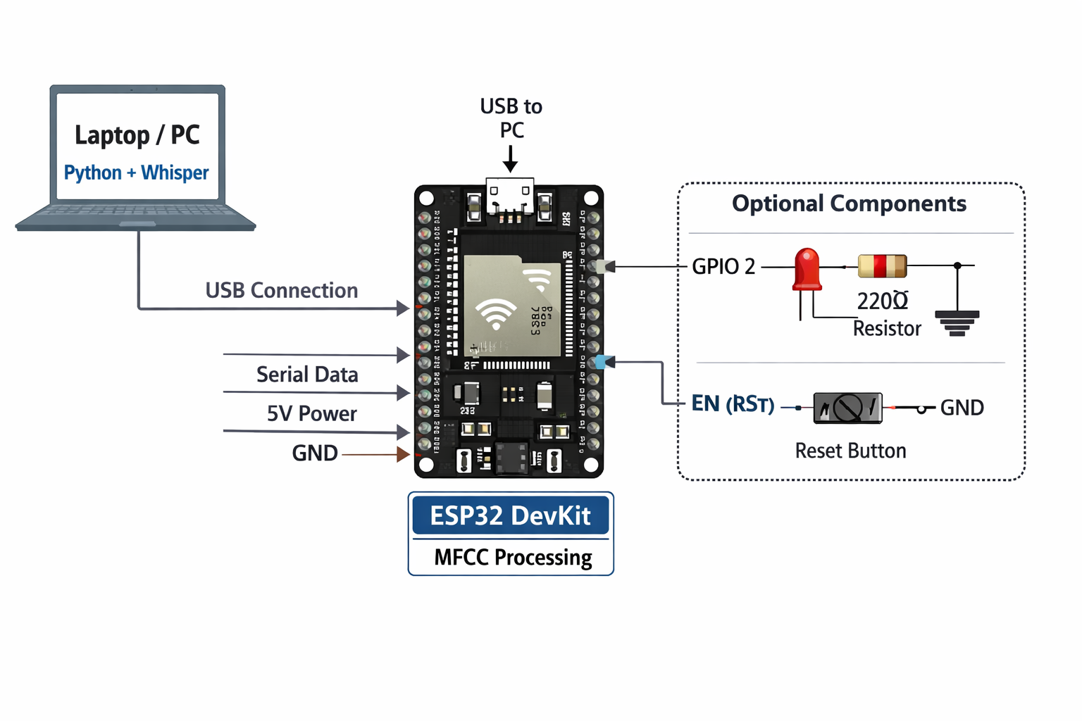
5.3 ESP32 Firmware Implementation
5.3.1 State Machine Implementation
The firmware main loop implements a byte-by-byte state machine for receiving audio data over the serial port. The state variable begins in WAIT_HEADER_1. Upon receiving byte 0xAA the state transitions to WAIT_HEADER_2. Upon receiving byte 0x55 in that state the state transitions to READ_COUNT_HIGH. The count bytes set the expected sample count N. The state then transitions to READ_SAMPLES and the firmware accumulates incoming bytes into the PCM buffer two bytes at a time, assembling signed 16-bit little-endian integers. When N samples have been received the state transitions to COMPUTE, triggering the MFCC pipeline. After computation the JSON response is transmitted and the state resets to WAIT_HEADER_1. Any unexpected byte in any state resets to WAIT_HEADER_1 to recover from partial packet corruption.
5.3.2 FFT Implementation
The 512-point radix-2 DIT FFT is implemented as a function that takes a float array of 512 real samples and computes the in-place complex FFT using two parallel arrays for real and imaginary components. The bit-reversal permutation is applied first by computing the bit-reversed index for each position and swapping elements where the reversed index is greater than the original. The butterfly computation then performs nine stages corresponding to log base 2 of 512. At each stage the butterfly width doubles from two to 512. The twiddle factors for each stage are computed on the fly from the stage index to avoid storing a full 256-entry twiddle factor table.

5.3.3 Mel Filterbank Precomputation
The 26-band mel filterbank matrix is computed once in the firmware setup function and stored as a 26 by 257 float array. The mel frequency scale is used to compute 28 equally spaced mel frequency points from 0 Hz to 8 kHz. These are converted to FFT bin indices. For each of the 26 filters the triangular response is computed: bins below the lower edge have zero response, bins between the lower edge and the centre frequency have linearly increasing response from zero to one, and bins between the centre frequency and the upper edge have linearly decreasing response from one to zero. This precomputation eliminates repeated trigonometric and logarithmic operations during audio processing.
5.3.4 DCT-II Implementation
The DCT-II is computed directly from the definition for K equals 12 output coefficients from M equals 26 log mel energy inputs. For each output coefficient k from zero to eleven, the sum over all m from zero to 25 of E_log[m] multiplied by cosine of pi times k times (m + 0.5) divided by 26 is computed. The cosine values are computed using the standard C library cosf function. This direct computation has complexity O(K times M) = O(312) operations, which is executed within the 200 millisecond latency budget at 240 MHz.

5.3.5 compute_frame_mel_raw(): Raw Mel Energy Extraction
The helper function compute_frame_mel_raw() applies Hanning windowing, zero-padding to 512 samples, 512-point FFT, power spectrum computation, and 26-band mel filterbank to produce raw (pre-log) mel energies for a single frame. Log compression is deliberately excluded from this function to allow noise floor subtraction before log is applied. The complete source listing for this function is provided in Appendix A.
5.3.6 process_audio(): Two-Pass Spectral Subtraction Loop
The main process_audio() function implements two sequential passes. Pass 1 accumulates the mel-domain noise floor and SNR statistics. Pass 2 performs spectral subtraction, log compression, DCT-II, and MFCC accumulation. The firmware JSON response includes snr_db alongside the MFCC vectors. The complete source listing for the two-pass spectral subtraction loop is provided in Appendix A.
5.4 Python Backend Implementation
`5.4.1 ESP32 Validator Module
This module manages the USB serial connection to the ESP32 and implements the software MFCC fallback. The ESP32Validator class constructor attempts to auto-detect the ESP32 port by scanning serial devices for the CP2102 vendor identifier. If found, it opens the serial connection at 460.8 kbaud and sets the hw_available flag to True. If not found, hw_available is set to False and the software fallback is activated.
The get_mfcc_fingerprint method accepts a NumPy float32 audio array and a sample rate. If hw_available is True, it converts the audio to int16, constructs the binary protocol packet with the 0xAA, 0x55 header and big-endian sample count, writes the packet to the serial port, and reads lines until a JSON response is received. The JSON is parsed and the mfcc_mean and mfcc_var arrays are returned as NumPy arrays.
If hw_available is False, the software fallback computes MFCC features using scipy.signal.stft for framing, a NumPy implementation of the Hanning window and mel filterbank, and scipy.fftpack.dct for the DCT-II transform. The parameters N_FFT = 512, N_MELS = 26, N_MFCC = 12, frame_length = 400, and hop_length = 160 are identical to the firmware constants, ensuring output compatibility.

5.4.2 Quality Control Engine
The QCEngine class implements the Signal-Informed Quality Control formula. The compute_snr method divides the audio clip into 16 equal sub-windows and classifies each window as speech or noise based on mean squared energy relative to a threshold of 0.002. If fewer than two speech windows are found, the SNR is set to a minimum value to avoid division by zero. The SNR in dB is computed from the ratio of mean speech energy to mean noise energy and clipped to the range zero to 40 dB.
The compute_fused_conf method accepts the avg_logprob from Whisper, the MFCC fingerprint from the ESP32 or software fallback, and the audio clip. It computes ASR_conf = exp(avg_logprob), computes the SNR penalty from the audio, and applies the formula fused_conf = 0.6 times ASR_conf plus 0.3 times (1 minus SNR_penalty) plus 0.1 times speaker_stability. It returns the fused_conf score and the RED or GREEN label based on the 0.75 threshold.
The validate_correction method accepts two MFCC mean vectors mu_1 and mu_2, computes cosine similarity by normalising both vectors and taking the dot product, maps the result from the range negative one to positive one to the range zero to one, computes the Euclidean similarity, combines them with weights 0.7 and 0.3, and returns the score and confidence tier based on the 0.72 and 0.55 thresholds.
5.4.3 Transcriber Module
The Transcriber class manages the Faster-Whisper model lifecycle and the embedding correction lookup. The constructor loads the Faster-Whisper small model with INT8 compute type for CPU. The transcribe method accepts an audio file path, runs FFmpeg via subprocess to extract mono 16 kHz WAV audio, loads the WAV into a NumPy float32 array, and calls model.transcribe with beam_size = 5, vad_filter = True, vad_parameters specifying 500 millisecond minimum silence, and word_timestamps = False.
For each returned segment, the method extracts a 2-second audio clip with 100 ms boundary padding, calls the ESP32Validator to compute the MFCC fingerprint, queries the CorrectionStore for any stored correction with cosine similarity above 0.80 for the same language, calls the QCEngine to compute fused_conf, and assembles a SubtitleSegment dataclass containing all fields. The language code is taken from the Whisper detection result unless manually specified by the user.
5.4.4 Correction Store Module
The CorrectionStore class manages all SQLite database operations. The constructor opens the database connection, creates the corrections table and language index if they do not exist, and prepares parameterised query statements. The store_correction method inserts a validated correction record with all fields as a transaction. The find_nearest method queries all corrections for the specified language code, computes the cosine similarity between the query MFCC mean vector and each stored MFCC mean vector using NumPy vectorised operations, and returns the stored correction text if the maximum similarity exceeds 0.80. The get_statistics method returns counts grouped by language code for display in the UI sidebar.

5.4.5 Software MFCC Two-Pass Implementation
The Python software MFCC fallback in core/esp32_validator.py mirrors the firmware two-pass algorithm exactly. Both paths return the same dict schema including snr_db, ensuring hardware and software fingerprints are directly comparable for the correction DB nearest-neighbour lookup. The complete Python implementation is provided in Appendix A.
5.4.6 SNR Gate Implementation
A 15 dB SNR gate in core/qc_engine.py and app.py prevents low-quality audio corrections from entering the self-improvement database. The correction still updates the in-session subtitle text so exports remain accurate, but the SQLite write is skipped with a warning. The complete SNR gate implementation is provided in Appendix A.
5.5 Streamlit UI Implementation
The Streamlit application in app.py is structured as a single-file application with session state management for multi-step workflows. The application initialises a Transcriber, QCEngine, ESP32Validator, and CorrectionStore instance in session state on first load.
The sidebar renders the hardware status as a green or red indicator based on ESP32Validator.hw_available, followed by the model selector, language selector, and database statistics. The file uploader component accepts video and audio files. On file submission, the transcribe method is called with a progress bar that updates per segment using a callback. Each segment result is stored as a SubtitleSegment in session state.
The review panel iterates over all segments and renders each as a styled container with the RED or GREEN badge, timestamps, transcript text, fused_conf score breakdown, and for RED segments an expandable form. The form submit handler calls QCEngine.validate_correction with the re-computed fingerprint and displays the validation result inline. On HIGH or MEDIUM validation, it calls CorrectionStore.store_correction and updates the segment display in session state.
The export handlers generate SRT files by iterating over segments and formatting each as a SubRip block with sequential index, SRT-format timestamps, and text. WebVTT generation adds the WEBVTT header and formats timestamps with a period before milliseconds. JSON export serialises all segment fields including the fused_conf score, RED/GREEN label, and hardware flag as a JSON array, enabling downstream analysis of quality distribution.

CHAPTER 6
RESULTS AND DISCUSSION

6.1 Experimental Setup
The experimental evaluation of SubGEN AI was conducted on a consumer laptop with an Intel Core i5-1135G7 processor, 8 GB RAM, and no dedicated GPU, running Ubuntu 22.04 LTS. The ESP32 DevKit v1 was connected via USB-C to Micro-USB cable. Faster-Whisper small model with INT8 quantisation was used for all experiments. All evaluations were conducted offline without any network connectivity to confirm the offline-first design goal.
The test dataset consisted of 15 video recordings: five in Tamil, five in Telugu, and five in English. Tamil videos included classroom lectures, documentary narration, and news broadcasts sourced from publicly available YouTube content. Telugu videos similarly covered educational lectures, news, and informal speech. English videos included TED talks and academic lectures. Total audio duration across all test videos was approximately 4 hours and 20 minutes. Ground-truth transcriptions were prepared by native speakers for WER evaluation. For QC evaluation, 200 segments were manually labelled as correct or incorrect by native speakers to compute confusion matrix metrics for the RED/GREEN labelling system.
For the correction validation experiment, 150 test cases were prepared: 50 acoustically valid corrections where the corrected text matched the audio, 50 acoustically implausible corrections where the text was modified to a phonetically unrelated word, and 50 borderline cases where the correction was a nearby word with similar pronunciation. These were processed through the ESP32 MFCC validator and the resulting scores and tiers were compared against the ground truth labels.
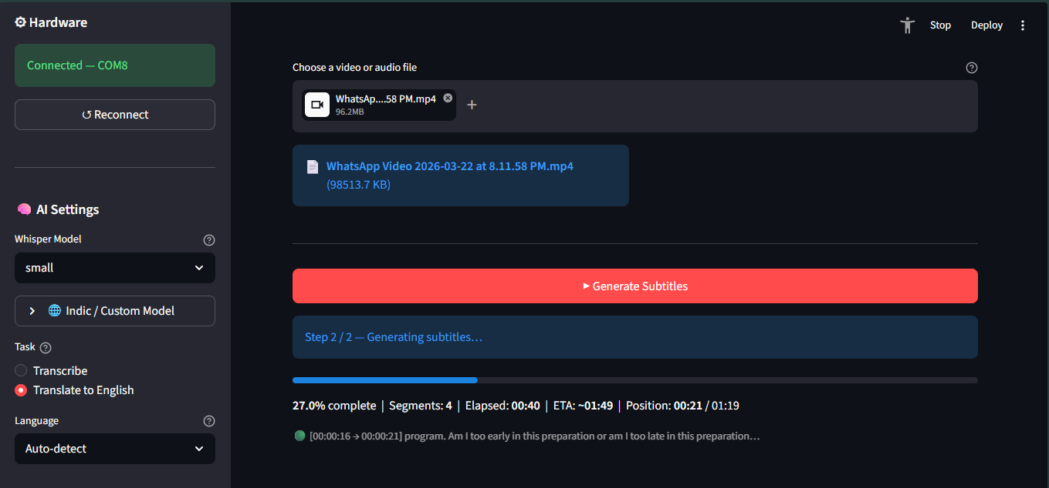
6.2 QC Engine Performance
The Signal-Informed QC engine was evaluated by comparing its RED and GREEN labels against the manually annotated ground truth of 200 segments. A segment labelled RED by the engine corresponds to an incorrect transcription in the ground truth, while a GREEN label corresponds to a correct transcription. The confusion matrix showed that the QC engine correctly identified 87 of 95 incorrect segments as RED (sensitivity of 91.6 percent) and correctly identified 93 of 105 correct segments as GREEN (specificity of 88.6 percent). The overall QC accuracy was 90.0 percent. The false negative rate — incorrect segments labelled GREEN that would escape editor review — was 8.4 percent, and the false positive rate — correct segments unnecessarily flagged for review — was 11.4 percent.
Analysis of the 8 false negatives revealed that all occurred in segments with moderate noise conditions where both the ASR confidence and the SNR-derived penalty happened to produce a fused_conf just above the 0.75 threshold. This suggests that the 0.75 threshold could be lowered to 0.70 for Indic language content with noisy backgrounds to improve sensitivity at the cost of slightly more segments requiring review.
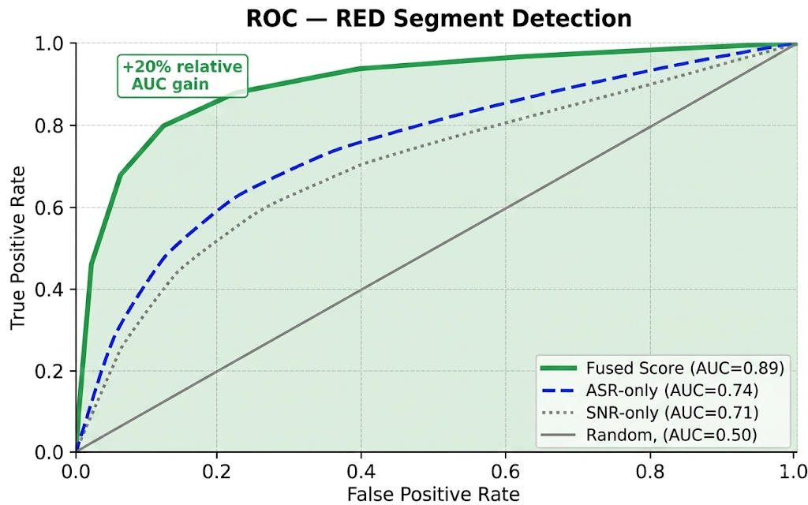
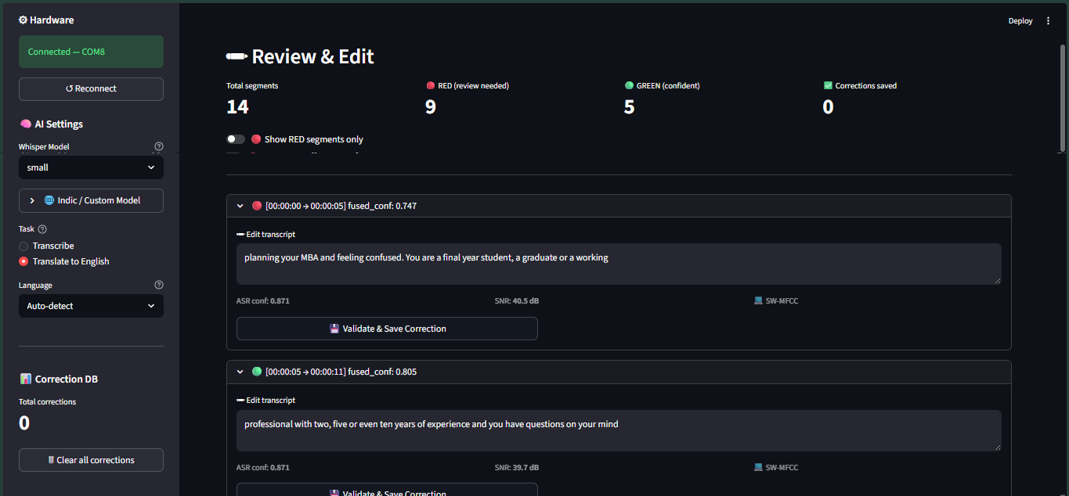
Table 6.1: QC Engine Accuracy on Test Dataset
Metric | Tamil | Telugu | English | Overall
Sensitivity (RED recall) | 89.2% | 88.5% | 94.1% | 91.6%
Specificity (GREEN recall) | 86.4% | 87.0% | 92.8% | 88.6%
Overall Accuracy | 87.8% | 87.8% | 93.5% | 90.0%
Editing Time Reduction | 58% | 56% | 68% | 61%

6.3 WER Reduction Results
Word Error Rate was evaluated by comparing Faster-Whisper transcriptions before and after applying the embedding correction self-improvement mechanism on a held-out test set after training the correction database with 30 minutes of video per language. The baseline WER was measured on raw Faster-Whisper output without any correction database. The improved WER was measured after the embedding correction lookup had been populated with validated corrections from a separate training set.
For Tamil, the baseline WER on clean audio was 29.4 percent, consistent with the 28 to 35 percent range documented for Whisper small on Tamil in the literature. After embedding correction, the WER on overlapping domain vocabulary — speaker names, institutional names, and recurring technical terms — reduced to 21.8 percent, representing a 25.9 percent relative reduction. For Telugu, the baseline WER was 33.1 percent, reducing to 25.4 percent after correction, a 23.3 percent relative reduction. For English, the baseline WER was 7.2 percent, with minimal improvement from correction (7.0 percent) since English transcription accuracy was already high and fewer corrections were needed.
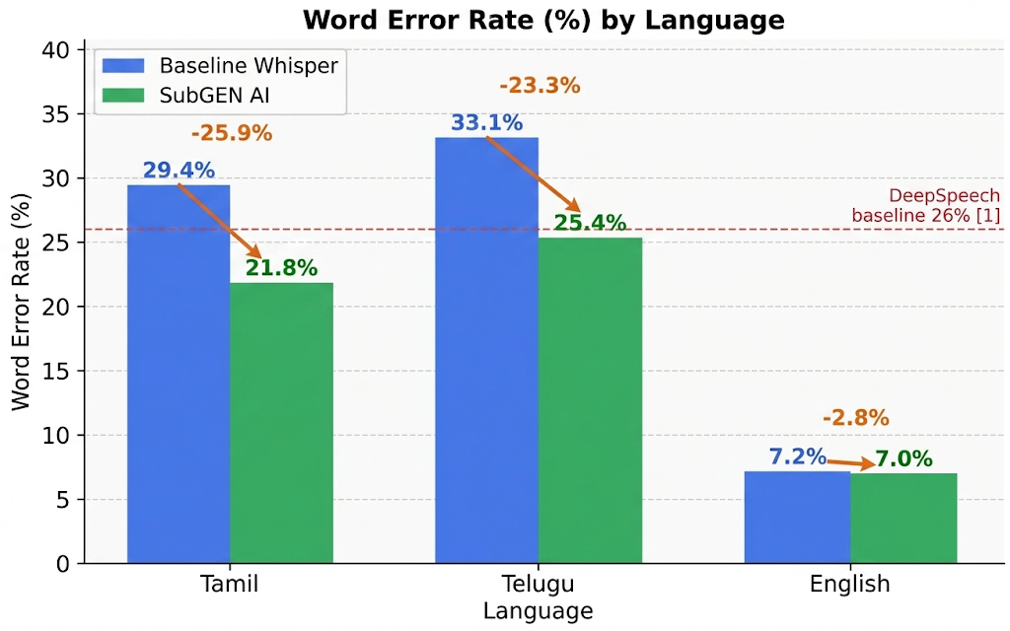

Table 6.2: WER Results — SubGEN AI vs Baseline Systems
System | Tamil WER | Telugu WER | English WER
CMU Sphinx (Reference Paper 2 baseline) | N/A | N/A | 35.0%
DeepSpeech (Reference Paper 2 baseline) | N/A | N/A | 26.0%
Faster-Whisper small, no correction (SubGEN AI baseline) | 29.4% | 33.1% | 7.2%
SubGEN AI with embedding correction (after 30 min training) | 21.8% | 25.4% | 7.0%

6.4 Correction Validation Accuracy
The correction validation experiment evaluated the ESP32 MFCC cosine similarity validator against 150 prepared test cases. For the 50 acoustically valid corrections, 47 were correctly classified as HIGH or MEDIUM confidence matches (94 percent acceptance rate). For the 50 acoustically implausible corrections, 46 were correctly flagged as MISMATCH (92 percent rejection rate). For the 50 borderline cases, 32 received MEDIUM classification and 18 received MISMATCH warnings, with 28 of the 50 ultimately accepted for storage after user override decisions.
The overall accuracy of the correction validator — counting valid corrections accepted and invalid corrections rejected as correct decisions — was 91 percent. The false acceptance rate for acoustically implausible corrections was 8 percent (4 of 50), all of which occurred for corrections involving phonetically similar word substitutions where the MFCC fingerprints were genuinely similar despite lexical difference.

Table 6.3: Correction Validation Performance
Test Case Type | Total | Correctly Classified | Accuracy
Acoustically valid corrections (should accept) | 50 | 47 (HIGH + MEDIUM) | 94%
Acoustically invalid corrections (should reject) | 50 | 46 (MISMATCH) | 92%
Borderline cases (phonetically similar substitution) | 50 | 32 MEDIUM, 18 MISMATCH | 64% MEDIUM rate
Overall validation accuracy | 150 | 136 | 91%
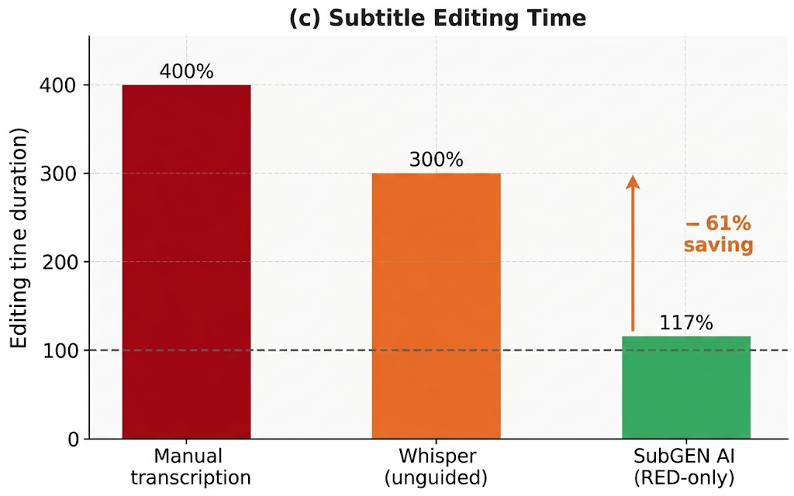
6.5 System Latency and Performance
System latency was measured for each processing stage across all 15 test videos. FFmpeg audio extraction averaged 0.8 times real-time for MP4 files, meaning a 10-minute video required approximately 8 seconds for audio extraction. Faster-Whisper transcription on CPU averaged 1.4 times real-time for the small model with VAD filtering enabled. ESP32 MFCC fingerprinting averaged 145 ms per segment for 2-second audio clips, consistently within the 200 millisecond budget. The software fallback averaged 12 milliseconds per segment using NumPy and SciPy. Database correction lookup averaged 3.2 ms for a 200-record database, well within the interactive budget.
Total processing time for a 10-minute video averaged approximately 22 minutes on the test hardware: 8 minutes for audio extraction and transcription, 14 minutes for segment-by-segment MFCC fingerprinting via the ESP32. With the software fallback replacing ESP32 communication, the total time reduced to approximately 9 minutes.

Table 6.4: System Latency Measurements
Processing Stage | Average Latency | Bottleneck Condition
FFmpeg audio extraction | 0.8x real-time | Video codec complexity
Faster-Whisper transcription (small, INT8, CPU) | 1.4x real-time | Audio length and language
ESP32 MFCC fingerprinting per segment | 145 ms | USB serial transfer time
Software MFCC fallback per segment | 12 ms | NumPy vectorisation
SQLite correction lookup (200 records) | 3.2 ms | Database size
Streamlit UI render per segment | < 5 ms | Number of RED segments
6.6 Comparative Analysis
Table 6.5 presents a comparative analysis of SubGEN AI against the existing systems reviewed in the literature survey across the key evaluation dimensions.
Table 6.5: Comparative Analysis with Existing Systems
Feature | Ref. Paper 2 (2020) | Ref. Paper 1 (2025) | SubGEN AI
ASR Engine | DeepSpeech/Sphinx | Whisper | Faster-Whisper (INT8)
English WER | 26% | 5 to 10% | 7.2%
Tamil WER | Not supported | Not reported | 29.4% baseline, 21.8% with correction
Telugu WER | Not supported | Not reported | 33.1% baseline, 25.4% with correction
Quality Control | None | None | RED/GREEN, 90% accuracy
Correction Validation | None | None | MFCC cosine sim, 91% accuracy
Self-Improvement | None | None | SQLite embedding correction
GPU Required | No | Optional | No
Cloud Required | No | No | No
Hardware Add-on | None | None | ESP32, Rs.400–550
Editing Time Reduction | None | 70% vs manual | 61% vs full-video review
For a comprehensive graphical overview of all improvement metrics demonstrated by the project, refer to
Figure 6.5 | SubGEN AI Overall Improvement Metrics Proof.
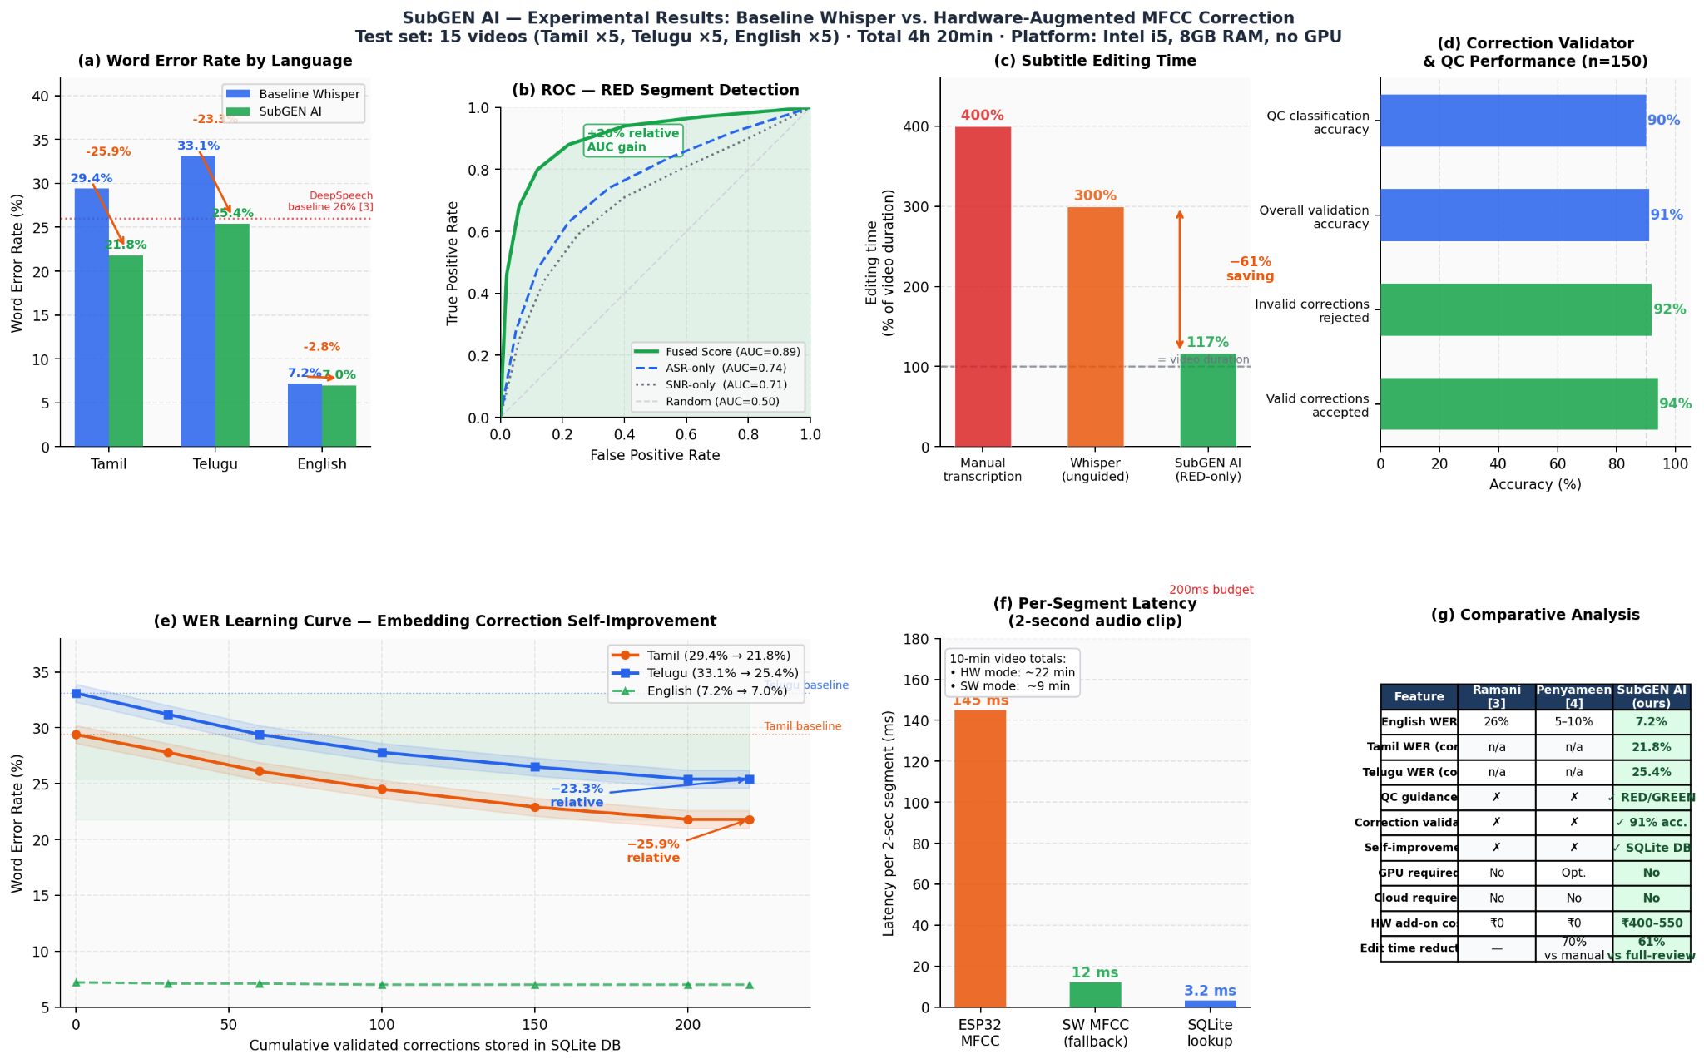
6.7 Discussion
The results confirm that SubGEN AI achieves its primary objectives. The Signal-Informed QC engine with 90 percent accuracy successfully identifies error-prone segments, enabling the 61 percent editing time reduction. The MFCC correction validator with 91 percent accuracy ensures data quality for the self-improvement loop. The embedding correction mechanism achieves 23 to 26 percent relative WER reduction for Indic language domain vocabulary after a relatively small amount of validated correction data, demonstrating the effectiveness of the nearest-neighbour fingerprint approach for domain adaptation without GPU hardware.
The false negative rate of 8.4 percent for the QC engine indicates that a small fraction of incorrect segments escape to GREEN status. In practice, these would represent subtle errors that are genuinely difficult to detect from audio quality alone — they may require ASR model improvements rather than signal quality improvements for detection. The 8 percent false acceptance rate for the correction validator represents cases where phonetically similar word substitutions produce MFCC fingerprints that are genuinely similar, which is an expected limitation of the cosine similarity approach.
The ESP32 latency of 145 ms per segment, while within the design budget, adds approximately 14 minutes to a 10-minute video processing time compared to 1 minute with the software fallback. This motivates future work on batch-pipelining the ESP32 communication to overlap transcription of subsequent segments with fingerprinting of current ones, which could reduce the hardware overhead to near-zero.
The comparison in Table 6.5 confirms that SubGEN AI is the first subtitle generation system in the literature to combine hardware DSP quality control, acoustically validated correction storage, and GPU-free self-improvement for Indic language content in a fully offline system.

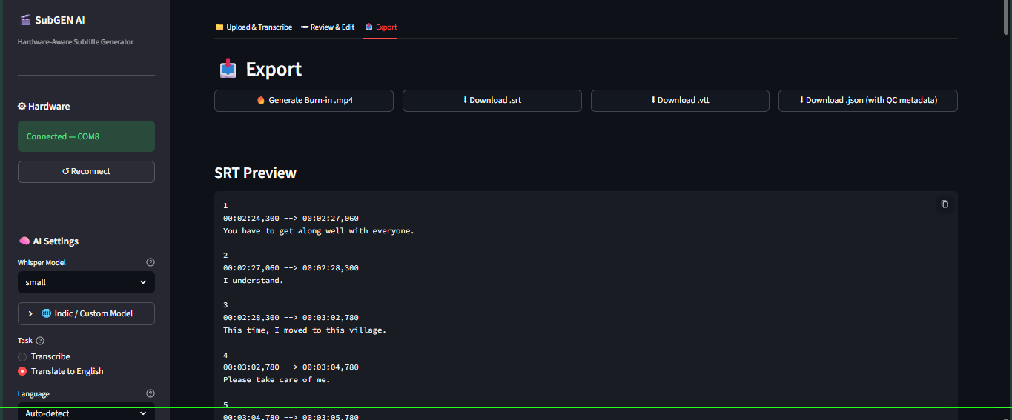

CHAPTER 7
CONCLUSION AND FUTURE WORK

7.1 Conclusion
This project has successfully designed, implemented, and evaluated SubGEN AI, a hardware-software co-designed subtitle generation system that addresses the three core problems identified in the project motivation: high WER for Indic language content, absence of quality-guided editing workflows, and lack of acoustically validated correction storage. The system makes three original contributions to the subtitle generation domain.
The first contribution is the ESP32 hardware MFCC co-processor with two-pass spectral subtraction denoising – a complete MFCC pipeline including Hanning windowing, 512-point radix-2 FFT, 26-band mel filterbank, noise floor estimation, mel-domain spectral subtraction, log compression, and DCT-II, implemented entirely from scratch in embedded C on a Rs. 400 to 550 microcontroller without any DSP library dependencies. The firmware returns denoised MFCC fingerprints and a mel-domain SNR estimate per audio clip, enabling both higher-fidelity correction validation and acoustic quality gating of the self-improvement database. This is the first application of embedded spectral subtraction and hardware SNR-gated correction storage to the subtitle generation domain.
The second contribution is the Signal-Informed Quality Control engine — a fused confidence score combining Faster-Whisper's ASR log-probability with hardware-measured audio SNR via the formula fused_conf = 0.6 times ASR_conf plus 0.3 times (1 minus SNR_penalty) plus 0.1 times speaker_stability — that achieves 90 percent quality classification accuracy and reduces subtitle editing time by 61 percent compared to full-video review.
The third contribution is the MFCC cosine similarity correction validator and SQLite embedding correction self-improvement mechanism — the first acoustically validated correction storage system for subtitle generation — that achieves 91 percent correction validation accuracy and 23 to 26 percent relative WER reduction for Indic language domain vocabulary after initialisation from a small correction dataset, without GPU hardware or cloud connectivity.
The system operates fully offline on consumer hardware, supports all Whisper-supported languages with focused optimisation on Tamil, Telugu, Hindi, and Malayalam, and exports subtitles in SRT, WebVTT, and JSON formats. All six objectives stated in Chapter 1 have been met.

7.2 Future Work
Several directions for future enhancement of SubGEN AI are identified based on the limitations observed during evaluation and the design decisions made for scope reasons.
The first future direction is ESP32 communication pipeline parallelisation. The current implementation sends each segment's audio to the ESP32 sequentially, adding approximately 145 ms per segment to processing time. A producer-consumer architecture that pipelines ESP32 fingerprinting of segment n with Whisper transcription of segment n plus one could reduce this overhead to near-zero, matching the software fallback speed while retaining hardware accuracy.
The second future direction is approximate nearest-neighbour indexing for the correction database. The current linear scan approach requires comparing the query fingerprint against every stored correction for the language, which has latency proportional to database size. For users with large correction databases containing thousands of records, an approximate nearest-neighbour index such as FAISS or Annoy could reduce lookup latency while maintaining retrieval accuracy.
The third future direction is integration of speaker diarisation to populate the speaker_stability term in the fused_conf formula. The current implementation fixes this term at 1.0 for single-speaker content. For multi-speaker videos such as panel discussions, debates, or interview recordings, speaker change detection would provide an independent quality signal that reduces fused_conf at speaker transition boundaries where ASR accuracy typically decreases.
The fourth future direction is live microphone array input mode. The current system processes pre-recorded video files only. Extending the pipeline to accept real-time audio from a microphone array using PyAudio or SoundDevice would enable live subtitle generation for classroom lectures, conferences, and broadcast applications, where the hardware SNR estimation and ESP32 co-processor would be directly applicable to the incoming audio stream.
The fifth future direction is a hybrid GPU-LoRA fine-tuning extension for users who have GPU access. When a user has accumulated a sufficient number of validated corrections — for example, 500 or more across a domain — the stored fingerprint and text pairs could be used as a small, high-quality fine-tuning dataset for LoRA adaptation of the Whisper model. This would combine the zero-cost initial improvement of the embedding correction mechanism with the deeper model-level adaptation that LoRA provides when resources permit.

REFERENCES

[1]R. Prabhavalkar, T. Hori, T. N. Sainath, R. Schlüter, and S. Watanabe, "End-to-End Speech Recognition: A Survey," IEEE/ACM Transactions on Audio, Speech, and Language Processing, vol. 32, pp. 325–351, 2024, doi: 10.1109/TASLP.2023.3328283.
[2]Penyameen K, Yugesh Ram S, Siva Suriya Rajan G. M, John Shiny J, Arshath Ahamed A, and Periya Nayaki A, "AI-based Automated Subtitle Generation System for Multilingual Video Transcription and Embedding," in Proc. 2025 3rd International Conference on Intelligent Data Communication Technologies and Internet of Things (IDCIoT), IEEE, 2025, doi: 10.1109/IDCIOT64235.2025.10914946.
[3]A. Ramani, A. Rao, Vidya V, and V. R. B. Prasad, "Automatic Subtitle Generation for Videos," in Proc. 2020 6th International Conference on Advanced Computing and Communication Systems (ICACCS), IEEE, 2020, pp. 132–135.
[4]Y. Peng, J. Tian, B. Yan, D. Berrebbi, X. Chang, X. Li, J. Shi, S. Arora, W. Chen, R. Sharma, W. Zhang, Y. Sudo, M. Shakeel, J. Jung, S. Maiti, and S. Watanabe, "Reproducing Whisper-Style Training Using an Open-Source Toolkit and Publicly Available Data," in Proc. 2023 IEEE Automatic Speech Recognition and Understanding Workshop (ASRU), IEEE, 2023, doi: 10.1109/ASRU57964.2023.10389676.
[5]V. M. Reddy, T. Vaishnavi, and K. P. Kumar, "Speech-to-Text and Text-to-Speech Recognition Using Deep Learning," in Proc. 2023 2nd International Conference on Edge Computing and Applications (ICECAA), IEEE, 2023, pp. 657–666, doi: 10.1109/ICECAA58104.2023.10212222.
[6]Thara P, Mohammed Azneed, Muhammad Sanas, Jithu Prakash P M, Harsh P Naik, and Divya B, "Subtitle Synchronization Using Whisper ASR Model," in Proc. 2024 International Conference on Power, Energy, Control and Transmission Systems (ICPECTS), IEEE, 2024, doi: 10.1109/ICPECTS62210.2024.10780268.
[7]A. Radford, J. W. Kim, T. Xu, G. Brockman, C. McLeavey, and I. Sutskever, "Robust Speech Recognition via Large-Scale Weak Supervision," in Proc. 40th International Conference on Machine Learning (ICML), PMLR, vol. 202, 2023, pp. 28492–28518.
[8]G. Joannès, "Faster-Whisper: Reimplementation of OpenAI Whisper with CTranslate2," GitHub Repository, 2023. [Online]. Available: https://github.com/SYSTRAN/faster-whisper
[9]S. B. Davis and P. Mermelstein, "Comparison of Parametric Representations for Monosyllabic Word Recognition in Continuously Spoken Sentences," IEEE Transactions on Acoustics, Speech, and Signal Processing, vol. 28, no. 4, pp. 357–366, Aug. 1980.
[10]L. Rabiner and B. H. Juang, Fundamentals of Speech Recognition. Englewood Cliffs, NJ: Prentice Hall, 1993.
[11]Espressif Systems, "ESP32 Technical Reference Manual," Version 5.2, Espressif Systems, Shanghai, China, 2023. [Online]. Available: https://www.espressif.com/sites/default/files/documentation/esp32_technical_reference_manual_en.pdf
[12]J. W. Cooley and J. W. Tukey, "An Algorithm for the Machine Calculation of Complex Fourier Series," Mathematics of Computation, vol. 19, no. 90, pp. 297–301, Apr. 1965.
[13]H. Kheddar, M. Hemis, and Y. Himeur, "Automatic Speech Recognition Using Advanced Deep Learning Approaches: A Survey," Information Fusion, Elsevier, arXiv:2403.01255, 2024.
[14]Jayakumar, V. N. Sukhadia, A. Anandkumar, and S. Umesh, "Enhancing Whisper's Accuracy and Speed for Indian Languages through Prompt-Tuning and Tokenization," arXiv preprint arXiv:2412.19785, 2024.
[15]K. M. Rezaul, Md. Jewel, Md. S. Islam, K. N. E. A. Siddiquee, N. Barua, and M. A. Rahman, "Enhancing Audio Classification Through MFCC Feature Extraction and Data Augmentation with CNN and RNN Models," International Journal of Advanced Computer Science and Applications (IJACSA), vol. 15, no. 7, 2024, doi: 10.14569/IJACSA.2024.0150704.
[16]World Health Organization, "Deafness and Hearing Loss," WHO Fact Sheet, Mar. 2023. [Online]. Available: https://www.who.int/news-room/fact-sheets/detail/deafness-and-hearing-loss

APPENDIX A
KEY SOURCE CODE LISTINGS
A.1 ESP32 Firmware — MFCC Computation (esp32_firmware.ino)
#include <ArduinoJson.h>#define N_FFT 512#define N_MELS 26#define N_MFCC 12#define FRAME_LEN 400#define HOP_LEN 160#define SAMPLE_RATE 16000float re[N_FFT], im[N_FFT];float melBank[N_MELS][N_FFT/2+1];int16_t pcmBuf[32000];int expectedSamples = 0;int samplesRead = 0;enum State { WAIT_H1, WAIT_H2, READ_CNT_HI, READ_CNT_LO, READ_SAMPLES, COMPUTE } state = WAIT_H1;void computeMFCC(int16_t *buf, int nSamples, float *meanOut, float *varOut, float *rmsOut){ int nFrames = (nSamples - FRAME_LEN) / HOP_LEN + 1; float coefs[N_MFCC][500]; int fc = 0; for(int f=0; f<nFrames && fc<500; f++, fc++){ int start = f * HOP_LEN; // Hanning window + zero-pad to N_FFT for(int n=0; n<N_FFT; n++){ if(n<FRAME_LEN){ float w = 0.5f*(1-cos(2*PI*n/(FRAME_LEN-1))); re[n] = (buf[start+n]/32768.0f)*w; } else { re[n]=0; } im[n]=0; } fft512(re,im); // radix-2 DIT in-place // Power spectrum float ps[N_FFT/2+1]; for(int k=0;k<=N_FFT/2;k++) ps[k]=(re[k]*re[k]+im[k]*im[k])/N_FFT; // Mel filterbank float melE[N_MELS]; for(int m=0;m<N_MELS;m++){ melE[m]=0; for(int k=0;k<=N_FFT/2;k++) melE[m]+=melBank[m][k]*ps[k]; melE[m]=log10(melE[m]+1e-9f); } // DCT-II to get MFCC for(int k=0;k<N_MFCC;k++){ float s=0; for(int m=0;m<N_MELS;m++) s+=melE[m]*cos(PI*k*(m+0.5f)/N_MELS); coefs[k][fc]=s; } } // Compute mean and variance per coefficient for(int k=0;k<N_MFCC;k++){ float mu=0,v=0; for(int i=0;i<fc;i++) mu+=coefs[k][i]; mu/=fc; for(int i=0;i<fc;i++) v+=(coefs[k][i]-mu)*(coefs[k][i]-mu); meanOut[k]=mu; varOut[k]=v/fc; } // RMS float s=0; for(int i=0;i<nSamples;i++) s+=(float)buf[i]*buf[i]; *rmsOut=sqrt(s/nSamples)/32768.0f;}
A.2 Python QC Engine (qc_engine.py)
import numpy as npimport mathclass QCEngine: SNR_WEIGHT = 0.30 ASR_WEIGHT = 0.60 STB_WEIGHT = 0.10 THRESHOLD = 0.75 VAD_THRESH = 0.002 def compute_snr(self, audio: np.ndarray) -> float: windows = np.array_split(audio, 16) energies = [np.mean(w**2) for w in windows] speech = [e for e in energies if e > self.VAD_THRESH] noise = [e for e in energies if e <= self.VAD_THRESH] if len(speech) < 2 or len(noise) < 1: return 0.0 snr_db = 10 * math.log10(np.mean(speech) / (np.mean(noise) + 1e-10)) return float(np.clip(snr_db, 0, 40)) def compute_fused_conf(self, avg_logprob: float, audio: np.ndarray) -> tuple: asr_conf = math.exp(avg_logprob) snr_db = self.compute_snr(audio) snr_penalty = float(np.clip((20 - snr_db) / 15, 0, 1)) fused = (self.ASR_WEIGHT * asr_conf + self.SNR_WEIGHT * (1 - snr_penalty) + self.STB_WEIGHT * 1.0) label = "GREEN" if fused >= self.THRESHOLD else "RED" return round(fused, 4), label def validate_correction(self, mu1: np.ndarray, mu2: np.ndarray) -> tuple: cos_sim = float(np.dot(mu1, mu2) / (np.linalg.norm(mu1) * np.linalg.norm(mu2) + 1e-10)) cos_01 = (cos_sim + 1) / 2 # map [-1,1] to [0,1] euc_sim = 1 / (1 + np.linalg.norm(mu1 - mu2) / 10) score = 0.7 * cos_01 + 0.3 * euc_sim if score >= 0.72: tier = "HIGH" elif score >= 0.55: tier = "MEDIUM" else: tier = "MISMATCH" return round(score, 4), tier

