[](http://www.comsol.com/)

Pcm+lcr

|  |  |
| --- | --- |
| Report date | Apr 29, 2025 10:51:31 AM |

Contents

1. Global Definitions

2. Component 1

2.1. Definitions

2.2. Geometry 1

2.3. Materials

2.4. Laminar Flow

2.5. Heat Transfer in Solids 2

2.6. Heat Transfer in Fluids 3

2.7. Mesh 1

3. Study 1

3.1. Time Dependent

3.2. Solver Configurations

4. Results

4.1. Data Sets

4.2. Derived Values

4.3. Plot Groups

1. Global Definitions

|  |  |
| --- | --- |
| Date | Apr 28, 2025 11:02:08 AM |

Global settings

|  |  |
| --- | --- |
| Name | Pcm+lcr.mph |
| Path | C:\Users\Harshita Agrawal\Desktop\pcm+lcr.mph |
| Version | COMSOL Multiphysics 5.4 (Build: 388) |
| Unit system | SI |

Used products

|  |
| --- |
| COMSOL Multiphysics |

1. Component 1

|  |  |
| --- | --- |
| Date | Apr 28, 2025 9:03:29 AM |

Settings

| **Description** | **Value** |
| --- | --- |
| Unit system | Same as global system |
| Geometry shape order | Automatic |

Spatial frame coordinates

| **First** | **Second** | **Third** |
| --- | --- | --- |
| x | y | z |

Material frame coordinates

| **First** | **Second** | **Third** |
| --- | --- | --- |
| X | Y | Z |

Geometry frame coordinates

| **First** | **Second** | **Third** |
| --- | --- | --- |
| Xg | Yg | Zg |

Mesh frame coordinates

| **First** | **Second** | **Third** |
| --- | --- | --- |
| Xm | Ym | Zm |

* 1. Definitions
     1. Component Couplings

#### Average 1

|  |  |
| --- | --- |
| Coupling type | Average |
| Operator name | aveop2 |

Selection

|  |  |
| --- | --- |
| Geometric entity level | Domain |
| Selection | Domain 2 |

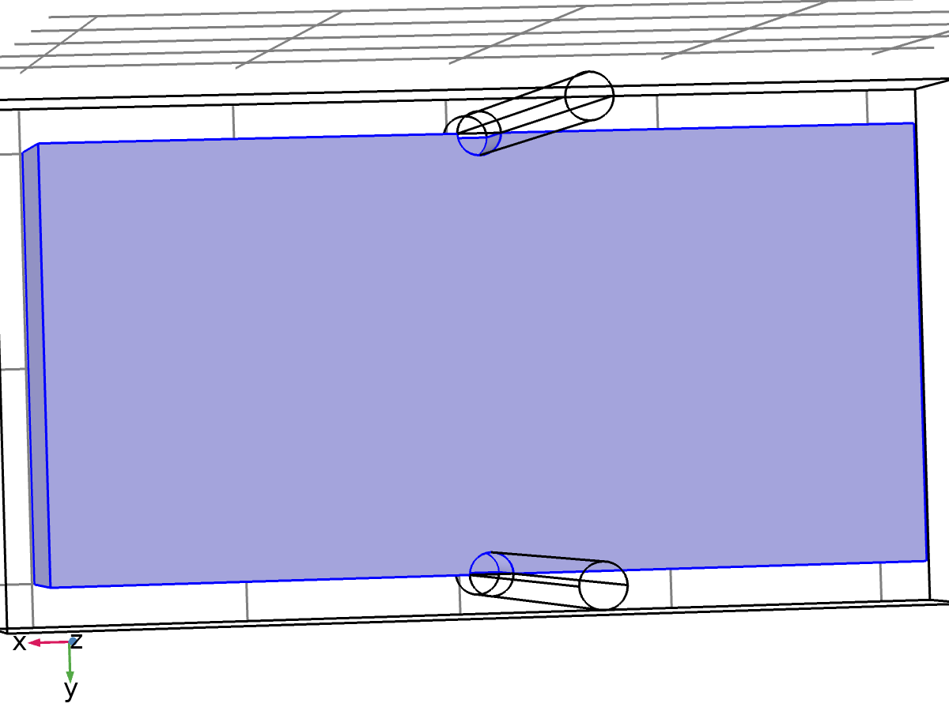

Selection

* + 1. Coordinate Systems

#### Boundary System 1

|  |  |
| --- | --- |
| Coordinate system type | Boundary system |
| Tag | sys1 |

Coordinate names

| **First** | **Second** | **Third** |
| --- | --- | --- |
| t1 | t2 | n |

* 1. Geometry 1

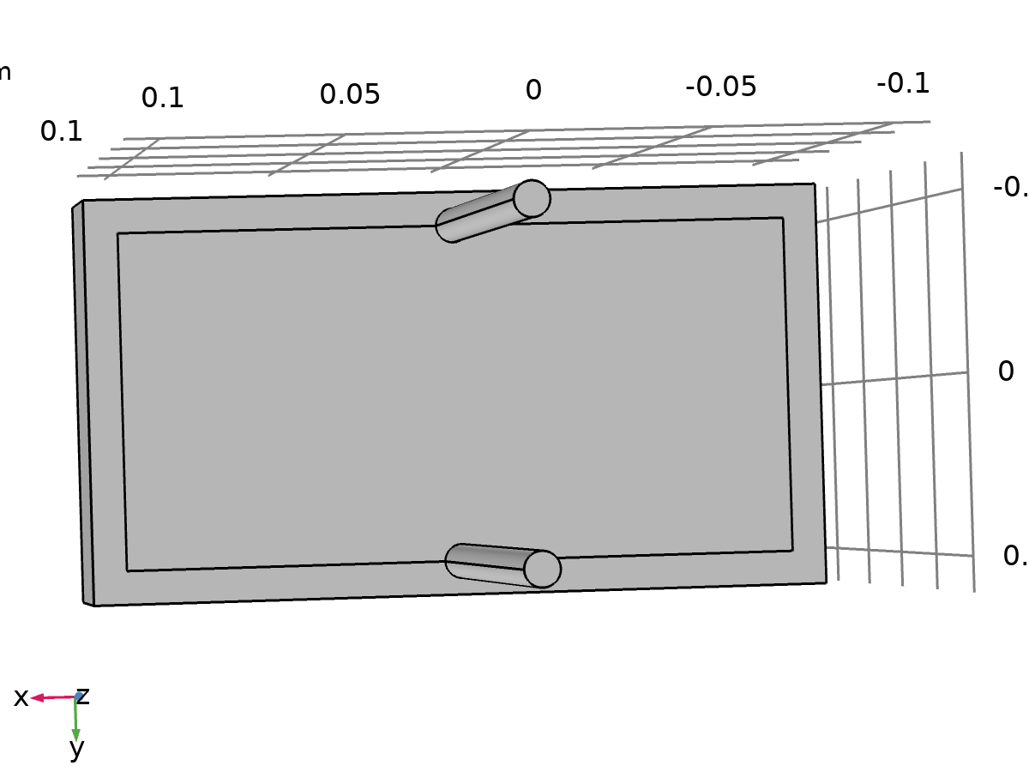

Geometry 1

Units

|  |  |
| --- | --- |
| Length unit | m |
| Angular unit | deg |

Geometry statistics

| **Description** | **Value** |
| --- | --- |
| Space dimension | 3 |
| Number of domains | 8 |
| Number of boundaries | 40 |
| Number of edges | 70 |
| Number of vertices | 40 |

* + 1. Battery Block (blk1)

Position

| **Description** | **Value** |
| --- | --- |
| Position | {0, 0, 0} |
| Base | Center |

Axis

| **Description** | **Value** |
| --- | --- |
| Axis type | z - axis |

Size and shape

| **Description** | **Value** |
| --- | --- |
| Width | 0.2 |
| Depth | 0.1 |
| Height | 0.05 |

* + 1. PCM Layer (blk2)

Position

| **Description** | **Value** |
| --- | --- |
| Position | {0, 0, 0} |
| Base | Center |

Axis

| **Description** | **Value** |
| --- | --- |
| Axis type | z - axis |

Size and shape

| **Description** | **Value** |
| --- | --- |
| Width | 0.22 |
| Depth | 0.12 |
| Height | 0.05 |

* + 1. Cooling Pipe1 (cyl1)

Position

| **Description** | **Value** |
| --- | --- |
| Position | {0, 0.05, 0} |

Axis

| **Description** | **Value** |
| --- | --- |
| Axis type | z - axis |

Size and shape

| **Description** | **Value** |
| --- | --- |
| Radius | 0.005 |
| Height | 0.2 |

* + 1. Cooling Pipe2 (cyl2)

Position

| **Description** | **Value** |
| --- | --- |
| Position | {0, -0.05, 0} |

Axis

| **Description** | **Value** |
| --- | --- |
| Axis type | z - axis |

Size and shape

| **Description** | **Value** |
| --- | --- |
| Radius | 0.005 |
| Height | 0.2 |

* 1. Materials
     1. Battery block

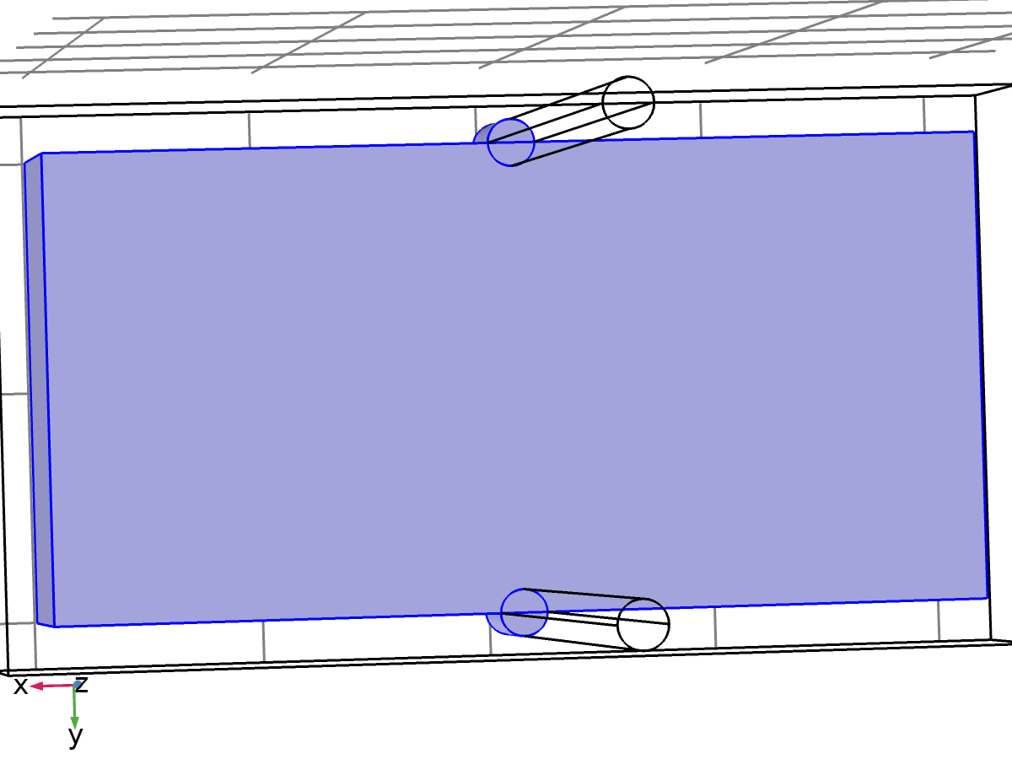

Battery block

Selection

|  |  |
| --- | --- |
| Geometric entity level | Domain |
| Selection | Domains 2–4, 6–7 |

Material parameters

| **Name** | **Value** | **Unit** |
| --- | --- | --- |
| Dynamic viscosity | eta(T) | Pa·s |
| Ratio of specific heats | 1.4 | 1 |
| Heat capacity at constant pressure | 1000 | J/(kg·K) |
| Density | 2500 | kg/m³ |
| Thermal conductivity | 1 | W/(m·K) |

Basic Settings

| **Description** | **Value** |
| --- | --- |
| Coefficient of thermal expansion | {{alpha_p(pA, T), 0, 0}, {0, alpha_p(pA, T), 0}, {0, 0, alpha_p(pA, T)}} |
| Mean molar mass | 0.02897 |
| Bulk viscosity | muB(T) |
| Relative permeability | {{1, 0, 0}, {0, 1, 0}, {0, 0, 1}} |
| Relative permittivity | {{1, 0, 0}, {0, 1, 0}, {0, 0, 1}} |
| Dynamic viscosity | eta(T) |
| Ratio of specific heats | 1.4 |
| Electrical conductivity | {{0[S/m], 0, 0}, {0, 0[S/m], 0}, {0, 0, 0[S/m]}} |
| Heat capacity at constant pressure | 1000 |
| Density | 2500 |
| Thermal conductivity | {{1, 0, 0}, {0, 1, 0}, {0, 0, 1}} |
| Speed of sound | cs(T) |

Functions

| **Function name** | **Type** |
| --- | --- |
| eta | Piecewise |
| Cp | Piecewise |
| rho | Analytic |
| k | Piecewise |
| cs | Analytic |
| alpha_p | Analytic |
| muB | Analytic |

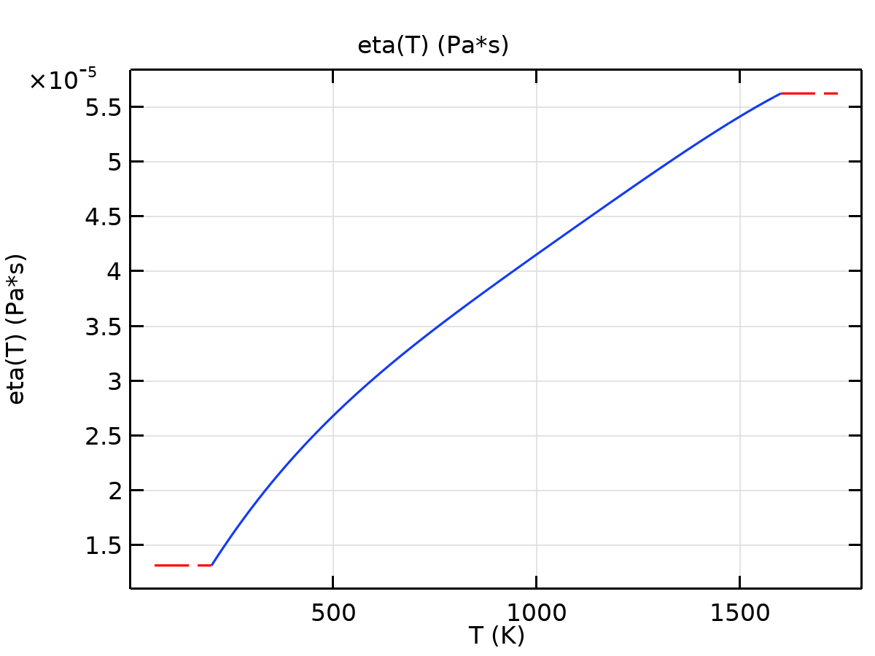

eta

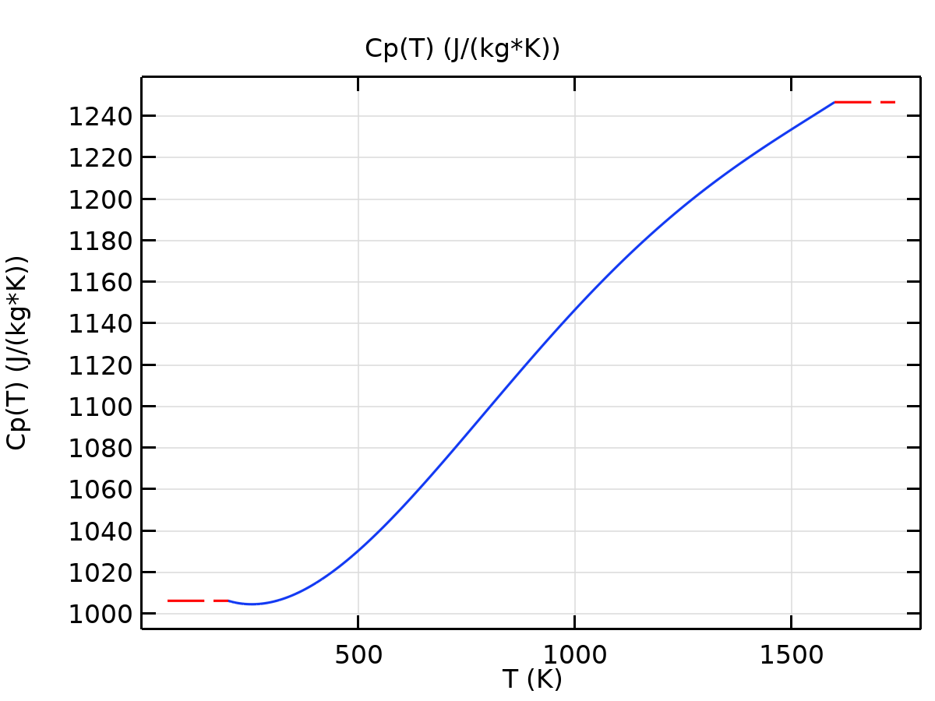

Cp

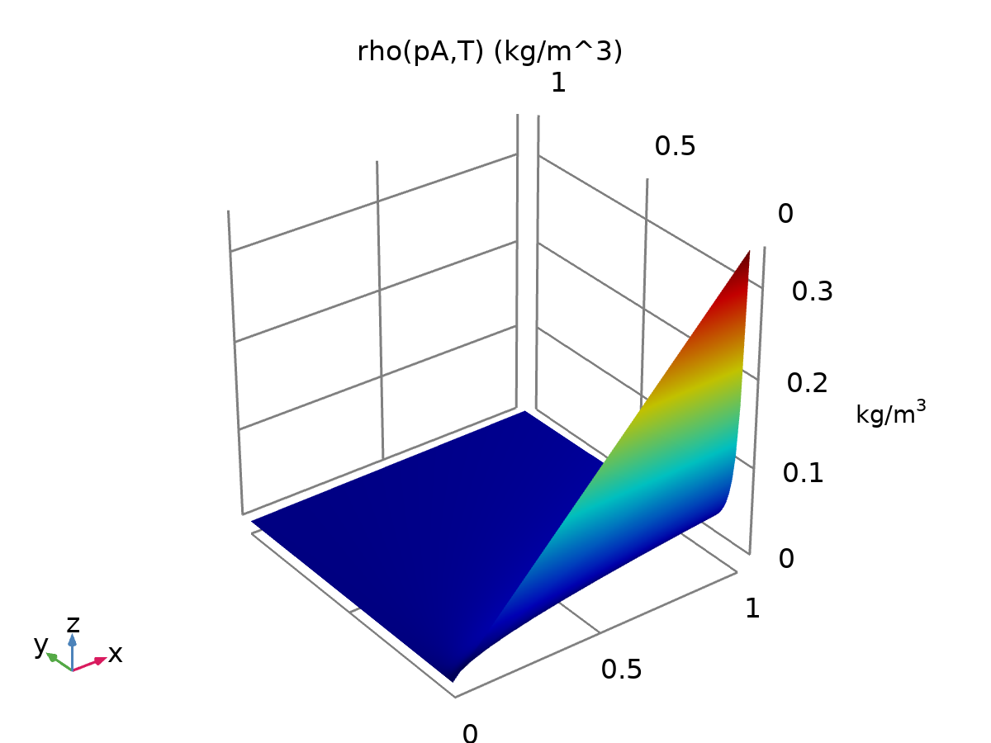

rho

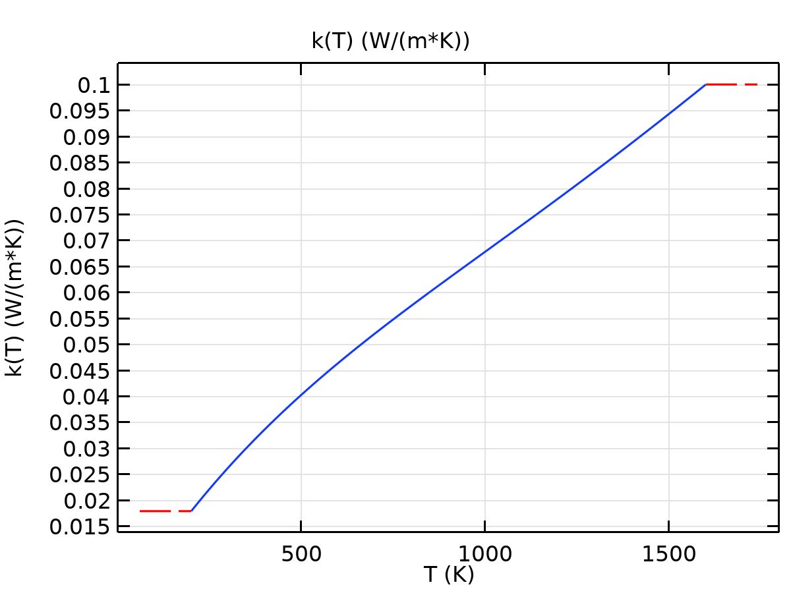

k

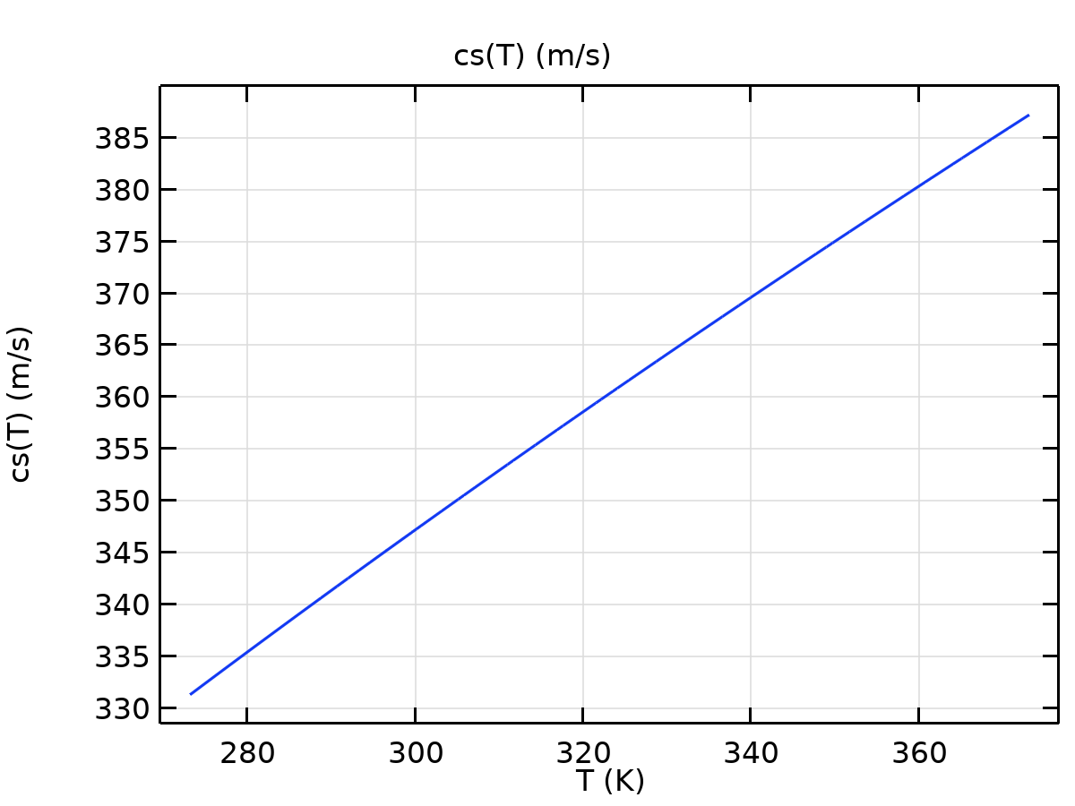

cs

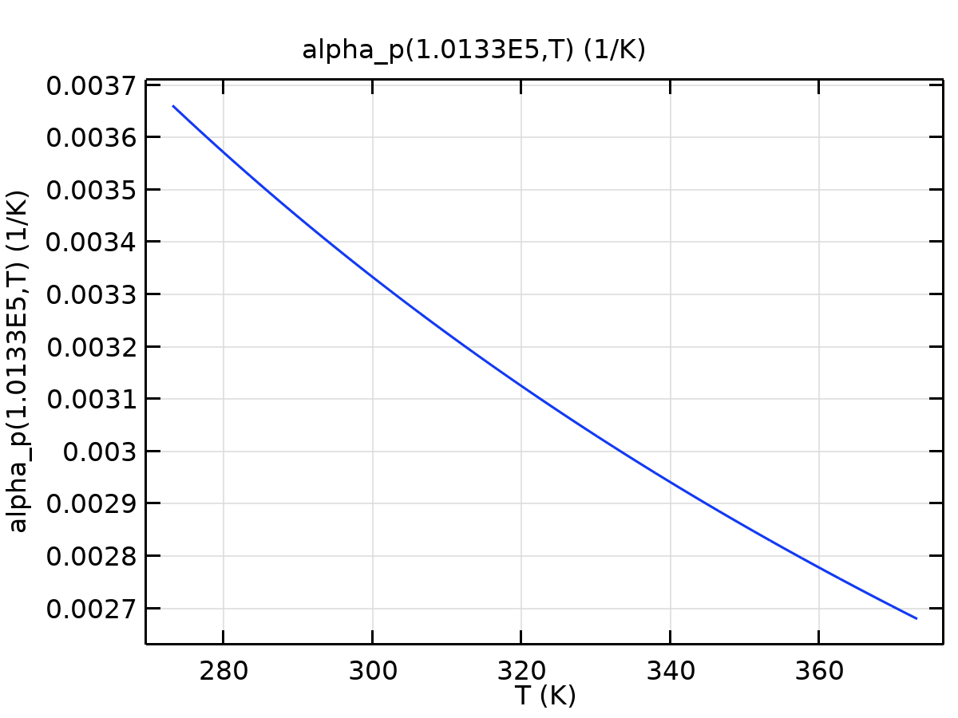

alpha_p

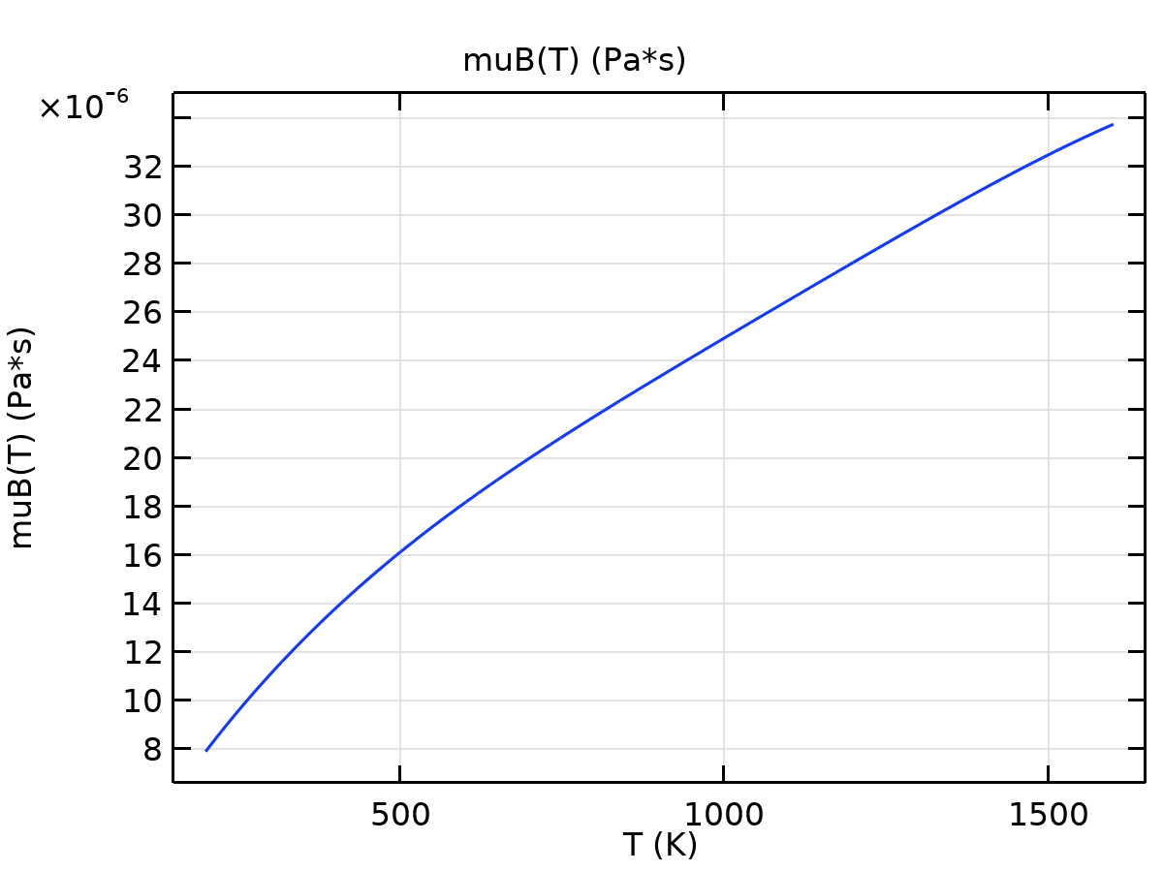

muB

Refractive index Settings

| **Description** | **Value** |
| --- | --- |
| Refractive index, real part | {{1, 0, 0}, {0, 1, 0}, {0, 0, 1}} |
| Refractive index, imaginary part | {{0, 0, 0}, {0, 0, 0}, {0, 0, 0}} |

Nonlinear model Settings

| **Description** | **Value** |
| --- | --- |
| Parameter of nonlinearity | (def.gamma + 1)/2 |

* + 1. PCM Layer

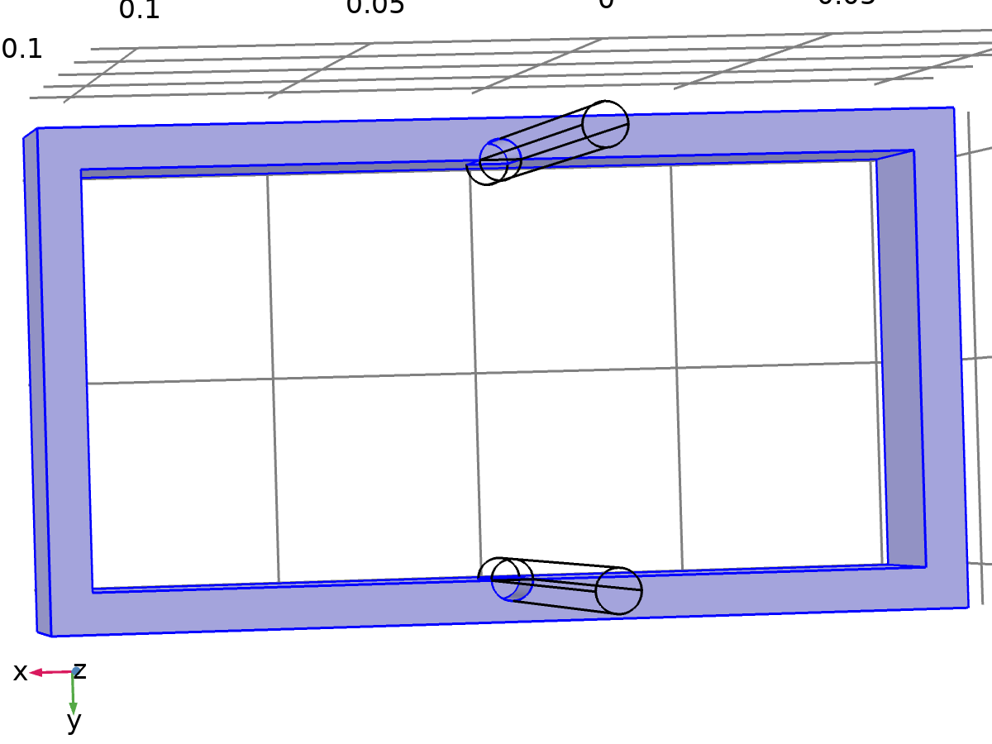

PCM Layer

Selection

|  |  |
| --- | --- |
| Geometric entity level | Domain |
| Selection | Domain 1 |

Material parameters

| **Name** | **Value** | **Unit** |
| --- | --- | --- |
| Dynamic viscosity | eta(T) | Pa·s |
| Ratio of specific heats | 1.4 | 1 |
| Heat capacity at constant pressure | 2000 | J/(kg·K) |
| Density | 800 | kg/m³ |
| Thermal conductivity | 0.2 | W/(m·K) |

Basic Settings

| **Description** | **Value** |
| --- | --- |
| Coefficient of thermal expansion | {{alpha_p(pA, T), 0, 0}, {0, alpha_p(pA, T), 0}, {0, 0, alpha_p(pA, T)}} |
| Mean molar mass | 0.02897 |
| Bulk viscosity | muB(T) |
| Relative permeability | {{1, 0, 0}, {0, 1, 0}, {0, 0, 1}} |
| Relative permittivity | {{1, 0, 0}, {0, 1, 0}, {0, 0, 1}} |
| Dynamic viscosity | eta(T) |
| Ratio of specific heats | 1.4 |
| Electrical conductivity | {{0[S/m], 0, 0}, {0, 0[S/m], 0}, {0, 0, 0[S/m]}} |
| Heat capacity at constant pressure | 2000 |
| Density | 800 |
| Thermal conductivity | {{0.2, 0, 0}, {0, 0.2, 0}, {0, 0, 0.2}} |
| Speed of sound | cs(T) |

Functions

| **Function name** | **Type** |
| --- | --- |
| eta | Piecewise |
| Cp | Piecewise |
| rho | Analytic |
| k | Piecewise |
| cs | Analytic |
| alpha_p | Analytic |
| muB | Analytic |



eta



Cp



rho



k



cs



alpha_p



muB

Refractive index Settings

| **Description** | **Value** |
| --- | --- |
| Refractive index, real part | {{1, 0, 0}, {0, 1, 0}, {0, 0, 1}} |
| Refractive index, imaginary part | {{0, 0, 0}, {0, 0, 0}, {0, 0, 0}} |

Nonlinear model Settings

| **Description** | **Value** |
| --- | --- |
| Parameter of nonlinearity | (def.gamma + 1)/2 |

* + 1. Coolin Pipes

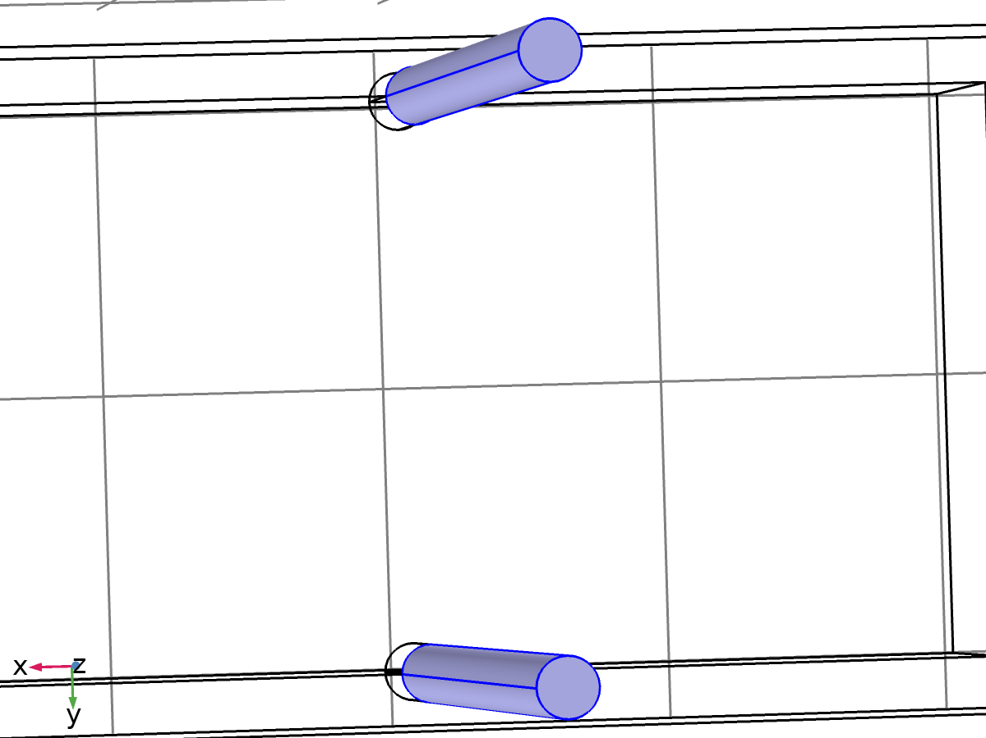

Coolin Pipes

Selection

|  |  |
| --- | --- |
| Geometric entity level | Domain |
| Selection | Domains 5, 8 |

Material parameters

| **Name** | **Value** | **Unit** |
| --- | --- | --- |
| Dynamic viscosity | eta(T) | Pa·s |
| Ratio of specific heats | 1.4 | 1 |
| Heat capacity at constant pressure | 4180 | J/(kg·K) |
| Density | 1050 | kg/m³ |
| Thermal conductivity | 0.6 | W/(m·K) |

Basic Settings

| **Description** | **Value** |
| --- | --- |
| Coefficient of thermal expansion | {{alpha_p(pA, T), 0, 0}, {0, alpha_p(pA, T), 0}, {0, 0, alpha_p(pA, T)}} |
| Mean molar mass | 0.02897 |
| Bulk viscosity | muB(T) |
| Relative permeability | {{1, 0, 0}, {0, 1, 0}, {0, 0, 1}} |
| Relative permittivity | {{1, 0, 0}, {0, 1, 0}, {0, 0, 1}} |
| Dynamic viscosity | eta(T) |
| Ratio of specific heats | 1.4 |
| Electrical conductivity | {{0[S/m], 0, 0}, {0, 0[S/m], 0}, {0, 0, 0[S/m]}} |
| Heat capacity at constant pressure | 4180 |
| Density | 1050 |
| Thermal conductivity | {{0.6, 0, 0}, {0, 0.6, 0}, {0, 0, 0.6}} |
| Speed of sound | cs(T) |

Functions

| **Function name** | **Type** |
| --- | --- |
| eta | Piecewise |
| Cp | Piecewise |
| rho | Analytic |
| k | Piecewise |
| cs | Analytic |
| alpha_p | Analytic |
| muB | Analytic |



eta



Cp



rho



k



cs



alpha_p



muB

Refractive index Settings

| **Description** | **Value** |
| --- | --- |
| Refractive index, real part | {{1, 0, 0}, {0, 1, 0}, {0, 0, 1}} |
| Refractive index, imaginary part | {{0, 0, 0}, {0, 0, 0}, {0, 0, 0}} |

Nonlinear model Settings

| **Description** | **Value** |
| --- | --- |
| Parameter of nonlinearity | (def.gamma + 1)/2 |

* 1. Laminar Flow

Used products

|  |
| --- |
| COMSOL Multiphysics |

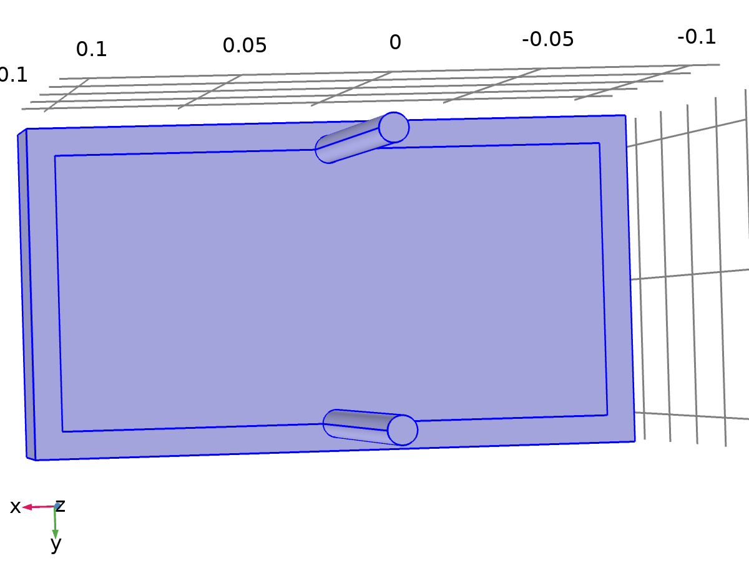

Laminar Flow

Selection

|  |  |
| --- | --- |
| Geometric entity level | Domain |
| Selection | Domains 1–8 |

Equations

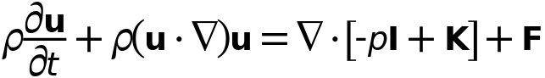



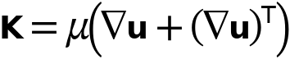

* + 1. Interface settings

#### Discretization

Settings

| **Description** | **Value** |
| --- | --- |
| Discretization of fluids | P1 + P1 |

#### Physical model

Settings

| **Description** | **Value** |
| --- | --- |
| Neglect inertial term (Stokes flow) | Off |
| Compressibility | Incompressible flow |
| Enable porous media domains | Off |
| Include gravity | Off |
| Reference temperature | User defined |
| Reference temperature | 293.15[K] |
| Reference pressure level | 1[atm] |

#### Turbulence

Settings

| **Description** | **Value** |
| --- | --- |
| Turbulence model type | None |

* + 1. Variables

| **Name** | **Expression** | **Unit** | **Description** | **Selection** | **Details** |
| --- | --- | --- | --- | --- | --- |
| spf.Tref | model.input.Tref | K | Reference temperature | Global | Meta |
| spf.dz | 1 | m | Thickness | Domains 1–8 |  |
| spf.pref | 1[atm] | Pa | Reference pressure level | Domains 1–8 |  |
| spf.pA | p+spf.pref | Pa | Absolute pressure | Domains 1–8 |  |
| spf.hasWF | 0 |  | Help variable | Boundaries 1–5, 8–9, 16–17, 20, 26–27, 30, 32, 34, 36, 38, 40 |  |
| spf.hasWF_u | 0 |  | Help variable | Boundaries 6–7, 10–15, 18–19, 21–25, 28–29, 31, 33, 35, 37, 39 |  |
| spf.hasWF_d | 0 |  | Help variable | Boundaries 6–7, 10–15, 18–19, 21–25, 28–29, 31, 33, 35, 37, 39 |  |
| spf.usePseudoTimeStepping | 0 | 1 | Help variable | Global | + operation |
| spf.localCFLvalue | 1.3^min(niterCMP,9)+if(niterCMP>=25,9*1.3^min(-25+niterCMP,9),0)+if(niterCMP>=45,90*1.3^min(-45+niterCMP,9),0) |  | Local CFL number | Domains 1–8 |  |
| spf.locCFL | CFLCMP | 1 | Local CFL number | Domains 1–8 |  |
| spf.geometryLengthScale | 0.03 | m | Geometry length scale | Domains 1–8 |  |
| spf.time_step_inv | max(sqrt(emetric_spatial(u,v,w)*2^gmg_level^2),spf.nu/spf.geometryLengthScale^2) | Hz | Inverse time step | Domains 1–8 |  |
| spf.tsti | nojac(spf.time_step_inv/spf.locCFL) | 1/s | Help variable | Domains 1–8 |  |
| spf.nx | nx | 1 | Normal vector, x component | Boundaries 6–7, 10–15, 18–19, 21–25, 28–29, 31, 33, 35, 37, 39 |  |
| spf.ny | ny | 1 | Normal vector, y component | Boundaries 6–7, 10–15, 18–19, 21–25, 28–29, 31, 33, 35, 37, 39 |  |
| spf.nz | nz | 1 | Normal vector, z component | Boundaries 6–7, 10–15, 18–19, 21–25, 28–29, 31, 33, 35, 37, 39 |  |
| spf.nx | dnx | 1 | Normal vector, x component | Boundaries 1–5, 8–9, 16–17, 20, 26–27, 30, 32, 34, 36, 38, 40 |  |
| spf.ny | dny | 1 | Normal vector, y component | Boundaries 1–5, 8–9, 16–17, 20, 26–27, 30, 32, 34, 36, 38, 40 |  |
| spf.nz | dnz | 1 | Normal vector, z component | Boundaries 1–5, 8–9, 16–17, 20, 26–27, 30, 32, 34, 36, 38, 40 |  |
| spf.nxmesh | root.nxmesh | 1 | Normal vector, x component | Boundaries 6–7, 10–15, 18–19, 21–25, 28–29, 31, 33, 35, 37, 39 |  |
| spf.nymesh | root.nymesh | 1 | Normal vector, y component | Boundaries 6–7, 10–15, 18–19, 21–25, 28–29, 31, 33, 35, 37, 39 |  |
| spf.nzmesh | root.nzmesh | 1 | Normal vector, z component | Boundaries 6–7, 10–15, 18–19, 21–25, 28–29, 31, 33, 35, 37, 39 |  |
| spf.nxmesh | dnxmesh | 1 | Normal vector, x component | Boundaries 1–5, 8–9, 16–17, 20, 26–27, 30, 32, 34, 36, 38, 40 |  |
| spf.nymesh | dnymesh | 1 | Normal vector, y component | Boundaries 1–5, 8–9, 16–17, 20, 26–27, 30, 32, 34, 36, 38, 40 |  |
| spf.nzmesh | dnzmesh | 1 | Normal vector, z component | Boundaries 1–5, 8–9, 16–17, 20, 26–27, 30, 32, 34, 36, 38, 40 |  |

* + 1. Fluid Properties 1



Fluid Properties 1

Selection

|  |  |
| --- | --- |
| Geometric entity level | Domain |
| Selection | Domains 1–8 |

Equations

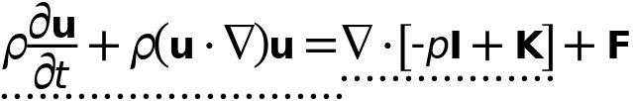





#### Fluid properties

Settings

| **Description** | **Value** |
| --- | --- |
| Density | From material |
| Dynamic viscosity | From material |

#### Model input

Settings

| **Description** | **Value** |
| --- | --- |
| Temperature | Common model input |

Properties from material

| **Property** | **Material** | **Property group** |
| --- | --- | --- |
| Density | Battery block | Basic |
| Dynamic viscosity | Battery block | Basic |
| Density | PCM Layer | Basic |
| Dynamic viscosity | PCM Layer | Basic |
| Density | Coolin Pipes | Basic |
| Dynamic viscosity | Coolin Pipes | Basic |

#### Variables

| **Name** | **Expression** | **Unit** | **Description** | **Selection** | **Details** |
| --- | --- | --- | --- | --- | --- |
| spf.rho | subst(material.rho,spf.fp1.minput_temperature,spf.Trho,spf.fp1.minput_pressure,spf.prho) | kg/m³ | Density | Domains 1–8 | Meta |
| spf.mu | material.mu | Pa·s | Dynamic viscosity | Domains 1–8 | Meta |
| spf.Trho | spf.Tref | K | Temperature for density evaluation | Domains 1–8 |  |
| spf.prho | spf.pref | Pa | Pressure for the evaluation of density | Domains 1–8 |  |
| spf.rhoref | subst(material.rho,spf.fp1.minput_temperature,spf.Tref,spf.fp1.minput_pressure,spf.pref) | kg/m³ | Reference density | Domains 1–8 | Meta |
| spf.mumat | material.mu | Pa·s | Dynamic viscosity | Domains 1–8 | Meta |
| spf.srijxx | ux | 1/s | Strain rate tensor, xx component | Domains 1–8 |  |
| spf.srijyx | 0.5*(vx+uy) | 1/s | Strain rate tensor, yx component | Domains 1–8 |  |
| spf.srijzx | 0.5*(wx+uz) | 1/s | Strain rate tensor, zx component | Domains 1–8 |  |
| spf.srijxy | 0.5*(uy+vx) | 1/s | Strain rate tensor, xy component | Domains 1–8 |  |
| spf.srijyy | vy | 1/s | Strain rate tensor, yy component | Domains 1–8 |  |
| spf.srijzy | 0.5*(wy+vz) | 1/s | Strain rate tensor, zy component | Domains 1–8 |  |
| spf.srijxz | 0.5*(uz+wx) | 1/s | Strain rate tensor, xz component | Domains 1–8 |  |
| spf.srijyz | 0.5*(vz+wy) | 1/s | Strain rate tensor, yz component | Domains 1–8 |  |
| spf.srijzz | wz | 1/s | Strain rate tensor, zz component | Domains 1–8 |  |
| spf.srijmeanxx | 0.5*root.comp1.spf.elemint(2*ux)/root.comp1.spf.elemint(1) | 1/s | Strain rate tensor, xx component | Domains 1–8 |  |
| spf.srijmeanyx | 0.5*root.comp1.spf.elemint(vx+uy)/root.comp1.spf.elemint(1) | 1/s | Strain rate tensor, yx component | Domains 1–8 |  |
| spf.srijmeanzx | 0.5*root.comp1.spf.elemint(wx+uz)/root.comp1.spf.elemint(1) | 1/s | Strain rate tensor, zx component | Domains 1–8 |  |
| spf.srijmeanxy | 0.5*root.comp1.spf.elemint(uy+vx)/root.comp1.spf.elemint(1) | 1/s | Strain rate tensor, xy component | Domains 1–8 |  |
| spf.srijmeanyy | 0.5*root.comp1.spf.elemint(2*vy)/root.comp1.spf.elemint(1) | 1/s | Strain rate tensor, yy component | Domains 1–8 |  |
| spf.srijmeanzy | 0.5*root.comp1.spf.elemint(wy+vz)/root.comp1.spf.elemint(1) | 1/s | Strain rate tensor, zy component | Domains 1–8 |  |
| spf.srijmeanxz | 0.5*root.comp1.spf.elemint(uz+wx)/root.comp1.spf.elemint(1) | 1/s | Strain rate tensor, xz component | Domains 1–8 |  |
| spf.srijmeanyz | 0.5*root.comp1.spf.elemint(vz+wy)/root.comp1.spf.elemint(1) | 1/s | Strain rate tensor, yz component | Domains 1–8 |  |
| spf.srijmeanzz | 0.5*root.comp1.spf.elemint(2*wz)/root.comp1.spf.elemint(1) | 1/s | Strain rate tensor, zz component | Domains 1–8 |  |
| spf.rrijxx | 0 | 1/s | Rotation rate tensor, xx component | Domains 1–8 |  |
| spf.rrijyx | 0.5*(vx-uy) | 1/s | Rotation rate tensor, yx component | Domains 1–8 |  |
| spf.rrijzx | 0.5*(wx-uz) | 1/s | Rotation rate tensor, zx component | Domains 1–8 |  |
| spf.rrijxy | 0.5*(uy-vx) | 1/s | Rotation rate tensor, xy component | Domains 1–8 |  |
| spf.rrijyy | 0 | 1/s | Rotation rate tensor, yy component | Domains 1–8 |  |
| spf.rrijzy | 0.5*(wy-vz) | 1/s | Rotation rate tensor, zy component | Domains 1–8 |  |
| spf.rrijxz | 0.5*(uz-wx) | 1/s | Rotation rate tensor, xz component | Domains 1–8 |  |
| spf.rrijyz | 0.5*(vz-wy) | 1/s | Rotation rate tensor, yz component | Domains 1–8 |  |
| spf.rrijzz | 0 | 1/s | Rotation rate tensor, zz component | Domains 1–8 |  |
| spf.sr | sqrt(2*spf.srijxx^2+2*spf.srijxy^2+2*spf.srijxz^2+2*spf.srijyx^2+2*spf.srijyy^2+2*spf.srijyz^2+2*spf.srijzx^2+2*spf.srijzy^2+2*spf.srijzz^2+eps) | 1/s | Shear rate | Domains 1–8 |  |
| spf.divu | ux+vy+wz | 1/s | Divergence of velocity field | Domains 1–8 |  |
| spf.Fx | 0 | N/m³ | Volume force, x component | Domains 1–8 | + operation |
| spf.Fy | 0 | N/m³ | Volume force, y component | Domains 1–8 | + operation |
| spf.Fz | 0 | N/m³ | Volume force, z component | Domains 1–8 | + operation |
| spf.U | sqrt(u^2+v^2+w^2) | m/s | Velocity magnitude | Domains 1–8 |  |
| spf.vorticityx | wy-vz | 1/s | Vorticity field, x component | Domains 1–8 |  |
| spf.vorticityy | -wx+uz | 1/s | Vorticity field, y component | Domains 1–8 |  |
| spf.vorticityz | vx-uy | 1/s | Vorticity field, z component | Domains 1–8 |  |
| spf.vort_magn | sqrt(spf.vorticityx^2+spf.vorticityy^2+spf.vorticityz^2) | 1/s | Vorticity magnitude | Domains 1–8 |  |
| spf.cellRe | 0.25*spf.rho*sqrt(emetric_spatial(u-d(x,TIME),v-d(y,TIME),w-d(z,TIME))/emetric2_spatial)/spf.mu | 1 | Cell Reynolds number | Domains 1–8 |  |
| spf.nu | spf.mu/spf.rho | m²/s | Kinematic viscosity | Domains 1–8 |  |
| spf.betaT | 0 | 1/Pa | Isothermal compressibility coefficient | Domains 1–8 |  |
| spf.Qm | 0 | kg/(m³·s) | Source term | Domains 1–8 | + operation |
| spf.Fgtotx | 0 | N/m³ | Gravity force, x component | Domains 1–8 | + operation |
| spf.Fgtoty | 0 | N/m³ | Gravity force, y component | Domains 1–8 | + operation |
| spf.Fgtotz | 0 | N/m³ | Gravity force, z component | Domains 1–8 | + operation |
| spf.mu_eff | spf.mu+spf.muT | Pa·s | Dynamic viscosity | Domains 1–8 |  |
| spf.muT | 0 | Pa·s | Turbulent dynamic viscosity | Domains 1–8 |  |
| spf.T_stressx | spf.K_stressx-p*spf.nxmesh | N/m² | Total stress, x component | Boundaries 1–40 | + operation |
| spf.T_stressy | spf.K_stressy-p*spf.nymesh | N/m² | Total stress, y component | Boundaries 1–40 | + operation |
| spf.T_stressz | spf.K_stressz-p*spf.nzmesh | N/m² | Total stress, z component | Boundaries 1–40 | + operation |
| spf.K_stressx | spf.mu_eff*(2*ux*spf.nxmesh+(uy+vx)*spf.nymesh+(uz+wx)*spf.nzmesh) | N/m² | Viscous stress, x component | Boundaries 1–40 | + operation |
| spf.K_stressy | spf.mu_eff*((vx+uy)*spf.nxmesh+2*vy*spf.nymesh+(vz+wy)*spf.nzmesh) | N/m² | Viscous stress, y component | Boundaries 1–40 | + operation |
| spf.K_stressz | spf.mu_eff*((wx+uz)*spf.nxmesh+(wy+vz)*spf.nymesh+2*wz*spf.nzmesh) | N/m² | Viscous stress, z component | Boundaries 1–40 | + operation |
| spf.K_stress_tensorxx | 2*spf.mu_eff*ux | N/m² | Viscous stress tensor, xx component | Domains 1–8 | + operation |
| spf.K_stress_tensoryx | spf.mu_eff*(vx+uy) | N/m² | Viscous stress tensor, yx component | Domains 1–8 | + operation |
| spf.K_stress_tensorzx | spf.mu_eff*(wx+uz) | N/m² | Viscous stress tensor, zx component | Domains 1–8 | + operation |
| spf.K_stress_tensorxy | spf.mu_eff*(uy+vx) | N/m² | Viscous stress tensor, xy component | Domains 1–8 | + operation |
| spf.K_stress_tensoryy | 2*spf.mu_eff*vy | N/m² | Viscous stress tensor, yy component | Domains 1–8 | + operation |
| spf.K_stress_tensorzy | spf.mu_eff*(wy+vz) | N/m² | Viscous stress tensor, zy component | Domains 1–8 | + operation |
| spf.K_stress_tensorxz | spf.mu_eff*(uz+wx) | N/m² | Viscous stress tensor, xz component | Domains 1–8 | + operation |
| spf.K_stress_tensoryz | spf.mu_eff*(vz+wy) | N/m² | Viscous stress tensor, yz component | Domains 1–8 | + operation |
| spf.K_stress_tensorzz | 2*spf.mu_eff*wz | N/m² | Viscous stress tensor, zz component | Domains 1–8 | + operation |
| spf.K_stress_tensor_testxx | 2*spf.mu_eff*test(ux) | N/m² | Viscous stress tensor test, xx component | Domains 1–8 | + operation |
| spf.K_stress_tensor_testyx | spf.mu_eff*(test(vx)+test(uy)) | N/m² | Viscous stress tensor test, yx component | Domains 1–8 | + operation |
| spf.K_stress_tensor_testzx | spf.mu_eff*(test(wx)+test(uz)) | N/m² | Viscous stress tensor test, zx component | Domains 1–8 | + operation |
| spf.K_stress_tensor_testxy | spf.mu_eff*(test(uy)+test(vx)) | N/m² | Viscous stress tensor test, xy component | Domains 1–8 | + operation |
| spf.K_stress_tensor_testyy | 2*spf.mu_eff*test(vy) | N/m² | Viscous stress tensor test, yy component | Domains 1–8 | + operation |
| spf.K_stress_tensor_testzy | spf.mu_eff*(test(wy)+test(vz)) | N/m² | Viscous stress tensor test, zy component | Domains 1–8 | + operation |
| spf.K_stress_tensor_testxz | spf.mu_eff*(test(uz)+test(wx)) | N/m² | Viscous stress tensor test, xz component | Domains 1–8 | + operation |
| spf.K_stress_tensor_testyz | spf.mu_eff*(test(vz)+test(wy)) | N/m² | Viscous stress tensor test, yz component | Domains 1–8 | + operation |
| spf.K_stress_tensor_testzz | 2*spf.mu_eff*test(wz) | N/m² | Viscous stress tensor test, zz component | Domains 1–8 | + operation |
| spf.upwind_helpx | u-d(x,TIME) | m/s | Upwind term, x component | Domains 1–8 | + operation |
| spf.upwind_helpy | v-d(y,TIME) | m/s | Upwind term, y component | Domains 1–8 | + operation |
| spf.upwind_helpz | w-d(z,TIME) | m/s | Upwind term, z component | Domains 1–8 | + operation |
| spf.tau_vdxx | 2*spf.mu*spf.srijxx | Pa | Viscous stress tensor, xx component | Domains 1–8 | + operation |
| spf.tau_vdyx | 2*spf.mu*spf.srijyx | Pa | Viscous stress tensor, yx component | Domains 1–8 | + operation |
| spf.tau_vdzx | 2*spf.mu*spf.srijzx | Pa | Viscous stress tensor, zx component | Domains 1–8 | + operation |
| spf.tau_vdxy | 2*spf.mu*spf.srijxy | Pa | Viscous stress tensor, xy component | Domains 1–8 | + operation |
| spf.tau_vdyy | 2*spf.mu*spf.srijyy | Pa | Viscous stress tensor, yy component | Domains 1–8 | + operation |
| spf.tau_vdzy | 2*spf.mu*spf.srijzy | Pa | Viscous stress tensor, zy component | Domains 1–8 | + operation |
| spf.tau_vdxz | 2*spf.mu*spf.srijxz | Pa | Viscous stress tensor, xz component | Domains 1–8 | + operation |
| spf.tau_vdyz | 2*spf.mu*spf.srijyz | Pa | Viscous stress tensor, yz component | Domains 1–8 | + operation |
| spf.tau_vdzz | 2*spf.mu*spf.srijzz | Pa | Viscous stress tensor, zz component | Domains 1–8 | + operation |
| spf.Qvd | spf.tau_vdxx*ux+spf.tau_vdxy*uy+spf.tau_vdxz*uz+spf.tau_vdyx*vx+spf.tau_vdyy*vy+spf.tau_vdyz*vz+spf.tau_vdzx*wx+spf.tau_vdzy*wy+spf.tau_vdzz*wz | W/m³ | Viscous dissipation | Domains 1–8 | + operation |
| spf.epsilon_p | 1 | 1 | Porosity | Domains 1–8 |  |
| spf.Fst_tensorxx | 0 | N/m² | Surface tension force, xx component | Domains 1–8 | + operation |
| spf.Fst_tensoryx | 0 | N/m² | Surface tension force, yx component | Domains 1–8 | + operation |
| spf.Fst_tensorzx | 0 | N/m² | Surface tension force, zx component | Domains 1–8 | + operation |
| spf.Fst_tensorxy | 0 | N/m² | Surface tension force, xy component | Domains 1–8 | + operation |
| spf.Fst_tensoryy | 0 | N/m² | Surface tension force, yy component | Domains 1–8 | + operation |
| spf.Fst_tensorzy | 0 | N/m² | Surface tension force, zy component | Domains 1–8 | + operation |
| spf.Fst_tensorxz | 0 | N/m² | Surface tension force, xz component | Domains 1–8 | + operation |
| spf.Fst_tensoryz | 0 | N/m² | Surface tension force, yz component | Domains 1–8 | + operation |
| spf.Fst_tensorzz | 0 | N/m² | Surface tension force, zz component | Domains 1–8 | + operation |
| spf.continuityEquation | spf.rho*spf.divu | kg/(m³·s) | Continuity equation | Domains 1–8 |  |
| spf.contCoeff | spf.rho | kg/m³ | Help variable | Domains 1–8 |  |
| spf.res_u | spf.rho*ut+px+spf.rho*u*ux+spf.rho*v*uy+spf.rho*w*uz-(d(2*ux,x)+d(uy+vx,y)+d(uz+wx,z))*spf.mu-spf.Fx | N/m³ | Equation residual | Domains 1–8 |  |
| spf.res_v | spf.rho*vt+spf.rho*u*vx+py+spf.rho*v*vy+spf.rho*w*vz-(d(vx+uy,x)+d(2*vy,y)+d(vz+wy,z))*spf.mu-spf.Fy | N/m³ | Equation residual | Domains 1–8 |  |
| spf.res_w | spf.rho*wt+spf.rho*u*wx+spf.rho*v*wy+pz+spf.rho*w*wz-(d(wx+uz,x)+d(wy+vz,y)+d(2*wz,z))*spf.mu-spf.Fz | N/m³ | Equation residual | Domains 1–8 |  |
| spf.res_p | spf.rho*spf.divu | kg/(m³·s) | Pressure equation residual | Domains 1–8 |  |

#### Shape functions

| **Name** | **Shape function** | **Unit** | **Description** | **Shape frame** | **Selection** |
| --- | --- | --- | --- | --- | --- |
| u | Lagrange (Linear) | m/s | Velocity field, x component | Spatial | Domains 1–8 |
| v | Lagrange (Linear) | m/s | Velocity field, y component | Spatial | Domains 1–8 |
| w | Lagrange (Linear) | m/s | Velocity field, z component | Spatial | Domains 1–8 |
| p | Lagrange (Linear) | Pa | Pressure | Spatial | Domains 1–8 |

#### Weak expressions

| **Weak expression** | **Integration order** | **Integration frame** | **Selection** |
| --- | --- | --- | --- |
| spf.rho*(-ut*test(u)-vt*test(v)-wt*test(w)) | 2 | Spatial | Domains 1–8 |
| (p-spf.K_stress_tensorxx)*test(ux)-spf.K_stress_tensorxy*test(uy)-spf.K_stress_tensorxz*test(uz)-spf.K_stress_tensoryx*test(vx)+(p-spf.K_stress_tensoryy)*test(vy)-spf.K_stress_tensoryz*test(vz)-spf.K_stress_tensorzx*test(wx)-spf.K_stress_tensorzy*test(wy)+(p-spf.K_stress_tensorzz)*test(wz) | 2 | Spatial | Domains 1–8 |
| spf.Fx*test(u)+spf.Fy*test(v)+spf.Fz*test(w) | 2 | Spatial | Domains 1–8 |
| spf.rho*(-(d(u,x)*u+d(u,y)*v+d(u,z)*w)*test(u)-(d(v,x)*u+d(v,y)*v+d(v,z)*w)*test(v)-(d(w,x)*u+d(w,y)*v+d(w,z)*w)*test(w)) | 2 | Spatial | Domains 1–8 |
| -spf.continuityEquation*test(p) | 2 | Spatial | Domains 1–8 |
| spf.streamlinens | 2 | Spatial | Domains 1–8 |
| spf.crosswindns | 2 | Spatial | Domains 1–8 |

* + 1. Initial Values 1



Initial Values 1

Selection

|  |  |
| --- | --- |
| Geometric entity level | Domain |
| Selection | Domains 1–8 |

#### Initial values

Settings

| **Description** | **Value** |
| --- | --- |
| Velocity field, x component | 0 |
| Velocity field, y component | 0 |
| Velocity field, z component | 0 |
| Pressure | 0 |

#### Coordinate system selection

Settings

| **Description** | **Value** |
| --- | --- |
| Coordinate system | Global coordinate system |

#### Variables

| **Name** | **Expression** | **Unit** | **Description** | **Selection** |
| --- | --- | --- | --- | --- |
| spf.u_initx | 0 | m/s | Velocity field, x component | Domains 1–8 |
| spf.u_inity | 0 | m/s | Velocity field, y component | Domains 1–8 |
| spf.u_initz | 0 | m/s | Velocity field, z component | Domains 1–8 |
| spf.p_init | 0 | Pa | Pressure | Domains 1–8 |

* + 1. Wall 1

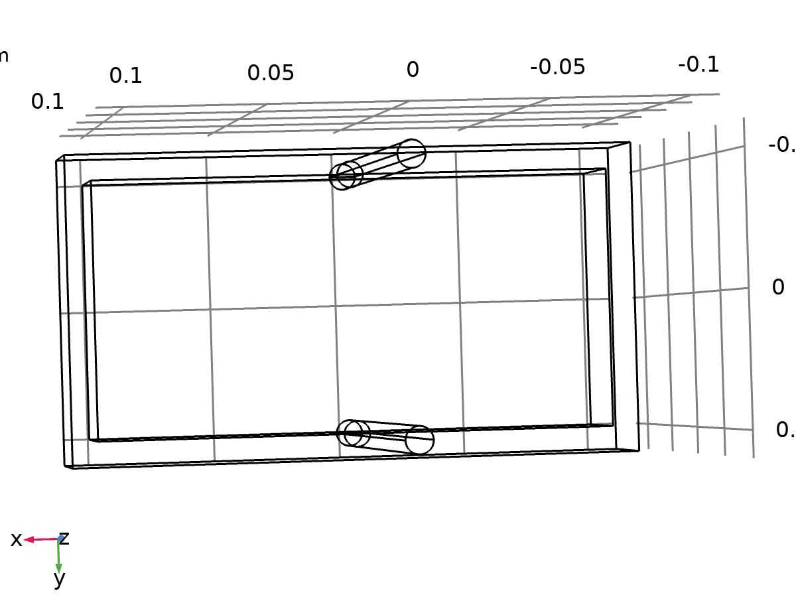

Wall 1

Selection

|  |  |
| --- | --- |
| Geometric entity level | Boundary |
| Selection | No boundaries |

Equations



#### Boundary condition

Settings

| **Description** | **Value** |
| --- | --- |
| Wall condition | No slip |

#### Wall movement

Settings

| **Description** | **Value** |
| --- | --- |
| Translational velocity | Automatic from frame |
| Sliding wall | Off |

* + 1. Inlet 1

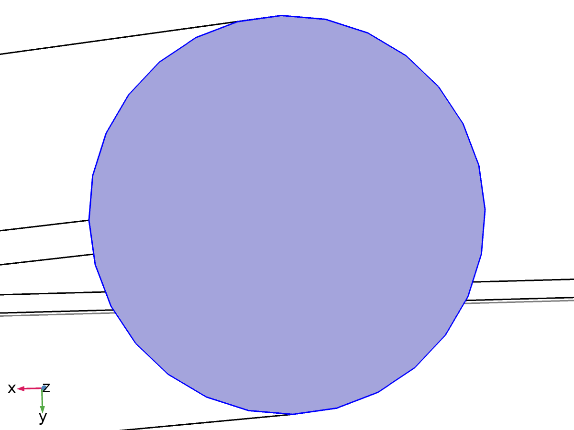

Inlet 1

Selection

|  |  |
| --- | --- |
| Geometric entity level | Boundary |
| Selection | Boundary 20 |

Equations



#### Boundary condition

Settings

| **Description** | **Value** |
| --- | --- |
| Boundary condition | Velocity |

#### Velocity

Settings

| **Description** | **Value** |
| --- | --- |
| Velocity field componentwise | Normal inflow velocity |
| Normal inflow velocity | 001 |

#### Variables

| **Name** | **Expression** | **Unit** | **Description** | **Selection** | **Details** |
| --- | --- | --- | --- | --- | --- |
| spf.ubndx | -nojac(spf.nxmesh)*spf.U0in | m/s | Velocity at boundary, x component | Boundary 20 | + operation |
| spf.ubndy | -nojac(spf.nymesh)*spf.U0in | m/s | Velocity at boundary, y component | Boundary 20 | + operation |
| spf.ubndz | -nojac(spf.nzmesh)*spf.U0in | m/s | Velocity at boundary, z component | Boundary 20 | + operation |
| spf.U0in | 1 | m/s | Normal inflow velocity | Boundary 20 |  |

#### Constraints

| **Constraint** | **Constraint force** | **Shape function** | **Selection** | **Details** |
| --- | --- | --- | --- | --- |
| -u+spf.ubndx | test(-u+spf.ubndx) | Lagrange (Linear) | Boundary 20 | Elemental |
| -v+spf.ubndy | test(-v+spf.ubndy) | Lagrange (Linear) | Boundary 20 | Elemental |
| -w+spf.ubndz | test(-w+spf.ubndz) | Lagrange (Linear) | Boundary 20 | Elemental |

* + 1. Outlet 1

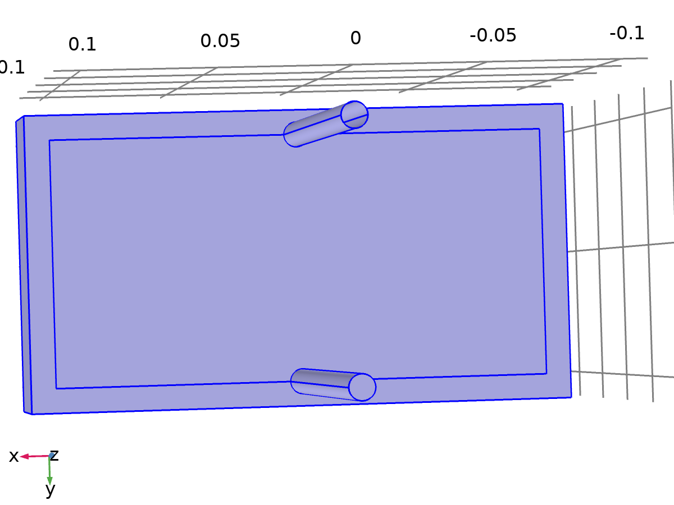

Outlet 1

Selection

|  |  |
| --- | --- |
| Geometric entity level | Boundary |
| Selection | Boundaries 1–5, 8–9, 16–17, 26–27, 30, 32, 34, 36, 38, 40 |

Equations





#### Boundary condition

Settings

| **Description** | **Value** |
| --- | --- |
| Boundary condition | Pressure |

#### Pressure conditions

Settings

| **Description** | **Value** |
| --- | --- |
| Pressure | 0 |
| Normal flow | Off |
| Suppress backflow | On |

#### Variables

| **Name** | **Expression** | **Unit** | **Description** | **Selection** |
| --- | --- | --- | --- | --- |
| spf.meshVol | meshvol_spatial | m² |  | Boundaries 1–5, 8–9, 16–17, 26–27, 30, 32, 34, 36, 38, 40 |
| spf.meshVolInt | down(meshvol_spatial) | m³ | Volume of interior mesh element | Boundaries 1–5, 8–9, 16–17, 26–27, 30, 32, 34, 36, 38, 40 |
| spf.c_here | 144/spf.epsilon_p | 1 | Intermediate variable | Boundaries 1–5, 8–9, 16–17, 26–27, 30, 32, 34, 36, 38, 40 |
| spf.rhoFace | down(spf.rho) | kg/m³ | Density face value | Boundaries 1–5, 8–9, 16–17, 26–27, 30, 32, 34, 36, 38, 40 |
| spf.umxTnFace | spf.upwind_helpx*spf.nxmesh+spf.upwind_helpy*spf.nymesh+spf.upwind_helpz*spf.nzmesh | m/s | Relative velocity on face | Boundaries 1–5, 8–9, 16–17, 26–27, 30, 32, 34, 36, 38, 40 |
| spf.upwind_ns | spf.backflowPenaltyConv*spf.uNormal | Pa | Upwind term | Boundaries 1–5, 8–9, 16–17, 26–27, 30, 32, 34, 36, 38, 40 |
| spf.p0 | 0 | Pa | Pressure | Boundaries 1–5, 8–9, 16–17, 26–27, 30, 32, 34, 36, 38, 40 |
| spf.out1.Uav | 0 | m/s | Average velocity | Global |
| spf.out1.Uavfdf | 0 | m/s | Average velocity | Global |
| spf.out1.Mflow | spf.out1.intFlow(spf.rho*(spf.nx*u+spf.ny*v+spf.nz*w)) | kg/s | Mass flow | Global |
| spf.f0 | spf.p0+spf.uNormal*(spf.backflowPenaltyDiff-spf.backflowPenaltyConv)*(spf.uNormal<0) | N/m² | Normal stress | Boundaries 1–5, 8–9, 16–17, 26–27, 30, 32, 34, 36, 38, 40 |
| spf.uNormal | u*nojac(spf.nxmesh)+v*nojac(spf.nymesh)+w*nojac(spf.nzmesh) | m/s | Normal velocity | Boundaries 1–5, 8–9, 16–17, 26–27, 30, 32, 34, 36, 38, 40 |
| spf.backflowPenaltyDiff | spf.c_here*min((down(spf.mu)+spf.muT)*spf.meshVol/spf.meshVolInt,down(spf.rho)*abs(spf.uNormal)/down(spf.epsilon_p)) | Pa·s/m | Backflow penalty parameter, diffusive contribution | Boundaries 1–5, 8–9, 16–17, 26–27, 30, 32, 34, 36, 38, 40 |
| spf.backflowPenaltyConv | spf.rhoFace*spf.umxTnFace/spf.epsilon_p^2 | kg/(m²·s) | Backflow penalty parameter, convective contribution | Boundaries 1–5, 8–9, 16–17, 26–27, 30, 32, 34, 36, 38, 40 |

#### Weak expressions

| **Weak expression** | **Integration order** | **Integration frame** | **Selection** |
| --- | --- | --- | --- |
| -spf.f0*(test(u)*spf.nxmesh+test(v)*spf.nymesh+test(w)*spf.nzmesh) | 2 | Spatial | Boundaries 1–5, 8–9, 16–17, 26–27, 30, 32, 34, 36, 38, 40 |

* 1. Heat Transfer in Solids 2

Used products

|  |
| --- |
| COMSOL Multiphysics |

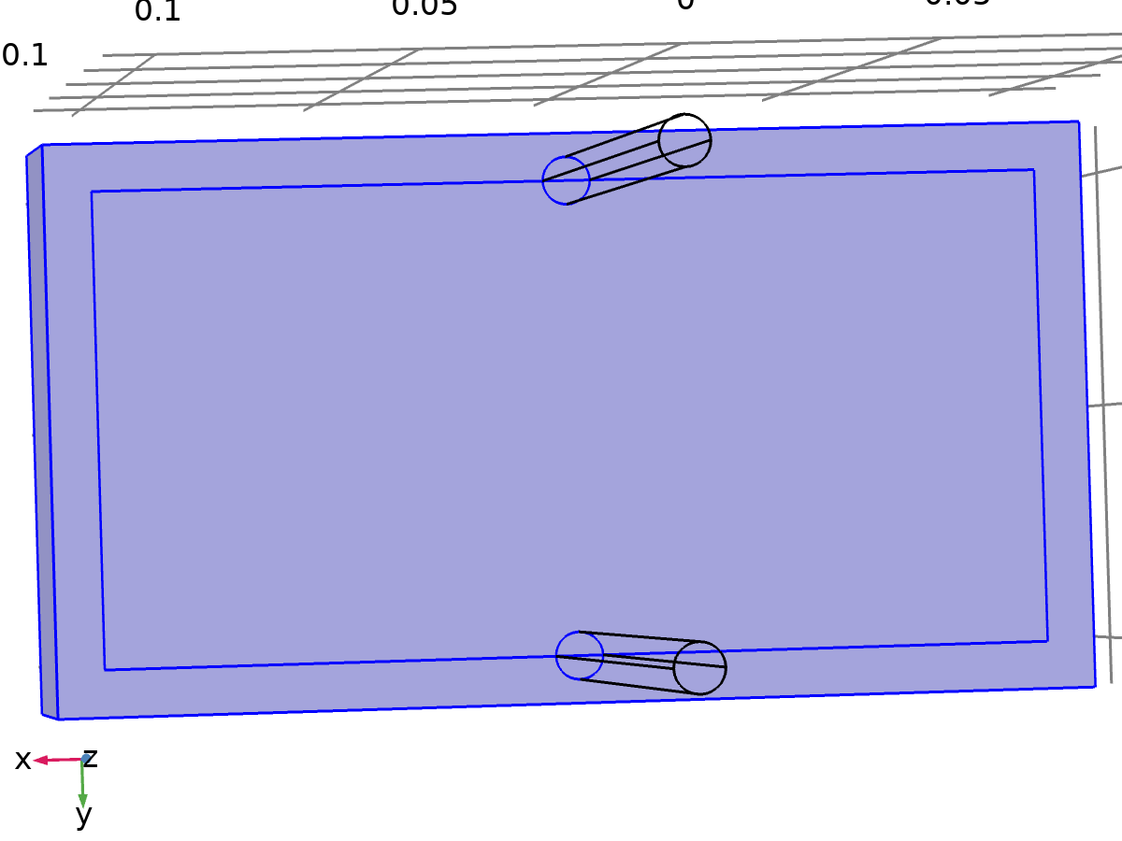

Heat Transfer in Solids 2

Selection

|  |  |
| --- | --- |
| Geometric entity level | Domain |
| Selection | Domains 1–4, 6–7 |

Equations

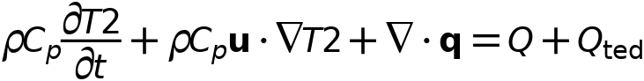



* + 1. Interface settings

#### Discretization

Settings

| **Description** | **Value** |
| --- | --- |
| Temperature | Quadratic Lagrange |

#### Physical model

Settings

| **Description** | **Value** |
| --- | --- |
| Heat transfer in biological tissue | Off |
| Isothermal domain | Off |
| Heat transfer in porous media | Off |
| Heat transfer in alloys | Off |
| Reference temperature | User defined |
| Reference temperature | 293.15[K] |

* + 1. Variables

| **Name** | **Expression** | **Unit** | **Description** | **Selection** | **Details** |
| --- | --- | --- | --- | --- | --- |
| ht2.q0 | 0 | W/m² | Inward heat flux | Boundaries 1–15, 18–19, 21–25, 28–29, 31, 33, 35, 37, 39–40 | + operation |
| ht2.Tu | up(T2) | K | Temperature | Boundaries 6–7, 10–15, 21–25, 31, 33, 35, 37, 39 |  |
| ht2.Tu | T2 | K | Temperature | Boundaries 1–5, 8–9, 18–19, 28–29, 40 |  |
| ht2.Td | down(T2) | K | Temperature | Boundaries 6–7, 10–15, 21–25, 31, 33, 35, 37, 39 |  |
| ht2.Td | T2 | K | Temperature | Boundaries 1–5, 8–9, 18–19, 28–29, 40 |  |
| ht2.Tref | model.input.Tref | K | Reference temperature | Global | Meta |
| ht2.d | 1 | 1 | Thickness | Domains 1–4, 6–7 |  |
| ht2.HRef | 0 | J/kg | Reference enthalpy | Domains 1–4, 6–7 |  |
| ht2.DeltaH | 0 | J/kg | Sensible enthalpy | Domains 1–4, 6–7 | + operation |
| ht2.H | 0 | J/kg | Enthalpy | Domains 1–4, 6–7 | + operation |
| ht2.H0 | ht2.H+ht2.Ek | J/kg | Total enthalpy | Domains 1–4, 6–7 |  |
| ht2.Ei | 0 | J/kg | Internal energy | Domains 1–4, 6–7 | + operation |
| ht2.Ei0 | ht2.Ei+ht2.Ek | J/kg | Total internal energy | Domains 1–4, 6–7 |  |
| ht2.Ek | 0 | J/kg | Kinetic energy | Domains 1–4, 6–7 | + operation |
| ht2.dfluxx | 0 | W/m² | Conductive heat flux, x component | Domains 1–4, 6–7 | + operation |
| ht2.dfluxy | 0 | W/m² | Conductive heat flux, y component | Domains 1–4, 6–7 | + operation |
| ht2.dfluxz | 0 | W/m² | Conductive heat flux, z component | Domains 1–4, 6–7 | + operation |
| ht2.dfluxx | mean(ht2.dfluxx) | W/m² | Conductive heat flux, x component | Boundaries 1–15, 18–19, 21–25, 28–29, 31, 33, 35, 37, 39–40 | + operation |
| ht2.dfluxy | mean(ht2.dfluxy) | W/m² | Conductive heat flux, y component | Boundaries 1–15, 18–19, 21–25, 28–29, 31, 33, 35, 37, 39–40 | + operation |
| ht2.dfluxz | mean(ht2.dfluxz) | W/m² | Conductive heat flux, z component | Boundaries 1–15, 18–19, 21–25, 28–29, 31, 33, 35, 37, 39–40 | + operation |
| ht2.dfluxtestx | 0 | W/m² | Conductive heat flux, x component | Domains 1–4, 6–7 | + operation |
| ht2.dfluxtesty | 0 | W/m² | Conductive heat flux, y component | Domains 1–4, 6–7 | + operation |
| ht2.dfluxtestz | 0 | W/m² | Conductive heat flux, z component | Domains 1–4, 6–7 | + operation |
| ht2.dfluxtestx | mean(ht2.dfluxtestx) | W/m² | Conductive heat flux, x component | Boundaries 1–15, 18–19, 21–25, 28–29, 31, 33, 35, 37, 39–40 | + operation |
| ht2.dfluxtesty | mean(ht2.dfluxtesty) | W/m² | Conductive heat flux, y component | Boundaries 1–15, 18–19, 21–25, 28–29, 31, 33, 35, 37, 39–40 | + operation |
| ht2.dfluxtestz | mean(ht2.dfluxtestz) | W/m² | Conductive heat flux, z component | Boundaries 1–15, 18–19, 21–25, 28–29, 31, 33, 35, 37, 39–40 | + operation |
| ht2.dfluxMag | sqrt(ht2.dfluxx^2+ht2.dfluxy^2+ht2.dfluxz^2) | W/m² | Conductive heat flux magnitude | Domains 1–4, 6–7 |  |
| ht2.cfluxx | 0 | W/m² | Convective heat flux, x component | Domains 1–4, 6–7 | + operation |
| ht2.cfluxy | 0 | W/m² | Convective heat flux, y component | Domains 1–4, 6–7 | + operation |
| ht2.cfluxz | 0 | W/m² | Convective heat flux, z component | Domains 1–4, 6–7 | + operation |
| ht2.cfluxMag | sqrt(ht2.cfluxx^2+ht2.cfluxy^2+ht2.cfluxz^2) | W/m² | Convective heat flux magnitude | Domains 1–4, 6–7 |  |
| ht2.tfluxx | ht2.dfluxx+ht2.cfluxx | W/m² | Total heat flux, x component | Domains 1–4, 6–7 |  |
| ht2.tfluxy | ht2.dfluxy+ht2.cfluxy | W/m² | Total heat flux, y component | Domains 1–4, 6–7 |  |
| ht2.tfluxz | ht2.dfluxz+ht2.cfluxz | W/m² | Total heat flux, z component | Domains 1–4, 6–7 |  |
| ht2.tfluxMag | sqrt(ht2.tfluxx^2+ht2.tfluxy^2+ht2.tfluxz^2) | W/m² | Total heat flux magnitude | Domains 1–4, 6–7 |  |
| ht2.tefluxx | 0 | W/m² | Total energy flux, x component | Domains 1–4, 6–7 | + operation |
| ht2.tefluxy | 0 | W/m² | Total energy flux, y component | Domains 1–4, 6–7 | + operation |
| ht2.tefluxz | 0 | W/m² | Total energy flux, z component | Domains 1–4, 6–7 | + operation |
| ht2.tefluxMag | sqrt(ht2.tefluxx^2+ht2.tefluxy^2+ht2.tefluxz^2) | W/m² | Total energy flux magnitude | Domains 1–4, 6–7 |  |
| ht2.dflux_ux | up(ht2.dfluxx) | W/m² | Conductive heat flux, x component | Boundaries 1–15, 18–19, 21–25, 28–29, 31, 33, 35, 37, 39–40 |  |
| ht2.dflux_uy | up(ht2.dfluxy) | W/m² | Conductive heat flux, y component | Boundaries 1–15, 18–19, 21–25, 28–29, 31, 33, 35, 37, 39–40 |  |
| ht2.dflux_uz | up(ht2.dfluxz) | W/m² | Conductive heat flux, z component | Boundaries 1–15, 18–19, 21–25, 28–29, 31, 33, 35, 37, 39–40 |  |
| ht2.dflux_dx | down(ht2.dfluxx) | W/m² | Conductive heat flux, x component | Boundaries 1–15, 18–19, 21–25, 28–29, 31, 33, 35, 37, 39–40 |  |
| ht2.dflux_dy | down(ht2.dfluxy) | W/m² | Conductive heat flux, y component | Boundaries 1–15, 18–19, 21–25, 28–29, 31, 33, 35, 37, 39–40 |  |
| ht2.dflux_dz | down(ht2.dfluxz) | W/m² | Conductive heat flux, z component | Boundaries 1–15, 18–19, 21–25, 28–29, 31, 33, 35, 37, 39–40 |  |
| ht2.dfluxtest_ux | up(ht2.dfluxtestx) | W/m² | Conductive heat flux, x component | Boundaries 1–15, 18–19, 21–25, 28–29, 31, 33, 35, 37, 39–40 |  |
| ht2.dfluxtest_uy | up(ht2.dfluxtesty) | W/m² | Conductive heat flux, y component | Boundaries 1–15, 18–19, 21–25, 28–29, 31, 33, 35, 37, 39–40 |  |
| ht2.dfluxtest_uz | up(ht2.dfluxtestz) | W/m² | Conductive heat flux, z component | Boundaries 1–15, 18–19, 21–25, 28–29, 31, 33, 35, 37, 39–40 |  |
| ht2.dfluxtest_dx | down(ht2.dfluxtestx) | W/m² | Conductive heat flux, x component | Boundaries 1–15, 18–19, 21–25, 28–29, 31, 33, 35, 37, 39–40 |  |
| ht2.dfluxtest_dy | down(ht2.dfluxtesty) | W/m² | Conductive heat flux, y component | Boundaries 1–15, 18–19, 21–25, 28–29, 31, 33, 35, 37, 39–40 |  |
| ht2.dfluxtest_dz | down(ht2.dfluxtestz) | W/m² | Conductive heat flux, z component | Boundaries 1–15, 18–19, 21–25, 28–29, 31, 33, 35, 37, 39–40 |  |
| ht2.rflux | 0 | W/m² | Radiative heat flux | Boundaries 1–15, 18–19, 21–25, 28–29, 31, 33, 35, 37, 39–40 | + operation |
| ht2.ncflux | mean(ht2.cfluxx)*ht2.nx+mean(ht2.cfluxy)*ht2.ny+mean(ht2.cfluxz)*ht2.nz | W/m² | Normal convective heat flux | Boundaries 1–15, 18–19, 21–25, 28–29, 31, 33, 35, 37, 39–40 |  |
| ht2.ncflux_u | up(ht2.cfluxx)*ht2.unx+up(ht2.cfluxy)*ht2.uny+up(ht2.cfluxz)*ht2.unz | W/m² | Internal normal convective heat flux, upside | Boundaries 1–15, 18–19, 21–25, 28–29, 31, 33, 35, 37, 39–40 |  |
| ht2.ncflux_d | down(ht2.cfluxx)*ht2.dnx+down(ht2.cfluxy)*ht2.dny+down(ht2.cfluxz)*ht2.dnz | W/m² | Internal normal convective heat flux, downside | Boundaries 1–15, 18–19, 21–25, 28–29, 31, 33, 35, 37, 39–40 |  |
| ht2.ndflux | 0.5*(ht2.ndflux_d-ht2.ndflux_u) | W/m² | Normal conductive heat flux | Boundaries 1–15, 18–19, 21–25, 28–29, 31, 33, 35, 37, 39–40 | + operation |
| ht2.ndflux_u | -ht2.ndflux_d | W/m² | Internal normal conductive heat flux, upside | Boundaries 1–5, 8–9, 18–19, 28–29, 40 | + operation |
| ht2.ndflux_u | 0 | W/m² | Internal normal conductive heat flux, upside | Boundaries 6–7, 10–15, 21–25, 31, 33, 35, 37, 39 | + operation |
| ht2.ndflux_d | 0 | W/m² | Internal normal conductive heat flux, downside | Boundaries 1–15, 18–19, 21–25, 28–29, 31, 33, 35, 37, 39–40 | + operation |
| ht2.ntflux | ht2.ndflux+ht2.ncflux | W/m² | Normal total heat flux | Boundaries 1–15, 18–19, 21–25, 28–29, 31, 33, 35, 37, 39–40 |  |
| ht2.ntflux_u | ht2.ndflux_u+ht2.ncflux_u | W/m² | Internal normal total flux, upside | Boundaries 1–15, 18–19, 21–25, 28–29, 31, 33, 35, 37, 39–40 |  |
| ht2.ntflux_d | ht2.ndflux_d+ht2.ncflux_d | W/m² | Internal normal total flux, downside | Boundaries 1–15, 18–19, 21–25, 28–29, 31, 33, 35, 37, 39–40 |  |
| ht2.nteflux | mean(ht2.tefluxx)*ht2.nx+mean(ht2.tefluxy)*ht2.ny+mean(ht2.tefluxz)*ht2.nz-mean(ht2.dfluxx)*ht2.nx-mean(ht2.dfluxy)*ht2.ny-mean(ht2.dfluxz)*ht2.nz+ht2.ndflux | W/m² | Normal total energy flux | Boundaries 1–15, 18–19, 21–25, 28–29, 31, 33, 35, 37, 39–40 |  |
| ht2.nteflux_u | up(ht2.tefluxx)*ht2.unx+up(ht2.tefluxy)*ht2.uny+up(ht2.tefluxz)*ht2.unz-up(ht2.dfluxx)*ht2.unx-up(ht2.dfluxy)*ht2.uny-up(ht2.dfluxz)*ht2.unz+ht2.ndflux_u | W/m² | Internal normal total energy flux, upside | Boundaries 1–15, 18–19, 21–25, 28–29, 31, 33, 35, 37, 39–40 |  |
| ht2.nteflux_d | down(ht2.tefluxx)*ht2.dnx+down(ht2.tefluxy)*ht2.dny+down(ht2.tefluxz)*ht2.dnz-down(ht2.dfluxx)*ht2.dnx-down(ht2.dfluxy)*ht2.dny-down(ht2.dfluxz)*ht2.dnz+ht2.ndflux_d | W/m² | Internal normal total energy flux, downside | Boundaries 1–15, 18–19, 21–25, 28–29, 31, 33, 35, 37, 39–40 |  |
| ht2.Qm | 0 | kg/(m³·s) | Mass source | Domains 1–4, 6–7 |  |
| ht2.Q | 0 | W/m³ | Heat source | Domains 1–4, 6–7 | + operation |
| ht2.Qoop | 0 | W/m³ | Out-of-plane heat source | Domains 1–4, 6–7 | + operation |
| ht2.Qtot | 0 | W/m³ | Total heat source | Domains 1–4, 6–7 | + operation |
| ht2.Qbtot | 0 | W/m² | Total boundary heat source | Boundaries 1–15, 18–19, 21–25, 28–29, 31, 33, 35, 37, 39–40 | + operation |
| ht2.qs | 0 | W/(m³·K) | Production/absorption coefficient | Domains 1–4, 6–7 | + operation |
| ht2.qs_oop | 0 | W/(m³·K) | Out-of-plane production/absorption coefficient | Domains 1–4, 6–7 | + operation |
| ht2.Tvar | T2 | K | Temperature | Domains 1–4, 6–7 |  |
| ht2.Tvar | T2 | K | Temperature | Boundaries 1–15, 18–19, 21–25, 28–29, 31, 33, 35, 37, 39–40 |  |
| ht2.Tvar | T2 | K | Temperature | Edges 1–20, 22–24, 27–30, 32–34, 37–38, 40, 42–43, 45, 47–48, 50, 52–53, 55, 57, 59–60, 62–70 |  |
| ht2.Tvar | T2 | K | Temperature | Points 1–10, 12–13, 15–16, 18–19, 21–22, 24–25, 27–28, 30–31, 33–40 |  |
| ht2.nx | nx | 1 | Normal vector, x component | Boundaries 6–7, 10–15, 21–25, 31, 33, 35, 37, 39 |  |
| ht2.ny | ny | 1 | Normal vector, y component | Boundaries 6–7, 10–15, 21–25, 31, 33, 35, 37, 39 |  |
| ht2.nz | nz | 1 | Normal vector, z component | Boundaries 6–7, 10–15, 21–25, 31, 33, 35, 37, 39 |  |
| ht2.nx | dnx | 1 | Normal vector, x component | Boundaries 1–5, 8–9, 18–19, 28–29, 40 |  |
| ht2.ny | dny | 1 | Normal vector, y component | Boundaries 1–5, 8–9, 18–19, 28–29, 40 |  |
| ht2.nz | dnz | 1 | Normal vector, z component | Boundaries 1–5, 8–9, 18–19, 28–29, 40 |  |
| ht2.nxmesh | root.nxmesh | 1 | Normal vector (mesh), x component | Boundaries 6–7, 10–15, 21–25, 31, 33, 35, 37, 39 |  |
| ht2.nymesh | root.nymesh | 1 | Normal vector (mesh), y component | Boundaries 6–7, 10–15, 21–25, 31, 33, 35, 37, 39 |  |
| ht2.nzmesh | root.nzmesh | 1 | Normal vector (mesh), z component | Boundaries 6–7, 10–15, 21–25, 31, 33, 35, 37, 39 |  |
| ht2.nxmesh | dnxmesh | 1 | Normal vector (mesh), x component | Boundaries 1–5, 8–9, 18–19, 28–29, 40 |  |
| ht2.nymesh | dnymesh | 1 | Normal vector (mesh), y component | Boundaries 1–5, 8–9, 18–19, 28–29, 40 |  |
| ht2.nzmesh | dnzmesh | 1 | Normal vector (mesh), z component | Boundaries 1–5, 8–9, 18–19, 28–29, 40 |  |
| ht2.dnx | dnx | 1 | Normal vector down direction, x component | Boundaries 1–15, 18–19, 21–25, 28–29, 31, 33, 35, 37, 39–40 |  |
| ht2.dny | dny | 1 | Normal vector down direction, y component | Boundaries 1–15, 18–19, 21–25, 28–29, 31, 33, 35, 37, 39–40 |  |
| ht2.dnz | dnz | 1 | Normal vector down direction, z component | Boundaries 1–15, 18–19, 21–25, 28–29, 31, 33, 35, 37, 39–40 |  |
| ht2.unx | unx | 1 | Normal vector up direction, x component | Boundaries 1–15, 18–19, 21–25, 28–29, 31, 33, 35, 37, 39–40 |  |
| ht2.uny | uny | 1 | Normal vector up direction, y component | Boundaries 1–15, 18–19, 21–25, 28–29, 31, 33, 35, 37, 39–40 |  |
| ht2.unz | unz | 1 | Normal vector up direction, z component | Boundaries 1–15, 18–19, 21–25, 28–29, 31, 33, 35, 37, 39–40 |  |
| ht2.dEiInt | 0 | W | Total accumulated heat rate | Global | + operation |
| ht2.dEi0Int | 0 | W | Total accumulated energy rate | Global | + operation |
| ht2.ntfluxInt | ht2.intExtBnd(ht2.ntflux*ht2.varIntSpa) | W | Total net heat rate | Global |  |
| ht2.ntefluxInt | ht2.intExtBnd(ht2.nteflux*ht2.varIntSpa) | W | Total net energy rate | Global |  |
| ht2.QInt | ht2.intDom(ht2.Qtot*ht2.varIntSpa)-ht2.intIntBnd((ht2.ndflux_u+ht2.ndflux_d)*ht2.varIntSpa) | W | Total heat source | Global |  |
| ht2.WnsInt | 0 | W | Total work source | Global | + operation |
| ht2.WInt | 0 | W | Total work source | Global | + operation |
| ht2.varIntSpa | ht2.d | 1 | Intermediate variable | Domains 1–4, 6–7 |  |

* + 1. Solid 1



Solid 1

Selection

|  |  |
| --- | --- |
| Geometric entity level | Domain |
| Selection | Domains 1–4, 6–7 |

Equations

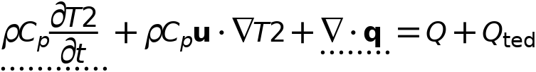



#### Heat conduction, solid

Settings

| **Description** | **Value** |
| --- | --- |
| Thermal conductivity | From material |

#### Thermodynamics, solid

Settings

| **Description** | **Value** |
| --- | --- |
| Density | From material |
| Heat capacity at constant pressure | From material |

#### Coordinate system selection

Settings

| **Description** | **Value** |
| --- | --- |
| Coordinate system | Global coordinate system |

#### Model input

Settings

| **Description** | **Value** |
| --- | --- |
| Volume reference temperature | Common model input |
| Absolute pressure | User defined |
| Absolute pressure | 1[atm] |

Properties from material

| **Property** | **Material** | **Property group** |
| --- | --- | --- |
| Thermal conductivity | Battery block | Basic |
| Density | Battery block | Basic |
| Heat capacity at constant pressure | Battery block | Basic |
| Thermal conductivity | PCM Layer | Basic |
| Density | PCM Layer | Basic |
| Heat capacity at constant pressure | PCM Layer | Basic |

#### Variables

| **Name** | **Expression** | **Unit** | **Description** | **Selection** | **Details** |
| --- | --- | --- | --- | --- | --- |
| domflux.T2x | ht2.dfluxx*ht2.d | W/m² | Domain flux, x component | Domains 1–4, 6–7 |  |
| domflux.T2y | ht2.dfluxy*ht2.d | W/m² | Domain flux, y component | Domains 1–4, 6–7 |  |
| domflux.T2z | ht2.dfluxz*ht2.d | W/m² | Domain flux, z component | Domains 1–4, 6–7 |  |
| ht2.DeltaH | integrate(subst(ht2.Cp,ht2.solid1.minput_pressure,ht2.pref),T2,ht2.Tref,T2)+integrate(ht2.mujtT,ht2.solid1.minput_pressure,ht2.pref,ht2.pA) | J/kg | Sensible enthalpy | Domains 1–4, 6–7 | + operation |
| ht2.H | ht2.HRef+ht2.DeltaH | J/kg | Enthalpy | Domains 1–4, 6–7 | + operation |
| ht2.Ei | ht2.H | J/kg | Internal energy | Domains 1–4, 6–7 | + operation |
| ht2.Ek | 0.5*(ht2.ux^2+ht2.uy^2+ht2.uz^2) | J/kg | Kinetic energy | Domains 1–4, 6–7 | + operation |
| ht2.dfluxx | -ht2.k_effxx*T2x-ht2.k_effxy*T2y-ht2.k_effxz*T2z | W/m² | Conductive heat flux, x component | Domains 1–4, 6–7 | + operation |
| ht2.dfluxy | -ht2.k_effyx*T2x-ht2.k_effyy*T2y-ht2.k_effyz*T2z | W/m² | Conductive heat flux, y component | Domains 1–4, 6–7 | + operation |
| ht2.dfluxz | -ht2.k_effzx*T2x-ht2.k_effzy*T2y-ht2.k_effzz*T2z | W/m² | Conductive heat flux, z component | Domains 1–4, 6–7 | + operation |
| ht2.dfluxtestx | -ht2.k_effxx*test(T2x)-ht2.k_effxy*test(T2y)-ht2.k_effxz*test(T2z) | W/m² | Conductive heat flux, x component | Domains 1–4, 6–7 | + operation |
| ht2.dfluxtesty | -ht2.k_effyx*test(T2x)-ht2.k_effyy*test(T2y)-ht2.k_effyz*test(T2z) | W/m² | Conductive heat flux, y component | Domains 1–4, 6–7 | + operation |
| ht2.dfluxtestz | -ht2.k_effzx*test(T2x)-ht2.k_effzy*test(T2y)-ht2.k_effzz*test(T2z) | W/m² | Conductive heat flux, z component | Domains 1–4, 6–7 | + operation |
| ht2.cfluxx | ht2.rho*ht2.ux*ht2.Ei | W/m² | Convective heat flux, x component | Domains 1–4, 6–7 | + operation |
| ht2.cfluxy | ht2.rho*ht2.uy*ht2.Ei | W/m² | Convective heat flux, y component | Domains 1–4, 6–7 | + operation |
| ht2.cfluxz | ht2.rho*ht2.uz*ht2.Ei | W/m² | Convective heat flux, z component | Domains 1–4, 6–7 | + operation |
| ht2.tefluxx | ht2.dfluxx+ht2.rho*ht2.ux*ht2.H0 | W/m² | Total energy flux, x component | Domains 1–4, 6–7 | + operation |
| ht2.tefluxy | ht2.dfluxy+ht2.rho*ht2.uy*ht2.H0 | W/m² | Total energy flux, y component | Domains 1–4, 6–7 | + operation |
| ht2.tefluxz | ht2.dfluxz+ht2.rho*ht2.uz*ht2.H0 | W/m² | Total energy flux, z component | Domains 1–4, 6–7 | + operation |
| ht2.ndflux_u | -uflux_spatial(T2)/ht2.d | W/m² | Internal normal conductive heat flux, upside | Boundaries 6–7, 10–15, 21–25, 31, 33, 35, 37, 39 | + operation |
| ht2.ndflux_d | -dflux_spatial(T2)/ht2.d | W/m² | Internal normal conductive heat flux, downside | Boundaries 6–7, 10–15, 21–25, 31, 33, 35, 37, 39 | + operation |
| ht2.ndflux_d | -dflux_spatial(T2)/ht2.d | W/m² | Internal normal conductive heat flux, downside | Boundaries 1–5, 8–9, 18–19, 28–29, 40 | + operation |
| ht2.dEiInt | ht2.solid1.dEiInt | W | Total accumulated heat rate | Global | + operation |
| ht2.dEi0Int | ht2.solid1.dEi0Int | W | Total accumulated energy rate | Global | + operation |
| ht2.WnsInt | ht2.solid1.WnsInt | W | Total work source | Global | + operation |
| ht2.kxx | material.k11 | W/(m·K) | Thermal conductivity, xx component | Domains 1–4, 6–7 | Meta |
| ht2.kyx | material.k21 | W/(m·K) | Thermal conductivity, yx component | Domains 1–4, 6–7 | Meta |
| ht2.kzx | material.k31 | W/(m·K) | Thermal conductivity, zx component | Domains 1–4, 6–7 | Meta |
| ht2.kxy | material.k12 | W/(m·K) | Thermal conductivity, xy component | Domains 1–4, 6–7 | Meta |
| ht2.kyy | material.k22 | W/(m·K) | Thermal conductivity, yy component | Domains 1–4, 6–7 | Meta |
| ht2.kzy | material.k32 | W/(m·K) | Thermal conductivity, zy component | Domains 1–4, 6–7 | Meta |
| ht2.kxz | material.k13 | W/(m·K) | Thermal conductivity, xz component | Domains 1–4, 6–7 | Meta |
| ht2.kyz | material.k23 | W/(m·K) | Thermal conductivity, yz component | Domains 1–4, 6–7 | Meta |
| ht2.kzz | material.k33 | W/(m·K) | Thermal conductivity, zz component | Domains 1–4, 6–7 | Meta |
| ht2.k_iso | material.k_iso | W/(m·K) | Thermal conductivity, isotropic value | Domains 1–4, 6–7 | Meta |
| ht2.rho | material.rho | kg/m³ | Density | Domains 1–4, 6–7 | Meta |
| ht2.Cp | material.Cp | J/(kg·K) | Heat capacity at constant pressure | Domains 1–4, 6–7 | Meta |
| ht2.solid1.pref | 1[atm] | Pa | Reference pressure level | Domains 1–4, 6–7 |  |
| ht2.res_T | T2t*ht2.C_eff-ht2.k_effxx*T2xx-ht2.k_effxy*T2xy-ht2.k_effxz*T2xz-ht2.k_effyx*T2yx-ht2.k_effyy*T2yy-ht2.k_effyz*T2yz-ht2.k_effzx*T2zx-ht2.k_effzy*T2zy-ht2.k_effzz*T2zz-(ht2.qs+ht2.qs_oop)*T2+ht2.rho*ht2.Cp*(ht2.ux*T2x+ht2.uy*T2y+ht2.uz*T2z)-ht2.Q-ht2.Qoop | W/m³ | Equation residual | Domains 1–4, 6–7 | + operation |
| ht2.alphap | -d(ht2.rho,T2)/(ht2.rho+eps) | 1/K | Isobaric compressibility coefficient | Domains 1–4, 6–7 |  |
| ht2.pA | ht2.pref | Pa | Absolute pressure | Domains 1–4, 6–7 |  |
| ht2.gradTmag | sqrt(ht2.gradTx^2+ht2.gradTy^2+ht2.gradTz^2) | K/m | Temperature gradient magnitude | Domains 1–4, 6–7 |  |
| ht2.Qmet | 0 | W/m³ | Metabolic heat source | Domains 1–4, 6–7 | + operation |
| ht2.pref | ht2.solid1.pref | Pa | Reference pressure level | Domains 1–4, 6–7 |  |
| ht2.rhoInit | subst(ht2.rho,ht2.solid1.minput_pressure,1[atm],T2,ht2.Tinit) | kg/m³ | Initial density | Domains 1–4, 6–7 |  |
| ht2.rho_eff | ht2.rho | kg/m³ | Effective density | Domains 1–4, 6–7 |  |
| ht2.C_eff | ht2.rho*ht2.Cp | J/(m³·K) | Effective volumetric heat capacity | Domains 1–4, 6–7 |  |
| ht2.mujtT | 0 | m³/kg | Isothermal Joule-Thomson coefficient | Domains 1–4, 6–7 |  |
| ht2.k_effxx | ht2.kxx | W/(m·K) | Effective thermal conductivity, xx component | Domains 1–4, 6–7 |  |
| ht2.k_effyx | ht2.kyx | W/(m·K) | Effective thermal conductivity, yx component | Domains 1–4, 6–7 |  |
| ht2.k_effzx | ht2.kzx | W/(m·K) | Effective thermal conductivity, zx component | Domains 1–4, 6–7 |  |
| ht2.k_effxy | ht2.kxy | W/(m·K) | Effective thermal conductivity, xy component | Domains 1–4, 6–7 |  |
| ht2.k_effyy | ht2.kyy | W/(m·K) | Effective thermal conductivity, yy component | Domains 1–4, 6–7 |  |
| ht2.k_effzy | ht2.kzy | W/(m·K) | Effective thermal conductivity, zy component | Domains 1–4, 6–7 |  |
| ht2.k_effxz | ht2.kxz | W/(m·K) | Effective thermal conductivity, xz component | Domains 1–4, 6–7 |  |
| ht2.k_effyz | ht2.kyz | W/(m·K) | Effective thermal conductivity, yz component | Domains 1–4, 6–7 |  |
| ht2.k_effzz | ht2.kzz | W/(m·K) | Effective thermal conductivity, zz component | Domains 1–4, 6–7 |  |
| ht2.kappaTxx | 0 | W/(m·K) | Turbulent thermal conductivity, xx component | Domains 1–4, 6–7 |  |
| ht2.kappaTyx | 0 | W/(m·K) | Turbulent thermal conductivity, yx component | Domains 1–4, 6–7 |  |
| ht2.kappaTzx | 0 | W/(m·K) | Turbulent thermal conductivity, zx component | Domains 1–4, 6–7 |  |
| ht2.kappaTxy | 0 | W/(m·K) | Turbulent thermal conductivity, xy component | Domains 1–4, 6–7 |  |
| ht2.kappaTyy | 0 | W/(m·K) | Turbulent thermal conductivity, yy component | Domains 1–4, 6–7 |  |
| ht2.kappaTzy | 0 | W/(m·K) | Turbulent thermal conductivity, zy component | Domains 1–4, 6–7 |  |
| ht2.kappaTxz | 0 | W/(m·K) | Turbulent thermal conductivity, xz component | Domains 1–4, 6–7 |  |
| ht2.kappaTyz | 0 | W/(m·K) | Turbulent thermal conductivity, yz component | Domains 1–4, 6–7 |  |
| ht2.kappaTzz | 0 | W/(m·K) | Turbulent thermal conductivity, zz component | Domains 1–4, 6–7 |  |
| ht2.kmean | (ht2.k_effxx+ht2.k_effyy+ht2.k_effzz)/3 | W/(m·K) | Mean effective thermal conductivity | Domains 1–4, 6–7 |  |
| ht2.ux | 0 | m/s | Velocity field, x component | Domains 1–4, 6–7 | + operation |
| ht2.uy | 0 | m/s | Velocity field, y component | Domains 1–4, 6–7 | + operation |
| ht2.uz | 0 | m/s | Velocity field, z component | Domains 1–4, 6–7 | + operation |
| ht2.gradTx | T2x | K/m | Temperature gradient, x component | Domains 1–4, 6–7 |  |
| ht2.gradTy | T2y | K/m | Temperature gradient, y component | Domains 1–4, 6–7 |  |
| ht2.gradTz | T2z | K/m | Temperature gradient, z component | Domains 1–4, 6–7 |  |
| ht2.cellPe | 0.5*ht2.rho*ht2.Cp*h*sqrt(ht2.ux^2+ht2.uy^2+ht2.uz^2)/ht2.kmean | 1 | Cell Péclet number | Domains 1–4, 6–7 |  |
| ht2.Qltot | 0 | W/m | Total line heat source | Edges 1–20, 22–24, 27–30, 32–34, 37–38, 40, 42–43, 45, 47–48, 50, 52–53, 55, 57, 59–60, 62–70 | + operation |
| ht2.Qptot | 0 | W | Total point heat source | Points 1–10, 12–13, 15–16, 18–19, 21–22, 24–25, 27–28, 30–31, 33–40 | + operation |
| ht2.alphaTdxx | ht2.k_effxx/ht2.C_eff | m²/s | Thermal diffusivity, xx component | Domains 1–4, 6–7 |  |
| ht2.alphaTdyx | ht2.k_effyx/ht2.C_eff | m²/s | Thermal diffusivity, yx component | Domains 1–4, 6–7 |  |
| ht2.alphaTdzx | ht2.k_effzx/ht2.C_eff | m²/s | Thermal diffusivity, zx component | Domains 1–4, 6–7 |  |
| ht2.alphaTdxy | ht2.k_effxy/ht2.C_eff | m²/s | Thermal diffusivity, xy component | Domains 1–4, 6–7 |  |
| ht2.alphaTdyy | ht2.k_effyy/ht2.C_eff | m²/s | Thermal diffusivity, yy component | Domains 1–4, 6–7 |  |
| ht2.alphaTdzy | ht2.k_effzy/ht2.C_eff | m²/s | Thermal diffusivity, zy component | Domains 1–4, 6–7 |  |
| ht2.alphaTdxz | ht2.k_effxz/ht2.C_eff | m²/s | Thermal diffusivity, xz component | Domains 1–4, 6–7 |  |
| ht2.alphaTdyz | ht2.k_effyz/ht2.C_eff | m²/s | Thermal diffusivity, yz component | Domains 1–4, 6–7 |  |
| ht2.alphaTdzz | ht2.k_effzz/ht2.C_eff | m²/s | Thermal diffusivity, zz component | Domains 1–4, 6–7 |  |
| ht2.alphaTdMean | ht2.kmean/ht2.C_eff | m²/s | Mean thermal diffusivity | Domains 1–4, 6–7 |  |
| ht2.Tradu | ht2.Tu | K | Upside temperature | Domains 1–4, 6–7 |  |
| ht2.Tradu | ht2.Tu | K | Upside temperature | Boundaries 1–15, 18–19, 21–25, 28–29, 31, 33, 35, 37, 39–40 |  |
| ht2.Tradd | ht2.Td | K | Downside temperature | Domains 1–4, 6–7 |  |
| ht2.Tradd | ht2.Td | K | Downside temperature | Boundaries 1–15, 18–19, 21–25, 28–29, 31, 33, 35, 37, 39–40 |  |
| ht2.solid1.dEiInt | ht2.solid1.intDom((ht2.dEi-ht2.Qm*ht2.Ei)*ht2.solid1.varIntSpa) | W | Total accumulated heat rate | Global |  |
| ht2.dEi | d(ht2.rho*ht2.Ei,t) | W/m³ | Total accumulated heat rate density | Domains 1–4, 6–7 |  |
| ht2.solid1.dEi0Int | ht2.solid1.intDom((ht2.dEi0-ht2.Qm*ht2.H)*ht2.solid1.varIntSpa) | W | Total accumulated energy rate | Global |  |
| ht2.dEi0 | d(ht2.rho*ht2.Ei0,t) | W/m³ | Total accumulated energy rate density | Domains 1–4, 6–7 |  |
| ht2.solid1.ntfluxInt | ht2.solid1.intExtBnd(ht2.ntflux*ht2.solid1.varIntSpa)+ht2.solid1.intExtBndUp(ht2.ntflux_u*ht2.solid1.varIntSpa)+ht2.solid1.intExtBndDown(ht2.ntflux_d*ht2.solid1.varIntSpa) | W | Total net heat rate | Global |  |
| ht2.solid1.ntefluxInt | ht2.solid1.intExtBnd(ht2.nteflux*ht2.solid1.varIntSpa)+ht2.solid1.intExtBndUp(ht2.nteflux_u*ht2.solid1.varIntSpa)+ht2.solid1.intExtBndDown(ht2.nteflux_d*ht2.solid1.varIntSpa) | W | Total net energy rate | Global |  |
| ht2.solid1.QInt | ht2.solid1.intDom(ht2.Qtot*ht2.solid1.varIntSpa)-ht2.solid1.intIntBnd((ht2.ndflux_u+ht2.ndflux_d)*ht2.solid1.varIntSpa) | W | Total heat source | Global |  |
| ht2.solid1.WnsInt | ht2.solid1.intDom(ht2.pA*(d(ht2.ux,x)+d(ht2.uy,y)+d(ht2.uz,z))*ht2.solid1.varIntSpa) | W | Total work source | Global |  |
| ht2.solid1.WInt | 0 | W | Total work source | Global |  |
| ht2.solid1.varIntSpa | ht2.d | 1 | Intermediate variable | Domains 1–4, 6–7 |  |
| ht2.timeDerivative | T2t | K/s | Temperature, first time derivative | Domains 1–4, 6–7 |  |
| ht2.gamma | 1 | 1 | Ratio of specific heats | Domains 1–4, 6–7 |  |
| ht2.Trho | ht2.Tref | K | Temperature for density evaluation | Domains 1–4, 6–7 |  |
| ht2.dfltopaque | 1 | 1 | Default opacity | Domains 1–4, 6–7 |  |
| ht2.helem | h_spatial | m | Element size | Domains 1–4, 6–7 |  |

#### Shape functions

| **Name** | **Shape function** | **Unit** | **Description** | **Shape frame** | **Selection** |
| --- | --- | --- | --- | --- | --- |
| T2 | Lagrange (Quadratic) | K | Temperature | Spatial | Domains 1–4, 6–7 |

#### Weak expressions

| **Weak expression** | **Integration order** | **Integration frame** | **Selection** |
| --- | --- | --- | --- |
| ht2.streamline | 4 | Spatial | Domains 1–4, 6–7 |
| (ht2.dfluxx*test(T2x)+ht2.dfluxy*test(T2y)+ht2.dfluxz*test(T2z))*ht2.d | 4 | Spatial | Domains 1–4, 6–7 |
| -ht2.C_eff*ht2.timeDerivative*test(T2)*ht2.d | 4 | Spatial | Domains 1–4, 6–7 |
| -ht2.rho*ht2.Cp*(ht2.ux*T2x+ht2.uy*T2y+ht2.uz*T2z)*test(T2)*ht2.d | 4 | Spatial | Domains 1–4, 6–7 |

* + 1. Initial Values 1



Initial Values 1

Selection

|  |  |
| --- | --- |
| Geometric entity level | Domain |
| Selection | Domains 1–4, 6–7 |

#### Initial values

Settings

| **Description** | **Value** |
| --- | --- |
| Temperature | User defined |
| Temperature | 293.15[K] |

#### Variables

| **Name** | **Expression** | **Unit** | **Description** | **Selection** |
| --- | --- | --- | --- | --- |
| ht2.Tinit | 293.15[K] | K | Temperature | Domains 1–4, 6–7 |

* + 1. Thermal Insulation 1



Thermal Insulation 1

Selection

|  |  |
| --- | --- |
| Geometric entity level | Boundary |
| Selection | Boundaries 1–5, 8–9, 18–19, 28–29, 40 |

Equations



#### Variables

| **Name** | **Expression** | **Unit** | **Description** | **Selection** |
| --- | --- | --- | --- | --- |
| ht2.ins1.Tave | nojac(ht2.ins1.intBnd(ht2.ins1.varIntSpa*ht2.rho*ht2.Cp*T2*max(abs(ht2.ux*ht2.nx+ht2.uy*ht2.ny+ht2.uz*ht2.nz),eps)))/nojac(ht2.ins1.intBnd(ht2.ins1.varIntSpa*ht2.rho*ht2.Cp*max(abs(ht2.ux*ht2.nx+ht2.uy*ht2.ny+ht2.uz*ht2.nz),eps))) | K | Weighted average temperature | Global |
| ht2.ins1.ntfluxInt | ht2.ins1.intExtBnd(ht2.ntflux*ht2.ins1.varIntSpa) | W | Total net heat rate | Global |
| ht2.ins1.ntefluxInt | ht2.ins1.intExtBnd(ht2.nteflux*ht2.ins1.varIntSpa) | W | Total net energy rate | Global |
| ht2.ins1.ntfluxInt_u | ht2.ins1.intIntBnd(ht2.ntflux_u*ht2.ins1.varIntSpa) | W | Total net heat rate, upside | Global |
| ht2.ins1.ntefluxInt_u | ht2.ins1.intIntBnd(ht2.nteflux_u*ht2.ins1.varIntSpa) | W | Total net energy rate, upside | Global |
| ht2.ins1.ntfluxInt_d | ht2.ins1.intIntBnd(ht2.ntflux_d*ht2.ins1.varIntSpa) | W | Total net heat rate, downside | Global |
| ht2.ins1.ntefluxInt_d | ht2.ins1.intIntBnd(ht2.nteflux_d*ht2.ins1.varIntSpa) | W | Total net energy rate, downside | Global |
| ht2.ins1.varIntSpa | ht2.d | 1 | Intermediate variable | Boundaries 1–5, 8–9, 18–19, 28–29, 40 |

#### Shape functions

| **Name** | **Shape function** | **Unit** | **Description** | **Shape frame** | **Selection** | **Details** |
| --- | --- | --- | --- | --- | --- | --- |
| T2 | Lagrange (Quadratic) | K | Temperature | Spatial | No boundaries | Slit |
| T2 | Lagrange (Quadratic) | K | Temperature | Material | No boundaries | Slit |
| T2 | Lagrange (Quadratic) | K | Temperature | Geometry | No boundaries | Slit |
| T2 | Lagrange (Quadratic) | K | Temperature | Mesh | No boundaries | Slit |

* + 1. Heat Source 1



Heat Source 1

Selection

|  |  |
| --- | --- |
| Geometric entity level | Domain |
| Selection | Domain 2 |

Equations



#### Heat source

Settings

| **Description** | **Value** |
| --- | --- |
| Heat source | General source |
| Heat source | User defined |
| Heat source | 5000 |

#### Variables

| **Name** | **Expression** | **Unit** | **Description** | **Selection** | **Details** |
| --- | --- | --- | --- | --- | --- |
| ht2.Q | ht2.hs1.Q | W/m³ | Heat source | Domain 2 | + operation |
| ht2.Qtot | ht2.hs1.Q | W/m³ | Total heat source | Domain 2 | + operation |
| ht2.hs1.Q0 | 5000 | W/m³ | Heat source | Domain 2 |  |
| ht2.hs1.Q | ht2.hs1.Q0*spatial.detInvF | W/m³ | Heat source | Domain 2 |  |

#### Weak expressions

| **Weak expression** | **Integration order** | **Integration frame** | **Selection** |
| --- | --- | --- | --- |
| ht2.hs1.Q*test(T2)*ht2.d*spatial.detF | 4 | Material | Domain 2 |

* 1. Heat Transfer in Fluids 3

Used products

|  |
| --- |
| COMSOL Multiphysics |

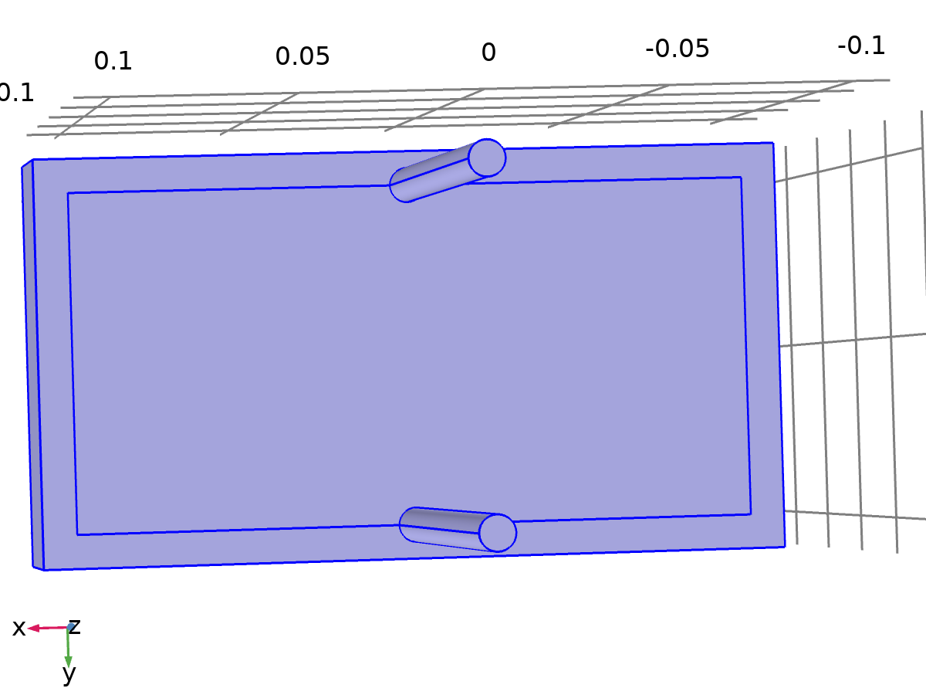

Heat Transfer in Fluids 3

Selection

|  |  |
| --- | --- |
| Geometric entity level | Domain |
| Selection | Domains 1–8 |

Equations

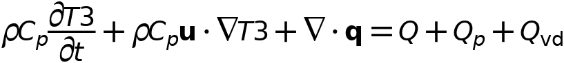



* + 1. Interface settings

#### Discretization

Settings

| **Description** | **Value** |
| --- | --- |
| Temperature | Linear |

#### Physical model

Settings

| **Description** | **Value** |
| --- | --- |
| Heat transfer in biological tissue | Off |
| Isothermal domain | Off |
| Heat transfer in porous media | Off |
| Heat transfer in alloys | Off |
| Reference temperature | User defined |
| Reference temperature | 293.15[K] |

* + 1. Variables

| **Name** | **Expression** | **Unit** | **Description** | **Selection** | **Details** |
| --- | --- | --- | --- | --- | --- |
| ht3.q0 | 0 | W/m² | Inward heat flux | Boundaries 1–40 | + operation |
| ht3.Tu | up(T3) | K | Temperature | Boundaries 6–7, 10–15, 18–19, 21–25, 28–29, 31, 33, 35, 37, 39 |  |
| ht3.Tu | T3 | K | Temperature | Boundaries 1–5, 8–9, 16–17, 20, 26–27, 30, 32, 34, 36, 38, 40 |  |
| ht3.Td | down(T3) | K | Temperature | Boundaries 6–7, 10–15, 18–19, 21–25, 28–29, 31, 33, 35, 37, 39 |  |
| ht3.Td | T3 | K | Temperature | Boundaries 1–5, 8–9, 16–17, 20, 26–27, 30, 32, 34, 36, 38, 40 |  |
| ht3.Tref | model.input.Tref | K | Reference temperature | Global | Meta |
| ht3.d | 1 | 1 | Thickness | Domains 1–8 |  |
| ht3.HRef | 0 | J/kg | Reference enthalpy | Domains 1–8 |  |
| ht3.DeltaH | 0 | J/kg | Sensible enthalpy | Domains 1–8 | + operation |
| ht3.H | 0 | J/kg | Enthalpy | Domains 1–8 | + operation |
| ht3.H0 | ht3.H+ht3.Ek | J/kg | Total enthalpy | Domains 1–8 |  |
| ht3.Ei | 0 | J/kg | Internal energy | Domains 1–8 | + operation |
| ht3.Ei0 | ht3.Ei+ht3.Ek | J/kg | Total internal energy | Domains 1–8 |  |
| ht3.Ek | 0 | J/kg | Kinetic energy | Domains 1–8 | + operation |
| ht3.dfluxx | 0 | W/m² | Conductive heat flux, x component | Domains 1–8 | + operation |
| ht3.dfluxy | 0 | W/m² | Conductive heat flux, y component | Domains 1–8 | + operation |
| ht3.dfluxz | 0 | W/m² | Conductive heat flux, z component | Domains 1–8 | + operation |
| ht3.dfluxx | mean(ht3.dfluxx) | W/m² | Conductive heat flux, x component | Boundaries 1–40 | + operation |
| ht3.dfluxy | mean(ht3.dfluxy) | W/m² | Conductive heat flux, y component | Boundaries 1–40 | + operation |
| ht3.dfluxz | mean(ht3.dfluxz) | W/m² | Conductive heat flux, z component | Boundaries 1–40 | + operation |
| ht3.dfluxtestx | 0 | W/m² | Conductive heat flux, x component | Domains 1–8 | + operation |
| ht3.dfluxtesty | 0 | W/m² | Conductive heat flux, y component | Domains 1–8 | + operation |
| ht3.dfluxtestz | 0 | W/m² | Conductive heat flux, z component | Domains 1–8 | + operation |
| ht3.dfluxtestx | mean(ht3.dfluxtestx) | W/m² | Conductive heat flux, x component | Boundaries 1–40 | + operation |
| ht3.dfluxtesty | mean(ht3.dfluxtesty) | W/m² | Conductive heat flux, y component | Boundaries 1–40 | + operation |
| ht3.dfluxtestz | mean(ht3.dfluxtestz) | W/m² | Conductive heat flux, z component | Boundaries 1–40 | + operation |
| ht3.dfluxMag | sqrt(ht3.dfluxx^2+ht3.dfluxy^2+ht3.dfluxz^2) | W/m² | Conductive heat flux magnitude | Domains 1–8 |  |
| ht3.cfluxx | 0 | W/m² | Convective heat flux, x component | Domains 1–8 | + operation |
| ht3.cfluxy | 0 | W/m² | Convective heat flux, y component | Domains 1–8 | + operation |
| ht3.cfluxz | 0 | W/m² | Convective heat flux, z component | Domains 1–8 | + operation |
| ht3.cfluxMag | sqrt(ht3.cfluxx^2+ht3.cfluxy^2+ht3.cfluxz^2) | W/m² | Convective heat flux magnitude | Domains 1–8 |  |
| ht3.tfluxx | ht3.dfluxx+ht3.cfluxx | W/m² | Total heat flux, x component | Domains 1–8 |  |
| ht3.tfluxy | ht3.dfluxy+ht3.cfluxy | W/m² | Total heat flux, y component | Domains 1–8 |  |
| ht3.tfluxz | ht3.dfluxz+ht3.cfluxz | W/m² | Total heat flux, z component | Domains 1–8 |  |
| ht3.tfluxMag | sqrt(ht3.tfluxx^2+ht3.tfluxy^2+ht3.tfluxz^2) | W/m² | Total heat flux magnitude | Domains 1–8 |  |
| ht3.tefluxx | 0 | W/m² | Total energy flux, x component | Domains 1–8 | + operation |
| ht3.tefluxy | 0 | W/m² | Total energy flux, y component | Domains 1–8 | + operation |
| ht3.tefluxz | 0 | W/m² | Total energy flux, z component | Domains 1–8 | + operation |
| ht3.tefluxMag | sqrt(ht3.tefluxx^2+ht3.tefluxy^2+ht3.tefluxz^2) | W/m² | Total energy flux magnitude | Domains 1–8 |  |
| ht3.dflux_ux | up(ht3.dfluxx) | W/m² | Conductive heat flux, x component | Boundaries 1–40 |  |
| ht3.dflux_uy | up(ht3.dfluxy) | W/m² | Conductive heat flux, y component | Boundaries 1–40 |  |
| ht3.dflux_uz | up(ht3.dfluxz) | W/m² | Conductive heat flux, z component | Boundaries 1–40 |  |
| ht3.dflux_dx | down(ht3.dfluxx) | W/m² | Conductive heat flux, x component | Boundaries 1–40 |  |
| ht3.dflux_dy | down(ht3.dfluxy) | W/m² | Conductive heat flux, y component | Boundaries 1–40 |  |
| ht3.dflux_dz | down(ht3.dfluxz) | W/m² | Conductive heat flux, z component | Boundaries 1–40 |  |
| ht3.dfluxtest_ux | up(ht3.dfluxtestx) | W/m² | Conductive heat flux, x component | Boundaries 1–40 |  |
| ht3.dfluxtest_uy | up(ht3.dfluxtesty) | W/m² | Conductive heat flux, y component | Boundaries 1–40 |  |
| ht3.dfluxtest_uz | up(ht3.dfluxtestz) | W/m² | Conductive heat flux, z component | Boundaries 1–40 |  |
| ht3.dfluxtest_dx | down(ht3.dfluxtestx) | W/m² | Conductive heat flux, x component | Boundaries 1–40 |  |
| ht3.dfluxtest_dy | down(ht3.dfluxtesty) | W/m² | Conductive heat flux, y component | Boundaries 1–40 |  |
| ht3.dfluxtest_dz | down(ht3.dfluxtestz) | W/m² | Conductive heat flux, z component | Boundaries 1–40 |  |
| ht3.rflux | 0 | W/m² | Radiative heat flux | Boundaries 1–40 | + operation |
| ht3.ncflux | mean(ht3.cfluxx)*ht3.nx+mean(ht3.cfluxy)*ht3.ny+mean(ht3.cfluxz)*ht3.nz | W/m² | Normal convective heat flux | Boundaries 1–40 |  |
| ht3.ncflux_u | up(ht3.cfluxx)*ht3.unx+up(ht3.cfluxy)*ht3.uny+up(ht3.cfluxz)*ht3.unz | W/m² | Internal normal convective heat flux, upside | Boundaries 1–40 |  |
| ht3.ncflux_d | down(ht3.cfluxx)*ht3.dnx+down(ht3.cfluxy)*ht3.dny+down(ht3.cfluxz)*ht3.dnz | W/m² | Internal normal convective heat flux, downside | Boundaries 1–40 |  |
| ht3.ndflux | 0.5*(ht3.ndflux_d-ht3.ndflux_u) | W/m² | Normal conductive heat flux | Boundaries 1–40 | + operation |
| ht3.ndflux_u | -ht3.ndflux_d | W/m² | Internal normal conductive heat flux, upside | Boundaries 1–5, 8–9, 16–17, 20, 26–27, 30, 32, 34, 36, 38, 40 | + operation |
| ht3.ndflux_u | 0 | W/m² | Internal normal conductive heat flux, upside | Boundaries 6–7, 10–15, 18–19, 21–25, 28–29, 31, 33, 35, 37, 39 | + operation |
| ht3.ndflux_d | 0 | W/m² | Internal normal conductive heat flux, downside | Boundaries 1–40 | + operation |
| ht3.ntflux | ht3.ndflux+ht3.ncflux | W/m² | Normal total heat flux | Boundaries 1–40 |  |
| ht3.ntflux_u | ht3.ndflux_u+ht3.ncflux_u | W/m² | Internal normal total flux, upside | Boundaries 1–40 |  |
| ht3.ntflux_d | ht3.ndflux_d+ht3.ncflux_d | W/m² | Internal normal total flux, downside | Boundaries 1–40 |  |
| ht3.nteflux | mean(ht3.tefluxx)*ht3.nx+mean(ht3.tefluxy)*ht3.ny+mean(ht3.tefluxz)*ht3.nz-mean(ht3.dfluxx)*ht3.nx-mean(ht3.dfluxy)*ht3.ny-mean(ht3.dfluxz)*ht3.nz+ht3.ndflux | W/m² | Normal total energy flux | Boundaries 1–40 |  |
| ht3.nteflux_u | up(ht3.tefluxx)*ht3.unx+up(ht3.tefluxy)*ht3.uny+up(ht3.tefluxz)*ht3.unz-up(ht3.dfluxx)*ht3.unx-up(ht3.dfluxy)*ht3.uny-up(ht3.dfluxz)*ht3.unz+ht3.ndflux_u | W/m² | Internal normal total energy flux, upside | Boundaries 1–40 |  |
| ht3.nteflux_d | down(ht3.tefluxx)*ht3.dnx+down(ht3.tefluxy)*ht3.dny+down(ht3.tefluxz)*ht3.dnz-down(ht3.dfluxx)*ht3.dnx-down(ht3.dfluxy)*ht3.dny-down(ht3.dfluxz)*ht3.dnz+ht3.ndflux_d | W/m² | Internal normal total energy flux, downside | Boundaries 1–40 |  |
| ht3.Qm | 0 | kg/(m³·s) | Mass source | Domains 1–8 |  |
| ht3.Q | 0 | W/m³ | Heat source | Domains 1–8 | + operation |
| ht3.Qoop | 0 | W/m³ | Out-of-plane heat source | Domains 1–8 | + operation |
| ht3.Qtot | 0 | W/m³ | Total heat source | Domains 1–8 | + operation |
| ht3.Qbtot | 0 | W/m² | Total boundary heat source | Boundaries 1–40 | + operation |
| ht3.qs | 0 | W/(m³·K) | Production/absorption coefficient | Domains 1–8 | + operation |
| ht3.qs_oop | 0 | W/(m³·K) | Out-of-plane production/absorption coefficient | Domains 1–8 | + operation |
| ht3.Tvar | T3 | K | Temperature | Domains 1–8 |  |
| ht3.Tvar | T3 | K | Temperature | Boundaries 1–40 |  |
| ht3.Tvar | T3 | K | Temperature | Edges 1–70 |  |
| ht3.Tvar | T3 | K | Temperature | Points 1–40 |  |
| ht3.nx | nx | 1 | Normal vector, x component | Boundaries 6–7, 10–15, 18–19, 21–25, 28–29, 31, 33, 35, 37, 39 |  |
| ht3.ny | ny | 1 | Normal vector, y component | Boundaries 6–7, 10–15, 18–19, 21–25, 28–29, 31, 33, 35, 37, 39 |  |
| ht3.nz | nz | 1 | Normal vector, z component | Boundaries 6–7, 10–15, 18–19, 21–25, 28–29, 31, 33, 35, 37, 39 |  |
| ht3.nx | dnx | 1 | Normal vector, x component | Boundaries 1–5, 8–9, 16–17, 20, 26–27, 30, 32, 34, 36, 38, 40 |  |
| ht3.ny | dny | 1 | Normal vector, y component | Boundaries 1–5, 8–9, 16–17, 20, 26–27, 30, 32, 34, 36, 38, 40 |  |
| ht3.nz | dnz | 1 | Normal vector, z component | Boundaries 1–5, 8–9, 16–17, 20, 26–27, 30, 32, 34, 36, 38, 40 |  |
| ht3.nxmesh | root.nxmesh | 1 | Normal vector (mesh), x component | Boundaries 6–7, 10–15, 18–19, 21–25, 28–29, 31, 33, 35, 37, 39 |  |
| ht3.nymesh | root.nymesh | 1 | Normal vector (mesh), y component | Boundaries 6–7, 10–15, 18–19, 21–25, 28–29, 31, 33, 35, 37, 39 |  |
| ht3.nzmesh | root.nzmesh | 1 | Normal vector (mesh), z component | Boundaries 6–7, 10–15, 18–19, 21–25, 28–29, 31, 33, 35, 37, 39 |  |
| ht3.nxmesh | dnxmesh | 1 | Normal vector (mesh), x component | Boundaries 1–5, 8–9, 16–17, 20, 26–27, 30, 32, 34, 36, 38, 40 |  |
| ht3.nymesh | dnymesh | 1 | Normal vector (mesh), y component | Boundaries 1–5, 8–9, 16–17, 20, 26–27, 30, 32, 34, 36, 38, 40 |  |
| ht3.nzmesh | dnzmesh | 1 | Normal vector (mesh), z component | Boundaries 1–5, 8–9, 16–17, 20, 26–27, 30, 32, 34, 36, 38, 40 |  |
| ht3.dnx | dnx | 1 | Normal vector down direction, x component | Boundaries 1–40 |  |
| ht3.dny | dny | 1 | Normal vector down direction, y component | Boundaries 1–40 |  |
| ht3.dnz | dnz | 1 | Normal vector down direction, z component | Boundaries 1–40 |  |
| ht3.unx | unx | 1 | Normal vector up direction, x component | Boundaries 1–40 |  |
| ht3.uny | uny | 1 | Normal vector up direction, y component | Boundaries 1–40 |  |
| ht3.unz | unz | 1 | Normal vector up direction, z component | Boundaries 1–40 |  |
| ht3.dEiInt | 0 | W | Total accumulated heat rate | Global | + operation |
| ht3.dEi0Int | 0 | W | Total accumulated energy rate | Global | + operation |
| ht3.ntfluxInt | ht3.intExtBnd(ht3.ntflux*ht3.varIntSpa) | W | Total net heat rate | Global |  |
| ht3.ntefluxInt | ht3.intExtBnd(ht3.nteflux*ht3.varIntSpa) | W | Total net energy rate | Global |  |
| ht3.QInt | ht3.intDom(ht3.Qtot*ht3.varIntSpa)-ht3.intIntBnd((ht3.ndflux_u+ht3.ndflux_d)*ht3.varIntSpa) | W | Total heat source | Global |  |
| ht3.WnsInt | 0 | W | Total work source | Global | + operation |
| ht3.WInt | 0 | W | Total work source | Global | + operation |
| ht3.varIntSpa | ht3.d | 1 | Intermediate variable | Domains 1–8 |  |

* + 1. Fluid 1



Fluid 1

Selection

|  |  |
| --- | --- |
| Geometric entity level | Domain |
| Selection | Domains 1–8 |

Equations

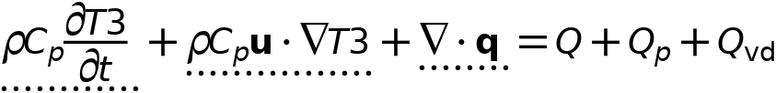



#### Heat conduction, fluid

Settings

| **Description** | **Value** |
| --- | --- |
| Thermal conductivity | From material |

#### Thermodynamics, fluid

Settings

| **Description** | **Value** |
| --- | --- |
| Fluid type | Gas/Liquid |
| Density | From material |
| Heat capacity at constant pressure | From material |
| Ratio of specific heats | From material |

#### Coordinate system selection

Settings

| **Description** | **Value** |
| --- | --- |
| Coordinate system | Global coordinate system |

#### Model input

Settings

| **Description** | **Value** |
| --- | --- |
| Velocity | User defined |
| Velocity | {0, 0, 0} |
| Absolute pressure | User defined |
| Absolute pressure | 1[atm] |

Properties from material

| **Property** | **Material** | **Property group** |
| --- | --- | --- |
| Thermal conductivity | Battery block | Basic |
| Density | Battery block | Basic |
| Heat capacity at constant pressure | Battery block | Basic |
| Ratio of specific heats | Battery block | Basic |
| Thermal conductivity | PCM Layer | Basic |
| Density | PCM Layer | Basic |
| Heat capacity at constant pressure | PCM Layer | Basic |
| Ratio of specific heats | PCM Layer | Basic |
| Thermal conductivity | Coolin Pipes | Basic |
| Density | Coolin Pipes | Basic |
| Heat capacity at constant pressure | Coolin Pipes | Basic |
| Ratio of specific heats | Coolin Pipes | Basic |

#### Variables

| **Name** | **Expression** | **Unit** | **Description** | **Selection** | **Details** |
| --- | --- | --- | --- | --- | --- |
| domflux.T3x | ht3.dfluxx*ht3.d | W/m² | Domain flux, x component | Domains 1–8 |  |
| domflux.T3y | ht3.dfluxy*ht3.d | W/m² | Domain flux, y component | Domains 1–8 |  |
| domflux.T3z | ht3.dfluxz*ht3.d | W/m² | Domain flux, z component | Domains 1–8 |  |
| ht3.DeltaH | integrate(subst(ht3.Cp,ht3.fluid1.minput_pressure,ht3.pref),T3,ht3.Tref,T3)+integrate(ht3.mujtT,ht3.fluid1.minput_pressure,ht3.pref,ht3.pA) | J/kg | Sensible enthalpy | Domains 1–8 | + operation |
| ht3.H | ht3.HRef+ht3.DeltaH | J/kg | Enthalpy | Domains 1–8 | + operation |
| ht3.Ei | ht3.H-ht3.pA/ht3.rho | J/kg | Internal energy | Domains 1–8 | + operation |
| ht3.Ek | 0.5*(ht3.ux^2+ht3.uy^2+ht3.uz^2) | J/kg | Kinetic energy | Domains 1–8 | + operation |
| ht3.dfluxx | -ht3.k_effxx*T3x-ht3.k_effxy*T3y-ht3.k_effxz*T3z | W/m² | Conductive heat flux, x component | Domains 1–8 | + operation |
| ht3.dfluxy | -ht3.k_effyx*T3x-ht3.k_effyy*T3y-ht3.k_effyz*T3z | W/m² | Conductive heat flux, y component | Domains 1–8 | + operation |
| ht3.dfluxz | -ht3.k_effzx*T3x-ht3.k_effzy*T3y-ht3.k_effzz*T3z | W/m² | Conductive heat flux, z component | Domains 1–8 | + operation |
| ht3.dfluxtestx | -ht3.k_effxx*test(T3x)-ht3.k_effxy*test(T3y)-ht3.k_effxz*test(T3z) | W/m² | Conductive heat flux, x component | Domains 1–8 | + operation |
| ht3.dfluxtesty | -ht3.k_effyx*test(T3x)-ht3.k_effyy*test(T3y)-ht3.k_effyz*test(T3z) | W/m² | Conductive heat flux, y component | Domains 1–8 | + operation |
| ht3.dfluxtestz | -ht3.k_effzx*test(T3x)-ht3.k_effzy*test(T3y)-ht3.k_effzz*test(T3z) | W/m² | Conductive heat flux, z component | Domains 1–8 | + operation |
| ht3.cfluxx | ht3.rho*ht3.ux*ht3.Ei | W/m² | Convective heat flux, x component | Domains 1–8 | + operation |
| ht3.cfluxy | ht3.rho*ht3.uy*ht3.Ei | W/m² | Convective heat flux, y component | Domains 1–8 | + operation |
| ht3.cfluxz | ht3.rho*ht3.uz*ht3.Ei | W/m² | Convective heat flux, z component | Domains 1–8 | + operation |
| ht3.tefluxx | ht3.dfluxx+ht3.rho*ht3.ux*ht3.H0 | W/m² | Total energy flux, x component | Domains 1–8 | + operation |
| ht3.tefluxy | ht3.dfluxy+ht3.rho*ht3.uy*ht3.H0 | W/m² | Total energy flux, y component | Domains 1–8 | + operation |
| ht3.tefluxz | ht3.dfluxz+ht3.rho*ht3.uz*ht3.H0 | W/m² | Total energy flux, z component | Domains 1–8 | + operation |
| ht3.ndflux_u | -uflux_spatial(T3)/ht3.d | W/m² | Internal normal conductive heat flux, upside | Boundaries 6–7, 10–15, 18–19, 21–25, 28–29, 31, 33, 35, 37, 39 | + operation |
| ht3.ndflux_d | -dflux_spatial(T3)/ht3.d | W/m² | Internal normal conductive heat flux, downside | Boundaries 6–7, 10–15, 18–19, 21–25, 28–29, 31, 33, 35, 37, 39 | + operation |
| ht3.ndflux_d | -dflux_spatial(T3)/ht3.d | W/m² | Internal normal conductive heat flux, downside | Boundaries 1–5, 8–9, 16–17, 20, 26–27, 30, 32, 34, 36, 38, 40 | + operation |
| ht3.dEiInt | ht3.fluid1.dEiInt | W | Total accumulated heat rate | Global | + operation |
| ht3.dEi0Int | ht3.fluid1.dEi0Int | W | Total accumulated energy rate | Global | + operation |
| ht3.WnsInt | ht3.fluid1.WnsInt | W | Total work source | Global | + operation |
| ht3.kxx | material.k11 | W/(m·K) | Thermal conductivity, xx component | Domains 1–8 | Meta |
| ht3.kyx | material.k21 | W/(m·K) | Thermal conductivity, yx component | Domains 1–8 | Meta |
| ht3.kzx | material.k31 | W/(m·K) | Thermal conductivity, zx component | Domains 1–8 | Meta |
| ht3.kxy | material.k12 | W/(m·K) | Thermal conductivity, xy component | Domains 1–8 | Meta |
| ht3.kyy | material.k22 | W/(m·K) | Thermal conductivity, yy component | Domains 1–8 | Meta |
| ht3.kzy | material.k32 | W/(m·K) | Thermal conductivity, zy component | Domains 1–8 | Meta |
| ht3.kxz | material.k13 | W/(m·K) | Thermal conductivity, xz component | Domains 1–8 | Meta |
| ht3.kyz | material.k23 | W/(m·K) | Thermal conductivity, yz component | Domains 1–8 | Meta |
| ht3.kzz | material.k33 | W/(m·K) | Thermal conductivity, zz component | Domains 1–8 | Meta |
| ht3.k_iso | material.k_iso | W/(m·K) | Thermal conductivity, isotropic value | Domains 1–8 | Meta |
| ht3.rho | subst(material.rho,ht3.fluid1.minput_pressure,ht3.prho,ht3.fluid1.minput_temperature,ht3.Trho) | kg/m³ | Density | Domains 1–8 | Meta |
| ht3.Cp | material.Cp | J/(kg·K) | Heat capacity at constant pressure | Domains 1–8 | Meta |
| ht3.gamma | material.gamma | 1 | Ratio of specific heats | Domains 1–8 | Meta |
| ht3.fluid1.pref | model.input.pref | Pa | Reference pressure level | Domains 1–8 | Meta |
| ht3.res_T | T3t*ht3.C_eff-ht3.k_effxx*T3xx-ht3.k_effxy*T3xy-ht3.k_effxz*T3xz-ht3.k_effyx*T3yx-ht3.k_effyy*T3yy-ht3.k_effyz*T3yz-ht3.k_effzx*T3zx-ht3.k_effzy*T3zy-ht3.k_effzz*T3zz-(ht3.qs+ht3.qs_oop)*T3+ht3.rho*ht3.Cp*(ht3.ux*T3x+ht3.uy*T3y+ht3.uz*T3z)-ht3.Q-ht3.Qoop | W/m³ | Equation residual | Domains 1–8 | + operation |
| ht3.alphap | -d(ht3.rho,T3)/max(ht3.rho,eps) | 1/K | Isobaric compressibility coefficient | Domains 1–8 |  |
| ht3.pA | ht3.fluid1.minput_pressure | Pa | Absolute pressure | Domains 1–8 |  |
| ht3.gradTmag | sqrt(ht3.gradTx^2+ht3.gradTy^2+ht3.gradTz^2) | K/m | Temperature gradient magnitude | Domains 1–8 |  |
| ht3.Qmet | 0 | W/m³ | Metabolic heat source | Domains 1–8 | + operation |
| ht3.pref | ht3.fluid1.pref | Pa | Reference pressure level | Domains 1–8 |  |
| ht3.rhoInit | subst(ht3.rho,ht3.fluid1.minput_pressure,1[atm],T3,ht3.Tinit) | kg/m³ | Initial density | Domains 1–8 |  |
| ht3.rho_eff | ht3.rho | kg/m³ | Effective density | Domains 1–8 |  |
| ht3.C_eff | ht3.rho*ht3.Cp | J/(m³·K) | Effective volumetric heat capacity | Domains 1–8 |  |
| ht3.mujtT | 0 | m³/kg | Isothermal Joule-Thomson coefficient | Domains 1–8 |  |
| ht3.k_effxx | ht3.kxx | W/(m·K) | Effective thermal conductivity, xx component | Domains 1–8 |  |
| ht3.k_effyx | ht3.kyx | W/(m·K) | Effective thermal conductivity, yx component | Domains 1–8 |  |
| ht3.k_effzx | ht3.kzx | W/(m·K) | Effective thermal conductivity, zx component | Domains 1–8 |  |
| ht3.k_effxy | ht3.kxy | W/(m·K) | Effective thermal conductivity, xy component | Domains 1–8 |  |
| ht3.k_effyy | ht3.kyy | W/(m·K) | Effective thermal conductivity, yy component | Domains 1–8 |  |
| ht3.k_effzy | ht3.kzy | W/(m·K) | Effective thermal conductivity, zy component | Domains 1–8 |  |
| ht3.k_effxz | ht3.kxz | W/(m·K) | Effective thermal conductivity, xz component | Domains 1–8 |  |
| ht3.k_effyz | ht3.kyz | W/(m·K) | Effective thermal conductivity, yz component | Domains 1–8 |  |
| ht3.k_effzz | ht3.kzz | W/(m·K) | Effective thermal conductivity, zz component | Domains 1–8 |  |
| ht3.kappaTxx | 0 | W/(m·K) | Turbulent thermal conductivity, xx component | Domains 1–8 |  |
| ht3.kappaTyx | 0 | W/(m·K) | Turbulent thermal conductivity, yx component | Domains 1–8 |  |
| ht3.kappaTzx | 0 | W/(m·K) | Turbulent thermal conductivity, zx component | Domains 1–8 |  |
| ht3.kappaTxy | 0 | W/(m·K) | Turbulent thermal conductivity, xy component | Domains 1–8 |  |
| ht3.kappaTyy | 0 | W/(m·K) | Turbulent thermal conductivity, yy component | Domains 1–8 |  |
| ht3.kappaTzy | 0 | W/(m·K) | Turbulent thermal conductivity, zy component | Domains 1–8 |  |
| ht3.kappaTxz | 0 | W/(m·K) | Turbulent thermal conductivity, xz component | Domains 1–8 |  |
| ht3.kappaTyz | 0 | W/(m·K) | Turbulent thermal conductivity, yz component | Domains 1–8 |  |
| ht3.kappaTzz | 0 | W/(m·K) | Turbulent thermal conductivity, zz component | Domains 1–8 |  |
| ht3.kmean | (ht3.k_effxx+ht3.k_effyy+ht3.k_effzz)/3 | W/(m·K) | Mean effective thermal conductivity | Domains 1–8 |  |
| ht3.ux | ht3.u_inputx | m/s | Velocity field, x component | Domains 1–8 | + operation |
| ht3.uy | ht3.u_inputy | m/s | Velocity field, y component | Domains 1–8 | + operation |
| ht3.uz | ht3.u_inputz | m/s | Velocity field, z component | Domains 1–8 | + operation |
| ht3.gradTx | T3x | K/m | Temperature gradient, x component | Domains 1–8 |  |
| ht3.gradTy | T3y | K/m | Temperature gradient, y component | Domains 1–8 |  |
| ht3.gradTz | T3z | K/m | Temperature gradient, z component | Domains 1–8 |  |
| ht3.cellPe | 0.5*ht3.rho*ht3.Cp*h*sqrt(ht3.ux^2+ht3.uy^2+ht3.uz^2)/ht3.kmean | 1 | Cell Péclet number | Domains 1–8 |  |
| ht3.Qltot | 0 | W/m | Total line heat source | Edges 1–70 | + operation |
| ht3.Qptot | 0 | W | Total point heat source | Points 1–40 | + operation |
| ht3.alphaTdxx | ht3.k_effxx/ht3.C_eff | m²/s | Thermal diffusivity, xx component | Domains 1–8 |  |
| ht3.alphaTdyx | ht3.k_effyx/ht3.C_eff | m²/s | Thermal diffusivity, yx component | Domains 1–8 |  |
| ht3.alphaTdzx | ht3.k_effzx/ht3.C_eff | m²/s | Thermal diffusivity, zx component | Domains 1–8 |  |
| ht3.alphaTdxy | ht3.k_effxy/ht3.C_eff | m²/s | Thermal diffusivity, xy component | Domains 1–8 |  |
| ht3.alphaTdyy | ht3.k_effyy/ht3.C_eff | m²/s | Thermal diffusivity, yy component | Domains 1–8 |  |
| ht3.alphaTdzy | ht3.k_effzy/ht3.C_eff | m²/s | Thermal diffusivity, zy component | Domains 1–8 |  |
| ht3.alphaTdxz | ht3.k_effxz/ht3.C_eff | m²/s | Thermal diffusivity, xz component | Domains 1–8 |  |
| ht3.alphaTdyz | ht3.k_effyz/ht3.C_eff | m²/s | Thermal diffusivity, yz component | Domains 1–8 |  |
| ht3.alphaTdzz | ht3.k_effzz/ht3.C_eff | m²/s | Thermal diffusivity, zz component | Domains 1–8 |  |
| ht3.alphaTdMean | ht3.kmean/ht3.C_eff | m²/s | Mean thermal diffusivity | Domains 1–8 |  |
| ht3.Tradu | ht3.Tu | K | Upside temperature | Domains 1–8 |  |
| ht3.Tradu | ht3.Tu | K | Upside temperature | Boundaries 1–40 |  |
| ht3.Tradd | ht3.Td | K | Downside temperature | Domains 1–8 |  |
| ht3.Tradd | ht3.Td | K | Downside temperature | Boundaries 1–40 |  |
| ht3.fluid1.dEiInt | ht3.fluid1.intDom((ht3.dEi-ht3.Qm*ht3.Ei)*ht3.fluid1.varIntSpa) | W | Total accumulated heat rate | Global |  |
| ht3.dEi | d(ht3.rho*ht3.Ei,t) | W/m³ | Total accumulated heat rate density | Domains 1–8 |  |
| ht3.fluid1.dEi0Int | ht3.fluid1.intDom((ht3.dEi0-ht3.Qm*ht3.H)*ht3.fluid1.varIntSpa) | W | Total accumulated energy rate | Global |  |
| ht3.dEi0 | d(ht3.rho*ht3.Ei0,t) | W/m³ | Total accumulated energy rate density | Domains 1–8 |  |
| ht3.fluid1.ntfluxInt | ht3.fluid1.intExtBnd(ht3.ntflux*ht3.fluid1.varIntSpa)+ht3.fluid1.intExtBndUp(ht3.ntflux_u*ht3.fluid1.varIntSpa)+ht3.fluid1.intExtBndDown(ht3.ntflux_d*ht3.fluid1.varIntSpa) | W | Total net heat rate | Global |  |
| ht3.fluid1.ntefluxInt | ht3.fluid1.intExtBnd(ht3.nteflux*ht3.fluid1.varIntSpa)+ht3.fluid1.intExtBndUp(ht3.nteflux_u*ht3.fluid1.varIntSpa)+ht3.fluid1.intExtBndDown(ht3.nteflux_d*ht3.fluid1.varIntSpa) | W | Total net energy rate | Global |  |
| ht3.fluid1.QInt | ht3.fluid1.intDom(ht3.Qtot*ht3.fluid1.varIntSpa)-ht3.fluid1.intIntBnd((ht3.ndflux_u+ht3.ndflux_d)*ht3.fluid1.varIntSpa) | W | Total heat source | Global |  |
| ht3.fluid1.WnsInt | ht3.fluid1.intDom(ht3.pA*(d(ht3.ux,x)+d(ht3.uy,y)+d(ht3.uz,z))*ht3.fluid1.varIntSpa) | W | Total work source | Global |  |
| ht3.fluid1.WInt | 0 | W | Total work source | Global |  |
| ht3.fluid1.varIntSpa | ht3.d | 1 | Intermediate variable | Domains 1–8 |  |
| ht3.T | ht3.fluid1.minput_temperature | K | Temperature | Domains 1–8 |  |
| ht3.prho | ht3.fluid1.minput_pressure | Pa | Pressure for the evaluation of density | Domains 1–8 |  |
| ht3.rhoref | subst(material.rho,ht3.fluid1.minput_pressure,ht3.pref,ht3.fluid1.minput_temperature,ht3.Tref) | kg/m³ | Reference density | Domains 1–8 | Meta |
| ht3.Cpmat | material.Cp | J/(kg·K) | Heat capacity at constant pressure | Domains 1–8 | Meta |
| ht3.kmatxx | material.k11 | W/(m·K) | Thermal conductivity, xx component | Domains 1–8 | Meta |
| ht3.kmatyx | material.k21 | W/(m·K) | Thermal conductivity, yx component | Domains 1–8 | Meta |
| ht3.kmatzx | material.k31 | W/(m·K) | Thermal conductivity, zx component | Domains 1–8 | Meta |
| ht3.kmatxy | material.k12 | W/(m·K) | Thermal conductivity, xy component | Domains 1–8 | Meta |
| ht3.kmatyy | material.k22 | W/(m·K) | Thermal conductivity, yy component | Domains 1–8 | Meta |
| ht3.kmatzy | material.k32 | W/(m·K) | Thermal conductivity, zy component | Domains 1–8 | Meta |
| ht3.kmatxz | material.k13 | W/(m·K) | Thermal conductivity, xz component | Domains 1–8 | Meta |
| ht3.kmatyz | material.k23 | W/(m·K) | Thermal conductivity, yz component | Domains 1–8 | Meta |
| ht3.kmatzz | material.k33 | W/(m·K) | Thermal conductivity, zz component | Domains 1–8 | Meta |
| ht3.c_s | sqrt(ht3.gamma/max(d(ht3.rho,ht3.fluid1.minput_pressure),eps)) | m/s | Speed of sound | Domains 1–8 |  |
| ht3.Ma | sqrt(ht3.fluid1.minput_velocityx^2+ht3.fluid1.minput_velocityy^2+ht3.fluid1.minput_velocityz^2)/ht3.c_s | 1 | Mach number | Domains 1–8 |  |
| ht3.Trho | ht3.fluid1.minput_temperature | K | Temperature for density evaluation | Domains 1–8 |  |
| ht3.dfltopaque | -1 | 1 | Default opacity | Domains 1–8 |  |
| ht3.timeDerivative | T3t | K/s | Temperature, first time derivative | Domains 1–8 |  |
| ht3.helem | h_spatial | m | Element size | Domains 1–8 |  |

#### Shape functions

| **Name** | **Shape function** | **Unit** | **Description** | **Shape frame** | **Selection** |
| --- | --- | --- | --- | --- | --- |
| T3 | Lagrange (Linear) | K | Temperature | Spatial | Domains 1–8 |

#### Weak expressions

| **Weak expression** | **Integration order** | **Integration frame** | **Selection** |
| --- | --- | --- | --- |
| ht3.crosswind | 2 | Spatial | Domains 1–8 |
| ht3.streamline | 2 | Spatial | Domains 1–8 |
| (ht3.dfluxx*test(T3x)+ht3.dfluxy*test(T3y)+ht3.dfluxz*test(T3z))*ht3.d | 2 | Spatial | Domains 1–8 |
| -ht3.C_eff*ht3.timeDerivative*test(T3)*ht3.d | 2 | Spatial | Domains 1–8 |
| -ht3.rho*ht3.Cp*(ht3.ux*T3x+ht3.uy*T3y+ht3.uz*T3z)*test(T3)*ht3.d | 2 | Spatial | Domains 1–8 |

* + 1. Initial Values 1



Initial Values 1

Selection

|  |  |
| --- | --- |
| Geometric entity level | Domain |
| Selection | Domains 1–8 |

#### Initial values

Settings

| **Description** | **Value** |
| --- | --- |
| Temperature | User defined |
| Temperature | 333.15[K] |

#### Variables

| **Name** | **Expression** | **Unit** | **Description** | **Selection** |
| --- | --- | --- | --- | --- |
| ht3.Tinit | 333.15[K] | K | Temperature | Domains 1–8 |

* + 1. Thermal Insulation 1

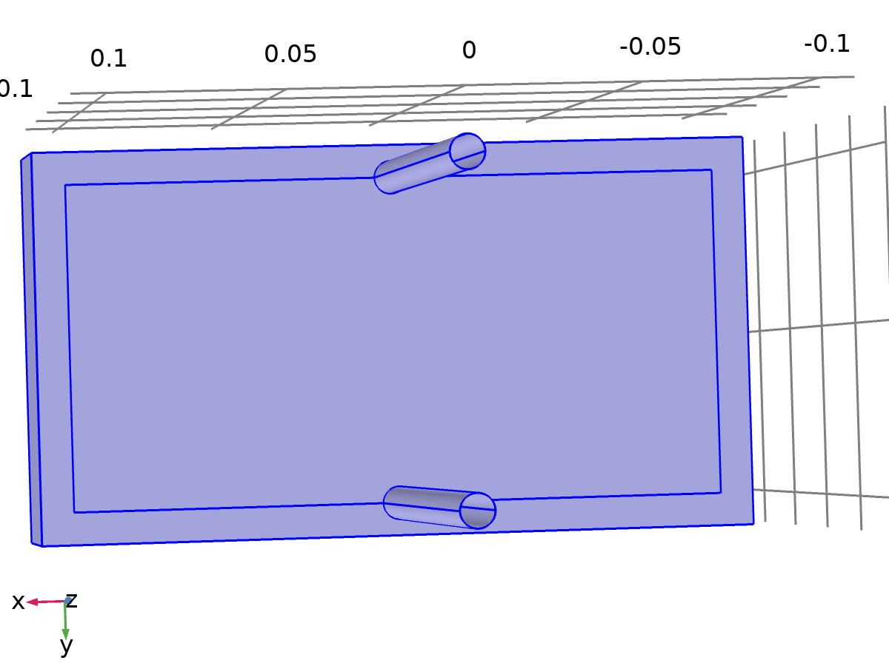

Thermal Insulation 1

Selection

|  |  |
| --- | --- |
| Geometric entity level | Boundary |
| Selection | Boundaries 1–5, 8–9, 16–17, 26–27, 32, 34, 36, 38, 40 |

Equations



#### Variables

| **Name** | **Expression** | **Unit** | **Description** | **Selection** |
| --- | --- | --- | --- | --- |
| ht3.ins1.Tave | nojac(ht3.ins1.intBnd(ht3.ins1.varIntSpa*ht3.rho*ht3.Cp*T3*max(abs(ht3.ux*ht3.nx+ht3.uy*ht3.ny+ht3.uz*ht3.nz),eps)))/nojac(ht3.ins1.intBnd(ht3.ins1.varIntSpa*ht3.rho*ht3.Cp*max(abs(ht3.ux*ht3.nx+ht3.uy*ht3.ny+ht3.uz*ht3.nz),eps))) | K | Weighted average temperature | Global |
| ht3.ins1.ntfluxInt | ht3.ins1.intExtBnd(ht3.ntflux*ht3.ins1.varIntSpa) | W | Total net heat rate | Global |
| ht3.ins1.ntefluxInt | ht3.ins1.intExtBnd(ht3.nteflux*ht3.ins1.varIntSpa) | W | Total net energy rate | Global |
| ht3.ins1.ntfluxInt_u | ht3.ins1.intIntBnd(ht3.ntflux_u*ht3.ins1.varIntSpa) | W | Total net heat rate, upside | Global |
| ht3.ins1.ntefluxInt_u | ht3.ins1.intIntBnd(ht3.nteflux_u*ht3.ins1.varIntSpa) | W | Total net energy rate, upside | Global |
| ht3.ins1.ntfluxInt_d | ht3.ins1.intIntBnd(ht3.ntflux_d*ht3.ins1.varIntSpa) | W | Total net heat rate, downside | Global |
| ht3.ins1.ntefluxInt_d | ht3.ins1.intIntBnd(ht3.nteflux_d*ht3.ins1.varIntSpa) | W | Total net energy rate, downside | Global |
| ht3.ins1.varIntSpa | ht3.d | 1 | Intermediate variable | Boundaries 1–5, 8–9, 16–17, 26–27, 32, 34, 36, 38, 40 |

#### Shape functions

| **Name** | **Shape function** | **Unit** | **Description** | **Shape frame** | **Selection** | **Details** |
| --- | --- | --- | --- | --- | --- | --- |
| T3 | Lagrange (Linear) | K | Temperature | Spatial | No boundaries | Slit |
| T3 | Lagrange (Linear) | K | Temperature | Material | No boundaries | Slit |
| T3 | Lagrange (Linear) | K | Temperature | Geometry | No boundaries | Slit |
| T3 | Lagrange (Linear) | K | Temperature | Mesh | No boundaries | Slit |

* + 1. Temperature 1

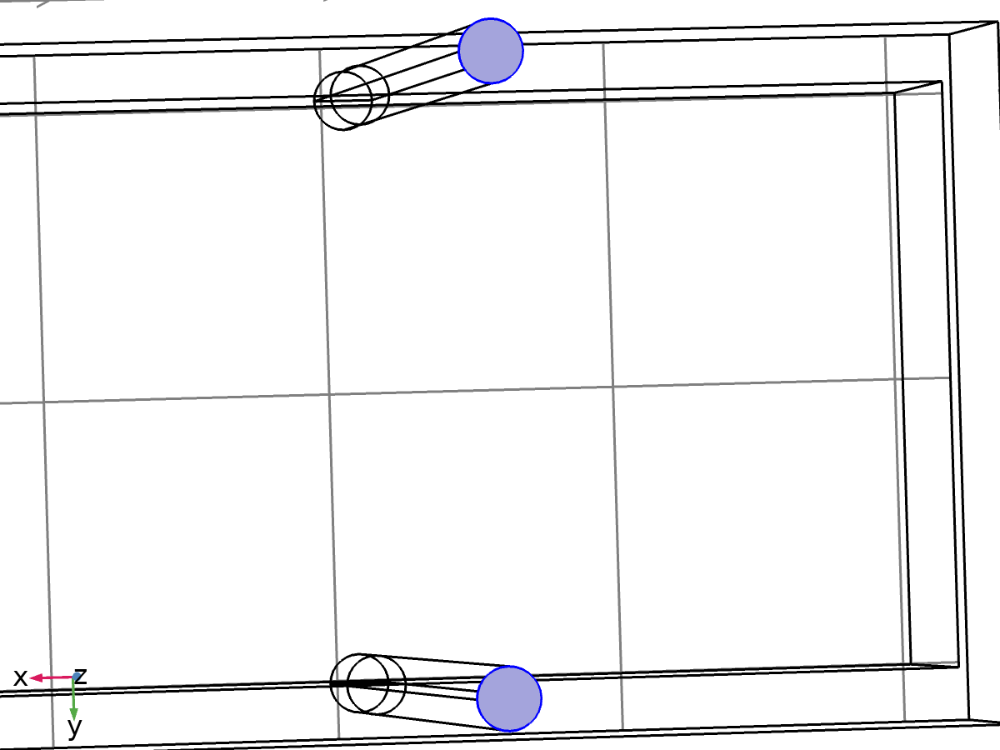

Temperature 1

Selection

|  |  |
| --- | --- |
| Geometric entity level | Boundary |
| Selection | Boundaries 20, 30 |

Equations



#### Temperature

Settings

| **Description** | **Value** |
| --- | --- |
| Temperature | User defined |
| Temperature | 293.15[K] |

#### Variables

| **Name** | **Expression** | **Unit** | **Description** | **Selection** | **Details** |
| --- | --- | --- | --- | --- | --- |
| ht3.T0 | 293.15[K] | K | Temperature | Boundaries 20, 30 | + operation |
| ht3.temp1.Tave | nojac(ht3.temp1.intBnd(ht3.temp1.varIntSpa*ht3.rho*ht3.Cp*T3*max(abs(ht3.ux*ht3.nx+ht3.uy*ht3.ny+ht3.uz*ht3.nz),eps)))/nojac(ht3.temp1.intBnd(ht3.temp1.varIntSpa*ht3.rho*ht3.Cp*max(abs(ht3.ux*ht3.nx+ht3.uy*ht3.ny+ht3.uz*ht3.nz),eps))) | K | Weighted average temperature | Global |  |
| ht3.temp1.ntfluxInt | ht3.temp1.intExtBnd(ht3.ntflux*ht3.temp1.varIntSpa) | W | Total net heat rate | Global |  |
| ht3.temp1.ntefluxInt | ht3.temp1.intExtBnd(ht3.nteflux*ht3.temp1.varIntSpa) | W | Total net energy rate | Global |  |
| ht3.temp1.ntfluxInt_u | ht3.temp1.intIntBnd(ht3.ntflux_u*ht3.temp1.varIntSpa) | W | Total net heat rate, upside | Global |  |
| ht3.temp1.ntefluxInt_u | ht3.temp1.intIntBnd(ht3.nteflux_u*ht3.temp1.varIntSpa) | W | Total net energy rate, upside | Global |  |
| ht3.temp1.ntfluxInt_d | ht3.temp1.intIntBnd(ht3.ntflux_d*ht3.temp1.varIntSpa) | W | Total net heat rate, downside | Global |  |
| ht3.temp1.ntefluxInt_d | ht3.temp1.intIntBnd(ht3.nteflux_d*ht3.temp1.varIntSpa) | W | Total net energy rate, downside | Global |  |
| ht3.temp1.varIntSpa | ht3.d | 1 | Intermediate variable | Boundaries 20, 30 |  |

#### Constraints

| **Constraint** | **Constraint force** | **Shape function** | **Selection** | **Details** |
| --- | --- | --- | --- | --- |
| ht3.T0-ht3.Tvar | test(ht3.T0-ht3.Tvar) | Lagrange (Linear) | Boundaries 20, 30 | Elemental |

* 1. Mesh 1

Mesh statistics

| **Description** | **Value** |
| --- | --- |
| Minimum element quality | 0.2046 |
| Average element quality | 0.6687 |
| Tetrahedron | 14876 |
| Triangle | 3420 |
| Edge element | 600 |
| Vertex element | 40 |

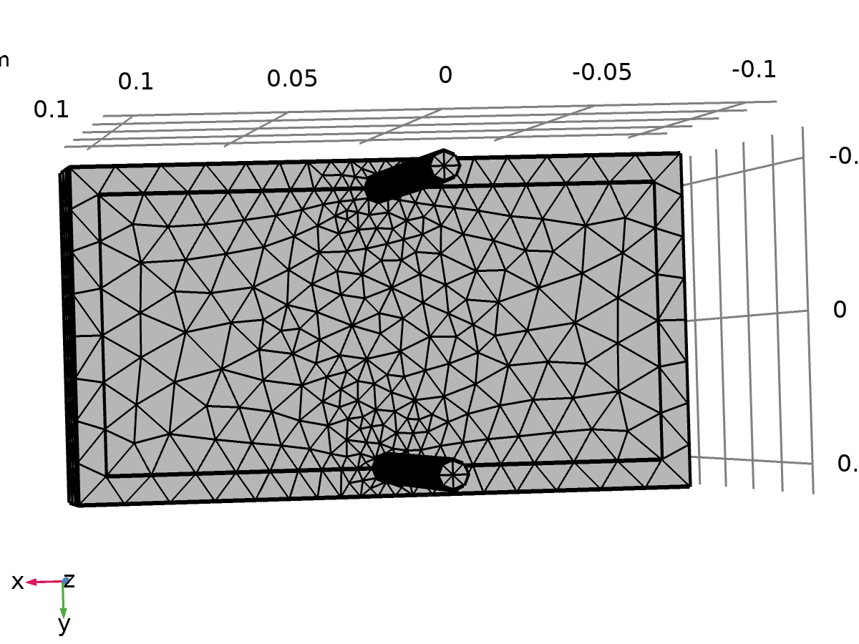

Mesh 1

* + 1. Size (size)

Settings

| **Description** | **Value** |
| --- | --- |
| Calibrate for | Fluid dynamics |
| Maximum element size | 0.0162 |
| Minimum element size | 0.00487 |
| Curvature factor | 0.7 |
| Resolution of narrow regions | 0.6 |
| Maximum element growth rate | 1.2 |
| Predefined size | Coarse |

* + 1. Free Tetrahedral 1 (ftet1)

Selection

|  |  |
| --- | --- |
| Geometric entity level | Remaining |



Free Tetrahedral 1

1. Study 1

Computation information

|  |  |
| --- | --- |
| Computation time | 5 min 39 s |
| CPU | AMD64 Family 23 Model 96 Stepping 1, 6 cores |
| Operating system | Windows 10 |

* 1. Time Dependent

| **Times** | **Unit** |
| --- | --- |
| 0 300 | s |

Study settings

| **Description** | **Value** |
| --- | --- |
| Include geometric nonlinearity | Off |

Mesh selection

| **Geometry** | **Mesh** |
| --- | --- |
| mesh1 | mesh1 |

Physics and variables selection

| **Physics interface** | **Discretization** |
| --- | --- |
| Laminar Flow (spf) | physics |
| Heat Transfer in Solids 2 (ht2) | physics |
| Heat Transfer in Fluids 3 (ht3) | physics |

Mesh selection

| **Geometry** | **Mesh** |
| --- | --- |
| Geometry 1 (geom1) | mesh1 |

* 1. Solver Configurations
     1. Solution 1

#### Compile Equations: Time Dependent (st1)

Study and step

| **Description** | **Value** |
| --- | --- |
| Use study | Study 1 |
| Use study step | Time Dependent |

Log

<---- Compile Equations: Time Dependent in Study 1/Solution 1 (sol1) -----------

Started at Apr 28, 2025 10:42:00 AM.

Geometry shape order: Linear

Running on AMD64 Family 23 Model 96 Stepping 1, AuthenticAMD.

Using 1 socket with 6 cores in total on Harshita.

Available memory: 7.63 GB.

Time: 4 s.

Physical memory: 1.62 GB

Virtual memory: 2.76 GB

Ended at Apr 28, 2025 10:42:04 AM.

----- Compile Equations: Time Dependent in Study 1/Solution 1 (sol1) ---------->

#### Dependent Variables 1 (v1)

General

| **Description** | **Value** |
| --- | --- |
| Defined by study step | Time Dependent |

Residual scaling

| **Description** | **Value** |
| --- | --- |
| Method | Manual |

Initial value calculation constants

| **Constant name** | **Initial value source** |
| --- | --- |
| t | 0 300 |
| timestep | 0.1[s] |

Log

<---- Dependent Variables 1 in Study 1/Solution 1 (sol1) -----------------------

Started at Apr 28, 2025 10:42:04 AM.

Solution time: 0 s.

Physical memory: 1.64 GB

Virtual memory: 2.77 GB

Ended at Apr 28, 2025 10:42:04 AM.

----- Dependent Variables 1 in Study 1/Solution 1 (sol1) ---------------------->

##### Pressure (comp1.p) (comp1_p)

General

| **Description** | **Value** |
| --- | --- |
| Field components | comp1.p |

##### Temperature (comp1.T2) (comp1_T2)

General

| **Description** | **Value** |
| --- | --- |
| Field components | comp1.T2 |

##### Temperature (comp1.T3) (comp1_T3)

General

| **Description** | **Value** |
| --- | --- |
| Field components | comp1.T3 |

##### Velocity field (comp1.u) (comp1_u)

General

| **Description** | **Value** |
| --- | --- |
| Field components | {comp1.u, comp1.v, comp1.w} |

#### Time-Dependent Solver 1 (t1)

General

| **Description** | **Value** |
| --- | --- |
| Times | {0, 300} |
| Relative tolerance | 0.005 |

Absolute tolerance

| **Description** | **Value** |
| --- | --- |
| Tolerance factor | 0.05 |

Settings: Pressure (comp1.p)

| **Description** | **Value** |
| --- | --- |
| Method | Scaled |
| Tolerance factor | 1 |

Time stepping

| **Description** | **Value** |
| --- | --- |
| Initial step | 0.1 |
| Initial step | On |
| Maximum BDF order | 2 |
| Nonlinear controller | On |
| Fraction of initial step for Backward Euler | 0.01 |
| Error estimation | Exclude algebraic |

Log

 146     0.30481   0.0024484     2202  483 2202     2     0      8

                   Group #1:      734  161  734                     7.3e-16  3.8e-16

                   Group #2:      734  161  734                     2.6e-16  2.9e-16

                   Group #3:      734  161  734                       7e-16  6.1e-16

 147     0.30726   0.0024484     2214  486 2214     2     0      8

                   Group #1:      738  162  738                     7.1e-16  3.9e-16

                   Group #2:      738  162  738                     2.7e-16  2.8e-16

                   Group #3:      738  162  738                       7e-16  4.2e-16

 148     0.30971   0.0024484     2226  489 2226     2     0      8

                   Group #1:      742  163  742                     7.4e-16  3.8e-16

                   Group #2:      742  163  742                     2.6e-16    3e-16

                   Group #3:      742  163  742                     9.3e-16  5.3e-16

 149     0.31216   0.0024484     2238  492 2238     2     0      8

                   Group #1:      746  164  746                     7.3e-16  3.7e-16

                   Group #2:      746  164  746                     2.2e-16  2.6e-16

                   Group #3:      746  164  746                     7.9e-16  4.8e-16

 150     0.31461   0.0024484     2250  495 2250     2     0      8

                   Group #1:      750  165  750                     7.2e-16  3.8e-16

                   Group #2:      750  165  750                     2.5e-16  2.5e-16

                   Group #3:      750  165  750                     5.6e-16    6e-16

 151     0.31706   0.0024484     2262  498 2262     2     0      8

                   Group #1:      754  166  754                     7.2e-16  3.9e-16

                   Group #2:      754  166  754                     1.8e-16  2.2e-16

                   Group #3:      754  166  754                     8.8e-16  5.7e-16

 152      0.3195   0.0024484     2274  501 2274     2     0      8

                   Group #1:      758  167  758                     7.2e-16  3.7e-16

                   Group #2:      758  167  758                     2.6e-16  3.4e-16

                   Group #3:      758  167  758                     1.3e-15  6.1e-16

 153     0.32195   0.0024484     2286  504 2286     2     0      8

                   Group #1:      762  168  762                     7.1e-16  3.8e-16

                   Group #2:      762  168  762                     2.2e-16    3e-16

                   Group #3:      762  168  762                     1.1e-15  4.4e-16

 154      0.3244   0.0024484     2298  507 2298     2     0      8

                   Group #1:      766  169  766                     7.3e-16  3.8e-16

                   Group #2:      766  169  766                     3.7e-16  4.3e-16

                   Group #3:      766  169  766                     6.7e-16  4.3e-16

 155     0.32685   0.0024484     2310  510 2310     2     0      8

                   Group #1:      770  170  770                     7.1e-16  3.9e-16

                   Group #2:      770  170  770                     2.6e-16  3.3e-16

                   Group #3:      770  170  770                     9.3e-16    7e-16

 156      0.3293   0.0024484     2322  513 2322     2     0      8

                   Group #1:      774  171  774                     7.2e-16  3.8e-16

                   Group #2:      774  171  774                     2.9e-16  3.7e-16

                   Group #3:      774  171  774                     7.5e-16  4.8e-16

 157     0.33175   0.0024484     2334  516 2334     2     0      8

                   Group #1:      778  172  778                     7.2e-16  3.8e-16

                   Group #2:      778  172  778                       3e-16    4e-16

                   Group #3:      778  172  778                     5.6e-16  4.8e-16

 158     0.33419   0.0024484     2346  519 2346     2     0      8

                   Group #1:      782  173  782                     7.2e-16  3.8e-16

                   Group #2:      782  173  782                     3.3e-16  4.5e-16

                   Group #3:      782  173  782                     4.8e-16  6.4e-16

 159     0.33664   0.0024484     2361  522 2361     2     0      8

                   Group #1:      787  174  787                     7.4e-16  3.8e-16

                   Group #2:      787  174  787                     2.7e-16  3.5e-16

                   Group #3:      787  174  787                       5e-16    8e-16

 160     0.33909   0.0024484     2370  525 2370     2     0      8

                   Group #1:      790  175  790                     6.7e-16  5.1e-16

                   Group #2:      790  175  790                       3e-16  3.9e-16

                   Group #3:      790  175  790                       6e-16  6.7e-16

 161     0.34154   0.0024484     2379  528 2379     2     0      8

                   Group #1:      793  176  793                     6.2e-16  4.7e-16

                   Group #2:      793  176  793                     2.3e-16  2.9e-16

                   Group #3:      793  176  793                     6.9e-16  7.4e-16

 162     0.34399   0.0024484     2391  531 2391     2     0      8

                   Group #1:      797  177  797                     7.1e-16  3.8e-16

                   Group #2:      797  177  797                     2.6e-16    3e-16

                   Group #3:      797  177  797                     1.3e-15  9.8e-16

 163     0.34644   0.0024484     2403  534 2403     2     0      8

                   Group #1:      801  178  801                     7.1e-16  3.8e-16

                   Group #2:      801  178  801                     2.2e-16  2.4e-16

                   Group #3:      801  178  801                     6.9e-16  8.2e-16

 164     0.34888   0.0024484     2415  537 2415     2     0      8

                   Group #1:      805  179  805                     7.2e-16  3.9e-16

                   Group #2:      805  179  805                     2.8e-16  2.7e-16

                   Group #3:      805  179  805                     5.2e-16  7.6e-16

 165     0.35133   0.0024484     2424  540 2424     2     0      8

                   Group #1:      808  180  808                     6.5e-16    5e-16

                   Group #2:      808  180  808                     2.6e-16  2.6e-16

                   Group #3:      808  180  808                     1.1e-15  1.1e-15

 166     0.35378   0.0024484     2433  543 2433     2     0      8

                   Group #1:      811  181  811                     6.9e-16  5.3e-16

                   Group #2:      811  181  811                     4.3e-16  4.4e-16

                   Group #3:      811  181  811                     1.2e-15  9.6e-16

 167     0.35623   0.0024484     2445  546 2445     2     0      8

                   Group #1:      815  182  815                     7.3e-16  3.7e-16

                   Group #2:      815  182  815                     3.7e-16    4e-16

                   Group #3:      815  182  815                       1e-15  9.8e-16

 168     0.35868   0.0024484     2457  549 2457     2     0      8

                   Group #1:      819  183  819                     7.4e-16  3.8e-16

                   Group #2:      819  183  819                     2.4e-16  2.6e-16

                   Group #3:      819  183  819                     1.3e-15  9.8e-16

 169     0.36113   0.0024484     2469  552 2469     2     0      8

                   Group #1:      823  184  823                     7.3e-16  3.8e-16

                   Group #2:      823  184  823                     2.5e-16  2.3e-16

                   Group #3:      823  184  823                     1.5e-15    1e-15

 170     0.36357   0.0024484     2481  555 2481     2     0      8

                   Group #1:      827  185  827                     7.2e-16  3.7e-16

                   Group #2:      827  185  827                     2.2e-16  2.5e-16

                   Group #3:      827  185  827                     1.5e-15  1.2e-15

 171     0.36602   0.0024484     2493  558 2493     2     0      8

                   Group #1:      831  186  831                     7.3e-16  3.8e-16

                   Group #2:      831  186  831                     3.2e-16  3.1e-16

                   Group #3:      831  186  831                     2.2e-15  1.3e-15

 172     0.36847   0.0024484     2502  561 2502     2     0      8

                   Group #1:      834  187  834                     6.2e-16  4.6e-16

                   Group #2:      834  187  834                     2.5e-16  2.6e-16

                   Group #3:      834  187  834                     1.3e-15    1e-15

 173     0.37092   0.0024484     2511  564 2511     2     0      8

                   Group #1:      837  188  837                     6.5e-16  4.8e-16

                   Group #2:      837  188  837                     2.9e-16  3.4e-16

                   Group #3:      837  188  837                     1.4e-15    1e-15

 174     0.37582   0.0048967     2523  567 2523     2     0      8

                   Group #1:      841  189  841                     6.9e-16  4.1e-16

                   Group #2:      841  189  841                     3.2e-16  3.8e-16

                   Group #3:      841  189  841                     1.2e-15    1e-15

 175     0.38022    0.004407     2535  570 2535     2     0      8

                   Group #1:      845  190  845                     7.2e-16  3.9e-16

                   Group #2:      845  190  845                     2.5e-16  3.4e-16

                   Group #3:      845  190  845                     1.3e-15  8.3e-16

 176     0.38463    0.004407     2547  573 2547     2     0      8

                   Group #1:      849  191  849                     7.3e-16  3.8e-16

                   Group #2:      849  191  849                     2.9e-16  3.5e-16

                   Group #3:      849  191  849                     1.8e-15  1.2e-15

 177     0.38904    0.004407     2559  576 2559     2     0      8

                   Group #1:      853  192  853                     7.1e-16  3.8e-16

                   Group #2:      853  192  853                     2.8e-16  3.2e-16

                   Group #3:      853  192  853                     1.3e-15    1e-15

 178     0.39344    0.004407     2571  579 2571     2     0      8

                   Group #1:      857  193  857                     7.2e-16  3.9e-16

                   Group #2:      857  193  857                     2.7e-16  3.6e-16

                   Group #3:      857  193  857                     2.1e-15  1.1e-15

 179     0.39785    0.004407     2583  582 2583     2     0      8

                   Group #1:      861  194  861                     7.2e-16  3.8e-16

                   Group #2:      861  194  861                     3.5e-16  4.1e-16

                   Group #3:      861  194  861                     1.4e-15  1.1e-15

 180     0.40226    0.004407     2595  585 2595     2     0      8

                   Group #1:      865  195  865                     7.3e-16  3.8e-16

                   Group #2:      865  195  865                     2.8e-16  3.3e-16

                   Group #3:      865  195  865                     1.7e-15  1.2e-15

 181     0.40667    0.004407     2607  588 2607     2     0      8

                   Group #1:      869  196  869                     7.1e-16    4e-16

                   Group #2:      869  196  869                     2.4e-16  2.8e-16

                   Group #3:      869  196  869                     2.3e-15  1.2e-15

 182     0.41107    0.004407     2619  591 2619     2     0      8

                   Group #1:      873  197  873                     7.2e-16  3.8e-16

                   Group #2:      873  197  873                     2.7e-16  3.4e-16

                   Group #3:      873  197  873                     1.8e-15  1.2e-15

 183     0.41548    0.004407     2631  594 2631     2     0      8

                   Group #1:      877  198  877                       7e-16  3.7e-16

                   Group #2:      877  198  877                     3.1e-16  3.6e-16

                   Group #3:      877  198  877                     2.2e-15  1.2e-15

 184     0.41989    0.004407     2643  597 2643     2     0      8

                   Group #1:      881  199  881                     7.2e-16  4.1e-16

                   Group #2:      881  199  881                     4.1e-16  4.5e-16

                   Group #3:      881  199  881                     1.8e-15  1.1e-15

 185     0.42429    0.004407     2655  600 2655     2     0      8

                   Group #1:      885  200  885                       7e-16  3.9e-16

                   Group #2:      885  200  885                     3.2e-16  3.5e-16

                   Group #3:      885  200  885                     2.1e-15  1.3e-15

 186      0.4287    0.004407     2667  603 2667     2     0      8

                   Group #1:      889  201  889                     7.2e-16  3.8e-16

                   Group #2:      889  201  889                     3.1e-16  3.8e-16

                   Group #3:      889  201  889                     1.8e-15    1e-15

 187     0.43311    0.004407     2679  606 2679     2     0      8

                   Group #1:      893  202  893                     7.1e-16  3.7e-16

                   Group #2:      893  202  893                     3.7e-16  4.5e-16

                   Group #3:      893  202  893                     2.1e-15  1.4e-15

 188     0.43751    0.004407     2691  609 2691     2     0      8

                   Group #1:      897  203  897                     7.2e-16  3.9e-16

                   Group #2:      897  203  897                     2.8e-16  3.4e-16

                   Group #3:      897  203  897                     2.3e-15    1e-15

 189     0.44192    0.004407     2703  612 2703     2     0      8

                   Group #1:      901  204  901                     7.3e-16  3.8e-16

                   Group #2:      901  204  901                     2.9e-16  3.6e-16

                   Group #3:      901  204  901                       2e-15  1.3e-15

 190     0.44633    0.004407     2715  615 2715     2     0      8

                   Group #1:      905  205  905                     7.2e-16  3.8e-16

                   Group #2:      905  205  905                     3.1e-16  4.1e-16

                   Group #3:      905  205  905                     1.6e-15    1e-15

 191     0.45074    0.004407     2727  618 2727     2     0      8

                   Group #1:      909  206  909                     7.2e-16  3.9e-16

                   Group #2:      909  206  909                     3.8e-16  5.1e-16

                   Group #3:      909  206  909                     1.5e-15  1.1e-15

 192     0.45514    0.004407     2739  621 2739     2     0      8

                   Group #1:      913  207  913                     7.2e-16  3.9e-16

                   Group #2:      913  207  913                     2.7e-16  3.2e-16

                   Group #3:      913  207  913                     2.2e-15  1.1e-15

 193     0.45955    0.004407     2751  624 2751     2     0      8

                   Group #1:      917  208  917                     7.1e-16  3.8e-16

                   Group #2:      917  208  917                     2.4e-16  3.2e-16

                   Group #3:      917  208  917                     1.8e-15  1.4e-15

 194     0.46396    0.004407     2763  627 2763     2     0      8

                   Group #1:      921  209  921                     7.3e-16  3.8e-16

                   Group #2:      921  209  921                     3.3e-16  4.2e-16

                   Group #3:      921  209  921                     2.3e-15  1.1e-15

 195     0.47277   0.0088141     2775  630 2775     2     0      8

                   Group #1:      925  210  925                     6.5e-16  5.1e-16

                   Group #2:      925  210  925                     2.8e-16  3.5e-16

                   Group #3:      925  210  925                     1.6e-15  8.2e-16

 196      0.4807   0.0079327     2787  633 2787     2     0      8

                   Group #1:      929  211  929                     6.6e-16  4.9e-16

                   Group #2:      929  211  929                     3.4e-16  4.5e-16

                   Group #3:      929  211  929                     1.6e-15  7.4e-16

 197     0.48864   0.0079327     2799  636 2799     2     0      8

                   Group #1:      933  212  933                     7.2e-16  3.8e-16

                   Group #2:      933  212  933                     3.2e-16  3.2e-16

                   Group #3:      933  212  933                     2.5e-15  9.4e-16

 198     0.49657   0.0079327     2811  639 2811     2     0      8

                   Group #1:      937  213  937                     6.3e-16  5.5e-16

                   Group #2:      937  213  937                     2.6e-16  3.5e-16

                   Group #3:      937  213  937                     1.6e-15  9.3e-16

 199      0.5045   0.0079327     2823  642 2823     2     0      8

                   Group #1:      941  214  941                     6.5e-16  5.5e-16

                   Group #2:      941  214  941                     2.9e-16  3.5e-16

                   Group #3:      941  214  941                     2.6e-15  9.5e-16

 200     0.51243   0.0079327     2835  645 2835     2     0      8

                   Group #1:      945  215  945                     6.6e-16  5.7e-16

                   Group #2:      945  215  945                       3e-16  3.5e-16

                   Group #3:      945  215  945                     1.6e-15  1.2e-15

 201     0.52037   0.0079327     2847  648 2847     2     0      8

                   Group #1:      949  216  949                     6.5e-16  5.5e-16

                   Group #2:      949  216  949                     2.6e-16  3.3e-16

                   Group #3:      949  216  949                     2.4e-15  1.3e-15

 202      0.5283   0.0079327     2859  651 2859     2     0      8

                   Group #1:      953  217  953                     6.3e-16  5.6e-16

                   Group #2:      953  217  953                     2.6e-16  3.4e-16

                   Group #3:      953  217  953                     1.7e-15    1e-15

 203     0.53623   0.0079327     2871  654 2871     2     0      8

                   Group #1:      957  218  957                     6.4e-16  5.6e-16

                   Group #2:      957  218  957                     2.4e-16  2.9e-16

                   Group #3:      957  218  957                     1.5e-15  1.2e-15

 204      0.5521    0.015865     2883  657 2883     2     0      8

                   Group #1:      961  219  961                     6.6e-16  5.7e-16

                   Group #2:      961  219  961                     2.7e-16  3.6e-16

                   Group #3:      961  219  961                     1.7e-15  8.7e-16

 205     0.56796    0.015865     2895  660 2895     2     0      8

                   Group #1:      965  220  965                     6.6e-16  5.5e-16

                   Group #2:      965  220  965                     3.3e-16  3.8e-16

                   Group #3:      965  220  965                     1.4e-15    1e-15

 206     0.58383    0.015865     2907  663 2907     2     0      8

                   Group #1:      969  221  969                     6.9e-16  5.7e-16

                   Group #2:      969  221  969                     2.3e-16  2.6e-16

                   Group #3:      969  221  969                     1.6e-15  1.1e-15

 207     0.59969    0.015865     2919  666 2919     2     0      8

                   Group #1:      973  222  973                     6.6e-16  5.6e-16

                   Group #2:      973  222  973                     3.3e-16  3.5e-16

                   Group #3:      973  222  973                       2e-15    1e-15

 208     0.61556    0.015865     2931  669 2931     2     0      8

                   Group #1:      977  223  977                     6.1e-16  5.2e-16

                   Group #2:      977  223  977                     3.6e-16  4.2e-16

                   Group #3:      977  223  977                       2e-15  1.1e-15

 209     0.64729    0.031731     2943  672 2943     2     0      8

                   Group #1:      981  224  981                     6.3e-16  5.4e-16

                   Group #2:      981  224  981                     3.6e-16  4.5e-16

                   Group #3:      981  224  981                     1.2e-15    1e-15

 210     0.67902    0.031731     2958  675 2958     2     0      8

                   Group #1:      986  225  986                     6.3e-16  5.2e-16

                   Group #2:      986  225  986                     2.5e-16  3.3e-16

                   Group #3:      986  225  986                     1.3e-15  9.9e-16

 211     0.71075    0.031731     2973  678 2973     2     0      8

                   Group #1:      991  226  991                     6.3e-16  5.2e-16

                   Group #2:      991  226  991                     2.7e-16  3.2e-16

                   Group #3:      991  226  991                     1.3e-15  8.4e-16

 212     0.74248    0.031731     2988  681 2988     2     0      8

                   Group #1:      996  227  996                     6.3e-16  5.3e-16

                   Group #2:      996  227  996                     2.6e-16  2.6e-16

                   Group #3:      996  227  996                       8e-16  9.5e-16

 213     0.77421    0.031731     3000  684 3000     2     0      8

                   Group #1:     1000  228 1000                     6.7e-16  5.3e-16

                   Group #2:     1000  228 1000                     2.8e-16  3.1e-16

                   Group #3:     1000  228 1000                     1.7e-15  9.5e-16

 214     0.83767    0.063461     3012  687 3012     2     0      8

                   Group #1:     1004  229 1004                     6.1e-16    5e-16

                   Group #2:     1004  229 1004                     3.1e-16  3.4e-16

                   Group #3:     1004  229 1004                     1.3e-15  8.7e-16

 215     0.90114    0.063461     3021  690 3021     2     0      8

                   Group #1:     1007  230 1007                     6.7e-16  5.4e-16

                   Group #2:     1007  230 1007                     2.9e-16  3.5e-16

                   Group #3:     1007  230 1007                     1.2e-15  8.8e-16

 216      0.9646    0.063461     3030  693 3030     2     0      8

                   Group #1:     1010  231 1010                     6.5e-16  5.2e-16

                   Group #2:     1010  231 1010                     1.8e-16  2.5e-16

                   Group #3:     1010  231 1010                     1.2e-15  1.1e-15

 217      1.0915     0.12692     3039  696 3039     2     0      8

                   Group #1:     1013  232 1013                     6.3e-16  5.1e-16

                   Group #2:     1013  232 1013                     2.3e-16  2.9e-16

                   Group #3:     1013  232 1013                     1.4e-15  1.2e-15

 218      1.2184     0.12692     3048  699 3048     2     0      8

                   Group #1:     1016  233 1016                     6.5e-16  5.2e-16

                   Group #2:     1016  233 1016                     2.8e-16  3.6e-16

                   Group #3:     1016  233 1016                     8.4e-16  1.4e-15

 219      1.4723     0.25385     3060  702 3060     2     0      8

                   Group #1:     1020  234 1020                     6.4e-16  4.9e-16

                   Group #2:     1020  234 1020                     2.6e-16  3.4e-16

                   Group #3:     1020  234 1020                     1.1e-15  1.5e-15

 220      1.7261     0.25385     3069  705 3069     1     0      8

                   Group #1:     1023  235 1023                     7.1e-16  4.2e-16

                   Group #2:     1023  235 1023                     2.7e-16  3.1e-16

                   Group #3:     1023  235 1023                     1.4e-15    1e-15

 221        1.98     0.25385     3075  708 3075     1     0      8

                   Group #1:     1025  236 1025                     6.9e-16  3.9e-16

                   Group #2:     1025  236 1025                     2.3e-16  2.5e-16

                   Group #3:     1025  236 1025                     1.2e-15    1e-15

 222      2.4877     0.50769     3081  711 3081     1     0      8

                   Group #1:     1027  237 1027                     7.1e-16    4e-16

                   Group #2:     1027  237 1027                     3.2e-16  2.8e-16

                   Group #3:     1027  237 1027                     1.1e-15  1.2e-15

 223      3.5031      1.0154     3087  714 3087     1     0      8

                   Group #1:     1029  238 1029                     6.8e-16  3.9e-16

                   Group #2:     1029  238 1029                     3.9e-16  3.5e-16

                   Group #3:     1029  238 1029                       2e-15  1.3e-15

 224      4.5184      1.0154     3090  717 3090     1     0      8

                   Group #1:     1030  239 1030                       7e-16  3.7e-16

                   Group #2:     1030  239 1030                     2.5e-16  2.3e-16

                   Group #3:     1030  239 1030                       2e-15  1.2e-15

 225      6.5492      2.0308     3096  720 3096     1     0      8

                   Group #1:     1032  240 1032                       7e-16  3.8e-16

                   Group #2:     1032  240 1032                     2.7e-16  2.7e-16

                   Group #3:     1032  240 1032                     1.2e-15  1.3e-15

 226      10.611      4.0615     3105  723 3105     1     0      8

                   Group #1:     1035  241 1035                       7e-16  3.9e-16

                   Group #2:     1035  241 1035                     2.5e-16  2.7e-16

                   Group #3:     1035  241 1035                     1.7e-15  1.4e-15

 227      18.734      8.1231     3114  726 3114     1     0      8

                   Group #1:     1038  242 1038                     7.1e-16  4.2e-16

                   Group #2:     1038  242 1038                     2.3e-16  2.7e-16

                   Group #3:     1038  242 1038                     9.8e-16  1.3e-15

 228       34.98      16.246     3120  729 3120     1     0      8

                   Group #1:     1040  243 1040                       7e-16  4.6e-16

                   Group #2:     1040  243 1040                     3.3e-16  3.8e-16

                   Group #3:     1040  243 1040                       1e-15  1.4e-15

 229       64.98          30     3126  732 3126     1     0      8

                   Group #1:     1042  244 1042                     7.5e-16  5.4e-16

                   Group #2:     1042  244 1042                       2e-16    3e-16

                   Group #3:     1042  244 1042                     1.5e-15  1.3e-15

 230       94.98          30     3129  735 3129     1     0      8

                   Group #1:     1043  245 1043                     7.1e-16  5.2e-16

                   Group #2:     1043  245 1043                     3.9e-16  5.2e-16

                   Group #3:     1043  245 1043                     1.4e-15  1.3e-15

 231      124.98          30     3135  738 3135     1     0      8

                   Group #1:     1045  246 1045                     7.1e-16  5.3e-16

                   Group #2:     1045  246 1045                     2.5e-16  3.4e-16

                   Group #3:     1045  246 1045                     1.2e-15  9.5e-16

 232      154.98          30     3144  741 3144     1     0      8

                   Group #1:     1048  247 1048                     6.7e-16  5.2e-16

                   Group #2:     1048  247 1048                     2.8e-16  5.3e-16

                   Group #3:     1048  247 1048                     1.2e-15    9e-16

 233      184.98          30     3147  744 3147     1     0      8

                   Group #1:     1049  248 1049                     6.9e-16  5.2e-16

                   Group #2:     1049  248 1049                     2.6e-16  4.8e-16

                   Group #3:     1049  248 1049                     1.1e-15    1e-15

 234      214.98          30     3156  747 3156     1     0      8

                   Group #1:     1052  249 1052                     6.7e-16    5e-16

                   Group #2:     1052  249 1052                     3.2e-16  5.9e-16

                   Group #3:     1052  249 1052                     1.4e-15  9.9e-16

 235      244.98          30     3159  750 3159     1     0      8

                   Group #1:     1053  250 1053                     6.6e-16    5e-16

                   Group #2:     1053  250 1053                     3.4e-16  6.1e-16

                   Group #3:     1053  250 1053                     1.7e-15  1.3e-15

 236      274.98          30     3168  753 3168     1     0      8

                   Group #1:     1056  251 1056                     6.6e-16  4.9e-16

                   Group #2:     1056  251 1056                     3.2e-16  6.4e-16

                   Group #3:     1056  251 1056                     1.5e-15  9.8e-16

   -         300           - out

 237      304.98          30     3171  756 3171     1     0      8

                   Group #1:     1057  252 1057                     6.5e-16    5e-16

                   Group #2:     1057  252 1057                     3.1e-16  5.5e-16

                   Group #3:     1057  252 1057                     1.7e-15  1.3e-15

Time-stepping completed.

Solution time: 333 s. (5 minutes, 33 seconds)

Physical memory: 2 GB

Virtual memory: 2.72 GB

Ended at Apr 28, 2025 10:47:40 AM.

----- Time-Dependent Solver 1 in Study 1/Solution 1 (sol1) -------------------->

##### Advanced (aDef)

Assembly settings

| **Description** | **Value** |
| --- | --- |
| Reuse sparsity pattern | On |

##### Segregated 1 (se1)

General

| **Description** | **Value** |
| --- | --- |
| Tolerance factor | 0.5 |
| Stabilization and acceleration | Anderson acceleration |
| Dimension of iteration space | 5 |
| Mixing parameter | 0.9 |
| Iteration delay | 1 |

###### Heat transfer T2 (ss1)

General

| **Description** | **Value** |
| --- | --- |
| Variables | Temperature (comp1.T2) |
| Linear solver | PARDISO (ht2) |

Method and termination

| **Description** | **Value** |
| --- | --- |
| Damping factor | 0.8 |
| Jacobian update | Once per time step |

###### Heat transfer T3 (ss2)

General

| **Description** | **Value** |
| --- | --- |
| Variables | Temperature (comp1.T3) |
| Linear solver | PARDISO (ht3) |

Method and termination

| **Description** | **Value** |
| --- | --- |
| Damping factor | 0.8 |
| Jacobian update | Once per time step |

###### Velocity u, Pressure p (ss3)

General

| **Description** | **Value** |
| --- | --- |
| Variables | {Velocity field (comp1.u), Pressure (comp1.p)} |
| Linear solver | Direct 3 |

Method and termination

| **Description** | **Value** |
| --- | --- |
| Damping factor | 0.9 |
| Jacobian update | Once per time step |

###### Lower Limit 1 (ll1)

Lower limit

| **Description** | **Value** |
| --- | --- |
| Lower limits (field variables) | comp1.T3 0 comp1.T2 0 |

##### PARDISO (ht2) (d1)

General

| **Description** | **Value** |
| --- | --- |
| Solver | PARDISO |
| Pivoting perturbation | 1.0E-13 |

##### PARDISO (ht3) (d2)

General

| **Description** | **Value** |
| --- | --- |
| Solver | PARDISO |
| Pivoting perturbation | 1.0E-13 |

##### Direct 3 (d3)

General

| **Description** | **Value** |
| --- | --- |
| Solver | PARDISO |
| Pivoting perturbation | 1.0E-13 |

1. Results
   1. Data Sets
      1. Study 1/Solution 1

Solution

| **Description** | **Value** |
| --- | --- |
| Solution | Solution 1 |
| Component | Save Point Geometry 1 |

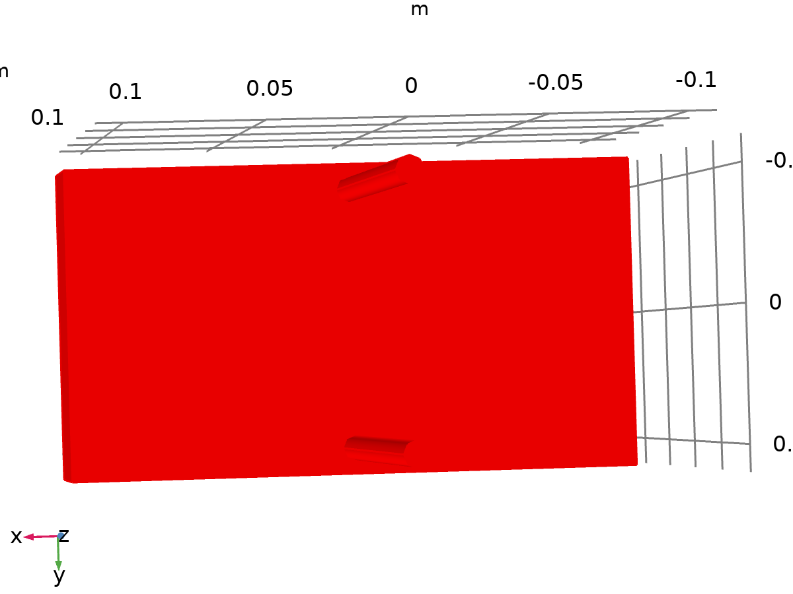

Data set: Study 1/Solution 1

* + 1. Exterior Walls

Data

| **Description** | **Value** |
| --- | --- |
| Data set | Study 1/Solution 1 |

Parameterization

| **Description** | **Value** |
| --- | --- |
| x- and y-axes | Surface parameters |

* 1. Derived Values
     1. Surface Integration 1

Data

| **Description** | **Value** |
| --- | --- |
| Data set | Study 1/Solution 1 |

Expressions

| **Expression** | **Unit** | **Description** |
| --- | --- | --- |
| T2 | m^2*K | Temperature |
| T3 | m^2*K | Temperature |

Integration settings

| **Description** | **Value** |
| --- | --- |
| Integration order | 4 |

* 1. Plot Groups
     1. Velocity (spf)

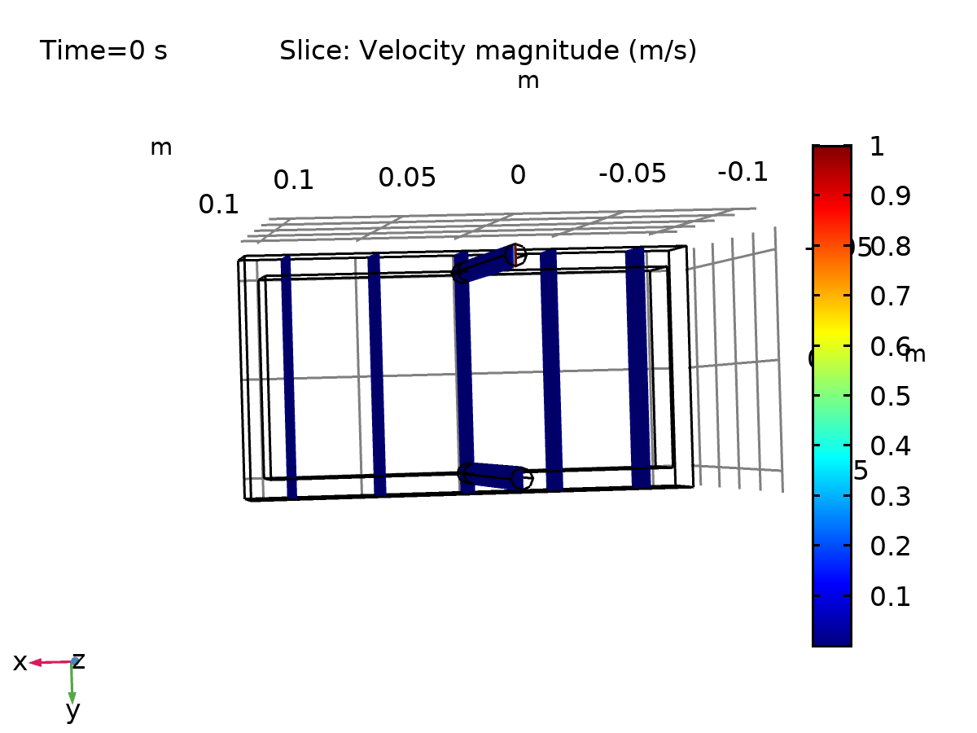

Slice: Velocity magnitude (m/s)

* + 1. Pressure (spf)

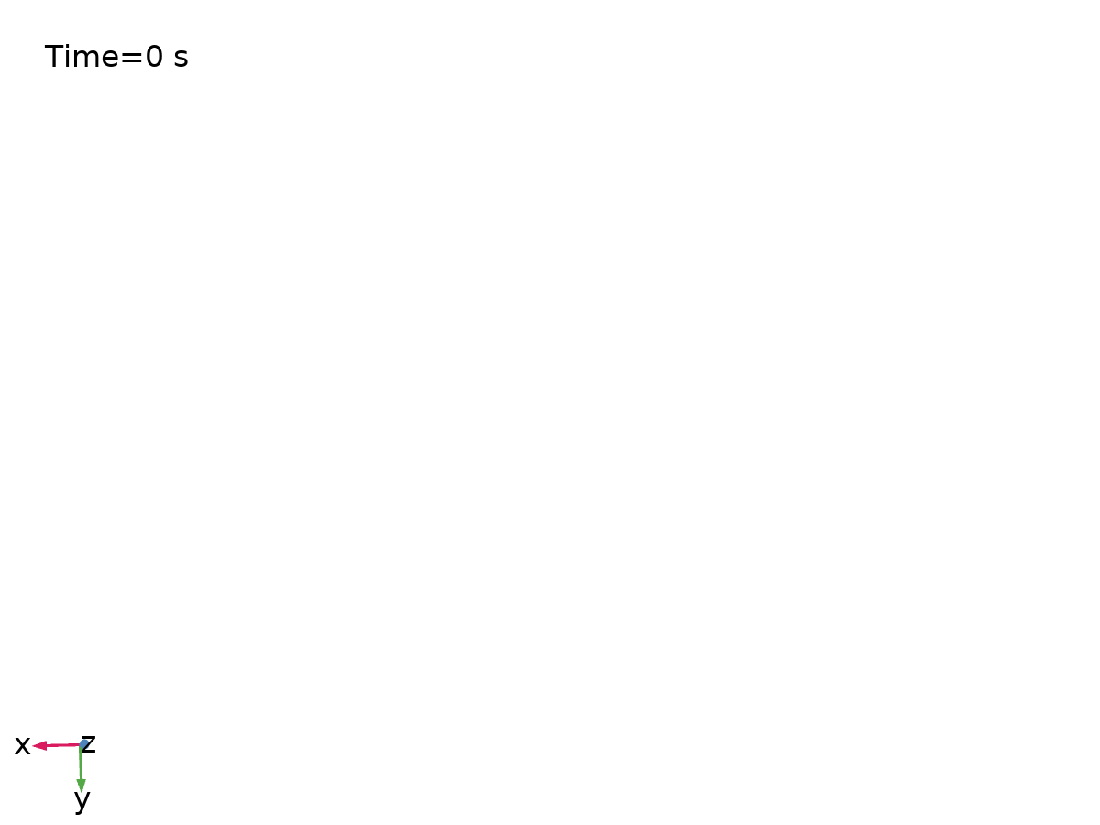

Contour: Pressure (Pa)

* + 1. Temperature (ht2)

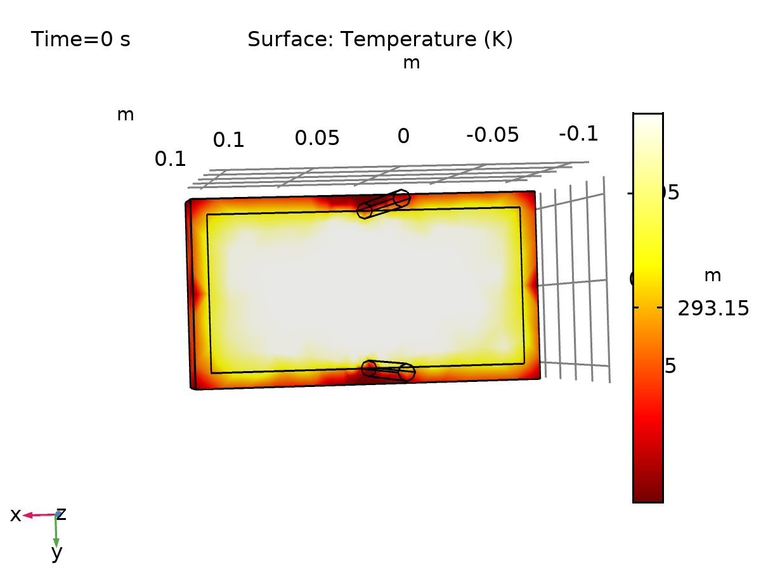

Surface: Temperature (K)

* + 1. Isothermal Contours (ht2)

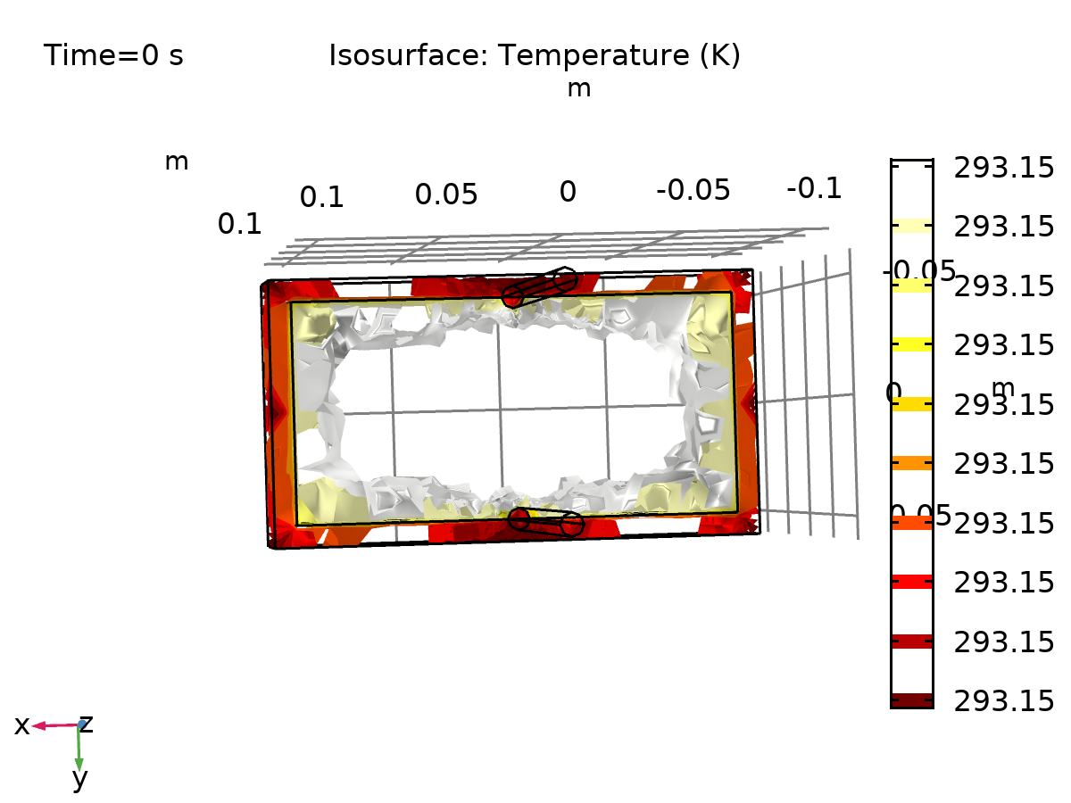

Isosurface: Temperature (K)

* + 1. Temperature (ht3)

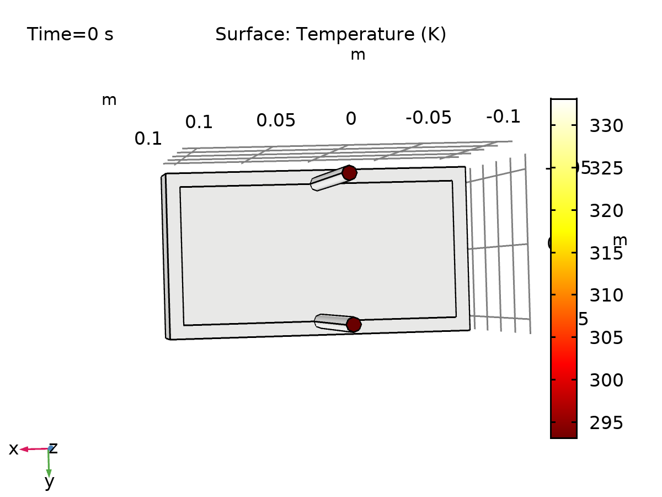

Surface: Temperature (K)

* + 1. Isothermal Contours (ht3)

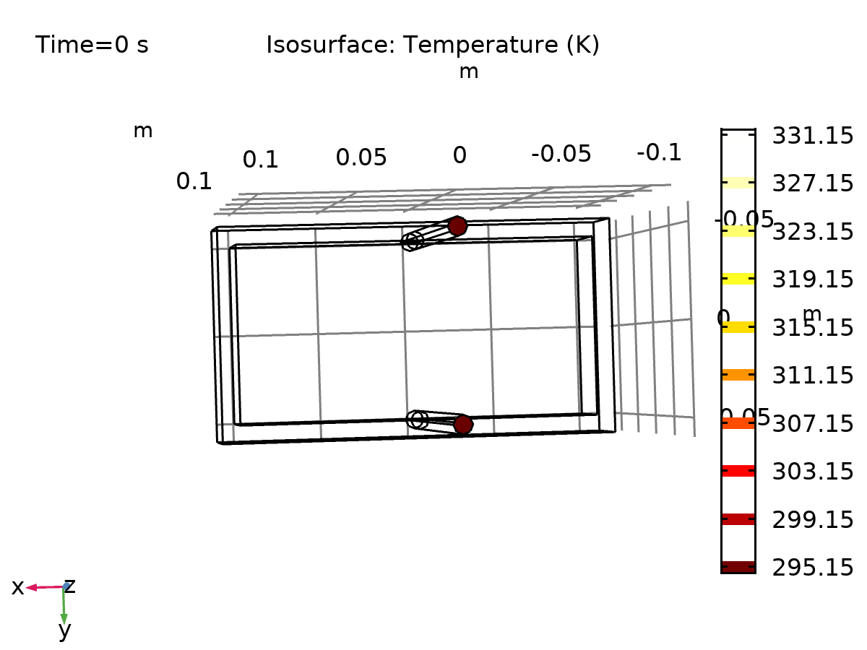

Isosurface: Temperature (K)

* + 1. 1D Plot Group 7

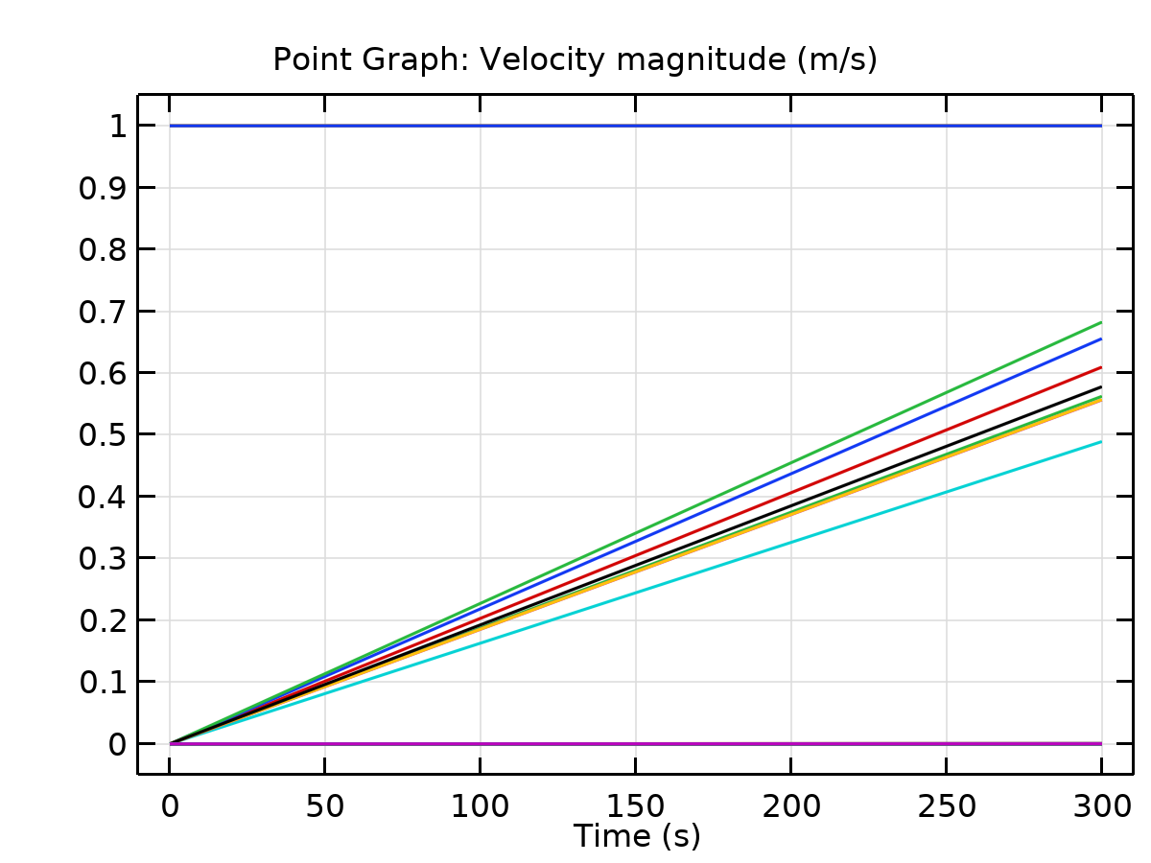

Point Graph: Velocity magnitude (m/s) Global: Average 1

* + 1. Cooling Power vs Time

