

**Elias Shaheen**

**20191102022 applying different algorithms**

**Gas Turbine CO and NOx Emission Dataset (YEAR 2014 DATASET) (before data processing):**

**Using linear Regression**

!pip install scikit-learn

import os

from google.colab import files

import pandas as pd

from sklearn.model_selection import train_test_split

from sklearn.linear_model import LinearRegression

from sklearn.metrics import mean_squared_error, mean_absolute_error, r2_score

# Print the current working directory

print("Current Working Directory:", os.getcwd())

# List files in the current directory

print("Files in the Directory:", os.listdir())

# Upload the 'gt_2014.csv' file

uploaded = files.upload()

# Get the file name from the uploaded files

file_name = list(uploaded.keys())[0]

# Load the dataset

df = pd.read_csv(file_name)

# Assuming your features are in columns 'AT', 'AP', 'AH', ..., 'CDP'

# and the target variable is in 'CO' and 'NOX'

features = df[['AT', 'AP', 'AH', 'AFDP', 'GTEP', 'TIT', 'TAT', 'TEY', 'CDP']]

target_CO = df['CO']

target_NOX = df['NOX']

# Split the data into training and testing sets

X_train_CO, X_test_CO, y_train_CO, y_test_CO = train_test_split(features, target_CO, test_size=0.2, random_state=42)

X_train_NOx, X_test_NOx, y_train_NOx, y_test_NOx = train_test_split(features, target_NOX, test_size=0.2, random_state=42)

# Create linear regression models

model_CO = LinearRegression()

model_NOx = LinearRegression()

# Train the models

model_CO.fit(X_train_CO, y_train_CO)

model_NOx.fit(X_train_NOx, y_train_NOx)

# Make predictions

predictions_CO = model_CO.predict(X_test_CO)

predictions_NOx = model_NOx.predict(X_test_NOx)

# Evaluate the models

mse_CO = mean_squared_error(y_test_CO, predictions_CO)

mae_CO = mean_absolute_error(y_test_CO, predictions_CO)

r2_CO = r2_score(y_test_CO, predictions_CO)

mse_NOx = mean_squared_error(y_test_NOx, predictions_NOx)

mae_NOx = mean_absolute_error(y_test_NOx, predictions_NOx)

r2_NOx = r2_score(y_test_NOx, predictions_NOx)

# Display the evaluation metrics

print("CO Emission Predictions:")

print("Mean Squared Error:", mse_CO)

print("Mean Absolute Error:", mae_CO)

print("R-squared:", r2_CO)

print("\nNOX Emission Predictions:")

print("Mean Squared Error:", mse_NOx)

print("Mean Absolute Error:", mae_NOx)

print("R-squared:", r2_NOx)

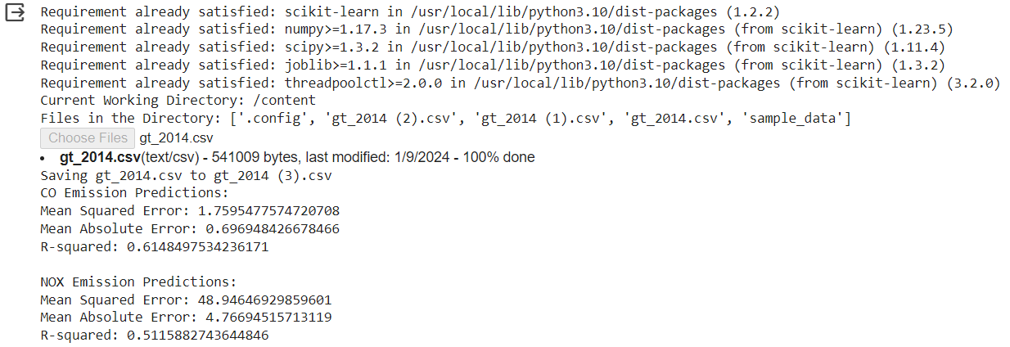***results using colab***

**NOW Gas Turbine CO and NOx Emission Dataset(after data processing):**

**Note: I tried to do scaling preprocessing but that almost didn't do any improvements on error so I tried Feature Engineering and it perfectly worked and reduced the errors by almost 40% on MSE (feature engineering did that by feature creation and transformation also handling missing data )**

!pip install scikit-learn

import os

from google.colab import files

import pandas as pd

from sklearn.model_selection import train_test_split

from sklearn.linear_model import LinearRegression

from sklearn.preprocessing import PolynomialFeatures

from sklearn.metrics import mean_squared_error, mean_absolute_error, r2_score

import matplotlib.pyplot as plt

import seaborn as sns

# Print the current working directory

print("Current Working Directory:", os.getcwd())

# List files in the current directory

print("Files in the Directory:", os.listdir())

# Upload the 'gt_2014.csv' file

uploaded = files.upload()

# Get the file name from the uploaded files

file_name = list(uploaded.keys())[0]

# Load the dataset

df = pd.read_csv(file_name)

# Assuming your features are in columns 'AT', 'AP', 'AH', ..., 'CDP'

# and the target variable is in 'CO' and 'NOX'

features = df[['AT', 'AP', 'AH', 'AFDP', 'GTEP', 'TIT', 'TAT', 'TEY', 'CDP']]

target_CO = df['CO']

target_NOX = df['NOX']

# Add polynomial features

poly = PolynomialFeatures(degree=2)

features_poly = poly.fit_transform(features)

# Split the data into training and testing sets

X_train_CO, X_test_CO, y_train_CO, y_test_CO = train_test_split(features_poly, target_CO, test_size=0.2, random_state=42)

X_train_NOx, X_test_NOx, y_train_NOx, y_test_NOx = train_test_split(features_poly, target_NOX, test_size=0.2, random_state=42)

# Create linear regression models

model_CO = LinearRegression()

model_NOx = LinearRegression()

# Train the models

model_CO.fit(X_train_CO, y_train_CO)

model_NOx.fit(X_train_NOx, y_train_NOx)

# Make predictions

predictions_CO = model_CO.predict(X_test_CO)

predictions_NOx = model_NOx.predict(X_test_NOx)

# Evaluate the models

mse_CO = mean_squared_error(y_test_CO, predictions_CO)

mae_CO = mean_absolute_error(y_test_CO, predictions_CO)

r2_CO = r2_score(y_test_CO, predictions_CO)

mse_NOx = mean_squared_error(y_test_NOx, predictions_NOx)

mae_NOx = mean_absolute_error(y_test_NOx, predictions_NOx)

r2_NOx = r2_score(y_test_NOx, predictions_NOx)

# Display the evaluation metrics

print("CO Emission Predictions:")

print("Mean Squared Error:", mse_CO)

print("Mean Absolute Error:", mae_CO)

print("R-squared:", r2_CO)

print("\nNOX Emission Predictions:")

print("Mean Squared Error:", mse_NOx)

print("Mean Absolute Error:", mae_NOx)

print("R-squared:", r2_NOx)

# Visualize CO Emission Predictions

plt.figure(figsize=(12, 6))

# Scatter plot for actual vs predicted CO emissions

plt.subplot(1, 2, 1)

sns.scatterplot(x=y_test_CO, y=predictions_CO)

plt.title('Actual vs Predicted CO Emissions')

plt.xlabel('Actual CO Emissions')

plt.ylabel('Predicted CO Emissions')

# Residual plot for CO emissions

plt.subplot(1, 2, 2)

residuals_CO = y_test_CO - predictions_CO

sns.histplot(residuals_CO, kde=True)

plt.title('Residuals for CO Emissions')

plt.xlabel('Residuals')

plt.ylabel('Frequency')

plt.tight_layout()

plt.show()

# Visualize NOX Emission Predictions

plt.figure(figsize=(12, 6))

# Scatter plot for actual vs predicted NOX emissions

plt.subplot(1, 2, 1)

sns.scatterplot(x=y_test_NOx, y=predictions_NOx)

plt.title('Actual vs Predicted NOX Emissions')

plt.xlabel('Actual NOX Emissions')

plt.ylabel('Predicted NOX Emissions')

# Residual plot for NOX emissions

plt.subplot(1, 2, 2)

residuals_NOx = y_test_NOx - predictions_NOx

sns.histplot(residuals_NOx, kde=True)

plt.title('Residuals for NOX Emissions')

plt.xlabel('Residuals')

plt.ylabel('Frequency')

plt.tight_layout()

plt.show()

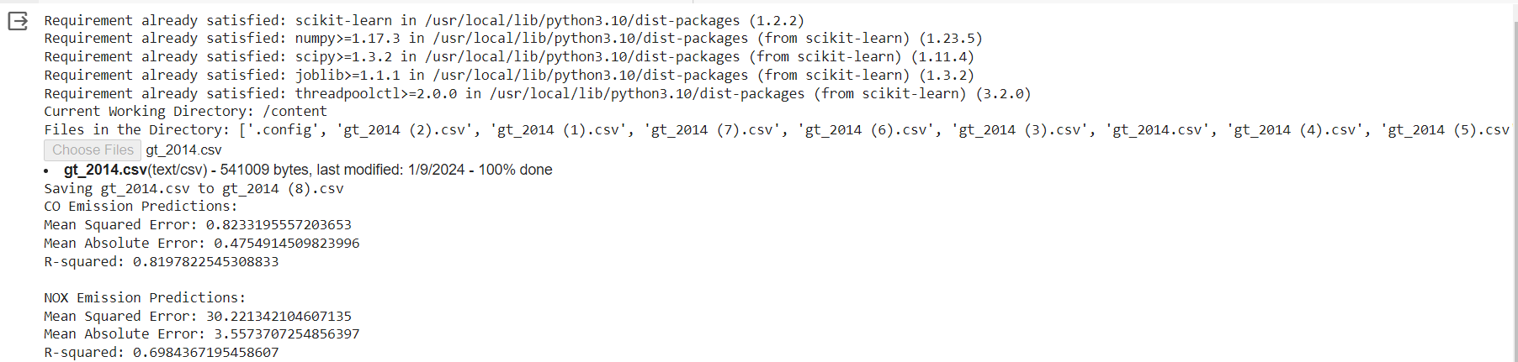**Results after preprocessing**

**Visualization**

