User manual DSA project. Shaheer Dastgir

[Company name]  [Company address]

**1. Introduction:**

The Library Management Program is designed to manage a library catalog and provide various functionalities for library staff, students, and faculty members. This user manual provides a step-by-step guide on how to use the program effectively.

Note: First the user have to register himself in the staff register user section.

**2. Logging In:**

- When you run the program, you will be prompted to press Enter to log in.

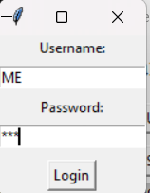

Invalid login:

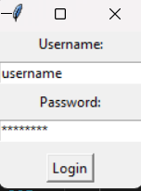

**3. Librarian Portal:**

If you logged in as library staff, you will have access to the Librarian Portal with the following options:

- Search Books: Search for books in the library catalog based on title, author, or subject.

- Display Books: Display all the books in the library catalog.

- Borrow Book: Mark a book as issued.

- Return Book: Mark a book as returned.

1. Search book:

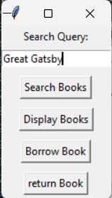

1. Display book:

1. Borrow book:

1. Return book:

