TITANIC SURVIVAL PREDICTION USING MACHINE LEARNING CLASSIFICATION MODELS

BY
M.VAMSI KRISHNA - 2473A39087
SHAIK AFTAB AHMED - 2473A39116

TABLE OF CONTENTS :
TITANIC SURVIVAL PREDICTION USING MACHINE LEARNING CLASSIFICATION MODELS
1.ABSTRACT
2.TOOLS AND ENVIRONMENT SETUP
2.1. CREATED A FOLDER FOR MINI PROJECT :
2.2. CREATED A VIRTUAL ENVIRONMENT FOR THAT MINI PROJECT :
2.3 ACTIVATED THE VIRTUAL ENVIRONMENT
2.4. INSTALLED REQUIRED LIBRARIES IN THE VIRTUAL ENVIRONMENT :
2.5. TITANIC DATASET SETUP FROM KAGGLE USING LINUX TERMINAL
2.6. VIEWING CSV FILES IN PROPER TABLE FORMAT IN VS CODE
3. PROJECT WORKFLOW OVERVIEW
PHASE 1: PROBLEM UNDERSTANDING
PHASE 2: DATA ACQUISITION & EXPLORATION
PHASE 3: DATA PREPROCESSING
PHASE 4: FEATURE SELECTION & DATA PREPARATION
PHASE 5: MODEL BUILDING
PHASE 6: MODEL EVALUATION
PHASE 7: FINAL MODEL USAGE
4. IMPLEMENTATION PHASE :
4.1 IMPORTING THE REQUIRED LIBRARIES :
4.2 LOADING THE TRAINING DATASET :
4.3 VERIFYING THE LOADED TRAINING DATASET :
4.5 EXPLORATORY DATA ANALYSIS :
4.6 DATA PREPROCESSING ON TRAINING DATA
4.7 FEATURE SELECTION -DATA PREPARATION
4.8 MODEL BUILDING
4.9 EVALUATION METRICS ( USING VALIDATION DATA )
4.10 CHOOSING BEST MODEL
4.11 LOADING TEST DATASET:
4.12 VERIFYING THE LOADED TEST DATASET
4.13 DATA PREPROCESSING ON TEST DATA
4.14 FEATURE SELECTION
4.15 PREDICTION:
4.16 TEST WITH CUSTOM INPUT

1.ABSTRACT
The sinking of the RMS Titanic remains one of the most tragic maritime disasters in history. This project aims to predict passenger survival using supervised machine learning techniques. The problem is formulated as a binary classification task, where the target variable Survived indicates whether a passenger survived (1) or not (0).
The dataset used in this project is obtained from the Titanic - Machine Learning from Disaster competition hosted on Kaggle. It includes passenger details such as ticket class (Pclass), gender (Sex), age, fare, number of siblings/spouses aboard (SibSp), number of parents/children aboard (Parch), and port of embarkation (Embarked).
Data Preprocessing is performed to ensure quality and consistency. Missing values in features like Age and Embarked are handled appropriately. Irrelevant columns such as Name, Ticket, and Cabin are removed where necessary. Categorical variables are encoded into numerical format to make them suitable for model training. Feature engineering techniques such as creating Family Size are applied to improve predictive performance.
Three classification algorithms are implemented: Logistic Regression, Decision Tree, and Random Forest. Logistic Regression serves as a baseline linear model to estimate survival probability. Decision Tree identifies survival patterns using rule-based splits. Random Forest, an ensemble learning method, combines multiple decision trees to improve accuracy and reduce over fitting.
Model performance is evaluated using metrics such as Accuracy, Confusion Matrix, Precision, Recall, and F1-Score. Comparative analysis is conducted to determine the most effective model. Among the implemented algorithms, Random Forest generally provides better performance due to its ensemble nature.
This project demonstrates how machine learning techniques can be applied to historical datasets to extract meaningful insights and build predictive systems for classification problems.

2.TOOLS AND ENVIRONMENT SETUP

2.1. CREATED A FOLDER FOR MINI PROJECT :
Command : mkdir mlminiproject2-2

2.2. CREATED A VIRTUAL ENVIRONMENT FOR THAT MINI PROJECT :
Command : python3 -m venv venv_name
Explanation :
- python3
  - Refers to the Python version 3 interpreter installed on the system.
  - Ensures that the virtual environment is created using Python 3, not Python 2.
- -m
  - Stands for module.
  - Tells Python to run a library module as a script instead of a file.
- venv
  - A built-in Python module used to create virtual environments.
  - A virtual environment is an isolated workspace for Python projects.
- venv_name
  - The name of the virtual environment directory.
  - This folder will contain:
    - A separate Python interpreter
    - Installed libraries
    - Configuration files
Purpose:
- Creates an isolated Python environment for the project.
- Prevents conflicts between project-specific libraries and system-wide Python packages.
- Ensures consistent behavior across different systems.

2.3 ACTIVATED THE VIRTUAL ENVIRONMENT
command : source venv_name/bin/activate
Explanation :
- source
  - A shell command used to execute a script in the current terminal session.
  - Ensures environment variables are applied immediately.
- venv_name/
  - Refers to the virtual environment directory created earlier.
- bin/
  - Contains executable files related to the virtual environment.
  - Includes Python interpreter and activation scripts.
- activate
  - A shell script that:
    - Modifies the terminal PATH
    - Points Python and pip to the virtual environment
    - Displays the environment name in the prompt
Effect After Activation:
- Terminal prompt changes to:(venv_name)
- All Python command and library installations are now limited to this environment.
- System Python remains untouched.

2.4. INSTALLED REQUIRED LIBRARIES IN THE VIRTUAL ENVIRONMENT :
Command : pip install numpy pandas matplotlib scikit-learn
Libraries Installed:
numpy
pandas
matplotlib
scikit-learn
Explanation of Each Library:
NumPy
- Provides support for:
  - Multi-dimensional arrays
  - Mathematical and numerical operations
Used for:
  - Fast computations
  - Matrix and vector operations
  - Scientific calculations
Pandas
- Used for:
  - Data manipulation and analysis
  - Handling datasets (CSV, Excel, etc.)
- Provides:
  - DataFrames and Series
  - Data cleaning and preprocessing tools
Matplotlib
- A plotting and visualization library.
- Used for:
  - Creating graphs and charts
  - Visualizing trends and patterns in data
- Common plots:
  - Line plots
  - Bar charts
  - Histograms
Scikit-learn
- A machine learning library.
- Used for:
  - Classification
  - Regression
  - Clustering
  - Model evaluation
- Provides ready-to-use ML algorithms and utilities.

Python and pip
Python is a high-level programming language used to write and execute machine learning code. pip is the package manager for Python. It is used to install, update, and remove external libraries that extend Python’s functionality

2.5. TITANIC DATASET SETUP FROM KAGGLE USING LINUX TERMINAL
This section documents the complete and clean workflow of downloading the Titanic dataset from Kaggle, moving it into a project directory, extracting it, and safely managing the ZIP file using Linux terminal command.

1. Navigating to Kaggle and Downloading the Dataset
- Open a web browser and go to Kaggle (https://www.kaggle.com).
- Log in using your Kaggle account.
- In the search bar, type "Titanic dataset".
- Open the dataset commonly named "Titanic - Machine Learning from Disaster".
- Click on the Download button.
Kaggle downloads datasets as ZIP files by default.
After downloading, the ZIP file (archive.zip) will be stored in the system's Downloads directory.

2. Understanding the Downloads Directory
In Linux, each user has a home directory represented by the symbol ~.
- ~/Downloads → Refers to the Downloads folder of the current user.
You can verify the downloaded file using:
ls ~/Downloads

3. Moving the ZIP File to the Project Folder
The dataset ZIP file is moved from the Downloads folder to the project directory named MLMINIPROJECT2-2 using the mv command.

command Used
mv ~/Downloads/archive.zip ~/MLMINIPROJECT2-2
Explanation of Each Term
- mv → Move command (used to move or rename files)
- ~/Downloads/archive.zip → Source file path (ZIP file in Downloads)
- ~/MLMINIPROJECT2-2 → Destination project directory
After this command, the ZIP file is no longer in Downloads and is now inside the project folder.

4. Navigating to the Project Directory
Before extracting the ZIP file, we navigate into the project folder.
cd ~/MLMINIPROJECT2-2
Explanation
- cd → Change directory
- ~/MLMINIPROJECT2-2 → Path of the ML project directory
You can confirm the file presence using:
ls

5. Extracting the ZIP File
The dataset is extracted using the unzip command.
unzip archive.zip
Explanation
- unzip → command used to extract ZIP files
- archive.zip → ZIP file containing the Titanic dataset
After extraction, dataset files such as CSV files become available for use in the project.

6. Removing the ZIP File After Extraction
Once the contents are successfully extracted, the ZIP file is no longer required. It is removed using the rm command.
rm archive.zip

Important Note on rm
- rm permanently deletes files
- Files deleted using rm do not go to Trash
- There is no undo operation
This step helps keep the project directory clean and organized.

2.6. VIEWING CSV FILES IN PROPER TABLE FORMAT IN VS CODE
Visual Studio Code opens CSV files as plain text by default. This is expected behavior because a CSV file is a text file. To make the data readable in a table-like format, we use a VS Code extension ( Rainbow csv ) .

Step 1 : Ensure the File Extension is CSV
If the file has a different extension, rename it to .csv and reopen it in VS Code.
Rainbow CSV command will not appear if the file is not recognized as a CSV file.

Step 2 Set the Language Mode to CSV
Look at the bottom-right corner of the VS Code window.
If it shows Plain Text, click on it and select CSV.
This tells VS Code to treat the file as a CSV file.

Step 3 Align the CSV Data Using Rainbow CSV
Open the command Palette using Ctrl + Shift + P.
Type Rainbow CSV: Align and execute the command.
The comma-separated values will align into columns, making the file look like a table.

3. PROJECT WORKFLOW OVERVIEW

PHASE 1: PROBLEM UNDERSTANDING
Step 1: Define the Problem
- Identify the task as Supervised Learning – Binary Classification.
- Objective: Predict whether a passenger survived the Titanic disaster.
- Target Variable: Survived
  - 0 → Not Survived
  - 1 → Survived

PHASE 2: DATA ACQUISITION & EXPLORATION
Step 2: Load Dataset
- Import Titanic dataset into a DataFrame.
- Verify number of samples and features.
Step 3: Understand Dataset Structure
- Identify numerical and categorical features.
- Confirm target variable (Survived).
- Inspect column names, data types, and sample records.
Step 4: Exploratory Data Analysis (EDA)
- Analyze survival distribution.
- Study impact of key features (Sex, Pclass, Age, Fare).
- Detect missing values, outliers, and irrelevant columns.

PHASE 3: DATA PREPROCESSING
Step 5: Handle Missing Values
- Apply Mean/Median for numerical features.
- Apply Mode for categorical features.
Step 6: Remove Irrelevant Features
- Drop non-predictive identifiers (PassengerId, Name, Ticket).
- Retain meaningful attributes.
Step 7: Encode Categorical Variables
- Convert categorical features into numerical format.
  - Sex → Binary Encoding
  - Embarked → One-Hot/Label Encoding
Step 8: Feature Scaling
- Normalize or standardize numerical features (Age, Fare) where required.

PHASE 4: FEATURE SELECTION & DATA PREPARATION
Step 9: Feature Selection
- Select relevant features using correlation analysis and domain knowledge.
- Remove weak or redundant variables.
Step 10: Train-Test Split
- Divide dataset into Training and Testing sets (70:30 or 80:20).
- Ensure no data leakage.

PHASE 5: MODEL BUILDING
Step 11: Algorithm Selection
- Implement classification models:
  - Logistic Regression
  - Decision Tree
  - Random Fores
- Select models based on interpret ability and performance.
Step 12: Model Training
- Train models using the training dataset.
- Learn patterns between features and survival outcome.

PHASE 6: MODEL EVALUATION
Step 13: Prediction
- Generate survival predictions on test data.
Step 14: Performance Evaluation
- Evaluate using:
  - Accuracy
  - Confusion Matrix
  - Precision
  - Recall
  - F1-Score
Step 15: Model Optimization
- Improve performance through hyperparameter tuning and model comparison.

PHASE 7: FINAL MODEL USAGE
Step 16: Custom Prediction
- Accept new passenger input.
- Apply same preprocessing pipeline.
- Predict survival outcome.
Step 17: Conclusion
- Summarize model performance , Identify key survival factors.
- Discuss limitations and future improvements.

4. IMPLEMENTATION PHASE :

4.1 IMPORTING THE REQUIRED LIBRARIES :
import pandas as pd
import matplotlib.pyplot as plt
import seaborn as sns
import numpy as np
from sklearn.preprocessing import StandardScaler
from sklearn.linear_model import LogisticRegression
from sklearn.tree import DecisionTreeClassifier
from sklearn.ensemble import RandomForestClassifier
from sklearn.model_selection import train_test_split
from sklearn.metrics import accuracy_score
from sklearn.metrics import confusion_matrix
from sklearn.metrics import precision_score
from sklearn.metrics import recall_score
from sklearn.metrics import f1_score
from sklearn.metrics import classification_report

import :
A Python keyword used to bring an external library or module into your program so you can use its functions, classes, and tools.
from :
A Python keyword used to import a specific part (module, class, or function) from a larger library instead of importing the entire library.
as :
A Python keyword used to give a short alias (nickname) to a library or module for easier usage.
. (dot operator) :
Used to access something inside a library or module.
Example: sklearn.preprocessing
Here, preprocessing is inside sklearn.
library :
A collection of pre-written code created by others to perform specific tasks.
module :
A single Python file inside a library that contains related functions or classes.
package :
A collection of modules grouped together inside a library.
framework :
A larger structured library that provides a complete system to build applications (e.g., machine learning systems).
sklearn :
Short name for Scikit-learn.
It is a Machine Learning library in Python used for building, training, and evaluating ML models.
preprocessing :
A module inside sklearn used to clean, scale, or transform data before training a model.
linear_model :
A module inside sklearn that contains linear algorithms like Logistic Regression.
tree :
A module inside sklearn that contains decision tree algorithms.
ensemble :
A module inside sklearn that contains models which combine multiple algorithms together to improve performance.
model_selection :
A module used to split data and select best models.
metrics :
A module used to measure how well a machine learning model performs.

- import pandas as pd
pandas :
A Python library used for data manipulation and analysis.
It works mainly with tables (rows and columns).
pd :
Alias name given to pandas.
Data structure used in pandas:
DataFrame :
A 2D table structure (like Excel sheet).
Series :
A single column of data.

- import matplotlib.pyplot as plt
matplotlib :
A Python library used for data visualization (drawing graphs).
pyplot :
A module inside matplotlib used to create plots easily.
plt :
Alias for pyplot.
Used for:
Line graphs, bar charts, histograms, scatter plots.

- import seaborn as sns
seaborn :
A Python visualization library built on top of matplotlib.
It gives more attractive and statistical graphs.
sns :
Alias for seaborn.
Used for:
Heatmaps, distribution plots, box plots, correlation maps.

- import numpy as np
numpy :
A Python library used for numerical operations and mathematical calculations.
np :
Alias for numpy.
Core structure:
ndarray :
A fast multi-dimensional array for numbers.
Used for:
Matrix operations, linear algebra, mathematical functions.

- from sklearn.preprocessing import StandardScaler
StandardScaler :
A class used to standardize data.
Why scaling needed:
Machine learning models perform better when features are on same scale.
Formula used:
Z = (X − mean) / standard deviation
Result:
Data will have mean = 0
Standard deviation = 1

- from sklearn.linear_model import LogisticRegression
LogisticRegression :
A classification algorithm used for binary classification problems.
It predicts probability using Sigmoid function.
Formula:
z = b0 + b1x1 + b2x2 + ... + bnxn
Sigmoid function:
P = 1 / (1 + e^(-z))
Output:
Value between 0 and 1 (probability).

- from sklearn.tree import DecisionTreeClassifier
DecisionTreeClassifier :
A classification model that makes decisions based on conditions (if-else structure).
It splits data into branches based on features.
Split criteria formulas:
Gini Index:
Gini = 1 − Σ (pi)^2
Entropy:
Entropy = − Σ (pi log2 pi)
Where pi = probability of class.

- from sklearn.ensemble import RandomForestClassifier
RandomForestClassifier :
An ensemble learning model that combines multiple decision trees.
ensemble :
Means combining multiple models to improve accuracy.
How it works:
- Builds many decision trees
- Each tree gives prediction
- Final output = majority vote
Improves:
Accuracy
Reduces overfitting

- from sklearn.model_selection import train_test_split
train_test_split :
A function used to divide dataset into:
Training data
Testing data
Purpose:
Train model on one part
Test model on unseen data
Common split:
80% training
20% testing

- from sklearn.metrics import accuracy_score
accuracy_score :
Measures how many predictions are correct.
Formula:
Accuracy = (Correct Predictions) / (Total Predictions)

- from sklearn.metrics import confusion_matrix
confusion_matrix :
A table used to evaluate classification performance.
Structure:
True Positive (TP)
True Negative (TN)
False Positive (FP)
False Negative (FN)

- from sklearn.metrics import precision_score
precision_score :
Measures how many predicted positives are actually correct.
Formula:
Precision = TP / (TP + FP)

- from sklearn.metrics import recall_score
recall_score :
Measures how many actual positives are correctly predicted.
Formula:
Recall = TP / (TP + FN)

- from sklearn.metrics import f1_score
f1_score :
Harmonic mean of precision and recall.
Formula:
F1 = 2 × (Precision × Recall) / (Precision + Recall)

- from sklearn.metrics import classification_report
classification_report :
Generates a complete summary including:
Precision
Recall
F1 Score
Support (number of samples per class)

4.2 LOADING THE TRAINING DATASET :
→ df = pd.read_csv("./titanic/train.csv")

This line is used to read a CSV (Comma Separated Values) file and load the dataset into a pandas DataFrame. Here, pd refers to the pandas library which is used for data analysis in Python. The function read_csv() is used to read data from the specified file path. The path "./titanic/train.csv" indicates that the file named train.csv is located inside the titanic folder in the current working directory. The variable df stores the dataset in a tabular format consisting of rows and columns, which makes it easier to perform data analysis and machine learning operations.

4.3 VERIFYING THE LOADED TRAINING DATASET :

1. INSPECTING THE COLUMN NAMES :
→ df.columns
This is used to display the column names present in the DataFrame df. In pandas, columns is an attribute that returns all the column labels of the dataset in a list-like format. It helps us understand the features or variables available in the dataset for data analysis and machine learning tasks
output :
Index(['PassengerId', 'Survived', 'Pclass', 'Name', 'Sex', 'Age', 'SibSp',
'Parch', 'Ticket', 'Fare', 'Cabin', 'Embarked'], dtype='str')

PassengerId
This is a unique identification number assigned to each passenger in the dataset. It is mainly used for indexing and identification purposes and does not contribute to prediction.

Survived
This indicates whether the passenger survived or not.
0 = Did not survived , 1 = Survived
This is usually the target variable in Titanic survival prediction models.

Pclass
Represents the passenger class or ticket class.
- 1 = First class , 2 = Second , class3 = Third class
It reflects the socioeconomic status of the passenger.

Name
Contains the full name of the passenger. It is a textual feature and is usually not directly used for prediction but can be used for feature extraction.

Sex
Indicates the gender of the passenger (male or female). This is an important feature in survival analysis.

Age
Represents the age of the passenger. It is a numerical feature and is useful in analyzing survival probability based on age groups.

SibSp
Represents the number of siblings or spouses the passenger had aboard the Titanic. It helps analyze family relationships during survival prediction.

Parch
Represents the number of parents or children the passenger had aboard. It is used to understand family size influence on survival chances.

Ticket
Represents the ticket number of the passenger. It is mostly an identifier and is usually not directly useful for prediction.

Fare
Represents the ticket fare paid by the passenger. It is a numerical feature that may indicate passenger class and wealth.

Cabin
Indicates the cabin number assigned to the passenger. This column has many missing values but can sometimes be used for feature engineering.

Embarked
Represents the port where the passenger boarded the Titanic.
C = Cherbourg , Q = Queenstown , S = Southampton
dtype = str means that the data type of the column names (index labels) is string (text format).

2. INSPECTING SAMPLE RECORDS :
→ df.head()
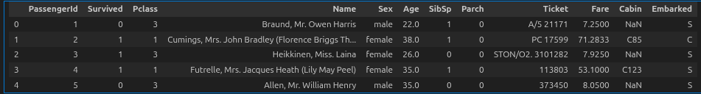

3. INSPECTING TOTAL NUMBER OF RECORDS AND COLUMNS :

→ print(len(df))
This line is used to print the number of rows (records) present in the DataFrame df.
In simple terms, it shows how many passengers’ data entries are there in the dataset.
Output : 891

→ print(len(df.columns))
This line is used to print the number of columns (features/attributes) present in the DataFrame df.
In simple terms, it shows how many variables or features are available in the dataset.
Output : 12

4.4 UNDERSTANDING THE DATA STRUCTURE :

1. INSPECTING THE DATA TYPES OF EACH COLUMN :
→ df.dtypes
Display the data types of each column in the DataFrame df.
In pandas, each column can have a different data type such as:
- int64 → Integer numbers
- float64 → Decimal numbers
- object → Text or mixed data (usually strings)
- bool → True/False values
output :
PassengerId int64
Survived int64
Pclass int64
Name str
Sex str
Age float64
SibSp int64
Parch int64
Ticket str
Fare float64
Cabin str
Embarked str
dtype: object

2. IDENTIFYING THE NUMERICAL FEATURES :
→numerical_features=df.select_dtypes(include=["int64","float64"]).columns.tolist()

selects all columns from dataframe df that have numerical data types such as:
- Integer values (int64)
- Decimal values (float64)
Then converts the column names into a Python list.
→ if target in numerical_features :
numerical_features.remove(target)

checks whether the target column is present in the numerical features list.
If yes, it removes the target column because:
- Target variable should not be used as an input feature during model training.
→ print(numerical_features)

output :
['PassengerId', 'Pclass', 'Age', 'SibSp', 'Parch', 'Fare']

3. IDENTIFYING CATEGORICAL FEATURES :
→ cateogorical_features = df.select_dtypes(include="string").columns.tolist()

df.select_dtypes(include = “ string “ )
Selects all columns in dataframe df that contain string/text data.
These are usually categorical variables like:
- Names , Categories , Labels , Gender
.columns.tolist() :
Converts the selected column names into a Python list format so you can easily use them in further processing like encoding or visualization.

→ print( cateogorical_features )

output :
['Name', 'Sex', 'Ticket', 'Cabin', 'Embarked']

4.5 EXPLORATORY DATA ANALYSIS :

1. SURVIVAL DISTRIBUTION :
→ plt.figure(figsize=(6, 4))
Creates a new plot figure with size 6 inches (width) × 4 inches (height).
This controls the visual size of the graph.
→ sns.countplot(data=df,x="Survived"
Creates a count plot using Seaborn.
It counts how many records are present in each category of the column survived.
In the Titanic dataset context : 0 → Not survived , 1 → Survived
So this plot shows how many passengers survived vs not survived.
→ plt.title("Survival Distribution")
Adds a title to the plot: "Survival Distribution".

→ plt.show()
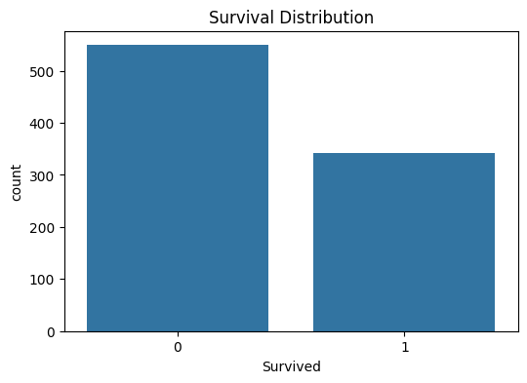

Core Data Observations
- Majority Non-Survival: More people in this dataset did not survive (0) than those who did (1).
- Exact Counts: * Survived (0): Approximately 550 individuals.
  - Survived (1): Approximately 340 individuals.
- Total Sample Size: The total population represented in this chart is roughly 890 individuals (consistent with the famous Titanic dataset).

Key Inferences
- Survival Rate: Roughly 38% of the individuals survived, while 62% did not.
- Class Imbalance: There is a noticeable "imbalance" in the classes. If you are using this for machine learning, a model that simply guesses "0" every time would be accurate about 62% of the time.
- High Mortality: The death toll (0) is nearly 1.6 times higher than the number of survivors (1).

→ print("Survival counts :",df['Survived'].value_counts())
output :
Survival counts : Survived
0 549
1 342
Name: count, dtype: int64

→ print("Survival % :",df['Survived'].value_counts(normalize=True)*100)
output :
Survival percentage : Survived
0 61.616162
1 38.383838
Name: proportion, dtype: float64

value_counts(normalize=True) → Counts the occurrences of each unique value (0 or 1) and normalizes it, giving the proportion instead of raw counts. *100 Converts the proportion into percentage.

2. FEATURE WISE SURVIVAL ANALYSIS :

1. SURVIVAL BY CATEGORICAL FEATURES :
→ cateogorical_features_main =['Sex','Embarked']
for col in cateogorical_features_main :
plt.figure(figsize=(6,4))
sns.countplot(data= df ,x = col ,hue = 'Survived')
plt.title(f"Survival distribution by {col}")
plt.show()

1. categorical_features_main = ['Sex', 'Embarked']
- Creates a list of categorical columns.
- Here, Sex (Gender) and Embarked (Boarding port) are selected for analysis.
2. for col in categorical_features_main:
- Loop is used to iterate through each categorical feature one by one.
3. sns.countplot(data=df, x=col, hue='Survived')
- Creates a count plot showing the number of passengers.
- x=col → Shows categories like male/female or boarding ports.
- hue='Survived' → Separates data into survived and not survived groups.
4. plt.title(f"Survival distribution by {col}")
- Sets title dynamically based on column name.

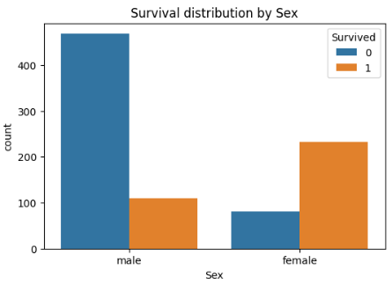

Key Observations
- High Male Mortality: The vast majority of males in this dataset did not survive (0).
- High Female Survival: The majority of females in this dataset survived (1).
- Disproportionate Representation: There were significantly more males on board (roughly 580 total) than females (roughly 310 total).

Detailed Inferences
- Survival Disparity: While there were fewer females overall, their survival count (roughly 230) is more than double the survival count of males (roughly 110).
- Mortality Rates:
  - Males: Roughly 80% of the male population did not survive.
  - Females: Roughly 75% of the female population survived.
- Predictive Strength: Gender is a very strong predictor of survival in this dataset. If you knew only the sex of a passenger, guessing "Female = Survived" and "Male = Deceased" would yield a high degree of accuracy.

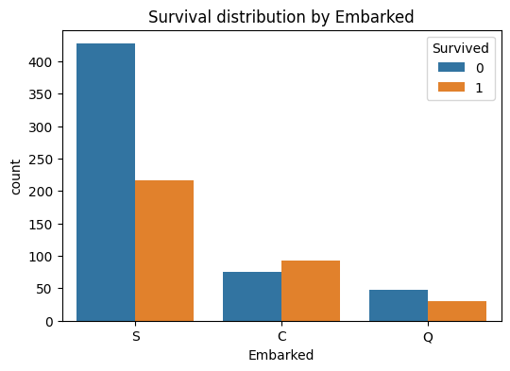

Survival by Port of Embarkation
- Dominance of Port S: The vast majority of passengers embarked at Port S (Southampton).
- Highest Mortality at Port S: Port S shows the highest number of non-survivors (over 425) and the lowest survival rate among the three ports.
- Survival Advantage at Port C: Port C (Cherbourg) is the only embarkation point where the number of survivors (roughly 95) actually exceeded the number of those who did not survive (roughly 75).
- Lowest Volume at Port Q: Port Q (Queenstown) had the fewest passengers overall, with a survival count of approximately 30 and a non-survival count near 50.

2. SURVIVAL BY NUMERICAL FEATURES :
→ numerical_features_main = ['Pclass','SibSp','Parch']
for col in numerical_features_main :
plt.figure(figsize=(6,4))
sns.countplot(data = df , x =col,hue = 'Survived')
plt.title(f"Survival distribution by {col}")
plt.show()
plt.figure(figsize=(6,4))
sns.boxplot(data = df ,x='Survived',y=col)
plt.title(f'{col} vs survival (box plot)')
plt.show()

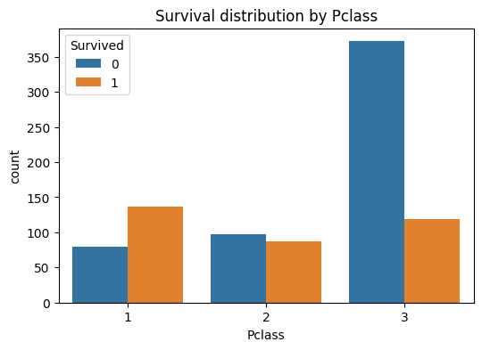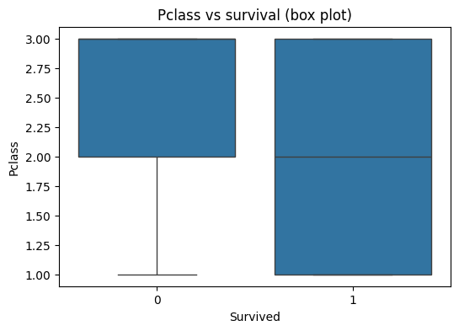

1. The "Survival Advantage" of First Class
The bar chart clearly shows that Pclass 1 is the only category where survivors (orange) significantly outnumber those who did not survive (blue).
- Inference: If you were in First Class, your probability of survival was greater than 50%.

2. The "Mortality Rate" of Third Class
The bar chart reveals a massive disparity in Pclass 3. While it has a survival count comparable to Pclass 1 and 2, the number of deaths is nearly 4x higher than in the other classes.
- Inference: Third Class had the highest absolute number of casualties, making it the most "dangerous" class to be in.

3. Median Class of Survivors
- For Survivors (1): The median line (the horizontal line inside the box) sits at 2.0. This indicates a balanced spread of survivors across all classes, but with a center of gravity in the middle class.
- For Non-Survivors (0): The median line is pushed up to 3.0.
- Inference: The "typical" person who did not survive was a Third Class passenger, whereas the "typical" survivor came from a higher social standing (First or Second Class).

4. Categorical Variance
The box for Survived = 1 is much larger (covering the full range from 1 to 3) compared to the box for Survived = 0 (which is concentrated between 2 and 3).
- Inference: Survival was relatively well-distributed across all classes (though skewed towards 1), but death was heavily concentrated in Classes 2 and 3.

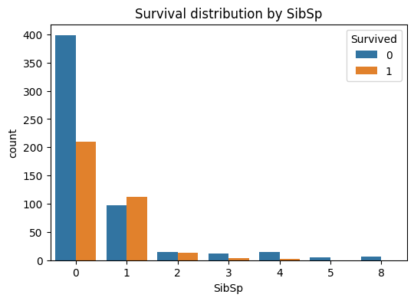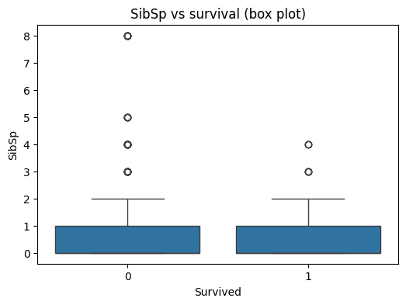

1. The "Sweet Spot" for Survival
The bar chart shows that passengers with exactly 1 sibling or spouse (SibSp = 1) had the best survival outcome.
- Inference: This is the only category where the number of survivors (orange) actually exceeds the number of those who perished (blue). Traveling with one other person appears to have provided a survival advantage.

2. Isolation vs. Risk
The vast majority of passengers traveled alone (SibSp = 0).
- Inference: While this group had the highest absolute number of survivors, they also faced a significantly higher risk, with nearly double the number of deaths compared to survivors.

3. Large Families Faced Extreme Peril
As the number of siblings/spouses increases beyond 2, the orange bars (survivors) nearly disappear.
- Inference: For passengers with SibSp of 5 or 8, the survival count is zero. Large family units likely found it much harder to coordinate an escape or reach lifeboats together.

4. Outlier Analysis
The box plot highlights significant outliers in the data:
- Non-Survivors (0): There are extreme outliers at SibSp = 5 and 8.
- Survivors (1): The maximum SibSp for anyone who survived was 4.
- Inference: A high SibSp count was almost an absolute predictor of non-survival. The "spread" of survivors is much tighter, indicating that those who made it off the ship generally had very few to no family members with them.
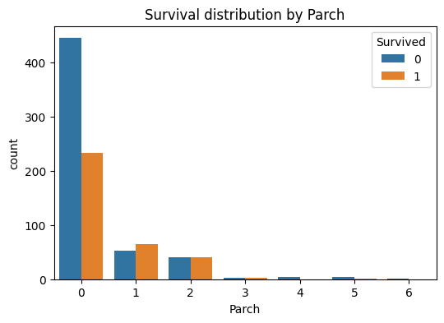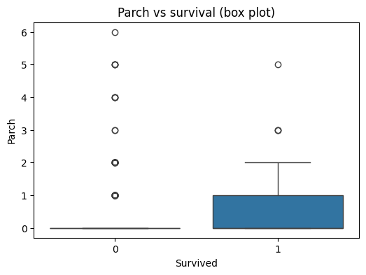

1. The "Solo Traveler" Penalty
The first chart (Survival distribution) shows that the vast majority of passengers had a Parch value of 0.
- While they make up the largest group of survivors in absolute numbers, they also have the highest mortality rate.
- The blue bar (died) is nearly double the size of the orange bar (survived) for this group. This suggests that traveling without parents or children significantly decreased one's chances of survival.

2. The "Sweet Spot" for Survival
There is a visible shift in the survival ratio for passengers with Parch 1 or 2:
- Parch 1: This is the only category where the number of survivors (orange) clearly exceeds the number of those who perished (blue).
- Parch 2: The survival and mortality rates are nearly equal (50/50).
- Inference: Having a small family unit onboard (1–2 parents/children) appears to have been a protective factor, likely due to the "women and children first" evacuation policy, as these passengers were more likely to be part of a family group.

3. Large Families Faced Greater Risk
As the Parch count increases to 3, 4, 5, and 6, the total count of passengers drops significantly, but the survival rate drops as well.
- The box plot shows that higher Parch values (4, 5, and 6) are almost exclusively associated with non-survival (0), represented by the outliers.
- Inference: Large families likely struggled to stay together or find enough space in lifeboats during the chaos, leading to lower survival rates compared to small familie

3. DETECTING OUTLIERS :

→ for col in numerical_features_main:
q1 = df[col].quantile(0.25)
q3 = df[col].quantile(0.75)
iqr = q3 - q1
lower = q1 - (1.5) * iqr
upper = q3 + (1.5) * iqr
outliers = df[(df[col]<lower) | (df[col]>upper)]
print(f"{col} Outliers :\n",outliers[col])

output :
Pclass Outliers :
Series([], Name: Pclass, dtype: int64)
SibSp Outliers :
7 3
16 4
24 3
27 3 …..
Name: SibSp, dtype: int64
Parch Outliers :
7 1
8 2
10 1 …….
Name: Parch, Length: 213, dtype: int64

Pclass
- No outliers were detected.
- This means Pclass values are well distributed within expected ranges.

SibSp (Number of siblings/spouses aboard)
- Several outliers were detected.
- Higher SibSp values (like 3, 4, etc.) are rare compared to the majority.
- This suggests most passengers traveled with 0–1 companions, while few traveled with larger family groups.

Parch (Number of parents/children aboard)
- Many outliers were detected (213 records).
- This indicates that larger family sizes were less common.
- Most passengers traveled with small family sizes, while some had unusually large family counts.

4. SKEWNESS CHECK :
→ for col in numerical_features_main:
skewness = df[col].skew()
print(f"{col} Skewness :{skewness:.2f}")

output :
Pclass Skewness :-0.63
SibSp Skewness :3.70
Parch Skewness :2.75

Skewness is used to measure the asymmetry of data distribution. It tells us whether the data is leaning towards the left or right side of the distribution curve.
This function measures how much the data deviates from a perfectly symmetrical (normal) distribution.
- Skewness = 0 → Perfectly symmetrical distribution (ideal bell curve).
- Skewness > 0 → Right skewed (positively skewed)
  - Tail is longer on the right side.
  - Most values are concentrated on the left.
- Skewness < 0 → Left skewed (negatively skewed)
  - Tail is longer on the left side.
  - Most values are concentrated on the right.

5. IRRELEVANT FEATURES :

1. CORRELATION :
→ correlation =df.select_dtypes(include=["int64","float64"]).corr()
target_corr =correlation['Survived'].drop('Survived')
print(target_corr)

output :
PassengerId -0.005007
Pclass -0.338481
Age -0.077221
SibSp -0.035322
Parch 0.081629
Fare 0.257307
Name: Survived, dtype: float64

Correlation analysis is used to understand how strongly numerical features are related to each other, especially how features are related to the target variable (in your case: Survived).

Step 1: Select Numerical Features & Compute Correlation
correlation = df.select_dtypes(include=["int64","float64"]).corr()
- Selects only numerical columns.
- Computes correlation coefficient between every pair of numerical variables.

Step 2: Correlation with Target Variable
target_corr = correlation['Survived'].drop('Survived')

- Extracts correlation values of all features with the Survived column.
- drop('Survived') removes self-correlation (which is always 1).

Correlation Value Interpretation
Correlation values range between -1 and +1:
- +1 → Strong positive correlation
  - As feature value increases → Survival probability increases.
- 0 → No correlation
  - Feature has little impact on survival.
- -1 → Strong negative correlation
  - As feature value increases → Survival probability decreases.

→ plt.figure(figsize=(8,6))
sns.heatmap(correlation, annot=True,cmap ='coolwarm',fmt='.2f')
plt.show()

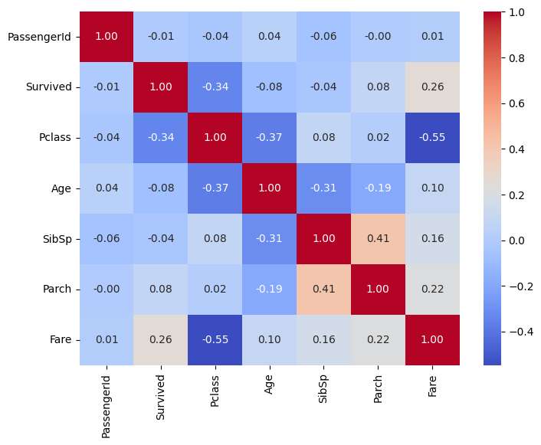

1. Key Drivers of Survival
Looking at the Survived row/column, we can see which factors most influenced whether a passenger lived:
- Pclass (-0.34): This is the strongest negative correlation in the survival column. It means as the class number increases (from 1st to 3rd), the chance of survival decreased.
- Fare (0.26): This is a positive correlation. Higher fares (usually associated with 1st class) led to a higher chance of survival.
- Age (-0.08): A very weak negative correlation, suggesting that while younger people had a slightly better chance, age alone wasn't as decisive as class or wealth.

2. Strongest Relationships in the Data
- Pclass and Fare (-0.55): This is the strongest correlation on the entire map (excluding the 1.00 diagonal). It’s a strong negative relationship: as the Pclass number goes down (approaching 1st class), the Fare goes up significantly.
- SibSp and Parch (0.41): A moderate positive correlation. This makes sense—passengers traveling with siblings or spouses (SibSp) were also likely to be traveling with parents or children (Parch), representing family units.
- Pclass and Age (-0.37): This suggests that older passengers were more likely to be in the higher classes (1st class), while younger passengers were more common in 3rd class.

3. The "PassengerId" Irrelevance
- PassengerId (approx 0.00): You’ll notice PassengerId has almost zero correlation with everything else (values like -0.01, -0.04, 0.01).
- Inference: This confirms that the ID is just a random label and has no predictive power for survival. You can safely drop this column during machine learning modeling.

→ # Temporary mapping for visualization only
df['Sex_encoded'] = df['Sex'].map({'female': 1, 'male': 0})
print(df[['Sex_encoded', 'Survived']].corr())

output :
Sex_encoded Survived
Sex_encoded 1.000000 0.543351
Survived 0.543351 1.000000

df['Sex_encoded'] = df['Sex'].map({'female': 1, 'male': 0})
Converts text values into numbers because machine learning and correlation calculations require numeric data.
Mapping used: Female → 1 , Male → 0
This is called Label Encoding (manual mapping).

print(df[['Sex_encoded', 'Survived']].corr())
Calculates correlation between:
- Encoded gender feature
- Survival outcome

2. DROPPING IRRELEVANT NUMERICAL FEATURES :
→ irrelevant_cols = ['PassengerId']
print("Dropping irrelevant columns :", irrelevant_cols)
df.drop(columns=irrelevant_cols,inplace=True,errors ='ignore')
df.head()

output :
Dropping irrelevant columns : ['PassengerId']
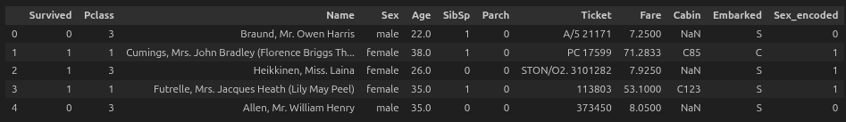

Explanation :

irrelevant_cols = ['PassengerId']
You are marking PassengerId as an irrelevant feature because:
- It is just an ID number
- It does not help in predicting survival (no predictive power)

df.drop(columns=irrelevant_cols, inplace=True, errors='ignore')
This actually removes the column from dataset.
Meaning of parameters:
- columns=irrelevant_cols → drop these columns
- inplace=True → modify original dataframe directly (no new copy)
- errors='ignore' → prevents error if column is already missing (safe coding)

3. DROPPING IRRELEVANT CATEOGORICAL FEATURES :
→ print(df['Name'].nunique())
print(df['Ticket'].nunique())
print(df['Cabin'].nunique())

output :
891
681
147

The nunique() function in pandas (defaulting to columns). It returns a Series with the number of unique values, excluding NaN values by default, making it ideal for identifying cardinalities in data analysis.
→ pd.crosstab(df['Sex'],df['Survived'],normalize='index')

output :
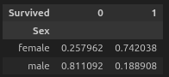

EDA using cross-tabulation shows that females had a significantly higher survival rate than males, indicating that the feature ‘Sex’ has strong predictive power and should be retained for modeling.”

→ pd.crosstab(df['Embarked'],df['Survived'])

output :



In the Titanic dataset, the Embarked feature represents the port of embarkation: C–Cherbourg, Q–Queenstown, and S–Southampton.
The port of embarkation is not random:
It is linked to ticket class
It correlates with socio-economic status
It indirectly affects survival probability
That's why Embarked is often a useful categorical feature

→ irrelevant_cat_cols = ['Name', 'Ticket', 'Cabin']
You are creating a list of categorical columns that you decided are not useful for prediction.
- Name → Almost every passenger has a unique name.
→ High cardinality, no predictive pattern.
- Ticket → Mostly unique ticket numbers.
→ Again high cardinality, not meaningful.
- Cabin → Many missing values (NaN).
→ Too sparse, inconsistent, messy.
→ df.drop(columns=irrelevant_cat_cols, inplace=True)

- Removing those columns from the dataframe
- inplace=True → modifying the original dataframe directly (no copy created)
→ df.head()

output :

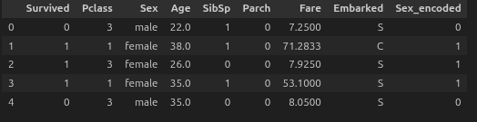

4.6 DATA PREPROCESSING ON TRAINING DATA

1.HANDLING MISSING VALUES :
→ print("Missing values in each column ")
print(df.isnull().sum())

output :
Missing values in each column
Survived 0
Pclass 0
Sex 0
Age 177
SibSp 0
Parch 0
Fare 0
Embarked 2
Sex_encoded 0
dtype: int64

df.isnull() : Checks every cell in the dataframe. If a value is missing, it returns True. else returns False .
sum() : Counts the number of True values in each column.

2. HANDLING MISSING VALUE IN NUMERICAL COLUMN ( MEAN ) :
→ mean_value = df['Age'].mean()

Selects the Age column from the dataframe.
Computes the mean of all non missing values in that column.
Stores the result inside the variable mean_value.

→ df['Age'] = df['Age'].fillna(mean_value)

Selects the Age column.
Finds all missing values in that column.
Replaces those missing values with mean_value.
Updates the Age column with the new values.
→ print(df.isnull().sum())

output :
Survived 0
Pclass 0
Sex 0
Age 0
SibSp 0
Parch 0
Fare 0
Embarked 2
Sex_encoded 0
dtype: int64

3. HANDLING MISSING VALUE IN CATEGORICAL COLUMN ( MODE ) :
→ mode_value = df['Embarked'].mode()[0]

Selects the Embarked column from the dataframe.
Calculates the mode, which is the most common value.
mode() returns a series of most frequent values.
[0] selects the first mode value from that series.
Stores it in the variable mode_value.

→ df['Embarked'] = df['Embarked'].fillna(mode_value)

Selects the Embarked column.
Identifies missing values in that column.
Replaces them with mode_value.
Updates the Embarked column with the new values.
→ print(df.isnull().sum())
output :
Survived 0
Pclass 0
Sex 0
Age 0
SibSp 0
Parch 0
Fare 0
Embarked 0
Sex_encoded 0
dtype: int64

4. ENCODING THE CATEGORICAL VARIABLES :

→ df = df.drop(columns=['Sex'])
Drop original categorical column 'Sex' (already encoded)

→ df = pd.get_dummies(df, columns=['Embarked'], drop_first=True)

Selects the Embarked column.
Creates separate binary columns for each unique category.
Each new column contains 0 or 1 values.
1 indicates presence of that category.
0 indicates absence of that category.
Removes the original Embarked column.
Updates the dataframe with new encoded columns.
Meaning of drop_first=True
Drops the first category column.
Prevents multicollinearity problem.
Avoids dummy variable trap in regression models.
Example
If Embarked has categories S, C, Q
New columns may be
Embarked_C
Embarked_Q
If a passenger boarded from S
Embarked_C = 0
Embarked_Q = 0
If from C
Embarked_C = 1
Embarked_Q = 0
Why It Is Used
Machine learning models require numerical input.
Categorical values cannot be directly used.
One Hot Encoding converts categories into model understandable format.
→ df[['Embarked_Q' ,'Embarked_S']] = df[['Embarked_Q' ,'Embarked_S']].astype(int)

Selects the columns Embarked_Q and Embarked_S.
Changes their data type to integer using astype(int).
Updates those columns in the dataframe.
Why It Is Needed ?
After One Hot Encoding, values may sometimes be in boolean type True or False.
Machine learning models generally expect numerical values like 0 and 1.
Converting to integer ensures proper numeric format.
→ df.head()
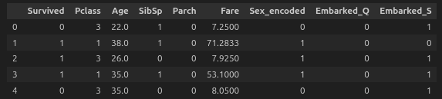

5. FEATURE SCALING :
→ scaling_features = ['Age','Fare']
Stores the column names Age and Fare inside a list.
This list is assigned to the variable scaling_features.
Used later for applying scaling methods like Standardization or Normalization.
Why It Is Used
Age and Fare may have different value ranges.
Large differences in scale can affect machine learning models.
Scaling ensures both features contribute fairly during training.

→ scaler = StandardScaler()
Initializes the StandardScaler class.
Stores the scaler object inside the variable scaler.
This object will later be used to scale numerical features.
Transforms data so that
Mean becomes 0 and Standard deviation becomes 1
Scaled value = (Value - Mean) / Standard Deviation
Why It Is Used
Ensures all numerical features are on the same scale.
Improves performance of models like Logistic Regression, SVM, KNN.
Prevents features with large values from dominating smaller ones.
→ df[scaling_features] = scaler.fit_transform(df[scaling_features])
Selects the columns stored in scaling_features.
Fits the StandardScaler on those columns.
Calculates mean and standard deviation for each column.
Transforms the values using standardization formula.
Replaces original values with scaled values in the dataframe.
Fit : Calculates mean and standard deviation from the data.
Transform : New value = (Value - Mean) / Standard Deviation.
Mean of each selected column becomes 0 and Standard deviation becomes 1.
Values may become negative or decimal
→ df.head ()
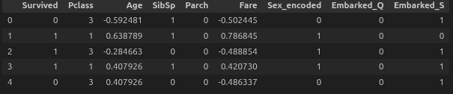

4.7 FEATURE SELECTION -DATA PREPARATION

1. FINAL FEATURE MATRIX
selected_features = [ 'Pclass', 'Age','Fare','Sex_encoded','Embarked_Q','Embarked_S']
X = df[selected_features]
Y = df['Survived']
→ X.head()
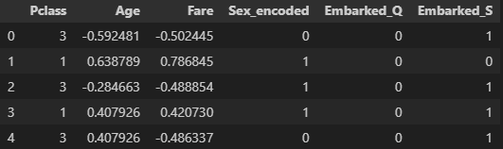
→ Y.head()
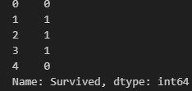

4.8 MODEL BUILDING

ALGORITHMS :

1. LOGISTIC REGRESSION

2. DECISION TREE

3. RANDOM FOREST

1. Logistic Regression
Description
Supervised machine learning algorithm used for classification problems.
Predicts probability of classes using a sigmoid function.
Working Principle
Uses linear equation and converts output into probability between 0 and 1.
If probability is greater than threshold (usually 0.5), class is predicted as positive.
Advantages
Simple and easy to implement.
Works well for binary classification.
Disadvantages
Not suitable for complex non linear data.
Use Cases
Spam detection.
Medical diagnosis classification.
2 .Decision Tree
Description
Supervised machine learning algorithm that makes decisions using tree like structure.
Working Principle
Splits data based on feature conditions.
Each internal node represents a decision.
Leaf nodes represent final output class.
Advantages
Easy to understand and interpret.
Handles both numerical and categorical data.
Disadvantages
Prone to overfitting.
Use Cases
Customer segmentation.
Credit risk analysis.
3. Random Forest
Description
Ensemble machine learning algorithm that combines multiple decision trees.
Working Principle
Creates multiple decision trees using random samples.
Combines results using voting (classification) or averaging (regression).
Advantages
Reduces overfitting compared to single decision tree.
Provides higher accuracy.
Disadvantages
More computationally expensive.
Less interpretable compared to single tree.
Use Cases
Fraud detection.
Image classification.

2. SPLIT THE TRAIN DATA INTO TRAIN AND VALIDATION DATA
→ X_train , X_validate ,Y_train , Y_validate = train_test_split(X,Y,test_size= 0.2,random_state = 42,stratify = Y)
Splits input features (X) and target labels (Y) into two parts.
Training data is used to train the model.
Validation data is used to test model performance.
Parameters Explanation
test_size = 0.2
20 percent of data is used for validation.
80 percent of data is used for training.
random_state = 42
Ensures reproducibility of results.
Same split will occur every time the code is run.
stratify = Y
Maintains same class distribution in training and validation sets.
Important for imbalanced datasets.
Output Variables
X_train and Y_train
Used for model training.
X_validate and Y_validate
Used for model evaluation.

3. TRAIN MODEL ON TRAIN SPLIT USING 3 ALGORITHMS
→ lgr_model = LogisticRegression(max_iter=1000)
lgr_model.fit(X_train, Y_train)

Logistic Regression is a supervised machine learning classification algorithm based on statistical probability.
Works using the sigmoid function.
Model first calculates linear combination of input features using formula
z = w1x1 + w2x2 + ... + wnxn + b
Where
w = weights
x = input features
b = bias
Then sigmoid function is applied
Sigmoid(z) = 1 / (1 + e^(−z))
This converts output into probability between 0 and 1.
If probability > 0.5, class is predicted as 1 else 0.
fit()
uses optimization algorithms like gradient descent or similar solvers.
Adjusts weights and bias to minimize loss function (log loss / cross entropy loss).
max_iter=1000 allows more iterations for better convergence.
Purpose
Used for classification problems where probability based prediction is needed.

→ dt_model = DecisionTreeClassifier(criterion='gini', max_depth=None, random_state=42)
dt_model.fit(X_train, Y_train)
Decision Tree is a rule based supervised classification algorithm that uses tree structure decisions.
Works by recursively splitting data based on feature thresholds.
At each node, algorithm selects best feature to split using impurity measures.
criterion='gini'
Uses Gini impurity to measure node purity.
Gini = 1 − Σ (pi²)
Where pi is probability of each class.
Lower Gini value means better split.
Tree Building Process
Select best feature.
Split dataset into subsets.
Repeat process until stopping condition is reached.
Stopping Conditions
Pure node achieved.
Maximum depth reached.
Minimum samples condition reached.
random_state=42 ensures reproducibility.
Purpose
Used when interpretability of model decisions is important.

→ rf_model = RandomForestClassifier(n_estimators=100, random_state=42)
rf_model.fit(X_train, Y_train)
Random Forest is an ensemble learning algorithm that combines multiple decision trees.
Internal Working Core Logic
Works using bagging (Bootstrap Aggregating).
Process
Creates multiple random subsets of training data using bootstrapping.
Each subset trains one decision tree independently.
Each tree makes its own prediction.
Final Prediction
Classification
Majority voting is used.
Regression (if used)
Average of all tree outputs is taken.
n_estimators=100
Creates 100 decision trees.
More trees generally improve accuracy but increase computation cost.
random_state=42 ensures consistent random sampling.
Advantages
Reduces overfitting compared to single decision tree.
Improves prediction stability

4. PREDICT ON VALIDATION DATA
→ Y_validate_predict_lgr = lgr_model.predict(X_validate)
→ Y_validate_predict_dt = dt_model.predict(X_validate)
→ Y_validate_predict_rf = rf_model.predict(X_validate)

Each model uses its learned patterns from training data.
Then predicts class labels for validation dataset features.
Internal Working Logic
Logistic Regression Prediction
Calculates probability using sigmoid function.
If probability is greater than threshold (usually 0.5), class label is assigned.
Decision Tree Prediction
Passes validation data through decision rules created during training.
Follows tree path based on feature conditions until reaching leaf node.
Leaf node gives final class prediction.
Random Forest Prediction
Each tree inside forest makes its own prediction.
Final prediction is decided using majority voting from all trees.
Output Variables
Y_validate_predict_lgr
Stores predictions from Logistic Regression model.
Y_validate_predict_dt
Stores predictions from Decision Tree model.
Y_validate_predict_rf
Stores predictions from Random Forest model.

4.9 EVALUATION METRICS ( USING VALIDATION DATA )

1.ACCURACY :
accuracy = accuracy_score(Y_validate ,Y_validate_predict_lgr)
print ( f"{'VALIDATION ACCURACY USING LOGISTIC REGRESSION': <50}:{accuracy}")

accuracy = accuracy_score(Y_validate ,Y_validate_predict_dt)
print (f"{'VALIDATION ACCURACY USING DECISION TREE': <50}:{accuracy}")

accuracy = accuracy_score(Y_validate ,Y_validate_predict_rf)
print (f"{'VALIDATION ACCURACY USING RANDOM FOREST CLASSIFIER': <50}:{accuracy}")

output:
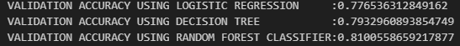

2. CONFUSION MATRIX
cm = confusion_matrix(Y_validate,Y_validate_predict_lgr)
print ('CONFUSION MATRIX USING LOGISTIC REGRESSION \n',cm)

cm = confusion_matrix(Y_validate,Y_validate_predict_dt)
print ('CONFUSION MATRIX USING DECISION TREES\n',cm)

cm = confusion_matrix(Y_validate,Y_validate_predict_rf)
print ('CONFUSION MATRIX USING RANDOM FOREST CLASSIFIER \n',cm)

output:

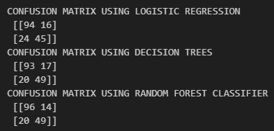

3.PRECISION
precision = precision_score(Y_validate,Y_validate_predict_lgr)
print (f"{'PRECISION USING LOGISTIC REGRESSION': <50}:{precision}")

precision = precision_score(Y_validate,Y_validate_predict_dt)
print (f"{'PRECISION USING DECISION TREE': <50}:{precision}")

precision = precision_score(Y_validate,Y_validate_predict_rf)
print (f"{'PRECISION USING RANDOM FOREST CLASSIFIER': <50}:{precision}")

output:
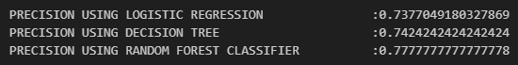

4. RECALL
recall = recall_score(Y_validate,Y_validate_predict_lgr)
print (f"{"RECALL USING LOGISTIC REGRESSION":<50}:{recall}")

recall = recall_score(Y_validate,Y_validate_predict_dt)
print (f"{"RECALL USING DECISION TREE": <50}:{recall}")

recall = recall_score(Y_validate,Y_validate_predict_rf)
print (f"{"RECALL USING RANDOM FOREST CLASSIFIER":<50}:{recall}")

output:
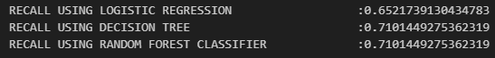
5. F1-SCORE:
f1 = f1_score(Y_validate,Y_validate_predict_lgr)
print(f"{'F1 SCORE USING LOGISTIC REGRESSION':<50}:{f1}")

f1 = f1_score(Y_validate,Y_validate_predict_dt)
print(f"{'F1 SCORE USING DECISION TREE':<50}:{f1}")

f1 = f1_score(Y_validate,Y_validate_predict_rf)
print(f"{'F1 SCORE USING RANDOM FOREST CLASSIFIER':<50}:{f1}")

output:
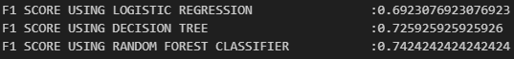

6. CLASSIFICATION REPORT:
print('LOGISTIC REGRESSION :\n')
print (classification_report(Y_validate,Y_validate_predict_lgr))

print("\nDECISION TREE :\n")
print (classification_report(Y_validate,Y_validate_predict_dt))

print("\nRANDOM FOREST CLASSIFIER :")
print (classification_report(Y_validate,Y_validate_predict_rf))

output:
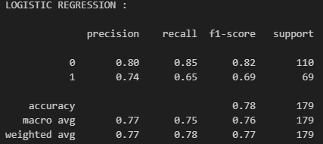
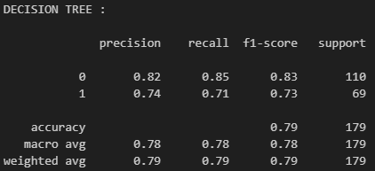
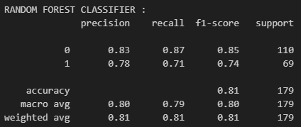

4.10 CHOOSING BEST MODEL

1. FITTING RANDOM FOREST ON FULL TRAINING DATA
→ rf_model.fit(X,Y)

output:

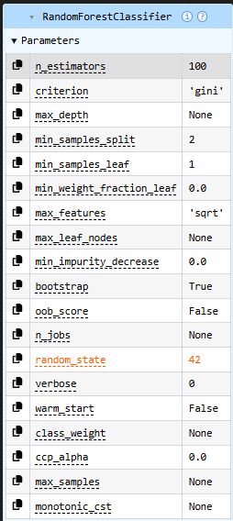

4.11 LOADING TEST DATASET:
→ df_test = pd.read_csv("./titanic/test.csv")

4.12 VERIFYING THE LOADED TEST DATASET

1. INSPECTING THE COLUMN NAMES
→ df_test.columns

output:

Index(['PassengerId', 'Pclass', 'Name', 'Sex', 'Age', 'SibSp', 'Parch',
'Ticket', 'Fare', 'Cabin', 'Embarked'],
dtype='str')

2. INSPECTING TOTAL SAMPLE RECORDS
→ df_test.head()
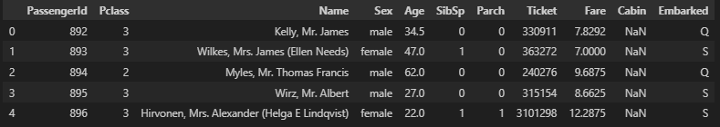

3. INSPECTING TOTAL NUMBER OF RECORDS AND COLUMNS
→ print(len(df_test))
438
→ print(len(df_test.columns))
11

4.13 DATA PREPROCESSING ON TEST DATA

1. HANDLING THE MISSING VALUES
→ print("Missing values in each column ")
→ print(df_test.isnull().sum())

Missing values in each column
PassengerId 0
Pclass 0
Name 0
Sex 0
Age 86
SibSp 0
Parch 0
Ticket 0
Fare 1
Cabin 327
Embarked 0
dtype: int64

2. HANDLING MISSING VALUES IN NUMERICAL COLUMN ( MEAN AND MEDIAN )
→ df_test['Age']=df_test['Age'].fillna( mean_value)
→ df_test.isnull().sum()
output :
PassengerId 0
Pclass 0
Name 0
Sex 0
Age 0
SibSp 0
Parch 0
Ticket 0
Fare 1
Cabin 327
Embarked 0
dtype: int64

→ median_value = df_test['Fare'].median()
→ df_test['Fare'] = df_test['Fare'].fillna(median_value)
→ df_test.isnull().sum()

output :
PassengerId 0
Pclass 0
Name 0
Sex 0
Age 0
SibSp 0
Parch 0
Ticket 0
Fare 0
Cabin 327
Embarked 0
dtype: int64

3. REMOVING THE IRRELEVANT OR REDUNDANT FEATURES
→ irrelevant_cols_test = ['PassengerId','Name','Ticket','Cabin']
→ print("Dropping irrelevant columns :", irrelevant_cols_test)

output:
Dropping irrelevant columns : ['PassengerId', 'Name', 'Ticket', 'Cabin']

→ df_test.drop(columns=irrelevant_cols_test,inplace=True,errors ='ignore')
→ df_test.head()

output:
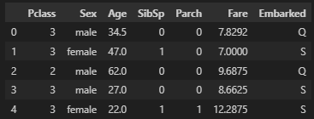

4. ENCODING THE CATEGORICAL VARIABLES
→ df_test['Sex_encoded'] = df_test['Sex'].map({'female': 1, 'male': 0})
→ df_test=df_test.drop(columns='Sex')

→ df_test = pd.get_dummies(df_test,columns=['Embarked'],drop_first=True)

→ df_test[['Embarked_Q','Embarked_S']] =df_test[['Embarked_Q','Embarked_S']].astype(int)

→ df_test.head()

output:
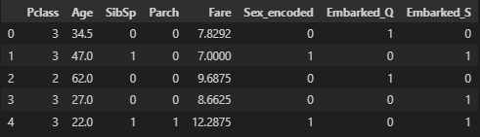

5. FEATURE SCALING:
→ df_test[['Age', 'Fare']] = scaler.transform(df_test[['Age', 'Fare']])
→ df_test.head()

output:
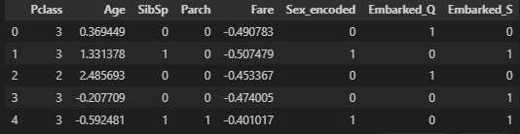

4.14 FEATURE SELECTION
→ selected_features = [
'Pclass',
'Age',
'Fare',
'Sex_encoded',
'Embarked_Q',
'Embarked_S'
]

→ X_test = df_test[selected_features]
→ X_test.head()

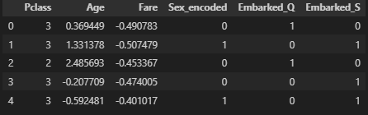

1. SANITY CHECK:
→ X.shape
(891, 6)

→ X_test.shape
(418, 6)

4.15 PREDICTION:
→ Y_test = rf_model.predict(X_test)
→ Y_test = pd.Series(Y_test)
→ Y_test.head()

output:
0 0
1 0
2 0
3 1
4 0
dtype: int64

4.16 TEST WITH CUSTOM INPUT
def predict_survival_interactive(rf_model, selected_features):
print("Enter passenger details to predict survival:")

# Input prompts
pclass = int(input("Pclass (1 = 1st, 2 = 2nd, 3 = 3rd): "))
age = float(input("Age (in years): "))
fare = float(input("Fare (ticket price): "))
sex = input("Sex (male/female): ").strip().lower()
embarked = input("Embarked (C/Q/S): ").strip().upper()

# Encode features exactly matching dataset column names
sex_encoded = 1 if sex == 'female' else 0
embarked_Q = 1 if embarked == 'Q' else 0
embarked_S = 1 if embarked == 'S' else 0

# Create DataFrame with same column order as selected_features
input_df = pd.DataFrame([[
pclass,
age,
fare,
sex_encoded,
embarked_Q,
embarked_S
]], columns=selected_features)

# Make prediction
prediction = rf_model.predict(input_df)[0]

# Output result
if prediction == 1:
print("\nResult: Passenger is likely to SURVIVE")
else:
print("\nResult: Passenger is likely to NOT SURVIVE")
# Make sure rf_model is already trained on full training data
# selected_features = ['Pclass','Age','Fare','Sex_encoded','Embarked_Q','Embarked_S']

predict_survival_interactive(rf_model, selected_features)

OUTPUT:
Enter passenger details to predict survival:

Result: Passenger is likely to NOT SURVIVE

