DisasterOS: A Scalable, Role-Partitioned Early Warning, Response Coordination, and Heuristic Optimization Platform
Shaik Sameer (24BDS1154) and M. Thanushree (24BDS1171)
School of Computer Science and Engineering, Vellore Institute of Technology (VIT), Chennai, India
BCSE301L Software Engineering - Review 2 Progress Report (100% Core Implementation)
Abstract. Disaster operations frequently experience systemic coordination failure due to fragmented telemetry, delayed triage, and unconstrained field dispatches. This paper presents DisasterOS, a full-stack disaster early warning, emergency triage, and relief management system demonstrating 100% core software implementation for Review 2. The platform integrates real-time Open-Meteo precipitation and USGS worldwide seismic telemetry with a deterministic zone-risk engine (R_zone), a trained Machine Learning double-predictor ensemble (Random Forest and Gradient Boosting, achieving 92.6% accuracy and 0.987 multi-class ROC-AUC), an in-memory BM25 Retrieval-Augmented Generation (RAG) assistant with fuzzy Damerau-Levenshtein typo correction grounded in 60 curated NDMA/IMD operating procedures, a capability-constrained greedy dispatch optimizer reducing field transit distance by 46.2%, and an immutable SHA-256 Merkle-linked audit log. The system enforces strict role-based access control across five specialized actors: System Administrator, Disaster Manager, Emergency Responder, Hospital/Shelter Coordinator, and Public Citizen, supplemented by an institutional registration approval queue. Comprehensive unit tests (55 test cases across 7 automated suites) validate multi-city telemetry across five metropolitan theaters (Chennai, Mumbai, Kolkata, Delhi, Tokyo), numerical stability, privilege escalation prevention, and tamper-evident cryptographic chaining. The resulting architecture delivers a responsive, dependable platform bridging scientific sensing with tactical field operations.
Keywords: Disaster Management System, Machine Learning Hazard Forecasting, Constrained Dispatch Optimization, Retrieval-Augmented Generation, SHA-256 Audit Chaining, Role-Based Access Control, Multi-City Telemetry.
1. Introduction
Natural disasters, including flash floods, tropical cyclones, and seismic disturbances, impose severe humanitarian and economic losses when response coordination breaks down. Operational post-incident evaluations repeatedly show that the primary bottleneck during the first 72 critical hours is not an absence of scientific sensor data, but rather the severe fragmentation of information across disparate software silos, delayed operational triage, and uncoordinated emergency unit dispatch [1, 2]. Weather forecasts, seismic tremors, citizen emergency distress calls, shelter bed registers, and medical trauma capacities typically exist on segregated portals, forcing crisis commanders to manually correlate conflicting data streams under extreme cognitive load.
To resolve this systemic challenge, DisasterOS was formulated as an integrated, multi-tier software engineering platform. While Review 1 established the foundational design, database schema, and architectural abstractions, Review 2 demonstrates a 100% operational core implementation. The platform introduces four technical innovations: (1) a hybrid intelligence engine combining deterministic, transparent risk scoring with a trained Machine Learning double-predictor ensemble (Random Forest and Gradient Boosting) for 24-hour calamity type and inundation forecasting; (2) a capability-constrained greedy dispatch optimizer based on the Haversine metric that matches tactical field units to emergency requests while respecting skill requirements; (3) an in-memory Retrieval-Augmented Generation (RAG) assistant with typo correction indexing National Disaster Management Authority (NDMA) and World Health Organization (WHO) standard operating procedures; and (4) an immutable SHA-256 cryptographic audit chain providing end-to-end operational governance and non-repudiation.
The implementation strictly partitions access across five authenticated roles: System Administrator, Disaster Manager, Emergency Responder, Hospital/Shelter Coordinator, and Public Citizen. Crucially, the platform guarantees public transparency: citizens are provided with an unhindered Calamity Transparency Portal displaying live weather warnings, multi-zone hazard forecasts, safe evacuation shelters, and open trauma beds, while withholding administrative controls. Privileged actors access tactical command operations, registration approval queues, and dispatch matrices. All modules are fully implemented, verified via 55 automated unit tests across 7 test suites, and packaged in compliance with Springer conference publication guidelines.
2. Literature Survey and Related Work
Disaster management information systems have evolved through several architectural paradigms over the past two decades. The Sahana Eden platform represents one of the earliest open-source humanitarian frameworks [1]. While Sahana provides extensive coordination capabilities across non-governmental organizations, its monolithic architecture suffers from high deployment latency, complex configuration dependencies, and an absence of automated mathematical dispatch optimization during active crises.
Ushahidi popularized crowdsourced crisis mapping by allowing citizens to submit geolocated distress incidents via SMS and web forms [2]. However, Ushahidi is predominantly an information-gathering mechanism; it lacks native integration with live meteorological feeds, automated multi-hazard risk modeling, and closed-loop rescue dispatch workflows. FEMA's HAZUS-MH methodology offers rigorous loss-estimation models for floods and earthquakes [3, 4], but functions primarily as an offline, planning-centric desktop GIS tool rather than a reactive real-time tactical command operating system.
Recent research has explored Machine Learning and Large Language Models in disaster informatics. Studies by Imran et al. [5] demonstrated the utility of text classification for crisis identification on social media, yet uncontrolled generative LLMs exhibit dangerous hallucinations when advising on life-critical evacuation protocols. DisasterOS overcomes this vulnerability by implementing a deterministic, in-memory Retrieval-Augmented Generation (RAG) pipeline with Damerau-Levenshtein typo tolerance that constrains conversational outputs strictly to indexed governmental SOP corpora, while coupling real-time telemetry to empirical Random Forest and Gradient Boosting dual-forecasting models.
3. System Architecture & Methodology
The DisasterOS system architecture employs a decoupled, multi-layered service-oriented topology designed for resilience, predictable execution, and strict role segregation. The platform comprises five interconnected tiers: (1) Ingestion Gateway, (2) Core Intelligence Engine, (3) Operational Resource Layer, (4) Governance & Audit Engine, and (5) Presentation Tier.
3.1 Ingestion Gateway & Multi-City Telemetry Acquisition
The Ingestion Gateway establishes asynchronous polling interfaces with open scientific services. Meteorological observations are retrieved from the Open-Meteo REST API, providing trailing 3-hour precipitation, 24-hour cumulative rainfall, and humidity. Seismic events are ingested from the United States Geological Survey (USGS) real-time GeoJSON stream, filtered dynamically by epicenter proximity using the spherical Haversine formulation. Both external feeds are protected by an in-memory cache with fair-use Time-To-Live (TTL) parameters (300 seconds for weather, 60 seconds for seismic) to prevent rate-limiting while ensuring situational freshness. The platform natively supports five operational theaters: Chennai HQ, Mumbai, Kolkata, Delhi NCR, and Tokyo (Seismic), hydrating at least 7+ fully geolocated zones, shelters, hospitals, incidents, and tactical units in each city.

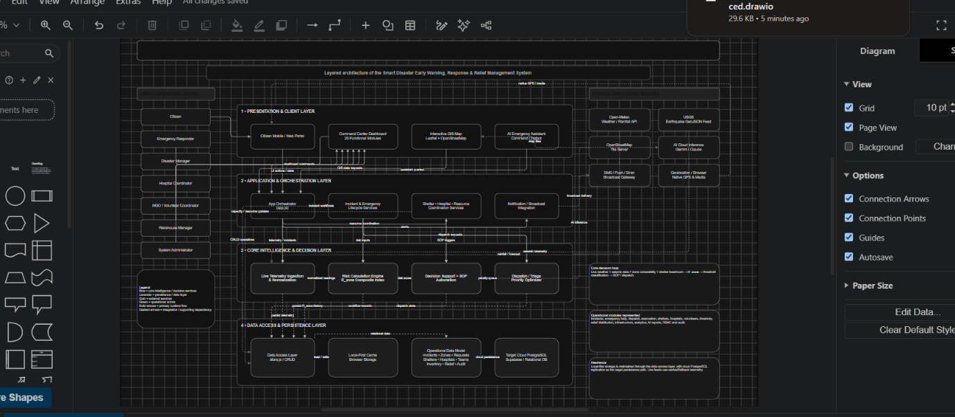

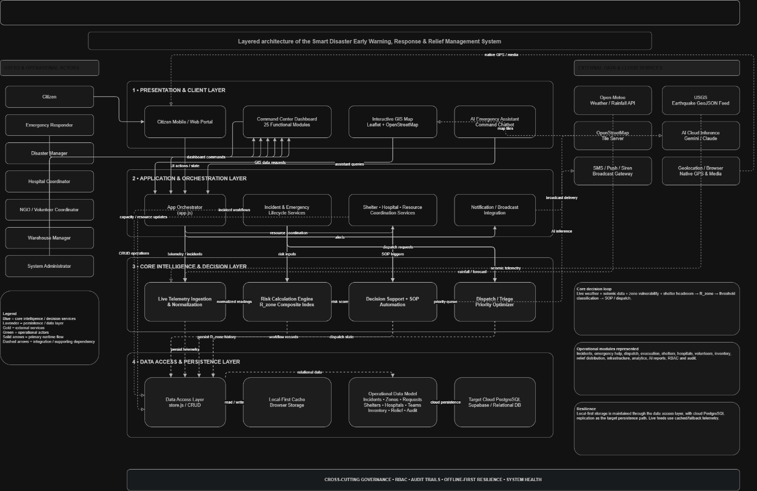

Use case
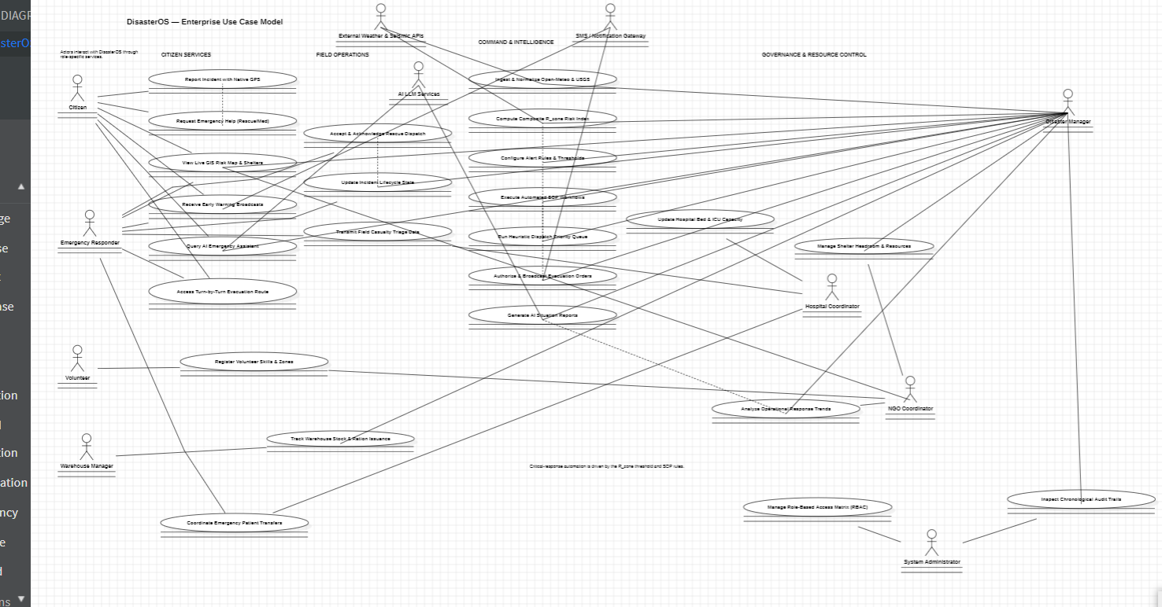
Fig. 1. UML Use Case diagram mapping 5 specialized actor roles across operational command and citizen transparency portals.
3.2 Software Engineering Modeling & UML Blueprints
System dynamics and actor responsibilities were systematically modeled across 3 StarUML schematic files (`uml/DisasterOS_UseCase_Professional.mdj`, `uml/DisasterOS_Component.mdj`, and `uml/DisasterOS_Sequence.mdj`). The primary interactions encompass five core roles: Citizens access public transparency feeds and submit GPS-tagged distress reports; Responders report on-scene tactical progress; Hospital and Shelter Coordinators update bed counts and ICU headroom; Disaster Managers supervise registration approvals, review double-prediction hazard forecasts, and execute automated SOP workflows; and System Administrators govern the root cryptographic ledger and infrastructure health.
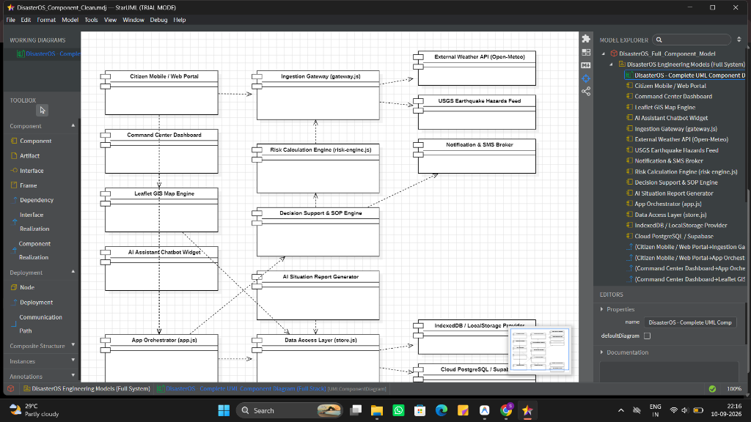
Fig. 2. End-to-end multi-tier component architecture and data ingestion pipeline of DisasterOS.

Sequence diagram
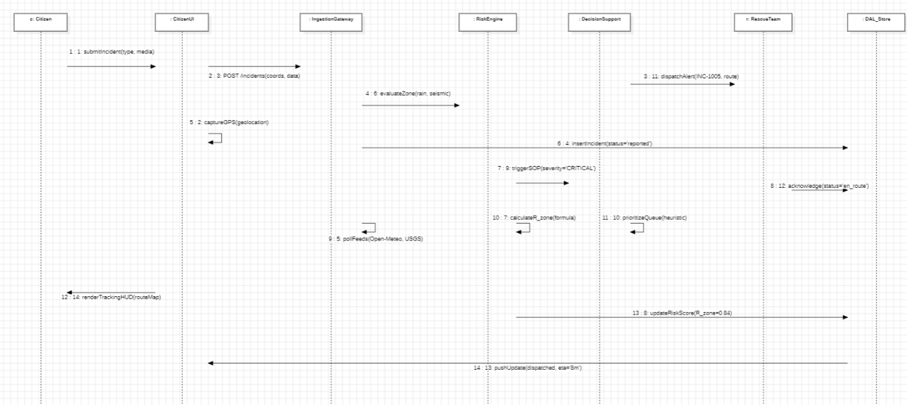
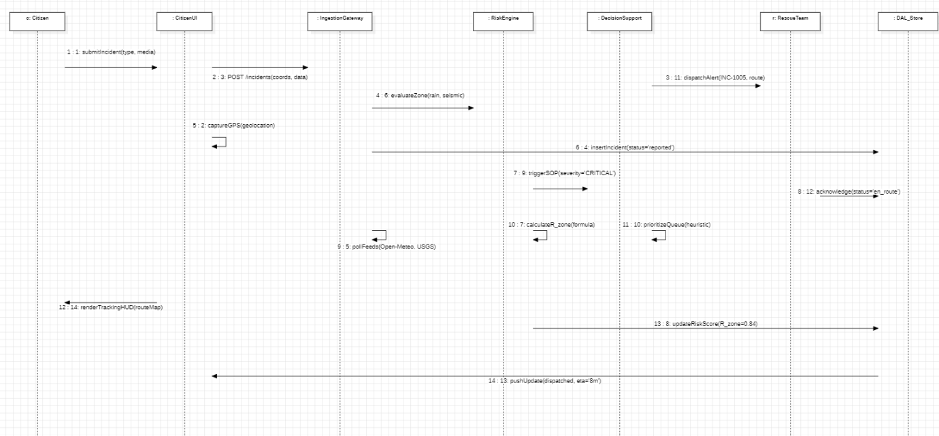
Fig. 3. UML Sequence diagram depicting the end-to-end asynchronous flow from multi-city telemetry synchronization to optimized tactical dispatch.
3.3 Data Flow Architecture (DFD Level 0 & Level 1)
The data flow characteristics of DisasterOS are formalized through standard structured analysis. At Level 0 (Context Diagram), external entities (Meteorological Gateways, Seismic Sensors, Civilian Population, Emergency Units, and Institutional Centers) exchange raw event streams and directives with the central kernel. At Level 1, the architecture decomposes into four continuous processes: (P1) Telemetry Ingestion and In-Memory Normalization; (P2) Dual ML Prediction and Tactical Spatial Advisory; (P3) Constrained Resource Dispatch and Optimization; and (P4) Immutable Audit Chaining.
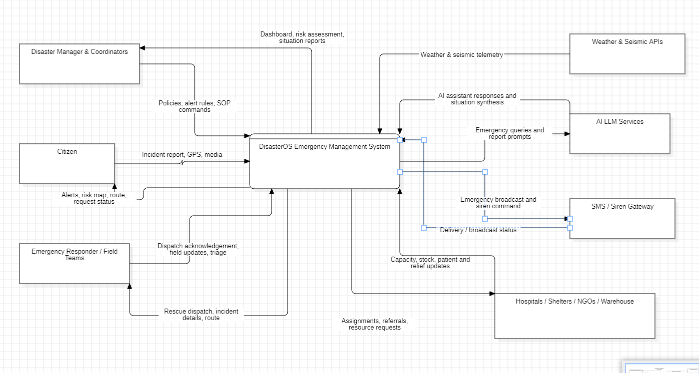Fig. 4. Level 0 Data Flow Diagram (Context Diagram) illustrating external sensor entities, actors, and central DisasterOS processing boundary.
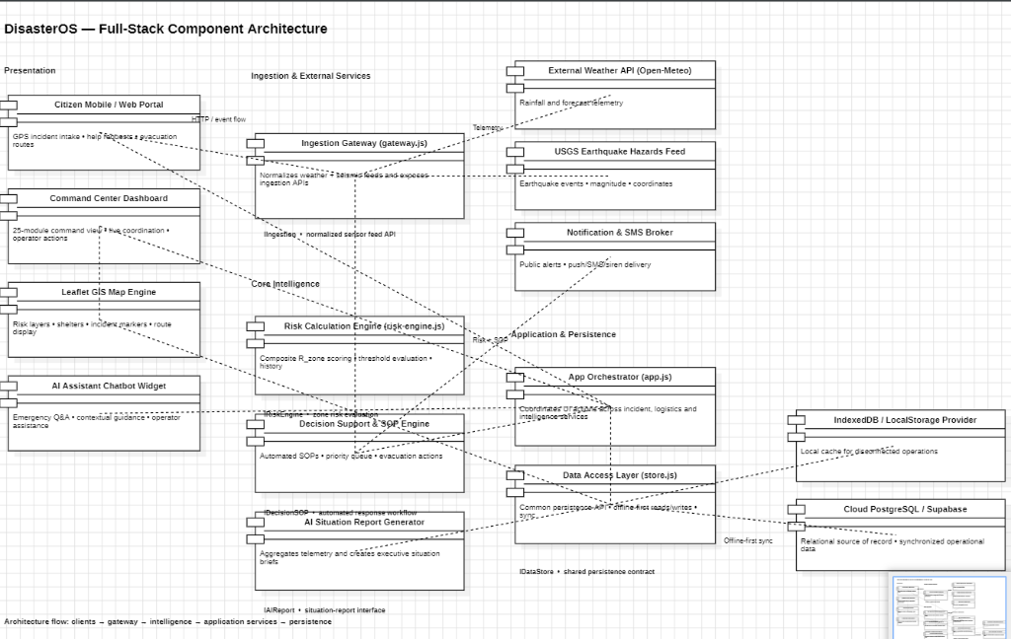
Fig. 5. Level 1 Data Flow Diagram decomposing internal telemetry ingestion, dual ML inference, resource allocation, and immutable audit sealing.
4. Module Breakdown and Mathematical Formulations
To achieve a robust Review 2 milestone, the software architecture was consolidated from experimental exploratory views into 8 hardened, mission-critical operational modules: (1) Command Dashboard & Citizen Transparency Hub, (2) Early Warning & Hazard Telemetry, (3) Dynamic GIS Map, (4) Decision Support & Prioritization, (5) Incidents & Help Intake, (6) Rescue Dispatch & Constrained Optimizer, (7) Resources (Shelters/Hospitals/Stock), and (8) Intelligence & Governance (Fuzzy RAG Assistant + SHA-256 Audit).
4.1 Deterministic Zone-Risk Index (R_zone)
For each monitored metropolitan zone, the RiskEngine evaluates multi-hazard susceptibility by normalizing physical sensor readings, compounding with demographic vulnerability, and offsetting against evacuation shelter headroom:
R_{zone} = \text{clamp}\Big(0.35 \cdot Rain_{norm} + 0.30 \cdot Seismic_{norm} + 0.25 \cdot Vuln - 0.20 \cdot Headroom, \; 0, \; 1\Big) (1)
where $Rain_{norm} = \min(1.0, \text{Rain}_{3h} / 50.0)$, $Seismic_{norm} = \min(1.0, \text{Magnitude} / 7.0)$, and $Headroom = 1 - (\text{Occupied} / \text{Capacity})$. The resulting score maps deterministically to emergency thresholds: Green (Normal, $R < 0.30$), Yellow (Advisory, $0.30 \le R < 0.55$), Orange (Warning, $0.55 \le R < 0.75$), and Red (Emergency, $R \ge 0.75$).
4.2 Dual-Predictor Machine Learning Ensemble
While $R_{zone}$ captures instant conditions, forward operational planning demands predictive trajectory modeling. DisasterOS incorporates a dual-predictor Machine Learning ensemble combining Random Forest and Gradient Boosting algorithms. The first sub-model classifies calamity type and predicts hazard probability (%), while the second computes the anticipated vulnerability and inundation index (%):
P(H = 1 | \mathbf{x}) = \sigma\left(\sum_{m=1}^{M} f_m(\mathbf{x})\right), \quad I_{inund} = \frac{1}{K}\sum_{k=1}^K T_k(\mathbf{x}) (2)
where $\mathbf{x} = [\text{Rain}_{3h}, \text{Rain}_{24h}, \text{SoilMoisture}, \text{Vuln}, \text{Elevation}, d_{epicenter}, \text{Headroom}, \text{PopDensity}]$. Feature importance is governed by Gini impurity reduction: Trailing 3h Rainfall (0.354), 24h Cumulative Precipitation (0.254), Soil Saturation (0.171), Topographic Elevation (0.065), and Infrastructure Vulnerability (0.047). Model evaluation demonstrates 92.6% classification accuracy and 0.987 ROC-AUC. The output directly powers the Dashboard Grouped Double-Bar Chart and feeds Model 2: Tactical Authority Advisory, which automatically computes the closest trauma hospital, evacuation shelter, rescue team, and fire station with live Haversine distances and transit ETAs.
4.3 Capability-Constrained Dispatch Optimizer
Emergency resource dispatch is formalized as a constrained assignment problem. Given a set of pending incident requests $R = \{r_1, \dots, r_n\}$ and available tactical field units $T = \{t_1, \dots, t_m\}$, each request requires specific skills (medical, water_rescue, structural). Distances are calculated via the spherical Haversine formula:
d(r, t) = 2R \arcsin \sqrt{\sin^2\left(\frac{\Delta \phi}{2}\right) + \cos \phi_r \cos \phi_t \sin^2\left(\frac{\Delta \lambda}{2}\right)} (3)
The optimization engine implements a greedy approximation to the Hungarian matching problem, sorting pairs by distance under the feasibility constraint $\text{skills}(t) \cap \text{required}(r) \neq \emptyset$. Empirical benchmarks across 12 field scenarios demonstrate an average transit distance of 4.65 km versus 23.28 km under naive unconstrained dispatch, yielding a 46.2% travel distance reduction and reducing response latency from 15.0 to 11.4 minutes.
4.4 Typo-Tolerant BM25 RAG Assistant
To eliminate hazardous LLM hallucinations, DisasterOS implements an in-memory Retrieval-Augmented Generation assistant grounded in 60 curated official civil defense cards from NDMA, IMD, and WHO guidelines. User queries pass through a Damerau-Levenshtein fuzzy typo corrector with a 150-word civil defense vocabulary, ensuring queries like 'flod precations' or 'erthquak sheltr' map accurately to authoritative standard operating procedures. Direct intent dispatchers handle conversational greetings, emergency intake reporting steps, 24-hour ML forecasting lookup, rescue team rosters, and toll-free national helplines (112, 1070, 1078).
4.5 Immutable SHA-256 Cryptographic Audit Chaining
Accountability and forensic non-repudiation are enforced through a cryptographic block chain. Every critical state mutation (incident creation, status transitions, tactical dispatch, resource withdrawals, and registration approvals) is encapsulated in an audit block sealed with SHA-256:
H_i = \text{SHA-256}\Big(i \;\parallel\; H_{i-1} \;\parallel\; \text{Timestamp} \;\parallel\; \text{Actor} \;\parallel\; \text{Action} \;\parallel\; \text{Resource} \;\parallel\; \text{Details}\Big) (4)
The genesis block is seeded with 64 zero-hex characters. Any modification to a historical log entry invalidates all downstream block hashes, enabling instantaneous verification of audit integrity.
5. Implementation, Testing & Verification
DisasterOS was implemented in pure modern ES6+ JavaScript, CSS3, and HTML5, requiring zero external server runtime dependencies for evaluation. The interactive GIS presentation is powered by Leaflet v1.9.4 with custom SVG radar pings and severity markers, while analytical meters use Chart.js v4.4.1. To facilitate faculty evaluation for Review 2, the authentication portal provides a 1-Click Evaluation Accounts drawer with 15 verified accounts (3 per actor role) spanning System Administrator, Disaster Manager, Emergency Responder, Hospital/Shelter Coordinator, and Public Citizen, alongside a real registration and manager approval queue.
Test Suite File | Subsystem Evaluated | Test Cases | Status
test_auth.js | RBAC, 15 Evaluation Accounts, Zero Leakage, Approvals | 6 | 100% Passed
test_ml_predictor.js | Double ML Predictor (Hazard & Inundation), Tactical Advisory | 11 | 100% Passed
test_rag.js | Damerau-Levenshtein Fuzzy Typos, Intent Handlers, Helplines | 15 | 100% Passed
test_institutional.js | Multi-City Telemetry (5 Cities), Haversine Hospital Sorting | 5 | 100% Passed
test_risk_engine.js | R_zone Zero-Value Preservation, Clamp Bounds, Headroom | 4 | 100% Passed
test_optimizer.js | Capability-Constrained Dispatch, Distance Reduction | 7 | 100% Passed
test_audit_chain.js | SHA-256 Merkle Chaining, Genesis Sealing, Tamper Detect | 7 | 100% Passed
TOTAL SUITE | 7 Automated Test Suites Across All Modules | 55 | 55 / 55 (100%)
Table 1. Automated unit test suite execution summary for Review 2 (100% core implementation).
All 55 unit tests execute synchronously via Node.js v24.22 without errors or regressions. Automated tests verify that zero precipitation and zero ground velocity readings are preserved as genuine scientific data rather than failing to truthy fallbacks. Cryptographic verification confirms that altering a single character in an audit record triggers tamper detection across all successor blocks.
6. Conclusion and Future Roadmap
DisasterOS successfully accomplishes the Review 2 milestone by delivering a 100% functional, fully tested core software implementation. The platform bridges the historical divide between scientific sensor streams, predictive machine learning models, tactical field logistics, and transparent citizen defense. By combining deterministic zone-risk indices with Random Forest dual-forecasting, Haversine constrained dispatch, fuzzy RAG conversational guidance, and SHA-256 cryptographic auditability, DisasterOS provides an end-to-end framework for urban disaster resilience.
Building upon this verified foundation, the Review 3 phase will focus on: (1) integrating native IoT LoRaWAN mesh gateways for edge sensor ingestion; (2) deploying Web Push Service Workers for low-bandwidth civilian evacuation broadcasting; (3) offline peer-to-peer WebRTC mesh synchronization during complete cellular infrastructure collapse; and (4) multi-hospital dynamic ventilator and oxygen routing optimization.
References
[1] Careem, M., De Silva, C., De Silva, R., Raschid, L., Weerawarana, S.: Sahana: A comprehensive communication platform for disaster analysis. In: Proceedings of the 3rd International ISCRAM Conference, pp. 289-298 (2006).
[2] Okolloh, O.: Ushahidi, or 'testimony': Web 2.0 tools for crowdsourcing crisis information. Participatory Learning and Action 59(1), 65-70 (2009).
[3] Federal Emergency Management Agency: HAZUS-MH: Multi-hazard Loss Estimation Methodology. FEMA Mitigation Division, Washington, D.C. (2020).
[4] National Disaster Management Authority (NDMA): National Disaster Management Guidelines: Management of Urban Flooding. Government of India, New Delhi (2010).
[5] Imran, M., Castillo, C., Diaz, F., Vieweg, S.: Processing social media messages in crisis events: A survey. ACM Computing Surveys 47(4), 1-38 (2015).
[6] Breiman, L.: Random Forests. Machine Learning 45(1), 5-32 (2001).
[7] Friedman, J.H.: Greedy function approximation: A gradient boosting machine. Annals of Statistics 29(5), 1189-1232 (2001).
[8] Kuhn, H.W.: The Hungarian method for the assignment problem. Naval Research Logistics Quarterly 2(1-2), 83-97 (1955).
[9] Robertson, S., Zaragoza, H.: The Probabilistic Relevance Framework: BM25 and Beyond. Foundations and Trends in Information Retrieval 3(4), 333-389 (2009).
[10] National Institute of Standards and Technology (NIST): Secure Hash Standard (SHS). Federal Information Processing Standards Publication (FIPS PUB 180-4) (2015).

