DisasterOS: A Modular, Rule-Based Early Warning and Coordinated Emergency Management Architecture

M. Thanushree (24BDS1171) and Shaik Sameer (24BDS1154)
School of Computer Science and Engineering, VIT
BCSE301L Software Engineering — Review 1

Abstract
DisasterOS is a modular disaster-management platform designed to reduce the coordination gap between hazard detection and field response. The system combines citizen incident reporting, live weather and seismic telemetry, geospatial visualization, emergency-resource coordination, and a deterministic risk engine in a shared operational workflow. The current implementation uses an ingestion gateway for Open-Meteo rainfall data and the USGS real-time earthquake feed, a zone-level risk engine based on rainfall, seismic magnitude, vulnerability, and shelter headroom, and a client-side data layer for operational records. The application exposes 25 functional modules covering command operations, incidents, emergency help, dispatch, SOP workflows, evacuation, shelters, hospitals, volunteers, inventory, relief distribution, infrastructure, analytics, AI-assisted reporting, access control, audit, and system health. Review 1 focuses on the implemented core software, database structures, algorithms, and system architecture required for the next development phase. The design deliberately favors transparent rules and explicit thresholds so that operators can understand why a zone is classified as advisory, watch, warning, or emergency. Remaining work includes production-grade persistence, deeper automation, and broader field validation.
Keywords: Disaster Management System; Early Warning Architecture; Rule-Based Risk Engine; Geospatial Intelligence; Emergency Resource Allocation

Keywords
Disaster Management System · Early Warning Architecture · Rule-Based Risk Engine · Geospatial Intelligence · Emergency Resource Allocation

1. Introduction
Disaster response often fails not because useful information is unavailable, but because information is fragmented across agencies, dashboards, field teams, and resource registers. A rainfall warning may reach an operator without immediately translating into a verified incident, a prioritized rescue request, an available shelter, or a hospital bed allocation. DisasterOS addresses this coordination problem by treating the response workflow as a connected software system rather than a collection of isolated monitoring tools.
The proposed platform combines public hazard feeds, citizen reports, operational resource data, and role-specific interfaces around a common data-access layer. Its risk calculation is intentionally deterministic. Operators can inspect the individual inputs, adjust thresholds, and reproduce the score without training or retraining a machine-learning model. The current implementation also provides a GIS view, operational dashboards, emergency-request handling, response-team coordination, resource tracking, reporting, audit logging, and role-based access.
The study is guided by three practical questions: (1) how can heterogeneous hazard and operational data be brought into one consistent operational picture; (2) how can a transparent zone-risk score translate incoming readings into actionable priorities; and (3) how can the resulting priorities be carried through incident, resource, and response workflows without creating separate data silos?
The main contribution at Review 1 is a concrete implementation contract: the system structure, module boundaries, data model, risk and prioritization algorithms, and the corresponding architecture, DFD, use-case, component, and sequence views. The report also records the present software status so that later reviews can measure implementation progress against a stable baseline.

2. Literature Survey and Related Work
Several established systems address important parts of disaster information management. Sahana and its later Sahana Eden platform provide a broad operational scope covering organizations, human resources, warehousing, hospitals, shelters, and geospatial information [1]. Their main relevance to DisasterOS is the idea that disaster operations benefit from a shared information model rather than isolated departmental tools.
Ushahidi established a widely used pattern for rapid, geolocated citizen reporting and crisis mapping [2]. Its strength is fast aggregation of crowd-sourced information, while structured resource coordination is outside its original emphasis. DisasterOS carries the citizen-reporting idea further by connecting incident intake to operational data such as teams, shelters, hospitals, and relief resources.
FEMA HAZUS provides a structured GIS-based methodology for multi-hazard loss estimation and planning [3,4]. Compared with that planning-oriented approach, DisasterOS focuses on a lightweight operational pipeline that can consume current readings and update a per-zone risk classification during an active event.
The resulting design combines the coordination breadth associated with Sahana Eden, the low-friction reporting model associated with Ushahidi, and the explicit quantitative reasoning associated with HAZUS. Its specific focus is a single rule-based pipeline connecting live feeds, operational records, role dashboards, and response prioritization using openly accessible data sources.

3. System Architecture & Methodology
The DisasterOS architecture is organized as a layered platform. At the outer boundary are operational actors and external data services. The presentation layer provides the citizen portal, command-center views, GIS visualization, and assistant interface. The application layer contains the main orchestrator and services for incidents, emergency requests, resources, and notifications. The core intelligence layer ingests telemetry, computes zone risk, applies decision and SOP logic, and prioritizes response work. The data layer provides CRUD operations and stores shared operational state. This separation keeps interface concerns distinct from risk and resource algorithms.
The current implementation uses App Orchestrator (app.js), IngestionGateway (gateway.js), GISMapController (map.js), RiskEngine (risk-engine.js), and DataStore (store.js) as its main software units. The browser application exposes 25 functional modules. The data layer maintains operational collections for zones, incidents, emergency requests, shelters, hospitals, volunteers, inventory, infrastructure, relief deliveries, teams, alerts, and audit logs. Browser local storage is the current persistence mechanism; PostgreSQL/Supabase is the planned target for multi-device operation.

3.1 High-Level System Architecture
(Draw.io)
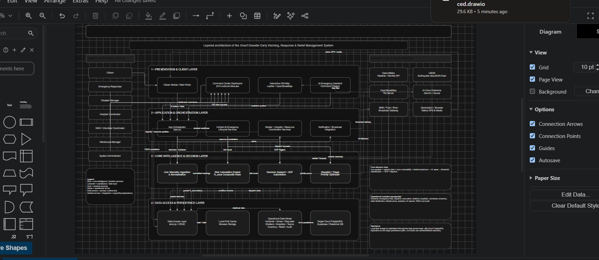
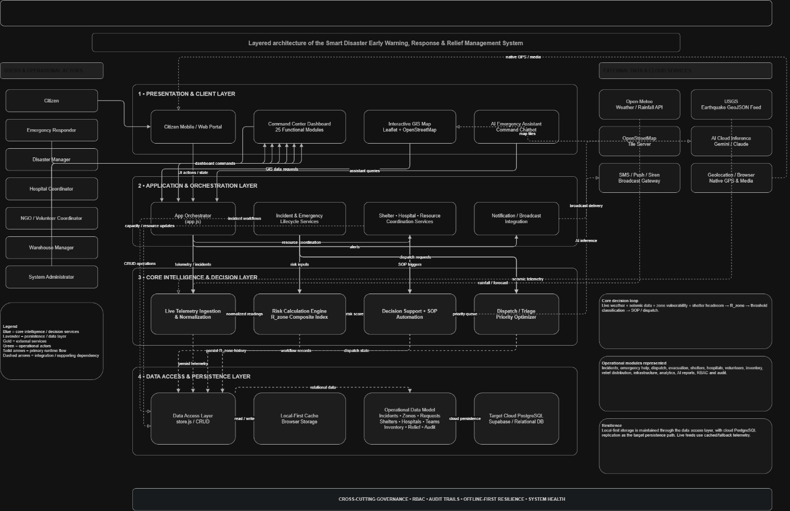

3.2 Data Flow and UML Views
The diagrams below document the system at different levels of abstraction. The DFD views describe information movement between actors, processes, and data stores. The UML views capture functional actors, architectural components, and the principal execution flow. The marked spaces are intentionally left for the final monochrome diagrams.

Data Flow Diagram-0: 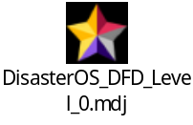

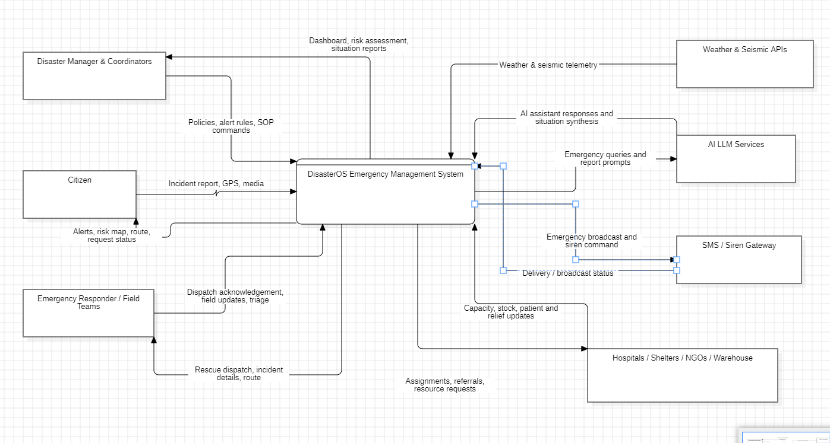

Data Flow Diagram-1: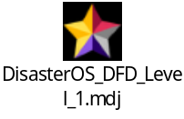
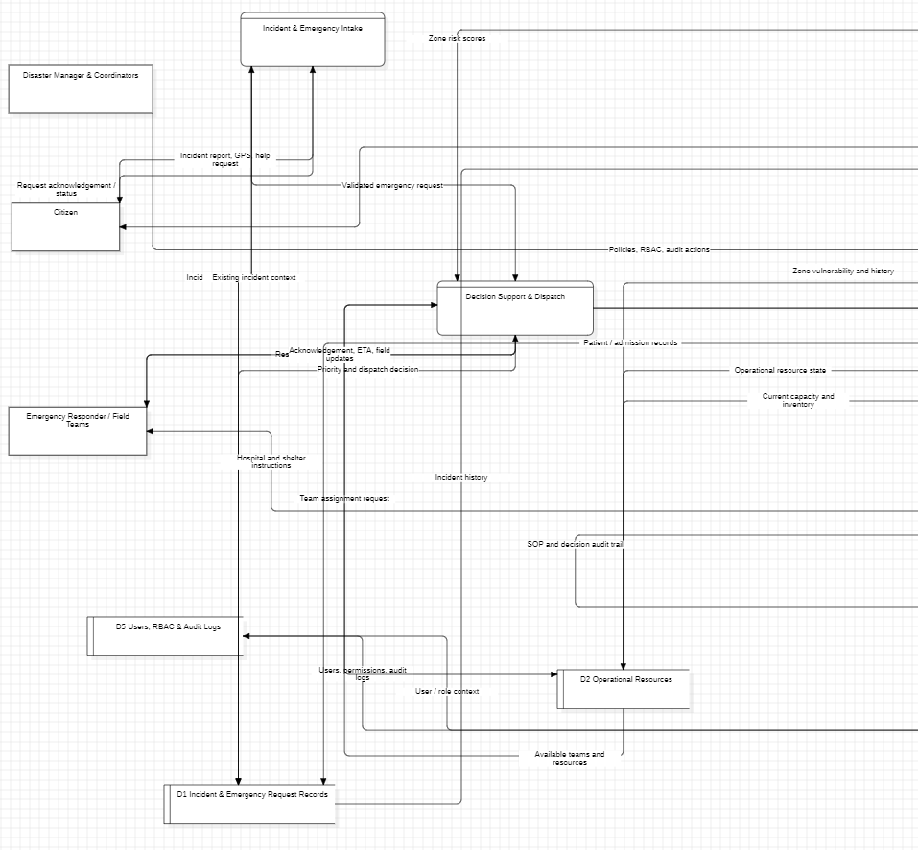
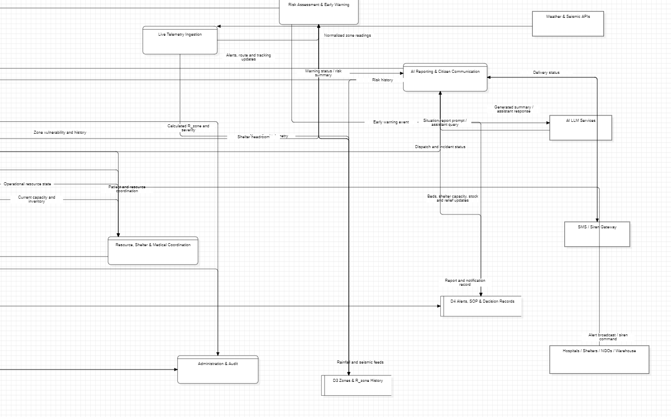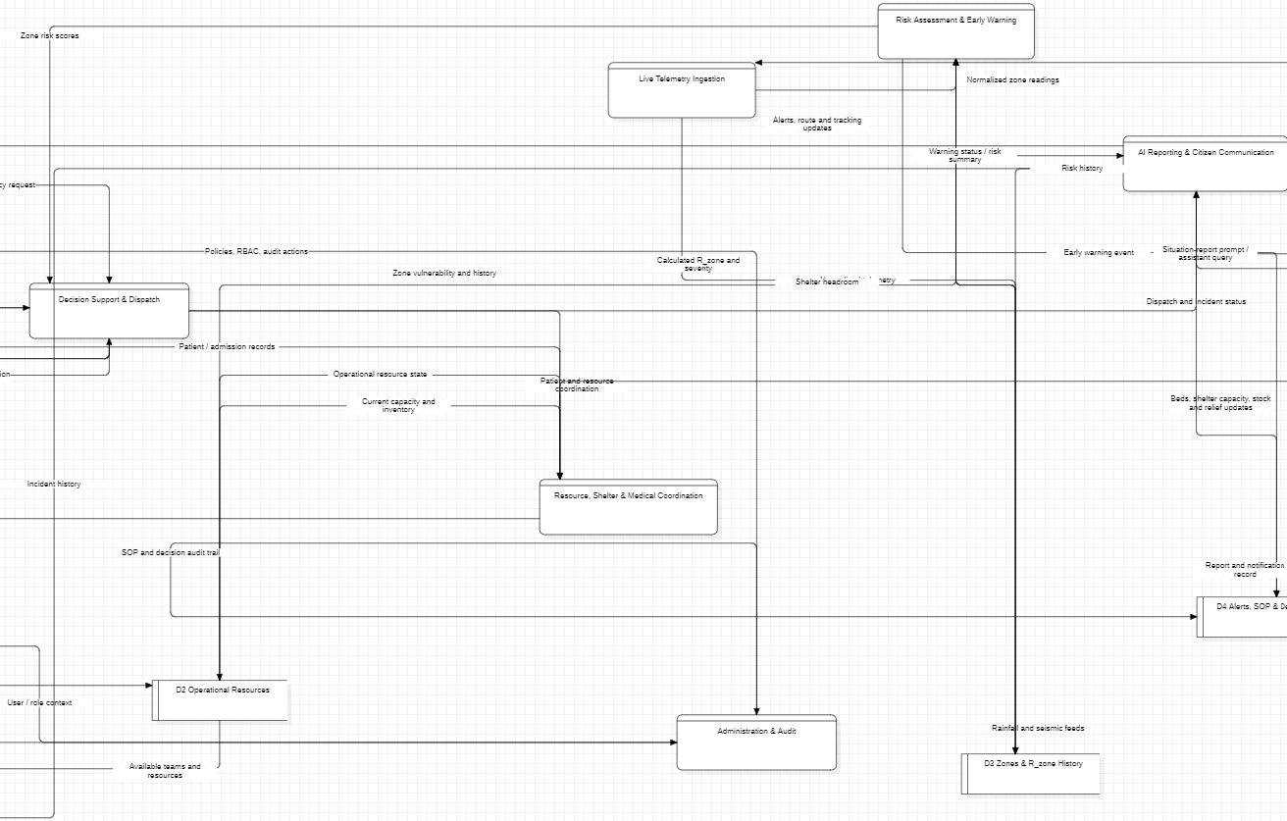
Use Case Diagram: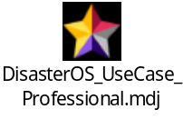
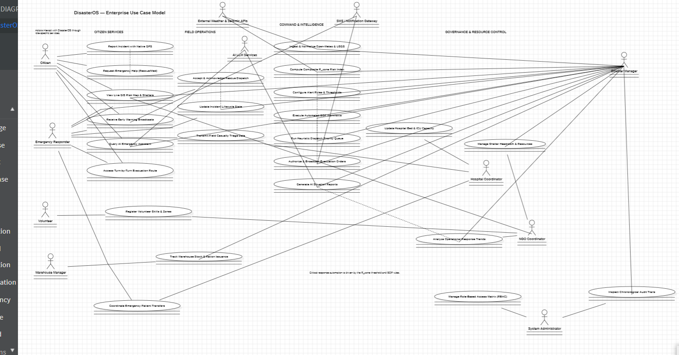

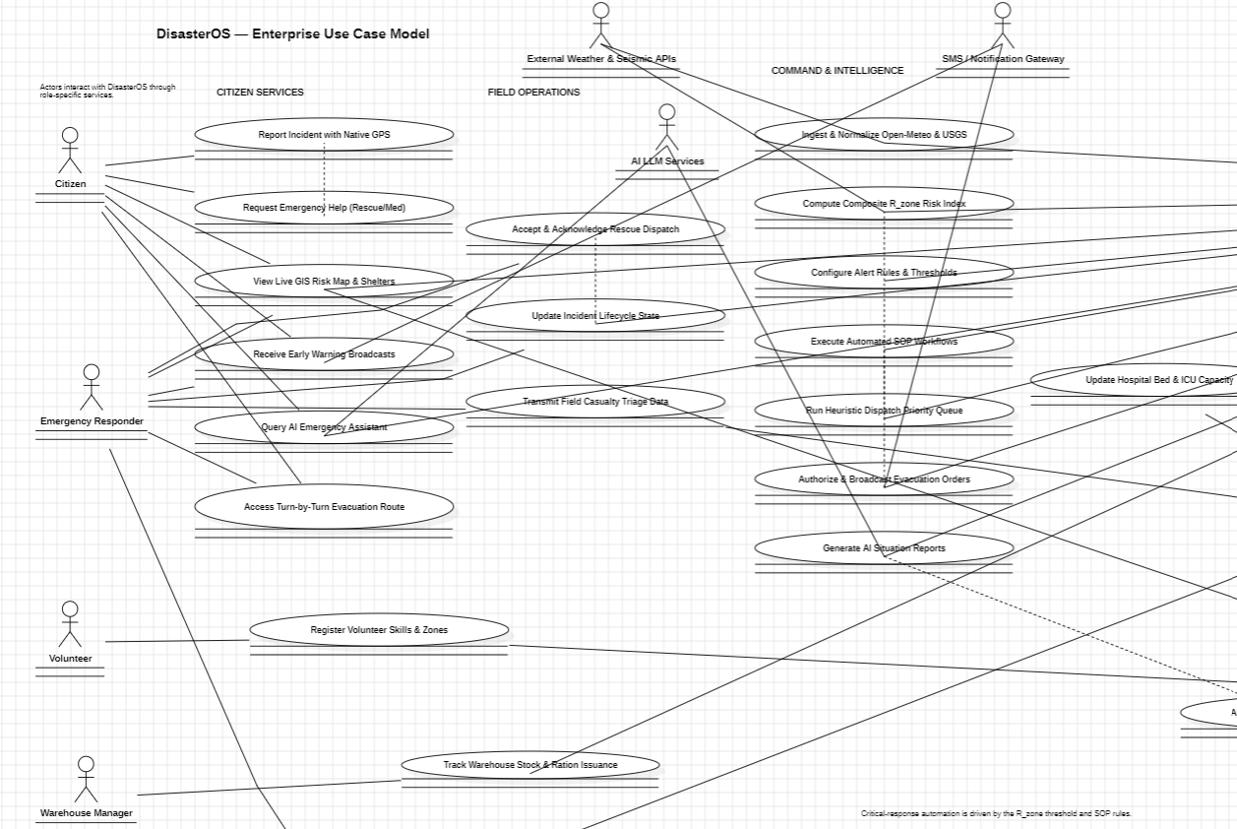

Sequence Diagram: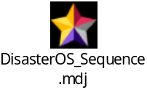
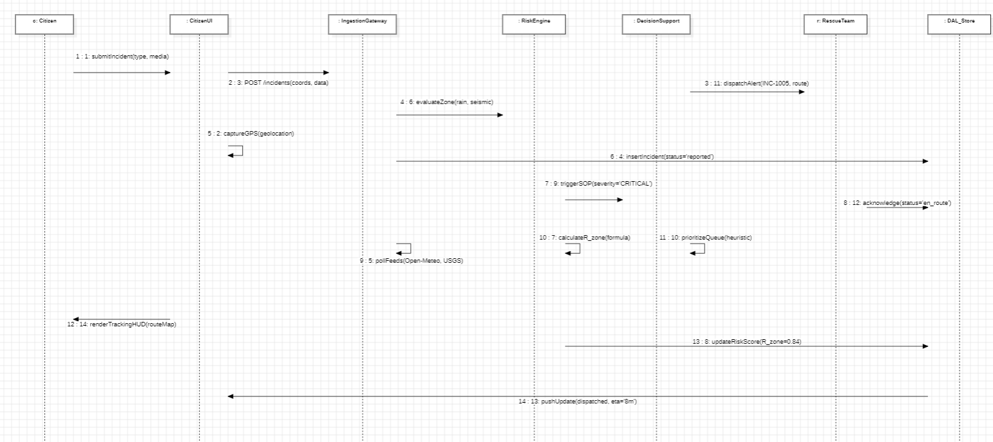

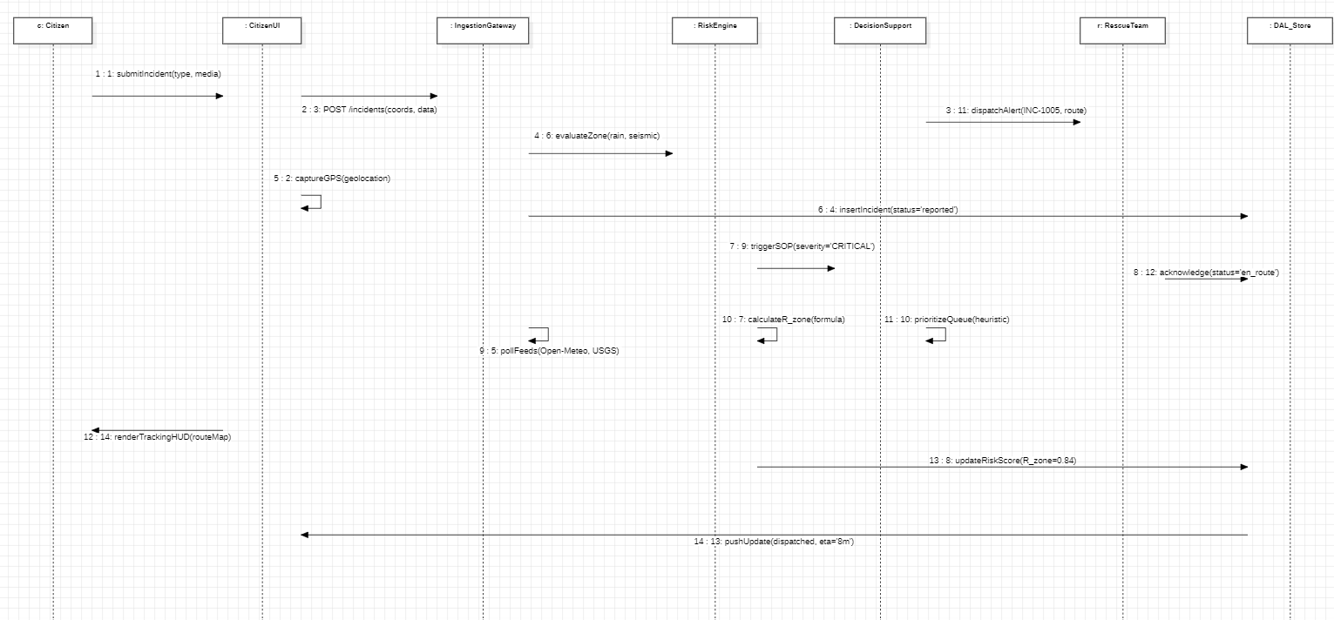

Component Diagram: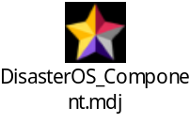
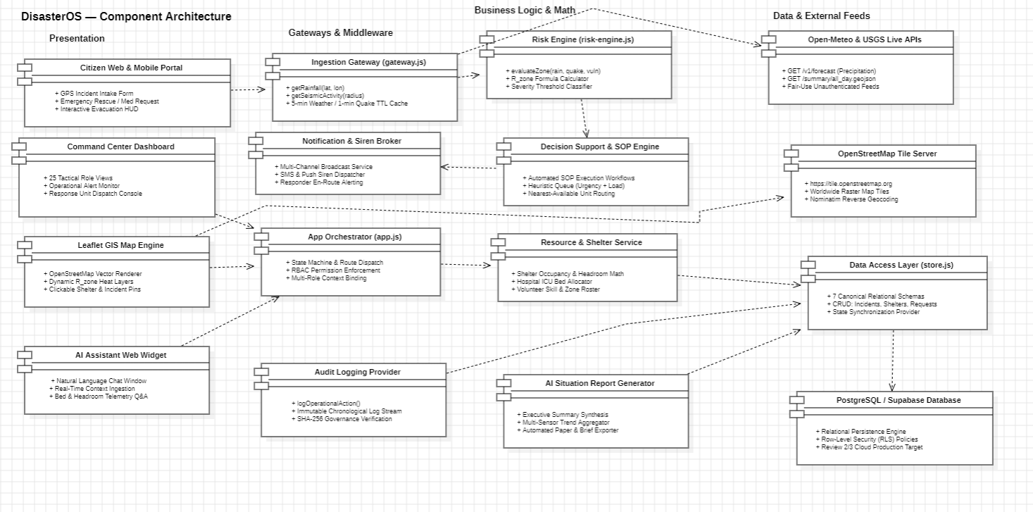

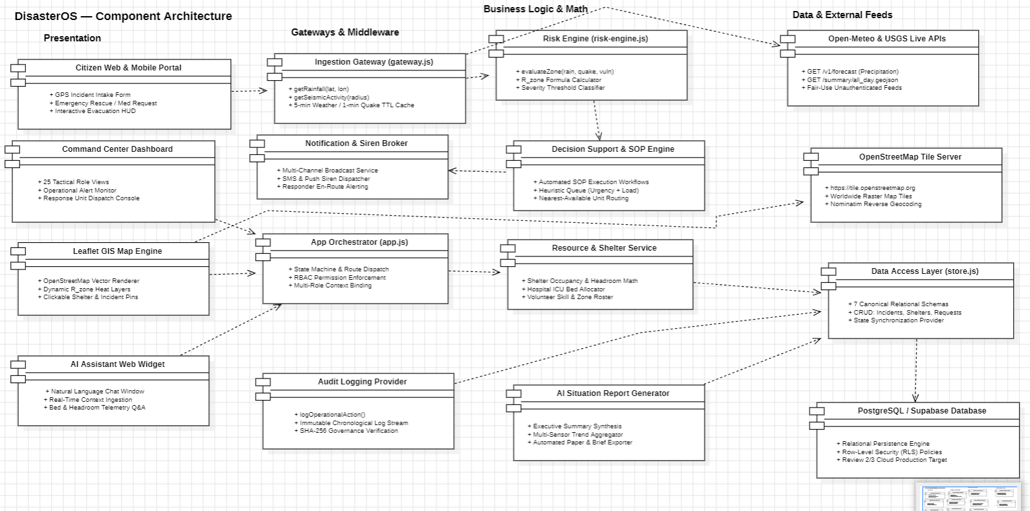

4. Module Breakdown and Algorithm Descriptions:
The current application exposes 25 functional modules. The module list below is kept complete so that the report matches the implemented application navigation and review scope.
No. | Module | Purpose
1 | Command Dashboard | Operational overview, active incidents, risk status, alerts, and response summaries.
2 | Early Warning Intelligence | Weather/seismic intelligence and deterministic zone-risk classifications.
3 | Dynamic GIS Risk Map | Leaflet map showing risk zones, incidents, shelters, hospitals, and seismic events.
4 | Decision Support Engine | Heuristic priority calculations and evacuation recommendations.
5 | Incident Lifecycle Management | Incident flow from report and verification through assignment, response, resolution, and closure.
6 | Emergency Help Requests | Citizen assistance needs and emergency triage.
7 | Rescue Team Dispatch | Response-team coordination and dispatch acknowledgement.
8 | Automated SOP Execution | Standard operating procedure workflows for emergency actions.
9 | Smart Evacuation Planning | Safe routes, shelter capacity, and evacuation assignments.
10 | Shelter Management | Shelter capacity, occupancy, status, and relief resources.
11 | Hospital Coordination | Beds, ICU capacity, trauma capability, and medical load.
12 | Volunteer Management | Volunteer skills, zones, and deployment status.
13 | Warehouse & Inventory | Relief stock, thresholds, units, and warehouse locations.
14 | Relief Distribution | Deliveries, destinations, beneficiaries, and delivery status.
15 | Critical Infrastructure | Infrastructure assets, condition, type, zone, and uptime.
16 | AI Report Generation | Structured situation briefs from current operational data.
17 | AI Emergency Assistant | Local rule-based assistance for incidents, shelters, and hospitals.
18 | Analytics Dashboard | Operational indicators, response times, and trends.
19 | Citizen Incident Reporting | Emergency details with native GPS and media-oriented input.
20 | Notifications Center | Operational and emergency alert information.
21 | System Architecture & Flow | Software architecture and ingestion pathway.
22 | API Sources & Integrations | External data providers and integration information.
23 | Role-Based Access Control | Eight configured application roles and their access levels.
24 | Audit Logs | Chronological records of actor, module, action, and time.
25 | System Health | Platform-service health and deployment-readiness information.

4.1 Zone-Risk Calculation
For each monitored zone, the RiskEngine normalizes rainfall and seismic inputs, combines them with static vulnerability and shelter headroom, and then clamps the result to [0,1]. The current weights are 0.35 for rainfall, 0.30 for seismic activity, 0.25 for vulnerability, and 0.20 for shelter headroom.
R_zone = 0.35 × Rain_norm + 0.30 × Seismic_norm + 0.25 × Vulnerability − 0.20 × ShelterHeadroom
(1)
Rainfall is normalized against a 50 mm / 3-hour reference and seismic activity against magnitude 7.0. ShelterHeadroom is 1 − occupied/total capacity when capacity data are available. The implemented thresholds classify R_zone ≥ 0.85 as emergency, 0.65–<0.85 as warning, 0.45–<0.65 as watch, 0.25–<0.45 as advisory, and values below 0.25 as baseline.
4.2 Emergency-Request Priority
Open emergency requests are scored using need-type urgency, the current risk of the request's zone, and a logarithmic load penalty based on the number of people involved.
Priority = 0.50 × Urgency + 0.35 × ZoneRisk + 0.15 × LoadPenalty
(2)
The urgency mapping gives the highest weight to rescue, followed by medical, evacuation, water, food, and shelter requests. The logarithmic load term prevents large population counts from dominating the score by themselves. Requests are sorted in descending order of computed priority.
4.3 Telemetry and GIS Processing
The ingestion gateway caches weather readings for five minutes and seismic readings for one minute. Open-Meteo precipitation and current weather values are normalized into internal readings, while the USGS GeoJSON feed is filtered by distance using the Haversine formula. The GIS controller renders risk zones, incidents, shelters, hospitals, and seismic events through Leaflet layers.

5. Implementation and Experimental Setup
The current prototype is implemented as a browser-based application using HTML, CSS, and JavaScript. app.js manages the application shell and navigation; gateway.js handles live weather and seismic acquisition; map.js handles geospatial visualization; risk-engine.js contains the risk and priority algorithms; and store.js manages operational data and audit records.
The implemented data path begins at the user interface or citizen report form, passes through application and telemetry logic, evaluates risk and priorities, updates the data layer, and returns refreshed state to the dashboards. The store contains zones, incidents, emergency requests, shelters, hospitals, volunteers, inventory, infrastructure, relief deliveries, teams, alerts, and audit logs. Browser local storage is the present persistence mechanism.
The experimental setup for the next review will use fixture or recorded Open-Meteo and USGS payloads so that ingestion and risk calculations can be verified independently of network availability. Test scenarios will vary rainfall, seismic magnitude, vulnerability, shelter occupancy, request type, and people count. The objective is to establish correctness first and then measure end-to-end response behavior.

5.1 Code Files and Folders
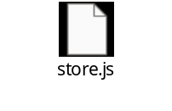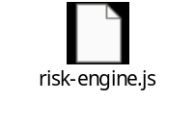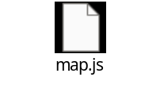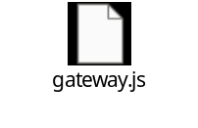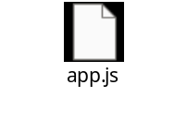
https://github.com/SHAIK-SAMEER1/DisasterOs.git
6. Current Status at Review 1
The current software base contains the main application shell and a substantial set of core implementation units. Eight roles are exposed in the login and RBAC interface: System Administrator, Disaster Manager, Emergency Responder, Hospital Coordinator, NGO Coordinator, Volunteer, Warehouse Manager, and Citizen. The
platform also exposes 25 functional modules and seeded operational data.

Area | Status | Evidence / Current Scope
Application shell | Implemented | Login, role selection, navigation, dashboard shell, and 25 module views.
Weather ingestion | Implemented | Open-Meteo request path, five-minute cache, and fallback telemetry.
Seismic ingestion | Implemented | USGS GeoJSON feed, one-minute cache, radius filtering, and Haversine distance.
Risk engine | Implemented | Normalized inputs, weighted R_zone score, clamping, and five classifications.
GIS visualization | Implemented | Leaflet layers for zones, incidents, shelters, hospitals, and seismic events.
Data store | Implemented | Browser persistence, seeded collections, CRUD operations, and audit logging.
Priority heuristic | Implemented | Urgency, zone-risk, logarithmic load penalty, and descending sort.
RBAC interface | Implemented | Eight configured roles and role/permission presentation.
AI assistant/reporting | Prototype | Local rule-based assistant responses and generated situation text; external LLM inference is not required for the current core flow.
Cloud relational persistence | Planned | PostgreSQL/Supabase remains the target multi-device deployment path.

7. Preliminary Results and Discussion
At Review 1, the principal result is functional coverage rather than a numerical performance claim. The software demonstrates a consistent separation between interface, ingestion, GIS, risk, and storage responsibilities. A region change updates map context and monitored-zone coordinates, followed by a telemetry synchronization pass that evaluates weather, seismic activity, shelter capacity, and zone vulnerability.
The deterministic algorithms also provide a straightforward verification path because identical fixture inputs lead to reproducible risk classifications and priority orderings. Recorded weather and earthquake payloads can therefore be replayed without depending on a live network. The broad module surface additionally supports scenario walkthroughs across command operations, emergency response, resources, intelligence, citizen services, and governance.
No fabricated performance result is reported. Response-time reduction, throughput, and concurrency measurements should be obtained only after the test deployment exists. The next review can therefore extend this work with controlled latency measurements and end-to-end workflow tests while retaining the same algorithms and data contracts.

8. Conclusion and Future Scope
DisasterOS presents a unified software architecture for disaster early warning, incident coordination, resource management, and operational decision support. Its central design choice is a transparent rule-based risk engine that combines live weather and seismic signals with zone vulnerability and shelter headroom. The resulting risk state can support emergency-request prioritization, dispatch-oriented workflows, and role-specific operational views.
The Review 1 implementation includes the application shell, 25 functional modules, live feed integration paths, GIS visualization, risk and priority algorithms, operational browser storage, role management, and audit support. Future work includes production relational persistence, deeper SOP automation, richer medical and infrastructure telemetry, more resilient offline field operation, and evaluation of dispatch assignment strategies beyond the current deterministic heuristic.

References
[1] Careem, B., De Silva, C., De Silva, R., Raschid, L., Weerawarana, S.: Sahana: Overview of a Disaster Management System. In: Proc. 3rd Int. Conf. on Information and Automation for Sustainability (ICIIS) (2006).
[2] Okolloh, O.: Ushahidi, or "testimony": Web 2.0 tools for crowdsourcing crisis information. Participatory Learning and Action 59(1), 65–70 (2009).
[3] National Institute of Building Sciences (NIBS), Federal Emergency Management Agency (FEMA): Multi-Hazard Loss Estimation Methodology (HAZUS-MH) Technical Manual. U.S. Department of Homeland Security, Washington, D.C. (2003).
[4] Scawthorn, C., et al.: HAZUS-MH Flood Loss Estimation Methodology, I: Overview and Flood Hazard Characterization. Natural Hazards Review 7(2) (2006).
[5] U.S. Geological Survey: Real-Time Earthquake Notification and GeoJSON Feed Documentation. USGS Earthquake Hazards Program.
[6] Open-Meteo: Free Weather Forecast API Documentation.
[7] OpenStreetMap Foundation: OpenStreetMap and Leaflet.js Open-Source Mapping Tools.
[8] National Disaster Management Authority (NDMA), Government of India: Disaster management policy and institutional framework reference.

