Supermarket Sales Analysis
Data Analytics Project | 500 transactions, Jan – Jul 2026

1. Problem Statement
The aim of this project is to analyze supermarket sales data and find useful information about products, branches, categories, customers, payments, and ratings.

2. Dataset
The dataset contains 500 sales transactions from four branches (Jaipur, Delhi, Mumbai, Bengaluru), dated 1 January to 1 July 2026. Each record includes invoice ID, date, branch, city, customer type, gender, product, category, quantity, unit price, payment method, rating, and sales.
Dataset link: Google Sheets

3. Steps Used for Analysis
- Collect and load the dataset.
- Check the data for missing or incorrect values. No missing values or duplicate invoice IDs were found.
- Verify Sales = Quantity × Unit Price. The formula matched on all 500 rows.
- Group and summarize the data using totals, counts, and averages.
- Create charts to compare the results.
- Use the results to make business decisions.

4. Key Metrics
Metric | Value
Total sales | ₹2,44,411.08
Transactions | 500
Average sales per transaction | ₹488.82
Average customer rating | 3.99 / 5

5. Analysis
Which product generates the highest sales?
Cheese generated the highest sales: ₹27,906.30. Coffee (₹27,694.87) and Shampoo (₹27,497.48) are very close behind, so the top three products are almost level.
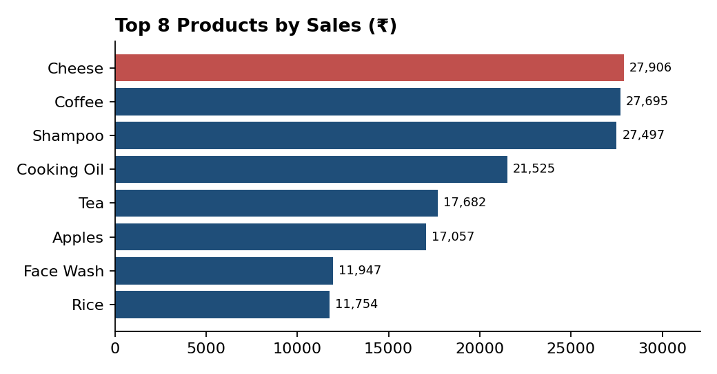
Which branch performs best?
Branch C (Mumbai) performed best with sales of ₹72,469.45, about 30% of total sales. Its lead comes mainly from volume (143 transactions), and its average transaction (₹507) is also the highest.
Branch | Sales (₹) | Transactions | Avg per transaction
C – Mumbai | 72,469.45 | 143 | ₹507
B – Delhi | 64,116.26 | 133 | ₹482
D – Bengaluru | 55,468.29 | 119 | ₹466
A – Jaipur | 52,357.08 | 105 | ₹499
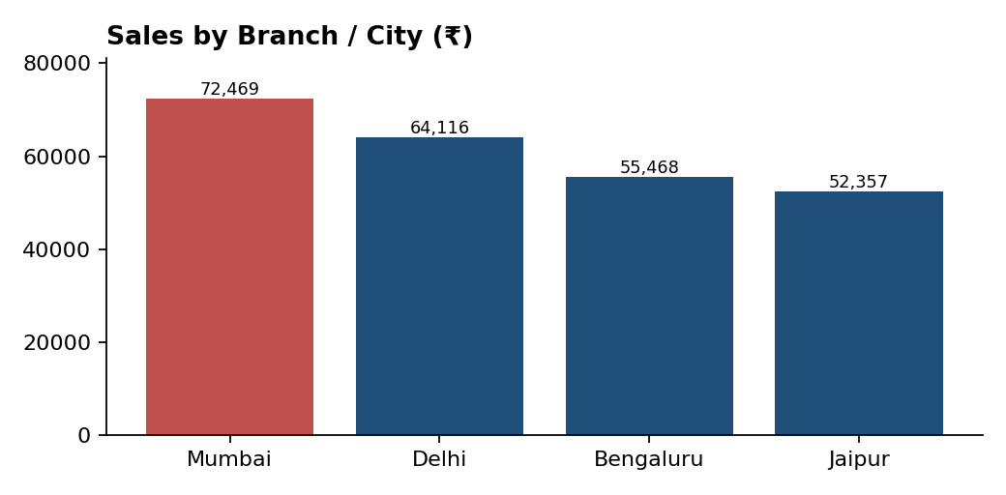
Which category sells the most?
Beverages had the highest sales with ₹56,108.24 (about 23% of total), followed by Personal Care (₹45,943.96) and Dairy (₹43,992.00). Bakery is the lowest at ₹6,516.10.
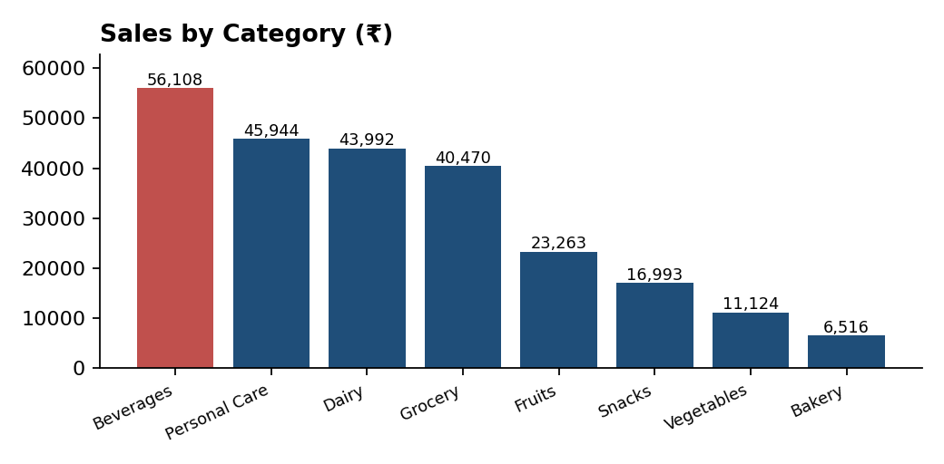
What is the most popular payment method?
UPI was the most used payment method with 127 transactions. However, the split is almost even: Net Banking 126, Card 125, and Cash 122. No single method clearly dominates.
Do Members spend more than Normal customers?
No. The average Member transaction was ₹483.14, while Normal customers averaged ₹497.07. The gap is small (about 3%). Members make up 59% of transactions (296 of 500).
What is the average customer rating?
The average customer rating was 3.99 out of 5.
How do sales change over time?
Sales were highest in April (₹52,569.77) and lowest in February (₹30,068.15). July is excluded from the chart because the data contains only 1 July.
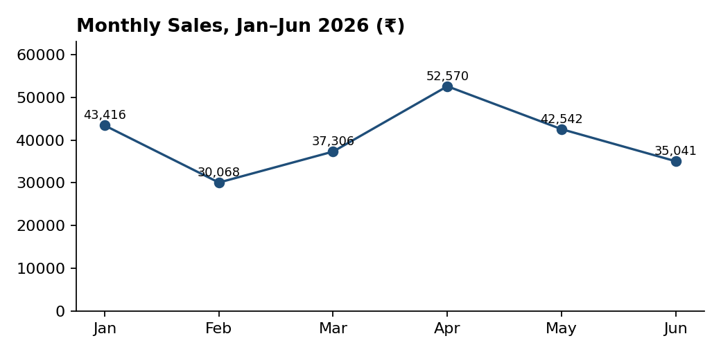

6. Business Decisions
- Keep more stock of high-selling items: Beverages, Cheese, Coffee, and Shampoo.
- Study why Mumbai performs strongly (product mix, footfall) and apply it in Bengaluru, which has the lowest average transaction (₹466).
- Support all payment methods, since UPI leads only slightly.
- Members do not spend more per visit, so use offers that increase basket size (bundles, minimum-spend rewards) instead of plain discounts.
- Improve customer service to raise the average rating above 3.99.
- Review Bakery and Vegetables, which have low sales value, to decide whether to promote or reduce them.

7. Conclusion
This analysis shows how sales data can be converted into simple insights that help a supermarket understand performance and make better decisions. Beverages, Cheese, and the Mumbai branch drive the most sales, payments are evenly spread, and membership offers should focus on larger baskets rather than discounts.
Note: the dataset has no currency or cost column, so values are assumed to be in rupees and profit could not be analyzed.

