Figma
Sign & login :DESIGN
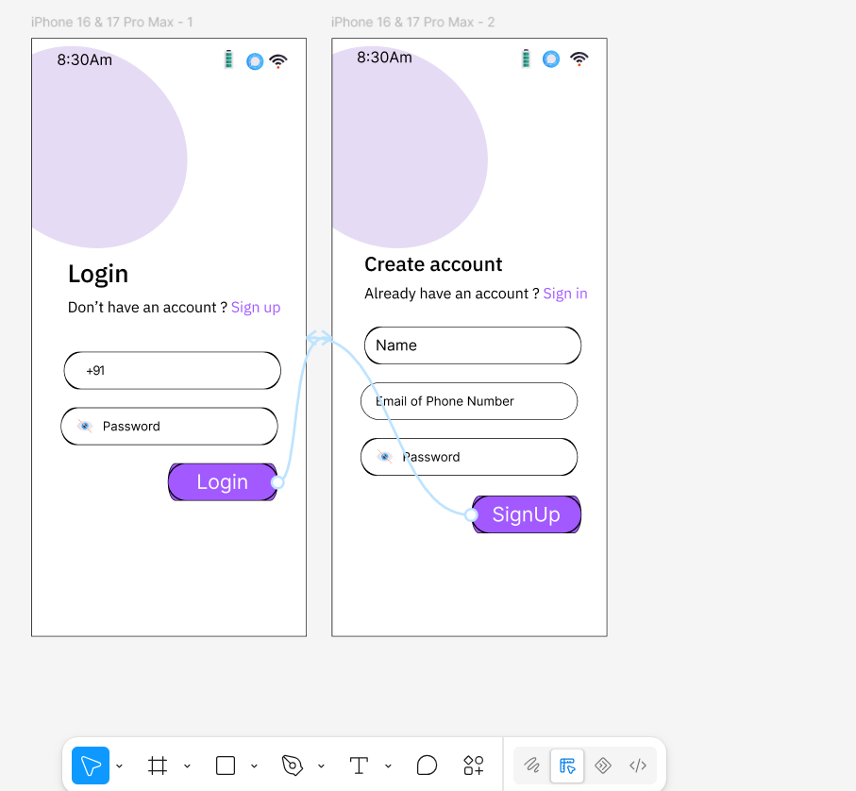

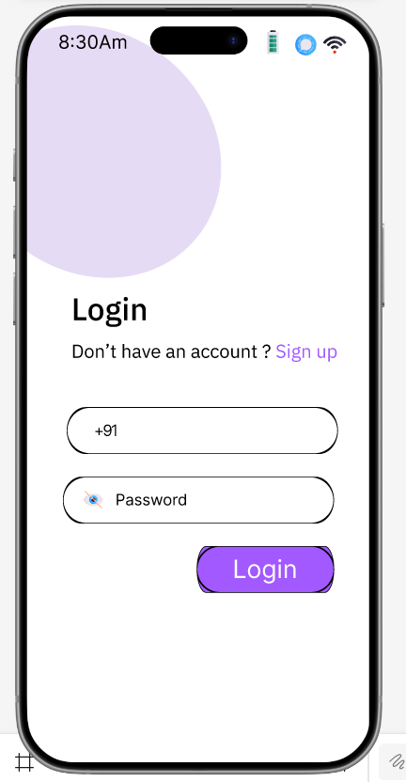
OutPut: https://www.figma.com/design/YNXYGIlxRlszsUVbcbCHtC/Untitled?node-id=0-1&p=f&t=OrA7y5fztIPYQU5I-0
